Table S2. Descriptive statistics of clubroot resistance variations in rutababa accessions collected from Norway, Sweden, Finland, Denmark and Iceland.
Pathotype | Mean ± sd | Mode | Min (%) | 50% Quantile (%) | Max (%) | Coefficient of variation (%)
2F | 78.7 ± 27.2 | 100.0 | 6.3 | 90.3 | 100.0 | 34.4
3H | 83.6 ± 27.1 | 100.0 | 0.0 | 100.0 | 100.0 | 32.3
5I | 82.9 ± 26.8 | 100.0 | 0.0 | 100.0 | 100.0 | 32.2
6M | 81.5 ± 27.2 | 100.0 | 1.6 | 95.8 | 100.0 | 33.2
8N | 82.9 ± 27.2 | 100.0 | 4.2 | 95.8 | 100.0 | 32.7
5X (LG2) | 73.6 ± 29.8 | 100.0 | 3.7 | 83.3 | 100.0 | 40.3
5X (LG3) | 63.8 ± 29.9 | 100.0 | 5.6 | 72.2 | 100.0 | 46.7
5L | 30.2 ± 34.0 | 100.0 | 0.0 | 14.3 | 100.0 | 112.1
3A | 77.5 ± 27.8 | 100.0 | 0.0 | 87.5 | 100.0 | 35.8
2B | 80.6 ± 28.2 | 100.0 | 0.0 | 97.9 | 100.0 | 34.8
5G | 78.9 ± 28.0 | 100.0 | 4.6 | 95.1 | 100.0 | 35.4
8E | 77.2 ± 30.4 | 100.0 | 0.0 | 97.9 | 100.0 | 39.2
5C | 82.4 ± 22.8 | 100.0 | 20.6 | 93.1 | 100.0 | 27.6
8J | 56.3 ± 38.6 | 100.0 | 0.0 | 63.1 | 100.0 | 68.4
5K | 30.3 ± 34.7 | 100.0 | 0.0 | 13.2 | 100.0 | 114.2
3O | 70.7 ± 32.1 | 100.0 | 5.6 | 87.5 | 100.0 | 45.2
8P | 69.7 ± 33.6 | 100.0 | 0.0 | 83.3 | 100.0 | 48.0

Table S3. Summary: Reactions of 124 rutabaga (Brassica napus ssp. napobrassica) accessions to 17 Plasmodiophora brassicae isolates.
Accession | 2F | 3H | 5I | 6M | 8N | 5X¹ | 5X² | 5L | 2B | 3A | 5C | 5G | 8E | 5K | 8J | 3O | 8P | All Pb | R | MR | S | Crr1 | Crr3 | CRb | CRa / CRb^{Kato} / Rcr1
FGRA001 | S | S | S | S | S | S | S | S | S | S | S | S | S | S | S | S | S | S | 0 | 0 | 17 | - | - | - | -
FGRA002 | S | S | S | S | S | S | R | R | S | S | S | S | S | R | R | S | S | S | 4 | 0 | 13 | - | - | - | -
FGRA003 | MR | S | R | R | R | S | S | MR | S | R | S | S | MR | S | S | R | R | S | 6 | 3 | 8 | - | - | - | -
FGRA004 | S | S | S | S | S | S | S | MR | S | S | S | S | S | MR | S | S | S | S | 0 | 2 | 15 | - | - | - | -
FGRA005 | S | S | S | S | S | S | S | S | S | S | S | S | S | S | S | S | S | S | 0 | 0 | 17 | - | - | - | -
FGRA006 | S | S | S | S | S | S | S | MR | S | S | S | S | S | S | S | S | S | S | 0 | 1 | 16 | - | - | - | -
FGRA007 | S | S | S | S | S | S | S | MR | S | S | S | S | S | R | MR | S | S | S | 1 | 2 | 14 | - | - | - | -
FGRA008 | S | S | S | S | S | S | S | S | S | S | S | S | S | R | S | S | S | S | 1 | 0 | 16 | - | - | - | -
FGRA009 | S | S | S | S | S | S | S | S | S | S | S | S | S | S | S | S | S | S | 0 | 0 | 17 | - | - | - | -
FGRA010 | S | S | S | S | S | S | S | R | S | S | S | S | S | S | S | S | S | S | 1 | 0 | 16 | - | - | - | -
FGRA011 | S | S | S | MR | MR | MR | S | S | MR | S | S | S | MR | MR | S | MR | S | S | 0 | 7 | 10 | - | - | - | -
FGRA012 | S | S | S | S | S | S | S | R | S | S | S | S | S | R | MR | S | S | S | 2 | 1 | 14 | - | - | - | -
FGRA013 | S | S | S | S | S | S | S | S | S | S | S | S | S | S | S | S | S | S | 0 | 0 | 17 | - | - | - | -
FGRA014 | S | S | S | S | S | S | S | R | S | S | S | S | S | R | S | S | S | S | 2 | 0 | 15 | - | - | - | -
FGRA015 | S | S | S | S | S | S | S | S | S | S | S | S | S | R | S | S | S | S | 1 | 0 | 16 | - | - | - | -
FGRA016 | S | S | S | S | S | S | S | S | S | S | S | S | S | S | S | S | S | S | 0 | 0 | 17 | - | - | - | -
FGRA017 | S | S | S | S | S | S | S | S | S | S | S | S | S | MR | S | S | S | S | 0 | 1 | 16 | - | - | - | -
FGRA018 | S | S | S | S | R | R | MR | R | S | MR | S | MR | S | R | R | MR | R | S | 6 | 4 | 7 | - | - | - | -
FGRA019 | S | S | S | S | S | S | S | R | S | S | S | S | S | R | S | MR | S | S | 2 | 1 | 14 | - | - | - | -
FGRA020 | S | S | S | S | S | S | S | R | S | S | S | S | S | MR | S | S | S | S | 1 | 1 | 15 | - | - | - | -
FGRA021 | S | S | S | S | S | S | S | S | S | S | S | S | S | S | S | S | S | S | 0 | 0 | 17 | - | - | - | -
FGRA022 | S | S | S | S | S | S | S | S | S | S | S | S | S | S | S | S | S | S | 0 | 0 | 17 | - | - | - | -
FGRA023 | S | S | S | S | S | S | MR | R | S | S | S | S | S | R | R | MR | S | S | 3 | 2 | 12 | - | - | - | -
FGRA024 | S | S | S | S | S | S | S | S | S | S | S | S | S | S | S | S | S | S | 0 | 0 | 17 | - | - | - | -
FGRA025 | S | S | S | S | S | S | S | S | S | S | S | S | S | MR | S | S | S | S | 0 | 1 | 16 | - | - | - | -
FGRA026 | S | S | S | S | S | S | S | S | S | S | S | S | S | S | S | S | S | S | 0 | 0 | 17 | - | - | - | -
FGRA027 | S | S | S | S | S | S | S | R | MR | S | S | S | S | MR | R | S | S | S | 2 | 2 | 13 | - | - | - | -
FGRA028 | S | S | S | S | S | S | S | R | S | S | S | S | S | R | MR | S | S | S | 2 | 1 | 14 | - | - | - | -
FGRA029 | S | S | S | S | S | S | S | S | S | S | S | S | S | MR | S | S | S | S | 0 | 1 | 16 | - | - | - | -
FGRA030 | S | MR | MR | S | S | MR | S | R | S | S | S | MR | S | R | R | S | S | S | 3 | 4 | 10 | - | - | - | -
FGRA031 | S | S | S | S | S | S | S | S | S | S | S | S | S | S | S | S | S | S | 0 | 0 | 17 | - | - | - | -
FGRA032 | S | S | S | S | S | S | S | R | S | S | S | S | S | R | S | S | S | S | 2 | 0 | 15 | - | - | - | -
FGRA033 | S | S | S | S | S | S | S | R | S | S | S | S | S | R | R | S | S | S | 3 | 0 | 14 | - | - | - | -
FGRA034 | S | S | S | S | S | S | S | R | S | S | S | S | S | R | R | S | S | S | 3 | 0 | 14 | - | - | - | -
FGRA035 | S | S | S | S | S | S | S | MR | S | S | S | S | S | R | MR | S | S | S | 1 | 2 | 14 | - | - | - | -
FGRA036 | S | S | S | MR | MR | MR | S | R | MR | R | S | R | R | R | S | MR | MR | MR | 5 | 6 | 6 | + | - | - | +
FGRA037 | R | R | R | R | MR | R | MR | MR | MR | R | MR | R | MR | R | R | S | R | R | 10 | 6 | 1 | + | + | + | +
FGRA038 | S | S | S | S | S | S | S | S | S | S | S | S | S | MR | R | S | S | S | 1 | 1 | 15 | - | - | - | -
FGRA039 | MR | S | S | S | S | S | S | MR | S | S | S | S | S | MR | R | S | S | S | 1 | 3 | 13 | - | - | - | -
FGRA040 | S | S | S | MR | S | S | S | R | MR | S | S | S | S | MR | S | S | MR | S | 1 | 4 | 12 | - | - | - | -
FGRA041 | MR | MR | R | R | R | S | S | S | S | R | S | MR | MR | S | S | R | R | S | 6 | 4 | 7 | - | - | - | -
FGRA042 | S | S | S | S | S | S | S | R | S | S | S | S | S | R | R | S | S | S | 3 | 0 | 14 | - | - | - | -
FGRA043 | S | S | S | S | S | S | S | MR | S | S | S | S | S | S | S | S | S | S | 0 | 1 | 16 | - | - | - | -
FGRA044 | S | R | MR | MR | R | S | R | MR | MR | MR | R | MR | R | R | R | R | R | R | 9 | 6 | 2 | + | + | + | +
FGRA045 | S | S | S | S | S | S | S | R | S | S | S | S | S | MR | S | S | S | S | 1 | 1 | 15 | - | - | - | -
FGRA046 | S | S | S | S | S | S | S | S | S | S | S | S | S | S | S | S | S | S | 0 | 0 | 17 | - | - | - | -
FGRA047 | S | S | S | S | S | S | R | R | S | S | S | MR | S | S | S | MR | R | S | 3 | 2 | 12 | - | - | - | -
FGRA048 | S | S | S | S | S | S | S | S | S | S | S | S | S | S | S | S | S | S | 0 | 0 | 17 | - | - | - | -
FGRA049 | S | S | S | S | S | S | S | MR | S | S | S | S | S | S | S | S | S | S | 0 | 1 | 16 | - | - | - | -
FGRA050 | S | S | S | S | S | S | R | R | S | S | S | S | S | R | R | MR | S | S | 4 | 1 | 12 | - | - | - | -
FGRA051 | S | S | S | S | S | S | S | S | S | S | S | S | S | S | S | S | S | S | 0 | 0 | 17 | - | - | - | -
FGRA052 | S | S | S | S | S | S | S | MR | S | S | S | S | S | R | S | S | S | S | 1 | 1 | 15 | - | - | - | -
FGRA053 | S | S | S | S | S | S | S | R | S | S | S | S | S | R | R | S | S | S | 3 | 0 | 14 | - | - | - | -
FGRA054 | S | S | S | S | S | S | S | MR | S | S | S | S | S | R | MR | S | S | S | 1 | 2 | 14 | - | - | - | -
FGRA055 | S | S | S | S | S | S | S | S | S | S | S | S | S | S | S | S | S | S | 0 | 0 | 17 | - | - | - | -
FGRA056 | S | S | S | S | S | S | MR | MR | S | S | S | S | S | R | MR | S | S | S | 1 | 3 | 13 | - | - | - | -
FGRA057 | S | S | S | S | S | S | S | S | S | S | S | S | S | S | S | S | S | S | 0 | 0 | 17 | - | - | - | -
FGRA058 | MR | S | MR | S | S | R | MR | R | S | R | S | S | R | R | R | R | MR | S | 7 | 4 | 6 | - | - | - | -
FGRA059 | S | S | S | S | S | R | S | R | S | S | S | S | S | S | S | MR | MR | S | 2 | 2 | 13 | - | - | - | -
FGRA060 | S | S | S | S | S | S | S | R | S | S | S | S | S | R | S | S | S | S | 2 | 0 | 15 | - | - | - | -
FGRA061 | S | S | S | MR | S | MR | R | R | S | S | S | S | S | R | R | S | R | S | 5 | 2 | 10 | - | - | - | -
FGRA062 | S | S | S | S | S | S | S | S | S | S | S | S | S | R | S | S | S | S | 1 | 0 | 16 | - | - | - | -
FGRA063 | S | S | S | S | S | S | S | R | S | S | S | S | S | MR | S | S | S | S | 1 | 1 | 15 | - | - | - | -
FGRA064 | S | S | S | S | S | S | S | MR | S | S | S | S | S | MR | S | S | S | S | 0 | 2 | 15 | - | - | - | -
FGRA065 | S | S | S | S | S | S | S | R | S | S | S | S | S | MR | S | S | S | S | 1 | 1 | 15 | - | - | - | -
FGRA066 | S | S | S | S | S | S | S | MR | S | S | S | S | S | R | R | S | S | S | 2 | 1 | 14 | - | - | - | -
FGRA067 | S | S | S | S | S | S | S | R | S | S | S | S | S | R | S | S | S | S | 2 | 0 | 15 | - | - | - | -
FGRA068 | MR | MR | MR | S | MR | R | R | R | R | MR | S | R | R | R | R | MR | R | MR | 9 | 6 | 2 | + | - | - | +
FGRA069 | S | S | S | S | S | S | S | S | S | S | S | S | S | S | S | S | S | S | 0 | 0 | 17 | - | - | - | -
FGRA070 | R | MR | S | R | S | S | S | S | S | S | S | S | S | MR | R | S | S | S | 3 | 2 | 12 | - | - | - | -
FGRA071 | S | S | S | S | S | S | S | S | S | S | S | S | S | S | S | S | S | S | 0 | 0 | 17 | - | - | - | -
FGRA072 | R | R | MR | MR | S | R | R | MR | MR | MR | MR | MR | MR | R | MR | MR | R | R | 6 | 10 | 1 | + | - | - | +
FGRA073 | S | S | S | S | S | S | S | S | S | S | S | S | S | S | S | S | S | S | 0 | 0 | 17 | - | - | - | -
FGRA074 | S | S | S | S | S | S | S | S | S | S | S | S | S | S | S | S | S | S | 0 | 0 | 17 | - | - | - | -
FGRA075 | S | S | S | S | S | S | S | R | S | S | S | S | S | R | S | S | S | S | 2 | 0 | 15 | - | - | - | -
FGRA076 | S | S | S | S | S | S | S | R | S | S | S | S | S | R | MR | S | S | S | 2 | 1 | 14 | - | - | - | -
FGRA077 | S | S | S | S | S | S | S | S | S | S | S | S | S | S | S | S | S | S | 0 | 0 | 17 | - | - | - | -
FGRA078 | S | S | S | S | S | R | MR | R | S | MR | MR | S | S | R | R | MR | MR | S | 4 | 5 | 8 | - | - | - | -
FGRA079 | S | S | S | S | S | MR | S | R | S | S | S | S | S | R | R | S | R | S | 4 | 1 | 12 | - | - | - | -
FGRA080 | S | S | S | S | S | S | S | R | S | S | S | S | S | R | R | S | S | S | 3 | 0 | 14 | - | - | - | -
FGRA081 | S | S | S | S | S | S | S | S | S | S | S | S | S | S | S | S | S | S | 0 | 0 | 17 | - | - | - | -
FGRA082 | S | S | S | S | S | S | S | MR | S | S | S | S | S | R | S | S | S | S | 1 | 1 | 15 | - | - | - | -
FGRA083 | S | S | S | S | S | MR | S | R | MR | MR | S | MR | MR | R | S | MR | MR | S | 2 | 7 | 8 | - | - | - | -
FGRA084 | S | S | S | S | S | S | S | S | S | S | S | S | S | MR | S | S | S | S | 0 | 1 | 16 | - | - | - | -
FGRA085 | S | S | S | S | S | S | S | S | S | S | S | S | S | S | S | S | S | S | 0 | 0 | 17 | - | - | - | -
FGRA086 | S | S | S | S | S | S | S | S | S | S | S | S | S | S | S | S | S | S | 0 | 0 | 17 | - | - | - | -
FGRA087 | S | S | S | S | S | S | S | R | S | S | S | S | S | R | S | S | S | S | 2 | 0 | 15 | - | - | - | -
FGRA088 | S | S | S | S | S | S | S | R | S | S | S | S | S | R | R | S | S | S | 3 | 0 | 14 | - | - | - | -
FGRA089 | S | S | S | S | S | S | S | R | S | S | S | S | S | R | S | S | S | S | 2 | 0 | 15 | - | - | - | -
FGRA090 | S | S | S | S | S | S | S | R | S | S | S | S | S | MR | MR | S | S | S | 1 | 2 | 14 | - | - | - | -
FGRA091 | S | S | S | S | S | S | S | R | S | S | S | S | S | R | S | S | S | S | 2 | 0 | 15 | - | - | - | -
FGRA092 | S | S | S | S | S | S | S | S | S | S | S | S | S | S | S | S | S | S | 0 | 0 | 17 | - | - | - | -
FGRA093 | S | S | S | S | S | S | S | S | S | S | S | S | S | S | S | S | S | S | 0 | 0 | 17 | - | - | - | -
FGRA094 | S | S | S | S | S | S | S | S | S | S | S | S | S | S | S | S | S | S | 0 | 0 | 17 | - | - | - | -
FGRA095 | S | S | S | S | S | S | S | S | S | S | S | S | S | MR | S | S | S | S | 0 | 1 | 16 | - | - | - | -
FGRA096 | S | S | S | S | S | S | S | S | S | S | S | S | S | S | S | S | S | S | 0 | 0 | 17 | - | - | - | -
FGRA097 | S | S | S | S | S | S | S | R | S | S | S | S | S | R | S | S | S | S | 2 | 0 | 15 | - | - | - | -
FGRA098 | S | S | S | S | S | S | S | S | S | S | S | S | S | S | S | S | S | S | 0 | 0 | 17 | - | - | - | -
FGRA099 | S | S | S | S | S | S | S | R | S | S | S | S | S | R | S | S | S | S | 2 | 0 | 15 | - | - | - | -
FGRA100 | S | S | S | S | S | S | S | S | S | S | S | S | S | S | S | S | S | S | 0 | 0 | 17 | - | - | - | -
FGRA101 | S | S | S | S | S | S | S | S | S | S | S | S | S | S | S | S | S | S | 0 | 0 | 17 | - | - | - | -
FGRA102 | S | S | S | S | S | S | S | S | S | S | S | S | S | S | S | S | S | S | 0 | 0 | 17 | - | - | - | -
FGRA103 | S | S | S | S | S | S | R | R | S | S | S | S | MR | MR | R | S | S | S | 3 | 2 | 12 | - | - | - | -
FGRA104 | S | S | S | S | S | S | S | R | S | S | S | S | S | R | S | S | S | S | 2 | 0 | 15 | - | - | - | -
FGRA105 | S | S | S | S | S | S | S | MR | S | S | S | S | S | MR | S | S | S | S | 0 | 2 | 15 | - | - | - | -
FGRA106 | R | MR | R | R | MR | MR | R | R | R | R | MR | MR | R | R | MR | R | R | R | 11 | 6 | 0 | + | - | - | +
FGRA107 | S | S | S | S | S | S | S | MR | S | S | S | S | S | R | MR | S | S | S | 1 | 2 | 14 | - | - | - | -
FGRA108 | MR | R | R | MR | S | MR | R | MR | R | R | MR | MR | R | MR | R | R | MR | R | 8 | 8 | 1 | + | - | - | +
FGRA109 | MR | S | S | S | S | MR | S | R | MR | S | MR | S | MR | R | S | MR | R | MR | 3 | 6 | 8 | + | - | - | +
FGRA110 | R | MR | MR | S | S | MR | S | R | S | S | S | S | S | MR | MR | S | S | S | 2 | 5 | 10 | - | - | - | -
FGRA111 | MR | MR | S | MR | S | S | S | S | S | S | S | S | S | MR | S | MR | S | S | 0 | 5 | 12 | - | - | - | -
FGRA112 | MR | S | S | MR | R | S | S | R | MR | S | S | MR | R | R | S | R | R | MR | 6 | 4 | 7 | + | - | - | +
FGRA113 | S | S | S | S | S | S | S | R | S | S | S | S | S | R | R | MR | MR | S | 3 | 2 | 12 | - | - | - | -
FGRA114 | S | S | S | S | S | S | R | R | S | S | S | S | S | R | R | S | S | S | 4 | 0 | 13 | - | - | - | -
FGRA115 | S | S | S | S | S | S | MR | MR | S | S | S | S | S | R | S | S | S | S | 1 | 2 | 14 | - | - | - | -
FGRA116 | S | S | S | S | S | S | S | R | S | S | S | S | S | MR | S | S | S | S | 1 | 1 | 15 | - | - | - | -
FGRA117 | S | S | S | S | S | S | S | MR | S | S | S | S | S | R | S | S | S | S | 1 | 1 | 15 | - | - | - | -
FGRA118 | S | S | S | S | S | S | S | R | S | S | S | S | S | R | R | S | MR | S | 3 | 1 | 13 | - | - | - | -
FGRA119 | S | S | S | S | S | S | S | R | S | S | S | S | S | R | MR | S | S | S | 2 | 1 | 14 | - | - | - | -
FGRA120 | S | S | S | S | S | MR | S | R | S | S | S | S | S | R | R | S | S | S | 3 | 1 | 13 | - | - | - | -
FGRA121 | S | S | S | S | S | MR | S | R | MR | S | S | S | MR | R | S | S | S | S | 2 | 3 | 12 | - | - | - | -
FGRA122 | S | S | S | S | S | S | S | R | S | S | S | S | S | MR | S | S | S | S | 1 | 1 | 15 | - | - | - | -
FGRA123 | S | S | S | S | S | S | S | S | S | S | S | S | S | S | S | S | S | S | 0 | 0 | 17 | - | - | - | -
FGRA124 | S | S | S | S | S | S | S | S | S | S | S | S | S | S | S | S | S | S | 0 | 0 | 17 | - | - | - | -
^{α} Pathotype designations are based on the systems of the Canadian Clubroot Differential (CCD) set (Strelkov et al. 2018). Pathotypes 2F, 3H, 5I, 6M and 8N are single-spore isolates identified prior to the introduction of clubroot resistant (CR) varieties in Canada, while pathotypes 5X (5X¹ = LG2 and 5X² = LG3), 5L, 3A, 2B, 5G, 8E, 5C, 8J, 5K, 3O and 8P are represented by field isolates identified after the introduction of CR varieties in Canada.
^{β} The genotypes were considered R if the disease severity index (ID) + Standard Deviation (SD) ≤ 30%, MR 30% < ID + SD ≤ 50% and S ID + SD > 50%.
“+” indicates detection of alleles linked to the Crr1 (Suwabe et al. 2006; Hatakeyama et al. 2013; Hassan and Rahman 2016; Hobson and Rahman 2016; Hirani et al. 2018) gene on chromosome A08 of Brassica rapa and for the Crr3 (Hirai et al. 2004; Saito et al. 2006), CRb (Piao et al. 2004; Zhang et al. 2014), CRa (Matsumoto et al. 1998, 2012), CRb^{Kato} (Kato et al. 2012, 2013), Rcr1 (Chu et al. 2014; Yu et al. 2016) gene(s) located on the chromosome A03 using PCR-based markers from aforementioned studies.
“-” does not necessarily mean that absence of a major gene or QTLs associated with resistance in an accession but may be rather due to lack of polymorphism in the markers used in this study.
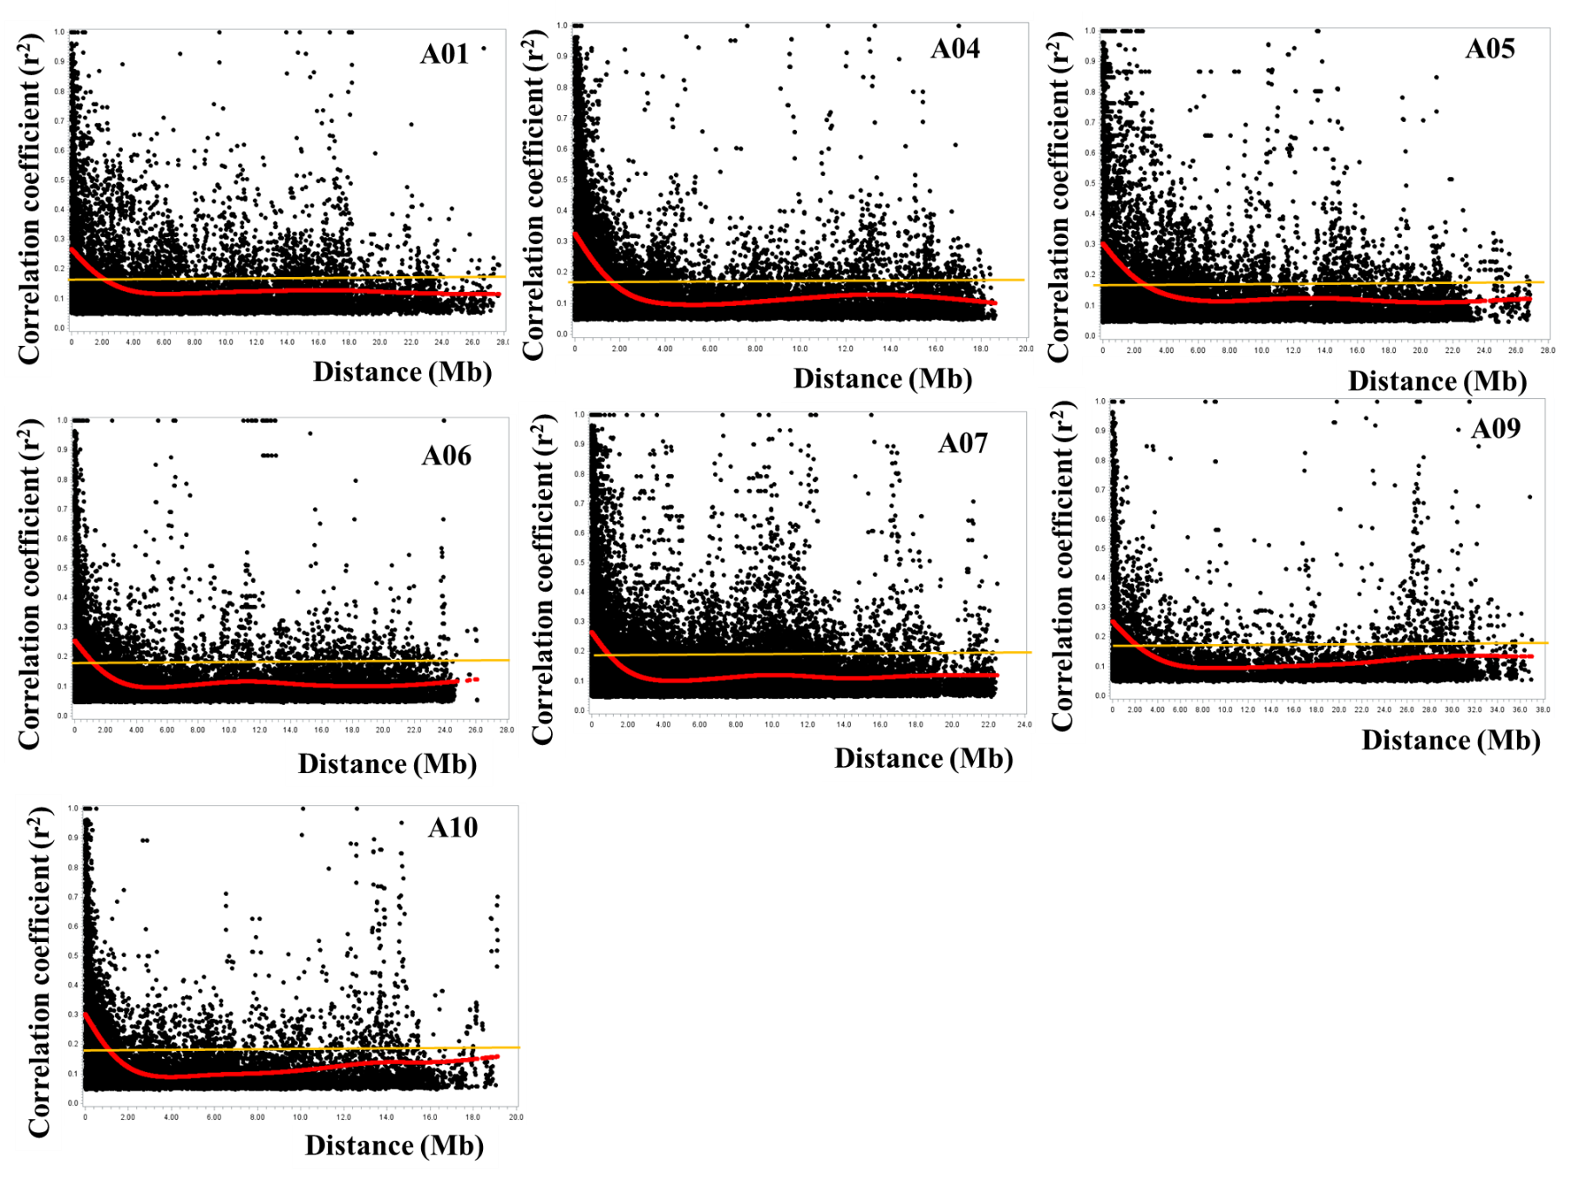
Fig S1. Plots of correlation coefficient (r²) vs. physical distance (Mb) for chromosomes A02, A04, A05, A06, A07, A09 and A10.
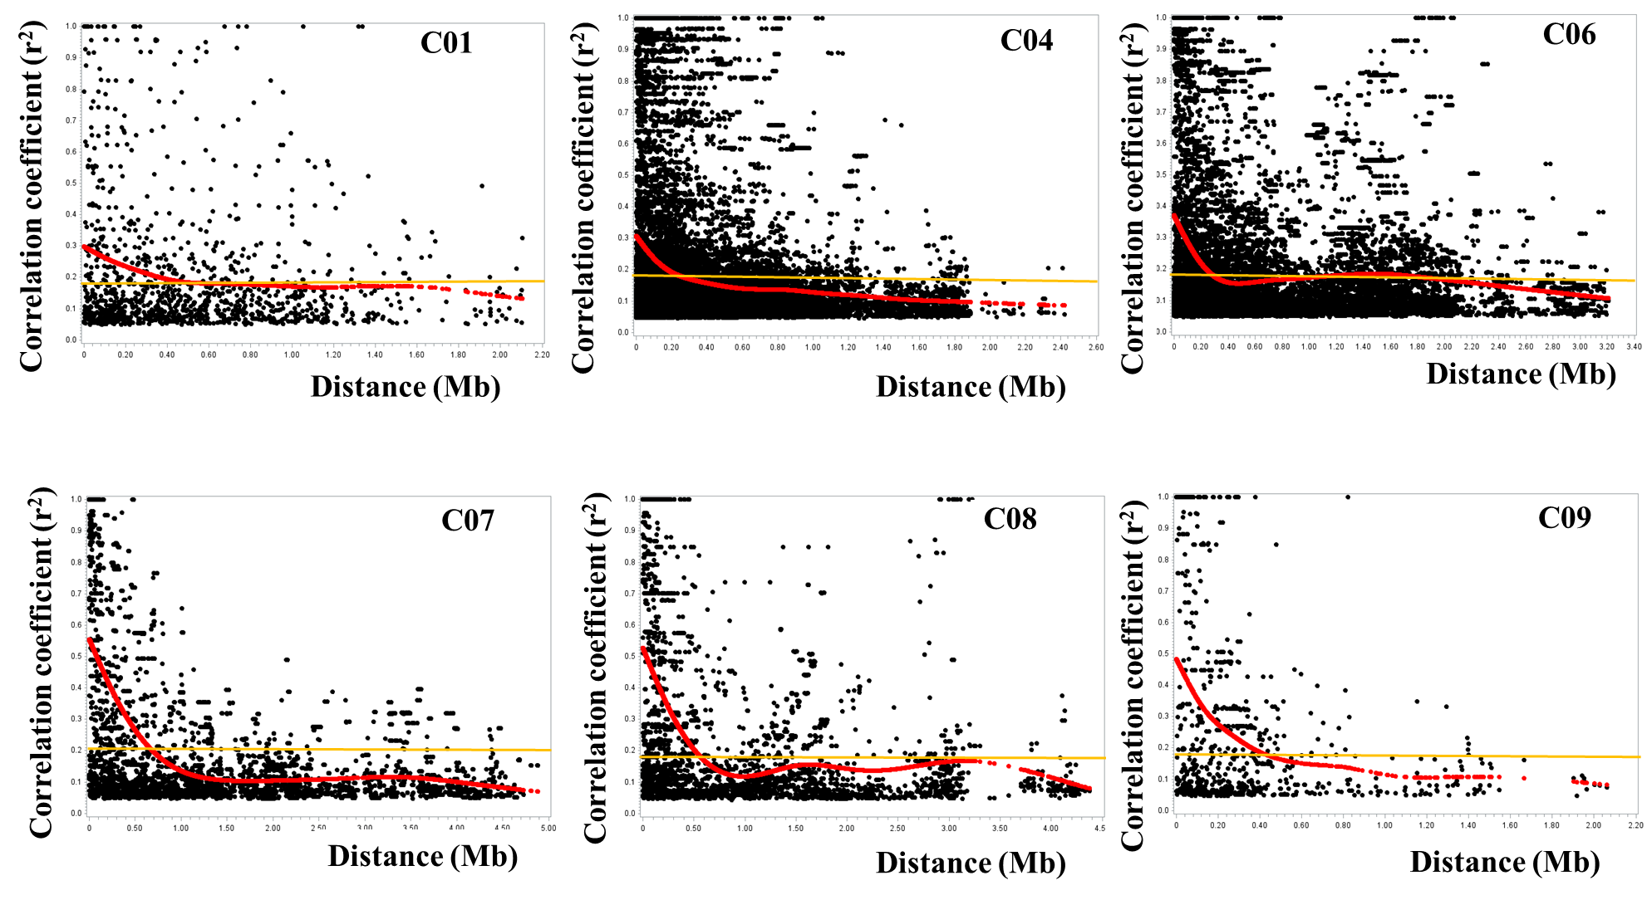
Fig S2. Plots of correlation coefficient (r²) vs. physical distance (Mb) for chromosomes C01, C04, C06, C07, C08 and C09.

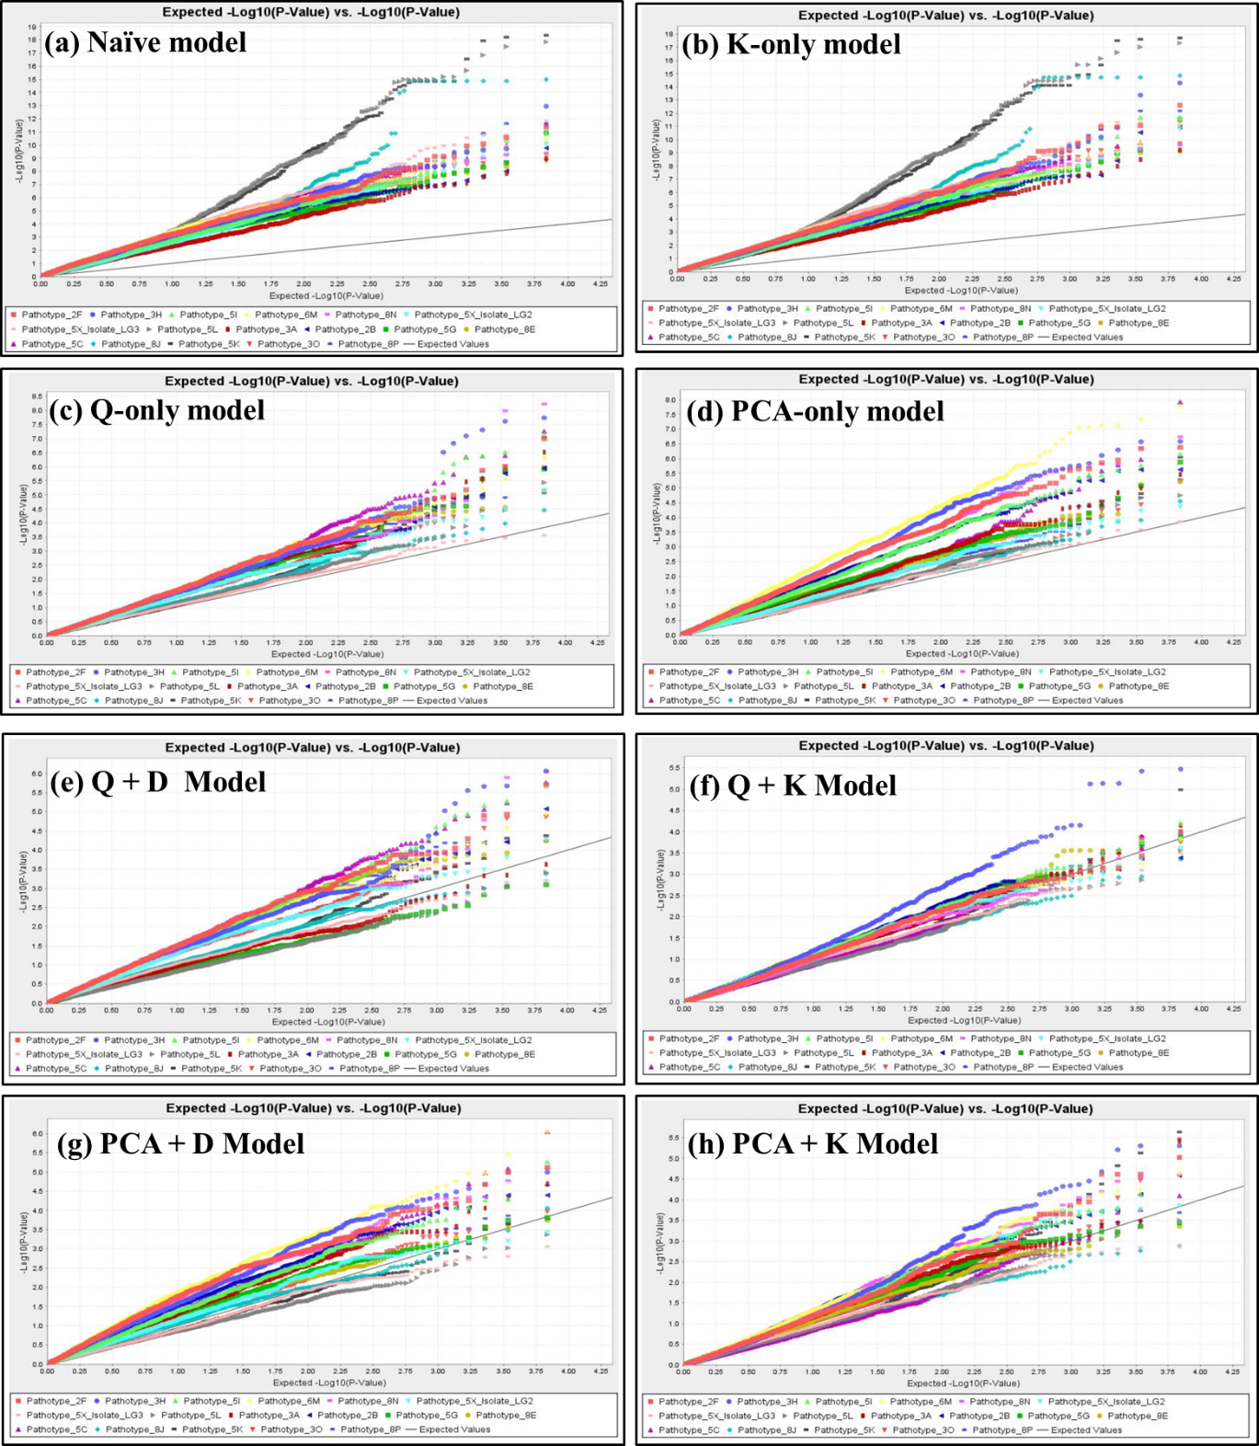
Fig S3. Quantile-Quantile comparison of eight GWAS models for identifying clubroot resistance loci in 124 rutabaga (Brassica napus ssp. napobrassica) accessions tested with 17 field and single-spore isolates of Plasmodiophora brassicae representing 16 different pathotypes. The four GLM tested comprised the Naïve(N)(a), Kinship (K)-only (b), Population structure (Q)-only (c) , and the Principal Coordinate Analysis (PCA)-only (d). The four MLM tested comprised Q + D (e), Q + K (f), PCA + D (g), PCA + K (h) models; where D is the Distance Matrix. The black line is the expected -log₁₀ P distribution while colored lines are the observed -log₁₀ P distribution for each of the 17 P. brassicae pathotypes.

