Systematic mapping review of evidence: Drivers of malnutrition in West Africa

Searching for literature in the International Bibliography of Social Science (IBSS) database

Technical note
May 2020
Prepared by Transform Nutrition West Africa
With support from the Bill & Melinda Gates Foundation

Summary
Transform Nutrition West Africa is a regional initiative to support effective policy and programmatic action on nutrition through evidence generation, synthesis, and mobilization.
This technical note provides methodological detail on the systematic mapping review of literature on drivers of nutrition in the West Africa region. The detailed search syntax is presented in a separate file and the results are presented in an Excel spreadsheet and a forthcoming journal manuscript.
- Objective of the systematic mapping review
The aim of this systematic mapping review was to identify literature related to the drivers of malnutrition in the West Africa region. We performed our search in a social science database (International Bibliography of Social Science--IBSS) and in a health literature database (MEDLINE), allowing us to assess the added value of understanding drivers of malnutrition from both health and social science perspectives. The methods detailed here are for the social science literature search. The health search is reported in another technical note.

Methodology

Research question
What is the research landscape for the drivers of malnutrition in women of reproductive age (WRA) and children in West Africa in social science literature?

Search strategy and PICOS framework
Our search strategy was designed to systematically review literature in the IBSS bibliographic database (https://proquest.libguides.com/IBSS). A search syntax was created using the PICOS model: Population (women, mothers, children), Intervention/Exposure (drivers of malnutrition), Outcome (World Health Assembly (WHA) targets and broader nutrition outcomes), Setting (West Africa) (Table 1). The search syntax is detailed in a separate document. There was no cut-off date applied for the search. We searched for studies published before April 1, 2018.
The UNICEF conceptual framework was used to define the driver categories. In addition to the existing categories, other relevant sources were used to include drivers more specifically for overweight and obesity and for enabling environment in the search syntax. Figure 1 illustrates the final framework used for this search, including the predefined driver categories that were searched for in the literature.
Table 1: PICOS model
PICOS model
Population | Women of reproductive age (WRA), mothers, children
Intervention/ exposure | Drivers of malnutrition as defined by the framework (see Figure 1 for more details)
Comparison | No comparison needed
Outcomes | Nutrition outcomes such as those identified in the World Health Assembly (WHA) targets (stunting, wasting, overweight, anaemia, low birthweight, exclusive breastfeeding) as well as inclusion of broader/ more general references to nutrition, hunger, undernutrition, etc.
Setting | West Africa

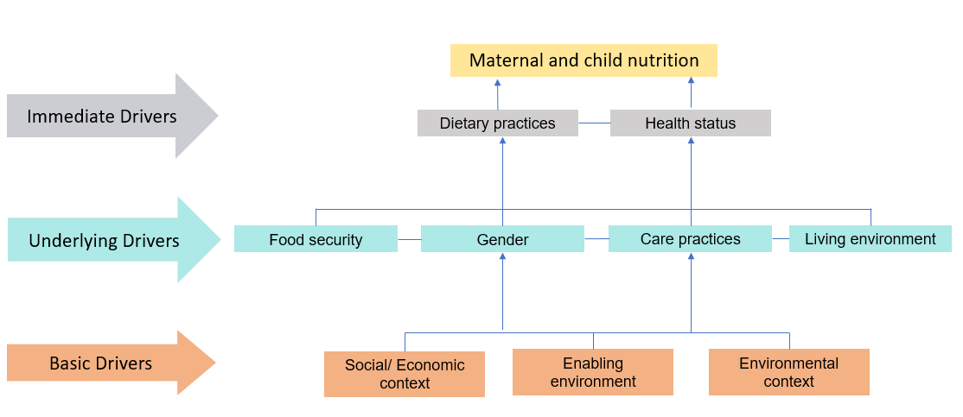
Figure 1: Drivers of malnutrition framework (Source: Created by authors, adapted from UNICEF Conceptual Framework)

Screening and eligibility criteria
The title and abstract of retrieved references were screened against predetermined eligibility criteria (Table 2). For studies to be included in this systematic mapping review, they had to: report on primary research in West Africa, report on a nutritional outcome in WRA or U5, be published in peer-reviewed journals, and be written in English or French. The search resulted in 767 unique references, of which 190 qualified for inclusion. One reviewer completed screening and a second reviewer screened those references for inclusion.

Table 2: Eligibility criteria
PICO | Inclusion criteria | Exclusion criteria
Participants | - General female, maternal, and child populations  - Studies that do not name a specific population, but relate to the identified drivers | Exclusion of studies reporting solely on populations other than women and children (e.g., males only, elderly populations only, HIV positive populations only)
Intervention/exposure | - Immediate drivers: Studies reporting on disease, dietary factors, or physical activity that impacts nutrition  - Underlying drivers: Studies reporting on food security, care practices, living environment, or gender  - Basic drivers: Studies reporting on social, economic, environmental, or enabling environment context | - Exclusion of studies that do not report on at least one feature of immediate, underlying, or basic driver categories  - Exclusion of studies that deal with technical debates within the subfields of the 3 broad driver categories  - Exclusion of studies that are set in a historical context
Outcomes | - Studies reporting on nutritional outcomes including the WHA targets (U5 stunting, U5 wasting, U5 overweight, WRA anaemia, low birthweight, WRA exclusive breastfeeding) as well as other nutrition outcomes (hunger, undernutrition, etc.)  - Studies included if no nutrition outcome is reported in abstract but all other inclusion criteria satisfied
Setting | - Studies that report on the West Africa region as defined by ECOWAS  - Studies that include one of the ECOWAS countries as a comparison with non-West African countries will be included, and the individual country data extracted  - Inclusion of regional data, national, and subnational (district, village, community)
Study design | - All study designs | Systematic reviews

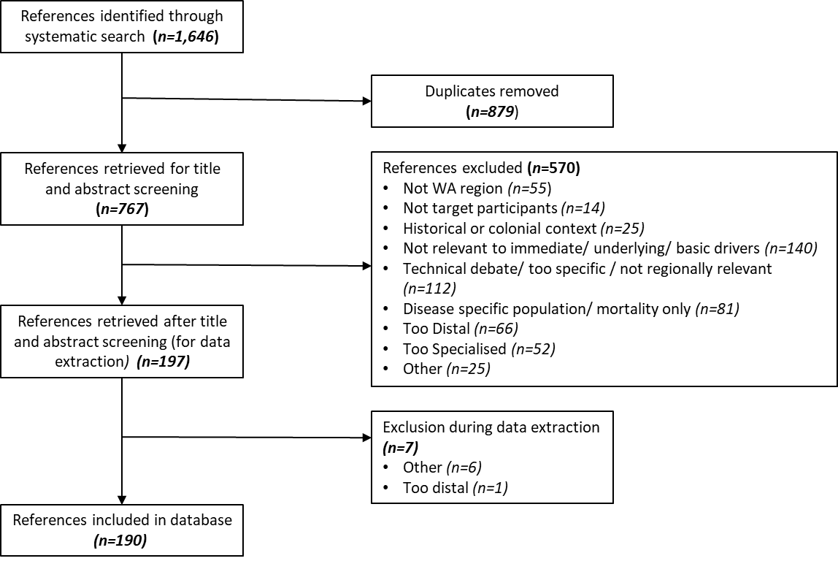
Figure 2. Flowchart of search results

Data extraction
Extraction of included studies (n=190) at the abstract level was completed by one reviewer and included information on: language, country, nutrition outcome, study design, study setting, population, and drivers (Table 3). The extraction of information related to the drivers of malnutrition was a three-stage process. First, information related to drivers was extracted in free text form, that is, as it appeared in the abstract. These studies were then grouped into broad categories (Driver taxonomy 1 variable in Table 3), i.e., what we refer to as a taxonomy, which correspond to the drivers in our framework (Figure 1). These categories were then further grouped according to the UNICEF categories of immediate, underlying, and basic drivers (Driver taxonomy 2 variable in Table 3).

Table 3: Data extraction template
Variable | Extraction categories
Language | English, French
Country | Benin, Burkina Faso, Côte d'Ivoire, Gambia, Ghana, Guinea, Guinea-Bissau, Liberia, Mali, Niger, Nigeria, Senegal, Sierra Leone, Togo, and the West Africa region
Nutrition Outcome | Stunting, wasting, anemia, calorie/micronutrient supply/deficiency, dietary diversity/ quality, double burden of malnutrition, exclusive breastfeeding, minimum acceptable diet, underweight, BMI, fruit and vegetable consumption, height, hunger, infant feeding, low birthweight, overweight/obese, nutrition (in general) not described in abstract
Study Design | Free text description of study design
Study Setting | City, community, district, health facility, hospital, household, not specified in abstract, other, primary healthcare center, regional (WA level), regional (country level), state, village
Population | Free text description of population, e.g. mothers and children
Driver (Free text) | Description of drivers as it appeared in the abstract (e.g., food availability, household income, gender inequality)
Driver Taxonomy 1 (Grouped categories) | Dietary intake (micronutrient deficiency, dietary deficiency, diet quality, food scarcity, food shortage, excessive consumption)  Health status (disease, disability/morbidity, physical activity, nutritional status)  Food security (food, diet, hunger, access, availability, utilization, safety, affordability, agricultural production)  Care practices (breastfeeding, complementary feeding, infant and young child feeding, lactation, weaning),  Living environments (WASH, sanitation, safe water, shelter, healthcare availability/services, health systems, health infrastructure, livelihood, trust in community health workers, support in accessing health services)  Gender (education, empowerment, (in)equality)  Economic/social context (poverty, socioeconomic status, income, wealth, inequality, socio-demographics, food beliefs)  Environmental context (urbanization, obesogenic environment, vulnerability, climate change)  Enabling environments (capacity building, domestic resources mobilization, politics, governance, corruption, leadership, policy, trust in legal systems, nutrition programming)
Driver Taxonomy 2 (UNICEF categories) | Immediate: dietary intake, health status  Underlying: food security, care practices, living environment, gender  Basic: economic/social context, environmental context, enabling environment

Synthesis and quality assessment
The extracted information was analyzed in Excel to identify trends and gaps in the information retrieved. These results were then summarized using narrative synthesis. Within this review we did not conduct a full quality appraisal of the studies but included only peer-reviewed studies as a quality control.

Bhutta ZA, Black RE. 2013. Global Maternal, Newborn, and Child Health--So Near and Yet So Far. N Engl J Med. 369(23):2226-35; Gillespie S, Haddad L, Mannar V, Menon P, Nisbett N. 2013. The Politics of Reducing Malnutrition: Building Commitment and Accelerating Progress. Lancet. 382(9891):552-69; Smith, L., and Haddad, L. 2015. Reducing Child Undernutrition: Past Drivers and Priorities for the Post-MDG Era. World Development. 68:180 – 204; Swinburn BA, Sacks G, Hall KD, McPherson K, Finegood DT, Moodie ML, et al. 2011. The Global Obesity Pandemic: Shaped by Global Drivers and Local Environments. Lancet. 378(9793):804-14.
Taxonomy refers to the classification of data into categories and subcategories.

