Systematic mapping review of evidence: World Health Assembly 2025 targets in West Africa
Searching for literature in the MEDLINE database

Technical note
May 2020
Prepared by Transform Nutrition West Africa
With support from the Bill & Melinda Gates Foundation

Summary
Transform Nutrition West Africa is a regional initiative to support effective policy and programmatic action on nutrition through evidence generation, synthesis, and mobilization.
This technical note provides methodological detail on the systematic mapping review of nutrition literature on the World Health Assembly (WHA) targets in the West Africa region. The detailed search syntax is presented in a separate document and the results are presented in an Excel spreadsheet and a forthcoming journal manuscript.

Objective of this systematic mapping review
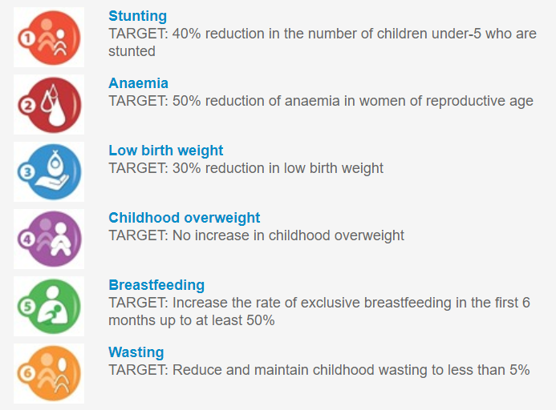
The purpose of this systematic mapping review is to provide an overview, identify, and catalogue existing peer-reviewed literature on the WHA targets to identify research gaps in the West Africa region and inform decision-making. To compliment this an additional systematic mapping review was undertaken to identify drivers of malnutrition in West Africa within social science literature. Details can be in separate files.
Figure 1: WHA targets (Source: WHO, 2020)

Methodology

Research question
What are the trends and gaps in research on the WHA targets in the West Africa Region?

Search strategy
Our search strategy was designed using a systematic approach to review literature in the bibliographic database MEDLINE (https://pubmed.ncbi.nlm.nih.gov/). A search syntax was created using the Population, Intervention Comparison, Outcome, Setting (PICOS) model (Table 1) and can be found in a separate document. A date range was applied to the evidence search, and studies published between January 1, 2010 and February 3, 2020 were included. The year 2010 was chosen as the cut-off as this is when the Scaling Up Nutrition initiative was launched.
Table 1: PICO model
PICOS model
Population | Women of reproductive age (WRA), children under 5 years (U5), infants less than 6 months
Intervention/ exposure | Prevalence, drivers, programs, and policies
Comparison | Comparison group required for program studies
Outcome | Anaemia in WRA, U5 stunting, U5 wasting, low birthweight, U5 overweight/ obesity and exclusive breastfeeding
Setting | West Africa

Table 2: WHA indicators
Category | Indicator | Definition / measurement
U5NS | Stunting | Height-for-age (HFA): Height-for-age measures linear growth (stunting). A child who is below two standard deviations (-2 SD) from the median of the WHO Child Growth Standards in terms of height-for-age is considered short for his/her age or stunted.  Triceps skin fold thickness is used to estimate body fat, measured on the right arm halfway between the olecranon process of the elbow and the acromial process of the scapula. If a child is below minus three standard deviations (-3 SD) from the median of the WHO Child Growth Standards, then he/she is considered to be severely stunted.  Stunting reflects a failure to receive adequate nutrition over a long period of time and is worsened by recurrent and chronic illness. Height-for-age, therefore, reflects the long-term effects of malnutrition in a population and does not vary appreciably according to recent dietary intake
U5NS | Wasting | Weight-for-height (WFH): Weight-for-height describes current nutritional status. A child who is below two standard deviations (-2 SD) from the median of the WHO Child Growth Standards for weight-for-height is considered to be too thin for his/her height or wasted. This condition reflects acute or recent nutritional deficit. As with stunting, wasting is considered severe if the child is more than three standard deviations below the reference median or by a mid-upper-arm circumference less than 115 mm with or without nutritional oedema. In the presence of bilateral pitting oedema, the term kwashiorkor is used. Severe wasting is closely linked to mortality risk.  Mid-upper arm circumference (MUAC) measures the muscle mass of the upper arm. A flexible measuring tape is wrapped around the mid-upper arm (between the shoulder and elbow) to measure its circumference. MUAC should be measured to the nearest 0.1 cm.
U5NS | Overweight | Weight-for-height (WFH)  Overweight is measured as weight-for-height greater than 2 standard deviations (+2 SD) above WHO Child Growth Standards median; and obesity is weight-for-height greater than 3 standard deviations (+3SD) above the WHO Child Growth Standards median.
U5NS | LBW | Low birth weight (LBW)  LBW is defined as a weight of less than 2500 grams at birth
EBF | EBF | Exclusive Breastfeeding (EBF)  The infant receives only breast milk for the first 6 months. No other liquids or solids are given – not even water – with the exception of oral rehydration solution, or drops/syrups of vitamins, minerals or medicines.
Anaemia in WRA | Anaemia in WRA  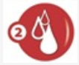 | Anaemia in WRA  Anaemia measured by blood Hemoglobin levels.  Hemoglobin and/or anemia prevalence below certain thresholds: lower than 110 grams per liter in pregnant women and lower than 120 grams per liter in non-pregnant women.
(Source: WHO, 2020)
Screening and eligibility criteria
The title and abstract of retrieved references were screened against predetermined eligibility criteria (Table 3), which varied according to the WHA target. For studies to be included in this systematic mapping review, they had to: report on primary research in West Africa, report on any of the WHA targets, report on problem, programs, or policy, be published in peer-reviewed journals, and be written in English or French. The search resulted in 3,755 unique references, of which 413 qualified for inclusion. One reviewer completed the screening and a second reviewer screened those references for inclusion.
Table 3: Eligibility criteria
PICO | Inclusion Criteria | Exclusion Criteria
Participants | - Children (from singleton births) from their day of birth up until their 5th birthday (U5NS)  - Studies can include both mothers and children up to 5 years old (U5NS)  - Healthy children from singleton births (U5NS)  - Pregnant women and breastfeeding mothers with no restriction on the age of mothers (EBF)  - Infants up to the age of 6 months (EBF)  - Women of reproductive age (15-49 years old) (WRA anaemia)  - Studies that include a subpopulation of 15- to 49-year-old women (e.g., adolescent studies focusing on 12-18 years old) (WRA anaemia)  - Inclusion of both pregnant and nonpregnant women (WRA anaemia) | - Exclusion of studies reporting solely on one group not included in the WHA targets, e.g. males only, elderly populations only  - Exclusion of studies reporting on disease- specific populations (e.g., HIV positive participants only)
Intervention | - Problem: Studies reporting on prevalence of and/or drivers/risk factors related to U5NS, EBF, and WRA anaemia  - Programs: Programs reported as randomized controlled trials (RCTs) require having either a nutrition- sensitive or nutrition-specific objective  - Policy: Studies reporting on policy, governance, agenda, etc. This includes policy across all spectrums, e.g. government, international, organizational, hospital | - Exclusion of non-randomized controlled trials (such as quasi-experimental, controlled before and after studies)
Outcomes | - Studies reporting on: HAZ, WAZ, WHZ, MUAC, skinfold, LBW (U5NS)  - Studies using Indian Academy of Paediatrics (IAP), WHO growth standards and National Center for Health Statistics references (U5NS)  - Studies reporting on EBF defined as “when the infant receives only breast milk. No other liquids or solids are given – not even water – with the exception of oral rehydration solution, or drops/syrups of vitamins, minerals or medicines” (WHO, 2017) (EBF)  - Studies reporting on anaemia measured by blood haemoglobin levels. Studies need to report summary statistics on mean haemoglobin and/or anaemia prevalence below certain thresholds: lower than 110 grams per litre in pregnant women and lower than 120 grams per litre in nonpregnant women (WRA anaemia)
Setting | - Studies that report on the West Africa region as defined by ECOWAS  - Studies that include one of the ECOWAS countries, as a comparison with non-West Africa countries will be included and the individual country data extracted  - Inclusion of regional data, national, and subnational (district, village, community)
Study design | - Epidemiology/cohort studies, case-control studies, cross-sectional studies, comparative or descriptive studies, RCTs | - Systematic reviews, qualitative studies  - RCT protocols

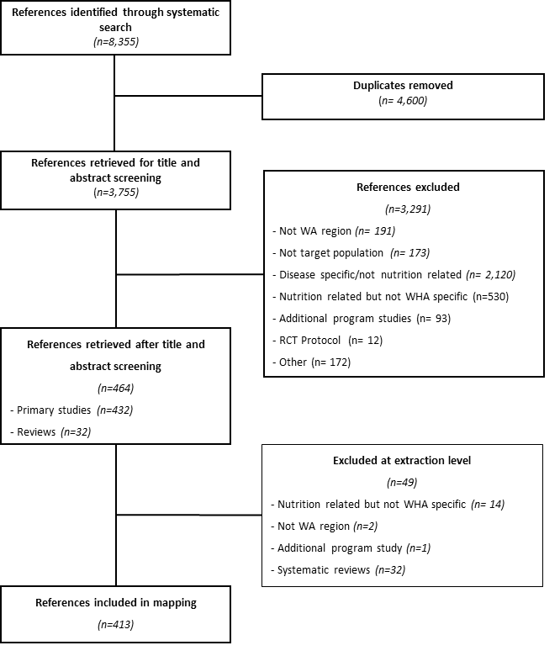
Figure 2: Flowchart of search results

Data extraction
Data was extracted for all studies separately by two reviewers (double data extraction) (n=413) at abstract level, and included information on: language, focus of research, country, outcome, study design, study setting, participants, intervention type, and drivers (Table 4). The extraction of information related to the drivers of malnutrition was a three-stage process. First, information related to drivers was extracted in free text form, that is, as it appeared in the abstract. These studies were then grouped into broad categories, i.e., what we refer to as a taxonomy (Driver taxonomy 1 variable in Table 4). These categories were then further grouped according to the UNICEF categories of immediate, underlying, and basic drivers (Driver taxonomy 2 variable in Table 4).
Table 4: Data extraction template
Variable | Extraction categories
Language | English, French
Focus of research | Prevalence, drivers, policy, program
Country | Benin, Burkina Faso, Côte d'Ivoire, Gambia, Ghana, Guinea, Guinea-Bissau, Liberia, Mali, Niger, Nigeria, Senegal, Sierra Leone, Togo, and the West Africa Region
Outcome | U5 stunting, U5 wasting, LBW, U5 overweight, WRA anaemia, EBF
Study design | Cohort, cross-sectional, case-control, case-series, qualitative, review, randomized controlled trials, not specified, other
Study setting | National, district, village, hospital, primary healthcare center, health facility, community, other, not specified
Intervention Type | Free text description of intervention (randomized controlled trials only)
Participants | Free text description of participants (e.g., 100 WRA)
Driver (Free text) | Description of drivers as it appeared in the abstract. (e.g., age of mother, immunization of child, food availability)
Driver Taxonomy 1 (Grouped categories) | Food consumption and intake (hunger, intake, dietary diversity, consumption of fortified foods)  Maternal nutritional status (anthropometry and micronutrients)  Maternal health status (prevalence of LBW, BW, infection, disease)  Child nutritional status (anthropometry: WHZ, BMI, MUAC and micronutrients)  Child health status (immunization, illness, parasitic infection)  Food security (seasonality, crop harvest)  IYCFP (breastfeeding, EBF, complementary feeding)  WASH (sanitation, WASH, water)  Health system environment (mode of delivery, antenatal visits, health-seeking behavior, health insurance)  Gender (female empowerment)  Socio-demographics (at the household level, maternal level, age, number of children), Poverty  Food environment (marketing of food products)  Enabling environment (nutrition policy and programming)
Driver Taxonomy 2 (UNICEF categories) | Immediate: Food consumption and intake, maternal nutritional status, maternal health, child nutritional status, child health status  Underlying: Food security, IYCFP, WASH, health system environment, gender  Basic: Socio-demographics, poverty, food environment, enabling environment

Synthesis and quality assessment
The extracted information was analyzed in Excel to identify trends and gaps in the information retrieved. This was then summarized using narrative synthesis. Within this review we did not conduct a full quality appraisal of these studies but included only peer-reviewed studies as a quality control.

Taxonomy refers to the classification of data into categories and subcategories.

