Online-Only Supplementary Material

Supplementary Table 1: Definitions of comorbid conditions and medications, on the basis of codes in 720 days before reaching the reduced kidney function threshold and prescriptions in the 180 days before kidney threshold

Supplementary Description of Propensity Score Model and Weighting

Supplementary Table 2: Propensity score model’s Chi-Square and degrees of freedom for each covariate

Supplementary Table 3: Risk of lactic acidosis events in subgroups stratified by history of age, race and estimated glomerular filtration rate at time of reaching kidney threshold

Supplementary Figure 1: Study Design Schematic

Supplementary Figure 2: Distribution of propensity scores by drug

Supplementary Figure 3: Mean standardized differences comparing metformin versus sulfonylurea before and after weighting the cohort

Supplementary Figure 4: Variance from the Propensity Score Model

Supplementary Table 1: Definitions of comorbid conditions based on codes in 720 days before reaching kidney threshold; Definitions of medications used are restricted to prescription fill in the 180 days before reaching kidney threshoaaaald
Covariate Condition | Inclusive conditions | Definition*
Malignancy | Cancer excluding non melanoma skin cancer | ICD 9- CM diagnosis codes:140.X-208.X (exclude 173)  ICD10 diagnosis codes: C00* - C96*; D37* -D48*
Liver failure | End stage liver disease | ICD 9- CM diagnosis codes: 570.X- 573.X  ICD10 diagnosis codes: K72*; K70.*; K73.*; K74.*; K76.*
Respiratory Failure | Respiratory failure/ Pulmonary Embolism/Hypertension | ICD 9- CM diagnosis codes: 518.81, 518.83, 518.84, 799.1, 415.X, 416.X  ICD10 diagnosis codes: J96.*; R092; I26.9*; I27.*
Congestive Heart Failure | CHF (excluding post procedure-CHF) | ICD 9- CM diagnosis codes: 428.X, 402.01, 402.11, 402.91, 404.01, 404.03, 404.11, 404.13, 404.91, 404.93  ICD10 diagnosis codes: I11.0, I13.0, I13.2, I50.9, I50.1, I50.20, I50.21, I50.22, I50.23, I50.30, I50.31, I50.32, I50.33, I50.40, I50.41, I50.42, I50.43
Cardiovascular disease | - MI | ICD 9- CM diagnosis codes: 410.X, 412.X, 429.7X  ICD10 diagnosis codes: I21*
 | - Obstructive coronary disease | ICD 9- CM diagnosis codes: 411.X, 413.X, 414.X  ICD10 diagnosis codes: I24.*; I25.*; I20.*  ICD9-CM procedure codes: 36.01, 36.02, 36.03, 36.05, 36.09, 36.10-36.19  CPT procedure codes: 33533-36, 33510-23, 33530, 92980-82,92984, 92995-6, 92974
 | - Peripheral artery disease or revascularization | ICD 9- CM diagnosis codes: 440.2X, 442.2, 443.1, 443.9, 445.0X  ICD10 diagnosis codes: I70.2*; I72.*; I77.*; I73.9; I75.*  ICD9-CM procedure codes:38.08-09, 38.18, 38.38, 38.39, 38.48, 38.49, 38.88, 38.89, 39.25, 39.29, 39.5, 84.1X  CPT procedure codes: 35226,35256, 35286, 35351, 35355, 35371, 35372, 35381, 35454, 35456, 35459, 35473, 35474, 35482, 35483, 35485, 35492, 35493, 35495, 35546, 35548, 35549, 35551, 35556, 35558, 35563, 35565, 35566, 35571, 35583, 35585, 35587, 35646, 35651, 35654, 35656, 35661, 35663, 35665, 35666, 35671, 34800, 34802-5
 | - Carotid revascularization | ICD9-CM procedure codes: 38.12, 38.11, 00.61, 00.63, 39.28  CPT procedure codes: 35301, 0005T, 0006T, 0007T, 0075T, 0076T, 37215, 37216 ICD10 procedure code: 031H0AG, 031H0JG, 031H0KG, 031H0ZG, 031J09G, 031J0AG, 031J0JG, 031J0KG,031H09G, 031J0ZG, 037H34Z, 037H3DZ, 037H3ZZ, 037H44Z, 037H4DZ, 037H4ZZ, 037J3DZ, 037J3ZZ, 037J44Z, 037J4DZ, 037J4ZZ, 037K34Z, 037K3DZ, 037K3ZZ, 037K4DZ, 037K4ZZ, 037L34Z, 037L3DZ, 037L3ZZ, 037L44Z, 037L4DZ, 037L4ZZ, 037M34Z, 037M3DZ, 037M3ZZ, 037M44Z, 037M4DZ, 037M4ZZ, 037N34Z, 037N3DZ, 037N3ZZ, 037N44Z, 037N4DZ, 037N4ZZ, 037P34Z, 037P3DZ, 037P3ZZ, 037P44Z, 037P4DZ, 037P4ZZ, 037Q34Z, 037Q3DZ, 037Q3ZZ, 037Q44Z, 037Q4DZ, 037Q4ZZ, 03CH0ZZ, 03CH3ZZ, 03CH4ZZ, 03CJ0ZZ, 03CJ3ZZ, 03CJ4ZZ, 03CK0ZZ, 03CK3ZZ, 03CK4ZZ, 03CL0ZZ, 03CL3ZZ, 03CL4ZZ, 03CM0ZZ, 03CM3ZZ, 03CM4ZZ, 037J34Z, 03CN0ZZ, 03CN3ZZ, 03CN4ZZ, 03CP0ZZ, 03CP3ZZ, 037K44Z,  03CP4ZZ, 03CQ0ZZ, 03CQ3ZZ, 03CQ4ZZ  HCPCS procedure code: S2211
TIA |  | ICD 9- CM diagnosis codes: 435.X  ICD10 diagnosis codes: G45.0; G45.1;G45.8; G45.9; I67.848
Stroke |  | ICD 9- CM diagnosis codes: 430.X, 431.X. 434.X, 436.X  ICD10 diagnosis codes: I67.89, I60.9, I61.9, I63.30, I63.40 , I63.50, I66.09, I66.19, I66.29, I66.9, I67.89
Serious Mental illness | - Dementia | ICD 9- CM diagnosis codes: 290.X, 291.2, 292.82, 294.1X, 331.0-331.1X, 331.82  ICD 10 diagnosis codes: F03.9;F01.5*; F10.27; F19.97; F02.80; F02.81; G30.9; G31.*  Medications: Donepezil, Rivastigmine, Galantamine, Tacrine, Memantine Bethanechol, Ambenonium, Atomoxetine, Ergoloid Mesylates, Dihydrogenated Ergot, Neostigmine, Physostigmine, Pyridostigmine, Riluzole, Hydergine
 | - Depression, | ICD 9- CM diagnosis codes: 311, 300.4, 296.2, 296.3, V79.0  ICD 10 diagnosis codes: F33.9, F34.1, F32.*
 | - Schizophrenia, | ICD 9- CM diagnosis codes: 295.X  ICD 10 diagnosis codes: F20.*
 | - Bipolar disorder | ICD 9- CM diagnosis codes: 296.0, 296.4X, 296.5X, 296.6X, 296.7, 296.80, 296.89  ICD 10 diagnosis codes: F30.* F31.*
 | - Post traumatic stress disorder | ICD 9- CM diagnosis codes: 309.81  ICD 10 diagnosis codes: F43.10; F43.12
Cardiac valve disease |  | ICD 9- CM diagnosis codes: 394.X, 395.X, 396.X, 424.0, 424.1  ICD 10 diagnosis codes: I05.*; I06.*; I08.*; I34.*; I35.*;
Arrhythmia | Atrial fibrillation/flutter | ICD 9- CM diagnosis codes: 427.3X  ICD 10 diagnosis codes: I48.91, I48.92
Smoking |  | ICD 9- CM diagnosis codes:305.1, V15.82, 989.84  ICD 10 diagnosis codes: F17.200, Z87.891, T65.211A, T65.212A, T65.213A, T65.214A, T65.221A, T65.222A, T65.223A, T65.224A, T65.292A, T65.293A, T65.294A  Medications: Varenicline tartrate, Nicotine Replacement (gum, patch, lozenge)
COPD/ Asthma |  | ICD 9- CM diagnosis codes:491.X, 492.X, 493.X, 496.X, V17.5, V81.3  ICD 10 diagnosis codes: J41.0, J41.1, J44.9, J44.1, J44.0, J41.8, J42-J43.9, J45.20, J45.22, J45.21, J45.990,J45.991, J45.909, J45.998, J45.902, J45.901, Z13.83
HIV |  | ICD 9- CM diagnosis codes: 042, 079.53, 795.71, V08  ICD 10 diagnosis codes: B20.*; B97.35; Z21
Parkinson’s Disease |  | ICD 9- CM diagnosis codes: 332  ICD 10 diagnosis codes: G20; G21.*  Medications: Apokyn, Apomorphine, Carbidopa/levodopa, Entacapone, Pergolide, Pramipexole, Ropinirole, Rotigotine, Selegiline, Tolcapone, Zelapar, Azilect/Rasagiline, Emsam, Isocarboxazid, Phenelzine, Tranylcypromine, Biperiden/Akineton, Comtan/Entacapone, Safinamide, Trihexyphenidyl
Urinary Tract / Kidney Infection |  | ICD 9- CM diagnosis codes: 590.*, 599.0*, 595.0  ICD 10 diagnosis codes: N11.*; N39.* N30.*
Osteomyelitis |  | ICD 9- CM diagnosis codes: 730.*  ICD 10 diagnosis codes: M86.1*; M86.2*; M86.6*; M86.9*; A02.24
Sepsis/Bacteremia |  | ICD 9- CM diagnosis codes: 995.91, 995.92, 038.*, 036.2, 790.7  ICD 10 diagnosis codes: A41.9; R65.20; A41.*; A39.4; R78.81
Pneumonia |  | ICD 9- CM diagnosis codes: 480.*-486.*, 487.0  ICD 10 diagnosis codes: J11.*; J12.*; J13.*; J14.*; J15.*; J16.*; J17.*; J18.*
Fractures (any) |  | ICD 9- CM diagnosis codes: 733.1*, 800.*-829.*, E887  ICD 10 diagnosis codes: M84.*; M80.*; S02; *; S12.*; S22.*; S32.*; S42.*; S52.*; S62.*; S72.*; S82.*; S92.*
Falls |  | ICD 9- CM diagnosis codes: E880.*, E881.*, E884.*, E885.9  ICD 10 diagnosis codes: Z98.8, W18.30XA,W18.49XA,W01.110A,W01.198A,W19.XXXA
Osteoporosis |  | ICD 9- CM diagnosis codes: 733.0*  ICD 10 diagnosis codes: M81.*
Retinopathy |  | ICD 9- CM diagnosis codes: 362.01, 362.02, 362.03, 362.04, 362.05, 362.06, 362.07  ICD 10 diagnosis codes: E08.311; E08.319; E08.3211; E08.3212; E08.3291; E08.3292; E08.3293; E08.3299; E08.3219; E08.3213; E08.3313; E08.3312; E08.3311; E08.3319; E08.3391; E08.3392; E08.3393; E08.3399; E08.3411; E08.3412; E08.3413; E08.3419; E08.3491; E08.3492; E08.3493; E08.3499; E08.3511; E08.3512; E08.3513; E08.3519; E08.3521; E08.3522; E08.3523; E08.3529; E08.3531; E08.3532; E08.3533; E08.3539; E08.3541; E08.3542; E08.3543; E08.3549; E08.3551; E08.3552; E08.3553; E08.3559; E08.3591; E08.3592; E08.3593; E08.3599; E11.311; E11.3491; E11.3492; E11.3493; E11.3499; E11.3591 ; E11.3592; E11.3593 ; E11.3599 ; E11.3591; E11.3592; E11.3593; E11.3599; E11.3291; E11.3292; E11.3293; E11.3299; E11.3391; E11.3392; E11.3393; E11.3399; E11.3491; E11.3492; E11.3493; E11.3499; E11.319
Amputations |  | ICD 9- CM diagnosis codes: V49.75; V49.76; V49.77  ICD 10 diagnosis codes: Z89.519; Z47.81; Z89.6*
Medications
Antipsychotics | Atypical and typical antipsychotic medications | Lithium, Clozapine, Haloperidol, Loxapine, Lurasidone, Molindone, Olanzapine, Paliperidone, Quetiapine Fumerate; Risperidone, Aripiprazole, Asenapine, Ziprasidone, Chlorpromazine, Fluphenazine, Fluphenazine Deconate, Mesoridazine, Perphenazine, Thioridazine, Thiothixene; Trifluoperazine; Triflupromazine, Asenapine, Chlorprothixene, Iloperidone, Molindone, Promazine, Piperacetazine, Methotrimeprazine, Acetophenazine, Fazaclo/clozapine, Molindone
ACE Inhibitors alone/combination |  | Benazepril, Captopril, Enalapril, Fosinopril, Lisinopril, Moexipril, Perindopril, Quinapril, Ramipril, Trandolapril
ARBs alone/combination |  | Candesartan, Eprosartan, Irbesartan, Losartan, Azilsartan, Olmesartan, Telmisartan, Valsartan
Beta-blockers |  | Acebutolol, Atenolol, Betaxolol, Bisoprolol, Carteolol, Carvedilol, Esmolol, Labetalol, Metoprolol Tartrate, Metoprolol Succinate, Propranolol, Penbutolol, Pindolol, Nadolol, Sotalol, Timolol, Nebivolol
Calcium Channel Blockers |  | Amlodipine, Isradipine; Felodipine, Nifedipine, Nifedipine ER, Nicardipine; Diltiazem, Verapamil, Nimodipine; Nisoldipine; Bepridil, Amlodipine/Atorvastatin, Clevidipine Butyrate; Mibefradil
Thiazide diuretics/ Potassium sparing diuretics |  | Chlorothiazide, Chlorthalidone, Hydrochlorothiazide, Methyclothiazide, Trichlormethiazide, Metolazone, Indapamide, Eplerenone; Amiloride, Spironolactone, Triamterene, Hydrochlorothiazide/Triamterene, Hydrochlorothiazide/Spironolactone, Bendroflumethiazide, Benzthiazide, Cyclothiazide, Hydroflumethiazide, Polythiazide, Quinethazone
Other Antihypertensives |  | Doxazosin, Prazosin, Terazosin, Clonidine, Guanabenz, Guanfacine, Hydralazine, Methyldopa, Metyrosine, Reserpine, Minoxidil, Alfuzosin, Silodosin, Alseroxylon, Cryptenamine, Deserpidine, Diazoxide, Guanethidine, Mecamylamine, Pargyline, Rescinnamine, Trimethaphan Camsylate
Anti-arrhythmics Digoxin and other inotropes | - Digoxin | Digoxin, Digitalis
 | - Anti- Arrythmics | Adenosine, Amiodarone, Lidocaine, Flecainide, Ibutilide, , Procainamide, Propafenone, Ropafenone, Quinidine, Disopyramide, Verapamil, Dofetilide, Mexiletine, Moricizine, Tocainide
Anticoagulants and Platelet inhibitors, not aspirin | - Anticoagulants | Warfarin, Argatroban, Bivalirudin, Dalteparin, Enoxaprin, Eptifibatide, Fondaparinux, Heparin, Lepirudin, Tirofiban, Tinzaparin, Reviparin, Nadroparin, Ardeparin, Certoparin, Dabigatran
 | - Platelet Inhibitors | Clopidogrel, Ticlopidine, Aspirin/Dipyridamole, Dipyridamole alone, Abciximab, Factor IX, Factor VIIa, Factor VIII, Prasugrel, Ticagrelor
Statins |  | Atorvastatin, Fluvastatin, Lovastatin, Pravastatin, Simvastatin, Rosuvastatin, Cerivastatin Pitavastatin, Lovastatin ER, Ezetimibe/Simvastatin, Lovastatin/Niacin, Amlodipine/Atorvastatin
Non-Statin lipid lowering drugs |  | Cholestyramine, Colesevelam, Clofibrate, Colestipol, Niacin, Niacinamide, Fish Oil Concentrate, Omega 3 Fatty Acids, Gemfibrozil, Fenofibrate, Fenofibric Acid, Ezetimibe Omacor, Tricor/Fenofibrate, Ezetimibe/Simvastatin
Nitrates |  | Amyl Nitrate, Isosorbide Dinitrate, Isosorbide Mononitrate, Erythrityl Tetranitrate, Nitroglycerin (all forms--SA, Patch, SL, Ointment; Aerosol spray), Ranolazine
Aspirin |  | Aspirin, Aspirin/ Dipyridamole
Loop Diuretics |  | Furosemide, Ethacrynic acid, Bumetanide, Torsemide

ACEI = angiotensin-converting enzyme inhibitor; ARB = angiotensin-receptor blocker; COPD = chronic obstructive pulmonary disease; CPT = Current Procedural Terminology; ICD-9- CM = International Classification of Diseases, Ninth Revision; ICD 10= International Classification of Diseases, Tenth Revision; MI = myocardial infarction; TIA = transient ischemic attack.
If medications are combinations of 2 drug classes then a patient is recorded as using both medications.
ª Each co-morbid condition was defined as present if there was 1 specified inpatient or 2 specified outpatient codes separated by 30 days, or 1 specified procedure code or prescription for a medication defining that comorbid condition before reaching the creatinine threshold. Medications were searched in the pharmacy data using both generic and trade names.

Supplementary Description of Propensity Score Model and Weighting
The cohort was composed of all eligible persons who reached the kidney threshold and were using metformin or sulfonylurea for diabetes treatment. The weighted cohort was formed using matching weights, derived using propensity scores, and up or down weighting patients to more closely resemble each other. 50 covariates Table 1 in the paper lists baseline covariates included. For simplicity, Table 1 presents contraindication date by year, whereas contraindication date is treated as a continuous covariate in the model. Missing covariate values were multiply imputed and indicators for each variable's missingness was included to account for potential informative missingness. The propensity scores used to create the matching weights were obtained using the last imputed data set and a regression model whose coefficients are found by averaging the coefficient estimates of all the imputed data sets. The PS model is displayed below.

The weighted analysis balances the covariate distributions by assigning various weights to the patients in both exposure groups such that the weighted groups resemble each other group (average treatment effect in evenly matchable units [ATM]). When comparing metformin and sulfonylurea users, both the metformin and sulfonylurea users were weighted so that their distribution of covariates resembled each other and at least a small amount of data is used from each subject. An important condition for weighting and propensity score methods is that every cohort member have a nontrivial probability of having received either of the study therapies. Our weighting procedure down-weighted metformin patients for whom very few similar sulfonylurea users existed (eFigure 2). When used to facilitate a weighted cohort, the success of the model is determined by the ability to include all patients and the achievement of covariate balance in the weighted cohort. eFigure 3 in the appendix demonstrates the standardized mean difference (SMD) before and after weighting. Table 1 in the paper demonstrates that all SMD after weighting have an absolute value < 0.1. Matching weights take values between 0 and 1. They yield approximately equal weighted sample sizes in a pseudo-matched cohort. Summaries of the matching weights by group demonstrate that among sulfonylurea users the median weight is 1.0, mean weight is 0.856 and 90th percentile is 1.0. Among metformin users the median weight is 0.25, mean weight is 0.36 and 90th percentile is 0.950.
Model for Probability of remaining on regimen at Kidney Threshold eFigure 4 demonstrates the PS model variance.

Supplementary Table 2: Propensity score model’s Chi-Square and degrees of freedom for each covariate
 | Chi-Square | d.f.
Demographics
Age | 455.0162 | 2
Gender | 77.35471 | 1
Race | 224.4366 | 2
Months from hypoglycemic start until kidney threshold | 39.91859 | 2
Contraindication date | 6651.669 | 2
VISN of Care | 414.2542 | 20
Clinical and Laboratory Variables
BMI | 29.8855 | 2
Systolic Blood Pressure mm/Hg | 107.0865 | 2
Diastolic Blood Pressure mm/Hg | 60.62776 | 2
Hemoglobin | 201.1006 | 2
GFR | 9.845639 | 2
GFR Historical | 138.7468 | 2
Creatinine | 3.345455 | 2
LDL Cholesterol | 39.60541 | 2
A1c | 698.9043 | 2
Urine protein | 43.71378 | 4
MACR | 12.9172 | 3
Healthcare Utilization
VA hospitalizations last year | 3.263972 | 1
VA hospitalizations last 30 days | 0.240846 | 1
Medicare/ Medicaid hospitalizations last year | 0.169064 | 1
Medicare/ Medicaid hospitalizations last 30 days | 0.309831 | 1
Medicaid use | 2.571839 | 1
Medicare Use | 1.992842 | 1
Nursing Home Use | 4.540011 | 1
Number of Outpatient visits | 7.148963 | 2
Number of Outpatient medications | 2.088823 | 2
Medicare Advantage | 0.13032 | 1
Comorbidities
Malignancy | 8.022282 | 1
Liver_disease | 169.9393 | 1
HIV | 3.621022 | 1
CHF | 125.5744 | 1
CVD | 14.79575 | 1
Stroke | 1.23538 | 1
TIA | 0.173177 | 1
Serious_Mental_Illness | 10.02042 | 1
Smoking | 0.307618 | 1
Chronic Obstructive Pulmonary Disease | 0.590587 | 1
Respiratory failure | 0.906836 | 1
Sepsis | 3.468575 | 1
Pneumonia | 8.171519 | 1
Arrhythmias | 0.003055 | 1
Cardiac valve | 0.016925 | 1
Parkinson | 4.46838 | 1
Urinary Tract Infection | 9.851086 | 1
Osteomyelitis | 5.018306 | 1
Osteoporosis | 0.000319 | 1
Falls | 0.432892 | 1
Fractures | 10.50717 | 1
Amputation | 7.806046 | 1
Retinopathy | 23.772 | 1
Medications
ACE | 1.987049 | 1
ARB | 5.368021 | 1
Beta Blocker | 1.423361 | 1
Calcium Channel Blocker | 0.171432 | 1
Thiazide diuretics | 17.2478 | 1
Loop diuretics | 115.488 | 1
Other Antihypertensives | 0.116276 | 1
Statins | 244.3769 | 1
Non Statin lipid lowering medications | 34.2055 | 1
Antiarrythmics | 11.9631 | 1
Anticoagulants | 0.353897 | 1
Nitrates | 21.46618 | 1
Aspirin | 0.097639 | 1
Platelet Inhibitors Non aspirin | 7.564502 | 1
Antipsychotics | 2.699288 | 1
Oral Glucocorticoids | 9.341242 | 1
Indicators of Missing Clinical Variables
BMI_Missing | 13.61474 | 1
Blood_Pressure_Missing | 0.161964 | 1
hemoglobin_Missing | 26.7989 | 1
GFR Historical | 34.83963 | 1
LDL_Cholesterol_Missing | 1.47128 | 1
A1c_Missing | 48.98264 | 1

Supplementary Table 3: Subgroup analysis by age, race, and GFR evaluating rate and hazard ratios (95% confidence interval [CI] for lactic acidosis (95% confidence interval [CI] for lactic acidosis hospitalizations among those with reduced glomerular filtration rate who use metformin versus sulfonylurea in matched unweighted cohort
 | Metformin | Sulfonylurea | P value for Interaction
Age younger than 65 years (N in weighted cohort | 7814 | 7968 | p = 0.901
Lactic Acidosis Events | 65 | 62
Person-Years | 12,820 | 13,693
Unadjusted Rate/1,000 person-years (95% CI) | 5.09 (4.00, 6.48) | 4.52 (3.52, 5.79)
Hazard Ratio ª (95% CI) | 1.10 (0.82, 1.48) | Reference
Age 65 years and older (N in weighted cohort) | 16,728 | 16,694
Lactic Acidosis Events | 128 | 118
Person-Years | 33,377 | 35,056
Unadjusted Rate/1,000 person-years (95% CI) | 3.83 (3.23, 4.56) | 3.37 (2.81, 4.03)
Hazard Ratioª (95% CI) | 1.13 (0.91, 1.41) | Reference
Non-Black race (N in weighted cohort) | 20538 | 20648 | p = 0.736
Lactic Acidosis Hospitalization | 153 | 143
Person-Years | 40,891 | 42,015
Unadjusted Rate/1,000 person-years (95% CI) | 3.73 (3.19, 4.37) | 3.40 (2.88, 4.00)
Hazard Ratioª (95% CI) | 1.10 (0.90,1.34) | Reference
Black race (N in weighted cohort) | 4004 | 4014
Composite Lactic Acidosis Hospitalization | 41 | 37
Person-Years | 5307 | 6734
Unadjusted Rate/1000 person-years (95% CI) | 7.63 (5.62, 10.35) | 5.53 (4.02, 7.61)
Hazard Ratio^{b} (95% CI) | 1.29 (0.88, 1.91) | Reference
eGFR >45 ml/min (N in weighted cohort) | 22,349 | 22,479 | GFR spline terms  eGFR  p = 0.731  eGFR’  p = 0.65
Lactic Acidosis Hospitalization | 161 | 150
Person-Years | 43,730 | 45,247
Unadjusted Rate/1000 person-years (95% CI) | 3.69 (3.16, 4.30) | 3.31 (2.82, 3.88)
Hazard Ratioª (95% CI) | 1.11 (0.92, 1.35 | Reference
eGFR <45 ml/min (N in weighted cohort) | 2193 | 2183
Lactic Acidosis Hospitalization | 32 | 30
Person-Years | 2467 | 3474
Unadjusted Rate/1000 person-years (95% CI) | 12.90 (9.14, 18.17) | 8.62 (6.04, 12.329)
Hazard Ratio (95% CI) | 1.31 (0.85, 2.01) | Reference
ª Cox Proportional Hazards model for time to event. All continuous variables were modeled as restricted cubic splines.
^{b} Hazard ratio could not be calculated given low number of events .
Supplementary Figure 1 Study Design Schematic

Main analysis: Comparison of metformin versus sulfonylurea initiators who reached the kidney threshold, and continued their original regimen, persistent exposure on the original regimen is required to remain in follow-up. Gaps (red bars) of up to 90 days are allowed for medication refill after reaching kidney threshold. Patients begin follow-up at the kidney threshold and are censored at addition of another diabetes treatment or no medication refill for 90 days.

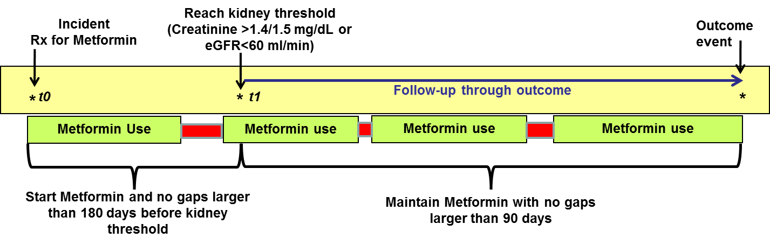

Supplementary Figure 2: Distribution of logit of propensity scores by drug
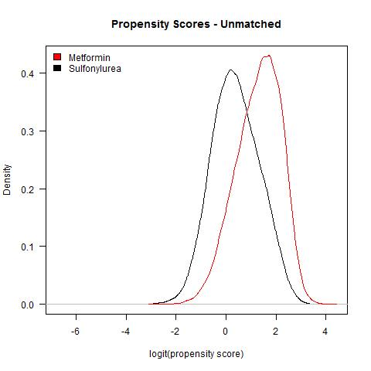

Supplementary Figure 3: Mean standardized differences comparing metformin versus sulfonylurea before and after weighting the cohort
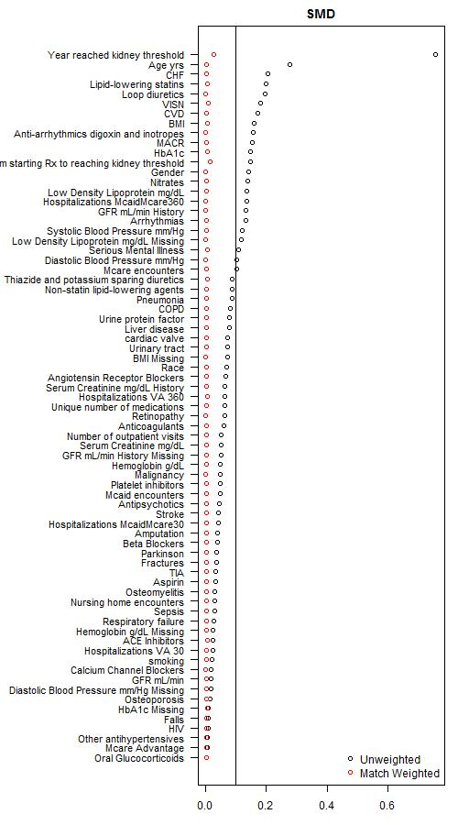

Supplementary Figure 4: Deviance of baseline covariates from the Propensity Score Model, relative contribution of each covariate in predicting exposure group.
