Supplementary Material

Table SM1. Generalized linear models testing potential drivers of spring migratory (direct vs. stopover): individual mean air-to-ground ratio (AGR), air temperature and departure date from the wintering sites, at 1000 hPa, 925 hPa and 850 hPa, representing 111, 762 and 1457 m above sea level, respectively, and until reaching latitude 37 and 47°N. Sample size = 57 individuals.
Pressure (hPa) | Latitude (°N) | Generalized Linear Model
 |  |  | Estimate | SE | z | p
1000 | 37 | Intercept | 45.19 | 14.68 | 3.08 | 0.002
 |  | Mean AGR | 0.08 | 1.94 | 0.04 | 0.968
 |  | Air temperature | 0.33 | 0.36 | 0.92 | 0.359
 |  | Departure date | -0.43 | 0.14 | -3.10 | 0.002
925 | 37 | Intercept | 45.96 | 15.06 | 3.05 | 0.002
 |  | Mean AGR | -0.14 | 2.03 | -0.07 | 0.945
 |  | Air temperature | 0.31 | 0.26 | 1.20 | 0.231
 |  | Departure date | -0.42 | 0.14 | -3.07 | 0.002
850 | 37 | Intercept | 46.41 | 14.37 | 3.23 | 0.001
 |  | Mean AGR | -0.73 | 2.33 | -0.32 | 0.753
 |  | Air temperature | 0.00 | 0.19 | 0.00 | 0.999
 |  | Departure date | -0.39 | 0.13 | -3.03 | 0.002
1000 | 47 | Intercept | 52.60 | 15.89 | 3.31 | 0.001
 |  | Mean AGR | 1.28 | 2.30 | 0.56 | 0.579
 |  | Air temperature | -0.47 | 0.36 | -1.33 | 0.185
 |  | Departure date | -0.42 | 0.13 | -3.24 | 0.001
925 | 47 | Intercept | 50.83 | 15.70 | 3.24 | 0.001
 |  | Mean AGR | 1.19 | 2.32 | 0.51 | 0.609
 |  | Air temperature | -0.21 | 0.19 | -1.11 | 0.266
 |  | Departure date | -0.44 | 0.14 | -3.16 | 0.002
850 | 47 | Intercept | 47.88 | 14.47 | 3.31 | 0.001
 |  | Mean AGR | -0.22 | 2.74 | -0.08 | 0.936
 |  | Air temperature | -0.11 | 0.14 | -0.76 | 0.449
 |  | Departure date | -0.40 | 0.13 | -3.09 | 0.002

Table SM2. Reduced generalized linear mixed models testing potential drivers of spring migratory behaviour (direct vs. stopover): individual mean air-to-ground ratio (AGR) until reaching latitude 42°N, air temperature at latitude 42°N, departure date from the wintering sites and zonal wind (east/westward) experienced between 37 and 50°N, at 1000 hPa (111 m above sea level). These are organized by random effect: individual, year and sex. In models with individual as random effect, the dataset includes only individuals with multiple observations, due to unbalanced sample size across individuals (i.e. 23 out of 36 individuals were only tracked once) can result in unstable models (Harrison et al. 2018).
Generalized Linear Mixed Model |  |  |  |  |  |  |  | Random effects
 | n |  | Estimate | SE | z | p |  |  | Variance | SD
A | 34 | Intercept | 5.22 | 3.66 | 1.43 | 0.15 |  | individual | 1.23 | 1.11
 |  | Mean AGR | -2.45 | 2.47 | -0.99 | 0.32
 | 34 | Intercept | -10.72 | 9.80 | -1.09 | 0.27 |  | individual | 3.51 | 1.87
 |  | Air temperature | 1.00 | 0.86 | 1.16 | 0.25
 | 34 | Intercept | 2.28 | 1.16 | 1.97 | 0.05 |  | individual | 0.62 | 0.78
 |  | Departure date¹ | -1.61 | 0.99 | -1.63 | 0.10
 | 58 | Intercept | 5.65 | 3.81 | 1.48 | 0.14 |  | individual | 31.01 | 5.57
 |  | U wind | -0.09 | 0.09 | -1.06 | 0.29
B | 57 | Intercept | 3.06 | 2.36 | 1.30 | 0.20 |  | year | 0.74 | 0.86
 |  | Mean AGR | -1.02 | 1.62 | -0.63 | 0.53
 | 57 | Intercept | -2.01 | 3.24 | -0.62 | 0.54 |  | year | 0.46 | 0.68
 |  | Air temperature | 0.27 | 0.25 | 1.11 | 0.27
 | 57 | Intercept | 3.23 | 1.50 | 2.16 | 0.03 |  | year | 6.20 | 2.49
 |  | Departure date¹ | -3.01 | 1.12 | -2.70 | 0.01
 | 98 | Intercept | 1.43 | 0.73 | 1.95 | 0.05 |  | year | 2.34 | 1.53
 |  | U wind | -0.02 | 0.05 | -0.30 | 0.77
C | 57 | Intercept | 3.12 | 2.15 | 1.45 | 0.15 |  | sex | 0.00 | 0.00
 |  | Mean AGR | -1.04 | 1.51 | -0.69 | 0.49
 | 57 | Intercept | -2.26 | 3.03 | -0.74 | 0.46 |  | sex | 0.00 | 0.00
 |  | Air temperature | 0.29 | 0.23 | 1.28 | 0.20
 | 57 | Intercept | 46.67 | 14.30 | 3.26 | <0.01 |  | sex | 0.00 | 0.00
 |  | Departure date | -0.40 | 0.13 | -3.18 | <0.01
 | 98 | Intercept | 1.33 | 0.35 | 3.81 | <0.001 |  | sex | 0.09 | 0.29
 |  | U wind | -0.06 | 0.04 | -1.45 | 0.15
 |  | ¹variable was rescaled

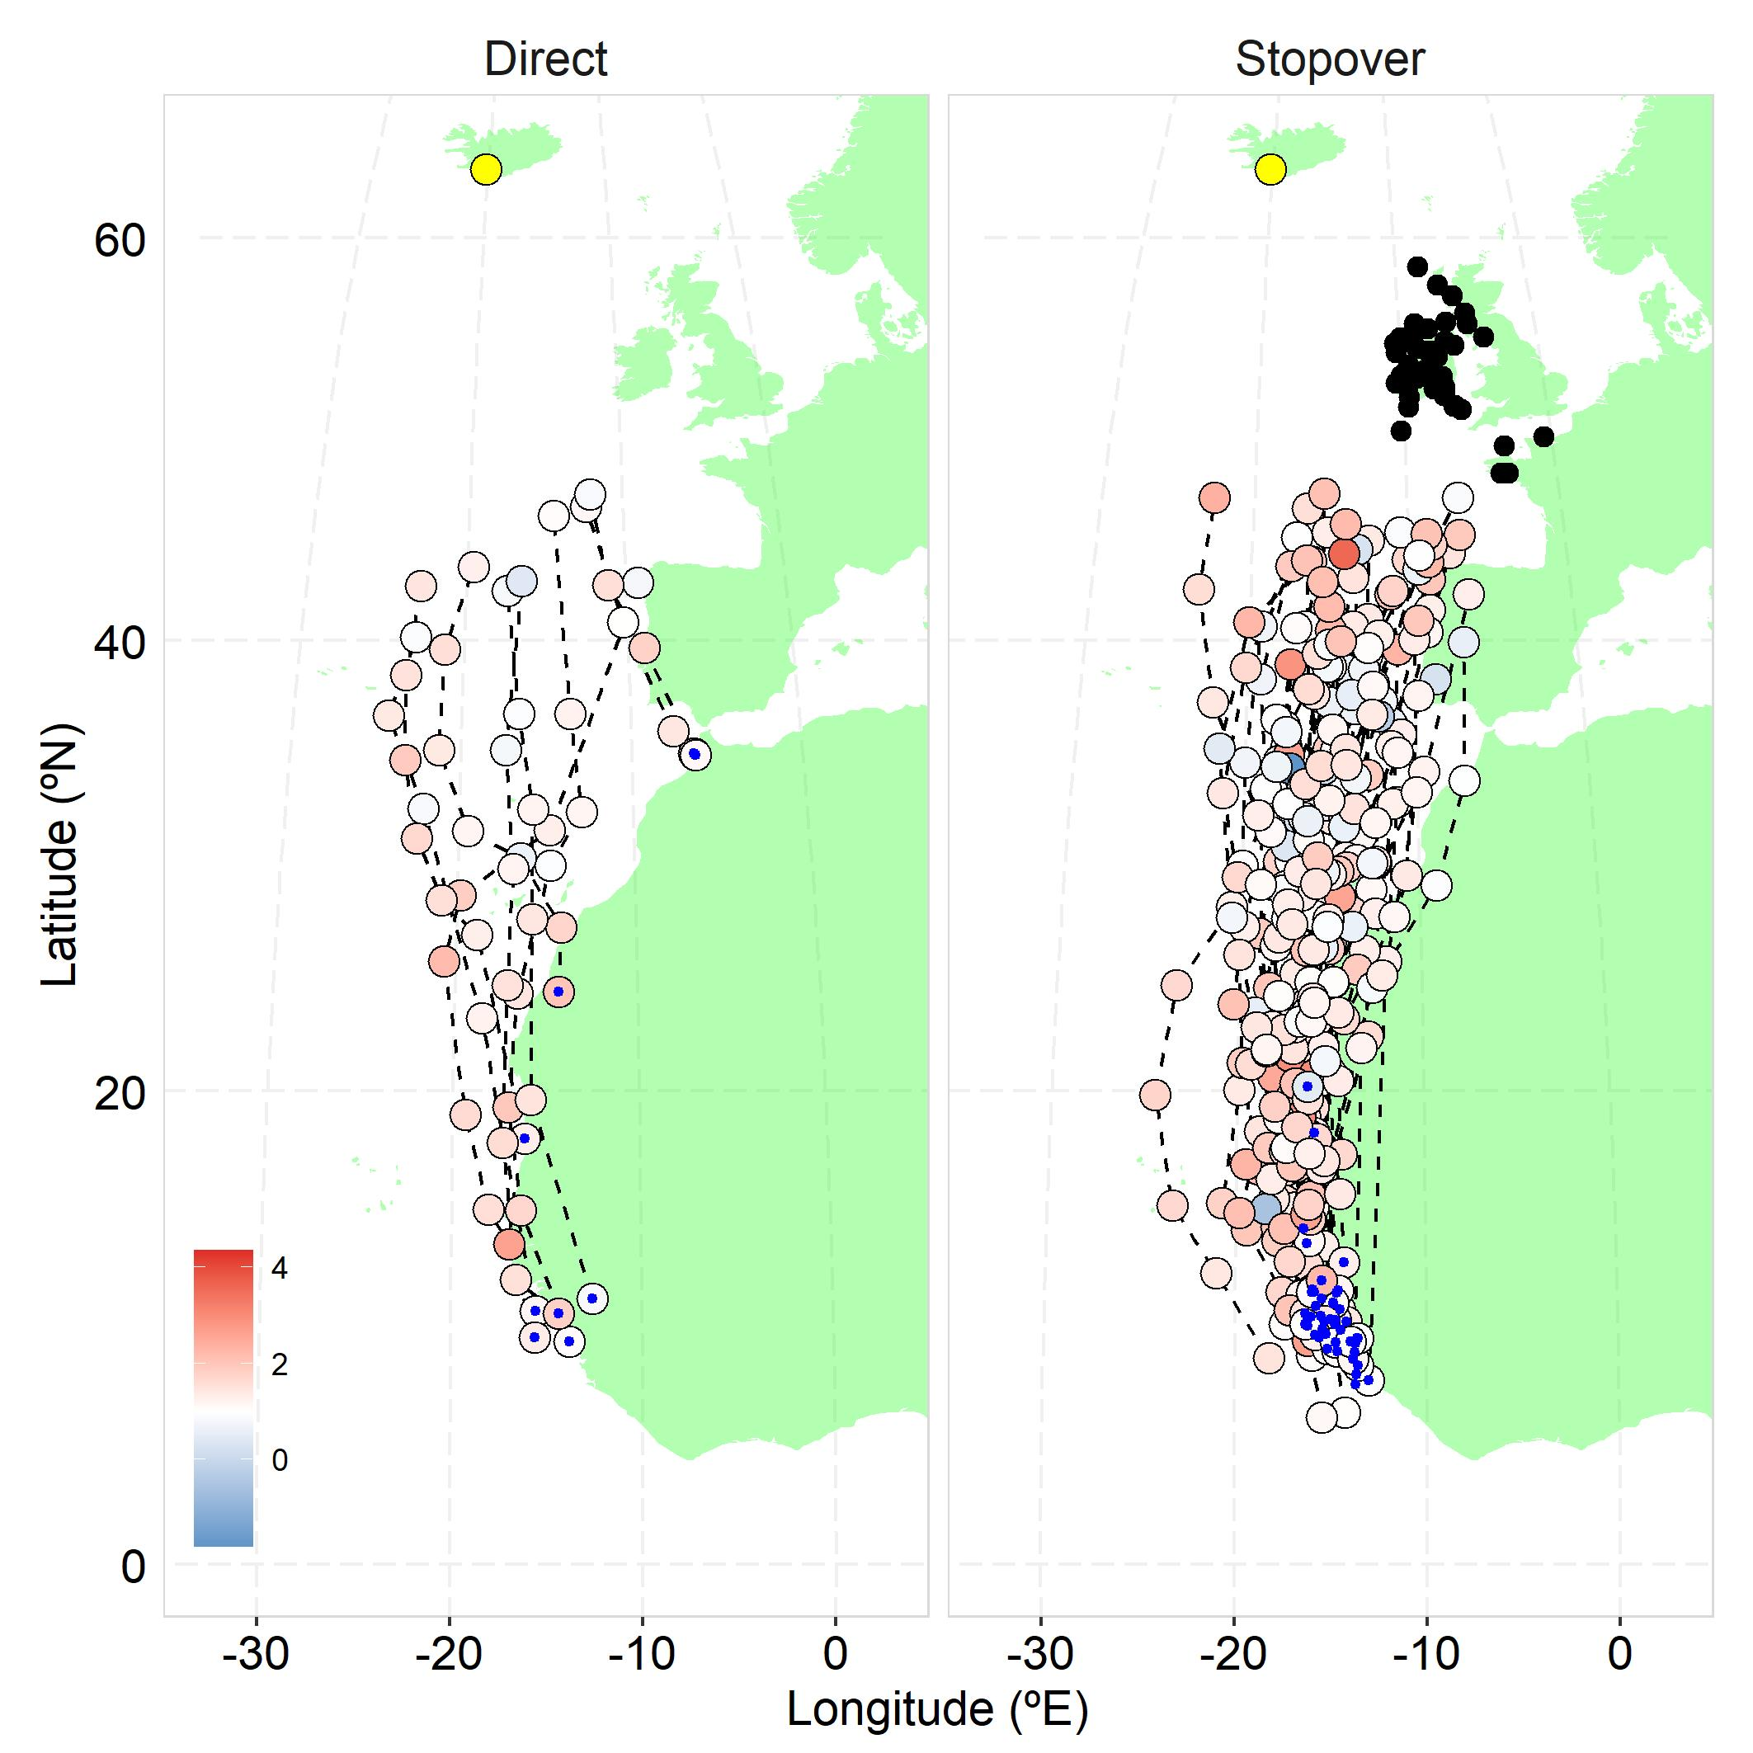
Figure SM1. Spring migration locations recorded with geolocators up to latitude 47°N, coloured by air-to-ground speed ratio (at 1000 hPa; i.e. 111m above sea level); blue (values below one) represents wind support, whereas red (values above one) represents wind impediment in the direction of movement. Black dots depict stopover locations, yellow dot marks the breeding site and blue dots the individual winter location.

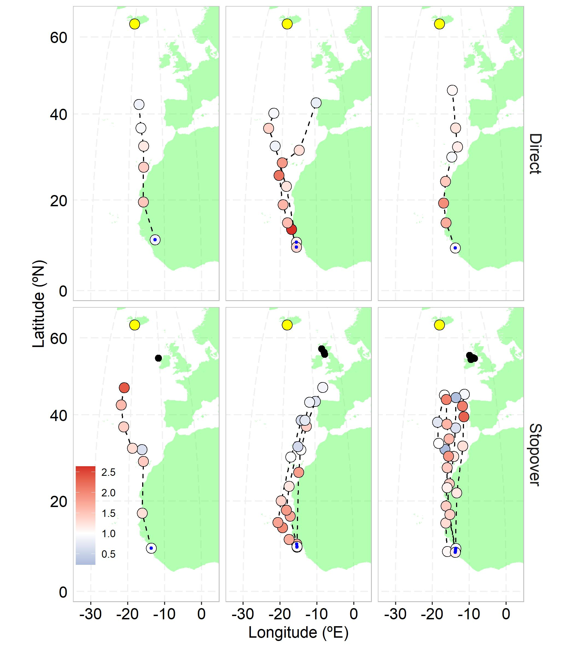
Figure SM2. Spring migration locations recorded with geolocators up to latitude 47°N, coloured by air-to-ground speed ratio (at 1000 hPa; i.e. 111m above sea level), for three individuals that performed both direct and stopover migrations (each column represents one individual); blue (values below one) represents wind support, whereas red (values above one) represents wind impediment in the direction of movement. Black dots depict stopover locations, yellow dot marks the breeding site and blue dots the individual winter location.
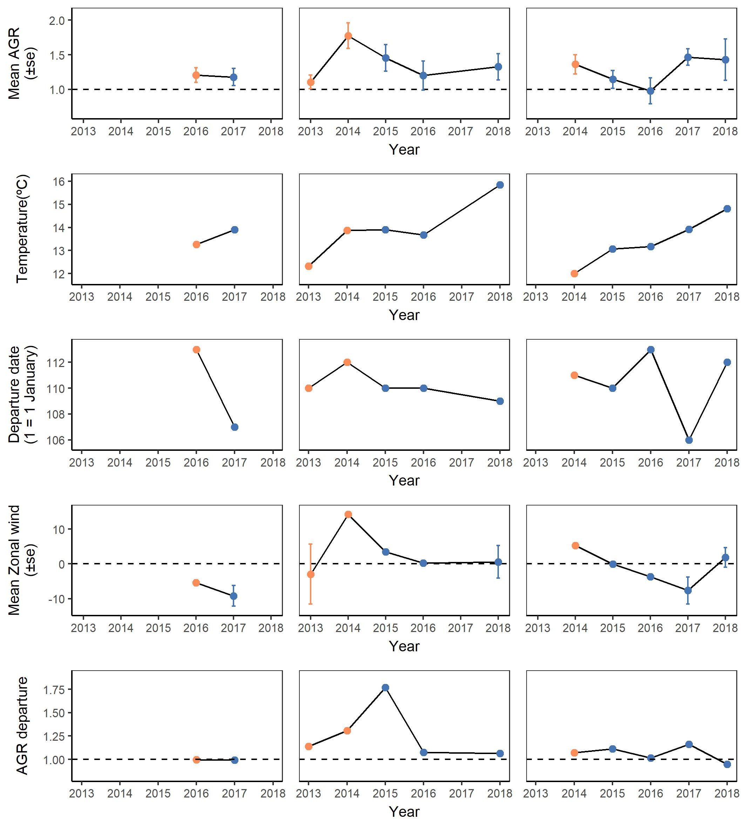
Figure SM3. Individual level annual data of the three individuals that changed from direct (orange) to stopover (blue) migratory behaviour (top to bottom rows): mean air-to-ground speed ratio (AGR) until 42°N, air temperature at 42°N, departure date in spring and average zonal wind experienced between 37 and 50°N, at 1000 hPa (i.e. 111m above sea level). Each column represents one individual.

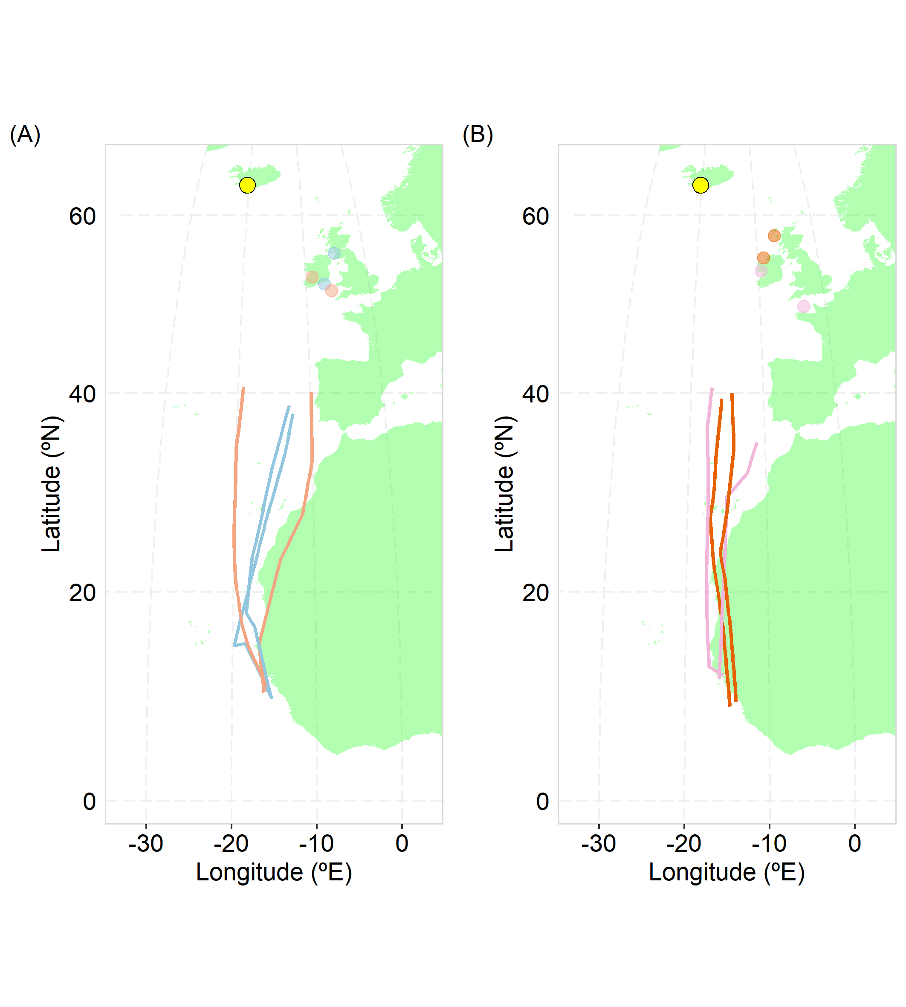
Figure SM4. Spring migration routes and stopover locations for Icelandic whimbrel that possibly departed from the wintering location in the same flock, in 2016 (A) and 2017 (B). Individuals in the same possible flock share the same colour. Blue in 2016 and red in 2017 may have travelled together, but the other two followed different routes after departure. These individuals were selected by filtering those departing on the same day and year, and having wintering locations closer than 100 km.

References
Harrison, X. A., Donaldson, L., Correa-Cano, M. E., Evans, J., Fisher, D. N., Goodwin, C. E. D., Robinson, B. S., Hodgson, D. J. and Inger, R. 2018. A brief introduction to mixed effects modelling and multi-model inference in ecology. - PeerJ 6: e4794. doi: 10.7717/peerj.4794

