Supplementary Material
Cryoconite Hole Location in East-Antarctic Untersee Oasis Shapes Physical and Biological Diversity

Klemens Weisleitner Alexandra Kristin Perras, Seraphin Hubert Unterberger, Christine Moissl-Eichinger, Dale T. Andersen, Birgit Sattler*

* Correspondence: Birgit Sattler: Birgit.Sattler@uibk.ac.at

8 Supplementary Figures and 3 Supplementary Tables

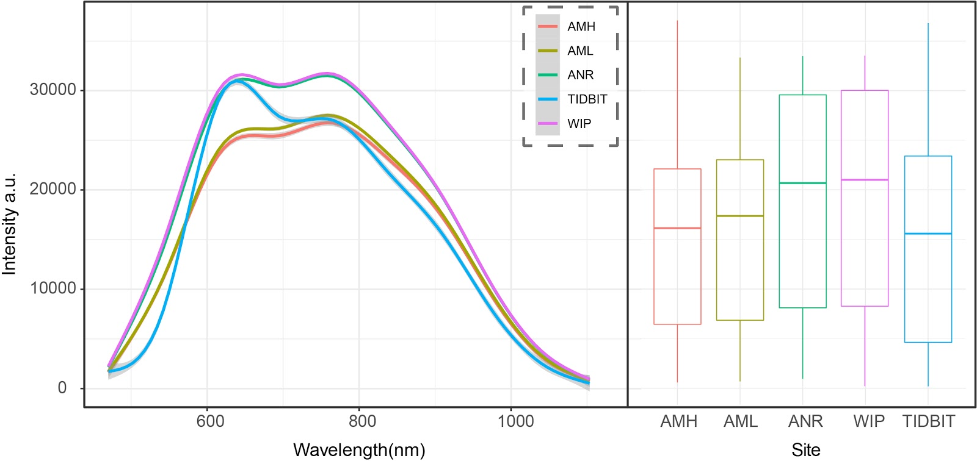
Supplementary Figure 1: Comparison of relative brightness between CH samples (AMH, AML, ANR, WIP) and the Tidbit temperature loggers. The samples and loggers were illuminated with a white LED and a tungsten filament. Reflected light was measured with a custom-built device using an Ibsen OEM FHT-315 spectrometer with an integration time of 600 ms in a range of 470 nm and 1100 nm under controlled laboratory conditions. Left: Averaged spectra from each site in comparison with the Tidbit logger. Right: Boxplots of relative brightness values. The median brightness of all CHs was 17,448.93. The median Tidbit brightness was slightly higher (18,603.06) but within the range of the CH samples.

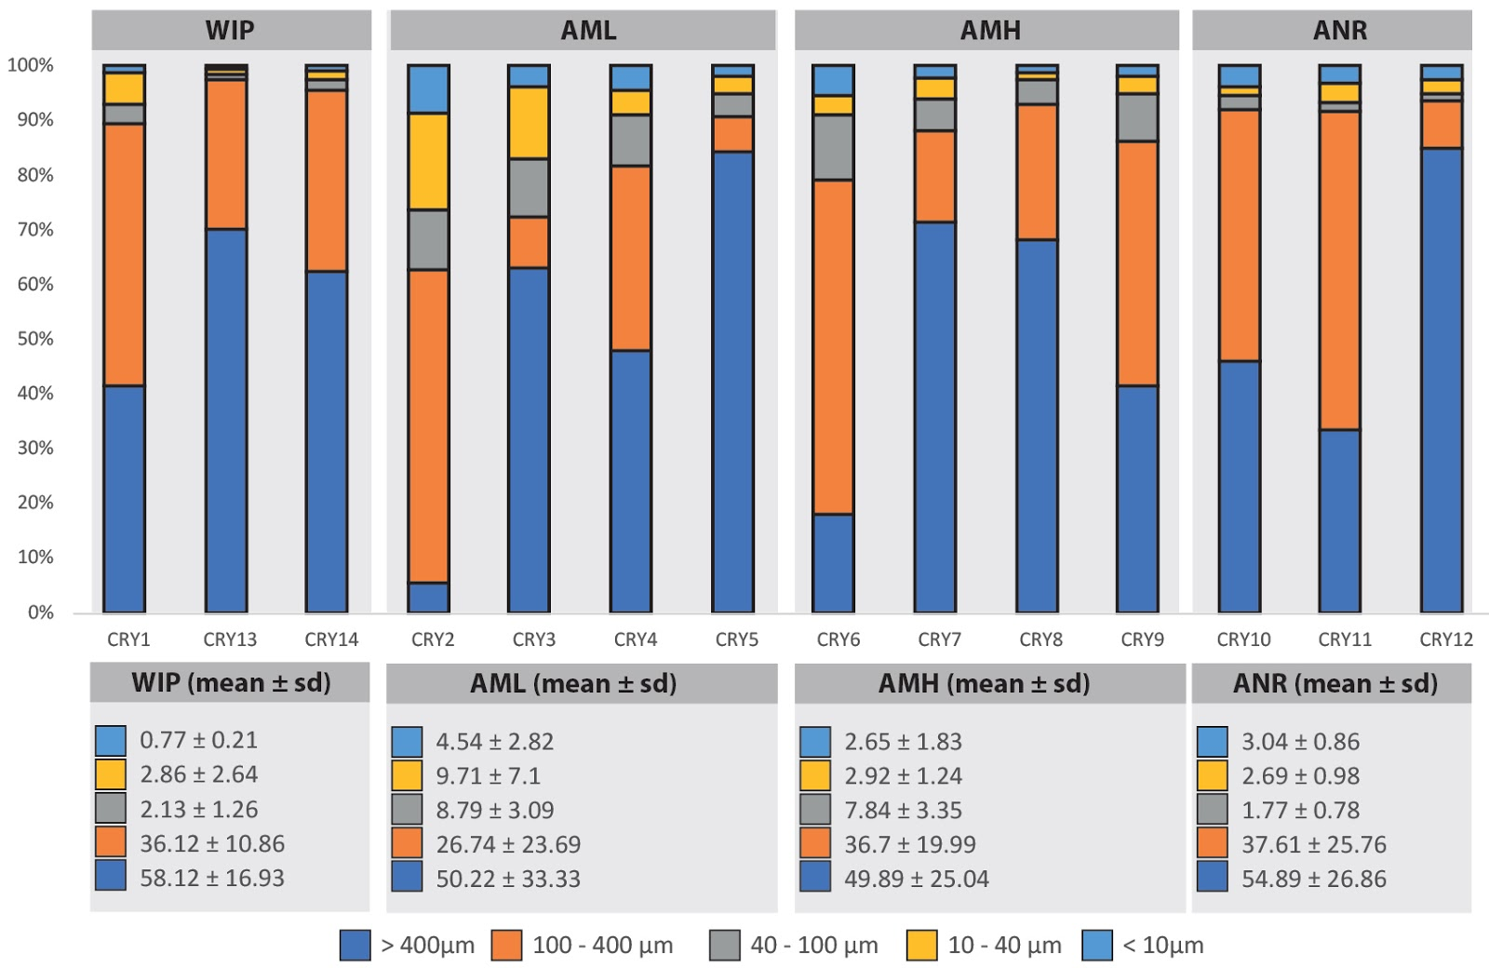
Supplementary Figure 2: Gravimetric particle size distribution of all samples (top) and mean values (± sd) from each site (bottom).

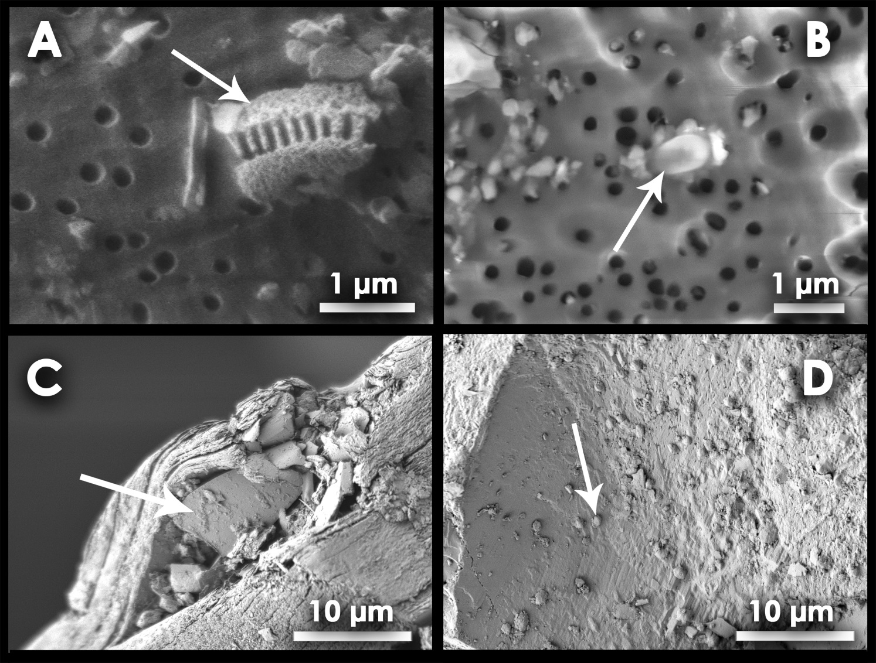
Supplementary Figure 3: Representative SEM images of cryoconite samples on a 0.2 µm polycarbonate filter (upper row) and after detaching cells from the sediment (bottom). A: Diatom frustule. B: Prokaryotic cell with mineral particles attached to it. C: A mineral stuck between layers of biotite; D: Prokaryotic cells in a matrix that covers the mineral surface. Key features in each image are highlighted with an arrow.

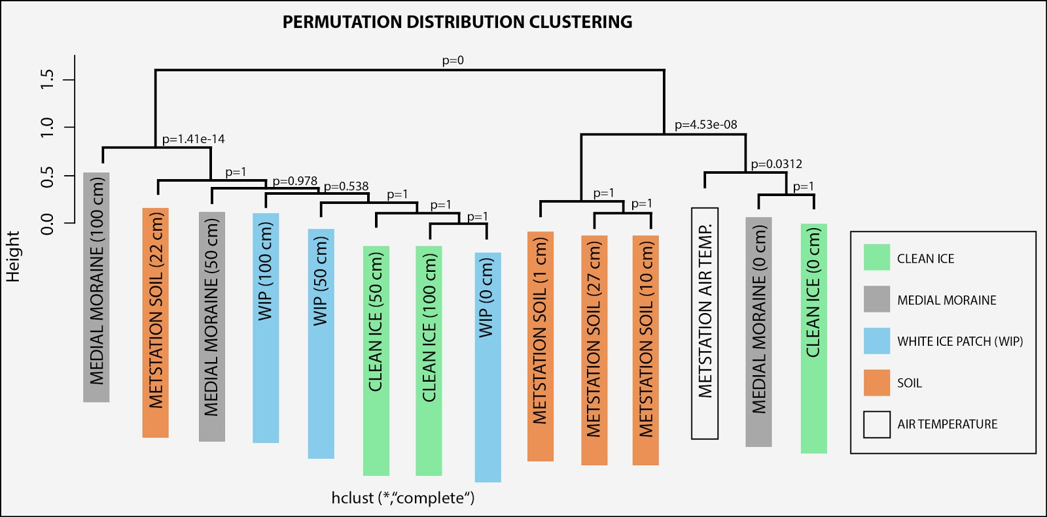
Supplementary Figure 4: Permutation clustering of temperature recorded in ice, soils and air.

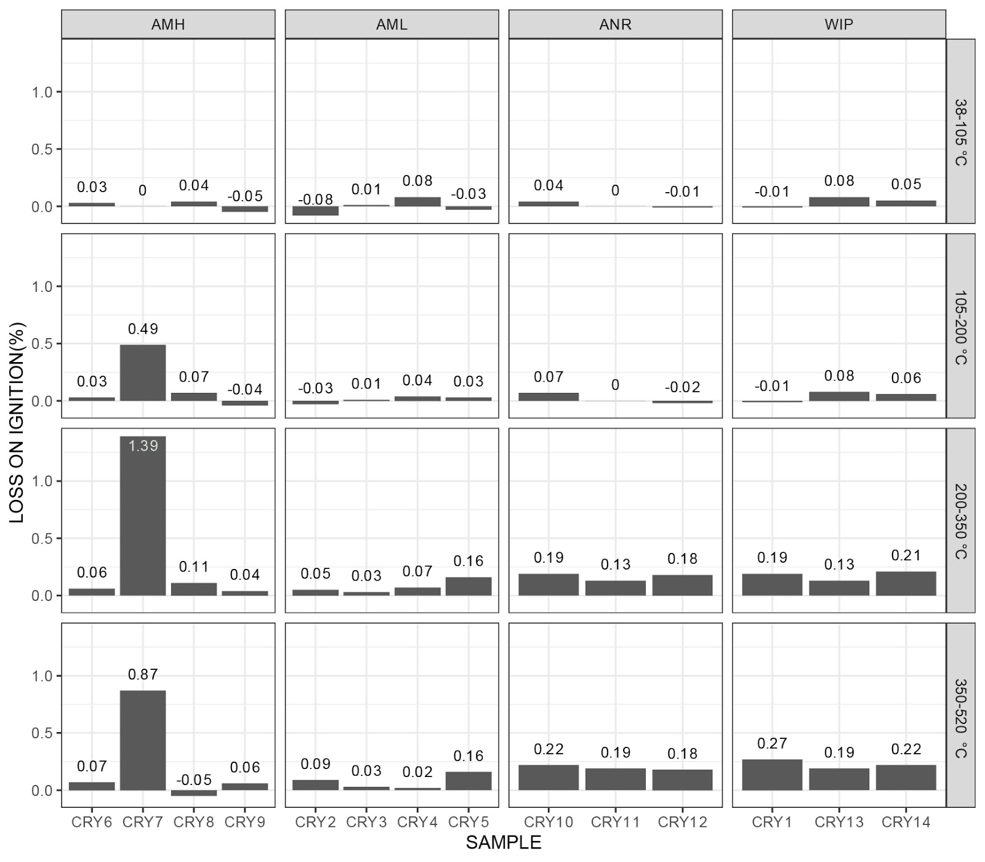
Supplementary Figure 5: Organic matter contents in cryoconite. Labile and stable organic matter are represented by the 200 - 350 °C and the 350 - 520 °C fractions, respectively. Sample CRY-7 was identified as an outlier most that was most likely caused by the presence of hydrogen-bonded water in the mineral laumontite.

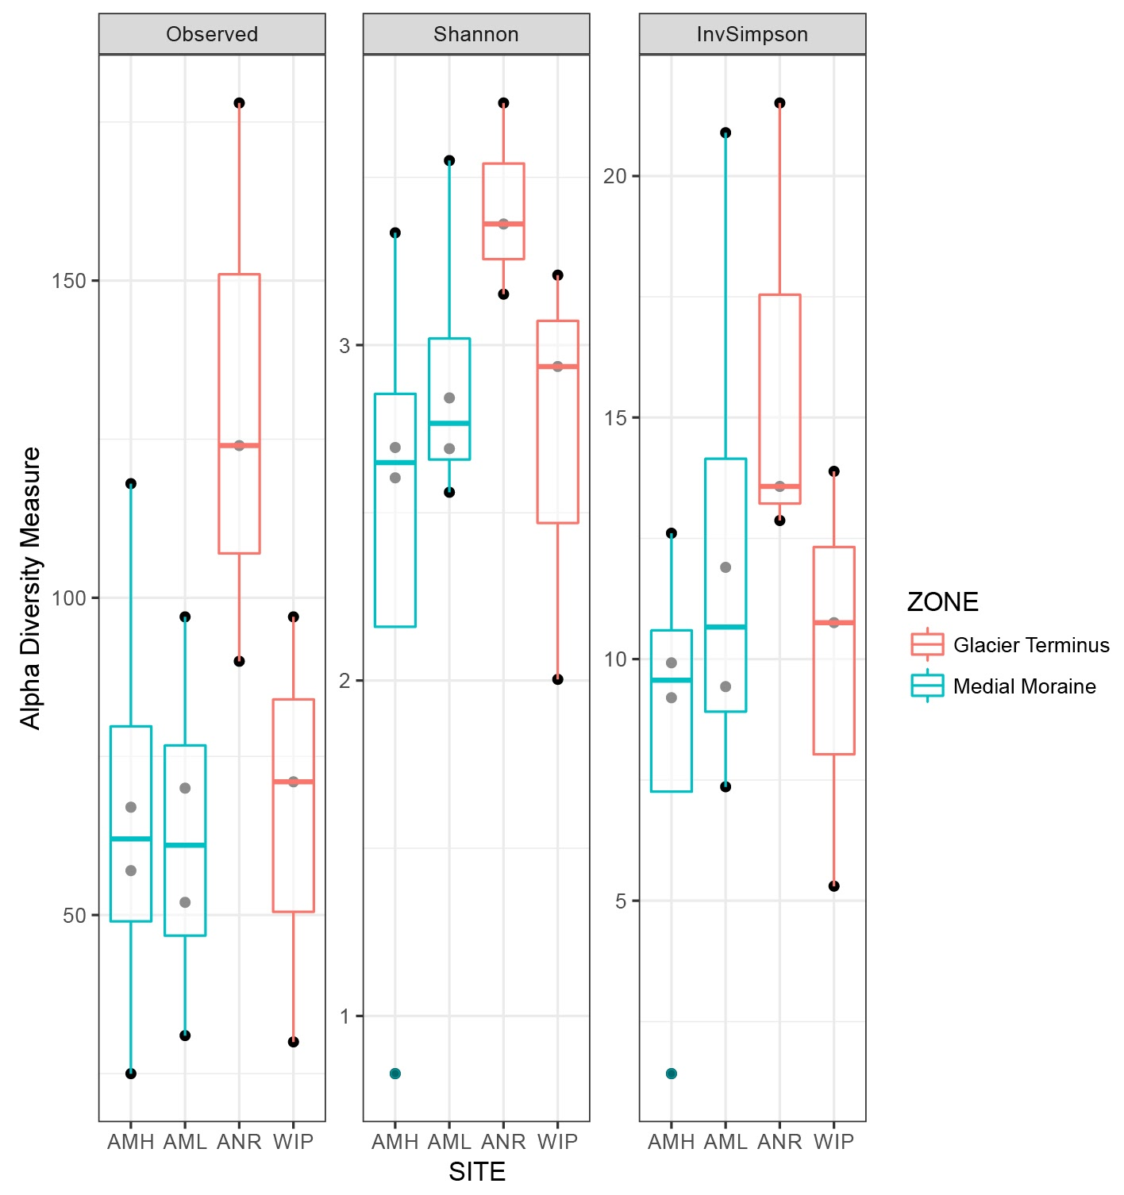
Supplementary Figure 6: Site comparison of alpha diversity measures.

Supplementary Figure 7: Bacterial RSVs (top) and archaeal RSVs (bottom) exceeding the ≥ 0.1% threshold according to their occurrence from 1 (i.e. occurrence at only one site) to 4 sites (i.e. core microbiome).

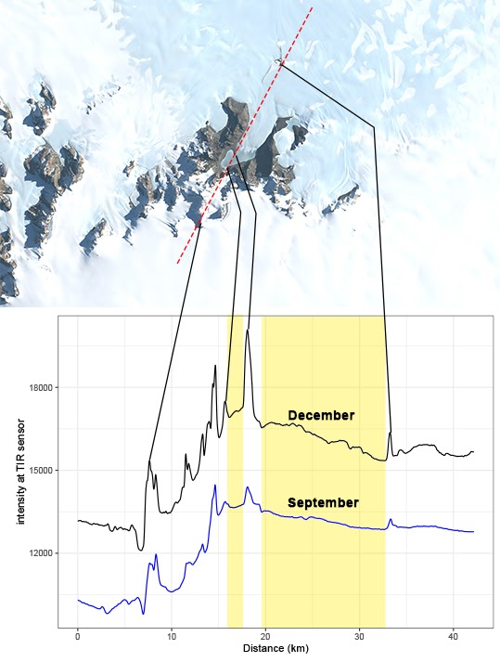
Supplementary Figure 8: Relative thermal emission captured by the Landsat 8 thermal infrared imager. Both thermal bands (band 10 (10.6 - 11.2 µm), band 11 (11.5 - 12.5 µm) were averaged prior analysis. The red line indicates the measured path (average of 4 pixels (400 m) along 42.18 km).

Supplementary Table 1: Accession numbers and site information for all samples. AML = Anuchin Medial moraine LOW, AMH = Anuchin Medial moraine High, ANR = Anuchin North of Ridge, WIP = White Ice Patch.

Sample | target | Accession number | Site
CRY 1 | Archaea | SRS3297449 | WIP
CRY 2 | Archaea | SRS3297448 | AML
CRY 3 | Archaea | SRS3297455 | AML
CRY 4 | Archaea | SRS3297454 | AML
CRY 5 | Archaea | SRS3297453 | AML
CRY 6 | Archaea | SRS3297452 | AMH
CRY 7 | Archaea | SRS3297447 | AMH
CRY 8 | Archaea | SRS3297446 | AMH
CRY 9 | Archaea | SRS3297547 | AMH
CRY 10 | Archaea | SRS3297549 | ANR
CRY 11 | Archaea | SRS3297546 | ANR
CRY 12 | Archaea | SRS3297548 | ANR
CRY 13 | Archaea | SRS3297545 | WIP
CRY 14 | Archaea | SRS3297544 | WIP
CRY 1 | Bacteria | SRS3297511 | WIP
CRY 2 | Bacteria | SRS3297510 | AML
CRY 3 | Bacteria | SRS3297509 | AML
CRY 4 | Bacteria | SRS3297507 | AML
CRY 5 | Bacteria | SRS3297516 | AML
CRY 6 | Bacteria | SRS3297514 | AMH
CRY 7 | Bacteria | SRS3297513 | AMH
CRY 8 | Bacteria | SRS3297512 | AMH
CRY 9 | Bacteria | SRS3297508 | AMH
CRY 10 | Bacteria | SRS3297506 | ANR
CRY 11 | Bacteria | SRS3297505 | ANR
CRY 12 | Bacteria | SRS3297504 | ANR
CRY 13 | Bacteria | SRS3297503 | WIP
CRY 14 | Bacteria | SRS3297502 | WIP

Supplementary Table 2: Permutational Multivariate Analysis of Variance Using Distance Matrices - Variables explaining variation in community structure.
Call:
adonis(formula = Bray-Curtis_distancematrix ~ Depth + OM + TC + TN + TP + BCP + Diameter + Abundance + Mineral_diversity + Particles<10µm + Particles10-40µm + Particles40-100µm, data = sampledf, strata = Site).

Explanatory variable | F-model | Explained variance (%) | P value
Depth | 8.3584 | 20.518 | 0.001
Total OM | 4.2664 | 10.473 | 0.003
TC | 2.1559 | 5.292 | 0.069
TN | 0.7836 | 3.993 | 0.158
TP | 3.3386 | 8.195 | 0.016
BCP | 2.5923 | 6.363 | 0.037
Diameter | 1.8508 | 4.543 | 0.110
Abundance | 2.6922 | 6.609 | 0.027
Mineral diversity | 4.9051 | 12.041 | 0.002
Particles  < 10 µm  10-40 µm  40-100 µm | 2.5961  2.3762  2.9783 | 6.373  5.833  7.311 | 0.307  0.401  0.015

Supplementary Table 3: Differential abundance analysis output (DESEQ 2) showing significantly different abundant RSVs between the medial moraine and glacier terminus.
#RSV | log2Fold  Change | Padj. | Phlyum | Class | Order | Family | Genus
15 | 12.38 | 1.32*10⁻⁹ | Proteobacteria | Gammaproteobacteria | Xanthomonadales | Xanthomonadaceae | Silanimonas
30 | 11.31 | 1.61*10⁻⁰⁵ | Cyanobacteria | Cyanobacteria | SubsectionIII | FamilyI | Leptolyngbya
46 | -8.17 | 7.71*10⁻⁰³ | Actinobacteria | Actinobacteria | Micrococcales | Microbacteriaceae | Salinibacterium
53 | 9.83 | 1.42*10⁻⁰⁵ | Bacteroidetes | Flavobacteriia | Flavobacteriales | Flavobacteriaceae | Flavobacterium
63 | 7.74 | 1.89*10⁻⁰³ | Bacteroidetes | Cytophagia | Cytophagales | Cyclobacteriaceae | Algoriphagus
70 | 8.75 | 1.89*10⁻⁰³ | Proteobacteria | Gammaproteobacteria | Xanthomonadales | Xanthomonadaceae | Lysobacter
76 | -8.65 | 3.67*10⁻⁰³ | Cyanobacteria | Cyanobacteria | SubsectionIII | FamilyI | Leptolyngbya
93 | 8.12 | 2.38*10⁻⁰⁴ | Bacteroidetes | Flavobacteriia | Flavobacteriales | Flavobacteriaceae | Flavobacterium
108 | -8.70 | 1.89*10⁻⁰³ | Bacteroidetes | Cytophagia | Cytophagales | Cytophagaceae | Spirosoma
111 | 7.19 | 5.18*10⁻⁰³ | Actinobacteria | Thermoleophilia | Solirubrobacterales | 480-2 | not assigned
112 | 6.56 | 8.57*10⁻⁰³ | Proteobacteria | Betaproteobacteria | Burkholderiales | Comamonadaceae | Hydrogenophaga
166 | 8.07 | 1.89*10⁻⁰³ | Proteobacteria | Alphaproteobacteria | Sphingomonadales | Sphingomonadaceae | Sphingopyxis
172 | 7.01 | 5.55*10⁻⁰³ | Planctomycetes | Planctomycetacia | Planctomycetales | Planctomycetaceae | not assigned
200 | 7.08 | 5.55*10⁻⁰³ | Armatimonadetes | not assigned | not assigned | not assigned | not assigned
213 | 8.80 | 3.67*10⁻⁰³ | Proteobacteria | Gammaproteobacteria | Xanthomonadales | Xanthomonadaceae | Rhodanobacter
249 | 9.45 | 1.42*10⁻⁰⁵ | Bacteroidetes | Flavobacteriia | Flavobacteriales | Flavobacteriaceae | Flavobacterium
257 | -7.51 | 6.79*10⁻⁰³ | Proteobacteria | Alphaproteobacteria | Sphingomonadales | Sphingomonadaceae | Sphingomonas
258 | 9.37 | 1.48*10⁻⁰⁵ | Bacteroidetes | Sphingobacteriia | Sphingobacteriales | Sphingobacteriaceae | Pedobacter
310 | 7.09 | 5.55*10-03 | Saccharibacteria | not assigned | not assigned | not assigned | not assigned
163 | 10.62 | 1.48*10-05 | Bacteroidetes | Cytophagia | Cytophagales | Cyclobacteriaceae | Algoriphagus
181 | 10.79 | 2.65*10-07 | Proteobacteria | Betaproteobacteria | Burkholderiales | Comamonadaceae | Rhizobacter
188 | 8.34 | 2.83*10-03 | Proteobacteria | Betaproteobacteria | Burkholderiales | Comamonadaceae | Hydrogenophaga
195 | 7.31 | 3.67*10-03 | Planctomycetes | Planctomycetacia | Planctomycetales | Planctomycetaceae | Pirellula
286 | 7.21 | 8.71*10-03 | Proteobacteria | Alphaproteobacteria | Rhodospirillales | Acetobacteraceae | Roseomonas
287 | 7.61 | 2.52*10-03 | Actinobacteria | Actinobacteria | Micrococcales | Intrasporangiaceae | Aquipuribacter
309 | 7.32 | 1.63*10-03 | Proteobacteria | Alphaproteobacteria | Rhodobacterales | Rhodobacteraceae | Rhodobacter

