FIGURE S1. Rarefaction analysis of microbial eukaryote 18S rRNA gene sequences in individual (A) and pooled sea water (SW) and melt pond (MP) samples (B).
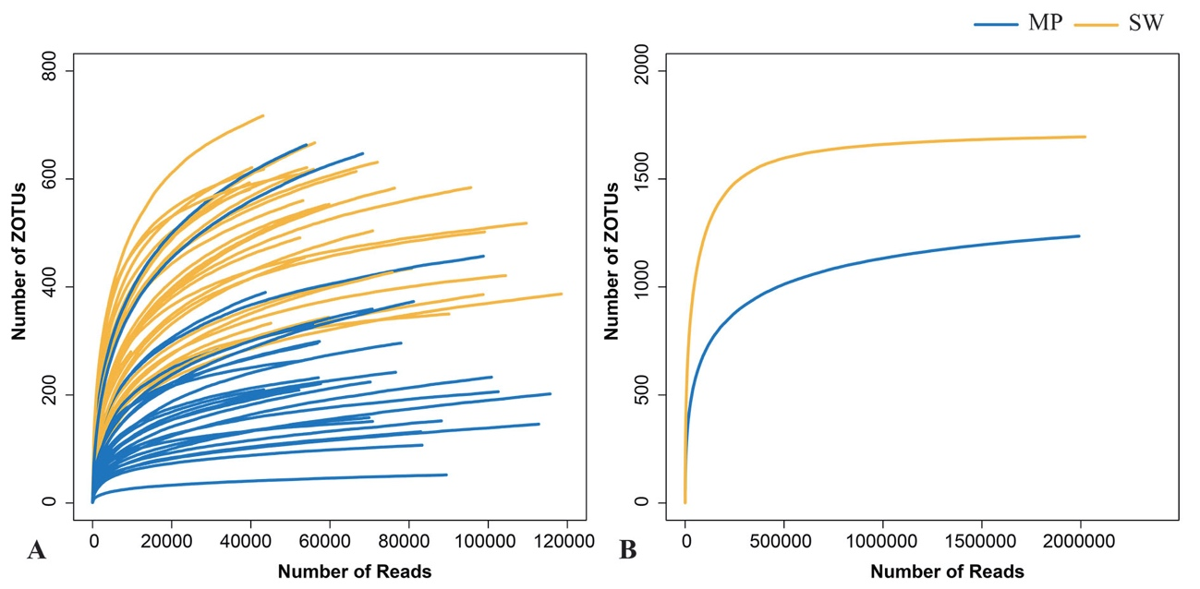

FIGURE S2. Alpha-diversity estimates (Shannon and Chao1) for the size-fractionated (A, B) samples of the melt ponds (MPs) and sea water (SW) and for the pooled (C, D) MP and SW samples, respectively. The line in each box plot indicates the median, the box delimits the 25th and 75th percentile. Bars in (C) and (D) without shared letters indicate significant differences at the level of p = 0.05.

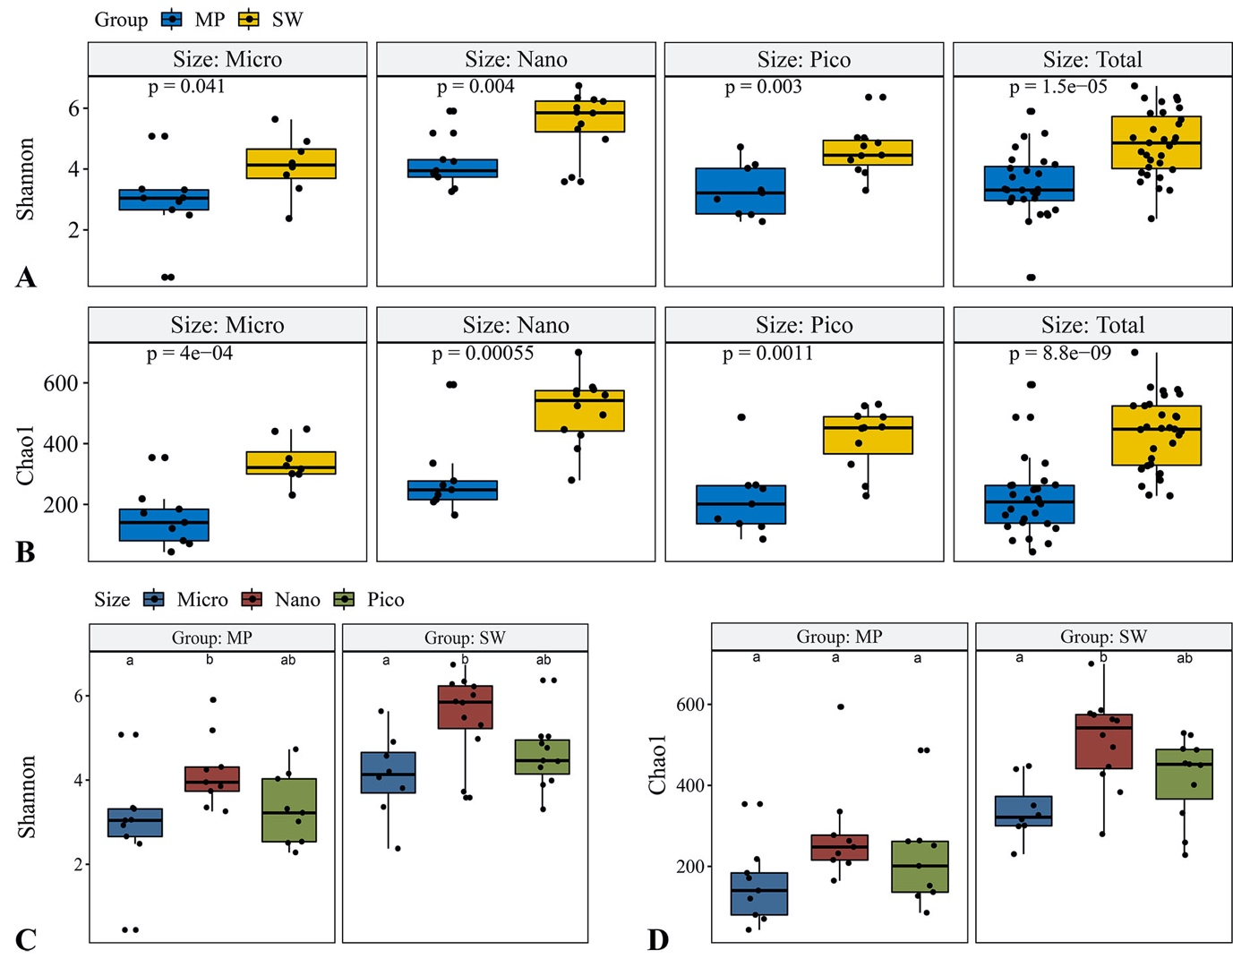

FIGURE S3. Relative numbers of sequences and ZOTUs of individual sea water (SW) and melt ponds (MPs) microbial eukaryotes.
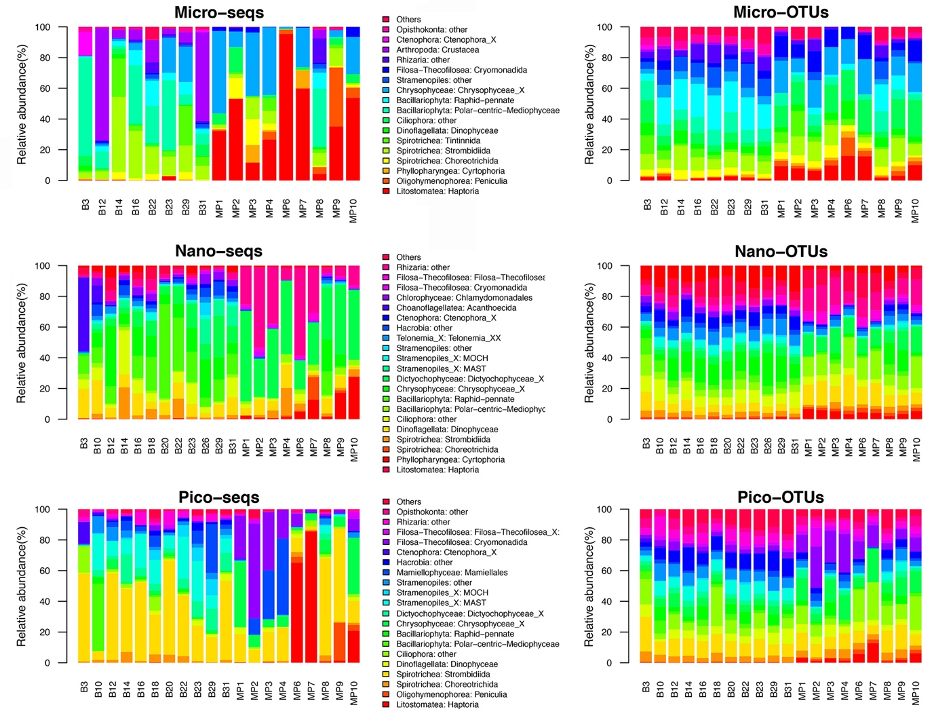

FIGURE S4. Venn diagram showing the shared ZOTUs among sea water (SW) and melt pond (MP) groups (A), among sea water (SW), open (OMP) and closed (CMP) melt ponds (C) and the shared ZOTUs affiliated with Ciliophora among micro-, nano-, and pico-sized subcommunities (B) respectively.
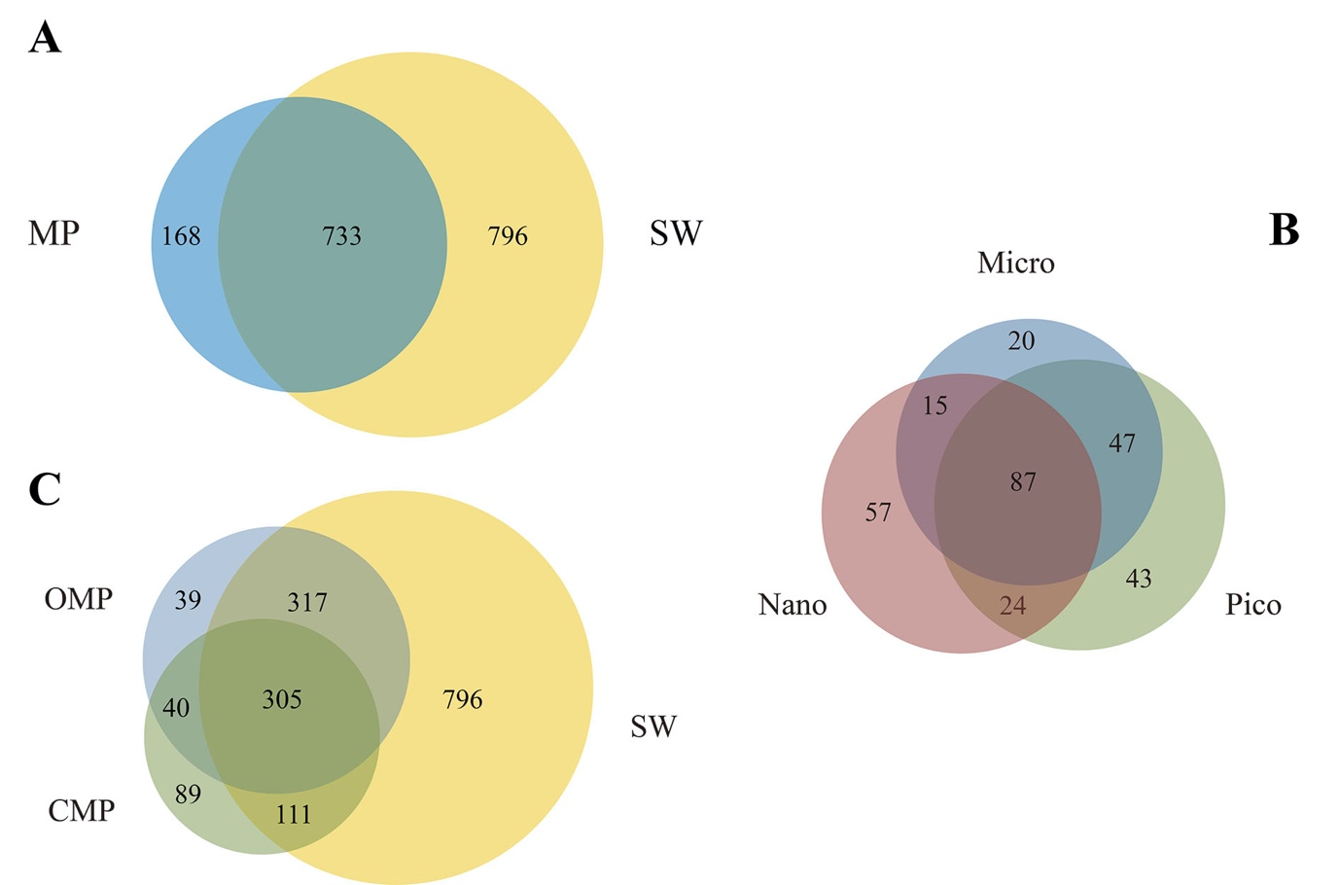

FIGURE S5. Community dissimilarity of sea water (SW) and melt pond (MP) samples as revealed by Bray Curtis dissimilarities.
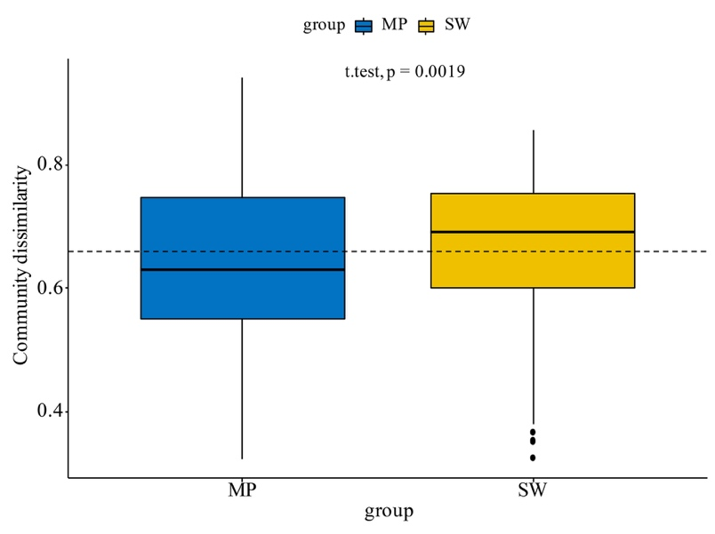

Table S1. Coordinates of the sampling sites and diversity parameters of the samples. *Reads after quality control; **Standardized numbers based on subsampling of 9,674 sequences without replacement.

Station | Lat. | Long. | Size | Sample ID | Reads  affiliated  with  microbial eukaryotes | ZOTUs** | Chao1 | Shannon |  | PD
B3 | 67.67 | -168.96 | micro | ARA07B3micro | 90124 | 197 | 299 | 3.36 | 25.95
 |  |  | nano | ARA07B3nano | 45022 | 197 | 280 | 3.72 | 23.03
 |  |  | pico | ARA07B3pico | 59948 | 163 | 228 | 3.30 | 19.54
B10 | 70.5 | -168.67 | nano | ARA07B10nano | 9647 | 269 | 428 | 5.48 | 29.99
 |  |  | pico | ARA07B10pico | 75746 | 189 | 259 | 3.89 | 21.13
B12 | 72.36 | -168.67 | micro | ARA07B12micro | 99177 | 257 | 350 | 2.37 | 33.11
 |  |  | nano | ARA07B12nano | 54139 | 398 | 574 | 5.86 | 38.53
 |  |  | pico | ARA07B12pico | 55996 | 358 | 524 | 5.03 | 32.08
B14 | 74.80 | -167.90 | micro | ARA07B14micro | 80538 | 221 | 301 | 4.20 | 25.15
 |  |  | nano | ARA07B14nano | 56125 | 400 | 585 | 5.84 | 34.95
 |  |  | pico | ARA07B14pico | 70637 | 265 | 452 | 4.76 | 26.98
B16 | 75.15 | -176.00 | micro | ARA07B16micro | 95656 | 310 | 448 | 4.91 | 33.33
 |  |  | nano | ARA07B16nano | 43089 | 493 | 700 | 6.74 | 44.48
 |  |  | pico | ARA07B16pico | 76281 | 292 | 401 | 3.99 | 32.43
B18 | 75.77 | 177.07 | nano | ARA07B18nano | 43244 | 472 | 578 | 6.28 | 44.69
 |  |  | pico | ARA07B18pico | 53923 | 439 | 487 | 6.37 | 36.80
B20 | 77.00 | 176.57 | nano | ARA07B20nano | 43864 | 306 | 446 | 3.58 | 32.58
 |  |  | pico | ARA07B20pico | 59084 | 306 | 450 | 4.44 | 29.54
B22 | 78.52 | 178.85 | micro | ARA07B22micro | 109627 | 303 | 440 | 5.63 | 34.51
 |  |  | nano | ARA07B22nano | 39610 | 367 | 560 | 4.97 | 37.71
 |  |  | pico | ARA07B22pico | 59763 | 307 | 455 | 4.46 | 31.95
B23 | 77.87 | -175.91 | micro | ARA07B23micro | 98728 | 189 | 316 | 4.57 | 24.01
 |  |  | nano | ARA07B23nano | 39777 | 411 | 563 | 6.02 | 40.83
 |  |  | pico | ARA07B23pico | 66800 | 356 | 529 | 4.87 | 31.20
B26 | 76.00 | -170.50 | nano | ARA07B26nano | 53161 | 375 | 494 | 6.22 | 32.73
B29 | 77.47 | -164.12 | micro | ARA07B29micro | 118451 | 179 | 230 | 4.06 | 25.21
 |  |  | nano | ARA07B29nano | 52387 | 300 | 383 | 5.31 | 28.51
 |  |  | pico | ARA07B29pico | 53569 | 252 | 332 | 4.30 | 26.56
B31 | 75.69 | -166.64 | micro | ARA07B31micro | 104398 | 228 | 327 | 3.81 | 31.06
 |  |  | nano | ARA07B31nano | 40266 | 409 | 524 | 6.34 | 37.22
 |  |  | pico | ARA07B31pico | 72114 | 356 | 490 | 5.03 | 34.30
BIC(MP10) |  |  | micro | ARA07MP10micro | 88157 | 80 | 121 | 2.66 | 9.74
 |  |  | nano | ARA07MP10nano | 52167 | 382 | 594 | 5.90 | 33.83
 |  |  | pico | ARA07MP10pico | 70740 | 178 | 262 | 4.03 | 22.35
BIC(MP1) | 77.99 | -176.99 | micro | ARA07MP1micro | 115659 | 86 | 171 | 3.04 | 9.87
 |  |  | nano | ARA07MP1nano | 57069 | 151 | 277 | 4.25 | 14.70
 |  |  | pico | ARA07MP1pico | 57448 | 163 | 264 | 4.15 | 17.43
BIC(MP2) |  |  | micro | ARA07MP2micro | 76692 | 115 | 184 | 2.93 | 14.00
 |  |  | nano | ARA07MP2nano | 43269 | 133 | 232 | 3.74 | 13.71
 |  |  | pico | ARA07MP2pico | 69912 | 82 | 127 | 3.32 | 9.41
BIC(MP3) |  |  | micro | ARA07MP3micro | 100827 | 95 | 218 | 3.34 | 13.53
 |  |  | nano | ARA07MP3nano | 57643 | 116 | 165 | 3.35 | 13.27
 |  |  | pico | ARA07MP3pico | 70174 | 101 | 152 | 3.01 | 10.29
BIC(MP4) |  |  | micro | ARA07MP4micro | 112754 | 61 | 80 | 3.05 | 6.95
 |  |  | nano | ARA07MP4nano | 56806 | 177 | 208 | 3.85 | 18.07
 |  |  | pico | ARA07MP4pico | 82878 | 68 | 86 | 2.28 | 7.82
BIC(MP6) |  |  | micro | ARA07MP6micro | 89399 | 25 | 43 | 0.44 | 4.87
 |  |  | nano | ARA07MP6nano | 52769 | 175 | 216 | 3.95 | 18.38
 |  |  | pico | ARA07MP6pico | 78029 | 139 | 201 | 2.51 | 18.53
BIC(MP7) |  |  | micro | ARA07MP7micro | 83288 | 57 | 70 | 2.48 | 6.85
 |  |  | nano | ARA07MP7nano | 55703 | 196 | 263 | 4.31 | 19.61
 |  |  | pico | ARA07MP7pico | 70763 | 86 | 137 | 2.54 | 8.87
BIC(MP8) |  |  | micro | ARA07MP8micro | 98777 | 235 | 354 | 5.08 | 28.01
 |  |  | nano | ARA07MP8nano | 53986 | 133 | 248 | 3.26 | 13.71
 |  |  | pico | ARA07MP8pico | 68385 | 345 | 486 | 4.73 | 34.81
BIC(MP9) |  |  | micro | ARA07MP9micro | 102493 | 98 | 141 | 3.31 | 10.39
 |  |  | nano | ARA07MP9nano | 43663 | 234 | 335 | 5.18 | 21.48
 |  |  | pico | ARA07MP9pico | 81080 | 162 | 251 | 3.22 | 18.38

Table S2. Analysis of similarities (ANOSIM) tests of the groupings of microbial eukaryote subcommunities according to size calculated from Bray Curtis dissimilarities.

 |  | ANOSIM
 |  | R | P
Melt pond | micro vs. nano | 0.417 | 0.001
 | micro vs. pico | 0.345 | 0.001
 | nano vs. pico | 0.236 | 0.003
Sea water | micro vs. nano | 0.460 | 0.001
 | micro vs. pico | 0.798 | 0.001
 | nano vs. pico | 0.484 | 0.001

