Divergence in parturition timing and vegetation onset in a large herbivore - differences along a latitudinal gradient
Wiebke Neumann, Navinder J Singh, Fredrik Stenbacka, Jonas Malmsten, Kjell Wallin, John P Ball, Göran Ericsson
Supplementary Material S1, details on the methodological and analytical approach
(a) Moose parturition data
We analysed 1,129 parturition dates across 12 degrees of latitude between 26/05/1990 and 21/06/2017 (S1.Table.1). To determine parturition date, we closely monitored daily female movement patterns during the calving season. During the period before GPS devices were available (VHF: 1990-2002), we approached female moose regularly for field observation until we observed at least one calf. We assessed the date of parturition by estimating calf age by observing factors like the presence of the umbilical cord and degree of desiccation, and movement ability in relation to observation date. With the help of high resolution positioning given by GPS (2004-2017), we monitored female moose closely by setting positions intervals to 30 minutes for detecting changes in movement patterns that indicate parturition. We inspected movement patterns visually on a daily base and assumed a parturition when a distinct movement cluster occurred. We confirmed parturitions by field observation. We defined the date of parturition by the time stamp of the first position within the movement cluster.

S1.Table.1. Distribution of 1,129 moose parturitions across years and latitudes, Sweden.
Years | Latitude
 | 56 | 57 | 58 | 59 | 60 | 61 | 62 | 64 | 65 | 66 | 67 | 68
1990 | . | . | . | . | . | . | . | 8 | 1 | . | . | .
1991 | . | . | . | . | . | . | . | 30 | 1 | . | . | .
1992 | . | . | . | . | . | . | . | 31 | 1 | . | . | .
1993 | . | . | . | . | . | . | . | 8 | 1 | . | . | .
1994 | . | 6 | 7 | . | . | 3 | 8 | 11 | . | . | . | .
1995 | . | 19 | 11 | . | 9 | 6 | 18 | 40 | 4 | . | . | .
1996 | . | 20 | 18 | . | 14 | 6 | 20 | 48 | 3 | . | . | .
1997 | . | 14 | 11 | . | 15 | 6 | 13 | 33 | 3 | . | . | .
1998 | . | 14 | 8 | . | . | . | . | 29 | 2 | . | . | .
1999 | . | 17 | 13 | . | . | . | . | 39 | 3 | . | . | .
2000 | . | 12 | 9 | . | . | . | . | . | . | . | . | .
2001 | . | 11 | 7 | . | . | . | . | . | . | . | . | .
2002 | . | 15 | 10 | . | . | . | . | . | . | . | . | .
2003 | . | . | . | . | . | . | . | . | . | . | . | .
2004 | . | . | . | . | . | . | . | 16 | . | . | . | .
2005 | . | . | . | . | . | . | . | 12 | 5 | 9 | . | .
2006 | . | . | . | . | . | . | . | . | 2 | 16 | 1 | .
2007 | . | . | . | . | . | . | . | . | 3 | 4 | . | .
2008 | . | . | . | . | . | . | . | . | 8 | 13 | . | 2
2009 | . | 17 | . | 6 | . | . | . | . | 1 | 5 | . | .
2010 | . | 23 | . | 6 | . | . | . | . | . | . | . | .
2011 | . | 16 | 1 | 2 | . | . | . | . | . | . | . | 1
2012 | . | 26 | . | 8 | . | . | . | . | . | . | . | .
2013 | 2 | 15 | . | 7 | . | . | . | . | . | 19 | 12 | 13
2014 | 1 | 17 | . | . | . | . | . | . | 1 | 24 | 17 | 7
2015 | 3 | 29 | . | 2 | . | . | . | . | 1 | 20 | 10 | 9
2016 | 4 | 22 | . | 9 | . | . | . | . | . | . | 1 | .
2017 | 4 | 17 | . | . | . | . | . | 24 | . | . | . | .

Female age at parturition varied at each latitude, and most parturition dates came from females 10 years and younger (S1.Fig.1). We determined year of birth by cementum annuli or tooth wear (Ericsson and Wallin 2001). Age estimation by tooth wear can be difficult for older animals, but comparison between field estimates (tooth wear) and cementum annuli show that age estimates for moose up to 10 years of age were accurate. For older moose, we found more deviation, but even so, age estimates were within 1 or 2 years. The majority of moose in this study were first marked at an age below 10 years. We therefore feel confident in our age estimates.
Moose are short-day breeders and seasonally polyestrous with cycles of 24 days if not mated. Most females conceive during the first oestrus (Malmsten et al. 2014). In moose, female age and ovulation timing are closely correlated (Garel et al. 2009). Mean length of gestation is 231 ± 5 (standard deviation, SD) days (Schwartz and Hundertmark 1993). To disentangle parturition timing across latitudes from effects of different oestrus cycles (Sæther et al. 1996; Garel et al. 2009; Malmsten et al. 2014), we excluded parturitions that fell into the second cycle (24 days) or later using density distribution (n=90, 8 %). Given the delayed ovulation timing in young and primiparous, as well as old (≥11.5 years of age) females, we may have thus eliminated some parturitions of those females, which tend to give birth later. We consider, however, the potential miss of parturitions of any given age class to be negligible as parturitions that fell outside the first mating cycle were distributed across different age classes (S1.Fig.1, in red), and our approach excluded only 8 % of the total anyway. To control for the effect of age, we included female age at parturition as a covariate.

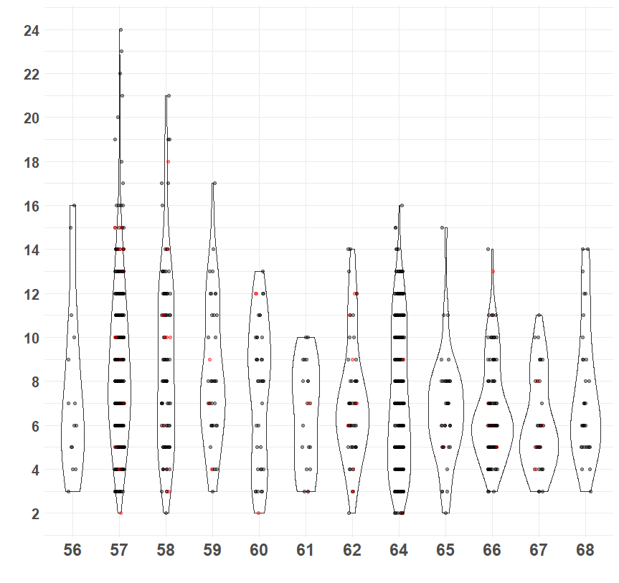
S1.Fig.1. Distribution of moose parturitions (n=1090) across age classes and latitudes. Parturitions that belong to the first mating cycle in black, those that fell outside in red.

To test for differences in parturition date along a longitudinal and thus continental gradient (S1.Fig.2), we classified each parturition in one of three categories: alpine, inland, and coastal. We used the layer of ecoregions to delimit the coastal zone (SAMWM 2018). Parturitions that fell into the alpine vegetation zone or into the alpine ecoregion, we defined as alpine (including both high and low alpine areas), and parturitions that fell between the alpine and coastal zone, we classified as inland (Gustafsson and Ahlén 1996; SAMWM 2018, S1.Fig.2). In the alpine region, mountain birch (Betula pubescens ssp. tortuosa) defines the forest at tree line (around 700-900 m above sea level, depending on latitude). Heathland and mires define the areas above tree line where Salix species, heather (Calluna vulgaris), grass, herbs, and mosses dominate the vegetation. Elevation averages 821 m ± 227 standard deviation (SD, zonal statistics on the Swedish Digital Elevation Model (DEM, 2009, 50 x 50m)), and snow covers the region for about 200-225 days and length of the vegetation period is ≤ 120 days (www.smhi.se). A continental climate characterize the inland region with a temperature difference of 35-40 ᵒC between January and July (www.smhi.se). Monocultures of Scots Pine (Pinus sylvestris) with elements of deciduous tree (e.g., Betula pubescens, Betula pendula, Populus tremula) dominate the inland forests. Mires are common elements in the gently rolling terrain (404 m ± 131 SD, zonal statistics DEM). Snow cover stays 175-200 days and vegetation period is 120-140 days long (www.smhi.se). A maritime climate characterizes the coastal region (www.smhi.se), where boreal forest with patches of deciduous trees and agricultural activity occur in a flat to gently rolling terrain (131 m ± 113 SD, zonal statistics DEM). To control for differences across latitudes, we added latitude as a covariate (Table 1, main document).

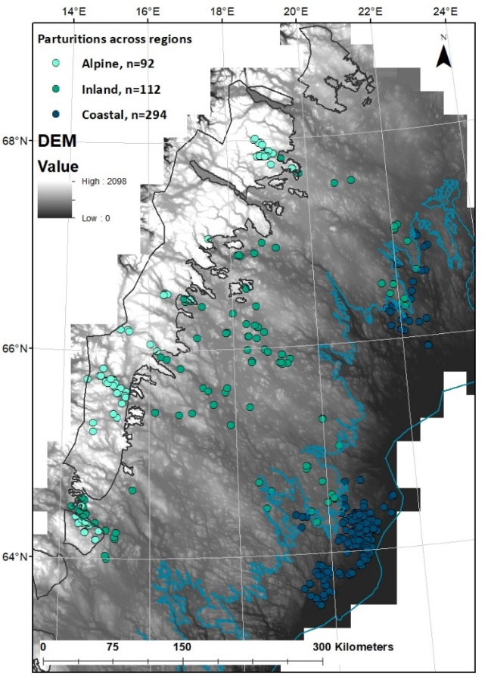
S1.Fig.2. Distribution of moose parturitions across the alpine (n=92, light green), inland (n=112, green), and coastal region (n=294, dark blue) in Northern Sweden. Delimitation of the coastal region (light blue line) following the coastal ecoregion (SAMWM 2018). Delimitation of the alpine region (dark grey line) as a combination of the alpine vegetation and ecoregion zone (Gustafsson and Ahlén 1996; SAMWM 2018). The Swedish digital elevation model as background to illustrate terrain difference across the regions.

(b) Data Analysis
We used patterns in ambient temperature as an index for vegetation onset. Given the scale and time span of our study, we had to rely on an indirect measure for plant phenology. Previous research has shown that vegetation onset correlates with ambient spring temperature in Fennoscandia (Chapin III 1983; Karlsen et al. 2006). To estimate vegetation onset at a given location and in a given year, we therefore asked the Swedish Hydrological Swedish Meteorological and Hydrological Institute (www.smhi.se) to interpolate annually daily ambient temperatures given by weather stations nationwide to express vegetation onset at a given year-location. We defined vegetation onset as the first day of a 14-day period with a mean daily temperature > 7ᵒ C (Karlsen et al. 2007; Allen et al. 2017). As a result, we received annual raster layers (pixel size 4km x 4km) that identified vegetation onset in a given location in our study area. Next, we linked spatially each parturition site to the corresponding annual raster to extract vegetation onset (as the Julian day) at a given place and in a given year.
Onset of the vegetation period varied across years, particular at higher latitudes (S1.Fig.3). We therefore included vegetation onset as a covariate also in the models testing hypotheses 1 and 2.
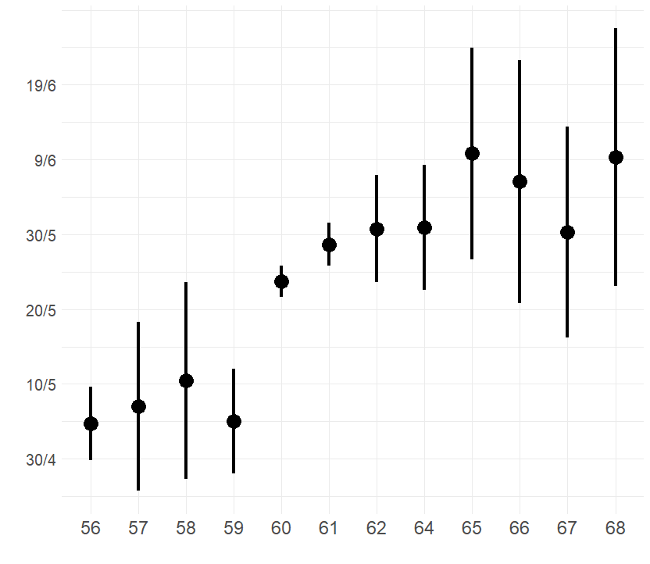
S1.Fig.3. Timing of vegetation onset at parturition sites (n=1001) across latitudes, given as mean ± standard deviation.

To estimate the variation in parturition timing explained by each fixed effect (i.e. explanatory variable) included in hypothesis 1 and 2, and thereby assessing their relative importance, we calculated the sum of model weights over all models including each fixed effect (R package MuMIn).

To differentiate how individual timing of parturition vary between and within females, we related parturition date to vegetation onset for females for which we had three parturitions on the same latitude. We included only latitudes where we had data of more than three different females. To distinguish within-subject (i.e. phenotypically plastic responses in individual female moose) and between-subject (i.e. evolutionary fixed responses in female moose) effects, we applied within-subject centering using a mixed linear model (van de Pol and White 2009). We generated thus two new predictor variables based on the fixed effects, one that expresses only the within-female variation and another that expresses only the between-female variation of a vegetation onset (van de Pol and White 2009). To access the within-female variation, we subtracted the subjects’ mean (i.e. female mean) from each observation (i.e. subject mean centering or more generally centering within clusters). We used the females’ means to access the between-female variation, which means that different observations from the same female all have the same value (van de Pol and White 2009). As before, we added year and female age at birth as covariate to control for possible effects over time and by age (main document Table 1). To estimate the variance explained on each level (i.e. within-female and between-female), we divided the variance explained by our model (main document Table 1, Hypothesis 4) with the variance explained by the null model with the same random effect structure (response ~ 1), and subtracted it from 1.

References
Allen AM, Dorey A, Malmsten J, Edenius L, Ericsson G, Singh NJ. 2017. Habitat-performance relationships of a large mammal on a predator-free island dominated by humans. Ecol. Evol. 7, 305-319, https://doi.org/10.1002/ece3.2594
Chapin III FS. 1983. Direct and indirect effects of temperature on arctic plants. Polar Biology 2, 47-52.
Ericsson G, Wallin K. 2001. Senescence in a northern ungulate: Age and sex-specific patterns of mortality in moose Alces alces. Ecoscience 8,157-163.
Garel M, Solberg EJ, Sæther B-E, Grøtan V, Tufto J, Heim M. 2009. Age, size, and spatiotemporal variation in ovulation patterns of a seasonal breeder, the Norwegian moose (Alces alces). Am. Nat. 173, 89–104.
Gustafsson L, Ahlén I. 1996. Geography of plants and animals. In: National Atlas of Sweden. SNA Publishing, Stockholm.
Karlsen SR, Solheim I, Beck PSA, Høgda KA, Wielgolaski FE, Tømmervik H. 2007. Variability of the start of the growing season in Fennoscandia, 1982–2002. Int. J. Biometeorol 51, 513–524.
Karlsen SR, Elvebakk A, Høgda KA, Johansen B. 2006. Satellite based mapping of the growing season and bioclimatic zones in Fennoscandia. Global Ecol. Biogeogr. 15, 416–430.
Malmsten J, Söderquist L, Thulin C-G, Gavier Widén D, Yon L, Hutchings MR, Dalin A-M. 2014. Reproductive characteristics in female moose (Alces alces), with emphasis on puberty, timing of oestrus, and mating. Acta Vet. Scand. 56, 23.
Sæther B-E, Andersen R, Hjeljord O, Heim M. 1996. Ecological Correlates of Regional variation in Life History of the Moose Alces alces. Ecology 77, 1493-1500.
SAMWM. 2018. Layer about ecoregions in Sweden, provided by the Swedish Agency for Marine and Water Management (www.havochvatten.se). Accessed 20 December 2018.
Schwartz CC, Hundertmark KJ. 1993. Reproductive characteristics of Alaskan moose. J.Wildl. Manage. 57, 454-468.
van de Pol M, Wright J. 2009. A simple method for distinguishing within- versus between-subject effects using mixed models. Anim. Behav. 77, 753–758.

