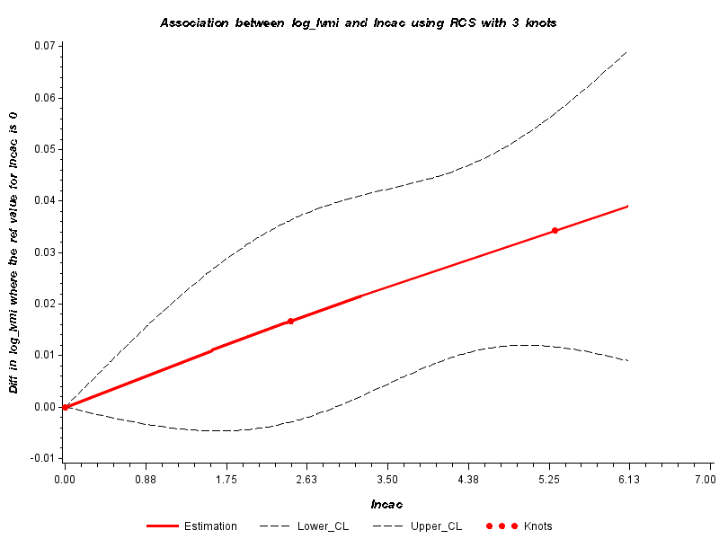
Log-transformed CAC by log-transformed LVMi (log(g/m²)) Test for non-linearity (P=0.89)

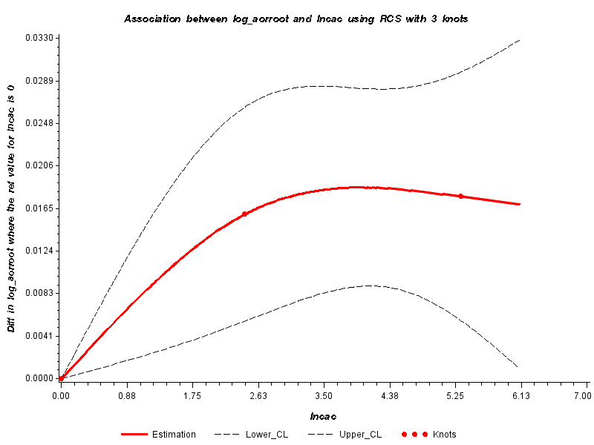
Log-transformed CAC by log-transformed AoR (log(cm))
Test for non-linearity (P=0.18)

Figure S2. Restricted cubic splines
Multivariable-adjusted restricted cubic splines of log-transformed CAC by log-transformed LVMi (log(g/m²)), log-transformed AoR (log(cm)) with knots placed at 50th, 75th and 95th percentile values.
Supplementary Figure S1

