Supplementary Material

1. The International Model for Policy Analysis of Agricultural Commodities and Trade (IMPACT) system of models

The IMPACT system of models links together the output of climate models, process-based crop simulation models, global hydrology models, and the IMPACT global economic model (Figure S1). Crop models use information on geographical distribution of the crops under study (maize, rice and wheat) as well as their water management (rainfed or irrigated) from the Spatial Production Allocation Model (SPAM).

The DSSAT model

This study uses the Decision Support System for Agrotechnology Transfer (DSSAT) process-based crop models (Jones et al 2003) to simulate the yield response of crops to baseline technologies and to the adoption of the CSA technologies. Process-based models like DSSAT rely on decades of accumulated research on agronomy, soil science, and crop physiology and allow to represent explicitly all the constituent processes (soil, water, plant, management practices and so forth) and facilitate the simulation of their interactions. DSSAT has been used for decades by researchers, extension workers, and decision-makers to improve agricultural practices at the farm level, and to assess regional effects of climatic variability (Singh et al 1992; Aggarwal et al 2000; Subash and Mohan 2012; Nelson et al 2010; Rosegrant et al 2014) and it is available at (<https://dssat.net/about>).

The SPAM model

The SPAM model uses crop suitability assessments, information regarding population density, and any other available prior knowledge regarding the geographical distribution of specific crops or crop systems to spatially allocate sub-national statistics of crop production and cropland data (period 2004-2006) at two levels of geographical disaggregation: 0.083 and 0.5-degree grid-cells. For each 0.5-degree SPAM grid cell (a square of approximately 50 by 50 kilometers at the equator), provides a database that catalogued the dominant management practices and input used by farmers (that is, varieties employed, application rates of inorganic fertilizers, organic amendment availability, and water management practices) and data on irrigation and soil properties. For further details see the model documentation (Wood-Sichra et al., 2016)

SPAM is downloadable from the IFPRI Dataverse at <https://dataverse.harvard.edu/dataset.xhtml?persistentId=doi:10.7910/DVN/DHXBJX> and the dedicated SPAM website at <http://mapspam.info/> .

The IMPACT model

At the core of the system of models there is IMPACT, the “International Model for Policy Analysis of Agricultural Commodities and Trade”. IMPACT is a partial-equilibrium economic model that simulates national and global markets of agricultural production, demand, and trade associated with 62 agricultural commodities across 159 countries.

IMPACT combines projections data for both population and income, with yields data simulated through crop models, estimates of water availability from water models, and estimates of changes in temperature and precipitation from climate model. Therefore, its outputs reflect changes that come from the interaction of both biophysical and economic factors.

Simulated changes in yields through the DSSAT crop modeling suite provide to IMPACT an estimate of the effects of temperature-changes on productivity; effects on water availability are captured through linked water models (Muller and Robertson 2014). The IMPACT model gives and receives feedback from three water models (global hydrologic model, water basin management model, and water allocation and stress model), which can reflect the impact of climate change or policy decisions on the hydrology, or water allocation, thereby allowing to simulate changes in water availability for irrigation and their effects on agricultural production. Agricultural production is specified by models of land supply, and by allocation of land (irrigated and rainfed) to crops. Production is modelled at sub-national level, across 320 regions called “food production units” or FPUs. Additionally, it receives information on yield responses from crop simulation models (e.g. DSSAT).

The main drivers of the baseline suite of IMPACT scenarios (i.e. BAU scenarios) are GDP, population, and intrinsic agricultural productivity growth (IPR). GDP growth is obtained from the OECD (Dellink et al 2017) and population growth from IIASA (2015). The choices of GDP and population growth are made to allow the IMPACT model to reproduce the Shared Socioeconomic Pathways (SSP scenarios) adopted by the Intergovernmental Panel on Climate Change Fifth Assessment Report (IPCC AR5). The intrinsic yield growth rates (IPRs) are based on past trends and expert opinion.

The IMPACT model takes into consideration population and GDP and income growth, changes in food availability and translates them into changes in the regional availability of kilocalories. The indicators of food security estimated through the IMPACT model are meant to capture the linkages between productivity, production and hunger, with a focus on calories availability. Therefore, the model does not pretend to capture all dimensions of food insecurity, which for instance include availability of micronutrients (not part of the IMPACT simulations). In IMPACT, the share of people at risk of hunger is calculated based on an empirical correlation between the share of undernourished people within the population and the relative availability of food (see pages 26 -28 in Robinson et al. 2015).The share of undernourished children under the age of five is based on the calculation of the average calorie availability per capita per day, women’s access to secondary education, the ratio of female to male life expectancy at birth, and health and sanitation (Smith and Haddad 2000; Robinson et al. 2015). It is an estimate of child wasting in terms of weight for age.

For extensive details on the equations at the core of the model, and information on data inputs especially population, GDP and yield growth (IPRs), refer to the IMPACT model documentation (Robinson et al 2015). IMPACT has a long record of applications and it has been employed in a wide range of analyses, from assessing the potential effects of climate change on global food production and nutrition (Nelson et al 2010; Springmann et al 2016) to explore linkages between agriculture production and food security at the national and regional levels (Sulser et al 2011; Jalloh et al 2013), to the assessment of economic effects of alternative mitigation policies (De Pinto et al 2016) and the global simulation of technology adoption (Rosegrant et al 2014).



*Figure S.1 The IMPACT system of models. Modified from Robinson et al. 2015*

1. Climate models

Two climate models are run under the representative concentration pathway (RCP) 8.5 RCP 8.5. The climate models, or Earth System Models (ESMs) as defined by IPCC AR5, are as follows:

* GFDL-ESM2M (Dunne et al. 2012)—designed and maintained by the US National Oceanic and Atmospheric Administration’s Geophysical Fluid Dynamic Laboratory (GFDL) ([www.gfdl.noaa.gov/earth-system-model](http://www.gfdl.noaa.gov/earth-system-model))
* HadGEM2-ES (Jones et al. 2011)—the Hadley Centre’s Global Environment Model, version 2 ([www.metoffice.gov.uk/research/modelling-systems/unified-model/climate-models/hadgem2](http://www.metoffice.gov.uk/research/modelling-systems/unified-model/climate-models/hadgem2)

Table S1 shows the annual difference in average global precipitation and maximum and minimum temperatures between a reference climate, representative of conditions around the year 2000, and two climate change scenarios obtained by running the GFDL, and HadGEM earth system models under RCP 8.5. Data are for the year 2050.

*Table S.1 Annual change in average precipitation and temperature. GFDL and HadGEM compared to no climate change climate.*

|  |  |  |  |  |  |  |  |  |
| --- | --- | --- | --- | --- | --- | --- | --- | --- |
|  | ∆ total precipitation (mm/year) | |  | ∆ average temperature maximum (oC) | |  | ∆ average temperature minimum (oC) | |
|  | GFDL | HadGEM |  | GFDL | HadGEM |  | GFDL | HadGEM |
| Agricultural Area | 1.1 | 44.8 |  | 2.0 | 3.3 |  | 1.9 | 3.2 |
| Land Area | 13.9 | 29.4 |  | 2.1 | 3.6 |  | 2.1 | 3.7 |

Source*:* Authors.

Notes*:* a) The data area shown for values either over the agricultural land, or across the total land of the country. GFDL = Geophysical Fluid Dynamic Laboratory; HadGEM = Hadley Centre’s Global Environment Model; b) RCP data was downloaded from the RCP Database, version 2.0.5 (IIASA 2015); RCP 8.5: Riahi, Gruebler, and Nakicenovic (2007). To represent some of the uncertainty inherent in climate change projections, we use two climate change scenarios. The scenarios are based on results from running two climate models under a Representative Concentration Pathway (RCP) of 8.5 watts/m2 (Meinshausen et al. 2011), each of which is combined with the IPCC’s “middle of the road” GDP and population growth scenario (Shared Socioeconomic Pathway 2, or SSP2) (O’Neill et al. 2014).

1. DSSAT Calibration

DSSAT’s simulation performance of three major crops was calibrated by adjusting model parameter and inputs so that DSSAT yields can be comparable with the grid-level SPAM yields, which are derived from FAO’s country-level statistics in 2005.

First, one model parameter (SLPF, a growth reduction factor on a scale of 0 to 1) and two model inputs (planting density and N fertilization rate) were used for DSSAT calibration. The former was chosen to account for the effects of the deficiencies of P and K and micro-nutrients on daily plant growth rate that DSSAT is not capable of modeling yet.

Second, a value of each parameter or input was changed using three levels. For example, the SLPF was assigned a value of either 0.6, 0.8 or 1.0, whereas planting density and N rate were assigned either the original values derived from the DSSAT input database or 50% or 150% of these original values. These levels resulted in total 27 possible combinations of model parameter and input values for each grid cell.

Third, SPAM yields were considered as “field-observed” yields for the calibration of DSSAT. These yields are represented as harvested production and are expressed as fresh matter weight. They were therefore converted into dry-matter weight to be used in DSSAT. For this conversion, we accounted for harvesting and threshing losses defined as production minus harvesting and threshing losses per unit of harvested area and corrected for grain moisture contents (15.5, 13.5, and 13% as grain moisture contents for maize, wheat, and rice, respectively).

Finally, DSSAT was ran to simulate yields corresponding to all these combinations for the five continuous years of 2001 to 2005, followed by selecting the best combination of parameter and input levels that gave the lowest relative difference (RD) between simulated and observed yields (Yieldsim and Yieldobs):

Where $RD$ indicates relative difference, $i$ is an identification number of each 0.5-degree grid cell, and ${\overline{Yield}}^{i}$ is a five year-average of yield for a grid cell $i$.

However, the value of RD at each grid cell can be a large number (either positive or negative) even with alternative combination of parameter values in DSSAT, especially when DSSAT simulates very low crop yields. To avoid this problem, RD were calculated only from grid cells where simulated yields are higher than minimum countries-wide yields reported in SPAM (Table S2). Then, a statistical test (Leys et al 2013) was conducted to identify outlier grid cells (both irrigated and rainfed, for each crop).

*Table S.2 Minimum yields used in this calibration*

|  |  |  |
| --- | --- | --- |
| Crop | Water Management | Yield (dry matter Mg ha-1) |
| Wheat | Irrigated | 0.35 |
| Wheat | Rainfed | 0.35 |
| Maize | Irrigated | 0.61 |
| Maize | Rainfed | 0.26 |
| Rice | Irrigated | 0.95 |
| Rice | Rainfed | 0.65 |

This test, based on RD, identifies those cells for which DSSAT is not able to simulate yields comparable to the “observed” SPAM yields. These outliers were eliminated from analysis.

After the calibration process, 42%, 45% and 47% of the total number of rice, wheat and maize pixels are retained, respectively. Regional representation is affected differently by this process. For maize cropland, about 80% of the original pixels belonging to the North America region are maintained after filtering, but only 20% are kept across sub-Saharan Africa. For rice, East Asia pacific is one of the regions with the largest number of retained pixels, with 54% of the total, whereas the number drops to 24% for Europe and central Asia (ECA). For wheat, 46% of the pixels survive the filtering process across South Asia and 30% in the Eastern Europe and central Asia region.

When the simulated yields after calibration were aggregated into country boundaries and compared to FAO’s country-level yields, simulated yields for maize and wheat are comparable to FAO yields with very good fits (R2 = 0.87 and 0.75 respectively); the fit for rice is lower (R2 = 0.63) is still acceptable (Figure S2).

|  |
| --- |
|  |
|  |
|  |

*Figure S.2 DSSAT calibration results summarized for each country in the World. Both FAO and DSSAT yields are reported as a unit of dry-matter weight.*

It must be noted that only monoculture systems were simulated. We acknowledge that this is a stylized representation of reality, which should be addressed in future research through inclusion of intercropping and rotation schemes.

Out of the total 320 food production units used in IMPACT, the loss of pixels results in the loss of maize data for 17 FPUs, rice data for 16 FPUs and wheat data for 14 FPUs (Figure S3).







*Figure S.3 Distribution of cropland across IMPACT FPUs. Red line indicates FPUs not included in this modeling after DSSAT calibration.*

By comparing the harvested area and production data from these FPUs to the world totals for harvested area and production in 2015, we see that the lost FPUs for maize accounts for 0.7% of global harvested area and 0.5% of global production. For rice, the dropped FPUs account for 0.6% of global harvested area and 1.3% of global production, and for wheat, the dropped FPUs account for 1.6 % of global harvested area and 2.3% of global production.

1. Assessment of GHG emissions

Yield responses associated with adoption of CSA practices together with harvested areas calculated in IMPACT were used to compute GHG emissions. Temporal changes in soil carbon stocks were simulated in the CENTURY soil organic matter (SOM) module embedded into DSSAT. Direct N2O emissions (kg N2O-N) were also simulated in DSSAT by modifying the source codes to model denitrification processes. The modifications ensured that our estimates of direct N2O N2O emissions are comparable to those calculated using the 2006 IPCC emission factors, where 1% of N additions from mineral fertilizers, organic amendments and crop residues, 1% of N mineralized from soil organic matter, and ~0.7% of N from residue inputs are converted into N2O emissions. For flooded rice soils, the IPCC default emission factor is 0.3% of applied N is used.

For rice production systems, methane (CH4) emissions (kg CH4) from rice fields were calculated by combining DSSAT-simulated rice biomass with IPCC Tier 1 method’s emission coefficients proposed by Yan et al. 2009 43. Parameters of the Tier 1 method include baseline emission factor (1.3), scaling factors for continuous flooding (1) and multiple drainage (0.52), simulating effect of rice straw (0.59), and conversion factor of farmyard manure (0.14). These were combined with the simulated outputs of rice yields and straws, days in growing season, and soil organic carbon content and the input data of manure application rate. Finally, all GHG emissions were converted into tons of CO2 e using global warming potential for 100-yr time horizon of each GHG (Table S.3).

*Table S.3 GWP conversions*

|  |  |  |  |  |
| --- | --- | --- | --- | --- |
| GHG | From Units | To Units | Conversion | GWP based on AR5 |
| dSOC (net CO2 sequestration) | kgC | kgCO2eq | kgC * (-1 * 44 / 12)*GWP | 1 |
| CH4 a | kgC | kgCO2eq | kgC * (16/12)*GWP | 28 |
| N2O | kgN | kgCO2eq | kgN * (44/28)*GWP | 265 |

a In this study, CH4 was estimated as an unit of kgCH4 (Yan et al. 2009).

1. Evaluation of modeled yields and GHG emissions

The reliability of model simulations for both productivity and emissions was tested by comparing our results to data from worldwide field experiments, through an extensive literature review. We looked at changes in yields reported from adoption of the technologies used in this study as well as absolute values and changes in GHG emissions under BAU and/or relative changes of GHG emissions under CSA practices. Table S4 shows that the magnitude and direction of simulated results is comparable to results in the literature.

*Table S.4 Comparison of literature based on field experiments with simulated results. The latter is statistically summarized by aggregating outputs, which are obtained from the first 10 yrs of simulations at each grid cell, for each country based on ISO3 code. Note that values reported in literature might not have all statistics (e.g. median, minimum, or maximum).*

|  |  |  |  |  |  |  |  |
| --- | --- | --- | --- | --- | --- | --- | --- |
| **Yields** | | | | | | | |
| **Crop** | **Technology** | **Source** | **Region** |  | | **Changes in yields in %** | |
| Median reported  (min, max) | Median  Simulated  (min, max) |
| Maize | isfm | Chivenge et al. (2009) 26 | Kenya | 32 (-20, 40) | 40 (-6.2, 140) |
| Wheat | isfm | Agegnehu et al. (2014) 27 | Ethiopia | (68, 129)* | 6 (-0.2, 51) |
| Wheat | no till | Erenstein (2009) 28 | Indo-Gangetic plains | (5, 7)* | 11 (-11, 221) |
| Maize/wheat | no till | Hobbs et al. (2008); Govaerts et al. (2005) 29,30 | Mexico | (8, 30)* | 0.8 (-16, 145) |
| Maize | no till | Ito et al. (2007) 31 | Ethiopia | 10 ** | -7.5 (-31, 184) |
| Wheat | no till | Ito et al. (2007) | Ethiopia | 9 ** | 0 (-12, 9) |
| Maize | no till | Ito et al. (2007) | Malawi | -1.5 (avg) ** | -3.8 (-10, 5.4) |
| Maize | no till | Ito et al. (2007) | Mozambique | 270 (avg) ** | -3.8 (-8.9, 29) |
| Rice | NUE1 | Huda et al. (2016) (35) | Bangladesh |  | | (29, 40)* | 5 (-36, 119) |
| Rice | NUE1 | Bandaogo et al. (2015) 32 | Burkina Faso | (5, 12)* | -17 (-48, 169) |
| **CO2** | | | | | | | |
| **Crop** | **Technology** | **Source** | **Region** | **SOC accumulation in kg C ha-1** | |  | |
| Median Obs (min, max) | Median Sim  (min, max) |
| Wheat | Noti | Powlson et al. (2014) 33 | indo-gangetic plains | 300 ** | 30 (-155, 157) |
| All crops | Noti | Denef et al. (2011); Ogle et al. (2005, 2010); Six et al. (2004); West and Marland (2002) 34–38 | USA | (10, 700)* | 40 (-521, 560) |
| All crops | isfm | Denef et al. (2011) (45) | USA | 400 ** | 25 (-199, 624) |
| Maize | no till | Beheydt et al. (2008) 39 | Belgium | 600 ** | 114 (-112, 308) |
| **CH4** | | | | | | | |
| **Crop** | **Technology** | **Source** | **Region** | **Emission in kg CH4 ha-1** | | **Changes of Emission in %** | |
| Median Obs (min, max) | Median Sim  (min, max) | Median Obs (min, max) | Median Sim  (min, max) |
| Rice | Base | Wang et al (1993); Wang M. (1995); Lu et al. (1995) 40–42 | China | 340 (50, 1,550) | 325 (63, 902) |  |  |
| Rice | Base | Adhya et al. (1994) 43 | India | 200 (50, 300) | 300 (77, 1,133) |  |  |
| Rice | Base | Nugroho et al (1994) 44 | Indonesia | 310 (140, 470) | 100 (74, 465) |  |  |
| Rice | Base | Holzapfel-Pschorn & Seiler  1986; Schütz et al. 1989 45,46 | Italy | (120, 770)* | 241 (140, 1,069) |  |  |
| Rice | Base | Shin Y. K. et al 1995; 47 | Korea | 330 (90, 630) | 279 (84, 409) |  |  |
|  |  | Metra-C.et al.1995 48 | Philippines | 270 (100, 870) | 98 (72, 3,578) |  |  |
| Rice | Base | Murase et al. 1994 49 | Thailand | 480 (340, 860) | 313 (78, 471) |  |  |
| Rice | Base | Lindau et al 1991;  Cicerone et al, 1992;  Sass & Fisher 1995 50–52 | USA | 250 (10, 480) | 530 (373, 650) |  |  |
| **N2O** | | | | | | | |
| **Crop** | **Technology** | **Source** | **Region** | **Emission in kg N2O-N ha-1** | | **Changes of Emission in %** | |
| Median Obs (min, max) | Median Sim  (min, max) | Median Obs (min, max) | Median Sim  (min, max) |
| Rice | Base | Cai et al (1999); Xiong et al (2002); Khalil et al (1998); Zheng et al (2000) 54–57 | China | (0.1, 4.4)* | 1.2 (0.1, 20) |  |  |
| Rice | Base | Kumar et al (2000); Majumdar et al (2000); Pathak et al (2002) | India | (0.03, 0.9)* | 1.6 (0, 14) |  |  |
| Rice | Base | Suratno et al (1998) 58–61 | Indonesia | (0.3, 1.1)* | 1.5 (0, 14) |  |  |
| Rice | Base | Yagi et al (1996) 62 | Japan | (0.03, 0.07)* | 1.1 (0.2, 12) |  |  |
| Rice | Base | Bronson et al (1997) 63 | Philippines | (0.06, 0.6)* | 1.4 (0, 8) |  |  |
| Rice | NUEa | Gaihre et al. 2015 65 | Bangladesh |  |  | (-84, -61)* | 14 (-93, 406) |
| maize | isfm | Muhammad et al. 2011 66 | field experiment (Australia) |  |  | (34, 42)* | -57 (-98, 11) |
| All crops | isfm | Frimpong et al. 2010 67 | microcosm experiment Ghana |  |  | (-8, 270)* | 18 (-5.4, 314) |

a NUE in our simulations uses 70% of N fertilizer rates applied in the business-as-usual scenario.

* Median was not reported in these studies

** No range available in these studies

1. Results – production, area, prices, food security

*Table S.5 Changes in production compared to BAU. Lower and upper-bound scenario 2010–2030*

|  |  |  |  |  |  |  |  |
| --- | --- | --- | --- | --- | --- | --- | --- |
|  |  | **Maize** | | **Rice** | | **Wheat** | |
| **Scenario** | Participation Rate | gfdl | hgem | gfdl | hgem | gfdl | hgem |
| lower bound | 0.4 | 0.75% | 0.82% | 1.32% | 1.36% | 0.44% | 0.46% |
| 0.5 | 0.50% | 0.58% | 0.57% | 0.59% | 0.24% | 0.23% |
| 0.7 | 0.37% | 0.44% | 0.35% | 0.33% | 0.15% | 0.14% |
| 0.9 | 0.29% | 0.37% | 0.28% | 0.26% | 0.11% | 0.11% |
| 1 | 0.26% | 0.32% | 0.26% | 0.24% | 0.10% | 0.10% |
| upper bound | 0.4 | 0.81% | 0.87% | 1.59% | 1.62% | 0.50% | 0.53% |
| 0.5 | 0.96% | 1.03% | 1.95% | 1.98% | 0.60% | 0.64% |
| 0.7 | 1.18% | 1.28% | 2.58% | 2.63% | 0.78% | 0.83% |
| 0.9 | 1.32% | 1.42% | 3.15% | 3.22% | 0.92% | 0.99% |
| 1 | 1.38% | 1.47% | 3.43% | 3.50% | 0.99% | 1.05% |

*Table S.6 Changes in prices compared to BAU. Lower and upper-bound scenario 2010–2030*

|  |  |  |  |  |  |  |  |
| --- | --- | --- | --- | --- | --- | --- | --- |
|  |  | **Maize** | | **Rice** | | **Wheat** | |
| **Scenario** | Participation Rate | gfdl | hgem | gfdl | hgem | gfdl | hgem |
| lower bound | 0.4 | -1.58% | -1.58% | -4.63% | -4.82% | -1.34% | -1.48% |
| 0.5 | -1.17% | -1.17% | -2.05% | -2.12% | -0.72% | -0.80% |
| 0.7 | -0.88% | -0.84% | -1.27% | -1.20% | -0.45% | -0.49% |
| 0.9 | -0.71% | -0.68% | -1.01% | -0.94% | -0.34% | -0.38% |
| 1 | -0.62% | -0.57% | -0.93% | -0.89% | -0.31% | -0.35% |
| upper bound | 0.4 | -1.64% | -1.65% | -5.57% | -5.68% | -1.55% | -1.69% |
| 0.5 | -1.93% | -1.95% | -6.76% | -6.90% | -1.85% | -2.04% |
| 0.7 | -2.28% | -2.31% | -8.82% | -9.02% | -2.39% | -2.60% |
| 0.9 | -2.46% | -2.51% | -10.64% | -10.90% | -2.81% | -3.06% |
| 1 | -2.53% | -2.58% | -11.50% | -11.77% | -3.00% | -3.25% |

*Table S.7 Changes in undernourished children. Lower and upper-bound scenario 2010–2030*

|  |  |  |  |  |
| --- | --- | --- | --- | --- |
|  | **Lower bound** | | **Upper bound** | |
| **Participation Rate** | gfdl | hgem | gfdl | hgem |
| 0.4 | -0.36% | -0.37% | -0.42% | -0.43% |
| 0.5 | -0.17% | -0.18% | -0.51% | -0.52% |
| 0.7 | -0.11% | -0.11% | -0.66% | -0.68% |
| 0.9 | -0.09% | -0.08% | -0.80% | -0.82% |
| 1 | -0.08% | -0.08% | -0.86% | -0.88% |

*Table S.8 Changes in population at risk of hunger. Lower and upper-bound scenario 2010–2030*

|  |  |  |  |  |
| --- | --- | --- | --- | --- |
|  | **Lower bound** | | **Upper bound** | |
| **Participation Rate** | gfdl | hgem | gfdl | hgem |
| 0.4 | -1.94% | -2.01% | -2.29% | -2.34% |
| 0.5 | -0.94% | -0.98% | -2.76% | -2.84% |
| 0.7 | -0.61% | -0.59% | -3.59% | -3.68% |
| 0.9 | -0.47% | -0.46% | -4.29% | -4.42% |
| 1 | -0.43% | -0.42% | -4.62% | -4.75% |

*Figures S.4 - 8 Changes in harvested area by commodity and regions. Lower and upper-bound scenario 2010–2030*

*Figure S.4 – Participation rate (or adoption are as in the figure) of 0.4%*

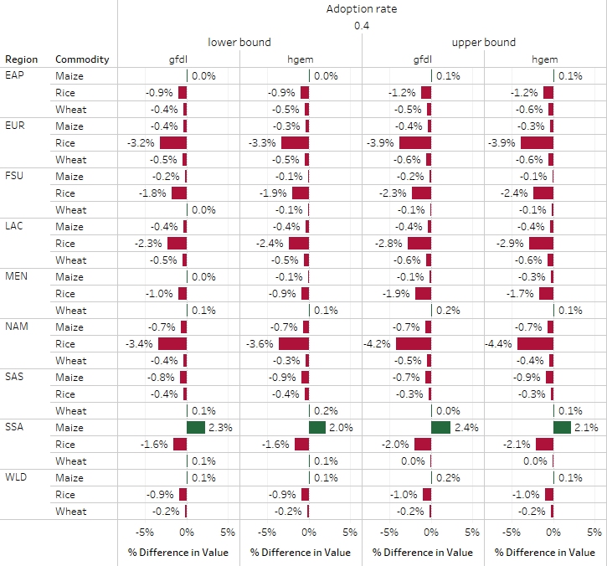

*Figure S.5 - Participation rate (or adoption are as in the figure) of 0.5%*

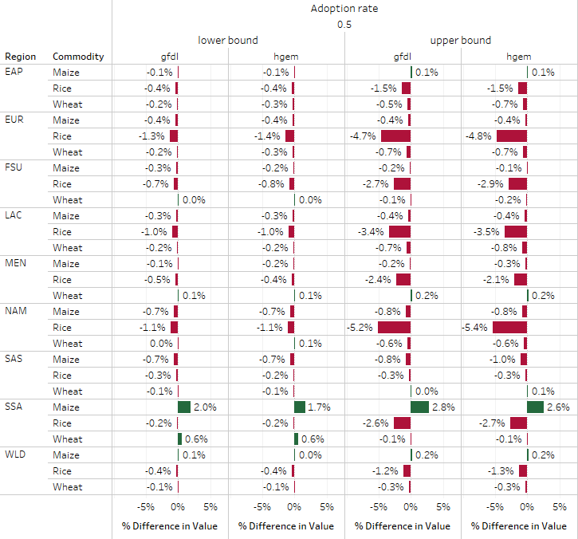

*Figure S.6 - Participation rate (or adoption are as in the figure) of 0.7%*

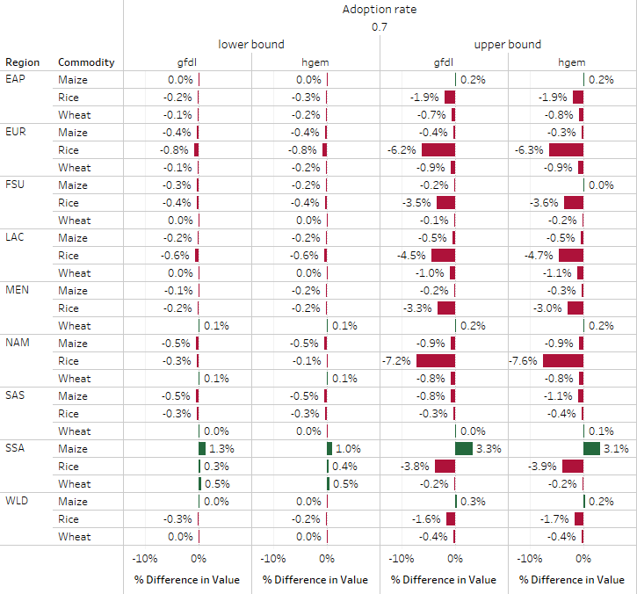

*Figure S.7 - Participation rate (or adoption are as in the figure) of 0.9%*

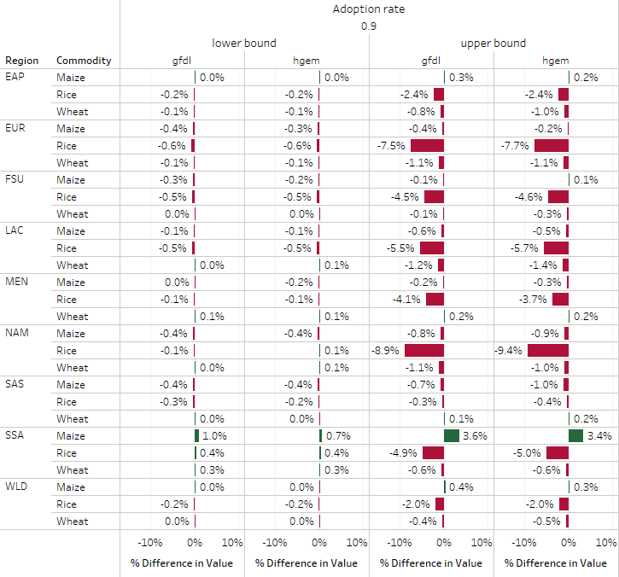

*Figure S.8 - Participation rate (or adoption are as in the figure) of 1%*

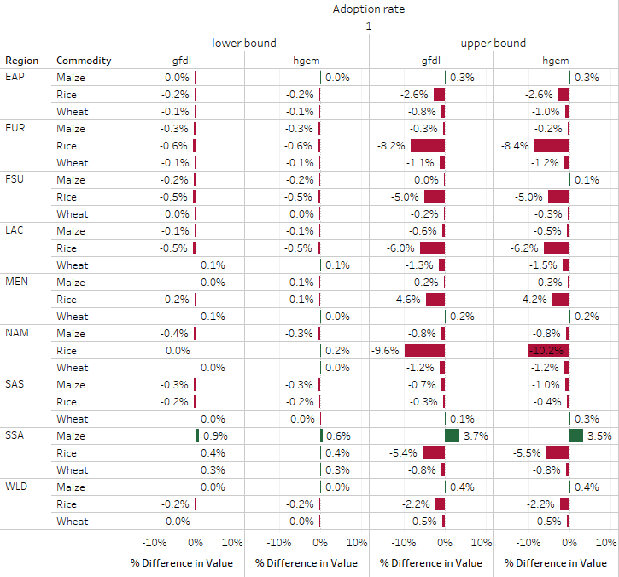

*Source: authors*

*Note 1: EAP = East Asia and Pacific; ECA = Eastern Europe and Central Asia; LAC = Latin America and Caribbean; MEN = Middle East and North Africa; NAM = North America; SAS = South Asia; SSA = Africa south of the Sahara; WEU = Western Europe*

*Note 2: Adoption rate= participation rate*

1. GHG Emissions compared to base, country results

Changes in emissions simulated in DSSAT, by county, are stored in an excel file hosted at this public GitHub repository: <https://github.com/IFPRI/Frontiers-FLR>

**References**

Adhya, T. K. et al. Methane emission from flooded rice fields under irrigated conditions. Biol. Fertil. Soils 18, 245–248 (1994).

Adhya, T. K., Linquist, B., Searchinger, T., Wassmann, R. & Yan, X. Wetting and Drying: reducing Greenhouse Gas Emissions and Saving Water from Rice Production. vol. Installmen (2014).

Agegnehu, G., Vanbeek, C. & Bird, M. I. Influence of integrated soil fertility management in wheat and tef productivity and soil chemical properties in the highland tropical environment. J. Soil Sci. Plant Nutr. 14, 532–545 (2014).

Aggarwal, P. K. et al. Analysis of Yield Trends of the Rice-Wheat System in North-Western India. Outlook Agric. 29, 259–268 (2000).

Ainsworth, E. A. & Long, S. P. What have we learned from 15 years of free-air CO2 enrichment (FACE)? A meta-analytic review of the responses of photosynthesis, canopy properties and plant production to rising CO2. New Phytol. 165, 351–372 (2005).

Ainsworth, E. A. & Ort, D. R. How Do We Improve Crop Production in a Warming World? Plant Physiol. 154, 526–530 (2010).

Asseng, S. et al. Climate change impact and adaptation for wheat protein. Glob. Chang. Biol. 25, 155–173 (2019).

Bandaogo, A. et al. Effect of fertilizer deep placement with urea supergranule on nitrogen use efficiency of irrigated rice in Sourou Valley (Burkina Faso). Nutr. Cycl. Agroecosystems 102, 79–89 (2015).

Beheydt, D., Boeckx, P., Ahmed, H. P. & Van Cleemput, O. N(2)O emission from conventional and minimum-tilled soils. Biol. Fertil. Soils 44, 863–873 (2008).

Boote, K. J., Allen Jr., L. H., Vara Prasad, P. V. & Jones, J. W. Testing effects of climate change in crop models. in Handbook of Climate Change and Agroecosystems (eds. Hillel, D. & Rosenzweig, C.) 109–157 (2011).

Bronson, K. F., Neue, H.-U., Abao, E. B. & Singh, U. Automated Chamber Measurements of Methane and Nitrous Oxide Flux in a Flooded Rice Soil: I. Residue, Nitrogen, and Water Management. Soil Sci. Soc. Am. J. 61, 981 (1997).

Cai, Z. C. et al. Measurements of CH4 and N2O emissions from rice paddies in Fengqiu, China. Soil Sci. Plant Nutr. 45, 1–13 (1999).

Cenacchi, N. et al. Climate change, agriculture, and adaptation in the Republic of Korea to 2050: An integrated assessment. (2016).

Chivenge, P. et al. Organic and Mineral Input Management to Enhance Crop Productivity in Central Kenya. Agron. J. 101, 1266–1275 (2009).

Cicerone, R. J., Delwiche, C. C., Tyler, S. C. & Zimmerman, P. R. Methane emissions from California rice paddies with varied treatments. Global Biogeochem. Cycles 6, 233–248 (1992).

De Pinto, A. et al. Low Emission Development Strategies in Agriculture. An Agriculture, Forestry, and Other Land Uses (AFOLU) Perspective. World Dev. 87, 180–203 (2016).

Dellink, R., Chateau, J., Lanzi, E. & Magné, B. Long-term economic growth projections in the Shared Socioeconomic Pathways. Glob. Environ. Chang. 42, 200–214 (2017).

Denef, K., Archibeque, S. & Paustian, K. Greenhouse Gas Emissions from U . S . Agriculture and Forestry : A Review of Emission Sources , Controlling Factors , and Mitigation Potential. Interim report to USDA under Contract #GS23F8182H (2011).

Deryng, D. et al. Regional disparities in the beneficial effects of rising CO 2 concentrations on crop water productivity. Nat. Clim. Chang. 6, 786–790 (2016).

Dong, N. M. et al. Effects of alternating wetting and drying versus continuous flooding on fertilizer nitrogen fate in rice fields in the Mekong Delta, Vietnam. Soil Biol. Biochem. 47, 166–174 (2012).

Dunne, J. P. et al. GFDL’s ESM2 Global Coupled Climate-Carbon Earth System Models. Part I: Physical Formulation and Baseline Simulation Characteristics. J. Clim. 25, 6646–6665 (2012).

Erenstein, O. Zero Tillage in the Rice-Wheat Systems of the Indo-Gangetic Plains A Review of Impacts and Sustainability Implications. vol. 00916 (2009).

FAO. Module 1: Why Climate-Smart Agriculture, Forestry and Fisheries. in Climate Smart Agriculture Sourcebook (Food and Agriculture Organization of the United Nations (FAO), 2013).

Farooq, U., Iqbal, M. & Bashir, A. Cost and Revenue Statistics of Paddy Production: Farmer’s Perspective. Int. J. Agric. Biol. 1, (1999).

Frimpong, K. A. & Baggs, E. M. Do combined applications of crop residues and inorganic fertilizer lower emission of N2O from soil? Soil Use Manag. 26, 412–424 (2010).

Gaihre, Y. K. et al. Impacts of urea deep placement on nitrous oxide and nitric oxide emissions from rice fields in Bangladesh. Geoderma 259, 370–379 (2015).

Gerber, P. J. et al. Technical options for the mitigation of direct methane and nitrous oxide emissions from livestock: a review. Animal : an international journal of animal bioscience vol. 7 Suppl 2 220–234 (2013).

Govaerts, B., Sayre, K. D. & Deckers, J. Stable High Yields with Zero Tillage and Permanent Bed Planting? F. Crop. Res. 94, 33–42 (2005).

Greer, C. A. et al. Sample costs to produce rice. http://cecolusa.ucdavis.edu/files/153082.pdf (2012).

Hachigonta, S., Nelson, G. C., Thomas, T. S. & Sibanda, L. M. Southern African Agriculture and Climate Change: A Comprehensive Analysis. (2013).

Hasegawa, T. et al. Risk of increased food insecurity under stringent global climate change mitigation policy. Nat. Clim. Chang. 8, 699–703 (2018).

Hobbs, P. R., Sayre, K. & Gupta, R. The Role of Conservation Agriculture in Sustainable Agriculture. Philos. Trans. R. Soc. B-Biological Sci. 363, 543–555 (2008).

Holzapfel-Pschorn, A. & Seiler, W. Methane emission during a cultivation period from an Italian rice paddy. J. Geophys. Res. 91, 11803 (1986).

Huda, A. et al. Floodwater ammonium, nitrogen use efficiency and rice yields with fertilizer deep placement and alternate wetting and drying under triple rice cropping systems. Nutr. Cycl. Agroecosystems 104, 53–66 (2016).

IIASA. RCP database. https://tntcat.iiasa.ac.at/RcpDb (2015).

IIASA. SSP Database. (2013).

Ito, M., Matsumoto, T. & Quinones, M. A. Conservation Tillage Practice in sub-Saharan Africa: The Experience of Sasakawa Global 2000. Crop Prot. 26, 417–423 (2007).

Jalloh, A., Nelson, G. C., Thomas, T. S., Zougmoré, R. & Roy-Macauley, H. West African Agriculture and Climate Change: A Comprehensive Analysis. (2013).

Jones, A. G., Scullion, J., Ostle, N., Levy, P. E. & Gwynn-Jones, D. Completing the FACE of elevated CO2 research. Environ. Int. 73, 252–258 (2014).

Jones, C. D. et al. The HadGEM2-ES Implementation of CMIP5 Centennial Simulations. Geosci. Model Dev. 4, 543–570 (2011).

Jones, J. W. et al. The DSSAT Cropping System Model. Eur. J. Agron. 18, 235–265 (2003).

Khalil, M. A. K. et al. Emissions of methane, nitrous oxide, and other trace gases from rice fields in China. J. Geophys. Res. Atmos. 103, 25241–25250 (1998).

Kumar, U., Jain, M. C., Pathak, H., Kumar, S. & Majumdar, D. Nitrous oxide emission from different fertilizers and its mitigation by nitrification inhibitors in irrigated rice. Biol. Fertil. Soils 32, 474–478 (2000).

Kürschner, E. et al. SLE Publication Series – S241 Water Saving in Rice Production– Dissemination, Adoption and Short Term Impacts of Alternate Wetting and Drying (AWD) in Bangladesh. SLE Publication Series http://edoc.hu-berlin.de/series/sle/241/PDF/241.pdf (2010).

Lampayan, R. M. et al. Adoption of water saving technologies in rice production in the Philippines. Transition in Agriculture for Enhancing Water Productivity (2003).

Lampayan, R. M. Water Saving Work Group. Development, dissemination, and adoption of technologies to help farmers cope with water scarcity. (2012).

Lampayan, R. M., Rejesus, R. M., Singleton, G. R. & Bouman, B. A. M. Adoption and economics of alternate wetting and drying water management for irrigated lowland rice. F. Crop. Res. 170, 95–108 (2015).

Lampayan, R. Smart Water Techniques for Rice. in (European Initiative for Agricultural Research for Development, 2013).

Leakey, A. D. B. et al. Elevated CO2 effects on plant carbon, nitrogen, and water relations: six important lessons from FACE. J. Exp. Bot. 60, 2859–2876 (2009).

Leys, C., Ley, C., Klein, O., Bernard, P. & Licata, L. Detecting outliers: Do not use standard deviation around the mean, use absolute deviation around the median. J. Exp. Soc. Psychol. 49, 764–766 (2013).

Lindau, C. W., Bollich, P. K., Delaune, R. D., Patrick, W. H. & Law, V. J. Effect of Urea Fertilizer and Environmental-Factors On Ch4 Emissions From a Louisiana, Usa Rice Field . Plant Soil 136, 195–203 (1991).

Lu, W., Chen, W., Guo, W. & Duan, B. Emission of Methane from the Rice Field Affected by Irrigation. in The Planning Meeting of Methane Emission from Rice Field 19–26 (China National Rice Reserach Institute, 1995).

Majumdar, D., Kumar, S., Pathak, H., Jain, M. . & Kumar, U. Reducing nitrous oxide emission from an irrigated rice field of North India with nitrification inhibitors. Agric. Ecosyst. Environ. 81, 163–169 (2000).

Meinshausen, M. et al. The RCP Greenhouse Gas Concentrations and Their Extensions from 1765 to 2300. Clim. Change 109, 213–241 (2011).

Metra-Corton, T., Bajita, J. B., Asisk, C. A., Pamplona, R. R. & Salamanca. Methane emissions from an irrigated rice field. (1995).

Muhammad, W., Vaughan, S. M., Dalal, R. C. & Menzies, N. W. Crop residues and fertilizer nitrogen influence residue decomposition and nitrous oxide emission from a Vertisol. Biol. Fertil. Soils 47, 15–23 (2011).

Muller, C. & Robertson, R. D. Projecting future crop productivity for global economic modeling. Agric. Econ. 45, 37–50 (2014).

Murase, J. et al. Methane emission from plots with differences in fertilizer application in thai paddy fields. Soil Sci. Plant Nutr. 40, 63–71 (1994).

Myhre, G. et al. Anthropogenic and natural radiative forcing. in Climate Change 2013 the Physical Science Basis: Contribution of Working Group I to the Fifth Assessment Report of the Intergovernmental Panel on Climate Change (eds. Stocker, T. F. et al.) (Cambridge University Press, 2013). doi:10.1017/CBO9781107415324.018.

Nelson, G. C. et al. Agriculture and climate change in global scenarios: Why don’t the models agree. Agric. Econ. (United Kingdom) 45, 85–101 (2014).

Nelson, G. C. et al. Food Security, Farming, and Climate Change to 2050: scenarios, results, policy options. Research Monograph (2010). doi:10.1111/an.1995.36.5.41.

Nugroho, S. G. et al. Effect of intermittent irrigation on methane emission from an indonesian paddy field. Soil Sci. Plant Nutr. 40, 609–615 (1994).

O’Neill, B. C. et al. A new scenario framework for climate change research: the concept of shared socioeconomic pathways. Clim. Change 122, 387–400 (2014).

Ogle, S. M., Archibeque, S. L., Gurung, R. & Paustian, K. Report on GHG Mitigation Literature Review for Agricultural Systems. (2010).

Ogle, S. M., Breidt, F. J. & Paustian, K. Agricultural Management Impacts on Soil Organic Carbon Storage Under Moist and Dry Climatic Conditions of Temperate and Tropical Regions. Biogeochemistry 72, 87–121 (2005).

Palis, F. G. et al. Farmer adoption of controlled irrigation in rice: a case study in Canarem, Victoria, Tarlac. Philipp. J. Crop Sci. 29, 3–12 (2004).

Pandey, A. et al. Organic matter and water management strategies to reduce methane and nitrous oxide emissions from rice paddies in Vietnam. Agric. Ecosyst. Environ. 196, 137–146 (2014).

Pathak, H. et al. Emission of nitrous-oxide from rice-wheat systems of indo-gangetic plains of India. Environ. Monit. Assess. 77, 163–178 (2002).

Perret, S.-R., Saringkarn, P., Jourdain, D. & Babel, M. S. Can rice farmers pay irrigation costs? An investigation of irrigation supply costs and use value in a case study scheme in Thailand. Cah. Agric. 22, 385–392 (2013).

Powlson, D. S. et al. Limited potential of no-till agriculture for climate change mitigation. Nat. Clim. Chang. 4, 678–683 (2014).

Prentice, C. et al. The carbon cycle and atmospheric carbon dioxide. in Climate Change 2001: The Scientific Basis. Contributions of working group I to the third assessment report of the intergovernmental panel on climate change (ed. . J. T. Houghton, Y. Ding, D. J. Griggs, M. Noguer, P. J. Van der Linder, X. Dai, K. M. & C. A. J.) (Cambridge, UK: Cambridge University Press., 2001). doi:10.1256/004316502320517344.

Pritchard, S. G. & Amthor, J. S. Crops and environmental change: an introduction to effects of global warming, increasing atmospheric CO2 and O3 concentrations, and soil salinization on crop physiology and yield. (New York: Food Products Press, 2005).

Reicosky, D. C., Lindstrom, M. J., Schumacher, T. E., Lobb, D. A. & Malo, D. D. Tillage-induced CO2 loss across an eroded landscape. Soil Tillage Res. 81, 183–194 (2005).

Rejesus, R. M., Palis, F. G., Rodriguez, D. G. P., Lampayan, R. M. & Bouman, B. A. M. Impact of the alternate wetting and drying (AWD) water-saving irrigation technique: Evidence from rice producers in the Philippines. Food Policy 36, 280–288 (2011).

Riahi, K., Grübler, A. & Nakicenovic, N. Scenarios of long-term socio-economic and environmental development under climate stabilization. Technol. Forecast. Soc. Change 74, 887–935 (2007).

Robinson, S. et al. The International Model for Policy Analysis of Agricultural Commodities and Trade (IMPACT): Model description for version 3. vol. 1483 (2015).

Rosegrant, M. W. Biofuels and Grain Prices: Impacts and Policy Responses. (2008).

Rosegrant, M. W. et al. Food Security in a World of Natural Resource Scarcity - The Role of Agricultural Technologies. (International Food Policy Research Institute (IFPRI), 2014).

Ruane, A. et al. Biophysical and economic implications for agriculture of +1.5° and +2.0°C global warming using AgMIP Coordinated Global and Regional Assessments. Clim. Res. 76, 17–39 (2018).

Sass, R. L. & Fisher, F. M. Methane Emissions from Texax Rice Fields: A Five Year Study. in Climate Change and Rice (eds. Peng, S., Ingram, K. T., Neue, H. U. & Ziska, L. H.) 46–59 (Springer-Verlag, 1995).

Schleussner, C. F. et al. Crop productivity changes in 1.5 °c and 2 °c worlds under climate sensitivity uncertainty. Environ. Res. Lett. 13, (2018).

Schütz, H., Holzapfel-Pschorn, A., Conrad, R., Rennenberg, H. & Seiler, W. A 3-year continuous record on the influence of daytime, season, and fertilizer treatment on methane emission rates from an Italian rice paddy. J. Geophys. Res. 94, 16405 (1989).

Sharkey, T. D., Bernacchi, C. J., Farquhar, G. D. & Singsaas, E. L. Fitting photosynthetic carbon dioxide response curves for C3 leaves. Plant, Cell Environ. 30, 1035–40 (2007).

Shin, Y. K., Yun, S. H. & Park, M. E. Estimation of Methane Emission by Water Management and Rice Straw Application in Paddy Soil in Korea. J. Korean Soc. Soil Sci. Fertil. 28, 261–65 (1995).

Singh, C. B., Aujla, T. S., Sandhu, B. S. & Khera, K. L. Effect of transplanting date and irrigation regime on growth, yield and water use in rice (Oryza sativa) in northern India. Indian J. Agric. Sci. 66, 137–141 (1996).

Singh, U. & Thornton, P. K. Using Crop Models for Sustainability and Environmental-Quality Assessment. Outlook Agric. 21, 209–218 (1992).

Six, J. et al. The Potential to Mitigate Global Warming with No-Tillage Management is only Realized when Practised in the Long Term. Glob. Chang. Biol. 10, 155–160 (2004).

Smith, P. et al. Agriculture, Forestry and Other Land Use (AFOLU). Clim. Chang. 2014 Mitig. Clim. Chang. Contrib. Work. Gr. III to Fifth Assess. Rep. Intergov. Panel Clim. Chang. [Edenhofer, O., R. Pichs-Madruga, Y. Sokona, E. Farahani, S. Kadner, K. Seyboth, A. Adler, 811–922 (2014) doi:10.1016/j.phrs.2011.03.002.

Springmann, M. et al. Global and regional health effects of future food production under climate change: A modelling study. The Lancet (2016) doi:10.1016/S0140-6736(15)01156-3.

Subash, N. & Mohan, H. S. R. Evaluation of the Impact of Climatic Trends and Variability in Rice-Wheat System Productivity Using Cropping System Model DSSAT Over the Indo-Gangetic Plains of India. Agric. For. Meteorol. 164, 71–81 (2012).

Sulser, T. B., Nestorova, B., Rosegrant, M. W. & van Rheenen, T. The future role of agriculture in the Arab region’s food security. Food Secur. 3, S23–S48 (2011).

Suratno, W. et al. Nitrous oxide flux from irrigated rice fields in West Java. in Environmental Pollution vol. 102 159–166 (1998).

Thierfelder, C., Mwila, M. & Rusinamhodzi, L. Conservation agriculture in eastern and southern provinces of Zambia: Long-term effects on soil quality and maize productivity. Soil Tillage Res. 126, 246–258 (2013).

Tyagi, L., Kumari, B. & Singh, S. N. Water management - A tool for methane mitigation from irrigated paddy fields. Sci. Total Environ. 408, 1085–1090 (2010).

Vanlauwe, B. et al. Agronomic Use Efficiency of N Fertilizer in Maize-based Systems in Sub-Saharan Africa within the Context of Integrated Soil Fertility Management. Plant Soil 339, 35–50 (2011).

Waithaka, M., Nelson, G. C., Thomas, T. S. & Kyotalimye, M. East African Agriculture and Climate Change: A Comprehensive Analysis. (2013).

Wang, M. et al. Sources of methane in China: rice fields, agricultural waste treatment, cattle, coal mines, and other minor sources. Sci. Atmos. Sin. 17, 52–64 (1993).

Wang, M. X. Methane Emission Rates from Various Rice Fields in China. in China Contribution to Global Change Studies (eds. Zheng, Y. Du & Hai, L.) 154–160 (Science Press, 1995).

West, T. O. & Marland, G. A synthesis of carbon sequestration, carbon emissions, and net carbon flux in agriculture: comparing tillage practices in the United States. Agric. Ecosyst. Environ. 91, 217–232 (2002).

Wiebe, K. D. et al. Climate change impacts on agriculture in 2050 under a range of plausible socioeconomic and emissions scenarios. Environ. Res. Lett. 10, 85010 (2015).

Wood-Sichra, U., Joglekar, A. B. & You, L. Spatial Production Allocation Model (SPAM) 2005: Technical Documentation. (2016).

Xiong, Z. Q. et al. Measurement of nitrous oxide emissions from two rice-based cropping systems in China. in Nutrient Cycling in Agroecosystems vol. 64 125–133 (2002).

Yagi, K., Tsuruta, H., Kanda, K. I. & Minami, K. Effect of water management on methane emission from a Japanese rice paddy field: Automated methane monitoring. Global Biogeochem. Cycles 10, 255–267 (1996).

You, L., Wood, S., Wood-Sichra, U. & Wu, W. Generating global crop distribution maps: From census to grid. Agric. Syst. 127, 53–60 (2014).

Zavala, J. A., Casteel, C. L., DeLucia, E. H. & Berenbaum, M. R. Anthropogenic increase in carbon dioxide compromises plant defense against invasive insects. Proc. Natl. Acad. Sci. 105, 5129 LP – 5133 (2008).

Zheng, X. et al. Impacts of soil moisture on nitrous oxide emission from croplands: A case study on the rice-based agro-ecosystem in Southeast China. Chemosph. - Glob. Chang. Sci. 2, 207–224 (2000).