You are what you eat, microplastics in porbeagle sharks from the North East Atlantic: method development and analysis in spiral valve content and tissue.
Thomas Maes^{1*}, Jael van Diemen de Jel², A. Dick Vethaak^{2,3}, Marieke Desender¹, Victoria A. Bendall¹, Martin van Velzen² and Heather A. Leslie²
¹Lowestoft Laboratory, The Centre for Environment, Fisheries and Aquaculture Science, Lowestoft, UK
²Department of Environment and Health, Vrije Universiteit Amsterdam, Amsterdam, the Netherlands
³Marine and Coastal Systems, Deltares, Delft, the Netherlands
*Corresponding author: thomas.maes@cefas.co.uk

SUPPORTING INFORMATION
- Method development:
One of the main aims of this study included testing different methodologies for the digestion of spiral valve content and tissue. To achieve this, the digestion performance of selected procedures was explored and examined. The performance was determined by how well the biological materials were removed from the sample during the digestion and therefore, how well the sample could be filtered through a glass fiber filter, how much residual content was observed by visual and microscopic inspection after filtration and by the recovery of spiked microplastics. The procedures were tested on content samples of two test spiral valves and included an enzymatic digestion, acid digestion and alkaline digestion. All chemicals were purchased from Sigma-Aldrich unless stated otherwise.
Enzymatic digestion: The performance of an enzymatic digestion on spiral valve content was tested according to Karlsson¹ based on the method of Cole and colleagues². Three replicates of 2.5 g of homogenized content were put overnight in 25 mL glass bottles in the freezer at minus 20°C. The frozen samples were then freeze-dried for 38 hours until the samples were completely dry. Freeze-dried content samples were broken up with a metal spoon and three replicates of 0.2 g homogenized sample were added to clean glass containers (50 mL) with a red plastic screw top. 15 mL of homogenization buffer (400 mM Tris-HCL, pH 8, 0.5% SDS) was added to the samples before incubation for 60 minutes at 60°C to denature proteins. 10 μL Proteinase K (Merck) and 1.5 mL CaCl2 were added to provide the solution with Ca2+ ions to activate the Proteinase K. The samples were then incubated for 120 minutes at 50°C, shaken for 20 minutes at room temperature and incubated for 20 more minutes at 60°C. Lastly, 25 mL H2O2 (30%) was added to the samples that were incubated at room temperature overnight to weaken remaining chitin. The samples were then ready to be vacuum filtered.
Acid digestion: The performance of an acid digestion on spiral valve content was tested according suggestion of de Witte and colleagues³. A 50 mL mixture of nitric acid (65%) and perchloric acid (J.T. Baker, 69-72%), HNO3:HClO4 (4:1 v:v) was added to 10 g of homogenized content in a 100 mL glass container. The content was digested overnight at room temperature in a closed fume hood. The container was covered with a clock glass to avoid air borne contamination. The digest was then boiled for 10 minutes, followed by a dilution of the digest with 50 mL of heated milliQ water. The solution was boiled a second time for 10 minutes and was left for 30 minutes to cool. The digest was then ready for vacuum filtration.
Alkaline digestion: Based on the method of Foekema⁴, potassium hydroxide, KOH (Riedel-de Haën, 10%) was used to test the digestion of spiral valve content. 15 mL of the KOH solution was added to 5 g homogenized sample in a 250 mL Erlenmeyer covered with a clock glass. The sample was placed in a fume hood to digest for 18 days.
In addition to these selected procedures, adjusted digestion tests were performed with the acids and KOH. Moreover, for these tests, different sample sizes and different time frames were studied to examine the most efficient sample size and the amount of time needed for the digestion. An overview of all tests is illustrated in Figure 5 and a description of the additional tests is given below.
Additional acid digestion tests: The mixture acid digestion was examined without the boiling steps to eliminate heating of the solution and the acid fumes while boiling. Heating of certain plastics might affect the plastic, although this was not tested in this study. Also, the mixture acids were diluted to 10% to determine the digestion performance with a lower acid concentration. Lastly, the use of nitric acid without perchloric acid has also been suggested by Claessens and colleagues⁵. Therefore, the use of nitric acid was tested to compare the results with the mixture digestion. These tests were performed without any heat.
Additional alkaline digestions tests: The difference in digestion performance was tested between 10% KOH and 30% KOH. 10% KOH was also used to test the digestion of spiral valve tissue samples. 3 mL of KOH was added to four replicates of 1 g tissue samples in 25 mL glass flasks, covered with clock glasses and stored for 17 days at room temperature in a fume hood. An overview of all different digestion methods, sample sizes, time frames and temperatures can be found in figure 5.
Method validation: Different types of microplastic particles (Appendix 3 - Supporting Information) were subjected to the different digestion methods to assess whether plastic particles could be recovered or were affected by the digestion procedures. The plastics used in this study were polyethylene (PE), polyamide (PA), polypropylene (PP), polycarbonate (PC), polyvinylchloride (PVC), acrylonitrile-butadiene-styrene (ABS), polystyrene (PS) and polyethylene terephthalate (PET). Of these plastics, PET was obtained from a water bottle, and PC was obtained from a CD. The other pellet, granule-shaped microplastics were in a size range of 5 mm to 1 cm and were cut in smaller pieces in a size range of approximately 0.5 to 5 mm. PVC was already in micro-sized fragments.
Spiked tests: After exposure to the acid and alkaline solutions, recovery and changes in color and shape of 12 plastics of each type were evaluated under the microscope. In addition, the best performing digestion procedure was further validated, by assessing the impact of the digestion procedure on the weight of the spiked plastic material. For these last-mentioned spiked tests, the digestion timeframe for the content and tissue samples was used to study the effect on plastic. For each time frame, a triplicate of spiked plastics was tested. In addition, the micro-sized PVC particles were replaced by small rectangular pieces of PVC (Appendix 3 - Supporting Information).
To determine the difference in weight of the plastic particles before and after the digestion, 10 pieces of each type of plastic were collected, weighed and placed in 25 mL glass containers. Each glass container contained four types of plastic, making sure the plastic types were distinguishable by eye. After the digestion procedure, the plastics were collected, rinsed with milliQ water and air-dried in aluminum foil covered petri-dishes at room temperature. After weighing again, the difference in weight was calculated and evaluated. Particles were air-dried, no differences in weight were observed after drying the particles at 37 ̊C overnight.
Results from the enzymatic digestion: Filtration was difficult for the first sample but improved for the second and third samples (Figure 1.1). Although we only used a very small sample size (0.2 g), a layer of residue hindered the visual inspection under the microscope.
Results from the acid digestion: The performance of the acid digestion was tested with 10 g sample and 50 ml acid solution. The digest could be filtered but a thick layer of unevenly distributed residue on the filter remained (Figure 1.1). This affected the microscope analysis negatively. In addition, the acid fumes and the heating of the digest were a cause of concern.
Results from the alkaline digestion: 15 mL KOH (10%) was used to test the digestion performance of 5 g of spiral valve content over a period of 18 days. The vacuum filtration went smoothly. However, a thin layer of a brown residue covered the filter which hindered the microscope analysis (Figure 1.3).
Filters after the acid digestions were covered with digest residue and could therefore cover possibly microplastics. The enzymatic digestion is an effective method for small samples. However, the method seemed be inappropriate for larger samples, such as spiral valve contents, due to the high costs of Proteinase K. The performance of the 10% KOH solution seemed to perform best at a sample size of 1 g, leaving a minimal digest residue on the filter. The filter was increasingly covered using larger sample sizes. However, larger volumes or a series of smaller replicate samples would provide a better representation of the spiral valve contents which ranged from approximately 90 to 424 g (Table 1). Concerning the most efficient timeframe, there did not seem to be a clear difference between the different timeframes. Due to the unknown contents of the next 10 spiral valves we decided to digest the content samples of the next 10 spiral valves slowly over a period of several days (Fig 1.4.).
Results from the additional acid digestion tests: The mixture acid digestion seemed to work without the boiling and could be filtered easily. However, a layer of yellow residue covered the complete filter for every sample size, hindering further identification processes (Figure 1.4). The digestion was greatest after 24/48 hours and did not improve by prolonging the digestion timeframe. The difference between the acid mixture digestion and the nitric acid digestion is illustrated in Figure 1.4. Adding the perchloric acid did provide better digestion performance, although the difference seemed to be small. Diluting the acid mixture to 10% did not digest the content and could, therefore, not be filtered.
Results from the additional alkaline digestions tests: Visual inspection showed that 30% KOH did not improve the digestion compared to 10% KOH (Figure 1.3). The digestion of the content after 18 days did not result in better removal of the sample matrix (as measured by the cleanness of the filter) compared to the digestion of 24 or 48 hours. The tissue samples with 10% KOH were completely digested after 17 days (Figure 1.4). Visual inspection during the digestion of the tissue showed that complete digestion did not occur after 1 week and that the tissue samples were not digested at the same rate.
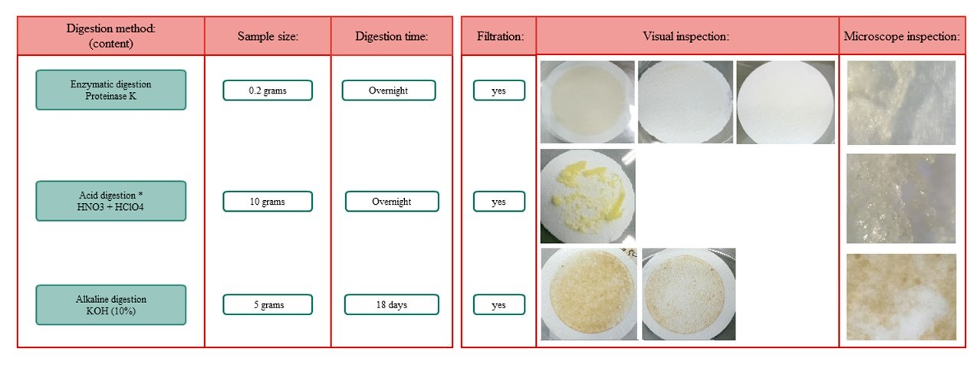
Figure 1.1 shows the results of the three initial digestion tests (enzymatic, acid & alkaline)
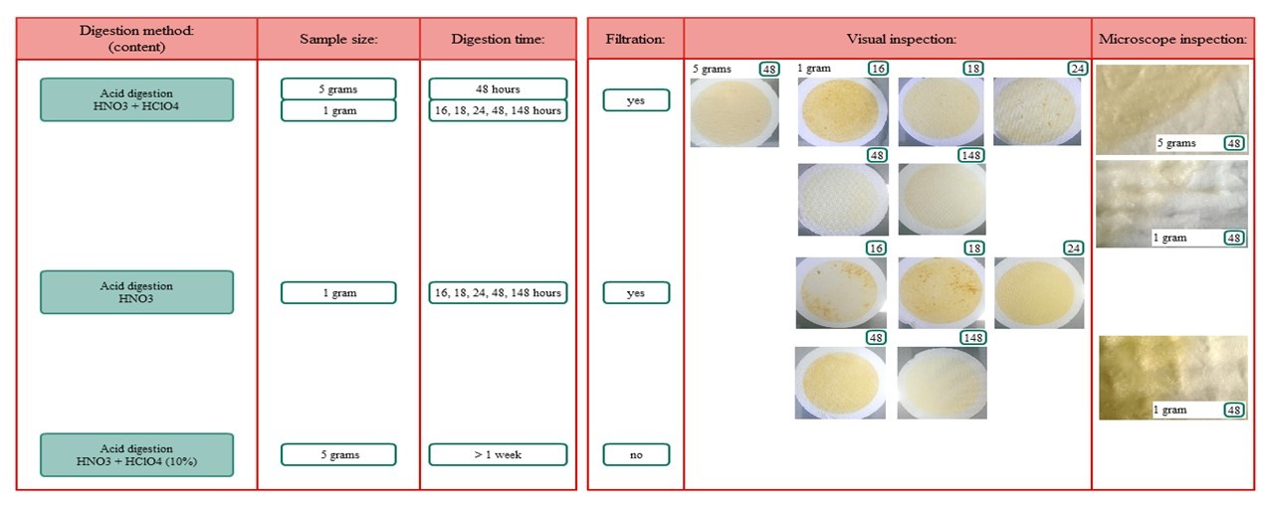
Figure 1.2. shows the results for the additional acid tests

- Tables
Table A. Prevalence of infected spiral valves and intensity (mean number of parasites per infected spiral valve) of parasites recovered from 10 porbeagle sharks.
Parasite species | Prevalence (%) | Intensity of infection
Dinobothrium septaria | 20% (n=2) | 1
Nematode gen.sp. | 30% (n=3) | >10

Table B. Results of blank testing for spiral valve content (2 g) and spiral valve tissue (1 g). Blanks showed mostly fibers and blue fragments. Other particles were black fragments.
Blanks | Measured blanks (n): | Average number of particles per sample (range) | Average number of blue fragments (range): | Average number of fibers (range): | Average number of black fragments (range)
Spiral valve content | 5 | 6.6 (2-18) | 3 (0-12) | 3 (0-6) | 0.6 (0-2)
Spiral valve tissue | 5 | 1 (0-2) | 0 | 1 (0-2) | 0

Table C. LoD and LoQ values determined for 1 g spiral valve content and 1 g spiral valve tissue

LoD and LoQ | Total |  | Blue fragments |  | Fibers |  | Black fragments |  | Other
 | LoD | LoQ | LoD | LoQ | LoD | LoQ | LoD | LoQ | LoD | LoQ
Spiral valve content | 9.8 | 32.4 | 7.6 | 25.2 | 4.2 | 14.0 | 1.3 | 4.4 | -- | --
Spiral valve tissue | 2.1 | 7.0 | -- | -- | 2.1 | 7.0 | -- | -- | -- | --

Table D: Lipid content percentages for spiral valve content collected after the massaging and scraping method. Samples were approximately 1 and 2 g respectively.
Sample intake | Lipid content (%)
Massaging: 1,03 | 2.8
Massaging: 2,07 | 2.8
Scraping: 1,04 | 2.6
Scraping: 1,98 | 2.6

- Figures
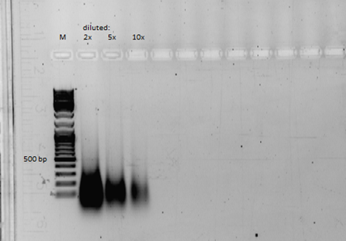
Fig.A: Electrophoresis of DNA extracted from spiral valve content.
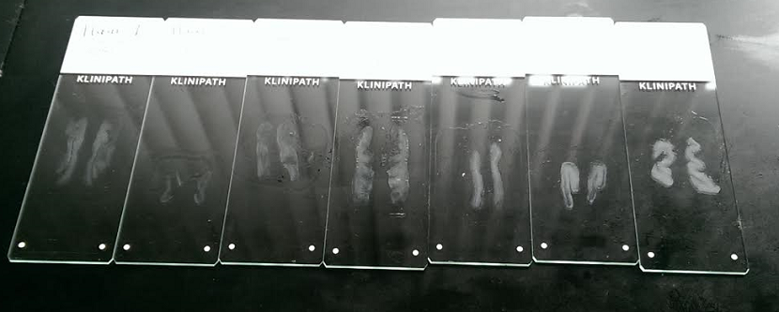
Fig.B: Tissue sections of spiral valve tissue on a heating plate before staining.
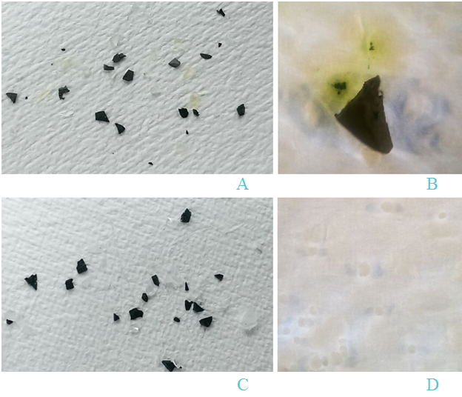
Fig.C. Plastic spiked tests with the mixture acid digestion without boiling (pictures A and B) and 10% KOH digestion (picture C). A: plastics after 48 hours exposure. PC colored from transparent to yellow. B: yellow staining of ABS particle on filter. C: plastics after 2 weeks and 4 days 10% KOH exposure. D: PVC fragments on filter.

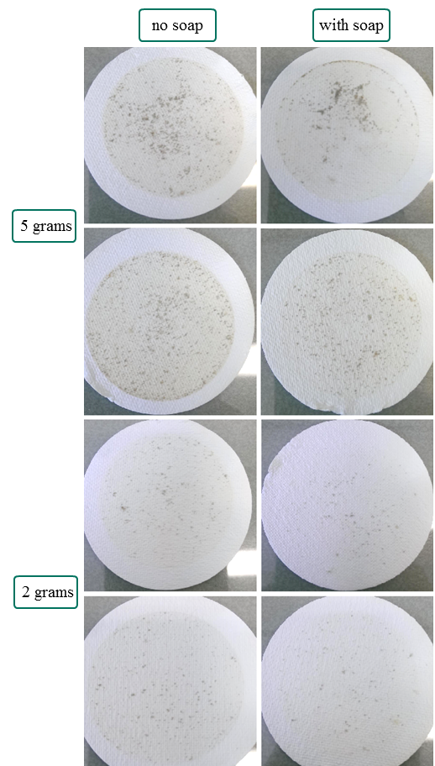
Fig.D: Difference between rinsing with solely milliQ water or with milliQ and 2.5 mL 20% Extran® after filtration of the sample. Tested on 2 and 5 g content samples.

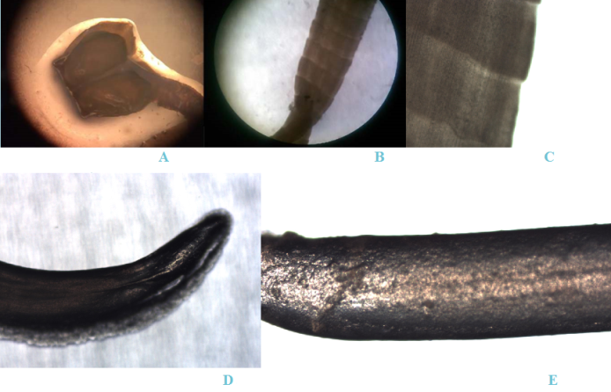
Fig.E: Parasites found in porbeagle sharks. A: head of tapeworm, B: body of tapeworm, C: close up of segments in body of tapeworm, D: end of nematode, E: body of nematode. Pictures are taken with a HTC phone of microscope at 4x magnification
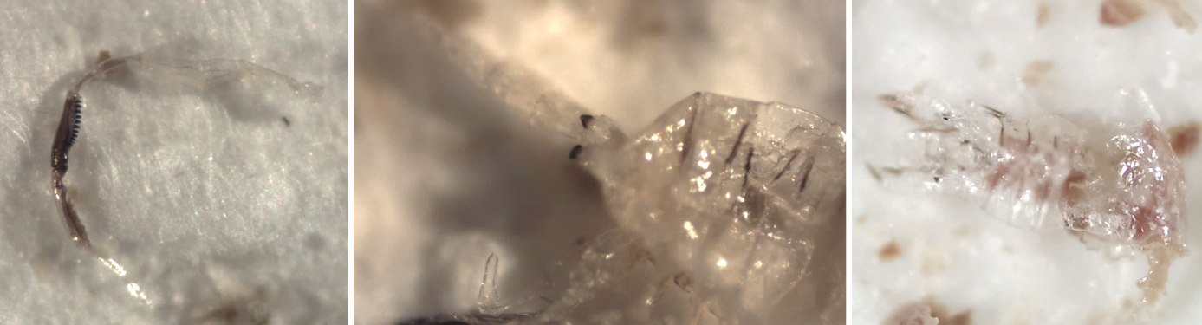
Fig.F: Exoskeleton on a filter after KOH digestion. Pictures are taken with HTC phone of microscope at 4x magnification.

Fig.G: Blank results for 2 g spiral valve content (left) and 1 g spiral valve tissue (right) illustrated in bar charts separated for type of particle.
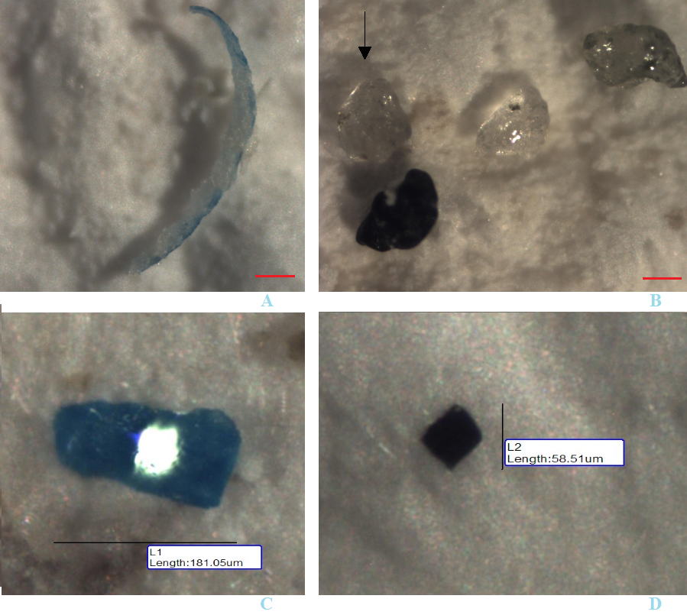

Fig.H: Selection of particles found in content samples. A: largest blue fragment. B: sand particles. Arrow indicates particle selected for Raman analysis. C: blue fragment. D: black fragment. Red line indicates 110 µm.
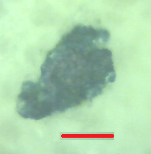
Fig.I: Blue fragment. Red line indicates 50 µm.

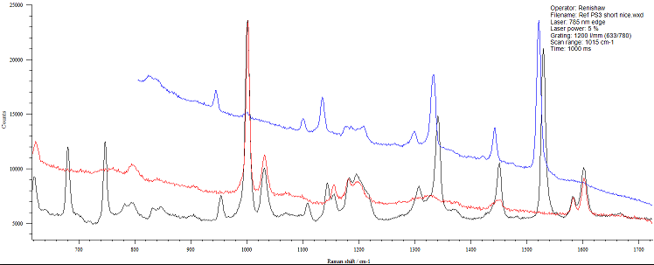

Fig.J: Raman spectra of polystyrene (red), blue filter packaging (black) and blue fragment from samples (blue). Blue line is slightly shifted due to technical issues. The red line has similar peaks as the black and the blue line, indicating that the blue filter packaging is polystyrene and contains the same pigment as the blue line.

4. The digestive tract of porbeagle sharks.
When food enters the body of the shark, it passes the wide mouth and esophagus as a whole or as relatively large bitten off chunks, as sharks do not chew their food. The stomach of most sharks is therefore a very large structure. This U-shaped structure dissolves most of what is eaten, by the work of strong acids and enzymes. What remains is an easily absorbed, soupy mush that can move further into the digestive system. The stomach ends at a constriction known as the pylorus or pyloric valve, which leads to the duodenum. The larger items cannot pass these constrictions and are often vomited or ejected by the body by turning the stomach inside out, before reaching the intestine. Only the smaller items or liquids move past these. The duodenum leads to the sharks’ intestine, the spiral valve. The intestinal tract of sharks is shorter than those of mammals. They compensate for this shortcoming by having a thick oval sac-like structure that is equipped with a corkscrew shaped pleat, so that food transport is greatly delayed, and the absorbent intestinal surface is increased. Undigested material moves from the spiral valve into the rectum. Connected to the rectum is the rectal gland, which excretes excess body salts. The rectum is connected to the anus and ends with the cloaca. The latter is where the digestive, urinary and genital tracts are open or emptied to the outside.

5. Plastic Particles Raw Data Tables.
Table 5.1. Raw data of plastic particles found in spiral valve content and spiral valve tissue based on the shape of plastic.

Fish no. | 2 | 3 | 4 | 5 | 6 | 7 | 8 | 9 | 10
Fragments | 123 | 35 | 124 | 44 | 107 | 39 | 39 | 37 | 31
Fibers | 31 | 13 | 23 | 16 | 59 | 43 | 36 | 40 | 26
Pellets | 1 | -- | 1 | 4 | 2 | -- | -- | -- | --
Films | 1 | 1 | -- | -- | -- | -- | 1 | -- | 1
Total | 156 | 49 | 148 | 64 | 168 | 82 | 76 | 77 | 58

Table 5.2. Raw data of plastic particles found in spiral valve content and spiral valve tissue based on the type of plastic found in the blanks. Spiral valve content is 2 g and content Is 1 g. The 4 numbers are from top to bottom, blue fragments, fibers, black fragments and others.

Fish no. | 2 | 3 | 4 | 5 | 6 | 7 | 8 | 9 | 10
Content
Sample 1 | 21  7  0  4 | 2  1  0  4 | 16  5  0  5 | 1  3  11  5 | 8  18  5  10 | 2  10  3  0 | 0  3  2  0 | 0  5  1  0 | 2  2  1  1
Sample 2 | 15  1  4  2 | 0  1  0  2 | 13  2  1  1 | 0  3  7  0 | 4  6  6  3 | 2  10  7  0 | 3  10  5  0 | 1  3  0  2 | 1  1  2  0
Sample 3 | 11  4  5  1 | 0  2  0  0 | 30  2  1  3 | 1  2  4  0 | 7  4  10  4 | 0  2  0  0 | 2  5  1  0 | 0  1  0  1 | 3  5  1  0
Sample 4 | 19  4  10  4 | 1  1  1  0 | 23  1  1  5 | 0  4  6  0 | 10  3  8  6 | 2  8  9  1 | 5  4  3  0 | 3  5  0  4 | 3  3  2  1
Sample 5 | 13  5  1  3 | 2  0  0  0 | 12  3  0  4 | 0  1  5  2 | 5  6  4  9 | 2  0  2  4 | 1  2  0  1 | 1  5  2  1 | 1  3  1  1
Total: | 134 | 17 | 128 | 55 | 136 | 64 | 47 | 35 | 34
Tissue
Sample 1 | 2  3  0  0 | 8  3  1  0 | 0  1  3  2 | 1  2  0  0 | 0  4  0  2 | 0  4  0  1 | 5  3  2  1 | 2  4  5  3 | 0  6  0  3
Sample 2 | 2  4  1  1 | 7  0  0  0 | 1  2  1  0 | 0  0  0  0 | 0  3  0  5 | 0  5  0  0 | 1  3  0  1 | 2  3  1  0 | 1  3  0  1
Sample 3 | 3  3  1  0 | 4  5  1  1 | 1  2  0  0 | 4  0  0  0 | 0  12  0  3 | 0  1  1  2 | 2  4  1  1 | 1  9  1  1 | 3  1  0  0
Sample 4 | 0  1  0  1 | 2  0  0  0 | 2  5  0  0 | 0  1  0  1 | 0  3  0  0 | 1  3  0  0 | 0  4  1  1 | 1  5  3  1 | 4  2  0  0
Total: | 22 | 32 | 20 | 9 | 32 | 18 | 30 | 42 | 24

Table 5.3. Blank subtracted data of total plastic particles found in spiral valve content and spiral valve tissue described for each sample.

Fish no. | 2 | 3 | 4 | 5 | 6 | 7 | 8 | 9 | 10
Content (2 g)
Sample 1 | 25.4 | 0.4 | 19.4 | 13.4 | 35.4 | 8.4 | 0 | 0 | 0
Sample 2 | 15.4 | 0 | 10.4 | 3.4 | 12.4 | 12.4 | 12.4 | 0 | 0
Sample 3 | 14.4 | 0 | 29.4 | 0.4 | 18.4 | 0 | 1.4 | 0 | 2.4
Sample 4 | 30.4 | 0 | 23.4 | 3.4 | 20.4 | 13.4 | 5.4 | 5.4 | 2.4
Sample 5 | 15.4 | 0 | 12.4 | 1.4 | 17.4 | 1.4 | 0 | 2.4 | 0
Average: | 20.8 | 0,08 | 19 | 4,4 | 3.84 | 7.12 | 1.56 | 1.56 | 0.96
Sample percentage of total content | 7.8% | 2.4% | 11.2% | 2.7% | 4.2% | 6.0% | 8.3% | 3.9% | 3.5%
Tissue ( 1g)
Sample 1 | 4 | 11 | 5 | 2 | 5 | 4 | 10 | 13 | 8
Sample 2 | 7 | 6 | 3 | 0 | 7 | 4 | 4 | 5 | 4
Sample 3 | 7 | 10 | 2 | 3 | 14 | 3 | 5 | 11 | 3
Sample 4 | 0 | 1 | 6 | 1 | 2 | 3 | 5 | 9 | 5
Average: | 7 | 7 | 4 | 1.5 | 7 | 3.5 | 6 | 9.5 | 5
Total: | 119 | 28.4 | 111 | 28 | 132 | 49.6 | 43.2 | 45.8 | 24.8

6. Spiked plastic tests
Spiked plastics
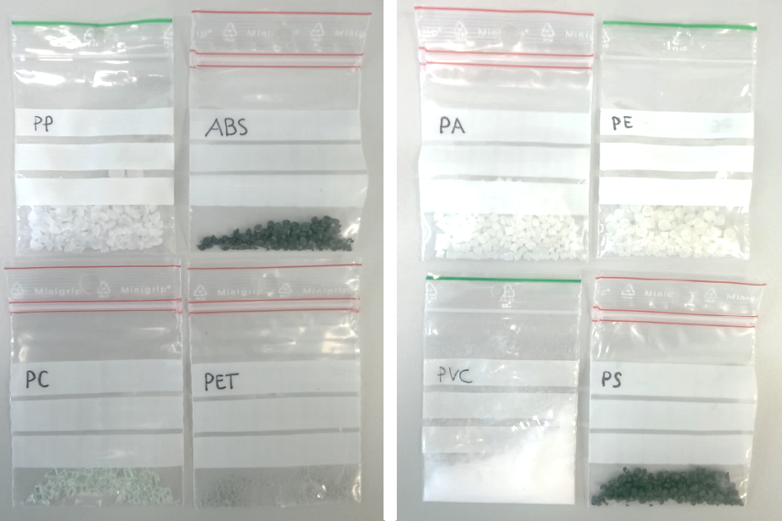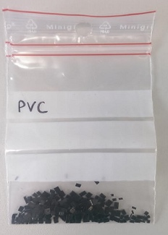
Fig.6.1. Plastic particles for spiked testing: PP, ABS, PC, PET, PA, PE, PVC, PS and large PVC particles
The tables below show the average weight of 3 spiked samples before and after the 10% KOH digestion. Table A gives the results for a 2 day exposure, table B for a 9 day exposure and table C for 17 days exposure.
Table 6.1. Average weight of spiked plastic (2day exposure)

Table 6.2. Average weight of spiked plastic (9day exposure)

Table 6.3. Average weight of spiked plastic (17day exposure)

The table below shows the paired samples test results for all spiked plastics at different exposures. All plastics contain number 1, 2 or 3. 1 indicates 2 days, 2 indicates 9 days and 3 indicates 2 weeks and 3 days. Significance level for PP at 2 weeks and 3 days is not calculated, since the difference was 0. Red dots illustrate the significant differences in mean.
Table 6.4. Average weight of spiked plastic (17day exposure)
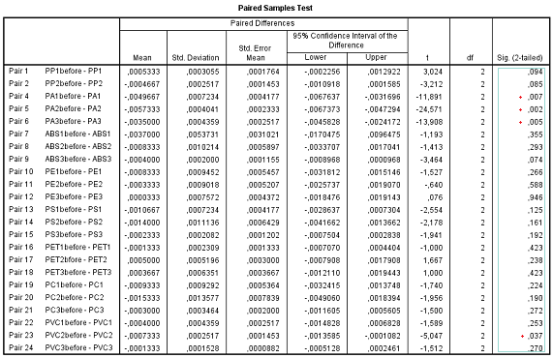
7. Prey DNA, Lipid Content Analysis and Histology
To ascertain whether prey was the source of microplastics, the presence of DNA in 9 mg homogenized spiral valve content of one of the test spiral valves was determined. Agarose gel electrophoreses⁶ was used to estimate the size of the DNA fragments (Figure A – Supporting Information).
The lipid content of one test spiral valve was determined to give an indication of dietary sources, nutritional content and consequent concentrations, volumes and times of digestion. Analysis of total lipid content and lipid class was used to explore functional diversity and nutritional content⁷. Lipids were extracted using non-chlorinated solvents cyclohexane (Sigma-Aldrich Chromasolv® for HPLC) and 2-propananol (Sigma-Aldrich Chromasolv® for HPLC) followed by an evaporation step and gravimetric analysis of the collected lipid mass. For this test, four homogenized content samples were used, and included a blank and an internal reference material, IRM (crab tissue, 2.0128 g). The lipid content (expressed in percentages) was determined for 1 and 2 g samples that were taken from the content that were collected via the massaging and scraping method (Figure 2 B and C).
Histology samples were taken from three spiral valves to gain more insight into the retention capacity of the intestines and potential transfer of contaminants. Approximately 2 cm by 2 cm samples were fixed in 4% Paraformaldehyde (PFA) in Phosphate-Buffered Saline (PBS) prior to the paraffin processing. Samples were serially sectioned at 3 μm and stained with hematoxylin and eosin. The transverse sections of tissue from various locations were examined under a microscope (Leica DM 3000) and imaged with a photo scanner (Philips Ultra Fast Scanner 1.6). Figure B (Supporting Information) shows histology sections before staining.

Results:
The DNA within the spiral valve content was fragmented below 500 base pairs, making further prey analysis impossible. The lipid content analysis suggested recent food intake⁸ and was slightly higher in the samples that were collected by massaging compared to those collected by scraping (Table D – Supporting Information). Microplastics could initiate inflammations^{9,10} of the intestinal epithelium, however, no microplastics were found in the histology samples of the spiral valve tissues. This could be due to the thickness of the histology sections (3 μm) which is much smaller than the particles found in the spiral valves.
REFERENCES SI
1. Karlsson, T. M. Can Microlitter in Sediment and Biota be Quantified? Method Development and Analysis of Microlitter in Field-collected Biota and Sediment. (University of Gothenburg, 2014).
2. Cole, M. et al. Isolation of microplastics in biota-rich seawater samples and marine organisms. Sci. Rep. 4, 4528 (2014).
3. De Witte, B. et al. Quality assessment of the blue mussel (Mytilus edulis): Comparison between commercial and wild types. Mar. Pollut. Bull. 85, 146–155 (2014).
4. Foekema, E. M. et al. Plastic in north sea fish. Environ. Sci. Technol. 47, 8818–24 (2013).
5. Claessens, M., Van Cauwenberghe, L., Vandegehuchte, M. B. & Janssen, C. R. New techniques for the detection of microplastics in sediments and field collected organisms. Mar. Pollut. Bull. 70, 227–233 (2013).
6. Lee, P. Y., Costumbrado, J., Hsu, C. Y., Kim, Y. H. Agarose Gel Electrophoresis for the Separation of DNA Fragments. J. Vis. Exp. 62, 3923 (2012).
7. Parzanini, C., Parrish, C. C., Hamel, J.-F. & Mercier, A. Functional diversity and nutritional content in a deep-sea faunal assemblage through total lipid, lipid class, and fatty acid analyses. PLoS One 13, e0207395 (2018).
8. Leigh, S. C., Papastamatiou, Y. & German, D. P. The nutritional physiology of sharks. Rev. Fish Biol. Fish. 27, 561–585 (2017).
9. GESAMP. Sources, fate and effects of microplastics in the marine environment: part 2 of a global assessment. (IMO, FAO/UNESCO-IOC/UNIDO/WMO/IAEA/UN/UNEP/UNDP). In: Kershaw, P.J. (Ed.), Rep. Stud. GESAMP No. 90 (96 pp). (2015).
10. Werner, S. et al. Harm caused by Marine Litter - European Commission. JRC Technical Report (2016). doi:10.2788/690366

