**Supplemental Information**

Effect of the Nitrate Group on Yields and Composition of Secondary Organic Aerosol Formed from Reactions of Alkyl Nitrates with OH Radicals in the Presence of NOx



Lucas B. Algrim and Paul J. Ziemann

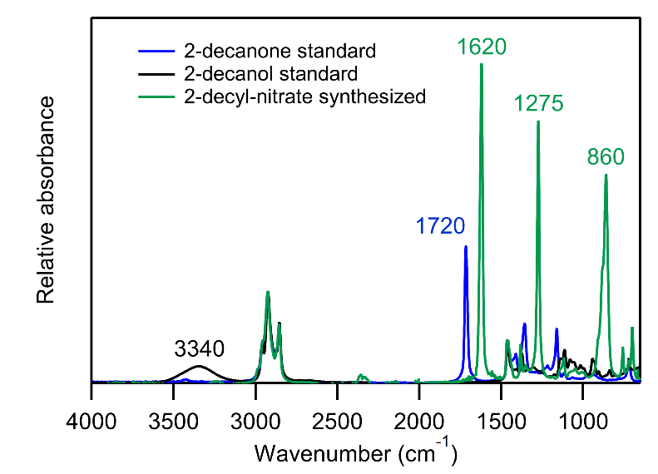

Figure S1. Overlaid ATR-FTIR absorbance spectra of synthesized 2-decyl nitrate; 2-decanol, the precursor; and 2-decanone, a common by-product of the synthesis. Spectra are normalized to the C–H stretch at 2925 cm-1.

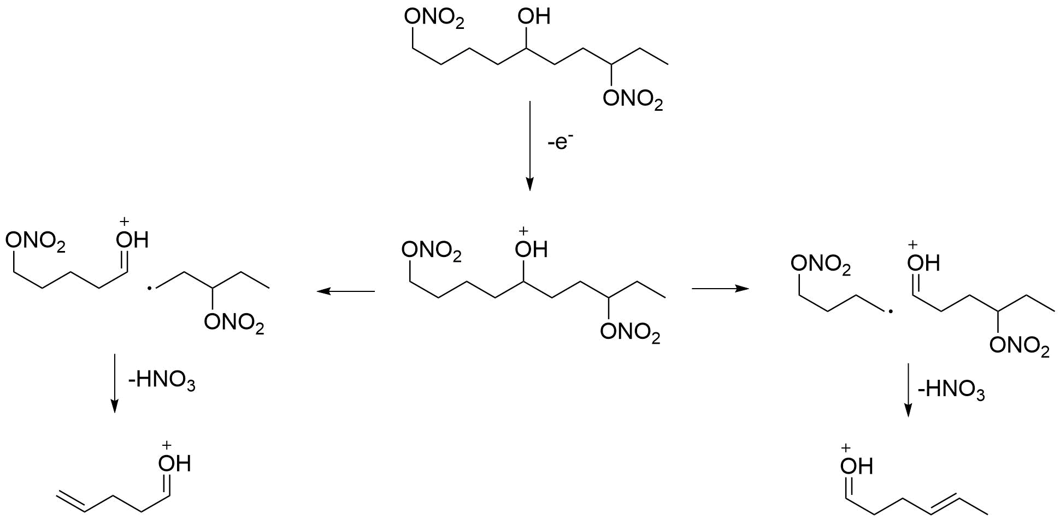

Figure S2. Proposed mechanism for the formation of characteristic ions from electron ionization and fragmentation of NHN isomers, using 1,5,8-NHN as an example.

**Model Description**

The model was used to calculate yields of first-generation products of the gas-phase reactions of each of the alkyl nitrate isomers. The approach is illustrated in Figure S3. A structure-reactivity relationship (Atkinson Ziemann 2012) was used to determine the percent of H atom abstraction at each carbon along the carbon chain. All nitrooxyalkyl radicals then added O2 to form nitrooxyperoxy radicals, which reacted with NO to form dinitrates or nitrooxyalkoxy radicals with branching ratios of 0.288 and 0.712 (Yeh and Ziemann 2014). The nitrooxyalkoxy radicals either reacted with O2 with an isomer-independent rate constant of 3.9 × 106 s-1 (Atkinson 2007, corrected for Boulder, CO pressure), or they decomposed or isomerized with isomer-specific rate constants calculated using the structure-activity relationships of Vereeken and Peeters (2009, 2010) that varied with the degree of substitution and relative position to the nitrate group. Following isomerization via a 1,5-H-shift and addition of O2, the nitrooxyhydroxy peroxy radicals formed react with NO to form either an NHN (an “isomerization product”) or a nitrooxyhydroxy alkoxy radical, which can reverse isomerize to form an NHC (another “isomerization product”). If, however, the alkoxy radical site is located on an α or β carbon relative to the nitrate group, it can decompose. Because recent work (Yeh, Claflin, and Ziemann 2015) indicates that the method of Vereecken and Peeters (2009) overestimates the barrier for the decomposition of a β-nitrooxyalkoxy radical by 3.7 kcal mol-1, the rate constants for β-nitroxyalkoxy radical decomposition calculated using the method of Vereeken and Peeters (2009) were increased by a factor of 100 to account for this difference. This correction significantly increased the yields of decomposition products, particularly for the 4- and 5-decyl nitrate isomers, and correspondingly decreased the yields of isomerization products for those isomers. The key rate constants used for nitrooxyalkoxy radical decomposition and isomerization are given in Table S1.

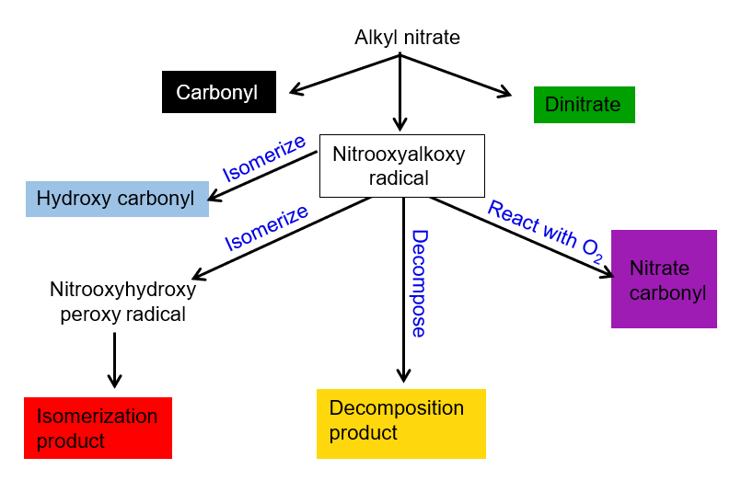

Figure S3. Flow chart of model product formation.

Table S1. Model rate constants for nitrooxyalkoxy radical decomposition and isomerization.

|  |  |  |  |
| --- | --- | --- | --- |
| Reaction | Mechanism | k (s-1) | Reference |
| Decomposition |  | 2.4 × 108  (scaled 100×from 2.4 × 106) | Vereecken and Peeters 2009; Yeh, Claflin, and Ziemann 2015 |
| Isomerization |  | 3.3 × 106 | Vereeken and Peeters 2010 |
| Isomerization |  | 6.3 × 105 | Atkinson 2007 |
| Isomerization |  | 1.1 × 107 | Atkinson 2007 |
| Isomerization |  | 7.5 × 107 | Atkinson 2007 |

**References**

Atkinson, R. 2007. Rate constants for the atmospheric reactions of alkoxy radicals: An updated estimation method. *Atmos. Environ*. 41:8468−8485.

Vereecken, L., and J. Peeters. 2009. Decomposition of substituted alkoxy radicals-part I: A generalized structure-activity relationship for reaction barrier heights. *Phys. Chem. Chem. Phys*. 11:9062−9074.

Vereecken, L., and J. Peeters. 2010. A structure-activity relationship for the rate coefficient of H-migration in substituted alkoxy radicals. *Phys. Chem. Chem. Phys*. 12:12608**−**12620.

Yeh, G. K., and P. J. Ziemann. 2014a. Alkyl nitrate formation from the reactions of C8−C14 *n*-alkanes with OH radicals in the presence of NOx. *J. Phys. Chem. A* 118:8147–8157.

Yeh, G. K., M. S. Claflin, and P. J. Ziemann. 2015. Products and mechanism of the reaction of 1-pentadecene with NO3 radicals and the effect of a -ONO2 group on alkoxy radical decomposition. *J. Phys. Chem. A* 119:10684−96.

Ziemann, P. J., and R. Atkinson. 2012. Kinetics, products, and mechanisms of secondary organic aerosol formation. *Chem. Soc. Rev.* 41:6582−6605.