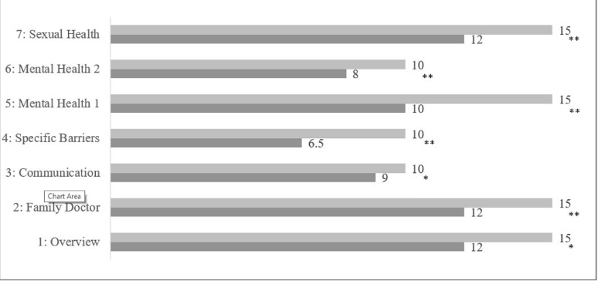

Descriptive statistics and significance of participants’ self-perceived pre- and post-session knowledge in weekly sessions.* Represent a significant increase in self-perceived knowledge post-session (* p < or = .05; ** p < or = .001).

