SUPPLEMENTAL TABLE S1
The distribution of gestational week when the progesterone was tested.
Gestational week | no. | % | Progesterone level, nmol/L  Mean ±SD (Range)
4 | 111 | 5.97 | 74.6±24.5 (31.9, 127.3)
5 | 307 | 16.51 | 71.1±21.3 (25.0, 127.3)
6 | 469 | 25.21 | 63.6±20.0 (21.1, 127.3)
7 | 694 | 37.31 | 61.3±20.3 (20.8, 127.3)
8 | 170 | 9.14 | 68.3±20.3 (32.9, 127.3)
9 | 81 | 4.35 | 72.4±20.5 (39.9, 127.3)
10 | 28 | 1.51 | 80.6±24.8 (38.4, 127.3)
Total | 1860 | 100.00 | 65.7±21.3 (20.8, 127.3)
Abbreviations: SD, standard deviation.
SUPPLEMENTAL TABLE S2
Maternal progesterone concentration in early pregnancy and the time of delivery by progesterone in quartiles.
 | N | Progesterone level, nmol/L,  Mean ±SD (Range) | Test week,  in weeks + days, Median (IQR) | Gestational age (time of delivery) , in weeks + days, Median (IQR) | pª
Median | 1860 | 65.7±21.3 (20.8, 127.3) | 7+0 (6+0，7+4) | 39+4 (38+5 ,40+1)
Quartiles
1st Quartile | 463 | 42.4±6.2 (20.8, 50.3) | 7+1 (6+2, 7+4) | 39+4 (38+6 ,40+1)
2nd Quartile | 462 | 56.2±3.3 (50.4, 62.2) | 7+1 (6+1, 7+4) | 39+4 (38+5 ,40+1) | 0.511
3rd Quartile | 470 | 68.9±4.5 (62.3, 77.3) | 6+6 (6+0, 7+5) | 39+2 (38+5 ,40+1)
4th Quartile | 465 | 95.1±15.3 (77.4, 127.3) | 6+4 (5+3, 7+5) | 39+4 (38+5 ,40+1)
Abbreviations: SD, standard deviation; IQR, interquartile range.
a p for the comparison of the length of gestation in the four progesterone concentration quartiles using log-rank test.

SUPPLEMENTAL TABLE S3
Crude and adjusted hazard ratios for risk of spontaneous preterm delivery according to maternal serum progesterone concentration in sensitive analysisª.
Progesterone concentration, quartiles | Total No. | No. of case | Crude  HR (95% CI) | Adjusted  HR (95% CI) ^{b}
1st quartile | 463 | 16 | 0.89 (0.45, 1.74) | 1.21 (0.55, 2.65)
2nd quartile | 462 | 19 | 1.06 (0.56, 2.02) | 1.52 (0.72, 3.19)
3rd quartile | 470 | 16 | 0.89 (0.45, 1.74) | 1.37 (0.63, 2.96)
4th quartile | 465 | 18 | Ref. | Ref.
Continuous, per 10 nmol/L increased | 1860 | 69 | 1.01 (0.91, 1.13) | 0.95 (0.84, 1.08)
Abbreviations: CI, confidence interval; HR, hazard ratio
ª The cases who missed information on cause of preterm delivery were consider as censored.
^{b} Adjusted for age (continuous), smoking during pregnancy (yes/no), second hand smoking exposure during pregnancy (yes/no), pre-pregnancy BMI (continuous), previous history of preterm birth (nulliparous, multipara and ≥37 weeks, multipara and<37 weeks), vaginal bleeding during pregnancy (yes/no), use of progesterone drugs during early pregnancy.

SUPPLEMENTAL TABLE S4
Crude and adjusted hazard ratios for risk of delivery or spontaneous delivery according to maternal serum progesterone concentration among women who had used progesterone drugs (n=968)
Progesterone concentration, quartiles | Total No. | No of preterm births | Unadjusted  HR (95% CI) | Adjusted  HR (95% CI)*
Risk of preterm delivery
1st quartile | 299 | 17 | 0.78 (0.39, 1.55) | 1.29 (0.59, 2.84)
2nd quartile | 250 | 13 | 0.71 (0.34, 1.49) | 1.15 (0.50, 2.62)
3rd quartile | 213 | 16 | 1.03 (0.51, 2.09) | 1.66 (0.75, 3.68)
4th quartile | 206 | 15 | Ref. | Ref.
Continuous, per 10 nmol/L increased | 968 | 61 | 1.08 (0.97, 1.20) | 0.99 (0.88, 1.12)
Risk of spontaneous preterm delivery
1st quartile | 299 | 14 | 0.87 (0.40, 1.92) | 1.69 (0.66, 4.29)
2nd quartile | 250 | 12 | 0.89 (0.39, 2.02) | 1.60 (0.62, 4.14)
3rd quartile | 213 | 13 | 1.14 (0.51, 2.55) | 2.05 (0.80, 5.28)
4th quartile | 206 | 11 | Ref. | Ref.
Continuous, per 10 nmol/L increased | 968 | 50 | 1.04 (0.91, 1.17) | 0.94 (0.82, 1.08)
Abbreviations: CI, confidence interval; HR, hazard ratio
*Adjusted for age (continuous), smoking during pregnancy (yes/no), second hand smoking exposure during pregnancy (yes/no), pre-pregnancy BMI (continuous), previous history of preterm birth (nulliparous, multipara and ≥37 weeks, multipara and<37 weeks), vaginal bleeding during pregnancy (yes/no).

SUPPLEMENTAL TABLE S5
Crude and adjusted hazard ratios for risk of delivery or spontaneous delivery according to maternal serum progesterone concentration among women who had not used progesterone drugs (n=757)
Progesterone concentration, quartiles | Total No. | No of cases | Unadjusted  HR (95% CI) | Adjusted  HR (95% CI)*
Risk of delivery
1st quartile | 129 | 1 | 0.25 (0.03, 2.03) | 0.30 (0.04, 2.53)
2nd quartile | 179 | 6 | 1.09 (0.37, 3.25) | 1.25 (0.40, 3.90)
3rd quartile | 221 | 6 | 0.89 (0.30, 2.64) | 1.02 (0.33, 3.18)
4th quartile | 228 | 7 | Ref. | Ref.
Continuous, per 10 nmol/L increased | 757 | 20 | 1.08 (0.89, 1.32) | 1.01 (0.81, 1.26)
Risk of preterm birth
1st quartile | 129 | 1 | 0.29 (0.04, 2.42) | 0.35 (0.04, 3.07)
2nd quartile | 179 | 6 | 1.28 (0.41, 3.95) | 1.51 (0.46, 4.97)
3rd quartile | 221 | 2 | 0.35 (0.07, 1.71) | 0.42 (0.08, 2.17)
4th quartile | 228 | 6 | Ref. | Ref.
Continuous, per 10 nmol/L increased | 757 | 15 | 1.08 (0.86, 1.36) | 0.99 (0.76, 1.29)
Abbreviations: CI, confidence interval; HR, hazard ratio
*Adjusted for age (continuous), smoking during pregnancy (yes/no), second hand smoking exposure during pregnancy (yes/no), pre-pregnancy BMI (continuous), previous history of preterm birth (nulliparous, multipara and ≥37 weeks, multipara and<37 weeks), vaginal bleeding during pregnancy (yes/no).
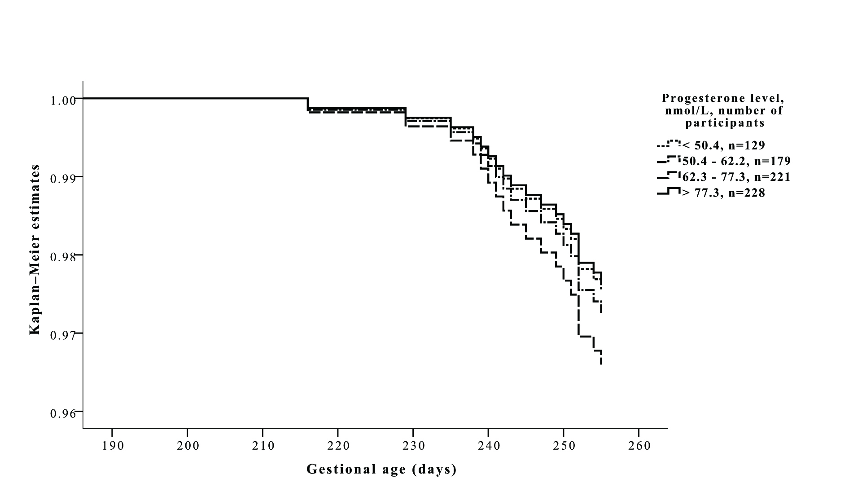
Figure S1.
Survival curves of preterm delivery for each quartile of progesterone concentration based on Cox proportional hazards regression model (n=1860).
Survival time is the time of preterm delivery, and term deliveries (≥259 days, 37 weeks) are considered as censoring events. Adjusted for age (continuous), smoking during pregnancy (yes/no), second hand smoking exposure during pregnancy (yes/no), pre-pregnancy BMI (continuous), previous history of preterm birth (yes/no), parity (0, ≥1),vaginal bleeding during pregnancy (yes/no), and use of progesterone drugs during early pregnancy (yes/no).

