Supplemental file
Effect of Co-Mo catalyst preparation and CH₄/H₂ flow on carbon nanotube synthesis
Lobiak E.V.¹, Kuznetsova V.R.^{1,2}, Flahaut E.³, Okotrub A.V.¹, Bulusheva L.G.¹
¹Nikolaev Institute of Inorganic Chemistry SB RAS, Novosibirsk, Russia
²Novosibirsk State Technical University, Novosibirsk, Russia
³CNRS, Institut Carnot Cirimat, F-31062 Toulouse, France
Lobiak E.V. lobiakev@niic.sbras.ru Nikolaev Institute of Inorganic Chemistry SB RAS, Novosibirsk, Russia

Ratio of CH₄/H₂ mixture, mL/min | RBM position, cm⁻¹
50/0 | 138, 209.3, 218.5, 164.5, 162
50/50 | 87-92-97,2-103,4-105,5  109-127,6-134,5-138,7-141,4-147,6-157,3-164,9-168,4-176,6-179,3  201,4-209-218-240,8-262,9
100/0 | 119,8-189,2-207
100/50 | 127,7-151,6-155,4-166,6-173,3-183-204,8  239,2-249,7-256,4  307,9-319,9
150/0 | 146.2-152.5-161.4  243.5-260.8
200/0 | 160.4-167.7-174-176.4-194.8-202.2-209.7-218.2-221.2-223  259-262-265-267.2-272.4
300/0 | 127.6-149-175.9  252, 308, 314
Table S1.

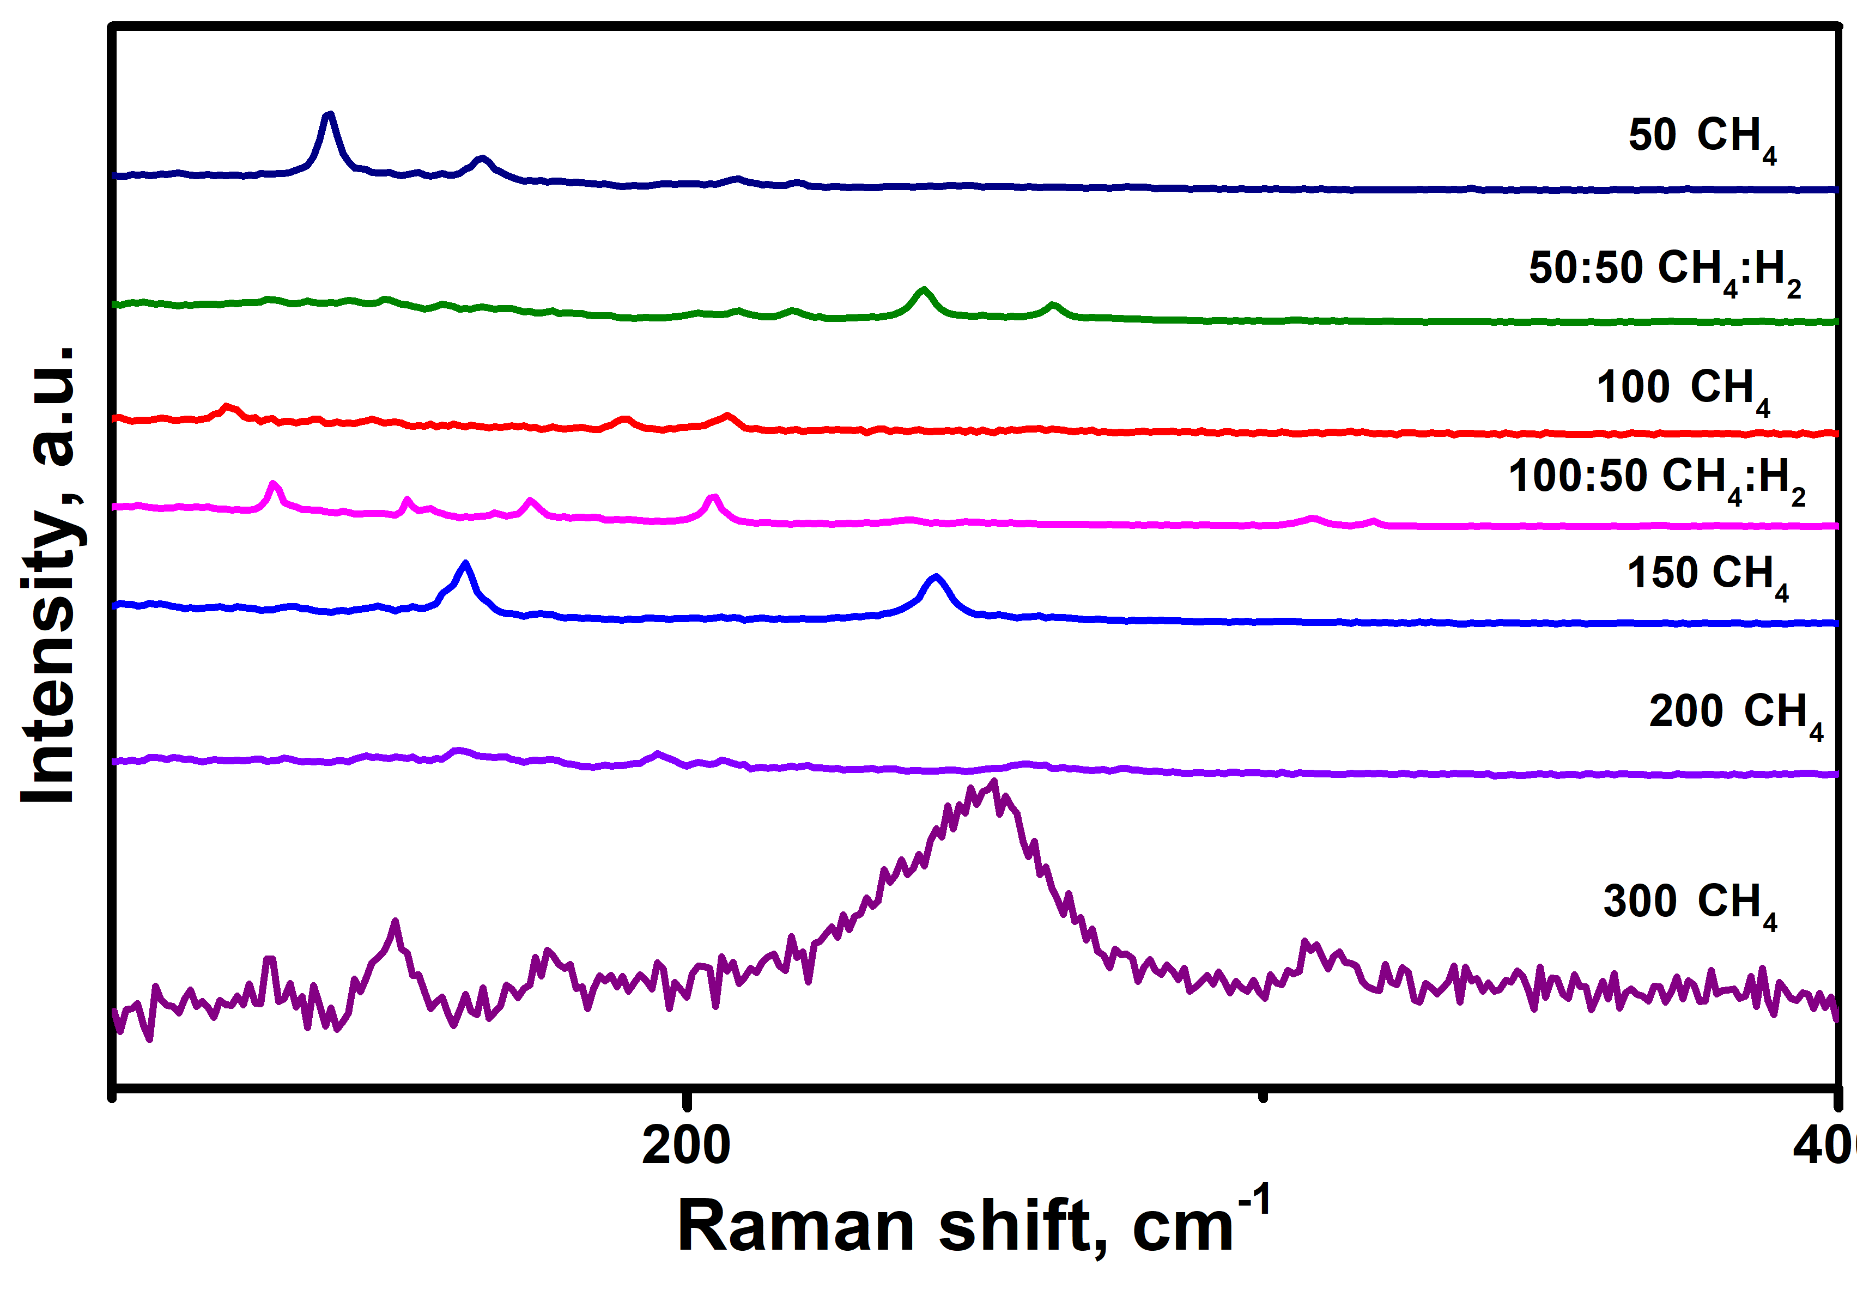
Figure S1.
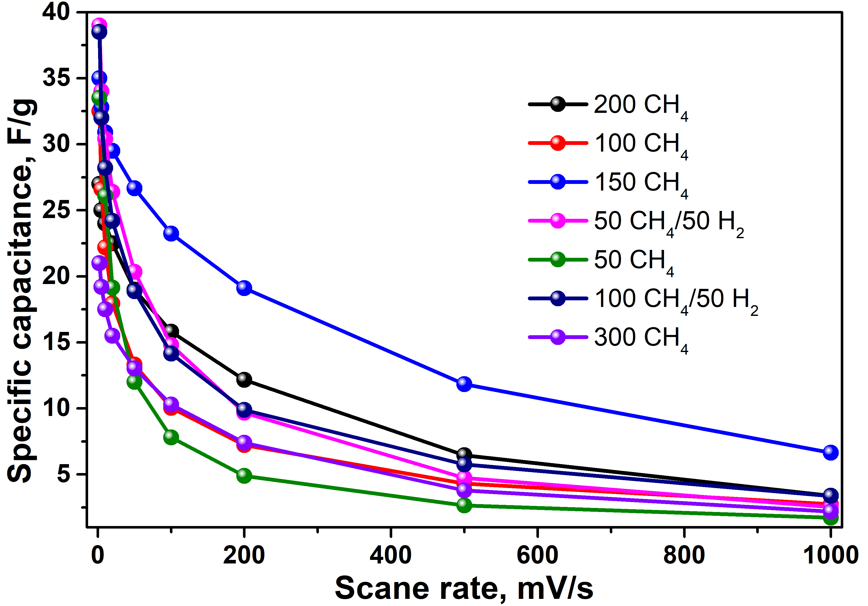
Figure S2.
Table S1. RBM positions of CNTs synthesized using comb-prepared catalyst at different CH₄/H₂ ratios and flow rates.
Fig. S1. RBM Raman spectra peaks of CNTs synthesized using comb-prepared catalyst at different CH₄/H₂ ratios and flow rates.
Fig. S2. Specific capacitance as a function of scan rate of CNTs obtained with comb-prepared catalyst at different CH₄/H₂ ratios and flow rates.

