Teacher Counselors are Better for Students’ Developmental Needs: A Case study of Kalinga Institute of Social Sciences (KISS), KIIT University
Pabitra Kumar Das*
(Abstract)
Teacher Counselors are better for addressing the students’ developmental needs. Best practices in school guidance implemented in KISS where 156 teachers are in role of counselor providing psychosocial support to thousands of students. Teacher’s position to meet the challenging demands of the indigenous students is beyond traditional routine. This is a success story focuses on teacher counselor’s participation in guidance activities that mainly center on awareness building on health, hygiene and skill development of students at tertiary level. This paper will present teacher counselor’s role and responsibility and the extent of involvement in guidance activities i.e. discussing how they arrange and manage in conducting sessions for needy students. Early planning, referral enquiry or supports from other teaching staff coordinates in conducting the required sessions either one to one or group as corresponding to students’ decision making, problem solving needs and development. Teachers instead in their contemporary role, they are making a volunteering epoch for the student community in KISS with a formal perspective to improve awareness, understanding and knowledge on most important issues such as health, education and career that exclusively impact on students’ growth. Practically, guidance supervisors and monitoring people of the program need to have full understanding of the capacity level of teacher counselors and timely supportive guidance to be provided them to institutionalize the practices.
Additionally this paper manifests for need of training, development of workable planning and feasible implementation mechanism for teachers who are simultaneously known as counselor and mentor. It considers this practice as a better means of implementing guidance program for enhancing competencies of adolescents and youth in a residential educational setting.
Key words: teacher counselor, counseling, guidance, life skills, student development

Introduction
In this era of knowledge economy traditional values and cultural practices are transforming very rapidly. Education structure of yesteryears aka traditional classroom and teaching pedagogy are no more significantly contribute as because students’ expectation and aspiration change. Teacher’s responsibility which was once exclusively considered ‘teaching’ has been converted to more of ‘guidance’ with the variety of pressing demands from ‘Y’ generation students of this day. Their prospects highly depend on their holistic development, i.e. not just mere academics and career but more of psychosocial competence and health, directly which are basis for boosting the first two. Teachers’ or faculty’s facilitative role is now more than subject experts since in various fields of education, virtual ways of knowledge sharing enables students to sail in sea of knowledge ; therefore, what should a teacher or faculty need to do?
Educational guidance might be sole answer to this. Carter V. Good has said in Dictionary of Education (1956), ‘Guidance is a process of dynamic interpersonal relationship designed to influence the attitude and subsequent behaviour of person’. For a student success comes when opportunities meet with his or her preparation, then new role of teaching community is more or less creating opportunities and facilitating them for right preparation. Furthermore, Psychological theories that have emerged over last three decades have moved away from the traditional, unidimensional description of human intelligence and approach taken as the human potential from a much broader and multidimensional perspective, human potential is multifaceted (Theory of Multiple Intelligences-Howard Gardner, 1993). With such viewpoint, teacher’s role in guiding students is myriad, especially in residential educational institute like Kalinga Institute of Social Sciences (KISS, Bhubaneswar).
In KISS, it is guidance in the form of teaching and supports provided by trustworthy, usually teachers, supervisor and counselors.Interestingly, solidarity for their own profession; the teacher-counselors redefine their role and responsibility result positivity in mind of tribal students. The extent of involvement in guidance and counseling activities benefits 8000 adolescent students studying in and from high school to college level. The guidance services at KISS are multilayered. All the first level, the teachers who are oriented on counseling services identifies the students with problem due to their longer interpersonal relationship with the students and provides services at their end. At the next level, resource persons trained in counseling and guidance offer services at the counseling centers after school hours. Often group counseling is conducted on matters like stress management, personal management, besides addressing issues on career and others. At the third level, demarked professional counselors attend to specific problems of the adolescent students. Thus, a successful networking and follow up service contributes a lot for students’ development.
Nevertheless, a number of professionals of various different disciplines synergistically help teacher and teacher counselors to have best from the students for their development through one to one, group or classroom facilitation in either of forms e.g. counseling, mentoring and coaching .The guidance supervisors being part of the programme interact with teacher counselors as well as students for fully understanding of their need and concerns, and these lead other key areas for further interventions. And now the changing practices and behavior of tribal students is observable phenomenon as a consequence to guidance service in KISS.
Context/school/Organization
Kalinga Institute of Social Sciences (estb.1993) is a residential organization pioneering for tribal education and endeavoring towards all-round development of tribal adolescents by empowering them with adequate life skills and knowledge. For fulfilling of such guidance and counseling service figured as the major chunk besides the academic activities, it’s because the institute entirely deals with adolescents who are residing in the campus. Among 22,500 students, nearly 8,000 are belonging to adolescence period and especially this period is known for optimum developmental phase of an individual. Ten to teen boys as well as girls undergo physical, social and psychological transformation and these transformations considerably influence the rest of an individual’s life. Concentrating on the highly important phase of one’s life, an adolescent should feel many more requirements that essentially contribute for balanced growth and development towards his or her adulthood. In this context, guidance and counseling prior to developmental needs of adolescents is acknowledged worldwide and the same has been put into practice in KISS.

Process and Practices
Convergence Practice Model of Guidance service in KISS
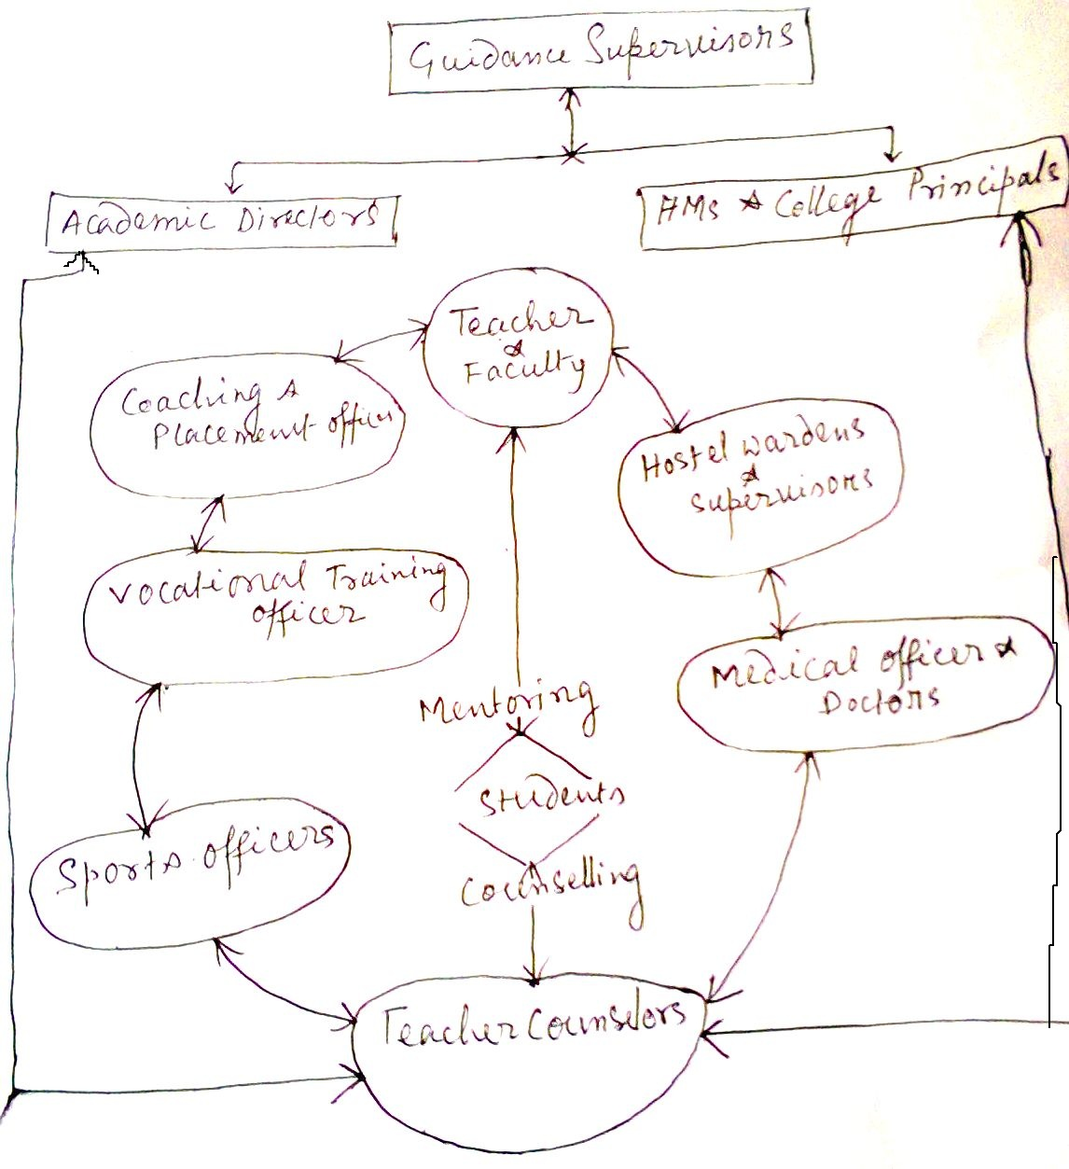
Considering the huge need of counseling service for student mass, KISS has done all sort of endeavour to meet the demand. From higher level of academic side, both school headmasters and college principals and management people are involved indirectly as guidance supervisors to this field. Their timely inputs are in many aspects helping the rest to perform tasks in the line of students’ requirement. They timely interact with the rest professional involved in this service, engage outside consultants, meet doctors and medical assistants and talk to hostel wardens to check out the trend of students’ progress, their requirements and the dilemmas the student community in the campus is facing. After having all details of information, specific action is being taken by arranging group or individual session. Teacher counselors are instructed to make their counseling techniques most appropriate so that student/s can get best benefit from session. Students those attended session/s, their records keeping is done, analysis of such records is the indicator for need of different interventions e.g. therapy, training and exposures etc, that too systematically arranged.
For fixed day counseling professionals are hired, students with personal problems and students referred by teacher counselors are dealt by them; they give them therapies and finally discuss the case with guidance supervisors and recommend for other sort of further referral services. In KISS, a dispensary (a mini hospital with 200 beds) serves for students medical causes. Many a time students who needs medical help as referred by counselors immediately addressed by medical attendance or doctors. Sometimes doctors take educational sessions i.e. group counseling in hostel rooms or in girls’ counseling room. It is seen that students with psychosomatic problems by mistake go for medication and these medical people after examining the condition of students they too refer for counseling.
Hostel wardens are overseer of students’ behavior in the campus. They used to visit each of the hostel rooms and enquire of them and friendly interaction with adolescent boys and girls give clues for health status. On the whole, in KISS under guidance and counseling service two ways channel of communication everyone from hierarchical level to the task performers all are contributing for the students’ constructive growth and development. The briefly the process practiced in KISS for guidance and counseling for students undergo certain stages to make it formal. They are:
Question Box approach in the process
Question box is conceived as a way of overcoming both the sigh and reluctant attitude of students who dare not to attend counseling session and it is an elegant shortcut to reach the large number of students. In school and college hostel they are kept and all boxes are at every student’s reach. Weekly, questions are collected and they are sorted as question pertaining to health including reproductive health and personal hygiene, behavioral problem, career and academic concerns etc. The questions are kept as record and counselors are made involved to support the curious students with best reliable answers and in this process, frequently students are being referred for counseling too.
i) Identifying the need for counseling
Project strategy for counseling service is complementary and supplementary assistance to LSE and health education for the adolescents in KISS. However in general developmental counseling service is arranged whenever the need arises. Teacher and teacher counselors have taken very active role in identifying need of the students through their observation, interactions and using a sort of checklists. One to one session is organized aiming at individual student’s development and empowerment so that he/she could be able to get rid of his/ her problem and make informed decision.
ii) Preparation for Counseling
All the students know counseling rooms and schedule of counseling session. In general students/s referred by either of self, teachers, wardens or hostel supervisors, they meet HoDs of respective departments and intimate for counseling session. The length of time required for counseling depends on the complexities of the issues. Generally, a session lasts often an hour and a half. If more time required, counselors inform the client/s for second session. And accordingly second session held for individual client. For specific event, counseling session is organized as close to the event as possible. In such circumstances, students are informed beforehand, why, where, and when session will take place. Group counseling session is usually organized in class room. Thorough preparation is done for effective counseling by reviewing all pertinent information. This includes the purpose, facts and observations about students, identification of specific problems, main points of discussion and development plan of action.
‘Student information sheet’ is used to record the students’ data and using the information, teacher counselors determine what to discuss during second session. The engaged teacher counselors identify possible comments/ questions to keep the session client centered and help the students’ progress through successive stages.
iii) Conduct counseling session
All workdays whenever a student is in need for counseling and free from class hours counseling session is organized. Often counseling for a specific incident occurs spontaneously as counseling coordinator meet students daily. In kiss, sometimes an informal situation makes appropriate atmosphere for counseling setting. The right atmosphere promotes better two way communication between a teacher counselor and a student. To establish a relaxed atmosphere, counselors sometimes take session in the lawn. Such counseling takes place in the ground, hostel room and library- they want to interact besides their usual work. This is very informal. In room setting, formal session held and formal session consists:
- Opening the session
In the session opening, coordinator intimates the teacher counselor/s about the student/s’ issues and state the purpose of the session. Teacher counselors establish a client friendly setting early in the session by inviting the client/s to speak. The best way they usually follow to open a group session is to clearly state its purpose. For example, an appropriate purpose statement might be, “The purpose of this session is to discuss how to improve academic performance and to create a plan to enhance performance attain goal” In personal one to one counseling session, teacher counselors/s first ensure rapport and confide the student The conversation is always two-way, and aims to address what the client/s need to do to meet the goal.
- Discuss the issues
In the discussion drawing the confidence of student/s the teacher counselor/s create an environment where student/s speaks more and reveals their feelings too. Once she or he opens up then counselors uses citation or narrative methods to get root of the problem, and for this 2/3 session they take for a single client as the case requires. During this teacher counselors assess the state and propensity of client/s and define the issues through paraphrasing and narrating.
- Developing the plan of action
Many of teacher counselors in their role of counselor follow humanistic school of counseling. Once a client or a group of clients desire to change, they develop the plan of action for themselves. It is sort of student/s’ expectation management that enable student/s to reach their goal. Every action considerably judged for its feasibility for student/s in KISS contexts and as per the student/s’ ability. Supportive action from peers or other helping group is also considered while planning as ‘guidance is a form of education through communication and structuring’. Because such planned intervention between the students and the teacher counselors in general help them to change, improve and resolve behaviors that are maladaptive, difficult and distressing.
- Recording and closing the session
Although the requirements to record session vary, teacher counselor/s for their professional as well as institutional internal purpose documenting the main points of a session what benefit the stake holders at large. Recording serves as a reference to proof of the student/s undergone counseling session, reference to the agreed upon plan of action and accomplishments, improvements, preferences or still existing problem. Teacher counselors follow a student information sheet to record details and it often aids making recommendations for personal, academic and social development intervention for students in KISS.

Table -3 shows the number of students taken guidance and counseling service
Year | Number of Students covered under group counselling | Number of students covered under Individual counselling
2010 | 2856 | 152
2011 | 2562 | 728
2012 | 1012 | 727
2013 | 480 | 117
2014 | Counting*
(Counseling Records maintained in LSE Project)
- Follow up service
Guidance and counseling service for a student does not end with the session only. It continues through implementation of the plan of action and evaluation of results. After counseling, teacher counselors have discussion with stakeholders to reinforce and monitor the student/s’ activities and thus support student/s as they implement their plans of action. These supports include teaching, coaching or providing time and resources. In KISS, especially teachers in this , do their best role as mentor by observing and assessing this progress and possibly modify (with consent of teacher counselor’ intervention) the plan to meet the student/s’ goals. Appropriate measures undertaken after counseling include follow up session, making referrals, informing the respective stakeholders for taking corrective measures.
Areas of activity/Interventions
Tribal students, first generation learners have plenty of difficulties and obstacles. They face barriers: language, adjustment in the campus, their own inhibitions, social taboos and customs and so on. In KISS environment, every sort of helps and assistance in one and other form of guidance provided them for overcoming such barriers, which sometimes get in their way of becoming skilled, potential students as well as good, unprejudiced and productive members of society tomorrow. Guidance is being provided to them for their self development, career development and development of competencies for dealing with day to day life situations.
Different ads on services e.g. yoga, sports and others started much earlier before literally guidance and counseling service came into existence, but professionally it made the first move during the project(LSE) as a complementary support to adolescents’ empowerment. For this, two counseling centers established and teachers and faculty of KISS are oriented and trained on counseling and guidance by the renowned professionals in this field. Teachers and faculty designated as Teacher Counselor who eagerly takes this initiative as by agreeing to their new role in school and college and thus, they accelerate the process for smooth running of guidance and counseling activities. Weekly fixed day counseling by expert counselors from outside is arranged and regularly on these particular days, difficult cases are referred and dealt with utmost care. The group sessions on personality development, academic skills, stress coping, health, hygiene etc are arranged in educational period.
Outcomes/Changes
Guidance service is being used to address psycho-social development, performance and caree issues of students. Recent evaluation study by SADAN (South Asia Development Association Network) 2014, brilliantly shows the impact of the institutioal endevour for student development. The flanking review of the report indicates: Students (62.9%) are having higher levels of positive attitude towards themselves. Being independent and responsible are the two most positive and important qualities of them. Every student has an academic aspiration. While the girls are for general education the boys are for professional degree. It shows 76.6% students seek help from teachers and teacher counselors. An equally large number of students (73.4%) are to resolve to study harder and not many feel tensed or hide their inefficacy for improvement.
For example: Table no-1 indicates about the percentage details:
Level of education aspired to achieve | Percentage of respondents who agree |  |  |  |  | Total  N=492
 | Sex |  | Class studying
 | Boy  (n=248) | Girl  (n=244) | Vii  (n=191) | Viii  (n=171) | IX  (n=130)
Higher secondary | 4.4 | 11.5 | 9.9 | 10.5 | 1.5 | 7.9
Graduation | 15.7 | 15.6 | 10.5 | 19.9 | 17.7 | 15.7
Post graduation | 23.4 | 25.8 | 23.0 | 22.2 | 30.0 | 24.6
Above pg | 18.5 | 21.7 | 16.2 | 18.1 | 28.5 | 20.1
Professional degree | 36.3 | 25.4 | 39.3 | 28.7 | 21.5 | 30.9
Don’t know | 1.6 | 0 | 1.0 | 0.6 | 0.8 | 0.8
(Taken from SADAN report 2014)
The students exhibited a high level of maturity in indicating that peer relation is positive. In event of an unwanted situation at home, the students again showed very positive response in sharing the problem with the friends & family members. In setting their dreams and aspirations of life, teachers play an important role. About their dreams, aspirations as well as on matters of studies and school work the students (81.1%) consult their teachers.
For example: Table no-2 indicates about the percentage details on peer influence:
Type of Influence | Type of Respondents |  |  |  |  | Total  N=492
 | Sex |  | Class Studying
 | Boy  (N=248) | Girl  (N=244) | VII  (N=191) | VIII  (N=171) | IX  (N=130)
Negative | 18.1 | 21.3 | 22.0 | 17.0 | 20.0 | 19.7
Positive | 80.6 | 73.0 | 74.9 | 77.8 | 78.5 | 76.8
Not Sure | 1.2 | 5.7 | 3.1 | 5.3 | 1.5 | 3.5
(Taken from SADAN report 2014)
Overall attitude of students towards sports and games by girls is positive. Irrespective class and sex, most students (83.7%) participate in either forms of sports and games. For most students, pursuing one’s education and other interests is of primary importance. Pursuing a career for earning is secondary. Most students (85.0%) know biological and social construction of gender.
Evidently impact of guidance and counseling service has created an enbling environment for students studying in Kalinga Institute of Social Sciences (KISS). Students are highly motivated by other than teacher, teacher counselor and other staff; they are encouraged directly by the Founder himself (Dr. Achyuta Samanta). Besides the findings in report, a quick look at the following ensures the positive transformation:
- 100% enrollment and 100% retention at the end of the year
- Career wise: higher studies ( 32 RGF), IIM, Engineering, Medical, LAW and management; passout students working in education sector (govt. & private) : Revenue Service, School & Mass Education, Police, Army, Infosysy,TCS, Cognigent and others
- Academic & other performance- 100 % result, ( Twice World Champion-Rugby, besides in various state and national level events they showed championship)
- Eligible students (100%) join vocational activities.

Significant Observations
In the light of the discussions on the above, the following observations are made:
Insight of students’ concerns
1) Systematic and feasible intervention programmes are organized to get an insight of students’ concerns for addressing their developmental needs.
2) Before initiating interventions for students there are purpose driven process orientation to teachers, mentors and counselors on dynamic roles and responsibility to draw closure to the students so to understand them better and their background.
3) Co-curricular activities are scientifically planned by persons with guidance and counseling background, to be implemented with good match to the campus activities to strengthen awareness among students about self and others that promote their creative thinking, critical thinking, decision making skills and spirit of imbibing values.
Inspiration to young professionals
4) Since the guidance and counseling is the professional service, institution dealing with youth should have strategic activities focusing on values and culture in order to provide platform to the teaching community to get inspiration for this professional service. Using training and various communication programs and usage of materials such as books, audiovisual kits, leaflets, and exposures etc and of course, rewards instill zeal among the teachers for proving guidance service to the learning community .i.e. the students.
5) Seminars, exchange of dialogues, conversations and meeting with experts and stakeholders in the field of education services are arranged in order to extensively encourage teacher counselors and promote professional services of them.
Revitalize the service
6) Quality is everyone’s responsibility. In KISS information related to various facilities available reaches to the students and need based assistance given, especially for the needy with active support from all level stakeholders/ authority.
7) The guidance supervisors are central to the process; by increasing frequency of informal meeting and interaction with students and teacher counselors they reveal what make students curious and eager for knowledge and thus develop strategies to make learning process liner to cyclical.
8) At last, it shows a very much accessible platform needs to be built irrespective of discipline wise biases so that an exemplary intervention in educational institution may become a benchmark drawing others to come forward and serve at least for their own student development as it’s found in KISS.
Conclusion
All who teach in an educational institution may be teacher but not guidance professional but all guidance professional might be teacher first. As evidence, the value is to meet the students’ need reflects on students’ experiences in KISS:
Researcher: Why ‘being independent’ so important for the present generation?
Respondent: “Our generation is looking to the future. It is not enough to have a glorious past. For us future is more important. Past binds you with the tradition, culture etc. Unless you are free from the past you can’t go forward.”
Respondent: “Being independent is being free from the clutches of the family. Our parents want to control our lives. We need to have the freedom to shape our life the way we want it.”
Respondent: “......Our teachers are ideal personality to emulate.”
And this may be a stimulus for further thought and research in school guidance practices. Activities i.e. informal counseling with formality, mentoring and timely coaching for the students help to have an insight into important aspects of students’ academic and non academic needs Although the role of counselors vary among settings, the common tasks include individual counseling, small group counseling, large group or classroom presentations etc the teacher counselors are involved in school and college wide behaviour plan for promoting positive and helpful behaviour of students in the campus, for prevention rather than remediation.

Reference
KISS Profile (2013) KIIT Publication Cell, Bhubaneswar, India
SADAN [South Asia Development Association Network], (2014), Empowering Young People- An Evaluation Study. KIIT Publication Cell, Bhubaneswar, India
Arulmani G,(2004), Career Counseling-A Handbook, McGraw Hill pub. Delhi, India
Oberoi. SC, (1993), Educational Vocational Guidance and Counselling, R L Book Depot. Haryana, India

