Supplementary Figure 1. Percentage of Patients Who Persisted with Index Biologic for 24 Months from Sensitivity Analyses (n=996)

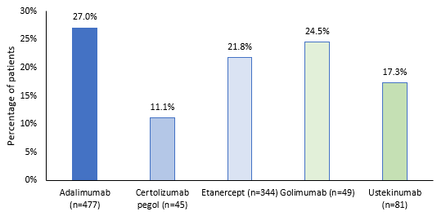

Note: Discontinuation of the index biologic was defined as a gap of ≥90 days between the end of days of supply of one prescription and the date of next prescription for all index biologics.

