Supplementary material for:

White light emission from a zero-dimensional lead-chloride hybrid material

S. Elleuch,^{1,*} A. Lusson,² S. Pillet,³ K. Boukheddaden² and Y. Abid¹

¹Laboratoire de Physique Appliquée, Faculté des Sciences de Sfax, Route de Soukra km 3.5 BP 1171, 3018 Sfax, Tunisia.
²Groupe d’Etudes de la Matière Condensée (GEMaC), UMR-CNRS 8653, Université de Versailles Saint Quentin En Yvelines, Université Paris-Saclay, 45 Avenue des Etats-Unis, 78035 Versailles, France.
³Laboratoire de Cristallographie, Résonance Magnétique et Modélisations, UMR-CNRS 7036, Institut Jean Barriol, Université de Lorraine, BP 239, 54506 Vandœuvre-lès-Nancy, France.
*Corresponding author : slimlpa@yahoo.fr

Table S1. Crystallographic data for (TAE)₂[Pb₂Cl₁₀](Cl)₂.
Chemical formula | (C6N4H22)2[Pb2Cl10]Cl2
Chemical formula moiety | Cl10 Pb2, 2(C6 H22 N4), 2(Cl)
Formula weight/gmol⁻¹ | 1140.33
Crystalsystem | triclinic
Space group | P-1
a/Å | 9.9851(10)
b/Å | 10.2719(10)
c/Å | 18.4551(17)
α/° | 74.596(3)
β/° | 85.797(4)
γ/° | 67.643(3)
Volume/Å³ | 1686.9(3)
Z | 2
Temperature (K) | 100(2)
Collected reflections | 177910
$θ_{min}-θ_{max}$/° | 2.206-36.418
Crystal colour | colourless
F(000) | 1080
Absorption coefficient | 10.938
Radiation source (wavelength) | MoK\a (0.71073)
h_{min}- h_{max}; k_{min}-k_{max}; l_{min}-l_{max}/° | -16-16 ; -17-17 ; -30-30
R_{int} | 0.0556
ªR1 [F²> 2*s(F²)] | 0.0306 [0.0219]
ªwR2 [F²> 2*s(F²)] | 0.0526 [0.0454]
^{b}Goodness-of-fit on F² | 1.154
Largest diff. peak/hole / e⁻ Å⁻³ | 1.291 / -1.604
ªR₁=Σ(Fo-Fc|/Fo) and wR2= {Σ[w(F_{o}²-F_{c}²)²]/ Σ[w(F_{o}²)²]}^{1/2}
^{b}G.O.F = [(Σ(w(Fo²-Fc²))²/(Nobs-Nvar)]^{1/2}

Table S2. Experimental bond lengths and angles of the two [Pb₂Cl₁₀]⁶⁻ groups.
Bond | Length (Å) | Angle | Value (°)
Pb1-Cl4 | 2.7724(5) | Cl4-Pb1-Cl3 | 87.252(16)
Pb1-Cl3 | 2.7840(5) | Cl4-Pb1-Cl5 | 83.671(14)
Pb1-Cl5 | 2.9078(6) | Cl3-Pb1-Cl5 | 87.174(15)
Pb1-Cl1 | 2.9345(5) | Cl4-Pb1-Cl1 | 170.175(14)
Pb1-Cl2 | 2.9599(6) | Cl3-Pb1-Cl1 | 91.010(15)
Pb1-Cl5 | 3.0488(5) | Cl5-Pb1-Cl1 | 86.587(14)
Pb2-Cl7 | 2.7835(5) | Cl4-Pb1-Cl2 | 88.480(15)
Pb2-Cl9 | 2.8406(5) | Cl3-Pb1-Cl2 | 95.037(15)
Pb2-Cl8 | 2.8624(5) | Cl5-Pb1-Cl2 | 171.740(14)
Pb2-Cl10 | 2.9397(6) | Cl1-Pb1-Cl2 | 101.309(15)
Pb2-Cl6 | 2.9523(6) | Cl4-Pb1-Cl5 | 97.068(15)
Pb2-Cl9 | 3.0430(6) | Cl3-Pb1-Cl5 | 174.998(14)
 |  | Cl5-Pb1-Cl5 | 90.787(14)
 |  | Cl1-Pb1-Cl5 | 84.306(15)
 |  | Cl2-Pb1-Cl5 | 87.622(14)
 |  | Cl7-Pb2-Cl9 | 91.798(16)
 |  | Cl7-Pb2-Cl8 | 90.723(15)
 |  | Cl9-Pb2-Cl8 | 83.934(15)
 |  | Cl7-Pb2-Cl10 | 88.353(15)
 |  | Cl9-Pb2-Cl10 | 91.501(15)
 |  | Cl8-Pb2-Cl10 | 175.313(14)
 |  | Cl7-Pb2-Cl6 | 91.297(15)
 |  | Cl9-Pb2-Cl6 | 176.750(14)
 |  | Cl8-Pb2-Cl6 | 97.021(15)
 |  | Cl10-Pb2-Cl6 | 87.595(15)
 |  | Cl7-Pb2-Cl9 | 166.464(14)
 |  | Cl9-Pb2-Cl9 | 89.539(15)
 |  | Cl8-Pb2-Cl9 | 76.021(15)
 |  | Cl10-Pb2-Cl9 | 105.081(15)
 |  | Cl6-Pb2-Cl9 | 87.684(15)
 |  | Pb1-Cl5-Pb1 | 89.213(14)
 |  | Pb2-Cl9-Pb2 | 90.461(15)

Figure S1.Crystal structure of the (TAE)₂[Pb₂Cl₁₀](Cl)₂ projected along the (left) a-axis and (right) c-axis.
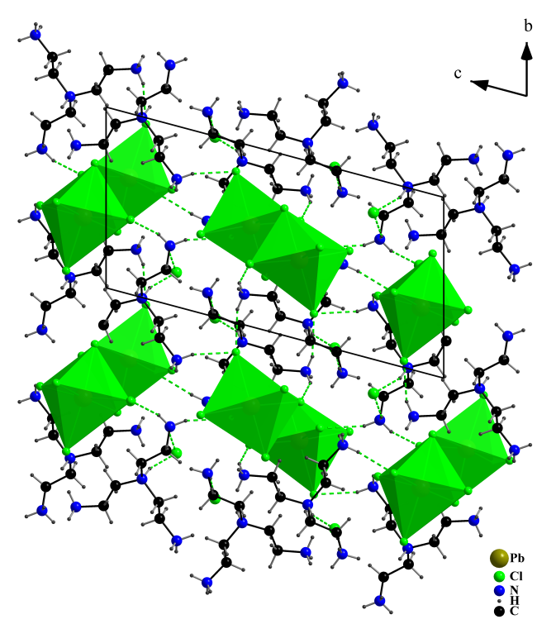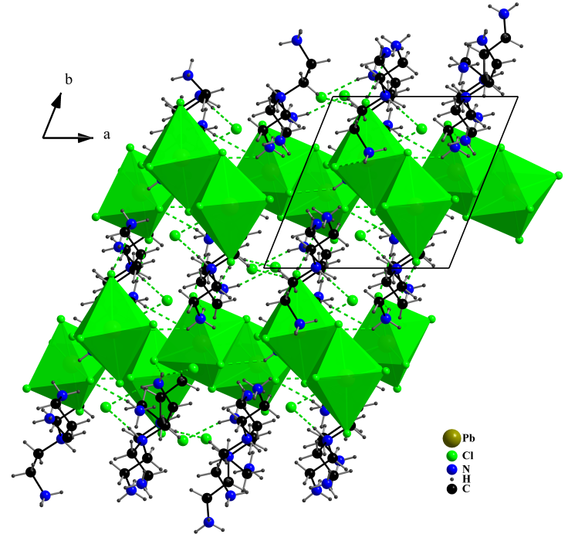

Figure S2. N-H…Cl hydrogen bonds in (TAE)₂[Pb₂Cl₁₀](Cl)₂. The two symmetry independent [TAE]⁴⁺ cations are involved in a dense network of N-H…Cl hydrogen bonds.(left) The first cation is connected to four [Pb₂Cl₁₀]⁶⁻ groups and 2 Cl⁻ ions; (right) the second cation is connected to five [Pb₂Cl₁₀]⁶⁻ groups and 2 Cl⁻ ions.
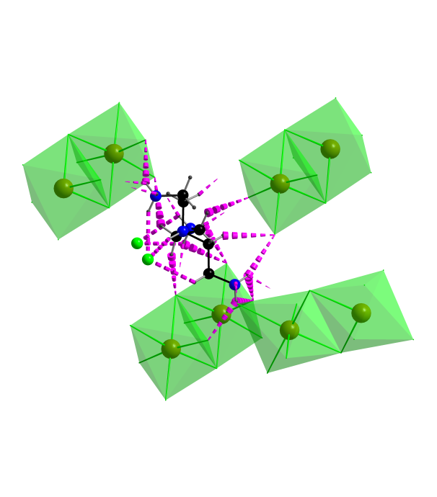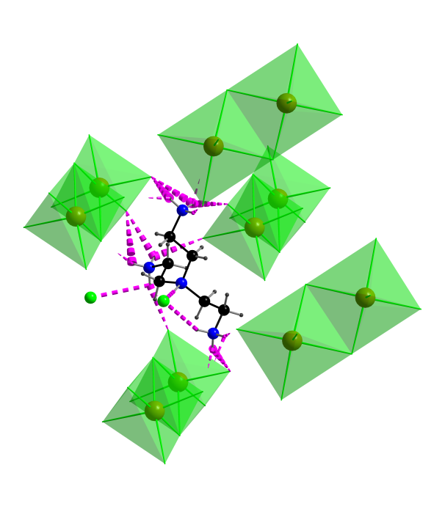
Figure S3. Structural distortion of the two [Pb₂Cl₁₀]⁶⁻ groups. The geometries of the two [Pb₂Cl₁₀]⁶⁻ groups is quite different
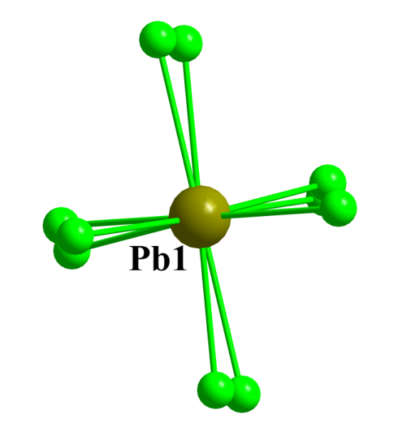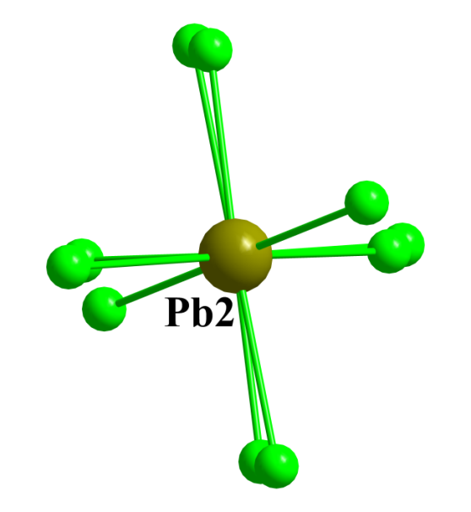

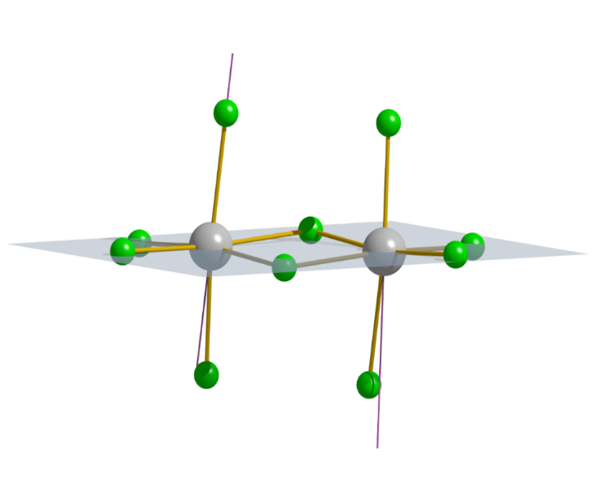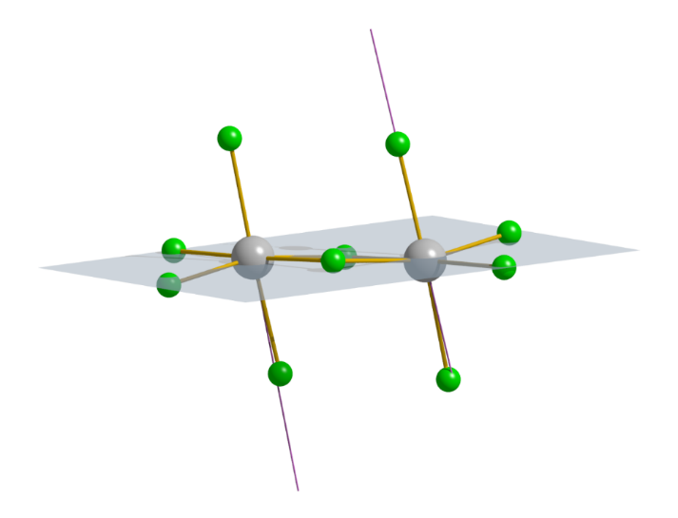
86.03(2)°
Pb1
81.36(2)°
Pb2
78.71(2)°
99.24(2)°

Figure S4. Superposition of the two [Pb₂Cl₁₀]⁶⁻ groups.
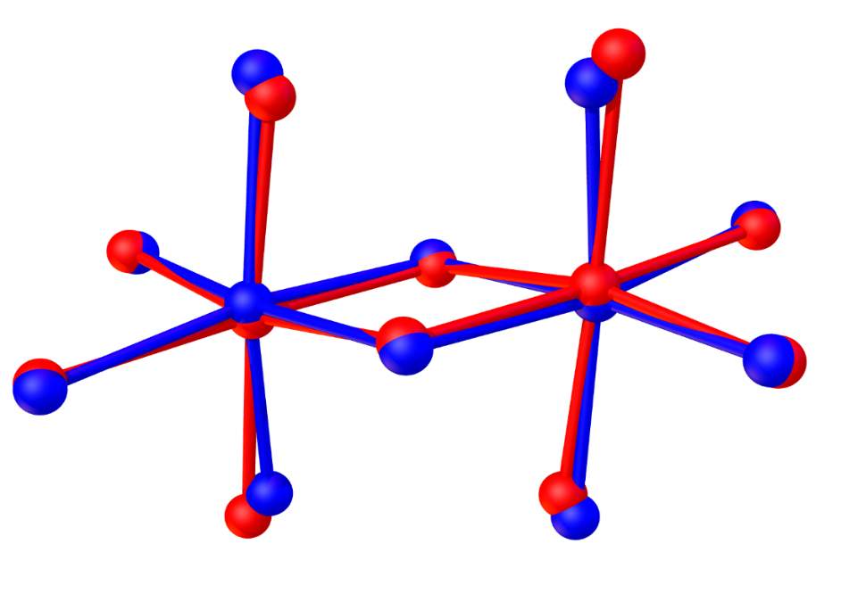
Pb1
Pb2
Figure S5. Superposition of the [TAE]⁴⁺ cations. The two [TAE]⁴⁺ adopt the same conformation

Figure S6. Room temperature Raman spectrum of (TAE)₂[Pb₂Cl₁₀](Cl)₂.
