Online Supplemental Material: Genetic risk modifier testing (GRMT) educational material
Background
- Please imagine that you have a mutation in the BRCA2 gene. We are not focusing on mutations in other genes today.
- Because of your BRCA2 mutation, you are at higher risk for getting breast cancer than the average woman. A review of many studies shows that for women with a BRCA2 mutation, the average risk for getting breast cancer by age 70 could be as low as 31% and as high as 56%. Put another way, among 100 women like you, as few as 31 and as many as 56 of them would get breast cancer. Many risk factors can make it more or less likely that you will get breast cancer. For example, studies show that having a BRCA2 mutation plus a strong family history of cancer could make a woman’s risk of getting breast cancer by age 70 as high as 85%.
- Other genes can also be risk factors for getting breast cancer. Some of these genes are called genetic modifiers. Genetic modifiers are common and a normal part of a person’s genetic make-up. Like all genes, you have two copies of each genetic modifier – one copy that was passed down from your mother, and one that was passed down from your father. Genetic modifiers likely do not cause cancer on their own. But, genetic modifiers interact with the BRCA2 gene to affect a woman’s cancer risk. Each genetic modifier can have a very small effect on whether a BRCA2 mutation causes breast cancer.
- Scientists have found 14 different genetic modifiers that interact with a BRCA2 mutation to affect a woman’s risk of breast cancer. Some versions of these genetic modifiers can reduce risk, because studies show that they are related to a lower risk of breast cancer among women with a BRCA2 mutation. Some versions of these genetic modifiers can enhance risk, because studies show that having more of these genetic modifiers is related to a higher risk of breast cancer among women with a BRCA2 mutation. Finally, some versions of these genetic modifiers are neutral, because they do not change a woman’s risk of breast cancer at all.
- If you have a mutation in the BRCA2 gene, then knowing about your genetic modifiers may help doctors to better estimate your breast cancer risk.

- An analogy may help. Imagine that we have a balance or scale. When the balance is level, this is equal to the risk of breast cancer for the average woman. Pretend that as the balance tips to the right, the risk of getting cancer increases.
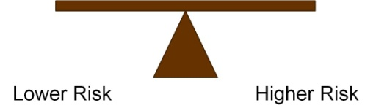
A BRCA2 mutation is like adding a big, heavy weight to the right side of the balance – it causes the balance to tip a lot.
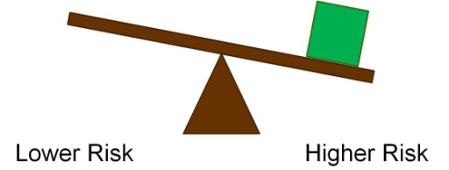
Genetic modifiers are like adding much smaller weights to the balance – they only cause it to tip a little. Modifiers that reduce risk cause the balance to tip a little to the left, and modifiers that enhance risk cause the balance to tip a little to the right.
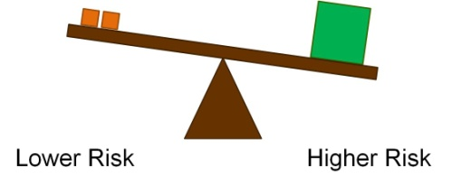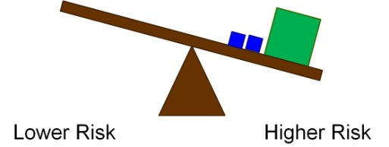
If you add the big, heavy weight and lots of the smaller weights together, then the balance will tip very far to the right, even if you add some smaller weights to the left.
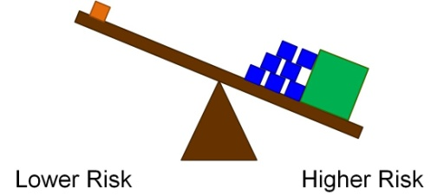
- Now, imagine that as a woman with a BRCA2 mutation, your doctor has offered you a new test that checks for the 14 genetic modifiers for breast cancer risk.

