**Supplementary Material**

**1. PRISMA checklist**

|  |  |  |  |  |  |  |  |  |  |
| --- | --- | --- | --- | --- | --- | --- | --- | --- | --- |
| **Section/Topic** | | **#** |  | **Checklist item** | **Reported on page #** | | |  | |
|  | |  |  |  |  | | |  | |
|  | |  |  |  |  | | |  | |
| **TITLE** | |  |  |  |  | | |  | |
| Title | | 1 |  | Identify the report as a systematic review, meta-analysis, or | 01 | | |  | |
|  | |  |  | both. |  | |
|  | |  |  |  | | |  | |
|  | |  |  |  |  | | |  | |
|  | |  |  |  |  | | |  | |
| **ABSTRACT** | |  |  |  |  | | |  | |
| Structured | | 2 |  | Provide a structured summary including, as applicable: |  | | |  | |
| summary | |  |  | background; objectives; data sources; study eligibility |  | | |  | |
|  | |  |  | criteria, participants, and interventions; study appraisal and | 02 | | |  | |
|  | |  |  | synthesis methods; results; limitations; conclusions and |  | |
|  | |  |  |  | | |  | |
|  | |  |  | implications of key findings; systematic review registration |  | | |  | |
|  | |  |  | number. |  | | |  | |
|  | |  |  |  |  | | |  | |
|  | |  |  |  |  | | |  | |
| **INTRODUCTION** | | |  |  |  | | |  | |
| Rationale | | 3 |  | Describe the rationale for the review in the context of what | 03 | | |  | |
|  | |  |  | is already known. |  | |
|  | |  |  |  | | |  | |
|  | |  |  |  |  | | |  | |
| Objectives | | 4 |  | Provide an explicit statement of questions being addressed |  | | |  | |
|  | |  |  | with reference to participants, interventions, comparisons, | 04 | | |  | |
|  | |  |  | outcomes, and study design (PICOS). |  | | |  | |
|  | |  |  |  |  | | |  | |
|  | |  |  |  |  | | |  | |
| **METHODS** | |  |  |  |  | | |  | |
| Protocol and | | 5 |  | Indicate if a review protocol exists, if and where it can be |  | | |  | |
| registration | |  |  | accessed (e.g., Web address), and, if available, provide | 04 | | |  | |
|  | |  |  | registration information including registration number. |  | | |  | |
|  | |  |  |  |  | | |  | |
| Eligibility | | 6 |  | Specify study characteristics (e.g., PICOS, length of follow- |  | | |  | |
| criteria | |  |  | up) and report characteristics (e.g., years considered, | 04-05 | | |  | |
|  | |  |  | language, publication status) used as criteria for eligibility, |  | |
|  | |  |  |  | | |  | |
|  | |  |  | giving rationale. |  | | |  | |
|  | |  |  |  |  | | |  | |
| Information | | 7 |  | Describe all information sources (e.g., databases with |  | | |  | |
| sources | |  |  | dates of coverage, contact with study authors to identify | 04 | | |  | |
|  | |  |  | additional studies) in the search and date last searched. |  | | |  | |
|  | |  |  |  |  | | |  | |
| Search | | 8 |  | Present full electronic search strategy for at least one |  | | |  | |
|  | |  |  | database, including any limits used, such that it could be | 04 | | |  | |
|  | |  |  | repeated. |  | | |  | |
|  | |  |  |  |  | | |  | |
| Study | | 9 |  | State the process for selecting studies (i.e., screening, |  | | |  | |
| selection | |  |  | eligibility, included in systematic review, and, if applicable, | 04 | | |  | |
|  | |  |  | included in the meta-analysis). |  | | |  | |
|  | |  |  |  |  | | |  | |
| Data | | 10 |  | Describe method of data extraction from reports (e.g., |  | | |  | |
| collection | |  |  | piloted forms, independently, in duplicate) and any | 05 | | |  | |
| process | |  |  | processes for obtaining and confirming data from |  | |
|  |  |  | | |  | |
|  | |  |  | investigators. |  | | |  | |
|  | |  |  |  |  | | | | |
| Data items | 11 | List and define all variables for which data were sought | | |  |  | |  | |
|  |  | (e.g., PICOS, funding sources) and any assumptions and | | | 05 | | |  | |
|  |  | simplifications made. | | |  |  | |  | |
|  |  |  | | |  |  | |  | |
| Risk of bias in | 12 | Describe methods used for assessing risk of bias of | | |  |  | |  | |
| individual |  | individual studies (including specification of whether this | | | 05 | | |  | |
| studies |  | was done at the study or outcome level), and how this | | |  | |
|  |  |  | |  | |
|  |  | information is to be used in any data synthesis. | | |  |  | |  | |
|  |  |  | | |  |  | |  | |
| Summary | 13 | State the principal summary measures (e.g., risk ratio, | | | 05-06 | | |  | |
| measures |  | difference in means). | | |  | |
|  |  |  | |  | |
|  |  |  | | |  |  | |  | |
| Synthesis of | 14 | Describe the methods of handling data and combining | | |  |  | |  | |
| results |  | results of studies, if done, including measures of | | |  | NA | | | |
|  |  | consistency (e.g., I2) for each meta-analysis. | | |  |  | |  | |
|  |  |  | | |  |  | |  | |
| Risk of bias | 15 | Specify any assessment of risk of bias that may affect the | | |  |  | |  | |
| across studies |  | cumulative evidence (e.g., publication bias, selective | | |  | NA | | | |
|  |  | reporting within studies). | | |  |  | |  | |
|  |  |  | | |  |  | |  | |
| Additional | 16 | Describe methods of additional analyses (e.g., sensitivity | | |  |  | |  | |
| analyses |  | or subgroup analyses, meta-regression), if done, indicating | | |  | NA | | | |
|  |  | which were pre-specified. | | |  |  | |  | |
|  |  |  | | |  |  | |  | |
|  |  |  | | |  |  | |  | |
| **RESULTS** |  |  | | |  |  | |  | |
| Study | 17 | Give numbers of studies screened, assessed for eligibility, | | |  |  | |  | |
| selection |  | and included in the review, with reasons for exclusions at | | | 06 | | |  | |
|  |  | each stage, ideally with a flow diagram. | | |  |  | |  | |
|  |  |  | | |  |  | |  | |
| Study | 18 | For each study, present characteristics for which data were | | |  |  | |  | |
| characteristics |  | extracted (e.g., study size, PICOS, follow-up period) and | | | 06-07 | | |  | |
|  |  | provide the citations. | | |  |  | |  | |
|  |  |  | | |  |  | |  | |
| Risk of bias | 19 | Present data on risk of bias of each study and, if available, | | | 07 | | |  | |
| within studies |  | any outcome level assessment (see item 12). | | |  | |
|  |  |  | |  | |
|  |  |  | | |  |  | |  | |
| Results of | 20 | For all outcomes considered (benefits or harms), present, | | |  |  | |  | |
| individual |  | for each study: (a) simple summary data for each | | | 07 | | |  | |
| studies |  | intervention group (b) effect estimates and confidence | | |  | |
|  |  |  | |  | |
|  |  | intervals, ideally with a forest plot. | | |  |  | |  | |
|  |  |  | | |  |  | |  | |
| Synthesis of | 21 | Present results of each meta-analysis done, including | | | 07 | | |  | |
| results |  | confidence intervals and measures of consistency. | | |  | |
|  |  |  | |  | |
|  |  |  | | |  |  | |  | |
| Risk of bias | 22 | Present results of any assessment of risk of bias across | | |  | NA | | | |
| across studies |  | studies (see Item 15). | | |  |
|  |  |  | |  | |
|  |  |  | | |  |  | |  | |
| Additional | 23 | Give results of additional analyses, if done (e.g., sensitivity | | |  | NA | | | |
| analysis |  | or subgroup analyses, meta-regression [see Item 16]). | | |  |
|  |  |  | |  | |
|  |  |  | | |  |  | |  | |
|  |  |  | | |  |  | |  | |
| **DISCUSSION** |  |  | | |  |  | |  | |
| Summary of | 24 | Summarize the main findings including the strength of | | |  |  | |  | |
| evidence |  | evidence for each main outcome; consider their relevance | | | 08 | | |  | |
|  |  | to key groups (e.g., healthcare providers, users, and policy | | |  | |
|  |  |  |  | |  | |
|  |  | makers). | | |  |  | |  | |
|  |  |  | | |  |  | |  | |
| Limitations | 25 | Discuss limitations at study and outcome level (e.g., risk of | | | 11-12 | | |  | |
|  |  | bias), and at review-level (e.g., incomplete retrieval of | | |  | |
|  |  |  |  | |  | |
|  |  |  | | |  |  | |  | |
|  |  | identified research, reporting bias). | | |  | | | | |
|  |  |  | | |  | | | | |
| Conclusions | 26 | Provide a general interpretation of the results in the | | |  | | | | |
|  |  | context of other evidence, and implications for future | | | 12 | | | | |
|  |  | research. | | |  | | | | |
|  |  |  | | |  | | | | |
|  |  |  | | |  | | | | |
| **FUNDING** |  |  | | |  | | | | |
| Funding | 27 | Describe sources of funding for the systematic review and | | |  | | | | |
|  |  | other support (e.g., supply of data); role of funders for the | | | 01 | | | | |
|  |  | systematic review. | | |  | | | | |
|  |  |  | | |  | | | | |
|  |  |  | | |  | | | | |

Reference: Moher D, Liberati A, Tetzlaff J, Altman DG, The PRISMA Group (2009). Preferred Reporting Items for Systematic Reviews and Meta-Analyses: The PRISMA Statement. PLoS Med 6(7): e1000097. doi:10.1371/journal.pmed1000097.

**2. Search strategies**

|  |  |  |  |
| --- | --- | --- | --- |
| **Database** | **Search Terms** | **Results** |  |
| **MEDLINE**  PubMed  11/26/2019 | **NON-INVASIVE STIMULATION**  ("noninvasive brain stimulation"[TIAB] OR "non-invasive brain stimulation"[TIAB] OR "neuromodulation"[TIAB] OR "NIBS"[TIAB] OR "motor cortex stimulation"[TIAB]) OR "transcranial magnetic stimulation"[Mesh] OR "transcranial magnetic stimulation"[TIAB] OR "TMS"[TIAB] OR "rTMS"[TIAB] OR “Transcranial Electric Stimulation”[TIAB] OR "transcranial direct current stimulation"[Mesh] OR "transcranial direct current stimulation"[TIAB] OR "transcranial Alternating Current Stimulation"[TIAB] OR “tACS”[TIAB] OR "transcranial Random Noise Stimulation"[TIAB] OR “tRNS”[TIAB] OR  "Transcutaneous Electric Nerve Stimulation"[Mesh] OR "Transcutaneous Electric Nerve Stimulation"[TIAB] OR "Transcutaneous Electrical Nerve Stimulation"[TIAB] OR TENS[TIAB] OR "Electroacupuncture"[Mesh] OR "tDCS"[TIAB]  **EXERCISE**  ("Exercise"[Mesh] OR "Exercise therapy"[Mesh] OR "Exercise Movement Techniques"[Mesh] OR "Exercise"[TIAB] OR "Exercise Therapy"[TIAB] OR "Resistance training"[TIAB] OR "aerobic exercise"[TIAB] OR kinesiotherapy [TIAB])  **PAIN**  ("pain"[Mesh] OR "Pain"[TIAB] OR "Chronic pain"[Mesh] OR "Chronic pain"[TIAB] OR "Neuralgia"[Mesh] OR "Neuropathic pain"[TIAB] OR "Nerve pain"[TIAB]) | **367** |  |
| **Central**  11/26/2019 | **NON-INVASIVE STIMULATION**  ("noninvasive brain stimulation":ti,ab OR "non-invasive brain stimulation":ti,ab OR "neuromodulation":ti,ab OR "NIBS":ti,ab OR "motor cortex stimulation":ti,ab OR "transcranial magnetic stimulation":ti,ab OR "TMS":ti,ab OR "rTMS":ti,ab OR “Transcranial Electric Stimulation”:ti,ab OR [mh "transcranial direct current stimulation"] OR "transcranial direct current stimulation":ti,ab OR "transcranial Alternating Current Stimulation":ti,ab OR “tACS”:ti,ab OR "transcranial Random Noise Stimulation":ti,ab OR “tRNS”:ti,ab OR  [mh "Transcutaneous Electric Nerve Stimulation"] OR "Transcutaneous Electric Nerve Stimulation":ti,ab OR "Transcutaneous Electrical Nerve Stimulation":ti,ab OR TENS:ti,ab OR [mh "Electroacupuncture"] OR "tDCS":ti,ab  **EXERCISE**  ([mh "Exercise"] OR [mh "Exercise therapy"] OR [mh "Exercise Movement Techniques"] OR "Exercise":ti,ab OR "Exercise Therapy":ti,ab OR "Resistance training":ti,ab OR "aerobic exercise":ti,ab OR kinesiotherapy:ti,ab)  **PAIN**  ([mh "pain"] OR "Pain":ti,ab OR ["Chronic pain":ti,ab OR [mh "Neuralgia"] OR "Neuropathic pain":ti,ab OR "Nerve pain":ti,ab) | **306** |  |
| **EMBASE**  11/26/2019 | #1 NON-INVASIVE STIMULATION  ‘transcranial direct current stimulation’/exp OR ‘noninvasive brain stimulation’:ab,ti OR ‘noninvasive brain stimulation’/exp OR ‘non-invasive brain stimulation’:ab,ti OR ‘trancranial direct current stimulation’:ab,ti OR ‘neuromodulation’:ab,ti OR ‘neuromodulation’/exp OR ‘nibs’:ab,ti OR ‘tdcs’:ab,ti OR ‘transcranial magnetic stimulation’/exp OR ‘transcranial magnetic stimulation’:ab,ti OR ‘tms’:ab,ti OR ‘rtms’:ab,ti OR ‘motor cortex stimulation’:ab,ti OR ‘transcutaneous electric nerve stimulation’:ab,ti OR ‘transcutaneous electrical nerve stimulation’/exp OR ‘tens’:ab,ti OR ‘electroacupuncture’:ab,ti OR ‘electroacupuncture’/exp  #2 EXERCISE  ‘exercise’/exp OR ‘exercise’:ab,ti OR ‘Kinesiotherapy’/exp OR ‘kinesiotherapy’:ab,ti OR ‘exercise’:ab,ti OR ‘resistance training’:ab,ti OR ‘aerobic exercise’:ab,ti OR ‘resistance training’/exp OR ‘resistance training’:ab,ti OR ‘aerobic exercise’/exp  #3 PAIN  ‘pain’/exp OR ‘pain’:ab,ti OR ‘chronic pain’/exp OR ‘chronic pain’/exp OR ‘chronic pain’:ab,ti OR ‘neuralgia’/exp OR ‘neuralgia’:ab,ti OR ‘neuropathic pain’/exp OR ‘neuropathic pain’:ab,ti OR ‘radicular pain’/exp OR ‘radicular pain’:ab,ti OR ‘nerve pain’:ab,ti | **1609** |  |
| **Pedro**  11/26/2019 | 1 pain and TMS and exercise  2 pain and tDCS and exercise  3 pain and neuromodulation and exercise  4 pain and TENS and exercise | **29** |  |
| **Scopus**  11/26/2019 | TITLE-ABS(“transcranial direct current stimulation”) OR TITLE-ABS(“noninvasive brain stimulation”) OR TITLE-ABS(“non-invasive brain stimulation”) OR  TITLE-ABS(“transcranial direct current stimulation”) OR TITLE-ABS(“neuromodulation”) OR  TITLE-ABS(“nibs") OR  TITLE-ABS(“tdcs”) OR  TITLE-ABS(“transcranial magnetic stimulation”) OR  TITLE-ABS(“tms”) OR  TITLE-ABS(“rtms") OR  TITLE-ABS(“motor cortex stimulation”) OR  TITLE-ABS(“transcutaneous electric nerve stimulation”) OR  TITLE-ABS(“transcutaneous electrical nerve stimulation”) OR  TITLE-ABS(“tens”) OR  TITLE-ABS(“electroacupuncture”) AN  TITLE-ABS-KEY ( "Exercise" OR "Exercise therapy" OR "Exercise Movement Techniques" OR "Resistance training" OR "aerobic exercise" OR "kinesiotherapy" )  TITLE-ABS("pain") OR TITLE-ABS("Pain") OR TITLE-ABS ("Chronic pain") OR TITLE-ABS("Chronic pain") OR TITLE-ABS("Neuralgia”) OR TITLE-ABS("Neuropathic pain") OR TITLE-ABS("Nerve pain") | **382** |  |

**3. Calibration**





**4. Exclusion list and reason**

|  |  |  |  |  |
| --- | --- | --- | --- | --- |
| Number | Author | Title | Year | Reason of exclusion |
| 1 | Herrera M et al. | Efficacy and safety of transcranial direct current stimulation associated to virtual reality and toaerobic exercises program on the treatment of patients with fibromyalgia. | 2017 | Abstract |
| 2 | Røe C. | Transcranial magnetic stimulation, paravertebral muscles training, and postural control in chronic low back pain. | 2017 | No data for inclusion |
| 3 | Choi YL et al. | Effects of isometric exercise using biofeedback on maximum voluntary isometric contraction, pain, and muscle thickness in patients with knee osteoarthritis. | 2015 | No NIBS |
| 4 | Krath A et al. | Electromagnetic transduction therapy in non-specific low back pain: A prospective randomised controlled trial. | 2017 | No NIBS |
| 5 | Umar A et al. | Effect of combined brain and back muscle stimulations on level of physical disability among chronic low back pain patients. | 2017 | No Exercise |
| 6 | Angius L et al. | The effect of transcranial direct current stimulation of the motor cortex on exercise-induced pain. | 2015 | No data for inclusion |
| 7 | Yesil H et al. | Does the use of analgesic current therapies increase the effectiveness of neck stabilization exercises for improving pain, disability, mood, and quality of life in chronic neck pain? a randomized, controlled, single-blind study (a pilot study). | 2017 | No NIBS |
| 8 | Le Déan Y et al. | Management of neuropathic central pain by non-invasive brain stimulation and mirror therapy. | 2016 | No exercise |
| 9 | Nct. | Optimizing Chronic Low Back Pain Exercise Therapies With Cerebral Electrical Stimulation. | 2018 | No data for inclusion |
| 10 | Nct. | Repetitive Transcranial Magnetic Stimulation in Fibromyalgia. | 2010 | No data for inclusion |
| 11 | Rinne M et al. | Therapeutic Exercise Training to Reduce Chronic Headache in Working Women: Design of a Randomized Controlled Trial. | 2016 | No NIBS |
| 12 | Adedoyin et al. | TRANSCUTANEOUSELECTRICALNERVESTIMULATIONANDINTERFERENTIALCURRENTCOMBINEDWITHEXERCISEFORTHETREATMENTOFKNEEOSTEOARTHRITIS:A RANDOMISEDCONTROLLEDTRIA | 2005 | No NIBS |
| 13 | Cheing et al. | Does four weeks of TENSa nd/or isometric exercise produce cumulative reduction of osteoarthritic knee pain? | 2002 | No NIBS |
| 14 | Chiu et al. | A randomized clinical trial of TENS and exercise for patients with chronic neck pain | 2005 | No NIBS |
| 15 | Devo et al. | A controlled trial of TENS and exercise for chronic low back pain | 1990 | No NIBS |
| 16 | Chang et al. | Effects of exercise and tens in chronic low back pain | 2005 | Abstract |

**5. Other forest plot: sub-group analysis**   
**Figure S1.** Pain score by location of stimulation

**Figure S2.** Pain score by condition

**Figure S2.** Pain score by condition**Figure S3.** Pain score by number of NIBS sessions

**Figure S4**. Pain score by number of exercise weeks

**Figure S5**. Pain score by intensity of the tDCS

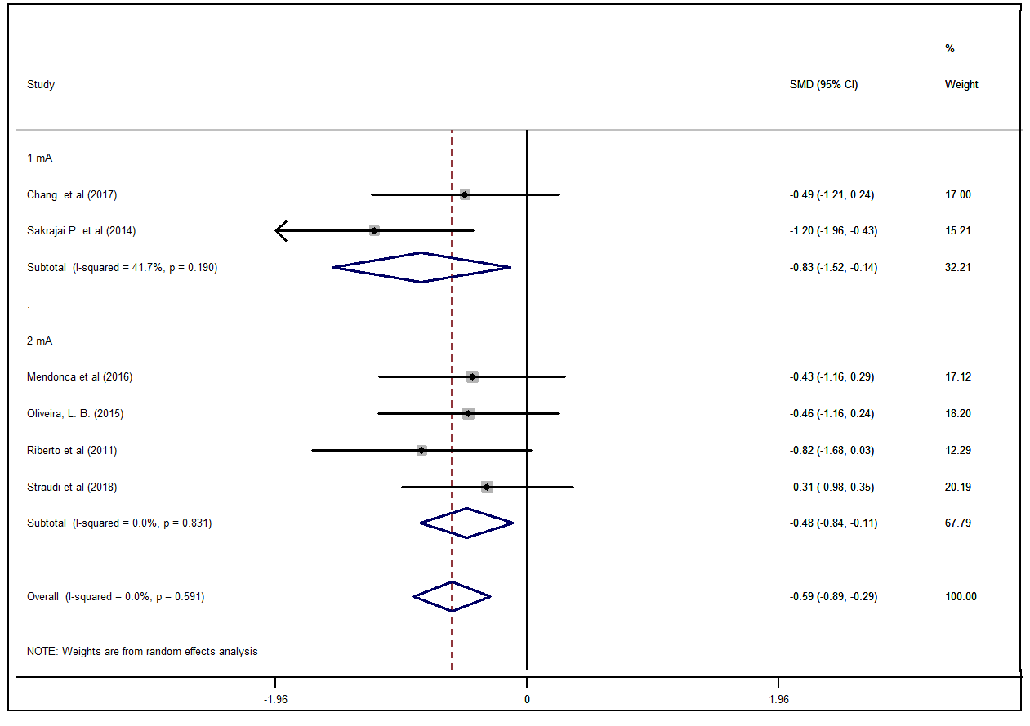

**Figure S6**. Sensitivity analysis

**Figure S7**. Sensitivity analysis

