Supplementary Data

Electric-field-induced electroporation and permeability of reactive oxygen species across a skin lipid membrane

Dharmendra Kumar Yadav^{a,b,$*}, Surendra Kumar^{a,b,$}, Eun-Ha Choi^{c}, Mi-Hyun Kim^{a,b*}

ªCollege of Pharmacy, Gachon University of Medicine and Science, Hambakmoeiro, 191, Yeonsu-gu, Incheon, 406-799, Korea
^{b}Gachon Institute of Pharmaceutical Science & Department of Pharmacy, College of Pharmacy, Gachon University, Incheon, 406-799, South Korea
^{c}Plasma Bioscience Research Center/PDP Research Center, Kwangwoon University, Nowon-Gu, Seoul 139-791, Korea
Email: dharmendra30oct@gmail.com, kmh0515@gachon.ac.kr

*corresponding author

Dr. Dharmendra Kumar Yadav, Ph.D
Assistant Professor
Office: +82-32-820-4947
Email: dharmendra30oct@gmail.com

Force Field Parameters for Reactive Oxygen Species.
Reactive Oxygen Species: H₂O₂ (Hydrogen Peroxide)

[ moleculetype ]
; Name nrexcl
HOOH 3
[ atoms ]
; nr type resnr resid atom cgnr charge mass total_charge
1 OP 1 HOOH O1 1 -0.42 15.9994
2 H 1 HOOH H2 1 0.42 1.0080 ; 0.000
3 OP 1 HOOH O3 2 -0.42 15.9994
4 H 1 HOOH H4 2 0.42 1.0080 ; 0.000
[ bonds ]
; ai aj funct c0 c1
1 2 2 0.0981 2.3064e+07 ;
1 3 2 0.1443 6.4702e+06
3 4 2 0.0981 2.3064e+07
[ exclusions ]
; ai aj
2 4 ; atoms involved in a RB-type dihedral
[ angles ]
; ai aj ak funct angle fc
2 1 3 2 100.36 524.48 ; 1 3 4 2 100.36 524.48
[ dihedrals ]
; ai aj ak al funct c0 c1 c2 c3 c4 c5
2 1 3 4 3 1.99544235 -10.72695 15.22612 -2.24420 0.25839 0.00000 ;

Reactive Oxygen Species: HO₂ (Hydroperoxyl)

[ moleculetype ]
; Name nrexcl
HOO 3
[ atoms ]
; nr type resnr resid atom cgnr charge mass total_charge
1 OP 1 HOO O1 1 -0.42 15.9994
2 H 1 HOO H2 1 0.494 1.0080
3 O 1 HOO O3 1 -0.074 15.9994 ; 0.000
[ bonds ]
; ai aj funct c0 c1
1 2 2 0.0981 2.3064e+07 ;
1 3 2 0.1443 6.4702e+06
[ angles ]
; ai aj ak funct angle fc
2 1 3 2 100.36 524.48 ;

Reactive Oxygen Species: HO (Hydroxyl)

[ moleculetype ]
; Name nrexcl
HO 3
[ atoms ]
; nr type resnr resid atom cgnr charge mass total_charge
1 OP 1 HO O1 1 -0.436 15.9994
2 H 1 HO H2 1 0.436 1.0080 ; 0.000
[ bonds ]
; ai aj funct c0 c1
1 2 2 0.0981 2.3064e+07 ;

Reactive Oxygen Species: O₂ (Molecular oxygen)

[ moleculetype ]
; Name nrexcl
O2 3
[ atoms ]
; nr type resnr resid atom cgnr charge mass total_charge
1 OO 1 O2 O1 1 0 15.9994
2 OO 1 O2 O2 2 0 15.9994 ; 0.000
[ bonds ]
; ai aj funct c0 c1
1 2 2 0.1210 1.6600e+07 ;

Table S1: The electroporation time (ps) in different conformations/frames of native skin-lipid bilayer membrane with respect to applied electric field (in V/nm).

 | Applied Electric Field (in V/nm)
 | 1 | 0.9 | 0.8 | 0.7 | 0.6 | 0.5 | 0.4 | 0.3 | (Time in ps)
CONF191 | 480 | 720 | 880 | 6280 | 10840 | - | - | -
CONF192 | 420 | 900 | 3140 | 3700 | 7540 | - | - | -
CONF193 | 300 | 540 | 1180 | 4940 | 7420 | - | - | -
CONF194 | 400 | 520 | 1740 | 5300 | 7920 | - | - | -
CONF195 | 300 | 760 | 1060 | 4920 | 10760 | - | - | -
CONF196 | 480 | 760 | 1380 | 4240 | 9820 | - | - | -
CONF197 | 280 | 600 | 940 | 5840 | 20940 | 68580 | - | -
CONF198 | 280 | 900 | 1740 | 6100 | 12380 | - | - | -
CONF199 | 530 | 720 | 1420 | 5490 | 21200 | 75140 | - | -
CONF200 | 530 | 1144 | 1846 | 4500 | 26454 | - | - | -
Note: ‘-‘indicated no poration observed in lipid bilayer membrane.

Table S2: Average electroporation time with respect to applied to electric field (in V/nm) of native skin-lipid bilayer membrane.

Electric Field (V/nm) | Electroporation Time (in ns)*
0.3 | -
0.4 | -
0.5 | 71.86(±4.64)
0.6 | 13.53(±6.79)
0.7 | 5.13 (±0.83)
0.8 | 1.53 (±0.66)
0.9 | 0.76(±0.19)
1.0 | 0.4 (±0.10)

Figure S1: The electroporation observed at different applied electric field (in V/nm) strength in native system. The hydrophilic headgroups are shown in vdW style.

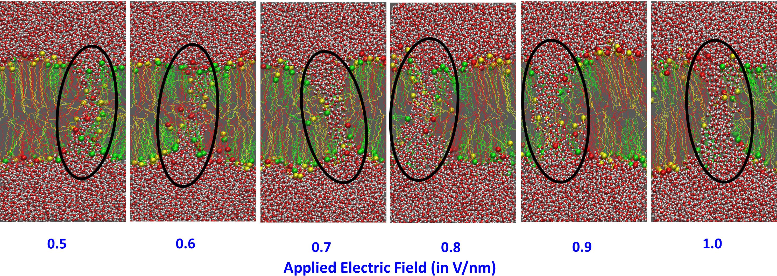
Table S3: The electroporation time (ps) in different conformations/frames of oxidized skin-lipid bilayer membrane (MEMB_12.5) with respect to applied electric field (in V/nm).

 | Applied Electric Field (in V/nm)
 | 1 | 0.9 | 0.8 | 0.7 | 0.6 | 0.5 | 0.4 | 0.3 | (Time in ps)
CONF191 | 346 | 680 | 1620 | 6758 | 3590 | 58320 | - | -
CONF192 | 210 | 450 | 1690 | 2440 | 8770 | - | - | -
CONF193 | 350 | 610 | 1180 | 2380 | 13030 | - | - | -
CONF194 | 300 | 740 | 970 | 2990 | 11230 | 26050 | - | -
CONF195 | 250 | 540 | 880 | 3590 | 22220 | 29050 | - | -
CONF196 | 340 | 740 | 1310 | 4370 | 14210 | 42560 | - | -
CONF197 | 400 | 680 | 750 | 4290 | 23910 | 62070 | - | -
CONF198 | 320 | 730 | 970 | 7980 | 8230 | 39720 | - | -
CONF199 | 450 | 530 | 1330 | 3420 | 16900 | 20580 | - | -
CONF200 | 310 | 760 | 1800 | 3750 | 11720 | 53720 | - | -
Note: ‘-‘indicated no poration observed in lipid bilayer membrane.

Table S4: Average electroporation time with respect to applied to electric field (in V/nm) of oxidized skin-lipid bilayer membrane (MEMB_12.5).

Electric Field (V/nm) | Electroporation Time (in ns)*
0.3 | -
0.4 | -
0.5 | 41.51 (±15.54)
0.6 | 13.38 (±6.26)
0.7 | 4.20 (±1.82)
0.8 | 1.25 (±0.36)
0.9 | 0.65 (±0.11)
1.0 | 0.33 (±0.07)

Figure S2: The electroporation observed at different applied electric field (in V/nm) strength in MEMB_12.5 system. The hydrophilic headgroups are shown in vdW style.

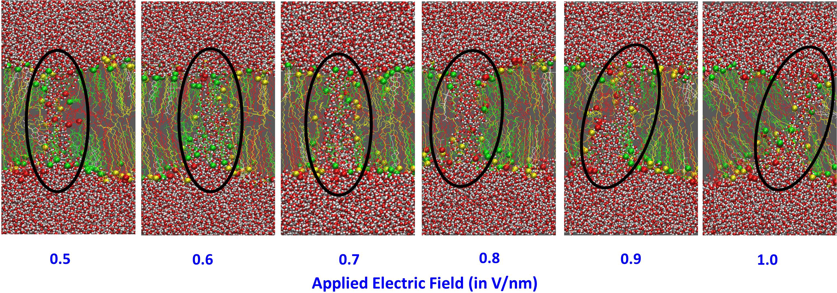
Table S5: The electroporation time (ps) in different conformations/frames of oxidized skin-lipid bilayer membrane (MEMB_25) with respect to applied electric field (in V/nm).

 | Applied Electric Field (in V/nm)
 | 1 | 0.9 | 0.8 | 0.7 | 0.6 | 0.5 | 0.4 | 0.3 | (Time in ps)
CONF191 | 180 | 580 | 1440 | 2520 | 5540 | 28770 | - | -
CONF192 | 260 | 700 | 1240 | 2720 | 4880 | 15110 | - | -
CONF193 | 480 | 620 | 740 | 2720 | 4040 | 32330 | - | -
CONF194 | 320 | 640 | 1520 | 2800 | 7640 | 30970 | - | -
CONF195 | 340 | 500 | 1420 | 3660 | 3600 | 19090 | - | -
CONF196 | 220 | 500 | 740 | 3860 | 8800 | 36640 | - | -
CONF197 | 260 | 540 | 1320 | 3260 | 7400 | 41870 | - | -
CONF198 | 310 | 520 | 870 | 2200 | 6000 | 28880 | - | -
CONF199 | 360 | 570 | 980 | 1440 | 3450 | 24530 | - | -
CONF200 | 360 | 450 | 1490 | 3420 | 7150 | 14690 | - | -
Note: ‘-‘indicated no poration observed in lipid bilayer membrane.

Table S6: Average electroporation time with respect to applied to electric field (in V/mm) of oxidized skin-lipid bilayer membrane (MEMB_25).

Electric Field (V/nm) | Electroporation Time (in ns)*
0.3 | -
0.4 | -
0.5 | 27.29 (±8.98)
0.6 | 5.85 (±1.86)
0.7 | 2.86 (±0.72)
0.8 | 1.18 (±0.31)
0.9 | 0.56 (±0.08)
1.0 | 0.31 (±0.08)

Figure S3: The electroporation observed at different applied electric field (in V/nm) strength in MEMB_25 system. The hydrophilic headgroups are shown in vdW style.

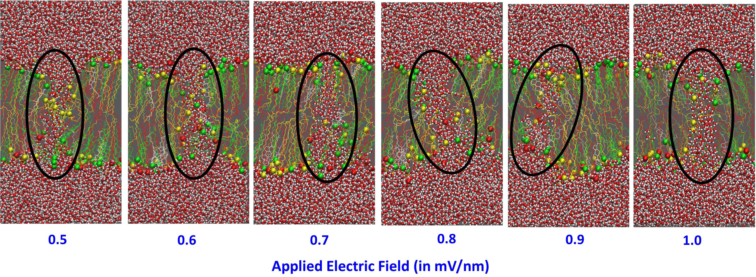
Table S7: The electroporation time (ps) in different conformations/frames of oxidized skin-lipid bilayer membrane (MEMB_50) with respect to applied electric field (in V/nm).

 | Applied Electric Field (in V/nm)
 | 1 | 0.9 | 0.8 | 0.7 | 0.6 | 0.5 | 0.4 | 0.3 | (Time in ps)
CONF191 | 270 | 650 | 870 | 2680 | 5290 | 39440 | - | -
CONF192 | 410 | 640 | 1350 | 1540 | 7540 | 19260 | - | -
CONF193 | 340 | 360 | 660 | 3700 | 8140 | 21090 | - | -
CONF194 | 190 | 180 | 770 | 1330 | 5180 | 12500 | - | -
CONF195 | 350 | 550 | 1350 | 1710 | 4210 | 16030 | - | -
CONF196 | 230 | 420 | 1080 | 2640 | 5740 | 29340 | - | -
CONF197 | 260 | 760 | 730 | 1650 | 7180 | 32860 | - | -
CONF198 | 390 | 540 | 1050 | 2910 | 4000 | 30940 | - | -
CONF199 | 260 | 700 | 1350 | 1040 | 4300 | 37410 | - | -
CONF200 | 320 | 530 | 1270 | 1470 | 4960 | 29740 | - | -
Note: ‘-‘indicated no poration observed in lipid bilayer membrane.

Table S8: Average electroporation time with respect to applied to electric field (in V/nm) of oxidized skin-lipid bilayer membrane (MEMB_50).

Electric Field (V/nm) | Electroporation Time (in ns)*
0.3 | -
0.4 | -
0.5 | 26.86 (±9.14)
0.6 | 5.65 (±1.47)
0.7 | 2.07 (±0.86)
0.8 | 1.05 (±0.28)
0.9 | 0.53 (±0.17)
1.0 | 0.30 (±0.07)

Figure S4: The electroporation observed at different applied electric field (in V/nm) strength in MEMB_50 system. The hydrophilic headgroups are shown in vdW style.

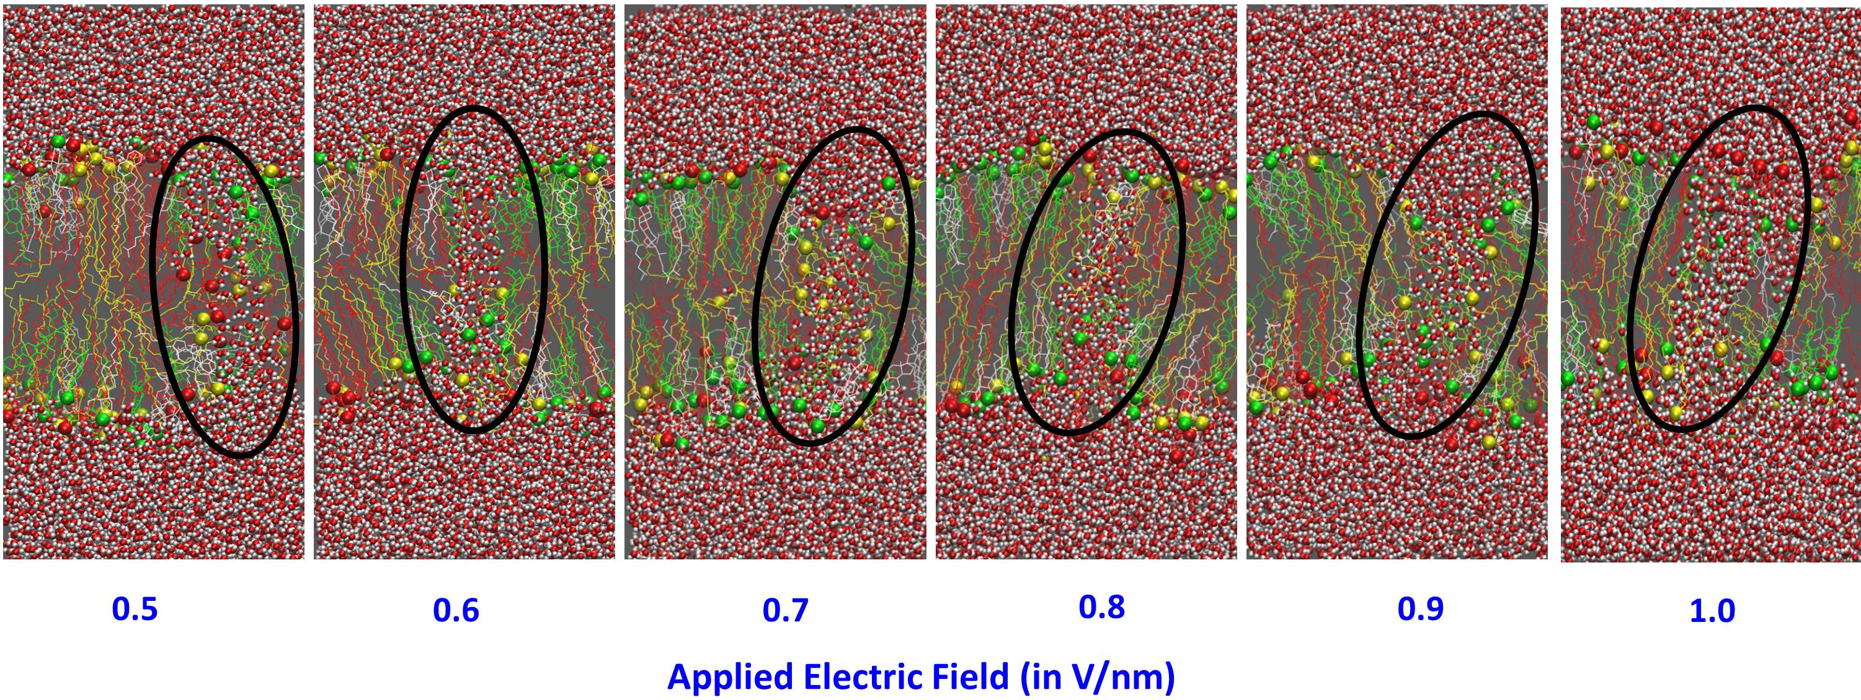
Table S9: The electroporation time (ps) in different conformations/frames of oxidized skin-lipid bilayer membrane (MEMB_60) with respect to applied electric field (in V/nm).

 | Applied Electric Field (in V/nm)
 | 1 | 0.9 | 0.8 | 0.7 | 0.6 | 0.5 | 0.4 | 0.3 | (Time in ps)
CONF191 | 260 | 600 | 580 | 1340 | 2180 | 5020 | - | -
CONF192 | 180 | 400 | 660 | 820 | 2940 | 13280 | - | -
CONF193 | 260 | 460 | 600 | 1340 | 2400 | 4520 | - | -
CONF194 | 160 | 360 | 680 | 2100 | 2440 | 5180 | - | -
CONF195 | 260 | 460 | 520 | 2220 | 4160 | 6000 | - | -
CONF196 | 260 | 320 | 900 | 1320 | 3800 | 9260 | - | -
CONF197 | 280 | 240 | 520 | 960 | 2300 | 15000 | - | -
CONF198 | 240 | 260 | 520 | 1180 | 2660 | 7740 | - | -
CONF199 | 180 | 280 | 640 | 1160 | 3060 | 9340 | - | -
CONF200 | 220 | 400 | 760 | 920 | 2780 | 16480 | - | -
Note: ‘-‘indicated no poration observed in lipid bilayer membrane.

Table S10: Average electroporation time with respect to applied to electric field (in V/nm) of oxidized skin-lipid bilayer membrane (MEMB_60).

Electric Field (V/nm) | Electroporation Time (in ns)*
0.3 | -
0.4 | -
0.5 | 9.18 (±4.36)
0.6 | 2.87 (±0.65)
0.7 | 1.34 (±0.47)
0.8 | 0.64 (±0.12)
0.9 | 0.38 (±0.11)
1.0 | 0.23 (±0.04)

Figure S5: The electroporation observed at different applied electric field (in V/nm) strength in MEMB_50 system. The hydrophilic headgroups are shown in vdW style.

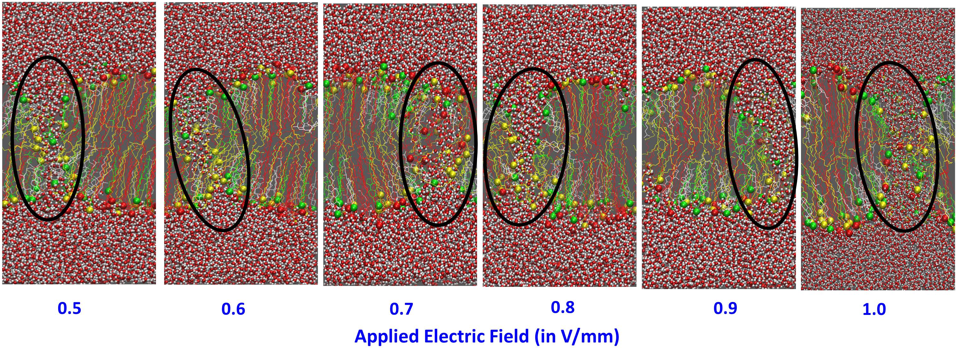
Figure S6: The selected frames representing the electroporation process in skin-lipid bilayer. The time given in each snapshot does represent only the kinetics of the defects developed in the bilayer after application of electric field. It is also important to note that, the electroporation process is stochastic in nature and the exact time at which poration observed are not exactly reproducible.

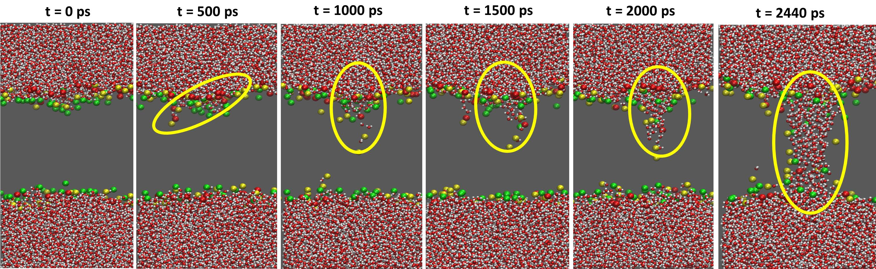

Table S11: The pore radius (in nm) after applied electric field across the native and oxidized skin-lipid bilayer membranes.
Electric Field  (V/nm) | Native | MEMB_12.5 | MEMB_25 | MEMB_50 | MEMB_60
0.5 | 1.90 | - | - | - | -
0.6 | 1.93 | 1.20 | 1.70 | 2.61 | 1.85
0.7 | 2.13 | 1.09 | 1.39 | 1.14 | 1.48
0.8 | 1.46 | 1.73 | 2.30 | 2.69 | 1.20
0.9 | 1.26 | 1.18 | 1.28 | 1.91 | 0.91
1.0 | 1.59 | 0.94 | 1.94 | 2.20 | 1.61

Table S12: Mean square displacement (MSD) for individual skin-lipid bilayer components in each system and the values are in cm²/s.
Systems | Electric Field  (V/nm) | Lipid Components
 |  | CER | CHO | FFA | 5α-CH
Native | 0.5 | 0.0033±0.0021 | 0.0055±0.0004 | 0.0046±0.0033 | -
 | 0.6 | 0.0047±0.0032 | 0.0052±0.0044 | 0.0052±0.0066 | -
 | 0.7 | 0.0129±0.0040 | 0.0097±0.0019 | 0.0141±0.0002 | -
 | 0.8 | 0.0177±0.0140 | 0.0136±0.0020 | 0.0340±0.0108 | -
 | 0.9 | 0.2018±0.0604 | 0.1960±0.0741 | 0.2041±0.0671 | -
 | 1.0 | 0.7110±0.5478 | 0.5908±0.4507 | 0.5719±0.3801 | -
MEMB_12.5 | 0.6 | 0.0123±0.0078 | 0.0107±0.0094 | 0.0139±0.0081 | 0.0110±0.0037
 | 0.7 | 0.0202±0.0167 | 0.0157±0.0122 | 0.0287±0.0140 | 0.0187±0.0199
 | 0.8 | 0.0689±0.0523 | 0.0654±0.0654 | 0.0745±0.0693 | 0.0711±0.0623
 | 0.9 | 0.1243±0.0815 | 0.1385±0.1134 | 0.1380±0.0702 | 0.1433±0/0857
 | 1.0 | 0.4384±0.3295 | 0.4090±0.2769 | 0.4838±0.3042 | 0.3584±0.2090
MEMB_25 | 0.6 | 0.0046±0.0029 | 0.0053±0.0029 | 0.0108±0.0004 | 0.0017±0.000
 | 0.7 | 0.0693±0.0294 | 0.0580±0.0405 | 0.0852±0.0350 | 0.0770±0.0648
 | 0.8 | 0.0803±0.0668 | 0.0864±0.0950 | 0.1019±0.0731 | 0.0776±0.0693
 | 0.9 | 0.1423±0.0812 | 0.1585±0.0927 | 0.1720±0.0912 | 0.1956±0.1571
 | 1.0 | 0.2752±0.1016 | 0.3134±0.2635 | 0.3219±0.1036 | 0.2717±0.1625
MEMB_50 | 0.6 | 0.0061±0.0079 | 0.0071±0.0002 | 0.0037±0.0038 | 0.0028±0.0043
 | 0.7 | 0.0281±0.0292 | 0.0316±0.0400 | 0.0341±0.0289 | 0.0307±0.0369
 | 0.8 | 0.0469±0.0413 | 0.0506±0.0537 | 0.0473±0.0309 | 0.0583±0.0650
 | 0.9 | 0.1270±0.0288 | 0.1430±0.0871 | 0.1717±0.0410 | 0.1275±0.068
 | 1.0 | 0.4961±0.3655 | 0.4777±0.3886 | 0.5242±0.3276 | 0.3459±0.2533
MEMB_60 | 0.6 | 0.0109±0.0102 | 0.0136±0.0108 | 0.0341±0.0002 | 0.0143±0.0116
 | 0.7 | 0.0364±0.0002 | 0.0247±0.0052 | 0.0494±0.0107 | 0.0374±0.0172
 | 0.8 | 0.0877±0.0462 | 0.1337±0.1104 | 0.2109±0.1619 | 0.1078±0.0847
 | 0.9 | 0.1960±0.1458 | 0.1667±0.1127 | 0.3000±0.1635 | 0.2240±0.2362
 | 1.0 | 0.3166±0.0930 | 0.2518±0.1616 | 0.3451±0.1078 | 0.2374±0.1568

Figure S7: MSD values of lipid component at (A) 0.5 V/mm; (B) 0.6 V/mm; (C) 0.7 V/mm; (D) 0.8 V/mm; (E) 0.9 V/mm; (F) 1.0 V/mm for native membrane system.
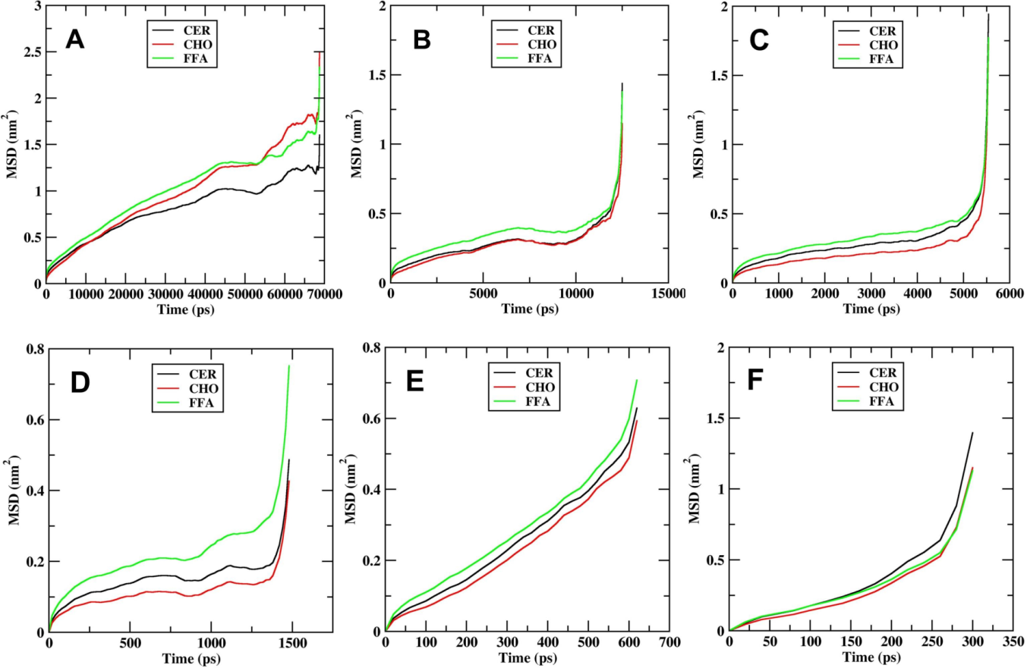

Figure S8: MSD values of lipid component at (A) 0.6 V/mm; (B) 0.7 V/mm; (C) 0.8 V/mm; (D) 0.9 V/mm; (E) 1.0 V/mm for MEMB_12.5 system.
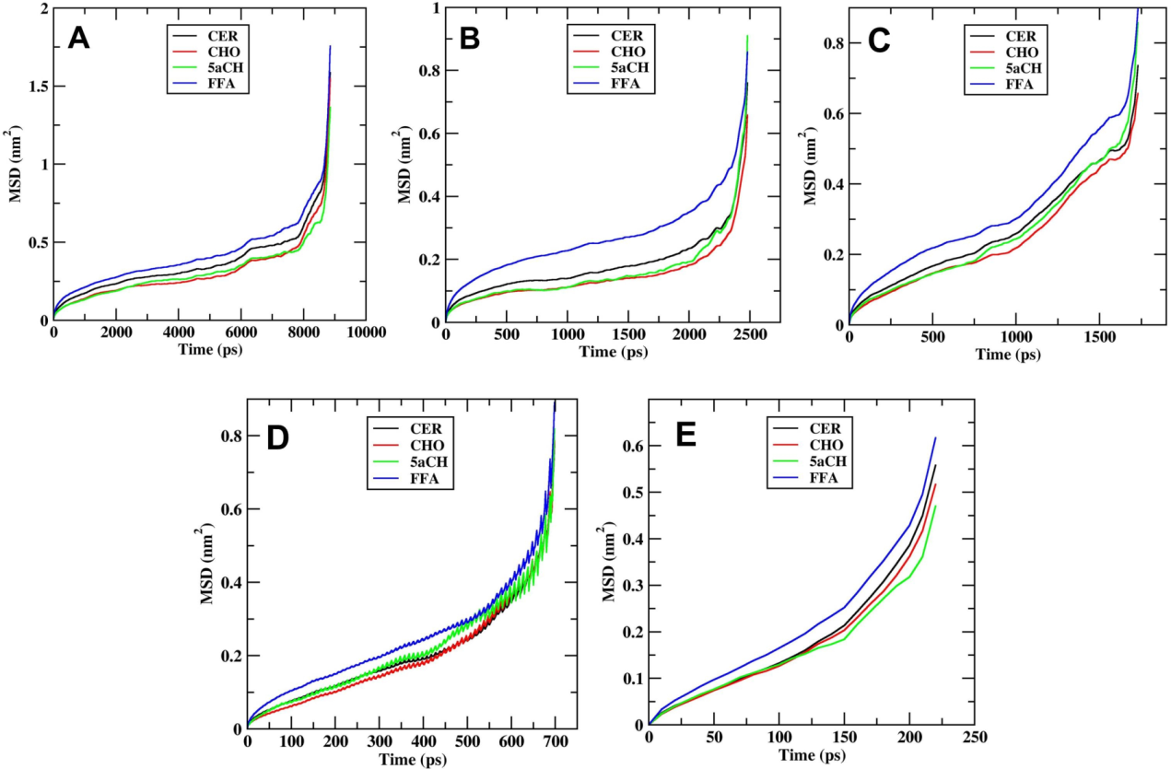

Figure S9: MSD values of lipid component at (A) 0.6 V/mm; (B) 0.7 V/mm; (C) 0.8 V/mm; (D) 0.9 V/mm; (E) 1.0 V/mm for MEMB_25 system.
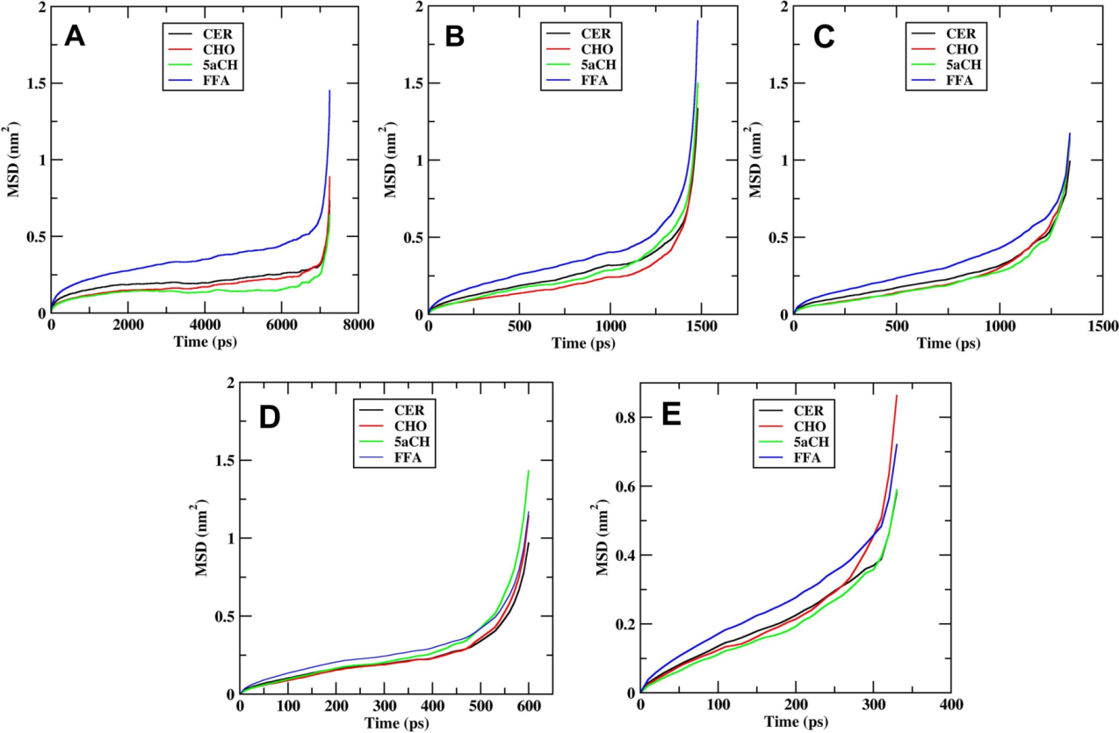

Figure S10: MSD values of lipid component at (A) 0.6 V/mm; (B) 0.7 V/mm; (C) 0.8 V/mm; (D) 0.9 V/mm; (E) 1.0 V/mm for MEMB_50 system.
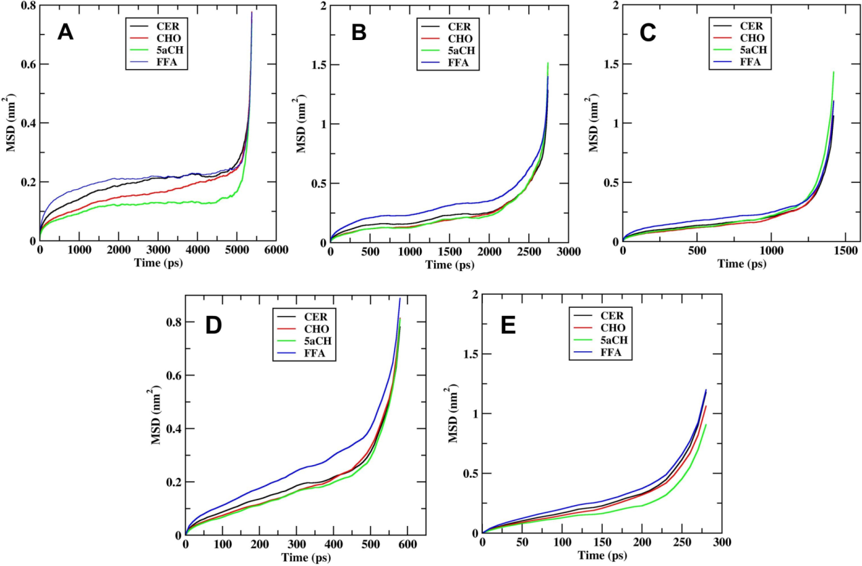

Figure S11: MSD values of lipid component at (A) 0.6 V/mm; (B) 0.7 V/mm; (C) 0.8 V/mm; (D) 0.9 V/mm; (E) 1.0 V/mm for MEMB_60 system.
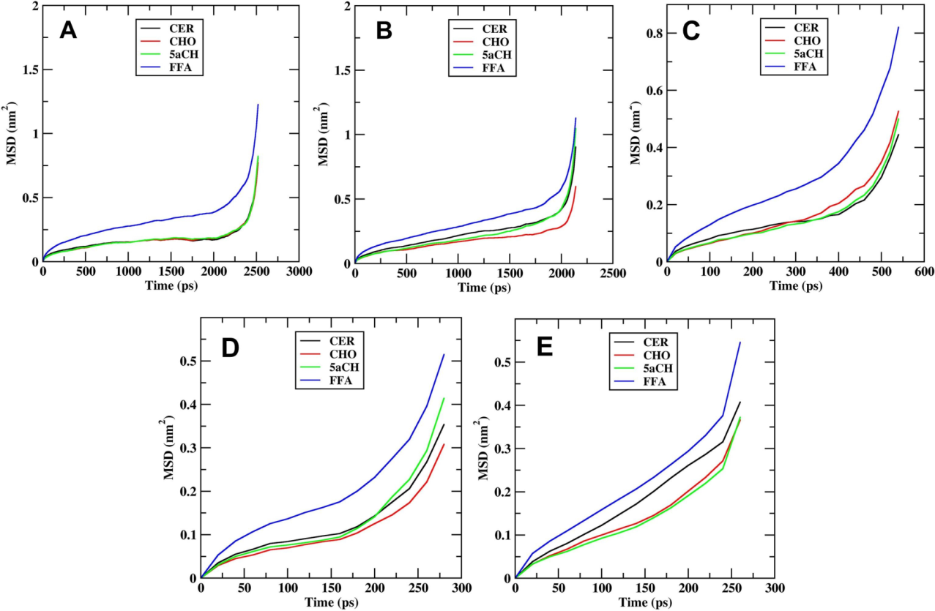

Figure S12: RDF values of lipid component at (A) 0.5 V/mm; (B) 0.6 V/mm; (C) 0.7 V/mm; (D) 0.8 V/mm; (E) 0.9 V/mm; (F) 1.0 V/mm for native membrane system.
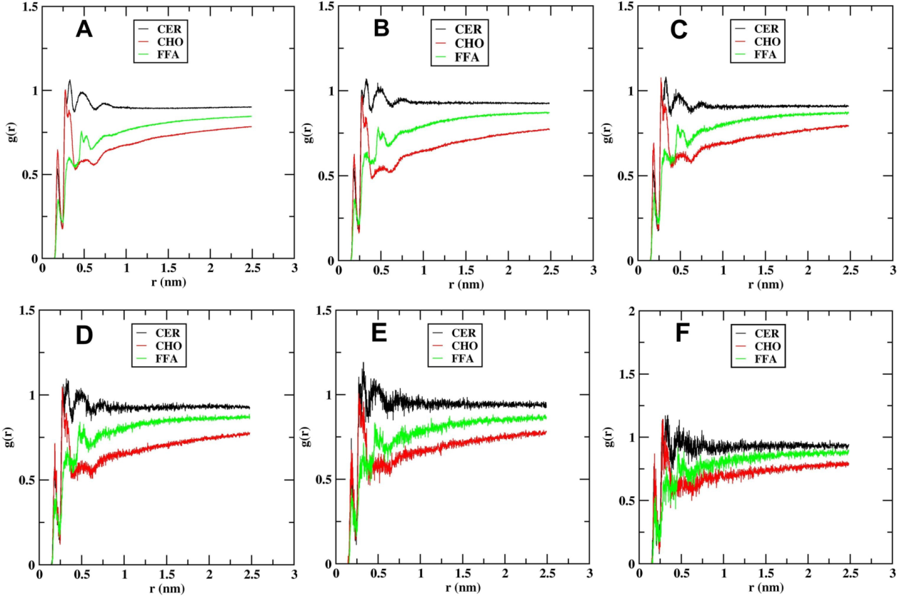

Figure S13: RDF values of lipid component at (A) 0.6 V/mm; (B) 0.7 V/mm; (C) 0.8 V/mm; (D) 0.9 V/mm; (E) 1.0 V/mm for MEMB_12.5 system.
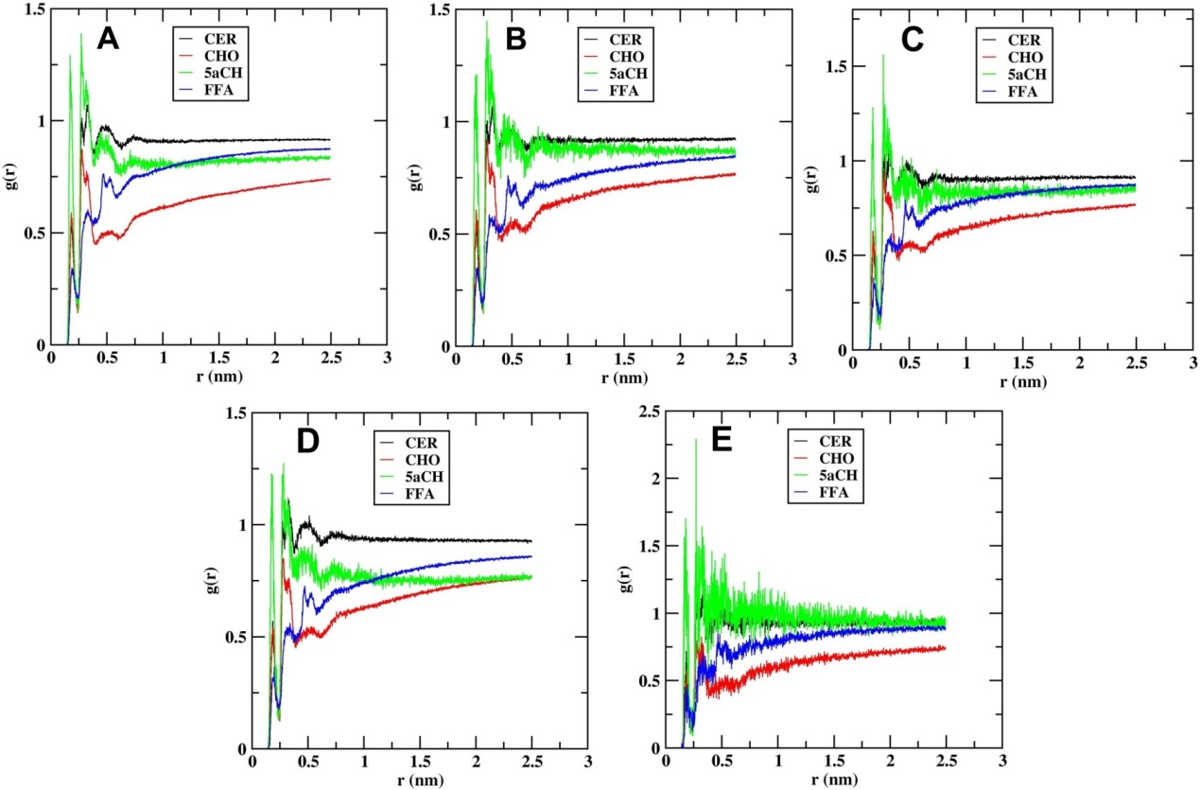

Figure S14: RDF values of lipid component at (A) 0.6 V/mm; (B) 0.7 V/mm; (C) 0.8 V/mm; (D) 0.9 V/mm; (E) 1.0 V/mm for MEMB_25 system.
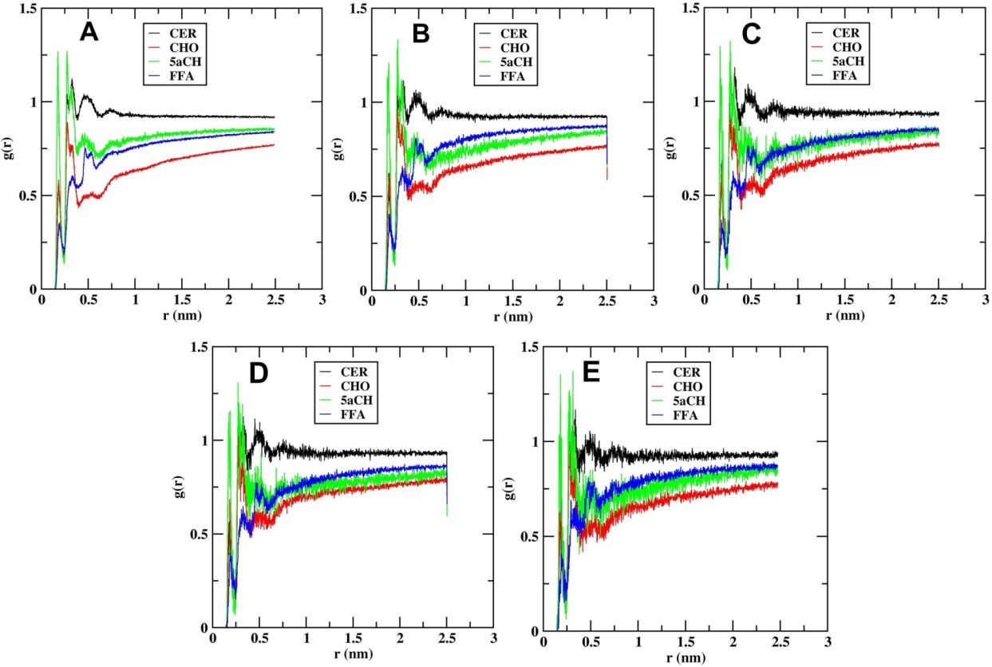

Figure S15: RDF values of lipid component at (A) 0.6 V/mm; (B) 0.7 V/mm; (C) 0.8 V/mm; (D) 0.9 V/mm; (E) 1.0 V/mm for MEMB_50 system.
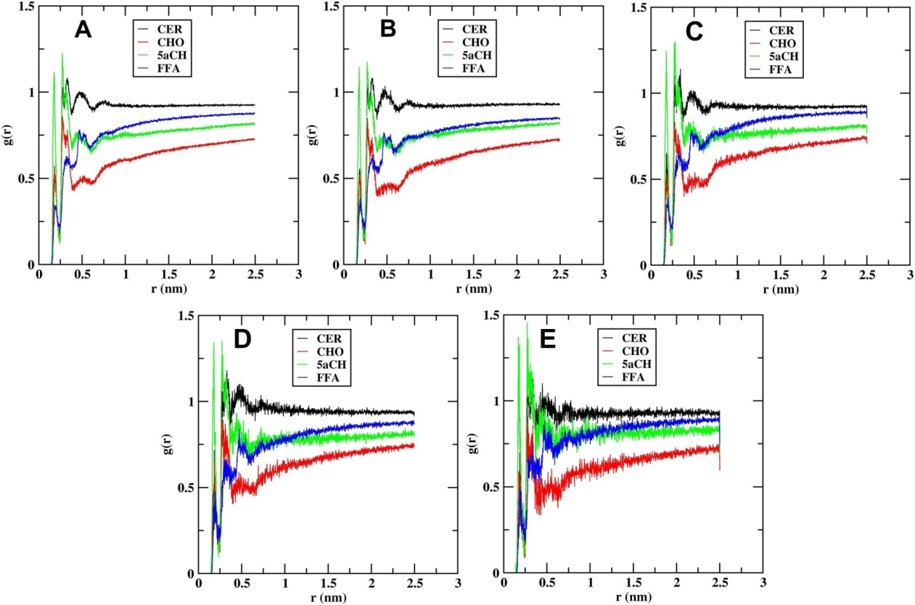

Figure S16: RDF values of lipid component at (A) 0.6 V/mm; (B) 0.7 V/mm; (C) 0.8 V/mm; (D) 0.9 V/mm; (E) 1.0 V/mm for MEMB_60 system.
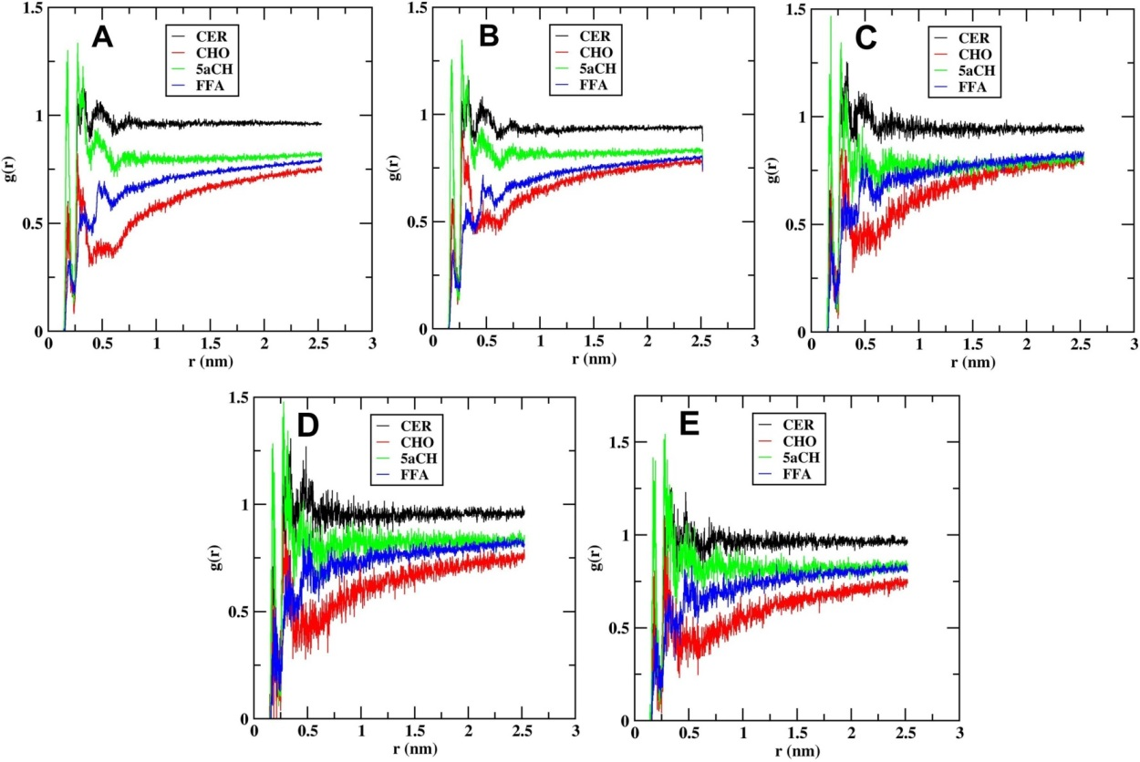

Figure S17: The representative snapshot showing the permeability of H₂O₂ species across the electroporated membrane system.
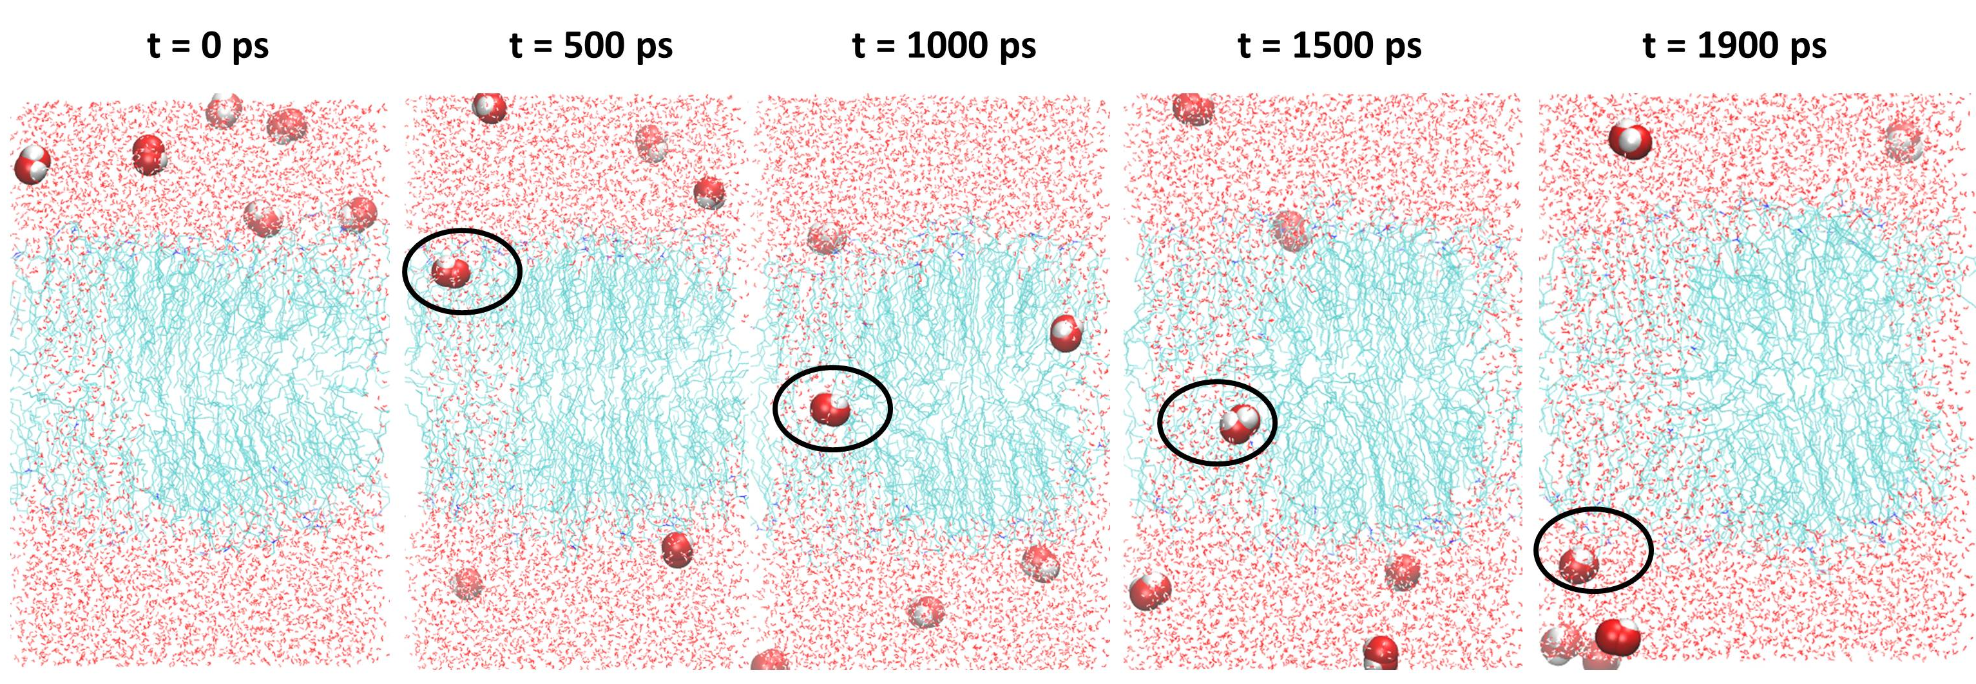
Figure S18: The representative snapshot showing the permeability of HO₂ species across the electroporated membrane system.
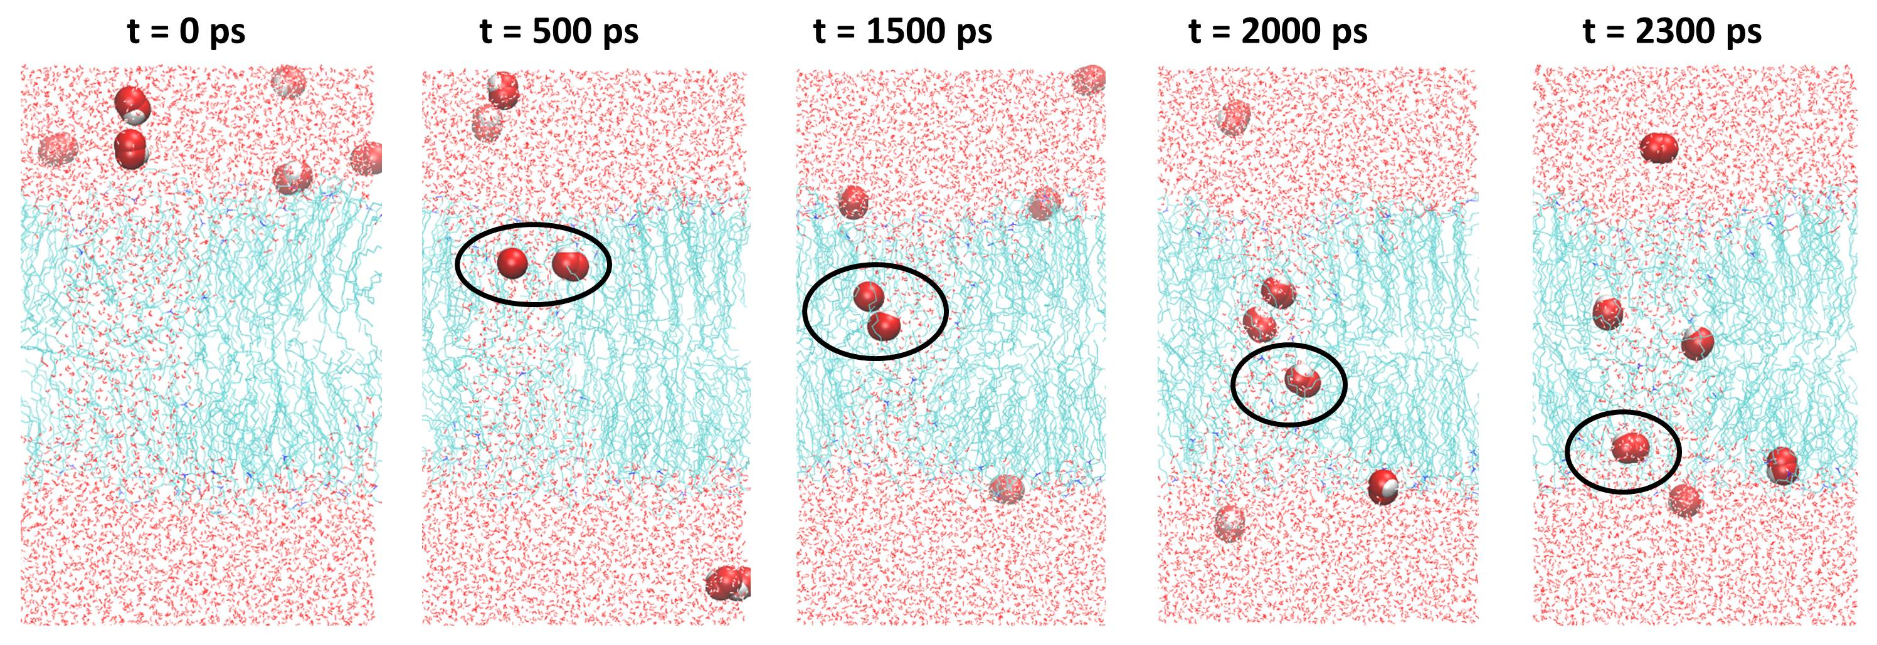
Figure S19: The representative snapshot showing the permeability of HO species across the electroporated membrane system.
