Supporting Information for
Green synthesis of chiral aromatic alcohols through Lactobacillus kefiri P2 as a novel biocatalyst

Yasemin Baydaş¹, Enes Dertli¹ and Engin Şahin^{2*}

¹Faculty of Engineering, Department of Food Engineering, Bayburt University, 69000, Bayburt, Turkey
² Faculty of Health Sciences, Department of Nutrition and Dietetics, Bayburt University, Bayburt,6900, Turkey

*Corresponding author: Engin Şahin, Faculty of Health Sciencies, Department of Nutrition and Dietetics, Bayburt University, Bayburt,6900, Turkey Tel: +90 (0) 458 2111153, Fax: +90 (0) 458 2111128, Email: esahin@bayburt.edu.tr

Spectral data for the compounds

(R)-1-phenylethanol (1a)¹: Colorless oil, ¹H-NMR (400 MHz, CDCl₃) δ = 7.38-7.33 (m, 4H), 7.31-7.26 (m, 1H), 4.84 (q, J = 6.45 Hz, 1H), 2.62 (bs, OH), 1.48 (d, J = 6.5 Hz, 3H); ¹³C-NMR (100 MHz, CDCl₃) δ 146.0, 128.4, 127.3, 125.5, 70.2, 25.2 (Figure S1); [α]_{D}²⁵ = 43.7 (c 1.1, CHCl₃), 99% ee; Lit. [α]_{D}²⁵ = 40.6 (c 1.1, CHCl₃, 92% ee for R enantiomer)¹; HPLC condition of product, Chiralcel OD-H column, 210 nm, flow rate: 1.0 mL/min, i‐PrOH/n-hexane 5:95, t_{R} (R) 9.2, (S) 10.9 min (Figure S19). HPLC analysis condition of ketone 1 is the same as alcohol (R)-1a and retention time of substrate was determined as 6.2 min (Figure S17).
(R)-1-(2-chlorophenyl)ethanol (2a)^{2,3}: Colorless oil, ¹H-NMR (400 MHz, CDCl₃) δ = 7.58-7.56 (m, 1H), 7.32-7.17 (m, 3H), 5.27 (q, J = 6.4 Hz, 1H), 2.25 (bs, OH), 1.47 (d, J = 6.4 Hz, 3H); ¹³C-NMR (100 MHz, CDCl₃) δ 143.0, 131.6, 129.4, 128.4, 127.2, 126.4, 66.9, 23.5; [α]_{D}²⁵ = 31.3 (c 1.0, CHCl₃), 46% ee; Lit. [α]_{D}²⁵ = 66.8 (c 1.1, CHCl₃, 98% ee for R enantiomer)²; HPLC condition of product, Chiralcel OD-H column, 220 nm, flow rate: 0.8 mL/min, i‐PrOH/n-hexane 2:98, t_{R} (R) 16.4, (S) 17.5 min (Figure S22). HPLC analysis condition of ketone 2 is the same as alcohol (R)-2a and retention time of substrate was determined as 8.2 min (Figure S20).
(S)- 1-(2 -bromophenyl)ethanol (3a)^{1,4}: Colorless oil, ¹H-NMR (400 MHz, CDCl₃) δ = 7.56-7.54 (m, 1H), 7.50-7.48 (m, 1H), 7.33-7.29 (m, 1H), 7.12-7.08 (m, 1H), 5.39 (q, J = 6.4 Hz, 1H), 2.79 (bs, OH), 1.44 (d, J = 6.4 Hz, 3H); ¹³C-NMR (100 MHz, CDCl₃) δ 144.7, 132.6, 128.7, 127.8, 126.7, 121.6, 69.1, 23.6; [α]_{D}²⁵ = 22.8 (c 1.0, CHCl₃), 40% ee; Lit. [α]_{D}²⁵ = 45.7 (c 1.0, CHCl₃, 80% ee for R enantiomer)¹; HPLC condition of product, Chiralcel OD-H column, 210 nm, flow rate: 1.0 mL/min, i‐PrOH/n-hexane 1:99, t_{R} (R) 22.2, (S) 19.6 min (Figure S25). HPLC analysis condition of ketone 3 is the same as alcohol (S)-3a and retention time of substrate was determined as 9.2 min (Figure S23).
(R)-1-(2-methoxyphenyl)ethanol (4a)⁵: Colorless oil, ¹H-NMR (400 MHz, CDCl₃) δ =7.36-7.43 (m, 1H), 7.28-7.23 (m, 1H), 6.97 (t, J = 7.5 Hz, 1H), 6.88 (d, J = 8.20 Hz, 1H), 5.13-5.07 (m, 1H), 3.86 (s, 1H), 2.78 (bs, OH), 1.50 (d, J = 7.1 Hz, 3H); ¹³C-NMR (100 MHz, CDCl₃) δ 156.5, 133.4, 128.3, 126.3, 120.8, 110.4, 66.4, 55.2, 22.9; [α]_{D}²⁵ = 23.9 (c 1.1, CHCl₃), 97% ee; Lit. [α]_{D}²⁵ = 23.3 (c 1.1, CHCl₃, 94% ee for S enantiomer)⁵; HPLC condition of product, Chiralcel OD-H column, 220 nm, flow rate: 1.0 mL/min, i‐PrOH/n-hexane 2:98, t_{R} (R) 20.8, (S) 19.2 min (Figure S28). HPLC analysis condition of ketone 4 is the same as alcohol (R)-4a and retention time of substrate was determined as 9.3 min (Figure S26).
(R)-1-(2-nitrophenyl)ethanol (5a)¹: Colorless oil, ¹H-NMR (400 MHz, CDCl₃) δ =7.84 (dd, J = 8.2, 1.1 Hz, 1H), 7.79 (dd, J = 7.9, 1.1 Hz, 1H), 7.63-7.59 (m, 1H), 7.40-7.36 (m, 1H), 5.35 (q, J = 6.4 Hz, 1H), 2.85 (bs, 1H), 1.51 (d, J = 6.4 Hz, 3H); ¹³C-NMR (100 MHz, CDCl₃) δ 147.7, 141.0, 133.6, 128.0, 127.5, 124.2, 65.4, 24.2 [α]_{D}²⁵ = 15 (c 0.4, CHCI₃), 50% ee; Lit. [α]_{D}²⁵ = 29.7 (c 0.4, CHCl₃, % >99 ee for S enantiomer)¹; HPLC condition of product, Chiralcel AS-H column, 220 nm, flow rate: 0.8 mL/min, i‐PrOH/n-hexane 5:95, t_{R} (R) 20.4, (S) 21.7 min (Figure S31). HPLC analysis condition of ketone 5 is the same as alcohol (R)-5a and retention time of substrate was determined as 6.0 min (Figure S29).
(S)-1-(3 -chlorophenyl)ethanol (6a)^{5,6}: Colorless oil, ¹H-NMR (400 MHz, CDCl₃) δ =7.34-7.19 (m, 4H), 4.82 (q, J = 6.4 Hz, 1H), 2.43 (bs, OH), 1.45 (d, J = 6.5 Hz, 3H); ¹³C-NMR (100 MHz, CDCl₃) δ 147.8, 134.3, 129.8, 127.5, 125.6, 123.5, 69.7, 25.2 [α]_{D}²⁵ = 38.7 (c 0.6, CHCl₃), 100% ee; Lit. [α]_{D}²⁵ = 38.3 (c 0.6, CHCl₃, %99 ee for S enantiomer)⁵; HPLC condition of product, Chiralcel AS-H column, 220 nm, flow rate: 1.0 mL/min, i‐PrOH/n-hexane 0.5:99.5, t_{R} (R) 54.2, (S) 49.5 min (Figure S34). HPLC analysis condition of ketone 6 is the same as alcohol (S)-6a and retention time of substrate was determined as 16.6 min (Figure S32).
(R)-1-(3-bromophenyl)ethanol (7a)⁴: Colorless oil, ¹H-NMR (400 MHz, CDCl₃) δ =7.49 (s, 1H), 7.36-7.38 (m, 1H), 7.25-7.16 (m, 2H), 4.79 (m, 1H), 2.67 (bs, 1H), 1.44 (d, J = 6.4 Hz, 3H); ¹³C-NMR (100 MHz, CDCl₃) δ 148.1, 130.4, 130.1, 128.5, 124.0, 122.5, 69.6, 25.2 [α]_{D}²⁵ = 33.3 (c 1.0, CHCI₃), 94% ee; Lit. [α]_{D}²⁵ = 33.3 (c 1.0, CHCl₃, %93 ee for R enantiomer)⁴; HPLC condition of product, Chiralcel OD-H column, 210 nm, flow rate: 1.0 mL/min, i‐PrOH/n-hexane 2:98, t_{R} (R) 18.4, (S) 16.3 min (Figure S37). HPLC analysis condition of ketone 7 is the same as alcohol (R)-7a and retention time of substrate was determined as 6.4 min (Figure S35).
(S)-1-(3-methoxyphenyl)ethanol (8a)⁷: Colorless oil, ¹H-NMR (400 MHz, CDCl₃) δ = 7.27-7.23 (m, 1H), 6.93-6.91 (m, 2H), 6.81-6.78 (m, 1H), 4.83 (q, J = 6.4 Hz, 1H), 3.79 (s, 3H), 2.41 (bs, OH), 1.46 (d, J = 6.5 Hz, 3H); ¹³C-NMR (100 MHz, CDCl₃) δ 159.7, 147.6, 129.5, 117.7, 112.8, 110.9, 70.2, 55.2, 25.1 [α]_{D}²⁵ = 53.4 (c 0.9, CHCl₃), 90% ee; Lit. [α]_{D}²⁵ = 58.8 (c 0.9, CHCl₃, %99 ee for S enantiomer)⁷; HPLC condition of product, Chiralcel OD-H column, 210 nm, flow rate: 0.8 mL/min, i‐PrOH/n-hexane 5:95, t_{R} (R) 21.0, (S) 18.1 min (Figure S40). HPLC analysis condition of ketone 8 is the same as alcohol (S)-8a and retention time of substrate was determined as 8.8 min (Figure S38).
(S)-1-(3-nitrophenyl)ethanol (9a)^{8,9}: Colorless oil, ¹H-NMR (400 MHz, CDCl₃) δ = 8.21 (m, 1H), 8.09 (m, 1H), 7.68 (m, 1H), 7.49(m, 1H), 4.99 (q, J = 6.5 Hz, 1H), 2.84 (bs, OH), 1.51 (d, J = 6.5 Hz, 3H); ¹³C-NMR (100 MHz, CDCl₃) δ 148.3, 147.9, 131.6, 129.4, 122.3, 120.4, 69.3, 29.4; [α]_{D}²⁵ = 28.6 (c 0.86, CHCI₃), 94% ee; Lit. [α]_{D}²⁵ = 30.2 (c 0.86, CHCl₃, %99 ee for S enantiomer)⁹; HPLC condition of product, Chiralcel AS-H column, 220 nm, flow rate: 0.8 mL/min, i‐PrOH/n-hexane 5:95, t_{R} (R) 23.4, (S) 25.4 min (Figure S43). HPLC analysis condition of ketone 9 is the same as alcohol (S)-9a and retention time of substrate was determined as 23.1 min (Figure S41).
(R)-1-(3-methylphenyl)ethanol (10a)⁵: Colorless oil, ¹H-NMR (400 MHz, CDCl₃) δ = 7.25-7.09 (m, 4H), 4.84 (q, J = 6.4 Hz, 1H), 3.38 (s, 3H), 2.20 (bs, OH), 1.46 (d, J = 6.5 Hz, 3H); ¹³C-NMR (100 MHz, CDCl₃) δ = 145.8, 138.1, 128.4, 128.2, 126.1, 122.4, 70.4, 25.1, 21.5; [α]_{D}²⁵ = 13.5 (c 0.6, CHCI₃), 98% ee; Lit. [α]_{D}²⁵ = 9.38 (c 0.6, CHCl₃, %68 ee for S enantiomer)⁵; HPLC condition of product, Chiralcel OD-H column, 210 nm, flow rate: 1.0 mL/min, i‐PrOH/n-hexane 3:97, t_{R} (R) 11.9, (S) 15.1 min (Figure S46). HPLC analysis condition of ketone 10 is the same as alcohol (R)-10a and retention time of substrate was determined as 6.0 min (Figure S44).
(R)-1-(4-chlorophenyl)ethanol (11a)⁵: Colorless oil, ¹H-NMR (400 MHz, CDCl₃) δ = 7.29-7.22 (m, 4H), 4.79 (q, J = 6.5 Hz, 1H), 2.77 (bs, 1H), 1.41 (d, J = 6.5 Hz, 3H); ¹³C-NMR (100 MHz, CDCl₃) δ 144.2, 132.9, 128.5, 126.8, 69.6, 25.2; [α]_{D}²⁵= 45.7 (c 1.0, CHCI₃), 98% ee; Lit. [α]_{D}²⁵ = 39.7 (c 1.0, CHCl₃, %85 ee for S enantiomer)⁵; HPLC condition of product, Chiralcel OD-H column, 220 nm, flow rate: 1.0 mL/min, i‐PrOH/n-hexane 2:98, t_{R} (R) 15.7, (S) 14.1 min (Figure S49). HPLC analysis condition of ketone 11 is the same as alcohol (R)-11a and retention time of substrate was determined as 6.4 min (Figure S47).
(S)-1-(4-bromophenyl)ethanol (12a)¹: Colorless oil, ¹H-NMR (400 MHz, CDCl₃) δ = 7.43-7.40 (m, 2H), 7.18-7.15 (m, 2H), 4.75 (q, J = 6.5 Hz, 1H), 2.93 (bs, OH), 1.39; ¹³C-NMR (100 MHz, CDCl₃) δ 144.7, 131.5, 127.2, 121.0, 69.6, 25.2; [α]_{D}²⁵ = 44.5 (c 1.0, CHCl₃), 94% ee; Lit. [α]_{D}²⁵ = 25.1 (c 1.0, CHCl₃, %54 ee for S enantiomer)¹; HPLC condition of product, Chiralcel OD-H column, 220 nm, flow rate: 1.0 mL/min, i‐PrOH/n-hexane 5:95, t_{R} (R) 9.9, (S) 10.8 min (Figure S52). HPLC analysis condition of ketone 12 is the same as alcohol (S)-12a and retention time of substrate was determined as 6.3 min (Figure S50).
(R)-1-(4-methoxyphenyl)ethanol (13a)¹⁰: Colorless oil, ¹H-NMR (400 MHz, CDCl₃) δ = 7.30-7.27 (m, 2H), 6.89-6.85 (m, 2H), 4.83 (q, J = 6.4 Hz, 1H), 3.79 (s, 3H), 2.11 (bs, OH), 1.46 (d, J = 6.5 Hz, 3H); ¹³C-NMR (100 MHz, CDCl₃) δ 158.9, 138.0, 126.7, 113.8, 69.9, 55.3, 25.0; [α]_{D}²⁵ = +44.2 (c 1.1, CHCl₃), 74% ee; Lit. [α]_{D}²⁵ = 20.5 (c 1. 1, CHCl₃) for 83% ee for S enantiomer)¹⁰; HPLC condition of product, Chiralcel OD-H column, 220 nm, flow rate: 0.8 mL/min, i‐PrOH/n-hexane 5:95, t_{R} (R) 17.2, (S) 19.2 min (Figure S55). HPLC analysis condition of ketone 13 is the same as alcohol (R)-13a and retention time of substrate was determined as 11.2 min (Figure S53).
(R)-1-(4-nitrophenyl)ethanol (14a)¹: Colorless oil, ¹H-NMR (400 MHz, CDCl₃) δ = 8.10-8.14 (m, 2H), 7.51-7.48 (m, 2H), 5.00-4.94 (m, 1H), 2.75 (bs, OH), 1.47 (d, J = 6.5 Hz, 3H); ¹³C-NMR (100 MHz, CDCl₃) δ 153.3, 147.0, 126.1, 123.7, 69.4, 25.4; [α]_{D}²⁵ = 22.5 (c 0.5, CHCl₃), 88% ee; Lit. [α]_{D}²⁵ = 25.4 (c 0.5, CHCl₃) for 99% ee for S enantiomer)¹; HPLC condition of product, Chiralcel AS-H column, 220 nm, flow rate: 1.0 mL/min, i‐PrOH/n-hexane 20:80, t_{R} (R) 12.0, (S) 15.7 min (Figure S58). HPLC analysis condition of ketone 14 is the same as alcohol (R)-14a and retention time of substrate was determined as 5.1 min (Figure S56).
(S)-1-(4-methylphenyl)ethanol (15a)¹: Colorless oil, ¹H-NMR (400 MHz, CDCl₃) δ = 7.27 (d, J = 8.0 Hz, 1H), 7.17 (d, J = 7.9 Hz, 1H), 4.84 (q, J = 6.5 Hz, 1H), 2.42 (bs, OH), 2.37 (s, 3H), 1.48 (d, J = 6.5 Hz, 3H); ¹³C-NMR (100 MHz, CDCl₃) δ 142.9, 137.0, 129.1, 125.4, 70.1, 25.1, 21.1; [α]_{D}²⁵ = +63.4 (c 1.0, CHCl₃); 100% ee; Lit. [α]_{D}²⁵ = 56.9 (c 1.0, CHCl₃) for 94% ee for S enantiomer)¹; HPLC condition of product, Chiralcel AS-H column, 220 nm, flow rate: 1.0 mL/min, i‐PrOH/n-hexane 5:95, t_{R} (R) 9.1, (S) 8.2 min (Figure S61). HPLC analysis condition of ketone 15 is the same as alcohol (S)-15a and retention time of substrate was determined as 9.3 min (Figure S59).
(R)-1-(p-biphenyl)ethanol (16a)¹: White solid, ¹H-NMR (400 MHz, CDCl₃) δ = 7.63-7.60 (m, 4H), 7.49-7.45 (m, 4H), 7.40-7.36 (m, 1H), 4.95 (qd, J = 6.4, 2.9 Hz, 1H), 2.24 (bs, OH), 1.56 (d, J = 6.5 Hz, 3H); ¹³C-NMR (100 MHz, CDCl₃) δ 144.9, 140.9, 140.4, 128.8, 127.3, 127.3, 127.1, 125.9, 70.1, 25.2; [α]_{D}²⁵ = 46.2 (c 0.55, CH₂Cl₂), 94% ee; Lit. [α]_{D}²⁵ = 45.3 (c 0.55, CH₂Cl₂) for 92% ee for R enantiomer)¹; HPLC condition of product, Chiralcel OD column, 220 nm, flow rate: 0.6 mL/min, i‐PrOH/n-hexane 10:90, t_{R} (R) 18.5, (S) 17.3 min (Figure S64). HPLC analysis condition of ketone 16 is the same as alcohol (R)-16a and retention time of substrate was determined as 14.1 min (Figure S62).

References
1. Şahin, E. Gümüşhane Üniversitesi Fen Bilimleri Enstitüsü Dergisi, 2017, 7, 285. DOI: 10.17714/gufbed.2017.07.019
2. Liu, W. P.; Yuan, M. L.; Yang, X. H.; Li, K.; Xie, J. H.; Zhou, Q. L., Chemical Communications, 2015, 51, 6123-6125. DOI: 10.1039/C5CC00479A
3. Zhang; Zuhui; Jain, P.; Antilla J. C. Angewanndte Chemie International Eddition, 2011, 50, 10961-10964. DOI: 10.1002/anie.201103883
4. Ren, X.; Li, G.; Wei, S.; Du H. Organic Letters, 2015, 17, 990-993. DOI:10.1021/acs.orglett.5b00085
5. Yılmaz, D.; Şahin, E.; Dertli, E. Chemistry & biodiversity, 2017, 14, e1700269. DOI:10.1002/cbdv.201700269
6. Guo, Jun; Chen J.; Lu Z. Chemical Communications, 2015, 51, 5725. DOI: 10.1039 / C5CC01084E
7. Şahin, E. Biocatalysis and Biotransformation, 2017, 35, 363. DOI:10.1080/10242422.2017.1348500
8. Liang, P.; Qin, B.; Mao, M.; Zhang, X.; Jia, X.; You, S. Biotechnology letters, 2013, 35, 1469-1473. DOI: 10.1007/s10529-013-1228-0
9. Lin, H.; Chen, Y.-Z.; Xu, X.-Y.; Xia, S.-W. Journal of Molecular Catalysis B:Enzymatic, 2009, 57, 1. DOI: 10.1016/j.molcatb.2008.06.003
10. Singh, A.; Chopra, H. K. Tetrahedron:Asymmetry, 2016, 27, 448-453. DOI:10.1016/j.tetasy.2016.04.004

¹H and ¹³C-NMR spectrums of compound 1a-16a
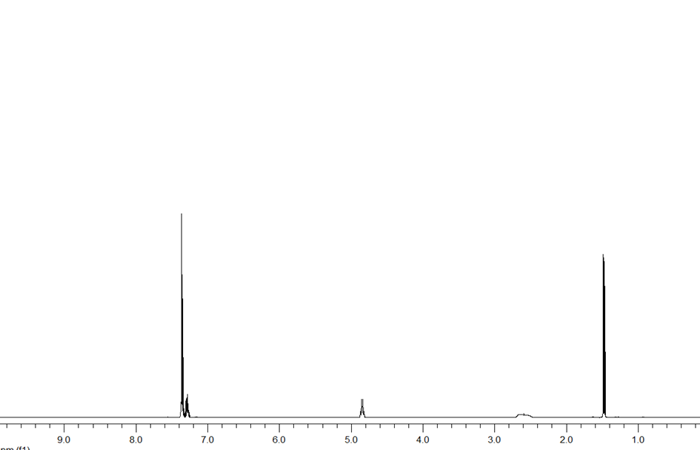
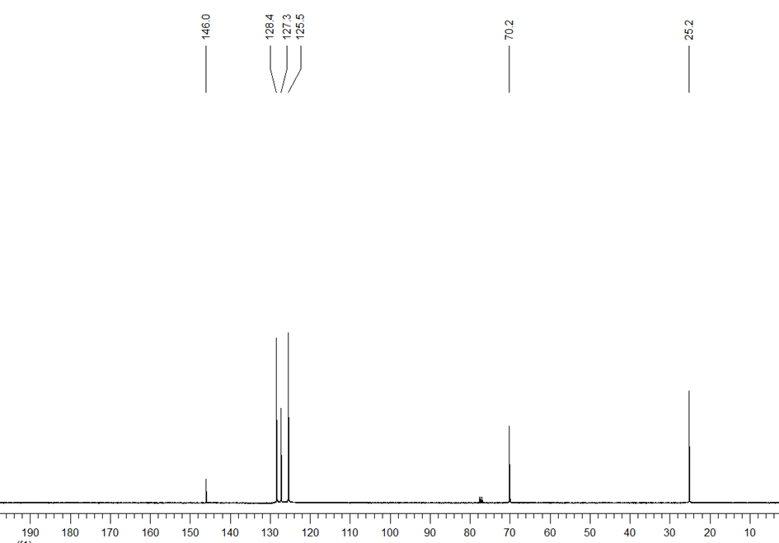
Figure S1: ¹H and ¹³C-NMR spectrum of (R)-1a

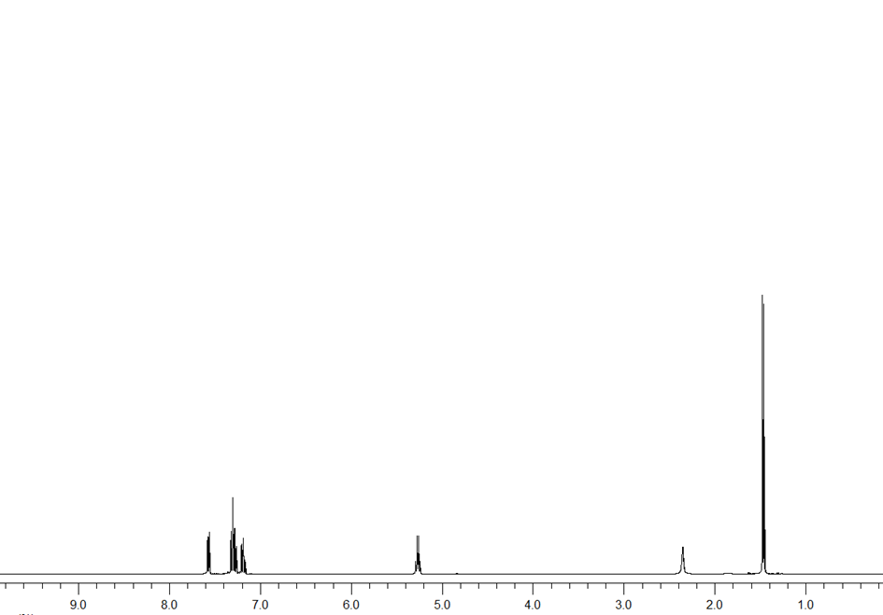
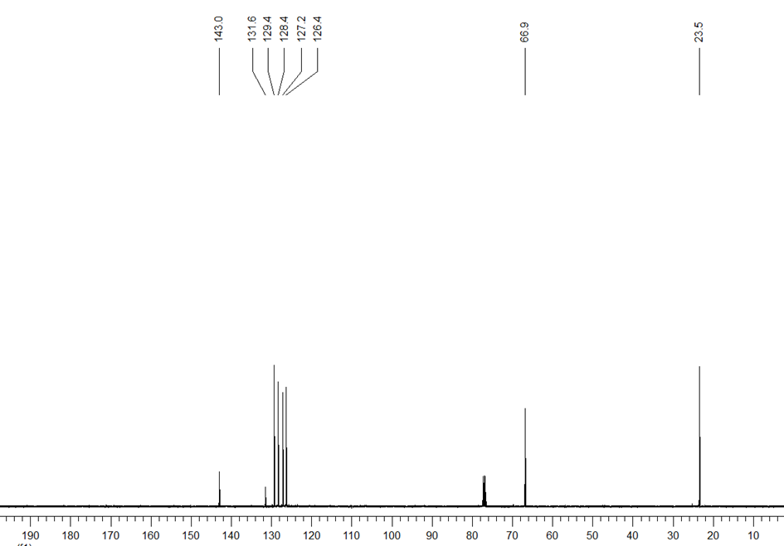
Figure S2: ¹H and ¹³C-NMR spectrum of (R)-2a

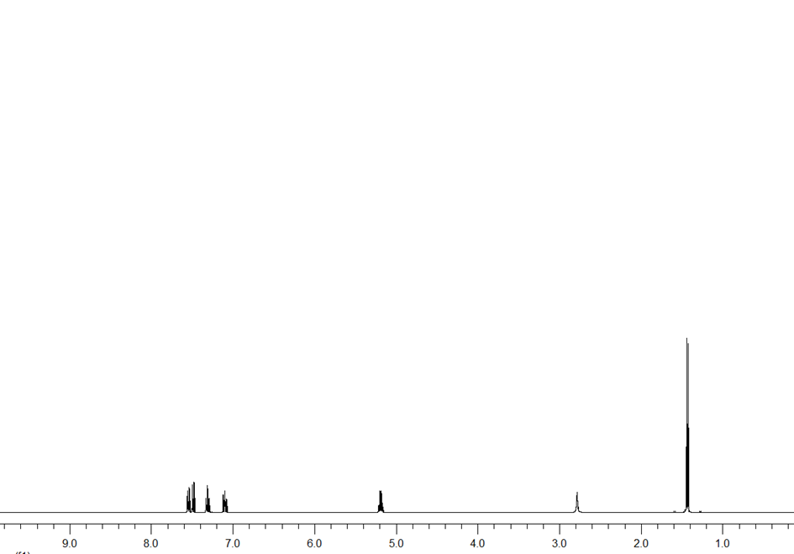
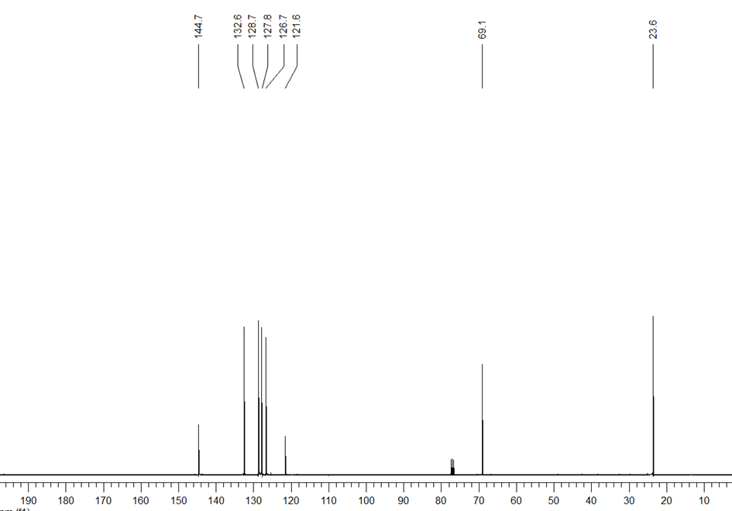
Figure S3: ¹H and ¹³C-NMR spectrum of (S)-3a

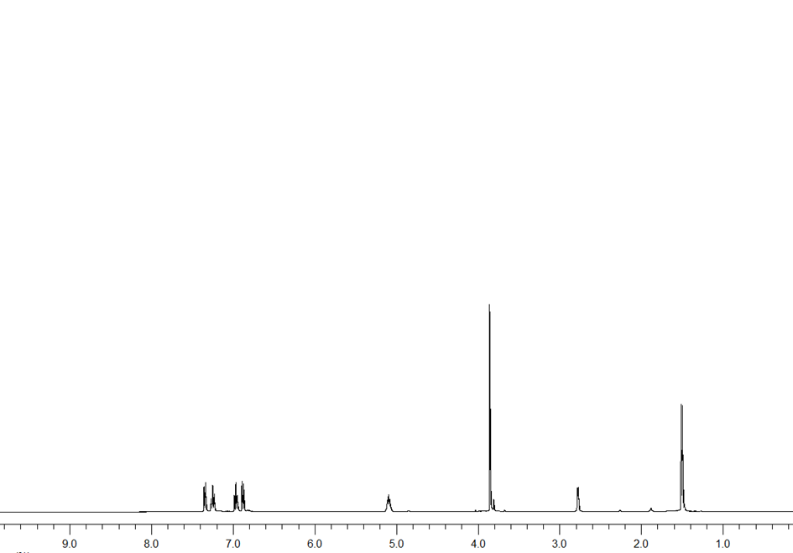
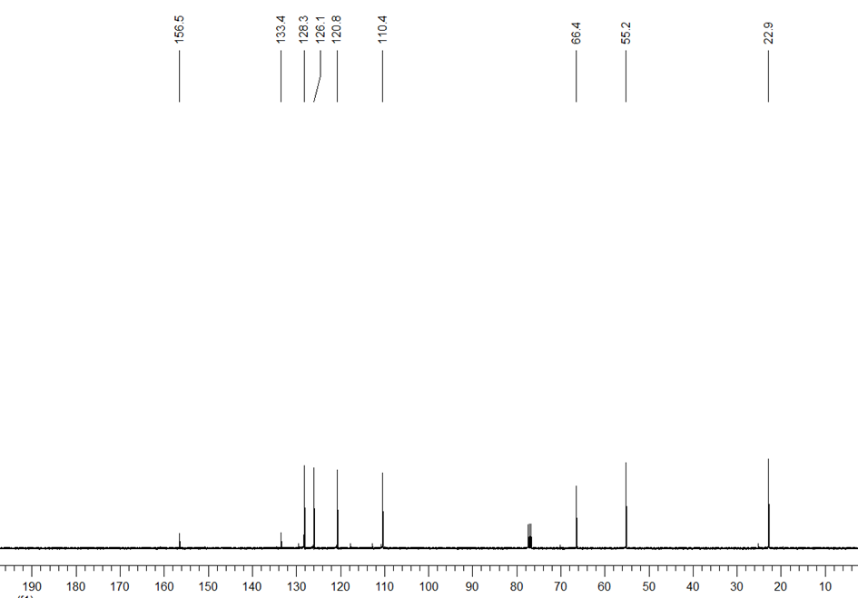
Figure S4: ¹H and ¹³C-NMR spectrum of (R)-4a

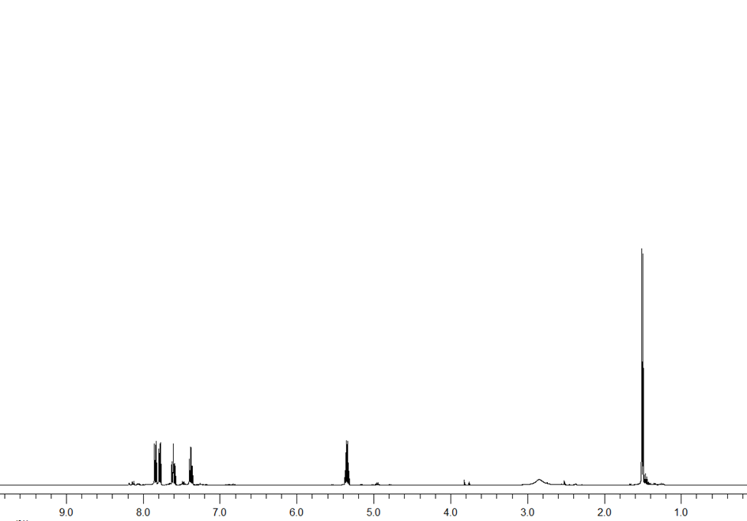
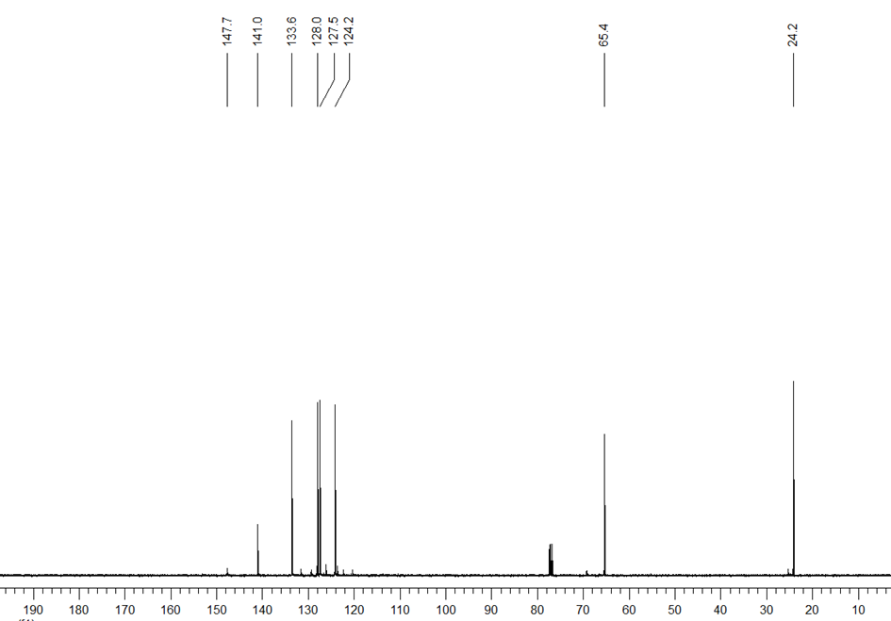
Figure S5: ¹H and ¹³C-NMR spectrum of (R)-5a

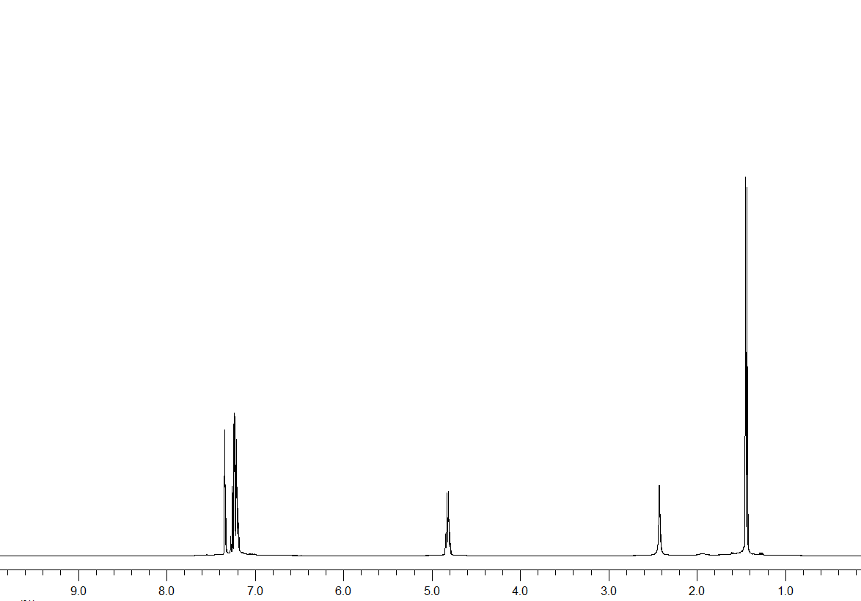
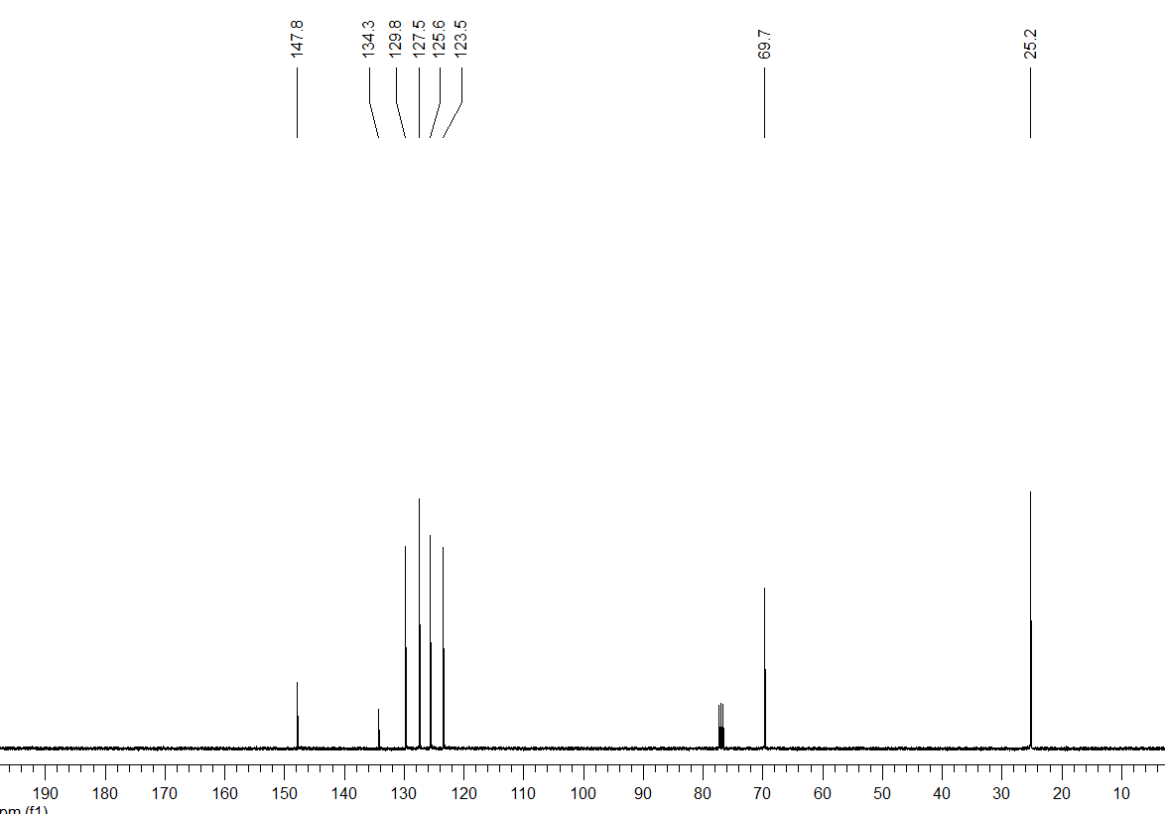
Figure S6: ¹H and ¹³C-NMR spectrum of (S)-6a

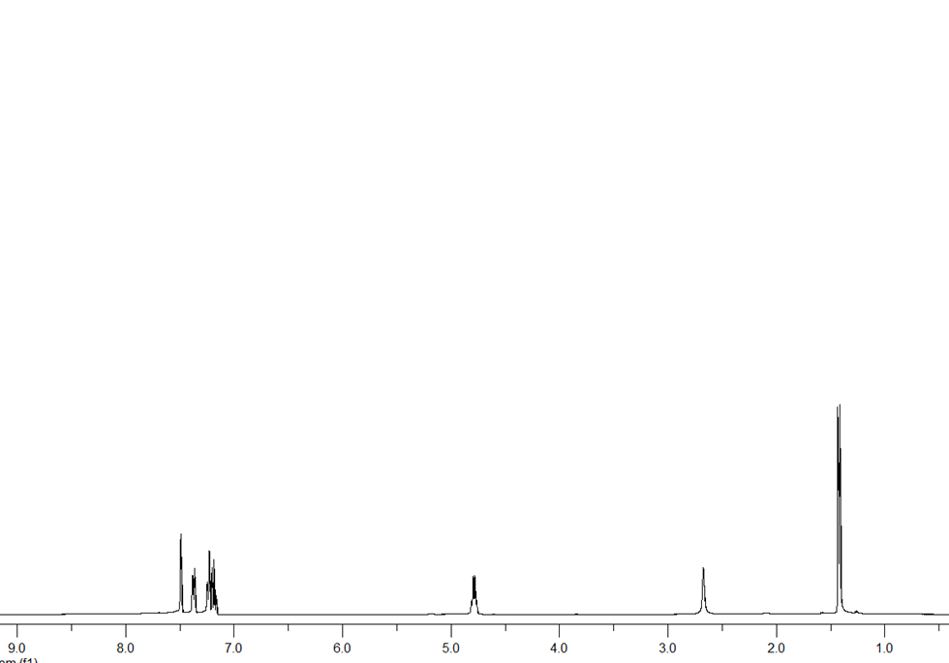
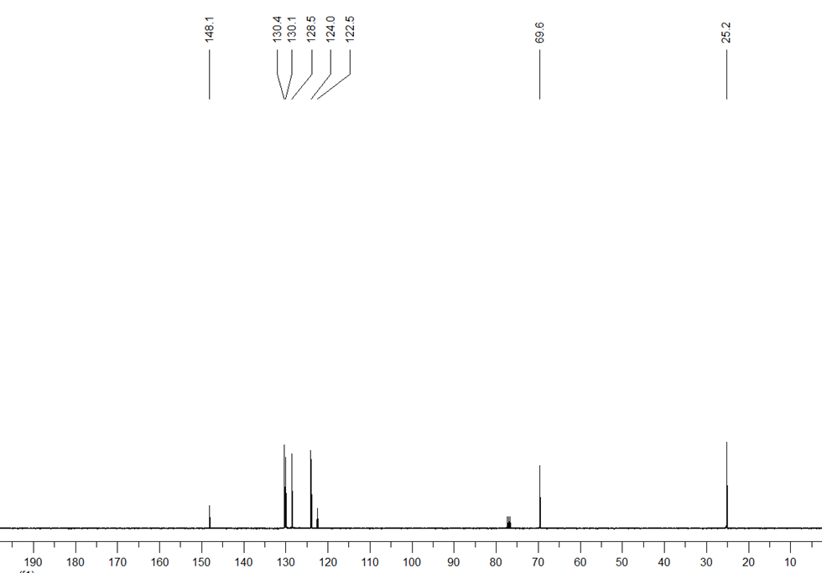
Figure S7: ¹H and ¹³C-NMR spectrum of (R)-7a

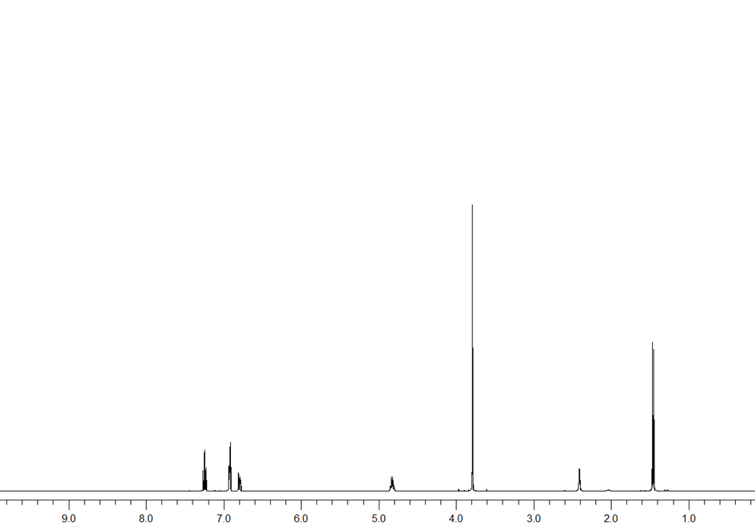
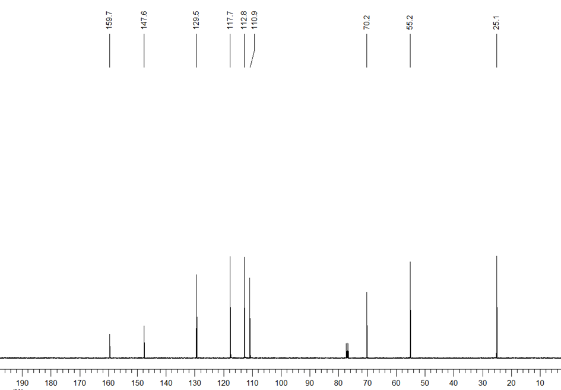
Figure S8: ¹H and ¹³C-NMR spectrum of (S)-8a

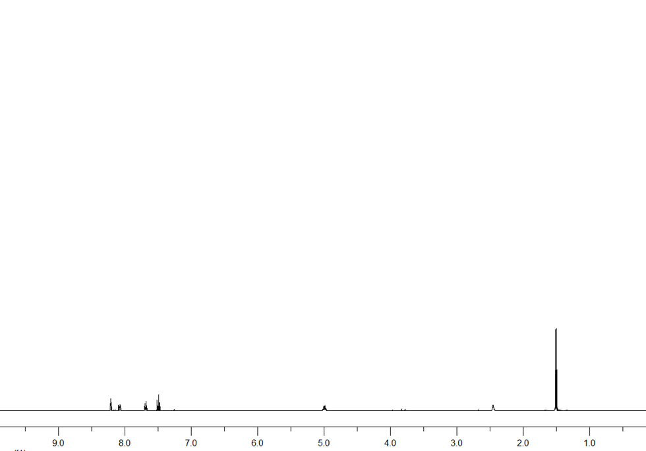
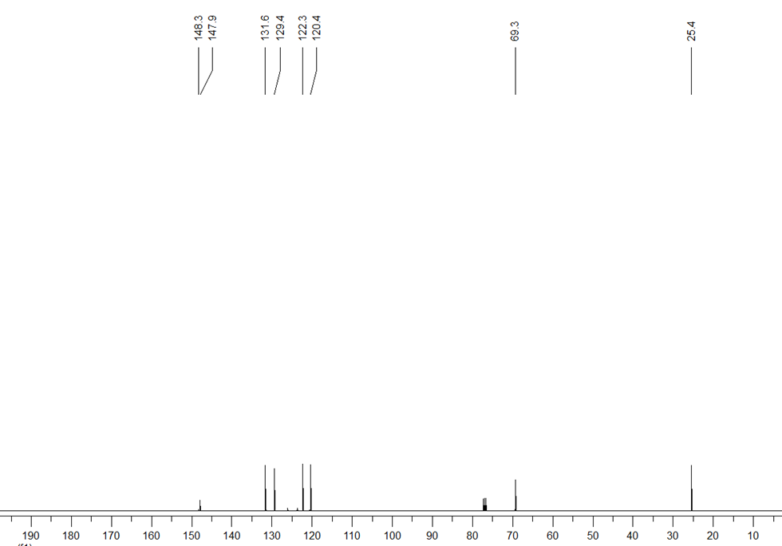
Figure S9: ¹H and ¹³C-NMR spectrum of (S)-9a

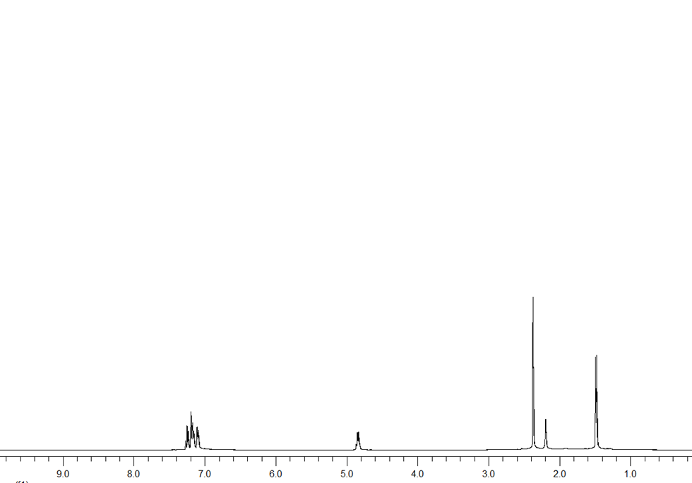
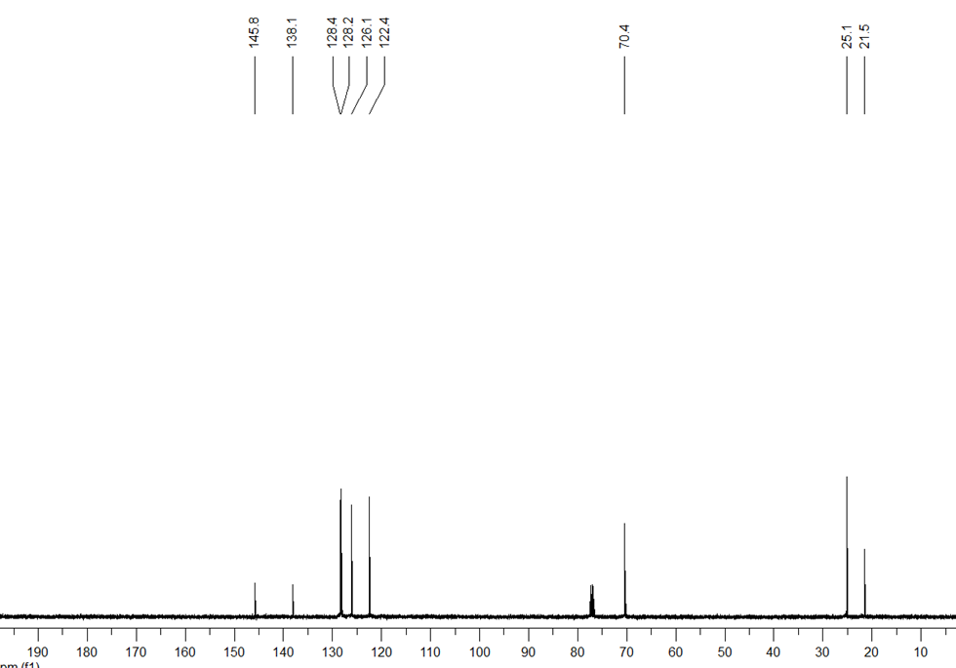
Figure S10: ¹H and ¹³C-NMR spectrum of (R)-10a

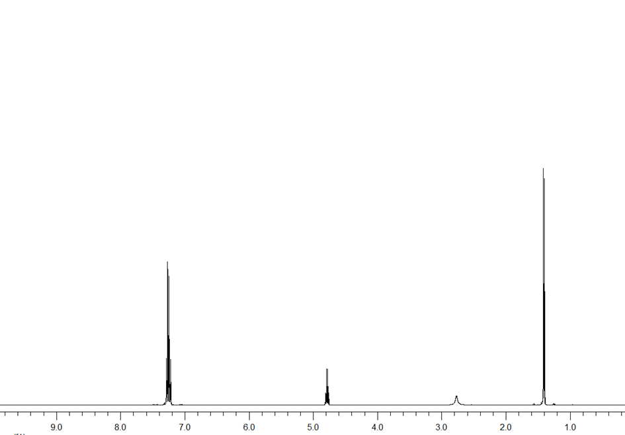
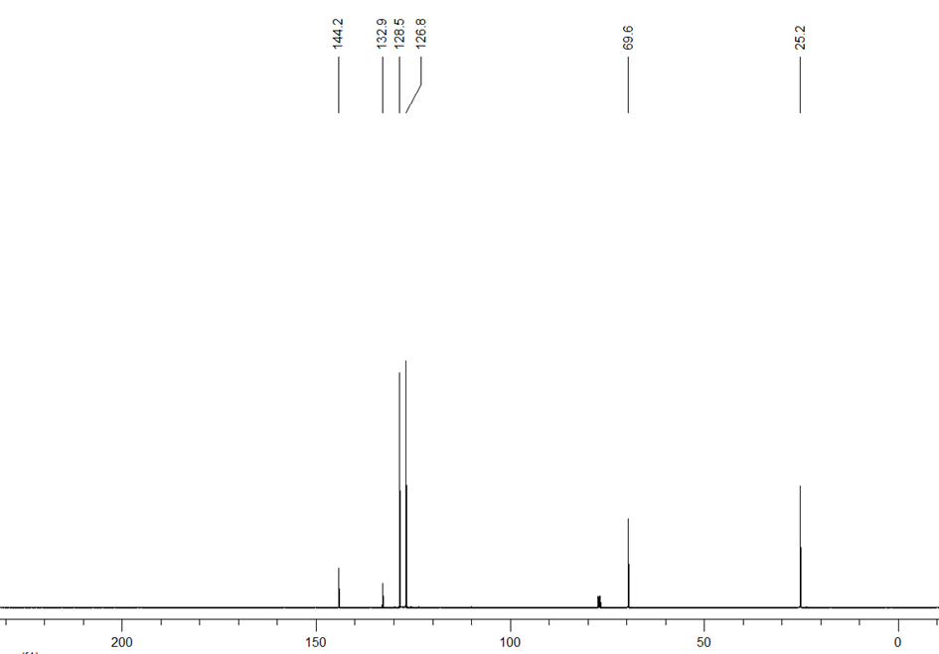
Figure S11: ¹H and ¹³C-NMR spectrum of (R)-11a

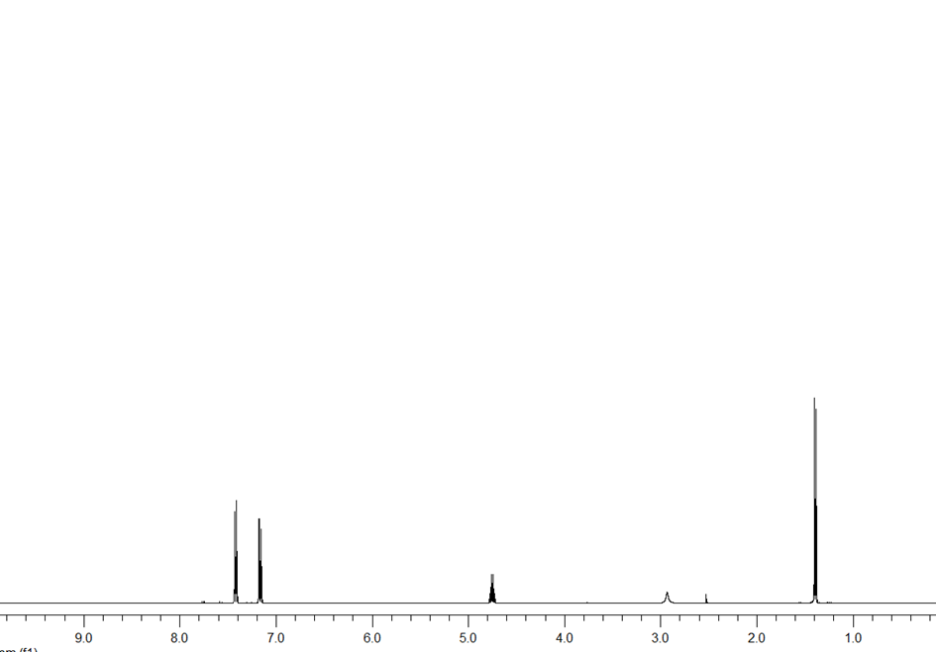
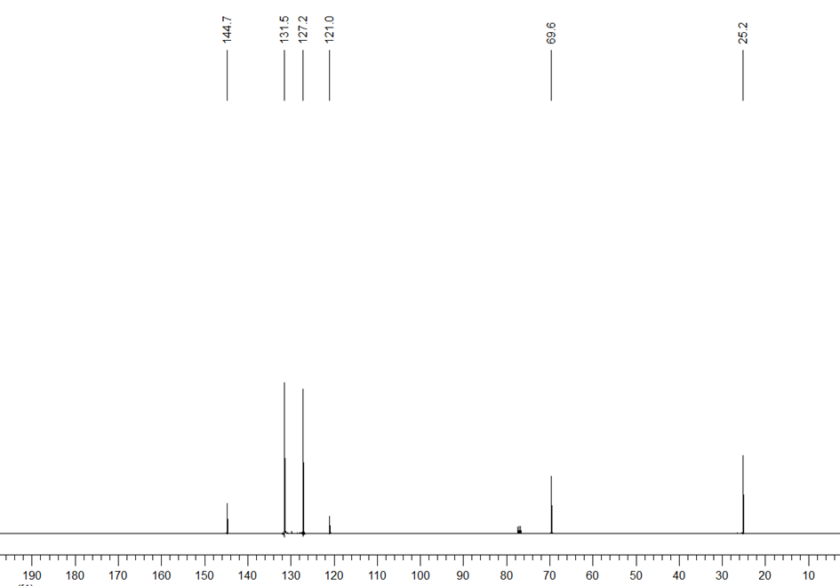
Figure S12: ¹H and ¹³C-NMR spectrum of (S)-12a

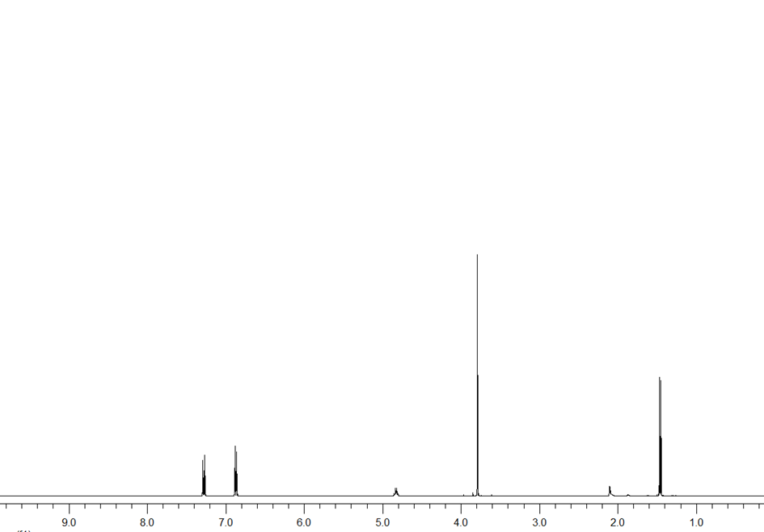

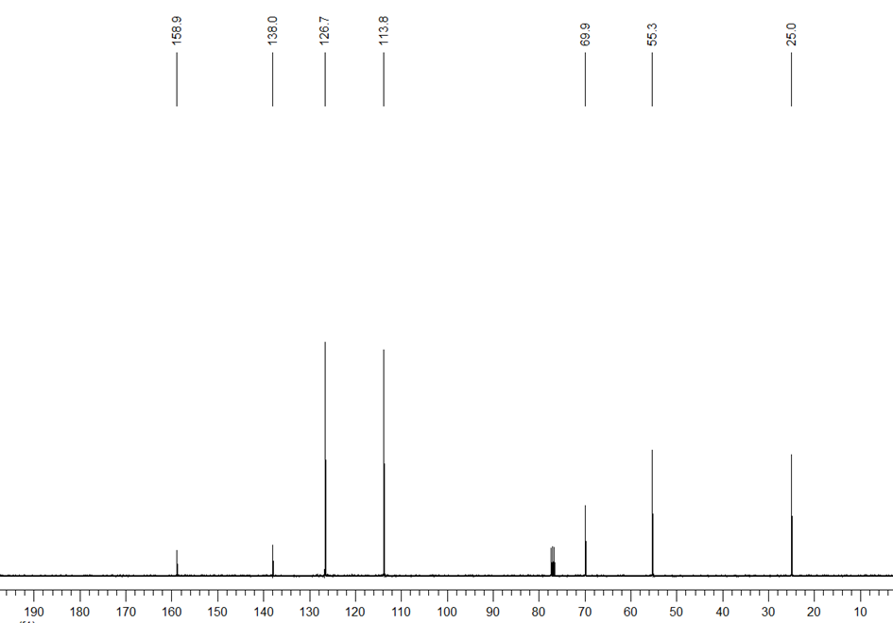
Figure S13: ¹H and ¹³C-NMR spectrum of (R)-13a

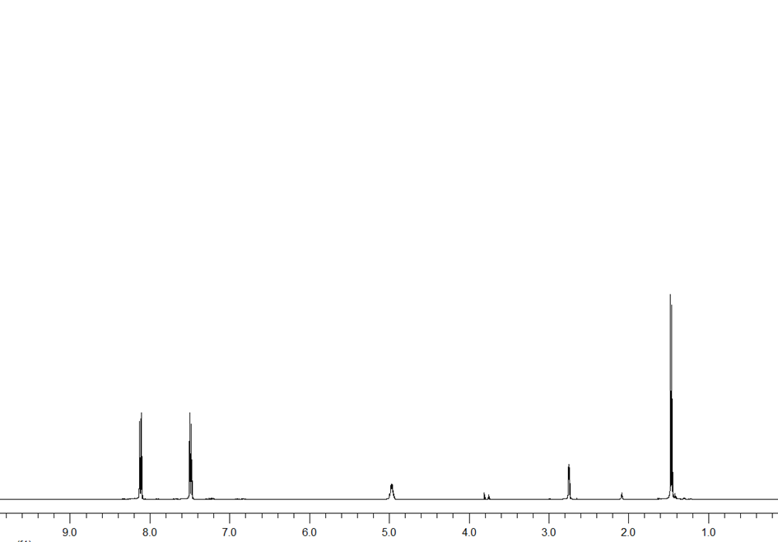
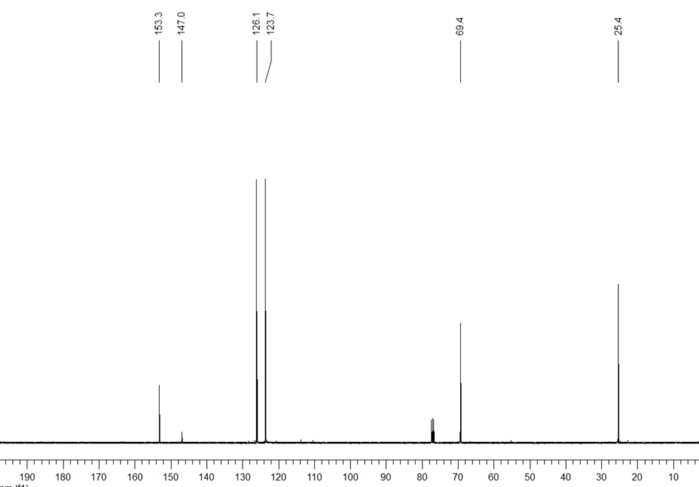
Figure S14: ¹H and ¹³C-NMR spectrum of (R)-14a

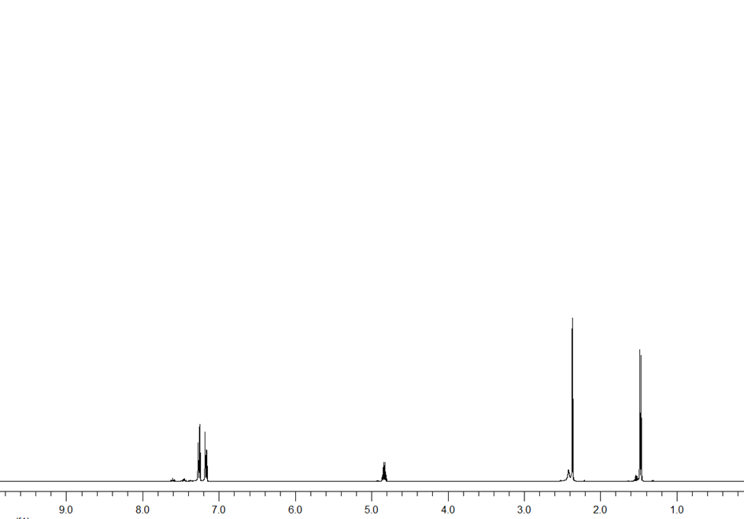
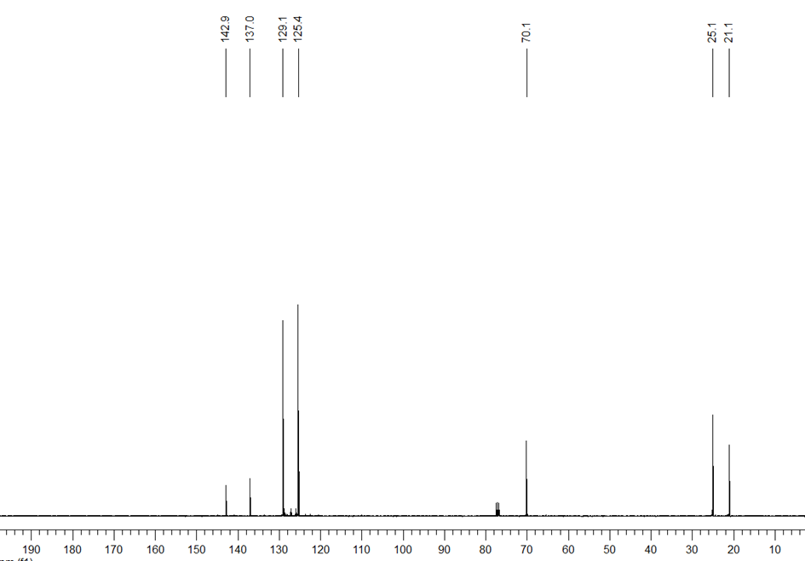
Figure S15: ¹H and ¹³C-NMR spectrum of (S)-15a

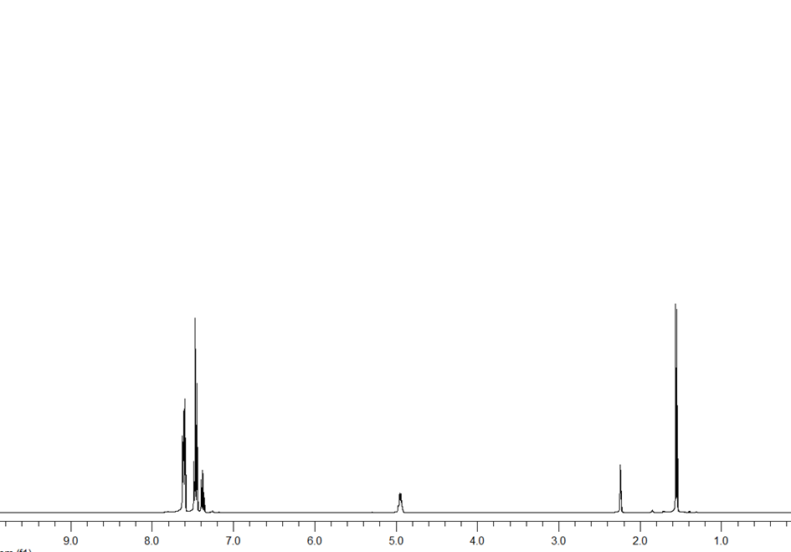
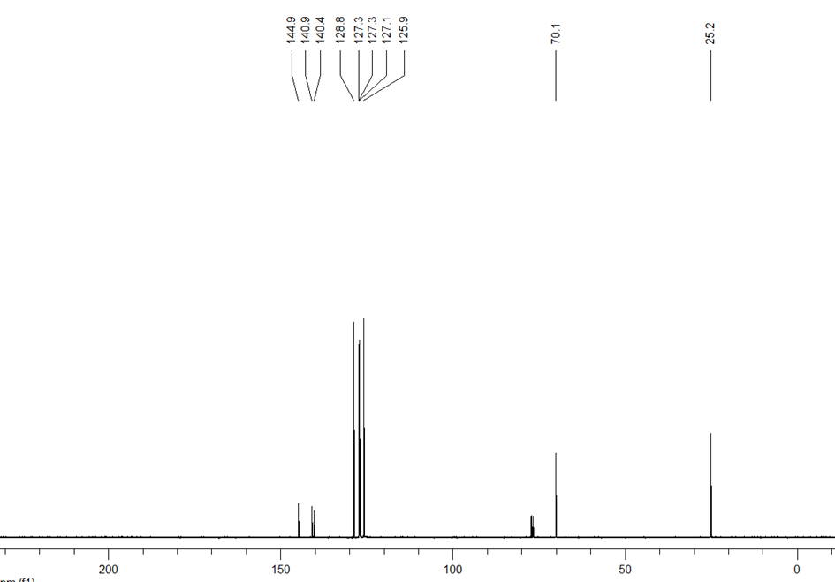
Figure S16: ¹H and ¹³C-NMR spectrum of (R)-16a

HPLC chromatograms of compounds
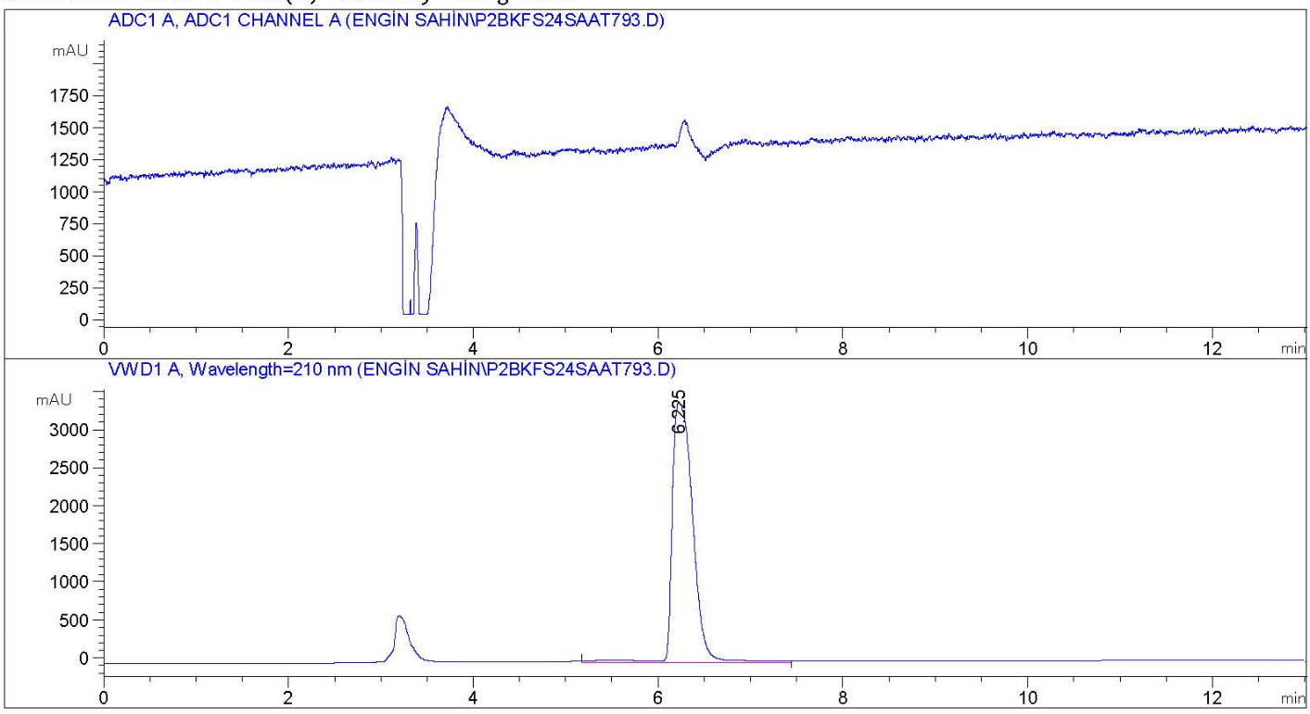
Figure S17: HPLC chromatogram of Substrate 1
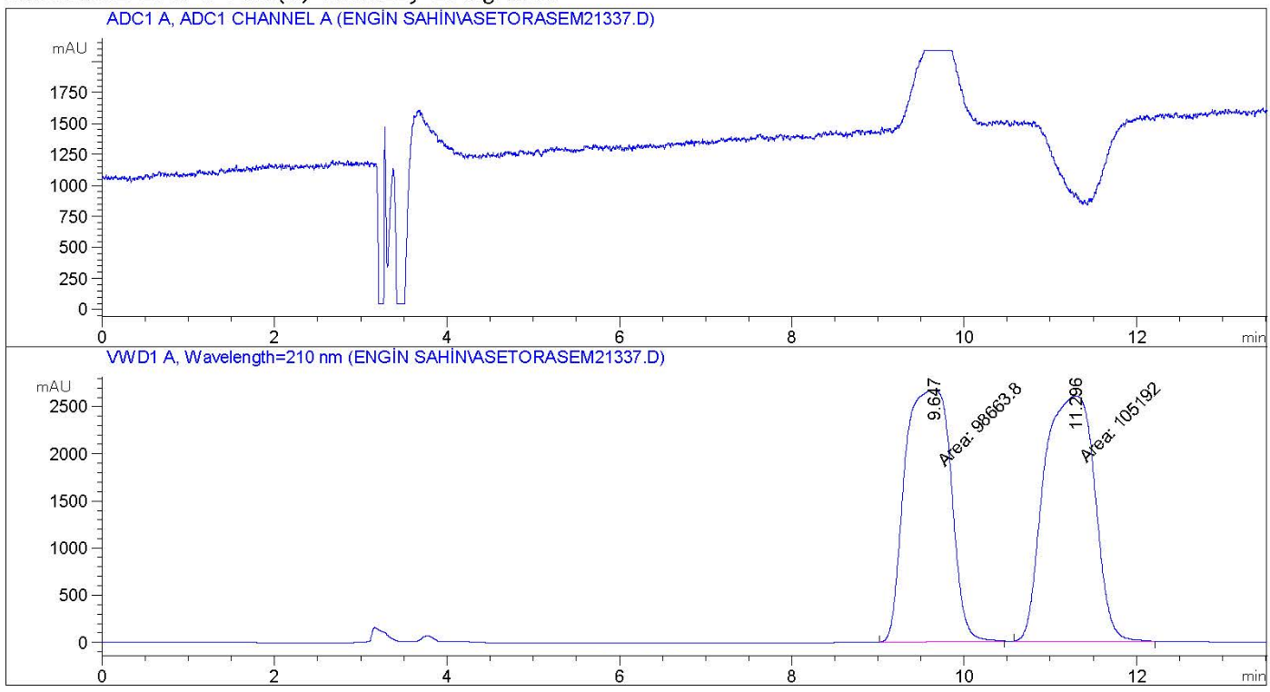
Figure S18: HPLC chromatogram of Racemic 1a

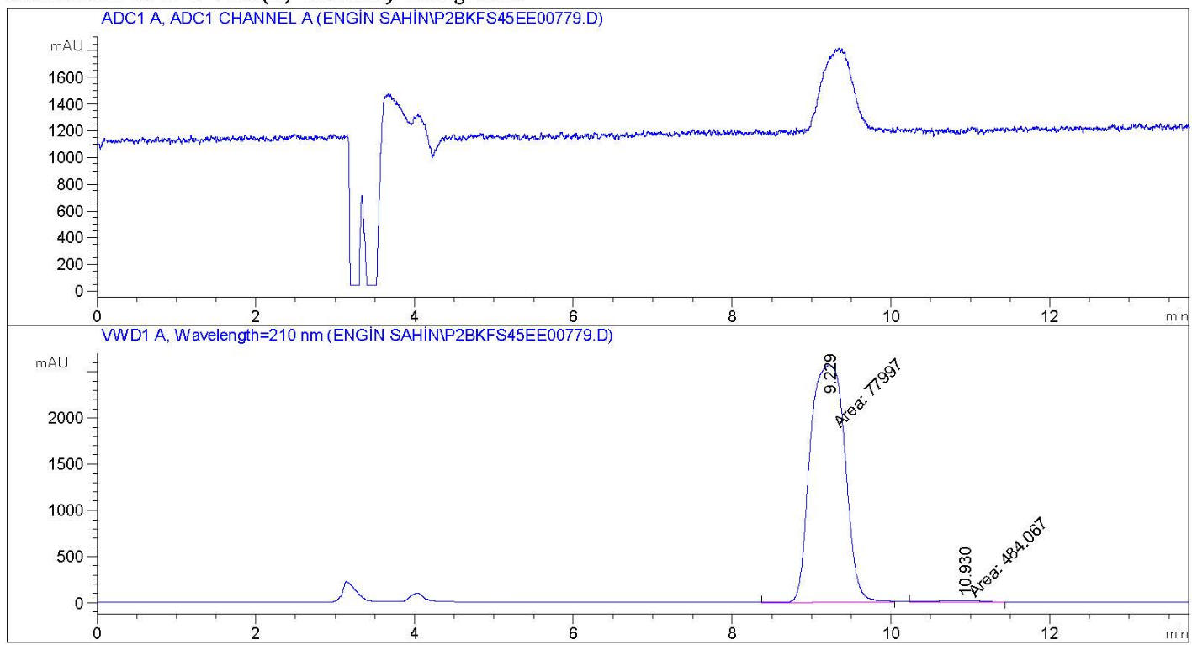
Figure S19: HPLC chromatogram of (R)-1a

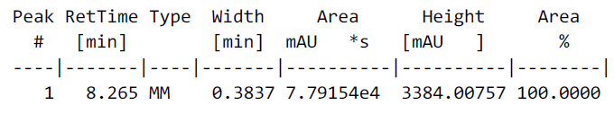

Figure S20: HPLC chromatogram of Substrate 2
Figure S21: HPLC chromatogram of Racemic 2a

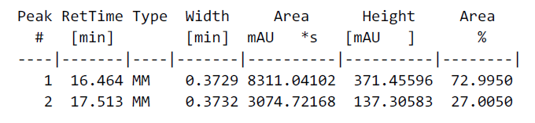
Figure S22: HPLC chromatogram of (R)-2a

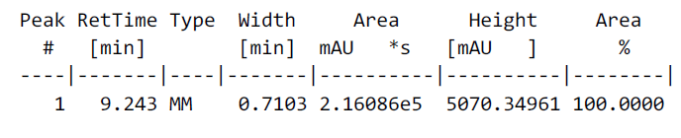
Figure S23: HPLC chromatogram of Substrate 3
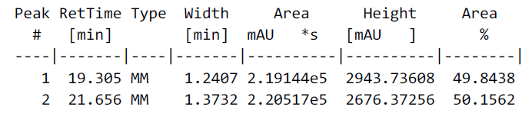

Figure S24: HPLC chromatogram of Racemic 3a

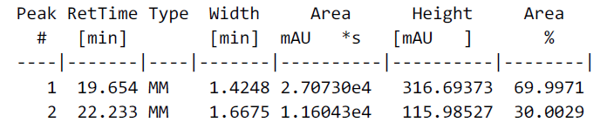
Figure S25: HPLC chromatogram of (S)-3a

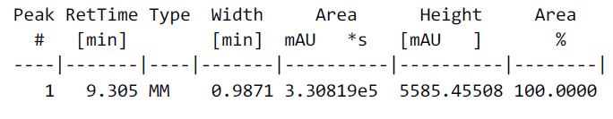
Figure S26: HPLC chromatogram of Substrate 4
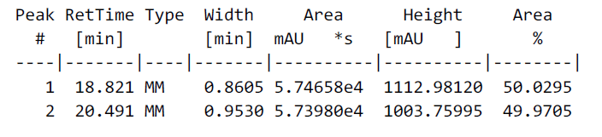
Figure S27: HPLC chromatogram of Racemic 4a

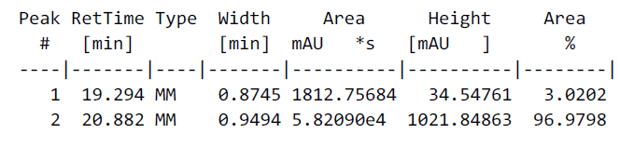
Figure S28: HPLC chromatogram of (R)-4a

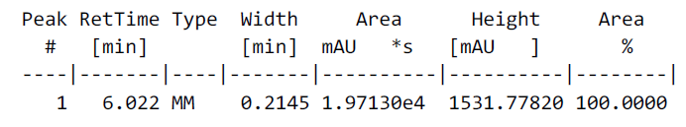
Figure S29: HPLC chromatogram of Substrate 5
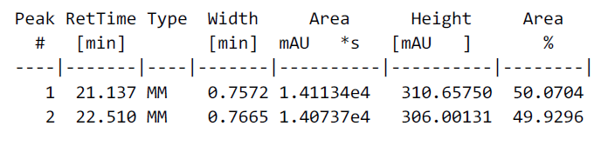

Figure S30: HPLC chromatogram of Racemic 5a

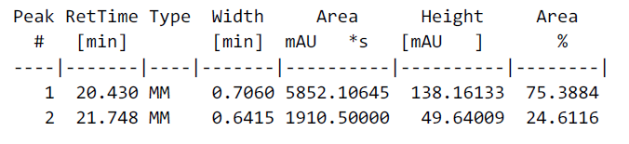
Figure S31: HPLC chromatogram of (R)-5a

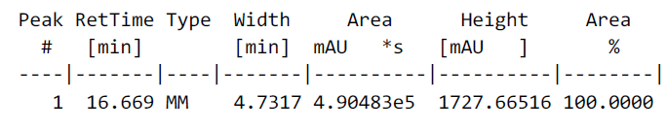
Figure S32: HPLC chromatogram of Substrate 6
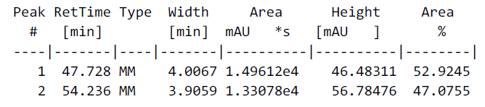
Figure S33: HPLC chromatogram of Racemic 6a

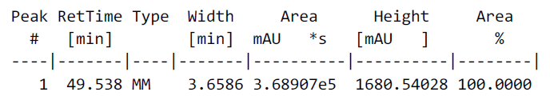
Figure S34: HPLC chromatogram of (S)-6a

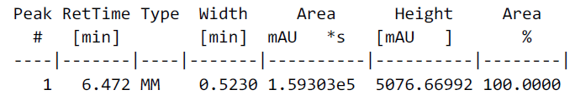
Figure S35: HPLC chromatogram of Substrate 7
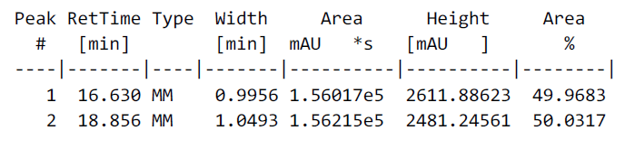
Figure S36: HPLC chromatogram of Racemic 7a

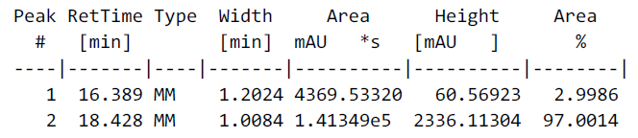
Figure S37: HPLC chromatogram of (R)-7a

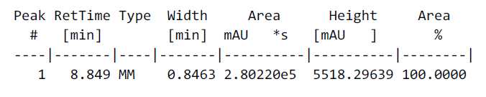
Figure S38: HPLC chromatogram of Substrate 8
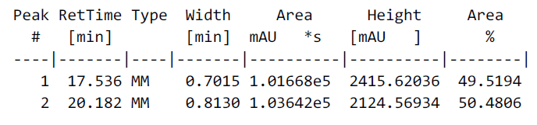
Figure S39: HPLC chromatogram of Racemic 8a

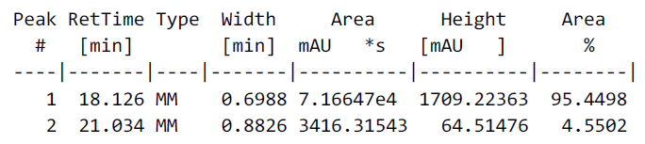
Figure S40: HPLC chromatogram of (S)-8a

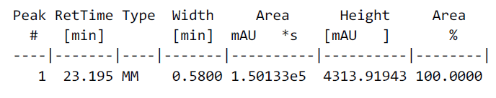
Figure S41: HPLC chromatogram of Substrate 9
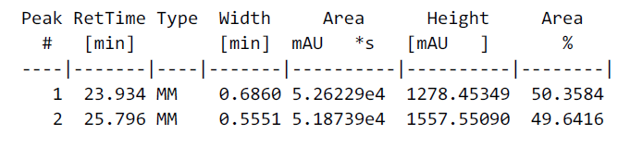

Figure S42: HPLC chromatogram of Racemic 9a

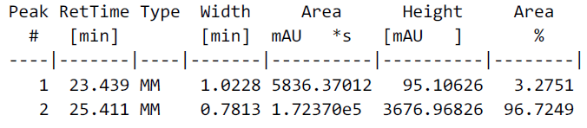
Figure S43: HPLC chromatogram of (S)-9a

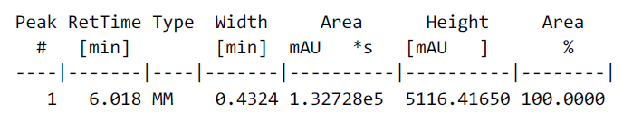
Figure S44: HPLC chromatogram of Substrate 10
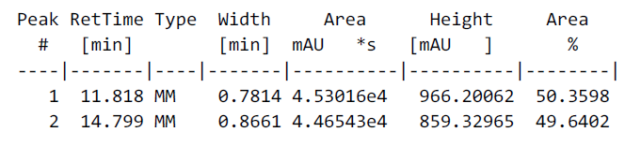
Figure S45: HPLC chromatogram of Racemic 10a

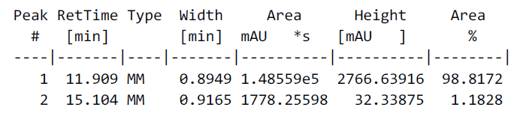
Figure S46: HPLC chromatogram of (R)-10a

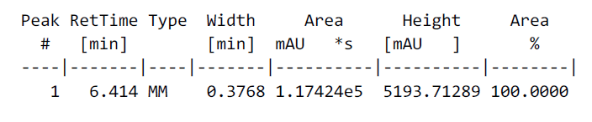
Figure S47: HPLC chromatogram of Substrate 11
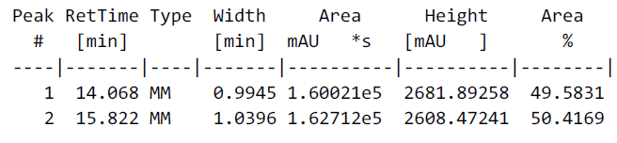
Figure S48: HPLC chromatogram of Racemic 11a

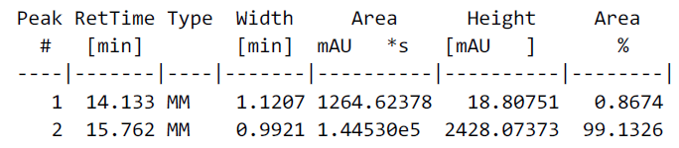
Figure S49: HPLC chromatogram of (R)-11a

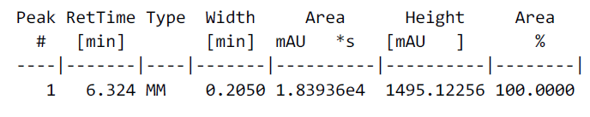
Figure S50: HPLC chromatogram of Substrate 12
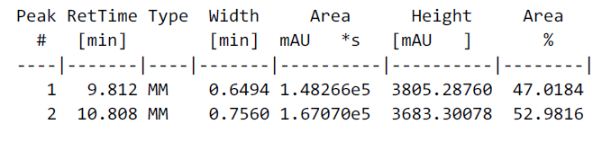

Figure S51: HPLC chromatogram of Racemic 12a

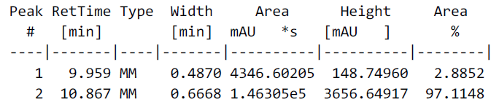
Figure S52: HPLC chromatogram of (S)-12a

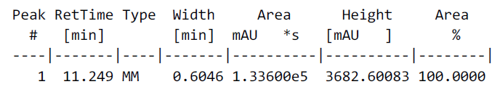
Figure S53: HPLC chromatogram of Substrate 13
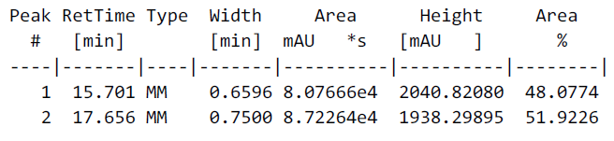
Figure S54: HPLC chromatogram of Racemic 13a

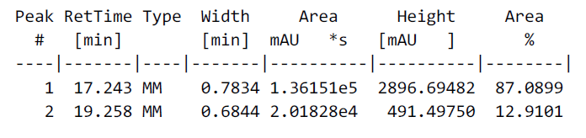
Figure S55: HPLC chromatogram of (R)-13a

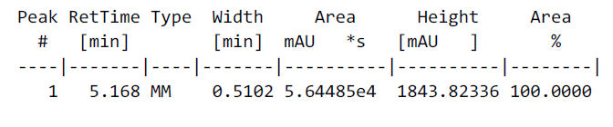
Figure S56: HPLC chromatogram of Substrate 14
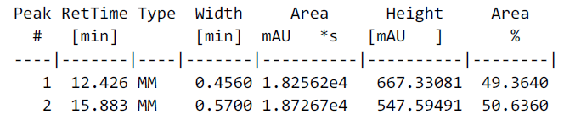
Figure S57: HPLC chromatogram of Racemic 14a

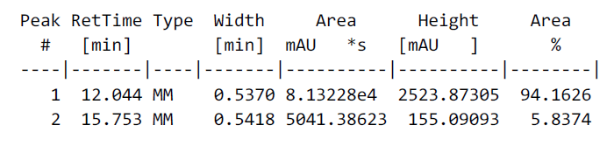
Figure S58: HPLC chromatogram of (R)-14a

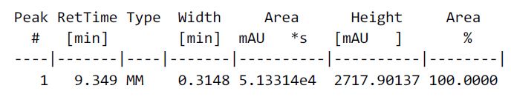
Figure S59: HPLC chromatogram of Substrate 15
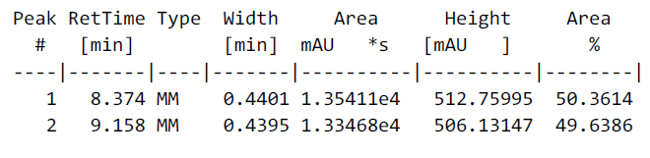
Figure S60: HPLC chromatogram of Racemic 15a

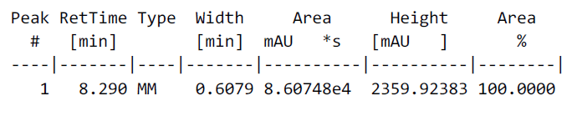
Figure S61: HPLC chromatogram of (S)-15a

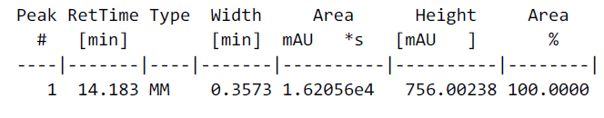
Figure S62: HPLC chromatogram of Substrate 16
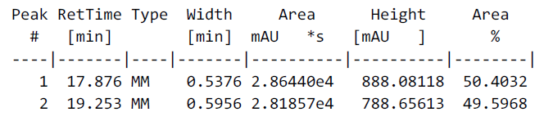
Figure S63: HPLC chromatogram of Racemic 16a

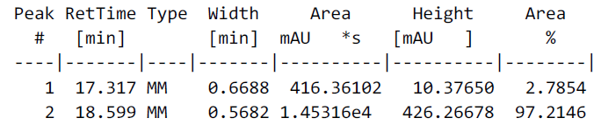
Figure S64: HPLC chromatogram of (R)-16a

