Characterisation of a transcriptional TPP riboswitch in the human pathogen Neisseria meningitidis

Supplementary material

Francesco Righetti,ª Solange Lise Materne,ª John Boss,ª Hannes Eichner,ª Emmanuelle Charpentier,^{b,c,d,e,f,} and Edmund Loh*^{a,g}
ªDepartment of Microbiology, Tumor- and Cell biology, BioClinicum, Karolinska University Hospital, 171 64 Stockholm, Sweden
^{b}Max Planck Unit for the Science of Pathogens, Berlin, Germany
^{c}Department of Regulation in Infection Biology, Max Planck Institute for Infection Biology, Berlin, Germany
^{d}Institute for Biology, Humboldt University, Berlin, Germany
^{e}Department of Regulation in Infection Biology, Helmholtz Centre for Infection Research, Braunschweig, Germany
^{f}The Laboratory for Molecular Infection Medicine Sweden (MIMS), Umeå Centre for Microbial Research (UCMR), Department of Molecular Biology, Umeå University, Umeå, Sweden
^{g}SCELSE, Nanyang Technological University, 639798, Singapore

*Corresponding author
E-mail: edmund.loh@ki.se

Table S1
Family | Gene | Product | E-value
preQ1 | NMB0317 | 7-cyano-7-deazaguanine reductase | 5e-10
SAM I-IV | metK | S-adenosylmethionine synthetase | 3e-05
TPP | cytX | hydroxymethylpyrimidine transporter | 5.4e-10
TPP | thiC | phosphomethylpyrimidine synthase | 1.1e-08

Table S1. Riboswitch Scanner output for N. meningitidis MC58 genome.
The four RS candidates identified by Riboswitch Scanner are listed. RS family, gene names, annotated gene product and estimated E-value of the RS element are indicated.

Figure S1
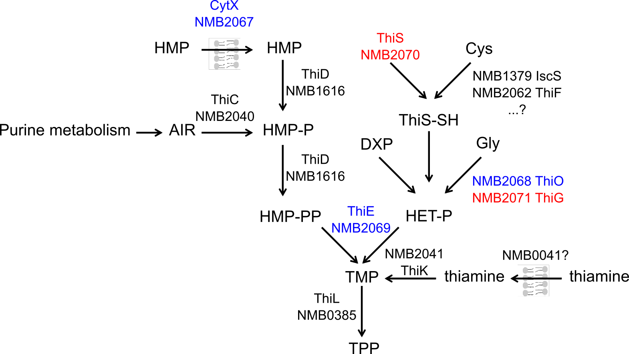
Figure S1. Simplified schematic representation of the TPP metabolism in N. meningitidis.
The expected TPP metabolism in N. meningitidis was reconstructed based on genomic data. HMP: hydroxymethylpyrimidine (-P and -PP: mono- and di-phosphorylated); AIR: phosphoaminoimidazole riboside; Cys: L-cysteine; DXP: 1-deoxy-D-xylulose phosphate; Gly: glycine; HET-P: hydroxyethylthiazole phosphate; TMP and TPP: thiamine mono- and pyro-phosphate. Per each step, the names of the enzymes and transporters are indicated, together with their gene ID from N. meningitidis MC58 genome annotation. Genes putatively located within the same transcriptional unit are marked with the same color (blue or red).

Figure S2
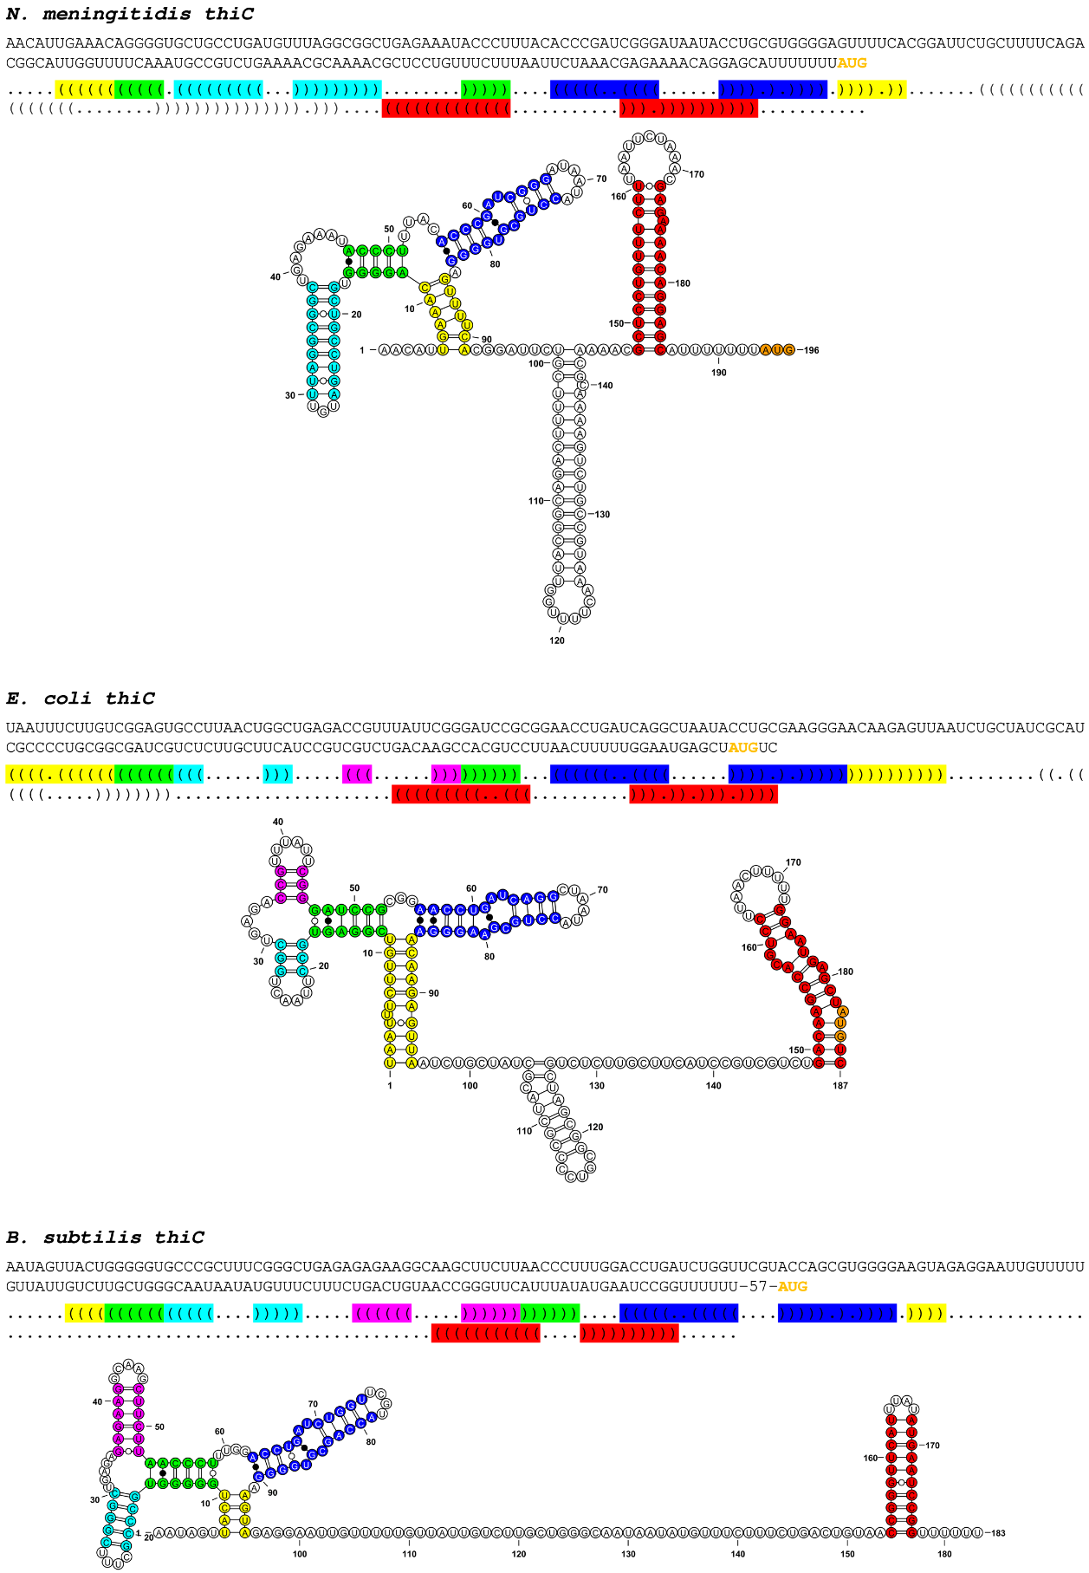
Figure S2. Structural comparison of N. meningitidis, E. coli and B. subtilis thiC TPP RSs.
The structures are indicated in Vienna dots and brackets format, as well as in a secondary structure drawing produced with VARNA applet. Conserved structural elements (stems) are labelled with same colors, the AUG start codon is depicted in orange.

Table S2
Species | Downstream gene | Gene product | Putative mechanism
S. pneumoniae | SP_0716 / tenA | Aminopyrimidine aminohydrolase | transcriptional
S. pneumoniae | SP_0719 / ykoE | Thiamine permease | transcriptional
S. pneumoniae | SP_0726 / thiD | Hydroxymethylpyrimidine kinase | transcriptional
S. pneumoniae | SP_2199 / thiX | Hydroxymethylpyrimidine transporter | transcriptional
H. influenzae | HIB_04670 / thiZ | Hydroxymethylpyrimidine transporter | translational
H. influenzae | HIB_05260 / thiM | Hydroxyethylthiazole kinase | translational
H. influenzae | HIB_11890 / thiB | Thiamine transporter | translational

Table S2. TPP RSs predicted in the genomes of the human nasopharyngeal bacteria Streptococcus pneumoniae and Haemophilus influenzae.
The TPP RS candidates identified by Riboswitch Scanner in S. pneumoniae (serotype 4, strain TIGR4, NC_003028.3) and H. influenzae (type B, strain 10810, NC_016809.1) are listed. Downstream gene names and ID, annotated gene products and predicted regulatory mechanisms are indicated. S. pneumoniae thiD TPP RS was not detected in Rodionov et al. (2002).

References

Rodionov DA, Vitreschak AG, Mironov AA, and Gelfand MS (2002). Comparative genomics of thiamin biosynthesis in procaryotes. New genes and regulatory mechanisms. J Biol Chem 277, 48949-48959. doi: 10.1074/jbc.M208965200.

