supplementary materials
Figure S1 Structure and identification of Trim59^{flox/flox} and Trim59-cKO mice. (A) The structure of the loxp site. (B) Genotype identification of mice. (C) Protein level of TRIM59 in BMDMs from Trim59^{flox/flox} and Trim59-cKO mice.

Figure S2 Purities of BMDMs from C57BL/6N (wild type), Trim59^{flox/flox} and Trim59-cKO mice.

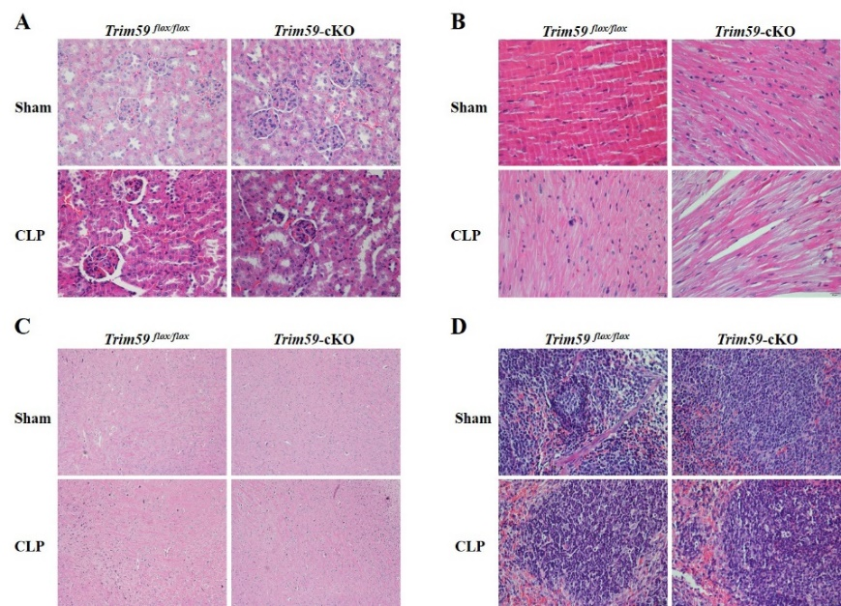
Figure S3 Results of H&E staining of kidney (A), heart (B), brain (C), and spleen (D) tissues from Trim59^{flox/flox} and Trim59-cKO mice after CLP for 24 hours. Original magnification ×400, scale bar = 20µm. Sham group, n=5, CLP group, n=6.

Figure S4 Identification of E.coli with pET-14b-EGFP. (A) The structure of pET-14b-EGFP. (B) Transfection results.

Figure S5 BMDMs were stimulated for 24 hours with or without LPS (0.2μg/ml). After selecting all the F4/80⁺ cells, the expressions of co-stimulation proteins in LPS-stimulated BMDMs from Trim59^{flox/flox} and Trim59-cKO mice: (A) MHCII, (B) CD80, and (C) CD86. In each group, n=5 or n=6. Data are presented as Means ± SEM.

Figure S6 BMDMs were stimulated with LPS (0.2μg/ml) for the indicated times. The expression of the MAP3K1, ECSIT (A) and PI3K/AKT signal pathways (B) in the LPS-stimulated BMDMs from Trim59^{flox/flox} and Trim59-cKO mice. Relative intensities were quantitated by densitometry using ImageJ and normalized by total protein levels or by GAPDH. Data are presented as Means ± SEM.

