Supplementary material for

Changes in supramolecular structure and improvement in reactivity of dissolving pulp via Enzymatic Pretreatment with Processive Endoglucanase EG1 from *Volvaria volvacea*

Shanshan Wu1, Yuemei Zhang1, Xiao Jiang2, Shulei Wang1, Jiang Liu1, Shufang Wu1

1. Jiangsu Co-Innovation Center of Efficient Processing and Utilization of Forest Resources, Nanjing Forestry University, Nanjing, China
2. Department of Forest Biomaterials, North Carolina State University, Raleigh, North Carolina, USA

Figure S1 Effect of enzyme dosage on SRS and DP

Figure S2 Effects of enzymatic treatment time on SRS and DP

Figure S3 Fibers length and coarseness of the pulps (C-control, R-C-refining)

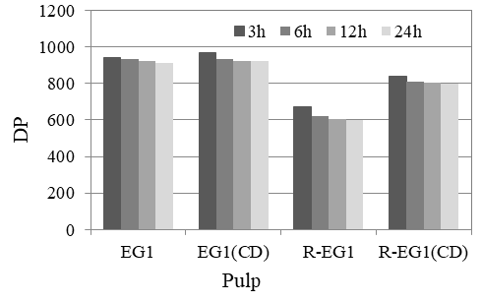

***a***

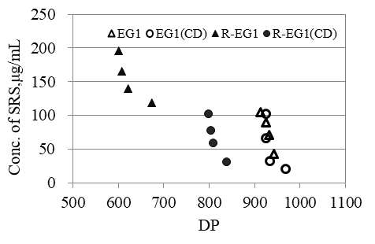

***b***

Fig S4. Effects of EG1 treatment time on DP of pulp (a) and relationship between SRS and the DP (b)

6h

6h

12h