Source data
Patterns of seismic cycle in the Kuril Island arc from GPS observations
Vladimirova I.S.^{1,2}, Lobkovsky L.I.^{1,3}, Gabsatarov Y.V.^{1,2}, Steblov G.M.^{1,2,4}, Vasilenko N.F.⁵, Frolov D.I.⁶, Prytkov A.S.⁵

¹Moscow Institute of Physics and Technology (State University), Moscow, Russia

²Geophysical Survey of the Russian Academy of Sciences, Obninsk, Russia

³Shirshov Institute of Oceanology, Russian Academy of Sciences, Moscow, Russia

⁴Schmidt Institute of Physics of the Earth of the Russian Academy of Sciences, Moscow, Russia

⁵Institute of Marine Geology and Geophysics of the Far Eastern Branch of the Russian Academy of Sciences, Yuzhno-Sakhalinsk, Russia

⁶Ioffe Institute of the Russian Academy of Sciences, St. Petersburg, Russia

Table 1.
Velocities of horizontal displacements of KurilNet stations estimated over 1-year intervals: within interval from 2006.5 to 2015.5 calculated in ITRF2008 reference frame relative to North American plate
Station | PARM | KHAM | MATC | KETC | URUP | VDLN | ITUR | KUNA | SHIK
Latitude, N Longitude, E | 50.67  156.12 | 49.16  154.45 | 48.04  153.23 | 47.30  152.49 | 46.23  150.57 | 45.58  149.40 | 45.23  147.87 | 44.04  145.86 | 43.87  146.83
Velocity  Period | V_{N} (mm/yr)±σ_{N} (mm/yr)  V_{E} (mm/yr)±σ_{E} (mm/yr)
2006.5–2007.5 | 0.37±2.51  -22.98±2.27 | — | — | — | — | 9.72±2.40  -13.62±1.8 | 13.96±2.44  -16.68±2.03 | 20.23±2.05  -24.36±2.04 | 18.79±2.57  -35.66±2.05
2007.5–2008.5 | 11.66±0.57  -12.41±1.17 | — | -48.16±3.19  63.06±3.18 | -49.25±3.19  85.95±3.19 | 1.88±3.72  21.12±3.81 | — | 12.79±0.81  -2.99±0.87 | 18.19±1.27  -15.07±1.15 | 19.23±1.05  -26.10±1.06
2008.5–2009.5 | 16.10±1.34  -10.85±1.17 | -9.01±1.13  12.27±0.81 | -36.38±1.06  51.80±0.69 | -29.50±0.93  67.68±1.29 | 3.73±2.09  12.46±2.16 | — | 5.04±1.13  -4.05±0.88 | 15.81±0.81  -18.14±0.81 | 19.65±0.70  -27.90±0.73
2009.5–2010.5 | 12.09±1.16  -14.64±1.29 | -5.65±1.08  5.27±0.93 | -14.66±1.14  26.90±0.88 | -15.50±1.01  35.43±0.98 | — | — | 15.70±0.90  -28.50±0.93 | 12.22±0.79  -16.05±0.81 | 18.23±0.83  -30.48±0.76
2010.5–2011.5 | 8.45±0.74  -18.12±0.98 | -4.48±1.11  3.25±0.92 | -10.52±1.17  17.07±0.73 | -9.08±0.91  24.10±1.04 | 9.64±1.98  -2.83±1.74 | — | 11.93±0.87  -9.95±0.88 | 20.59±0.69  -22.86±0.74 | 19.54±0.80  -31.46±0.77
2011.5–2012.5 | 8.69±1.09  -11.11±1.16 | -7.01±1.06  9.37±1.02 | -7.50±0.93  17.39±0.75 | -5.86±1.04  19.67±1.02 | 11.52±1.93  -3.53±1.84 | — | 12.74±0.91  -7.41±0.90 | 20.94±0.74  -15.63±0.91 | 22.14±0.88  -25.93±0.73
2012.5–2013.5 | 7.24±0.75  -14.70±0.81 | -5.73±0.98  10.99±0.99 | -6.55±0.76  11.99±1.13 | -4.44±0.84  11.45±0.92 | 5.65±1.44  -8.24±1.63 | — | 14.86±0.79  -6.17±0.82 | 20.45±0.71  -16.80±0.63 | 21.82±0.88  -26.83±0.84
2013.5–2014.5 | 7.87±0.82  -17.63±0.92 | -2.18±0.85  7.45±0.83 | -5.32±0.99  4.64±0.76 | -2.33±0.82  4.14±0.87 | 7.16±1.02  -14.33±1.34 | — | — | — | —
2014.5–2015.5 | 11.85±0.76  -14.09±0.88 | -2.81±0.87  2.85±0.90 | -2.46±0.81  9.53±0.82 | -0.98±0.84  9.54±0.95 | 11.58±1.28  -8.12±1.17 | — | — | — | —
Table 2.
Horizontal coseismic displacements of the Earth’s surface recorded by the stations of KurilNet and other networks during the First Simushir earthquake 11/15/2006 (calculated in ITRF2008 reference frame relative to North American plate)
GPS-station | Station coordinates |  | North Offset  U_{N} (mm)±σ_{N} (mm) | East Offset  U_{E} (mm)±σ_{E} (mm)
 | Latitude, N | Longitude, E
PETS | 53.02 | 158.65 | 8.37±0.54 | 5.06±0.45
PARM | 50.67 | 156.12 | 7.48±1.08 | 2.58±0.85
MATC | 48.04 | 153.23 | -250.20±0.27 | 246.80±49.40
KETC | 47.30 | 152.49 | -201.30±40.30 | 362.80±72.60
URUP | 46.23 | 150.57 | 2.72±1.08 | 88.12±0.87
VDLN | 45.58 | 149.40 | 3.20±1.80 | 22.10±4.90
ITUR | 45.23 | 147.87 | 2.35±0.71 | 88.12±0.56
KUNA | 44.04 | 145.86 | 1.64±0.77 | 7.01±0.63
SHIK | 43.87 | 146.83 | 1.43±0.67 | 7.57±0.55
YSSK | 47.03 | 142.72 | 9.38±0.51 | 1.84±0.41

Table 3.
Horizontal coseismic displacements of the Earth’s surface recorded by the stations of KurilNet and other networks during the Second Simushir earthquake 13/01/2007 (calculated in ITRF2008 reference frame relative to North American plate)
GPS-station | Station coordinates |  | North Offset  U_{N} (mm)±σ_{N} (mm) | East Offset  U_{E} (mm)±σ_{E} (mm)
 | Latitude, N | Longitude, E
PETS | 53.02 | 158.65 | 3.44±1.48 | 1.59±1.30
PARM | 50.67 | 156.12 | 14.25±0.77 | -1.94±0.83
URUP | 46.23 | 150.57 | 8.55±1.23 | -3.16±1.01
ITUR | 45.23 | 147.87 | 2.83±0.91 | 3.01±1.07
KUNA | 44.04 | 145.86 | 2.82±1.04 | 3.33±1.19
SHIK | 43.87 | 146.83 | 2.69±1.15 | 3.25±1.25
YSSK | 47.03 | 142.72 | 0.99±0.41 | 0.36±0.47

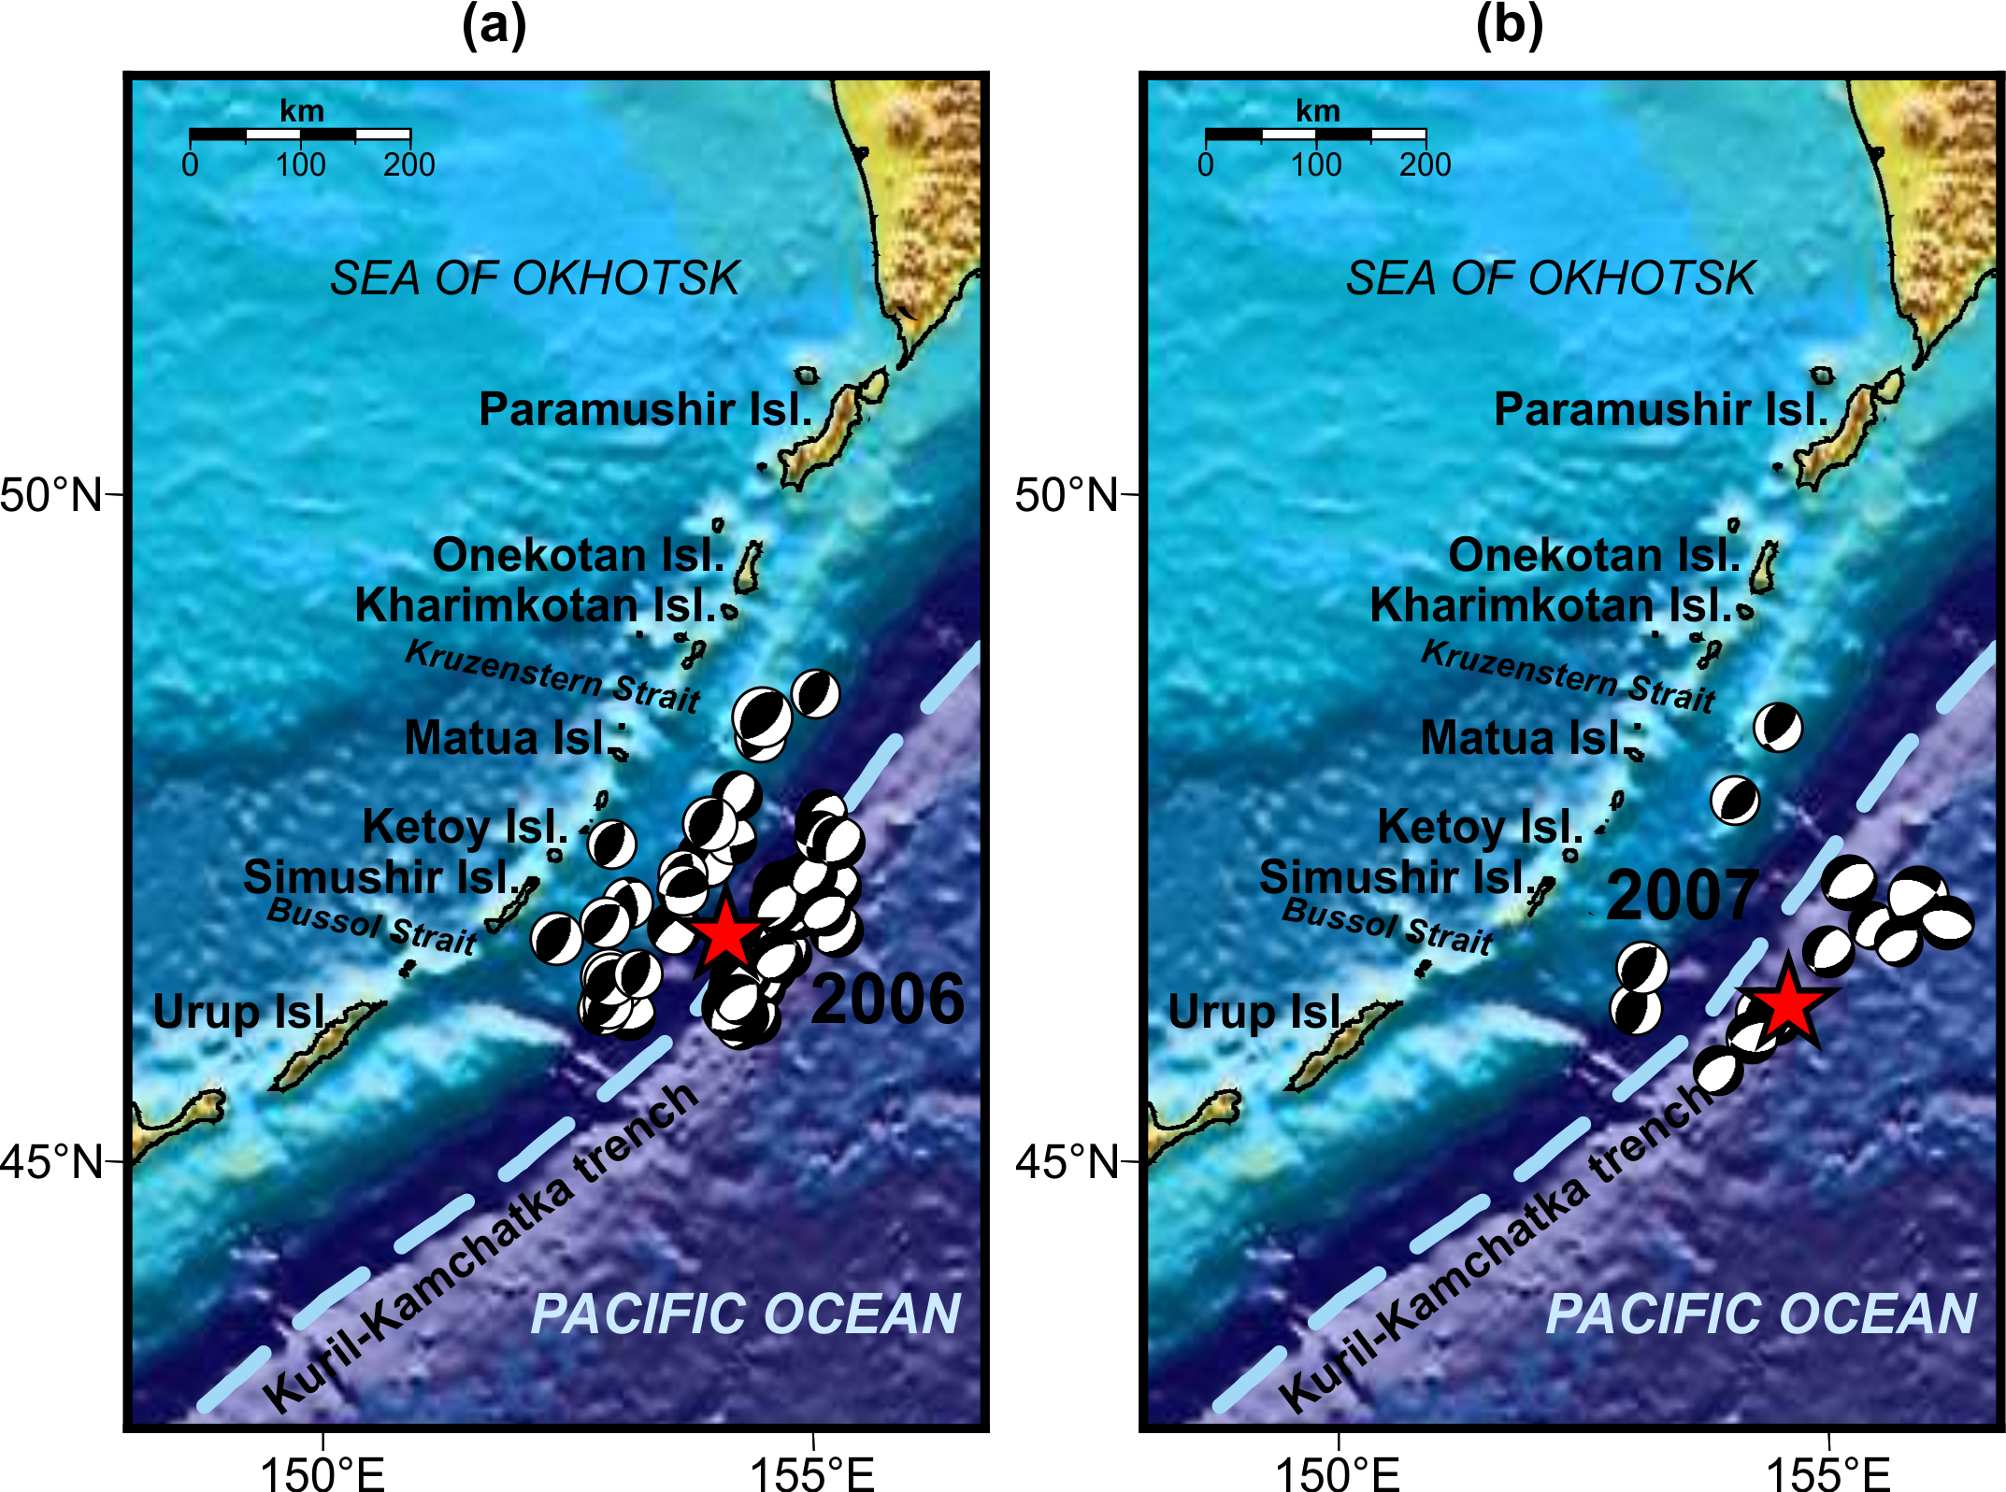
Fig 1. Spatial distribution and focal mechanisms of aftershocks of the 2006 (a) and 2007 (b) Simushir with M≥5, recorded within first two months after each of these seismic events (based on GCMT catalogue). Red stars denotes the main shocks of the 2006 and 2007 Simushir earthquakes/
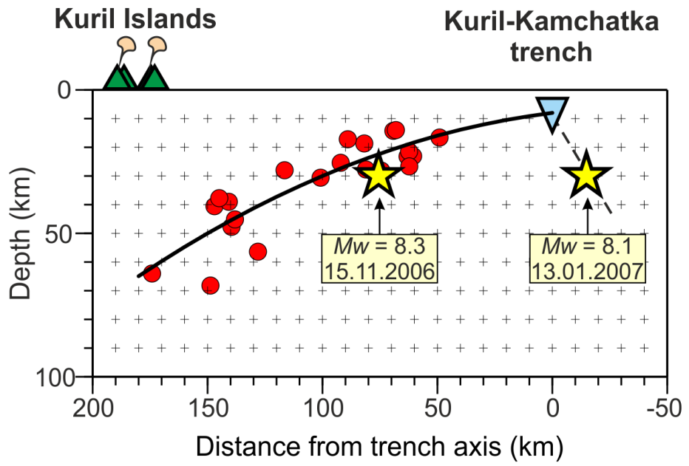
Fig 2. Cross section of the upper 100 km of the central part of the Kuril subduction zone. Red circles denotes hypocenters of thrust events since 1976. The solid curve is the second-order polynomial regression model. The dashed black line denotes the fault plane of the 2007 Simushir earthquake.

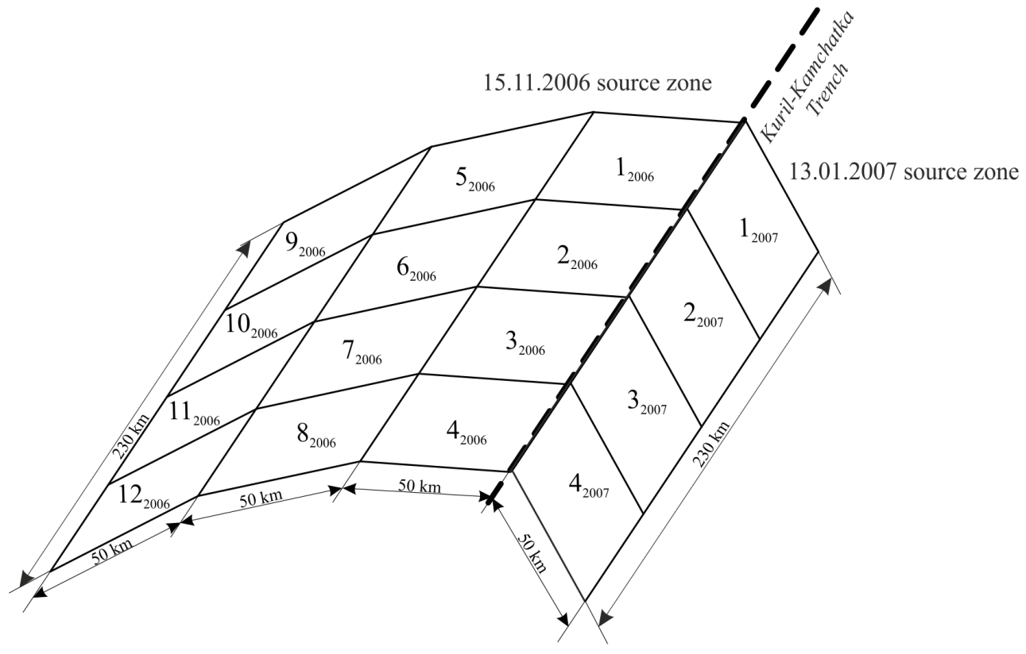
Fig 3. Approximation scheme of the 2006 and 2007 earthquakes source zones by a set of disjoint rectangular finite elements

Table 4.
Parameters of the source model of the First Simushir earthquake on November 15, 2006 (numbers of finite elements are given according to Fig. 1). “Lat, N” and “Lon, E” are coordinates of center of corresponding rectangular element.
Element number | Lower side  depth (km) | Upper side  depth (km) | Azimuth  (deg) | Dip (deg.) | Lat, N | Lon, E | Rake (deg.) | Slip (m)
1₂₀₀₆ | 7.92 | 0.00 | 221.1 | 9.0 | 47.46 | 154.82 | 107.51 | 2.60
2₂₀₀₆ | 7.92 | 0.00 | 221.1 | 9.0 | 47.07 | 154.32 | 136.65 | 3.41
3₂₀₀₆ | 7.92 | 0.00 | 221.1 | 9.0 | 46.68 | 153.82 | 116.92 | 5.28
4₂₀₀₆ | 7.92 | 0.00 | 221.1 | 9.0 | 46.29 | 153.32 | 140.00 | 11.06
5₂₀₀₆ | 22.26 | 7.92 | 221.1 | 16.0 | 47.75 | 154.32 | 100.00 | 3.04
6₂₀₀₆ | 22.26 | 7.92 | 221.1 | 16.0 | 47.36 | 153.82 | 100.00 | 4.09
7₂₀₀₆ | 22.26 | 7.92 | 221.1 | 16.0 | 46.97 | 153.33 | 100.00 | 4.06
8₂₀₀₆ | 22.26 | 7.92 | 221.1 | 16.0 | 46.58 | 152.83 | 137.39 | 11.94
9₂₀₀₆ | 42.46 | 22.26 | 221.1 | 22.0 | 48.03 | 153.86 | 96.61 | 1.68
10₂₀₀₆ | 42.46 | 22.26 | 221.1 | 22.0 | 47.66 | 153.33 | 100.00 | 1.57
11₂₀₀₆ | 42.46 | 22.26 | 221.1 | 22.0 | 47.25 | 152.85 | 103.85 | 1.88
12₂₀₀₆ | 42.46 | 22.26 | 221.1 | 22.0 | 46.86 | 152.35 | 120.00 | 2.94

Table 5.
Parameters of the source model of the Second Simushir earthquake on January 13, 2007 (numbers of finite elements are given according to Fig. 1). “Lat, N” and “Lon, E” are coordinates of center of corresponding rectangular element.
Element number | Lower side  depth (km) | Upper side  depth (km) | Azimuth  (deg) | Dip (deg.) | Lat, N | Lon, E | Rake (deg.) | Slip (m)
1₂₀₀₇ | 42.86 | 0.00 | 39.9 | 59.0 | 47.31 | 155.63 | 7.63 | 1.83
2₂₀₀₇ | 42.86 | 0.00 | 39.9 | 59.0 | 46.91 | 155.14 | 33.46 | 1.88
3₂₀₀₇ | 42.86 | 0.00 | 39.9 | 59.0 | 46.51 | 154.66 | 54.85 | 3.38
4₂₀₀₇ | 42.86 | 0.00 | 39.9 | 59.0 | 46.11 | 154.18 | 69.25 | 6.42

Table 6.
Horizontal postseismic displacements of the Earth’s surface recorded by the stations of KurilNet during the first two months after the First Simushir earthquake 11/15/2006 (calculated in ITRF2008 reference frame relative to North American plate). Two-weeks-sampling displacements are given
Station | PARM | URUP | ITUR | KUNA | SHIK
Latitude, N Longitude, E | 50.67  156.12 | 46.23  150.57 | 45.23  147.87 | 44.04  145.86 | 43.87  146.83
Displacement  Period | U_{N} (mm)±σ_{N} (mm)  U_{E} (mm)±σ_{E} (mm)
16/11/2006–30/11/2006 | 0.56±0.92  -2.32±0.83 | -1.60±0.86  25.90±0.73 | -0.80±0.95  3.75±0.80 | 2.04±0.97  -2.68±0.79 | 2.10±0.77  -3.17±0.66
01/12/2006–15/12/2006 | 2.52±0.74  -2.42±0.82 | -1.56±0.83  9.86±0.81 | -0.96±0.88  1.30±0.77 | 1.82±0.92  -1.95±1.07 | 2.08±0.88  -2.04±0.84
16/12/2006–30/12/2006 | 2.18±0.83  2.54±0.85 | -1.43±0.78  5.56±0.76 | 0.95±0.73  2.20±0.79 | 1.60±0.82  -1.71±0.78 | 2.20±0.74  1.27±0.72
31/12/2006–12/01/2007 | 2.67±0.79  -1.61±0.75 | 1.38±0.80  4.59±0.86 | 0.22±0.71  -1.62±0.72 | 2.50±0.83  -2.44±0.79 | 2.92±0.82  -2.02±0.88

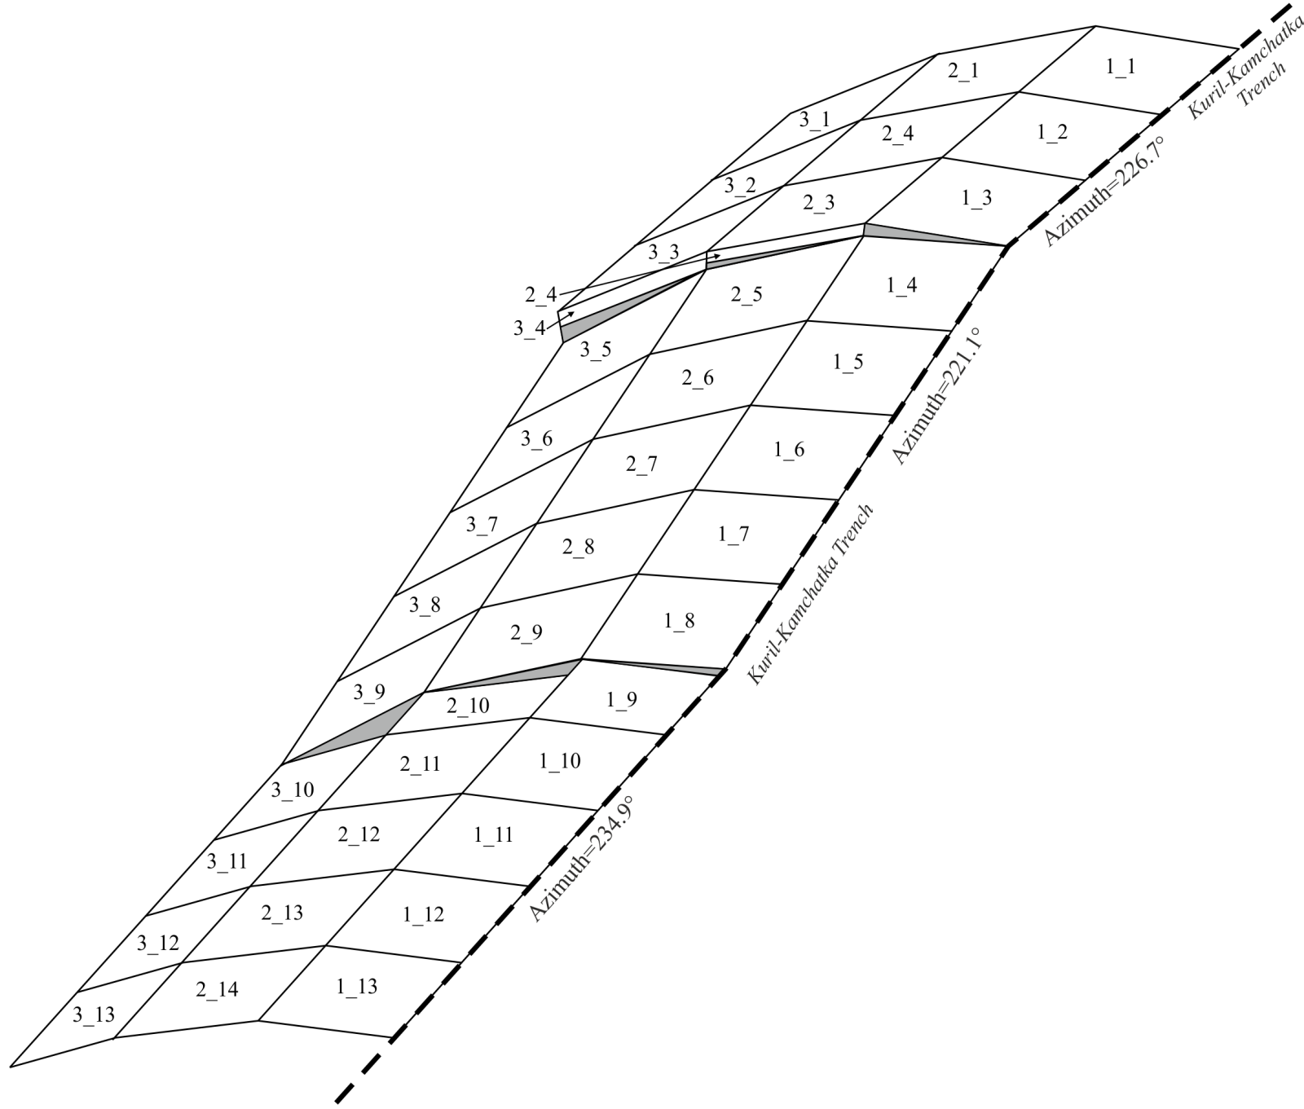Fig 4. Approximation scheme of the extended source zone by a set of disjoint rectangular finite elements. In the areas indicated by gray triangles calculation of slip was not performed.

Table 7.
Parameters of the source models of the afterslip process in the first two months after the First Simushir earthquake on November 15, 2006 (numbers of finite elements are given according to Fig. 2). “Lat, N” and “Lon, E” are coordinates of center of corresponding rectangular element
- Time period: 16/11/2006–30/11/2006
Element number | Lower side  depth (km) | Upper side  depth (km) | Azimuth  (deg) | Dip (deg.) | Lat, N | Lon, E | Rake (deg.) | Slip (m)
1_1 | 7.92 | 0.00 | 226.7 | 9.0 | 49.01 | 157.44 | 88.17 | 0.57
1_2 | 7.92 | 0.00 | 226.7 | 9.0 | 48.66 | 156.87 | 75.56 | 0.66
1_3 | 7.92 | 0.00 | 226.7 | 9.0 | 48.31 | 156.30 | 87.42 | 0.77
1_4 | 7.92 | 0.00 | 221.1 | 9.0 | 47.91 | 155.78 | 101.12 | 0.08
1_5 | 7.92 | 0.00 | 221.1 | 9.0 | 47.52 | 155.27 | 116.08 | 1.04
1_6 | 7.92 | 0.00 | 221.1 | 9.0 | 47.13 | 154.77 | 110.45 | 1.15
1_7 | 7.92 | 0.00 | 221.1 | 9.0 | 46.74 | 154.27 | 112.14 | 1.52
1_8 | 7.92 | 0.00 | 221.1 | 9.0 | 46.35 | 153.78 | 98.67 | 1.88
1_9 | 7.92 | 0.00 | 234.9 | 9.0 | 46.05 | 153.38 | 84.31 | 1.69
1_10 | 7.92 | 0.00 | 234.9 | 9.0 | 45.83 | 152.95 | 82.47 | 0.74
1_11 | 7.92 | 0.00 | 234.9 | 9.0 | 45.53 | 152.34 | 75.65 | 0.00
1_12 | 7.92 | 0.00 | 234.9 | 9.0 | 45.23 | 151.74 | 78.33 | 0.00
1_13 | 7.92 | 0.00 | 234.9 | 9.0 | 44.93 | 151.14 | 94.24 | 0.17
2_1 | 22.26 | 7.92 | 226.7 | 16.0 | 49.32 | 157.00 | 81.62 | 0.21
2_2 | 22.26 | 7.92 | 226.7 | 16.0 | 48.97 | 156.42 | 102.09 | 0.24
2_3 | 22.26 | 7.92 | 226.7 | 16.0 | 48.62 | 155.85 | 114.18 | 0.28
2_4 | 22.26 | 7.92 | 226.7 | 16.0 | 48.43 | 155.55 | 108.06 | 0.02
2_5 | 22.26 | 7.92 | 221.1 | 16.0 | 48.19 | 155.33 | 109.28 | 0.36
2_6 | 22.26 | 7.92 | 221.1 | 16.0 | 47.80 | 154.82 | 112.52 | 0.38
2_7 | 22.26 | 7.92 | 221.1 | 16.0 | 47.41 | 154.32 | 112.98 | 0.37
2_8 | 22.26 | 7.92 | 221.1 | 16.0 | 47.02 | 153.82 | 109.05 | 0.23
2_9 | 22.26 | 7.92 | 221.1 | 16.0 | 46.63 | 153.32 | 90.00 | 0.00
2_10 | 22.26 | 7.92 | 234.9 | 16.0 | 46.38 | 153.00 | 90.00 | 0.00
2_11 | 22.26 | 7.92 | 234.9 | 16.0 | 46.18 | 152.60 | 90.00 | 0.00
2_12 | 22.26 | 7.92 | 234.9 | 16.0 | 45.88 | 151.99 | 90.00 | 0.00
2_13 | 22.26 | 7.92 | 234.9 | 16.0 | 45.58 | 151.38 | 90.00 | 0.00
2_14 | 22.26 | 7.92 | 234.9 | 16.0 | 45.28 | 150.78 | 90.00 | 0.00
3_1 | 42.46 | 22.26 | 226.7 | 22.0 | 49.63 | 156.57 | 90.00 | 0.00
3_2 | 42.46 | 22.26 | 226.7 | 22.0 | 49.28 | 155.99 | 90.00 | 0.00
3_3 | 42.46 | 22.26 | 226.7 | 22.0 | 48.93 | 155.41 | 90.00 | 0.00
3_4 | 42.46 | 22.26 | 226.7 | 22.0 | 48.74 | 155.10 | 102.45 | 0.26
3_5 | 42.46 | 22.26 | 221.1 | 22.0 | 48.47 | 154.87 | 96.15 | 0.35
3_6 | 42.46 | 22.26 | 221.1 | 22.0 | 48.08 | 154.36 | 96.86 | 0.29
3_7 | 42.46 | 22.26 | 221.1 | 22.0 | 47.69 | 153.85 | 107.44 | 0.62
3_8 | 42.46 | 22.26 | 221.1 | 22.0 | 47.30 | 153.35 | 105.38 | 0.00
3_9 | 42.46 | 22.26 | 221.1 | 22.0 | 46.91 | 152.85 | 90.00 | 0.00
3_10 | 42.46 | 22.26 | 234.9 | 22.0 | 46.53 | 152.23 | 90.00 | 0.00
3_11 | 42.46 | 22.26 | 234.9 | 22.0 | 46.23 | 151.62 | 90.00 | 0.00
3_12 | 42.46 | 22.26 | 234.9 | 22.0 | 45.93 | 151.01 | 90.00 | 0.00
3_13 | 42.46 | 22.26 | 234.9 | 22.0 | 45.63 | 150.40 | 90.00 | 0.00
- Time period: 01/12/2006–15/12/2006
Element number | Lower side  depth (km) | Upper side  depth (km) | Azimuth  (deg) | Dip (deg.) | Lat, N | Lon, E | Rake (deg.) | Slip (m)
1_1 | 7.92 | 0.00 | 226.7 | 9.0 | 49.01 | 157.44 | 90.73 | 0.88
1_2 | 7.92 | 0.00 | 226.7 | 9.0 | 48.66 | 156.87 | 82.17 | 1.02
1_3 | 7.92 | 0.00 | 226.7 | 9.0 | 48.31 | 156.30 | 84.26 | 1.08
1_4 | 7.92 | 0.00 | 221.1 | 9.0 | 47.91 | 155.78 | 105.88 | 0.12
1_5 | 7.92 | 0.00 | 221.1 | 9.0 | 47.52 | 155.27 | 114.57 | 1.52
1_6 | 7.92 | 0.00 | 221.1 | 9.0 | 47.13 | 154.77 | 112.46 | 1.63
1_7 | 7.92 | 0.00 | 221.1 | 9.0 | 46.74 | 154.27 | 112.58 | 1.64
1_8 | 7.92 | 0.00 | 221.1 | 9.0 | 46.35 | 153.78 | 100.08 | 1.58
1_9 | 7.92 | 0.00 | 234.9 | 9.0 | 46.05 | 153.38 | 88.62 | 1.29
1_10 | 7.92 | 0.00 | 234.9 | 9.0 | 45.83 | 152.95 | 87.54 | 0.00
1_11 | 7.92 | 0.00 | 234.9 | 9.0 | 45.53 | 152.34 | 79.06 | 0.00
1_12 | 7.92 | 0.00 | 234.9 | 9.0 | 45.23 | 151.74 | 90.00 | 0.00
1_13 | 7.92 | 0.00 | 234.9 | 9.0 | 44.93 | 151.14 | 79.93 | 0.13
2_1 | 22.26 | 7.92 | 226.7 | 16.0 | 49.32 | 157.00 | 80.13 | 0.33
2_2 | 22.26 | 7.92 | 226.7 | 16.0 | 48.97 | 156.42 | 92.16 | 0.38
2_3 | 22.26 | 7.92 | 226.7 | 16.0 | 48.62 | 155.85 | 103.52 | 0.43
2_4 | 22.26 | 7.92 | 226.7 | 16.0 | 48.43 | 155.55 | 102.98 | 0.02
2_5 | 22.26 | 7.92 | 221.1 | 16.0 | 48.19 | 155.33 | 104.47 | 0.53
2_6 | 22.26 | 7.92 | 221.1 | 16.0 | 47.80 | 154.82 | 109.66 | 0.56
2_7 | 22.26 | 7.92 | 221.1 | 16.0 | 47.41 | 154.32 | 111.05 | 0.52
2_8 | 22.26 | 7.92 | 221.1 | 16.0 | 47.02 | 153.82 | 107.14 | 0.29
2_9 | 22.26 | 7.92 | 221.1 | 16.0 | 46.63 | 153.32 | 90.18 | 0.01
2_10 | 22.26 | 7.92 | 234.9 | 16.0 | 46.38 | 153.00 | 90.00 | 0.00
2_11 | 22.26 | 7.92 | 234.9 | 16.0 | 46.18 | 152.60 | 90.00 | 0.00
2_12 | 22.26 | 7.92 | 234.9 | 16.0 | 45.88 | 151.99 | 90.00 | 0.00
2_13 | 22.26 | 7.92 | 234.9 | 16.0 | 45.58 | 151.38 | 90.00 | 0.00
2_14 | 22.26 | 7.92 | 234.9 | 16.0 | 45.28 | 150.78 | 90.00 | 0.00
3_1 | 42.46 | 22.26 | 226.7 | 22.0 | 49.63 | 156.57 | 90.00 | 0.00
3_2 | 42.46 | 22.26 | 226.7 | 22.0 | 49.28 | 155.99 | 90.00 | 0.00
3_3 | 42.46 | 22.26 | 226.7 | 22.0 | 48.93 | 155.41 | 90.00 | 0.00
3_4 | 42.46 | 22.26 | 226.7 | 22.0 | 48.74 | 155.10 | 100.99 | 0.39
3_5 | 42.46 | 22.26 | 221.1 | 22.0 | 48.47 | 154.87 | 98.46 | 0.56
3_6 | 42.46 | 22.26 | 221.1 | 22.0 | 48.08 | 154.36 | 98.12 | 0.46
3_7 | 42.46 | 22.26 | 221.1 | 22.0 | 47.69 | 153.85 | 101.54 | 1.00
3_8 | 42.46 | 22.26 | 221.1 | 22.0 | 47.30 | 153.35 | 90.00 | 0.00
3_9 | 42.46 | 22.26 | 221.1 | 22.0 | 46.91 | 152.85 | 90.00 | 0.00
3_10 | 42.46 | 22.26 | 234.9 | 22.0 | 46.53 | 152.23 | 90.00 | 0.00
3_11 | 42.46 | 22.26 | 234.9 | 22.0 | 46.23 | 151.62 | 90.00 | 0.00
3_12 | 42.46 | 22.26 | 234.9 | 22.0 | 45.93 | 151.01 | 90.00 | 0.00
3_13 | 42.46 | 22.26 | 234.9 | 22.0 | 45.63 | 150.40 | 90.00 | 0.00
3. Time period: 16/12/2006–30/12/2006
Element number | Lower side  depth (km) | Upper side  depth (km) | Azimuth  (deg) | Dip (deg.) | Lat, N | Lon, E | Rake (deg.) | Slip (m)
1_1 | 7.92 | 0.00 | 226.7 | 9.0 | 49.01 | 157.44 | 90.00 | 0.00
1_2 | 7.92 | 0.00 | 226.7 | 9.0 | 48.66 | 156.87 | 90.00 | 0.00
1_3 | 7.92 | 0.00 | 226.7 | 9.0 | 48.31 | 156.30 | 90.00 | 0.00
1_4 | 7.92 | 0.00 | 221.1 | 9.0 | 47.91 | 155.78 | 90.00 | 0.00
1_5 | 7.92 | 0.00 | 221.1 | 9.0 | 47.52 | 155.27 | 90.00 | 0.00
1_6 | 7.92 | 0.00 | 221.1 | 9.0 | 47.13 | 154.77 | 95.17 | 0.83
1_7 | 7.92 | 0.00 | 221.1 | 9.0 | 46.74 | 154.27 | 92.38 | 1.07
1_8 | 7.92 | 0.00 | 221.1 | 9.0 | 46.35 | 153.78 | 91.16 | 1.17
1_9 | 7.92 | 0.00 | 234.9 | 9.0 | 46.05 | 153.38 | 89.15 | 0.00
1_10 | 7.92 | 0.00 | 234.9 | 9.0 | 45.83 | 152.95 | 89.44 | 0.00
1_11 | 7.92 | 0.00 | 234.9 | 9.0 | 45.53 | 152.34 | 90.00 | 0.00
1_12 | 7.92 | 0.00 | 234.9 | 9.0 | 45.23 | 151.74 | 90.00 | 0.00
1_13 | 7.92 | 0.00 | 234.9 | 9.0 | 44.93 | 151.14 | 90.00 | 0.00
2_1 | 22.26 | 7.92 | 226.7 | 16.0 | 49.32 | 157.00 | 90.00 | 0.00
2_2 | 22.26 | 7.92 | 226.7 | 16.0 | 48.97 | 156.42 | 90.00 | 0.00
2_3 | 22.26 | 7.92 | 226.7 | 16.0 | 48.62 | 155.85 | 90.00 | 0.00
2_4 | 22.26 | 7.92 | 226.7 | 16.0 | 48.43 | 155.55 | 90.00 | 0.00
2_5 | 22.26 | 7.92 | 221.1 | 16.0 | 48.19 | 155.33 | 90.00 | 0.00
2_6 | 22.26 | 7.92 | 221.1 | 16.0 | 47.80 | 154.82 | 89.62 | 0.00
2_7 | 22.26 | 7.92 | 221.1 | 16.0 | 47.41 | 154.32 | 91.15 | 0.00
2_8 | 22.26 | 7.92 | 221.1 | 16.0 | 47.02 | 153.82 | 91.27 | 0.00
2_9 | 22.26 | 7.92 | 221.1 | 16.0 | 46.63 | 153.32 | 90.18 | 0.00
2_10 | 22.26 | 7.92 | 234.9 | 16.0 | 46.38 | 153.00 | 90.00 | 0.00
2_11 | 22.26 | 7.92 | 234.9 | 16.0 | 46.18 | 152.60 | 90.00 | 0.00
2_12 | 22.26 | 7.92 | 234.9 | 16.0 | 45.88 | 151.99 | 90.00 | 0.00
2_13 | 22.26 | 7.92 | 234.9 | 16.0 | 45.58 | 151.38 | 90.00 | 0.00
2_14 | 22.26 | 7.92 | 234.9 | 16.0 | 45.28 | 150.78 | 90.00 | 0.00
3_1 | 42.46 | 22.26 | 226.7 | 22.0 | 49.63 | 156.57 | 90.00 | 0.00
3_2 | 42.46 | 22.26 | 226.7 | 22.0 | 49.28 | 155.99 | 90.00 | 0.00
3_3 | 42.46 | 22.26 | 226.7 | 22.0 | 48.93 | 155.41 | 90.00 | 0.00
3_4 | 42.46 | 22.26 | 226.7 | 22.0 | 48.74 | 155.10 | 90.91 | 0.00
3_5 | 42.46 | 22.26 | 221.1 | 22.0 | 48.47 | 154.87 | 90.17 | 0.00
3_6 | 42.46 | 22.26 | 221.1 | 22.0 | 48.08 | 154.36 | 89.11 | 0.00
3_7 | 42.46 | 22.26 | 221.1 | 22.0 | 47.69 | 153.85 | 89.15 | 0.00
3_8 | 42.46 | 22.26 | 221.1 | 22.0 | 47.30 | 153.35 | 90.06 | 0.00
3_9 | 42.46 | 22.26 | 221.1 | 22.0 | 46.91 | 152.85 | 90.00 | 0.00
3_10 | 42.46 | 22.26 | 234.9 | 22.0 | 46.53 | 152.23 | 90.00 | 0.00
3_11 | 42.46 | 22.26 | 234.9 | 22.0 | 46.23 | 151.62 | 90.00 | 0.00
3_12 | 42.46 | 22.26 | 234.9 | 22.0 | 45.93 | 151.01 | 90.00 | 0.00
3_13 | 42.46 | 22.26 | 234.9 | 22.0 | 45.63 | 150.40 | 90.00 | 0.00
4. Time period: 31/12/2006–12/01/2007
Element number | Lower side  depth (km) | Upper side  depth (km) | Azimuth  (deg) | Dip (deg.) | Lat, N | Lon, E | Rake (deg.) | Slip (m)
1_1 | 7.92 | 0.00 | 226.7 | 9.0 | 49.01 | 157.44 | 90.00 | 0.00
1_2 | 7.92 | 0.00 | 226.7 | 9.0 | 48.66 | 156.87 | 90.00 | 0.00
1_3 | 7.92 | 0.00 | 226.7 | 9.0 | 48.31 | 156.30 | 90.00 | 0.00
1_4 | 7.92 | 0.00 | 221.1 | 9.0 | 47.91 | 155.78 | 90.00 | 0.00
1_5 | 7.92 | 0.00 | 221.1 | 9.0 | 47.52 | 155.27 | 90.00 | 0.00
1_6 | 7.92 | 0.00 | 221.1 | 9.0 | 47.13 | 154.77 | 91.08 | 0.00
1_7 | 7.92 | 0.00 | 221.1 | 9.0 | 46.74 | 154.27 | 91.32 | 0.68
1_8 | 7.92 | 0.00 | 221.1 | 9.0 | 46.35 | 153.78 | 91.20 | 1.17
1_9 | 7.92 | 0.00 | 234.9 | 9.0 | 46.05 | 153.38 | 90.55 | 0.23
1_10 | 7.92 | 0.00 | 234.9 | 9.0 | 45.83 | 152.95 | 90.23 | 0.00
1_11 | 7.92 | 0.00 | 234.9 | 9.0 | 45.53 | 152.34 | 90.00 | 0.00
1_12 | 7.92 | 0.00 | 234.9 | 9.0 | 45.23 | 151.74 | 90.00 | 0.00
1_13 | 7.92 | 0.00 | 234.9 | 9.0 | 44.93 | 151.14 | 90.00 | 0.00
2_1 | 22.26 | 7.92 | 226.7 | 16.0 | 49.32 | 157.00 | 90.00 | 0.00
2_2 | 22.26 | 7.92 | 226.7 | 16.0 | 48.97 | 156.42 | 90.00 | 0.00
2_3 | 22.26 | 7.92 | 226.7 | 16.0 | 48.62 | 155.85 | 90.00 | 0.00
2_4 | 22.26 | 7.92 | 226.7 | 16.0 | 48.43 | 155.55 | 90.00 | 0.00
2_5 | 22.26 | 7.92 | 221.1 | 16.0 | 48.19 | 155.33 | 90.00 | 0.00
2_6 | 22.26 | 7.92 | 221.1 | 16.0 | 47.80 | 154.82 | 89.88 | 0.00
2_7 | 22.26 | 7.92 | 221.1 | 16.0 | 47.41 | 154.32 | 90.95 | 0.00
2_8 | 22.26 | 7.92 | 221.1 | 16.0 | 47.02 | 153.82 | 91.16 | 0.00
2_9 | 22.26 | 7.92 | 221.1 | 16.0 | 46.63 | 153.32 | 90.64 | 0.00
2_10 | 22.26 | 7.92 | 234.9 | 16.0 | 46.38 | 153.00 | 90.00 | 0.00
2_11 | 22.26 | 7.92 | 234.9 | 16.0 | 46.18 | 152.60 | 90.00 | 0.00
2_12 | 22.26 | 7.92 | 234.9 | 16.0 | 45.88 | 151.99 | 90.00 | 0.00
2_13 | 22.26 | 7.92 | 234.9 | 16.0 | 45.58 | 151.38 | 90.00 | 0.00
2_14 | 22.26 | 7.92 | 234.9 | 16.0 | 45.28 | 150.78 | 90.00 | 0.00
3_1 | 42.46 | 22.26 | 226.7 | 22.0 | 49.63 | 156.57 | 90.00 | 0.00
3_2 | 42.46 | 22.26 | 226.7 | 22.0 | 49.28 | 155.99 | 90.00 | 0.00
3_3 | 42.46 | 22.26 | 226.7 | 22.0 | 48.93 | 155.41 | 90.00 | 0.00
3_4 | 42.46 | 22.26 | 226.7 | 22.0 | 48.74 | 155.10 | 89.52 | 0.00
3_5 | 42.46 | 22.26 | 221.1 | 22.0 | 48.47 | 154.87 | 89.42 | 0.00
3_6 | 42.46 | 22.26 | 221.1 | 22.0 | 48.08 | 154.36 | 89.17 | 0.00
3_7 | 42.46 | 22.26 | 221.1 | 22.0 | 47.69 | 153.85 | 89.26 | 0.00
3_8 | 42.46 | 22.26 | 221.1 | 22.0 | 47.30 | 153.35 | 89.76 | 0.00
3_9 | 42.46 | 22.26 | 221.1 | 22.0 | 46.91 | 152.85 | 90.00 | 0.00
3_10 | 42.46 | 22.26 | 234.9 | 22.0 | 46.53 | 152.23 | 90.00 | 0.00
3_11 | 42.46 | 22.26 | 234.9 | 22.0 | 46.23 | 151.62 | 90.00 | 0.00
3_12 | 42.46 | 22.26 | 234.9 | 22.0 | 45.93 | 151.01 | 90.00 | 0.00
3_13 | 42.46 | 22.26 | 234.9 | 22.0 | 45.63 | 150.40 | 90.00 | 0.00

Table 8.
Cumulative posteseismic horizontal displacements of KurilNet stations averaged over 14-days intervals used in modeling (calculated in ITRF2008 reference frame relative to North American plate). The interseismic strain rate is taken into account.
Station | PARM | KHAM | MATC | KETC | URUP | ITUR | KUNA | SHIK
Latitude, N Longitude, E | 50.67  156.12 | 49.16  154.45 | 48.04  153.23 | 47.30  152.49 | 46.23  150.57 | 45.23  147.87 | 44.04  145.86 | 43.87  146.83
Displacement  Decimal  date | North Displacement U_{N} (mm)±σ_{N} (mm)  East Displacement U_{E} (mm)±σ_{E} (mm)
2007.667 | 0.00±0.52  0.00±0.47 | — | 0.00±0.45  0.00±0.40 | 0.00±0.49  0.00±0.44 | 0.00±0.95  0.00±0.61 | 0.00±0.48  0.00±0.43 | 0.00±0.49  0.00±0.44 | 0.00±0.46  0.00±0.42
2007.749 | 0.41±0.52  -3.08±0.48 | — | -8.67±0.45  7.36±0.40 | -9.05±0.5  9.78±0.45 | -3.01±0.94  0.06±0.71 | -0.89±0.49  -1.03±0.45 | 0.33±0.50  -1.41±0.47 | 0.21±0.47  -2.91±0.43
2007.832 | 0.73±0.49  -1.18±0.42 | — | -18.10±0.42  14.88±0.35 | -18.40±0.45  19.66±0.39 | -3.42±0.76  2.01±0.61 | 0.20±0.45  -0.53±0.38 | 1.75±0.48  -2.11±0.41 | 1.56±0.44  -4.93±0.37
2007.914 | 2.85±0.48  -4.11±0.39 | — | -24.35±0.40  22.48±0.33 | -24.43±0.43  28.69±0.36 | -3.01±0.57  3.96±0.48 | 1.74±0.44  0.30±0.37 | 4.02±0.47  -2.27±0.40 | 3.97±0.42  -4.76±0.35
2007.999 | 3.5±0.44  -5.58±0.36 | — | -31.95±0.38  26.65±0.31 | -32.23±0.40  34.82±0.33 | -4.44±0.49  2.39±0.40 | 1.93±0.40  -1.71±0.34 | 4.22±0.44  -4.64±0.37 | 4.68±0.38  -8.54±0.32
2008.081 | 3.38±0.47  -5.54±0.42 | — | -37.52±0.41  31.88±0.36 | -37.24± 0.42  41.84±0.37 | -5.95±2.90  0.22±2.64 | 4.19±0.41  -2.51±0.36 | 7.51±0.45  -7.56±0.40 | 7.08±0.39  -11.53±0.34
2008.163 | 4.65±0.49  -7.46±0.43 | — | -44.06+0.41  36.23±0.36 | -43.92±0.43  47.94±0.38 | — | 4.17±0.42  -3.46±0.37 | 6.98±0.46  -8.96±0.40 | 6.86±0.41  -14.24±0.36
2008.245 | 5.04±0.64  -5.35±0.57 | — | -51.95±0.47  41.35±0.40 | -52.87±0.51  56.83±0.45 | — | 4.06±0.49  -3.71±0.42 | 5.66±0.53  -8.00±0.45 | 6.30±0.46  -16.29±0.39
2008.327 | 5.41±0.52  -7.91±0.45 | — | -56.65±0.40  47.45±0.33 | -59.13±0.43  64.44±0.36 | — | 5.72±0.42  -2.66±0.35 | 7.39±0.46  -8.31±0.38 | 8.98±0.40  -16.55±0.33
2008.408 | 6.68±0.50  -8.56±0.42 | — | -60.18±0.40  51.78±0.33 | -63.72±0.44  70.12±0.37 | — | 7.30±0.44  -4.46±0.37 | 10.02±0.47  -11.07±0.39 | 10.97±0.42  -20.09±0.35
2008.490 | 6.49±0.48  -9.75±0.40 | — | -66.21±0.40  55.76±0.33 | -68.70±0.44  76.04±0.37 | — | 8.58±0.45  -4.71±0.38 | 11.74±0.45  -12.24±0.38 | 12.96±0.42  -21.97±0.36
2008.572 | 8.31±0.48  -12.03±0.42 | 0.00±1.09  0.00±0.93 | -68.88±0.43  58.13±0.38 | -72.80±0.47  78.85±0.41 | -4.67±0.87  5.18±0.65 | 9.54±0.46  -7.13±0.41 | 13.60±0.48  -15.48±0.42 | 14.79±0.45  -26.57±0.39
2008.654 | 8.97±0.50  -13.24±0.43 | -2.53±0.44  0.77±0.37 | -73.63±0.44  61.52±0.37 | -80.17± 0.49  83.19±0.41 | -5.25±0.61  5.34±0.46 | 10.59±0.49  -7.70±0.41 | 15.16±0.51  -17.06±0.42 | 15.62±0.48  -28.35±0.40
2008.736 | 10.89±0.58  -14.21±0.49 | -4.30±0.50  2.62±0.41 | -78.34±0.50  65.42±0.42 | -83.76± 0.54  89.93±0.45 | -4.66±0.52  5.34±0.43 | 10.80±0.54  -8.81±0.45 | 16.49±0.56  -19.28±0.46 | 16.45±0.52  -32.00±0.43
2008.818 | 14.04±0.54  -16.14±0.46 | -3.34±0.43  4.69±0.36 | -80.80±0.45  68.75±0.37 | -88.18±0.49  96.44±0.4 | -3.54±0.46  6.54±0.38 | 12.44±0.48  -8.85±0.40 | 17.98±0.50  -20.66±0.42 | 18.69±0.46  -33.39±0.38
2008.900 | 13.09±0.49  -17.93±0.43 | -5.09±0.41  4.52±0.36 | -85.46±0.41  72.20±0.36 | -91.89±0.44  100.88±0.38 | -3.89±0.78  5.65±0.67 | 14.09±0.45  -10.11±0.39 | 18.61±0.47  -22.91±0.41 | 20.43±0.42  -35.80±0.37
2008.980 | 15.12±0.55  -19.05±0.47 | -5.37±0.46  5.96±0.39 | -88.06±0.45  76.21±0.39 | -95.11±0.5  106.54±0.42 | — | 15.11±0.55  -10.03±0.48 | 20.47±0.56  -24.06±0.48 | 22.73±0.48  -37.81±0.41
2009.037 | 15.27±0.69  -15.59±0.62 | -7.46±0.60  6.00±0.55 | -91.88±0.61  78.24±0.57 | -98.58± 0.65  109.54±0.6 | — | — | 19.71±0.71  -24.99±0.66 | 22.09±0.62  -39.74±0.59
2009.081 | 17.61±0.67  -15.82±0.61 | -8.89±0.58  8.94±0.53 | -93.35±0.59  79.12±0.55 | -100.11±0.61  110.62±0.57 | — | — | 20.76±0.66  -25.11±0.61 | 23.21±0.58  -40.21±0.55
2009.163 | 19.03±0.48  -21.25±0.44 | -9.53±0.40  9.87±0.37 | -96.85±0.41  81.35±0.38 | -103.50±0.43  114.67±0.4 | — | — | 21.98±0.48  -26.27±0.45 | 23.49±0.65  -40.44±0.58
2009.245 | 16.35±0.51  -20.48±0.45 | -12.94±0.44  9.86±0.40 | -101.87±0.41  84.30±0.38 | -108.93±0.45  119.18±0.41 | — | — | 20.53±0.50  -26.95±0.45 | —
2009.327 | 16.75±0.53  -20.73±0.45 | -13.11±0.45  12.26±0.39 | -104.06±0.44  87.98±0.39 | -111.73± 0.47  124.39±0.41 | — | — | 22.74±0.67  -27.39±0.58 | —
2009.410 | 19.76±0.56  -20.94±0.47 | -12.46±0.47  14.15±0.40 | -106.19±0.46  91.97±0.40 | -114.32±0.49  130.07±0.42 | — | — | 25.52±0.67  -28.08±0.58 | 27.81±0.67  -48.86±0.58
2009.492 | 19.61±0.65  -23.82±0.55 | -15.03±0.61  12.41±0.51 | -107.48±0.60  93.84±0.5 | -119.29±0.64  133.82±0.53 | — | — | 26.19±0.66  -31.80±0.56 | 29.40±0.63  -52.45±0.53
2009.574 | 21.66±0.50  -23.65±0.42 | -14.37±0.45  13.44±0.38 | -108.80±0.45  96.55±0.38 | -118.91±0.49  136.66±0.41 | — | — | 28.93±0.49  -33.19±0.42 | 31.62±0.48  54.32±0.40
2009.656 | 20.03±0.49  -26.02±0.41 | -16.97±0.45  13.50±0.38 | -113.93±0.46  98.13±0.38 | -124.37± 0.49  137.63±0.41 | — | — | 28.27±0.49  -35.62±0.41 | 31.09±0.47  -57.97±0.39
2009.738 | 21.52±0.48  -27.81±0.39 | -17.29±0.45  15.22±0.36 | -115.75±0.45  100.84±0.37 | -126.99±0.48  142.29±0.39 | — | — | 29.84±0.50  -36.55±0.41 | 32.16±0.47  -59.99±0.38
2009.821 | 23.33±0.5  -28.76±0.41 | -18.78±0.44  15.64±0.36 | -119.40±0.44  103.91±0.36 | -131.39±0.47  148.50±0.39 | — | — | 30.70±0.48  -38.54±0.40 | 32.66±0.45  -62.40±0.38
2009.903 | 23.61±0.51  -33.53±0.42 | -18.07±0.40  16.29±0.33 | -121.77±0.40  107.10±0.34 | -133.44± 0.43  152.49±0.36 | — | — | 30.96±0.45  -41.02±0.39 | 33.54±0.42  -65.72±0.36
2009.999 | 25.44±0.41  -31.27±0.35 | -16.71±0.76  15.58±0.63 | -122.75± 0.36  108.82±0.3 | -134.62±0.37  154.85±0.32 | — | — | 33.18±0.41  -42.61±0.36 | 36.94±0.36  -67.98±0.31
2010.081 | 24.84±0.46  -34.15±0.39 | -19.34±0.40  15.28±0.34 | -126.74±0.40  109.47±0.35 | -138.74±0.43  157.57±0.37 | — | — | 33.36±0.46  -45.24±0.40 | 37.19±0.40  -71.89±0.35
2010.163 | 27.87±0.47  -36.81±0.41 | -18.97±0.39  15.51±0.34 | -127.94±0.37  110.57±0.32 | -140.70±0.41  160.49±0.35 | — | — | 35.63±0.44  -48.17±0.38 | 40.08±0.38  -75.38±0.33
2010.410 | 27.95±0.57  -37.65±0.46 | -21.72±0.50  17.74±0.41 | -135.83±0.48  119.08±0.39 | -150.83± 0.51  171.77±0.42 | — | — | — | 43.81±0.49  -81.56±0.40

Table 9.
Parameters of the “postseismic” source model of the First Simushir earthquake on November 15, 2006 (numbers of finite elements are given according to Fig. 2). “Lat, N” and “Lon, E” are coordinates of center of corresponding rectangular element.
Element number | Lower side  depth (km) | Upper side  depth (km) | Azimuth  (deg) | Dip (deg.) | Lat, N | Lon, E | Rake (deg.) | Slip (m)
1_1 | 7.92 | 0.00 | 226.7 | 9.0 | 49.01 | 157.44 | 85.18 | 0.17
1_2 | 7.92 | 0.00 | 226.7 | 9.0 | 48.66 | 156.87 | 70.49 | 0.21
1_3 | 7.92 | 0.00 | 226.7 | 9.0 | 48.31 | 156.30 | 82.54 | 0.23
1_4 | 7.92 | 0.00 | 221.1 | 9.0 | 47.91 | 155.78 | 111.18 | 0.81
1_5 | 7.92 | 0.00 | 221.1 | 9.0 | 47.52 | 155.27 | 114.26 | 3.01
1_6 | 7.92 | 0.00 | 221.1 | 9.0 | 47.13 | 154.77 | 113.05 | 6.77
1_7 | 7.92 | 0.00 | 221.1 | 9.0 | 46.74 | 154.27 | 107.55 | 10.76
1_8 | 7.92 | 0.00 | 221.1 | 9.0 | 46.35 | 153.78 | 95.60 | 11.72
1_9 | 7.92 | 0.00 | 234.9 | 9.0 | 46.05 | 153.38 | 82.03 | 5.72
1_10 | 7.92 | 0.00 | 234.9 | 9.0 | 45.83 | 152.95 | 72.61 | 7.06
1_11 | 7.92 | 0.00 | 234.9 | 9.0 | 45.53 | 152.34 | 65.21 | 2.31
1_12 | 7.92 | 0.00 | 234.9 | 9.0 | 45.23 | 151.74 | 72.04 | 0.22
1_13 | 7.92 | 0.00 | 234.9 | 9.0 | 44.93 | 151.14 | 105.64 | 0.24
2_1 | 22.26 | 7.92 | 226.7 | 16.0 | 49.32 | 157.00 | 60.51 | 0.03
2_2 | 22.26 | 7.92 | 226.7 | 16.0 | 48.97 | 156.42 | 98.88 | 0.04
2_3 | 22.26 | 7.92 | 226.7 | 16.0 | 48.62 | 155.85 | 116.20 | 0.10
2_4 | 22.26 | 7.92 | 226.7 | 16.0 | 48.43 | 155.55 | 108.77 | 0.92
2_5 | 22.26 | 7.92 | 221.1 | 16.0 | 48.19 | 155.33 | 111.43 | 0.11
2_6 | 22.26 | 7.92 | 221.1 | 16.0 | 47.80 | 154.82 | 120.00 | 0.16
2_7 | 22.26 | 7.92 | 221.1 | 16.0 | 47.41 | 154.32 | 120.00 | 2.51
2_8 | 22.26 | 7.92 | 221.1 | 16.0 | 47.02 | 153.82 | 111.04 | 1.70
2_9 | 22.26 | 7.92 | 221.1 | 16.0 | 46.63 | 153.32 | 60.00 | 0.41
2_10 | 22.26 | 7.92 | 234.9 | 16.0 | 46.38 | 153.00 | 60.13 | 1.20
2_11 | 22.26 | 7.92 | 234.9 | 16.0 | 46.18 | 152.60 | 60.00 | 4.74
2_12 | 22.26 | 7.92 | 234.9 | 16.0 | 45.88 | 151.99 | 60.00 | 0.73
2_13 | 22.26 | 7.92 | 234.9 | 16.0 | 45.58 | 151.38 | 60.00 | 0.14
2_14 | 22.26 | 7.92 | 234.9 | 16.0 | 45.28 | 150.78 | 90.00 | 0.00
3_1 | 42.46 | 22.26 | 226.7 | 22.0 | 49.63 | 156.57 | 60.00 | 5.20
3_2 | 42.46 | 22.26 | 226.7 | 22.0 | 49.28 | 155.99 | 60.88 | 3.77
3_3 | 42.46 | 22.26 | 226.7 | 22.0 | 48.93 | 155.41 | 118.10 | 5.62
3_4 | 42.46 | 22.26 | 226.7 | 22.0 | 48.74 | 155.10 | 116.94 | 2.78
3_5 | 42.46 | 22.26 | 221.1 | 22.0 | 48.47 | 154.87 | 99.47 | 3.91
3_6 | 42.46 | 22.26 | 221.1 | 22.0 | 48.08 | 154.36 | 96.61 | 0.02
3_7 | 42.46 | 22.26 | 221.1 | 22.0 | 47.69 | 153.85 | 119.22 | 4.70
3_8 | 42.46 | 22.26 | 221.1 | 22.0 | 47.30 | 153.35 | 103.85 | 0.36
3_9 | 42.46 | 22.26 | 221.1 | 22.0 | 46.91 | 152.85 | 120.00 | 0.20
3_10 | 42.46 | 22.26 | 234.9 | 22.0 | 46.53 | 152.23 | 60.00 | 0.15
3_11 | 42.46 | 22.26 | 234.9 | 22.0 | 46.23 | 151.62 | 60.00 | 2.13
3_12 | 42.46 | 22.26 | 234.9 | 22.0 | 45.93 | 151.01 | 60.12 | 2.90
3_13 | 42.46 | 22.26 | 234.9 | 22.0 | 45.63 | 150.40 | 119.97 | 4.85

