Appendix
In order to quantify the variance of the regurgitant orifice size from the MV, we calculated the anatomic MV orifice areas (AMVOA) using an in-house MATLAB script. First, the least square plane of the mitral annulus was calculated at each interrogated time point during the systole. Then, the AMVOA was measured as the projected 2D area of the free edge of the MV leaflets on the least square plane. The AMVOAs throughout the systole were plotted in Figure S1. The anatomic orifice areas are almost constant throughout the systole for all models except for the P1&P2 model.

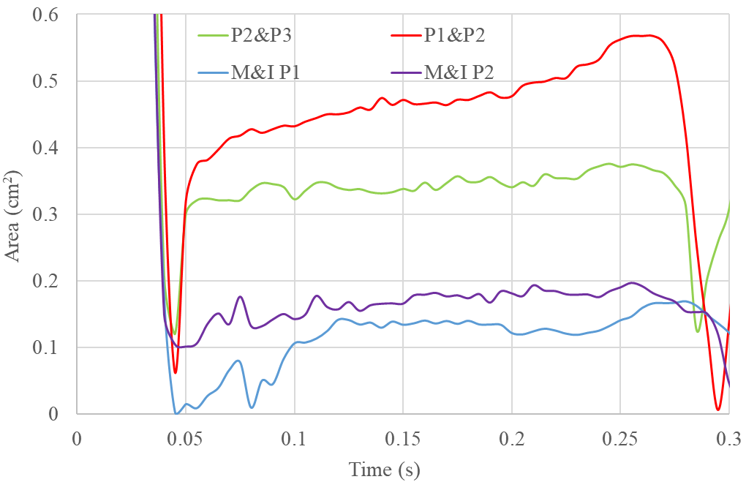
Figure S1. The anatomic MV orifice areas throughout the systole for all models

To verify the accuracy of our FSI results, a commercial computational fluid dynamics (CFD) software Star-CCM+ was used to simulate the regurgitant flow through the MV at the peak systole for the P2&P3 model. In brief, we extracted the surfaces including the MV and AV leaflets and LV wall from the FSI simulation at the peak systole, imported them into the Star-CCM+, and then created a polyhedral volumetric mesh. The pressure boundary conditions used at the atrial and aortic sides are in consistency with the FSI simulation. Meanwhile, we also extracted the flow velocity information at the LV wall from the FSI simulation and applied it as the velocity boundary condition in the Star-CCM+. We followed the same procedure as before to extract the PFC. The PFC shape is very similar to that obtained from the FSI simulation (Figure 7a), as shown in Figure S2. The calculated 3D echo PISA is 7.7 cm², which is close to its counterpart from the FSI simulation (8.9 cm²). Although the steady flow assumption used in the Star-CCM+ cannot exactly replicate the transient flow in the FSI simulations, the small discrepancy in their results indicates that the inaccuracy of the SPH method at the wall boundary should not significantly affect the results of the PISA method.

Figure S2. The shapes of 3D-echo PISA obtained from the CFD software Star-CCM+ for the P2&P3 model are shown on the side and top views.

