Electronic Supplementary Information

Photo-responsive Azo-functionalised Flexible Polymer Substrate for Liquid Crystal Alignment
B.Sivaranjiniª, K. Mohanaª,S. Esakkimuthuª, V. Ganesh^{b}and S. Umadeviª*

ªDepartment of Industrial Chemistry, Alagappa University, Karaikudi – 630002, India.
^{b}Electrodics and Electrocatalysis Division (EEC), CSIR – Central Electrochemical Research
Institute (CSIR−CECRI), Karaikudi – 630003, India

∗ Corresponding Author
e-mail: umadevilc@gmail.com

Figure S1. FT-IR spectra recorded for (a) alkene-terminated compound (B) and (b) silane-
terminated compound (C) respectively.

Figure S2.¹H-NMR spectrum of alkene-terminated azo compound (B).

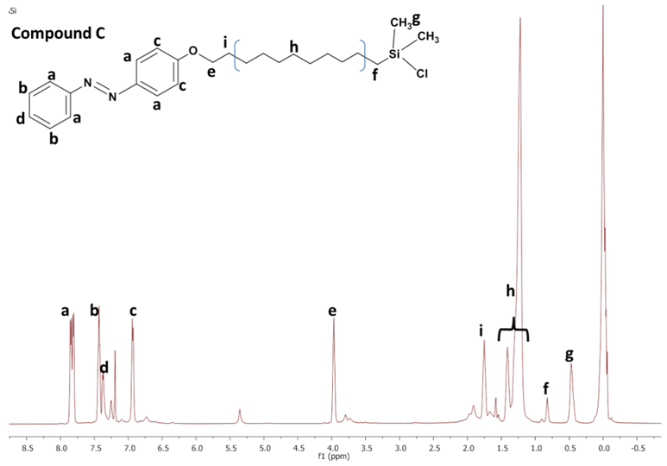
Figure S3.¹H-NMR spectrum of silane-terminated azocompound (C).

