Supplementary Table S1. The primer sequences used in this study and their resources. The designing of primer sequences was performed with the online tool Primer3 Plus (http://www.bioinformatics.nl/cgi-bin/primer3plus/primer3plus.cgi), and the designed primers were verified with Primer BLAST (https://www.ncbi.nlm.nih.gov/tools /primer-blast/index.cgi?LINK_LOC=BlastHome) with the Solanum lycopersicum (taxid: 4081) database.
Genes | Primer sequences | Resources
Solanum lycopersicum uncharacterized (LOC101261757) | F：CAGTTCTTTCCCAGAGGAACC | This study
Solanum lycopersicum uncharacterized (LOC101261757) | R：TAGAGACCTTGAGTGCCCAGA | This study
EXO70B1 (LOC101260888) | F：CTCCAAAATCAGGAGGTGGAT | This study
EXO70B1 (LOC101260888) | R：CAGCAAAGCAAACTGAACCAAC | This study
EXO70B1 (LOC101261092 | F：CTCCCGATGTTCCTGTGTTT | This study
EXO70B1 (LOC101261092 | R：AATGATGTGGCTTCCTCCTG | This study
EXO70B1 (LOC101261607) | F：TTTGGTGTATGCGGATGCTAT | This study
EXO70B1 (LOC101261607) | R：CACCTGGCAACATTCCTTTT | This study
EXO70B1-like (LOC101255283) | F：CGGGTGAAGTTGTCGATACAC | This study
EXO70B1-like (LOC101255283) | R：GGATTCGAGCCTGGATGTTAT | This study
EXO70A1 (LOC101254773 | F：ACGGCATTCTGGTGTTTCTC | This study
EXO70A1 (LOC101254773 | R：CAACATGCTTACAGGGCAGAG | This study
Solanum lycopersicum uncharacterized (LOC101243886) | F：ATCCGTAAGCTGTTGGATGTG | This study
Solanum lycopersicum uncharacterized (LOC101243886) | R：ACTGCTTCTGCCACTGCTTTAT | This study
EXO70A1-like (LOC101253481) | F：CCTCAGAGATTTTTGCTGGTG | This study
EXO70A1-like (LOC101253481) | R：AAGGCCAAGCTCAAAGAAGAC | This study
EXO70B1-like (LOC101256487), | F：AGATCTACAACCGTGAGGCAAT | This study
EXO70B1-like (LOC101256487), | R：GCTTTGTCACCTTCCCATTTAC | This study
EXO70A1-like (LOC101253690) | F：CCCGGAGATGGTAATGAAGTT | This study
EXO70A1-like (LOC101253690) | R：TAATGGCATCACCGAGCTTAC | This study
EXO70A1 (LOC101260696) | F：ACTACGTCGTCTCGAAGGTGAAG | This study
EXO70A1 (LOC101260696) | R：ACGTCAGCACTTTGTTCCATC | This study
Solanum lycopersicum uncharacterized (LOC101257050) | F：AGTGTATCGCGGAATTGGTCT | This study
Solanum lycopersicum uncharacterized (LOC101257050) | R：AGCTAATCCATTGGTGGCACT | This study
SlPT1 | F:CATTGTTTCTGCAGCATTCAAGG | Balestrini et al., 2007
SlPT1 | R:GGCTCCTTTTGCTTCAGAAATAGCTG | Balestrini et al., 2007
SlPT2 | F:GATTCGATCACGCGTATAGATCC | Balestrini et al., 2007
SlPT2 | R:GAAATTTGTTCGATTTTGGCTTCC | Balestrini et al., 2007
SlPT3 | F:TCAATCTACTGATCCATCTAAAGTC | Balestrini et al., 2007
SlPT3 | R:TAGTTTGTGCATTTTCCCCTTTAG | Balestrini et al., 2007
SlPT4 | F:GAAGGGGAGCCATTTAATGTGG | Balestrini et al., 2007
SlPT4 | R:ATCGCGGCTTGTTTAGCATTTCC | Balestrini et al., 2007
SlPT5 | F:CACTGCCATTATTGAAGGAAATG | Balestrini et al., 2007
SlPT5 | R:CTAACAAGTCCCATGGTCGG | Balestrini et al., 2007
Actin | F:TTCCGTTGCCCAGAGGTCCT | Chen et al., 2007
Actin | R:GGGAGCCAAGGCAGTGATTTC | Chen et al., 2007
Balestrini, R., Gómez-Ariza, J., Lanfranco, L., Bonfante, P. 2007. Laser microdissection reveals that transcripts for five plant and one fungal phosphate transporter genes are contemporaneously present in arbusculated cells. Mol. Plant Microbe In. 20, 1055‒1062.
Chen, A., Hu, J., Sun, S., Xu, G., 2007. Conservation and divergence of both phosphate- and mycorrhiza-regulated physiological responses and expression patterns of phosphate transporters in solanaceous species. New Phytol. 173, 817‒831.
Supplementary Table S2. The proportion (%) of arbuscule at each developmental stage as affected by acidic soil (pH 4.5) and limed soil (pH 6.5). For each replicate, ten slides were observed, and at least 20 arbuscules were evaluated for each slide.
Treatment | Stage I | Stage II | Stage III | Stage IV | Stage V
pH 6.5 | 10.4 | 14.7 | 24.8 | 41.1 | 9.0
pH 4.5 | 22.7 | 63.1 | 14.2 | — | —

Supplementary Fig. S1. The fungal structures in tomato roots colonized by Rhizophagus intraradices. Root fragments were double stained with fluorescence probes, Alexa Fluor 488 WGA (green) and propidium iodide (red). White, yellow, and pink arrows indicate intraradical hyphae, arbusclues, and root cell walls, respectively.

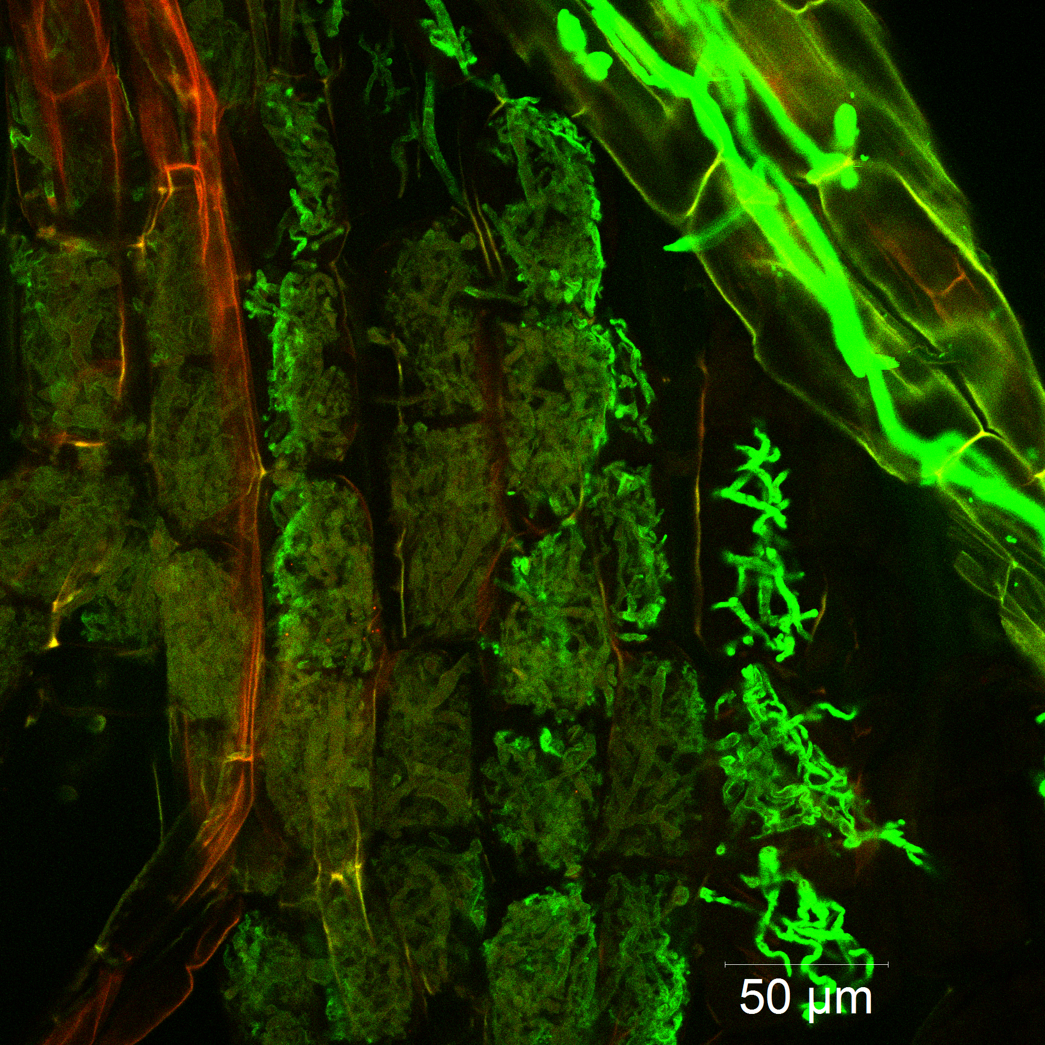

Supplementary Fig. S2. The relative expression of 10 members of EXO70 family, which was not significantly affected by soil pH. AM, inoculated treatment; NM, noninoculated treatment. The primers were designed with online tool Primer3 Plus (http://www.bioinformatics.nl/cgi-bin/primer3plus /primer3plus.cgi), and the designed primers were verified with Primer BLAST (https://www.ncbi. nlm.nih.gov/tools/primer-blast/index.cgi?LINK_LOC=BlastHome) with the Solanum lycopersicum (taxid: 4081) database.



