Appendix File

Use of modelling to help identify Taenia solium control strategies beyond 2020
Matthew A. Dixon^{1,2,*}, Uffe C. Braae^{3,4}, Peter Winskill², Brecht Devleesschauwer^{5,6}, Chiara Trevisan⁷, Inge Van Damme⁶, Martin Walker⁸, Jonathan I.D. Hamley^{1,2}, Sylvia N. Ramiandrasoa⁹, Veronika Schmidt^{10,11}, Sarah Gabriël⁶, Wendy Harrison¹², Maria-Gloria Basáñez ^{1,2}
1 London Centre for Neglected Tropical Disease Research (LCNTDR), Department of Infectious Disease Epidemiology, Faculty of Medicine, School of Public Health, Imperial College London, London W2 1PG, UK
2 MRC Centre for Global Infectious Disease Analysis (MRC GIDA), Department of Infectious Disease Epidemiology, Faculty of Medicine, School of Public Health, Imperial College London, London W2 1PG, UK
3 One Health Center for Zoonoses and Tropical Veterinary Medicine, Ross University School of Veterinary Medicine, Basseterre, St. Kitts & Nevis
4 Department of Infectious Disease Epidemiology and Prevention, Statens Serum Institut, Copenhagen, Denmark
5 Department of Epidemiology and Public Health, Sciensano, Brussels, Belgium
6 Department of Veterinary Public Health and Food Safety, Faculty of Veterinary Medicine, Ghent University, Salisburylaan 133, 9820 Merelbeke, Belgium
7 Department of Biomedical Sciences, Institute of Tropical Medicine, Nationalestraat 155, 2000 Antwerp, Belgium
8 London Centre for Neglected Tropical Disease Research (LCNTDR), Department of Pathobiology and Population Sciences, Royal Veterinary College, Hatfield AL9 7TA, UK
9 Service de Lutte contre les Maladies Endémiques et Négligées (SLMEN), Ministry of Public Health, Madagascar
10 Center for Global Health, Department of Neurology, Klinikum rechts der Isar, Technical University Munich (TUM), Munich, Germany
11 Centre for Global Health, Institute of Health and Society, University of Oslo, Oslo, Norway
12 Schistosomiasis Control Initiative Foundation, Edinburgh House, 170 Kennington Lane, Lambeth, London SE11 5DP, UK
*Corresponding author: Matthew A. Dixon (e-mail: m.dixon15@imperial.ac.uk)
*All authors are members of the CystiTeam Group for Epidemiology and Modelling of Taenia solium Taeniasis/Cysticercosis (CystiTeam: A coalition of Taenia solium taeniasis/cysticercosis field and quantitative epidemiologists, clinicians, veterinarians, one-health experts and program stakeholders recently formed to address collaboratively questions regarding the population biology, transmission dynamics, epidemiology and control of TS through mathematical modelling approaches).

Text A1. Workshop synopsis

Taenia solium epidemiology and modelling comparison workshop

Tuesday 26th and Wednesday 27th March 2019, Imperial College London, London, United Kingdom

Workshop overview

The 2012 World Health Organization Roadmap on Neglected Tropical Diseases (NTDs) highlighted the need for a validated strategy for control and elimination of Taenia solium taeniasis/cysticercosis by 2015. A major step in this process is to test the predictive ability of existing transmission models to robustly simulate field-based interventions used in T. solium control trials and programmes. This will strengthen the case for using these models for intervention planning and assessment across different settings.
A 2-day workshop was convened at Imperial College London with the overarching aim of bringing together T. solium taeniasis/cysticercosis modellers, epidemiologists and field/programme experts to discuss policy-relevant questions, regarding targets for tackling T. solium beyond 2020, that can be informed by comparison, refinement and validation, of transmission dynamics models. Specifically, the workshop had the following objectives:
- Discuss the structure and assumptions of the EPICYST and cystiSim transmission models.
- Discuss research avenues for model comparison regarding transmission dynamics and the impact of interventions on such dynamics.
- Discuss opportunities for cross-validation of the models informed by field data.
- Examine the feasibility of impact assessments (including dynamic burden of disease modelling) in endemic settings.

Tuesday 26th March

Session 1: Mathematical modelling

Welcome: Professor María-Gloria Basáñez and Matt A. Dixon (15 minutes): 10:00 – 10.15
Each 20-minute talk to be followed by 10-minute Q&A and group discussion
Presentation 1: Modelling Neglected Tropical Diseases (NTDs) (Professor María-Gloria Basáñez - 30 minutes): 10:15 – 10:45
Presentation 2: Example of NTD cross-modelling comparison and validation efforts: Onchocerciasis as a case-study (Dr Martin Walker - 30 minutes): 10:45 – 11:15
Coffee break: 11:15 - 11:30
Presentation 3: Taenia solium modelling I: EPICYST (Matt A. Dixon – 30 minutes): 11:30 – 12:00
Presentation 4: Taenia solium modelling II: cystiSim (Dr Uffe Christian Braae – 30 minutes): 12:00 – 12:30
Lunch: 12:30 – 13:30

Session 2: Modelling and Interventions

Presentation 5: Taenia solium modelling III: cystiSim and CYSTISTOP (Dr Inge Van Damme / Professor Sarah Gabriël): 13:30 – 14:00
Presentation 6: Taenia solium pilot control programme in Madagascar (Dr Sylvia N. Ramiandrasoa): 14:00 – 14:30
Presentation 7: Taenia solium burden of disease modelling: case studies from Mozambique/Tanzania (Dr Chiara Trevisan): 14:30 – 15:00

Discussion I: Modelling strategies and data to support Taenia solium control and elimination policy: Population and mass treatment interventions (Facilitator: Dr Martin Walker): 15:20 – 17:30

Wednesday 27th March

Session 3: Modelling and Data

Introduction to day 2: Dr Wendy Harrison and Matt A. Dixon: 10:00 – 10:15
Discussion II: Modelling strategies and data to support Taenia solium control and elimination policy: Targeted interventions (Facilitator: Dr Uffe Christian Braae): 10:15 – 12:30
Coffee break: 11:15 – 11:30

Session 4: Modelling and Impact Assessment

Discussion II: Impact assessment: Linking dynamic transmission models and burden of disease models (Facilitator: Dr Peter Winskill): 13:00 – 14:30
Wrap-up and action plan: 14:30 – 15:30

Main workshop outcomes and next steps

- The preparation of a brief meeting report by all attendees.
- The creation of CystiTeam: A coalition of Taenia solium taeniasis/cysticercosis field and quantitative epidemiologists and programme stakeholders aimed to address collaboratively questions regarding the population biology, transmission dynamics, epidemiology and control of T. solium through mathematical modelling approaches¹.
- Initiation of a GitHub for code sharing and model testing between EPICYST and cystiSim.
- Characterisation of epidemiological settings for model testing, defining different and realistic endemicity scenarios (i.e. prevalence of infection in humans and pigs, and its distribution among the host populations).
- Conduction of formal model comparison of the models’ ability to reproduce baseline endemicities to understand how key parameters (parasite biology-specific, e.g. worm and egg lifespans; transmission coefficients, or setting-specific, e.g. human/pig ratio) influence model outcomes (e.g. stability of low endemic prevalence levels) with harmonised assumptions by EPICYST and cystiSim.
- Delineation of realistic intervention scenarios with current (and potentially novel/complementary) strategies along with outcomes measurable in both models (e.g. reductions in prevalence, timelines to reaching operational targets for control, dynamics of resurgence following cessation of interventions).
- Development of an approach to account, in model outputs, for imperfect diagnostic performance of current tests (especially important in settings with low prevalence/nearing elimination), and to align model outcomes with current tools used to measure progress towards intervention targets.
- Linking the transmission models to societal burden of disease methods^{2,3} for dynamic burden of disease modelling. Further work will include modelling the impact, in Madagascar, of a pilot control programme for T. solium, and of the national schistosomiasis control programme (which distributes praziquantel) on T. solium infection and burden of disease, in collaboration with the Madagascar Ministry of Health.

Attendees and affiliations (in alphabetical order)

Professor María-Gloria Basáñez (Imperial College London)
Dr Uffe Christian Braae (Statens Serum Institut, Copenhagen, Denmark)
Dr Brecht Devleesschauwer (Sciensano, Brussels, Belgium; Ghent University, Ghent, Belgium) (by Skype)
Mr Matthew A. Dixon (Imperial College London)
Professor Sarah Gabriël (Ghent University, Ghent, Belgium) (by Skype)
Dr Jonathan I.D. Hamley (Imperial College London)
Dr Wendy Harrison (Imperial College London/Schistosomiasis Control Initiative)
Dr Sylvia Ramiandrasoa (Epidemic and Neglected Diseases Control Service, Minister of Public Health, Madagascar) (by Skype)
Dr Veronika Schmidt (Technical University Munich, Germany; Centre for Global Health, Institute of Health and Society, University of Oslo, Norway) (by Skype)
Dr Chiara Trevisan (Institute of Tropical Medicine, Antwerp, Belgium)
Dr Inge Van Damme (Ghent University, Ghent, Belgium)
Dr Martin Walker (Imperial College London/Royal Veterinary College)
Dr Peter Winskill (Imperial College London)

Simultaneous (English–French) translation: Sarah Whitton

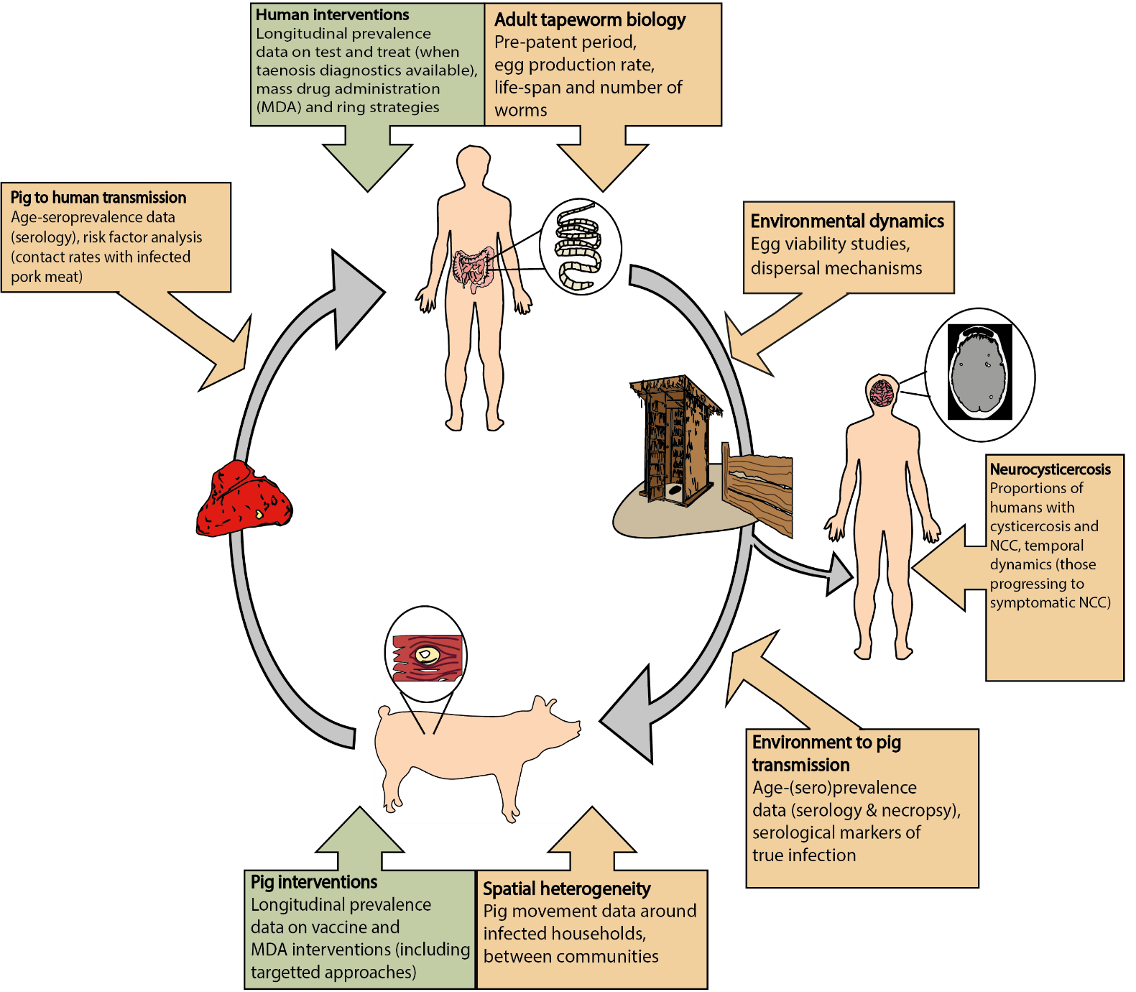
Figure A1. Lifecycle of T. solium indicating, at each stage, key research gaps and data needs important for epidemiological modelling¹.

Table A1. Contributors to technical commentary executive summary (Box 1) and Table 1 in main text (founding members of CystiTeam)
Institution | Contributors
Imperial College London, UK | Matt Dixon, Peter Winskill, Martin Walker,  Maria-Gloria Basáñez
Schistosomiasis Control Initiative, London, UK | Wendy Harrison
Royal Veterinary College, London, UK | Martin Walker
Statens Serum Institut, Copenhagen, Denmark | Uffe Braae
University of Copenhagen, Copenhagen, Denmark | Maria Vang Johansen
Sciensano, Brussels, Belgium | Brecht Devleesschauwer
Institute of Tropical Medicine, Antwerp, Belgium | Chiara Trevisan
Ghent University, Ghent, Belgium | Sarah Gabriël, Inge Van Damme,  Brecht Devleesschauwer
Ministry of Public Health, Madagascar | Sylvia Ramiandrasoa

Supplementary references:
- Dixon MA, Braae UC, Winskill P, Walker M, Devleesschauwer B, Gabriël S, Basáñez MG. Strategies for tackling Taenia solium taeniosis/cysticercosis: A systematic review and comparison of transmission models, including an assessment of the wider Taeniidae family transmission models. PLoS Negl Trop Dis. 2019;13(4):e0007301. doi: 10.1371/journal.pntd.0007301.

- Trevisan C, Devleesschauwer B, Praet N, Pondja A, Assane YA, Dorny P, et al. Assessment of the societal cost of Taenia solium in Angónia district, Mozambique. BMC Infect Dis. 2018; 18(27). doi: 10.1186/s12879-018-3030-z.

- Trevisan C, Devleesschauwer B, Schmidt V, Winkler AS, Harrison W, Johansen MV. The societal cost of Taenia solium cysticercosis in Tanzania. Acta Trop. 2017; 165:141–154. doi: 10.1016/j.actatropica.2015.12.021.

CystiTeam: in its initial composition consists of Taenia solium researchers based at Imperial College London and Royal Veterinary College, UK; Statens Serum Institut and University Copenhagen, Denmark; Sciensano, Brussels, Ghent University, and Institute of Tropical Medicine, Antwerp, Belgium; Technical University of Munich, Germany and University of Oslo, Norway, and Ministry of Public Health, Madagascar.

