Supplementary material for:
Sarnocinska J, Teilmann J, Balle J, van Beest FM, Delefosse M and Tougaard J (2019) Harbor
Porpoise (Phocoena phocoena) Reaction to a 3D Seismic Airgun Survey in the North Sea. Front. Mar. Sci. 6:824. doi: 10.3389/fmars.2019.00824

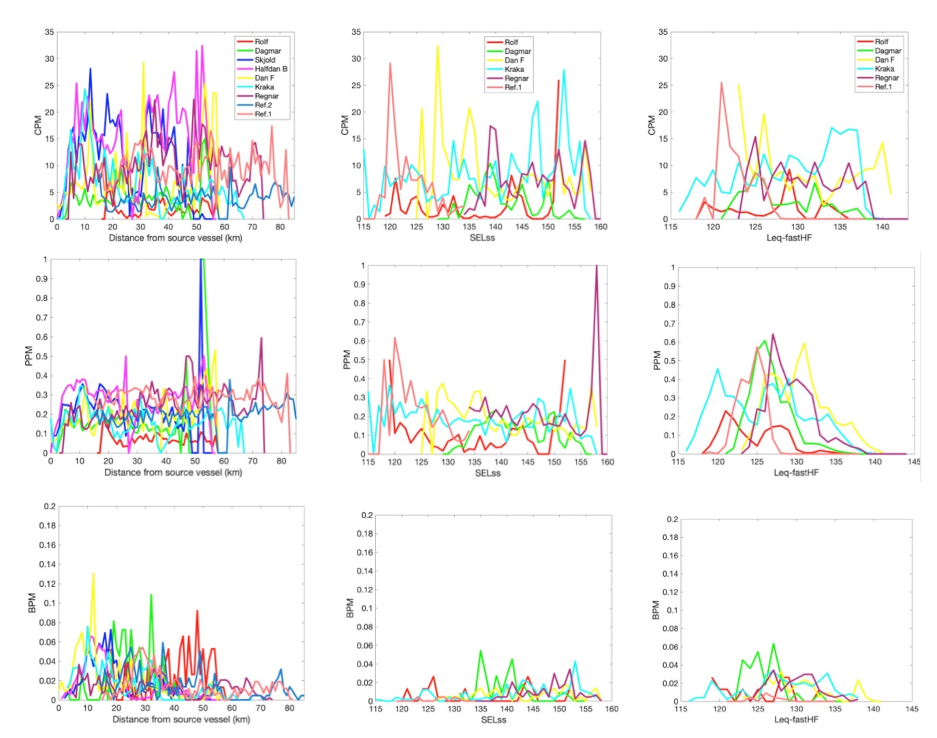
Figure S1. Mean porpoise activity: the number of porpoise clicks (CPM) (first row), porpoise positive minutes (PPM) (second row), and raw data on porpoise positive buzzing minutes (BPM) (bottom row) over distance to source vessel with active airgun (left panel), SEL_{SS} (centre panel), and L_{eq-fastHF} (right panel).

Table S1. Sensitivity of C-PODs. Reported thresholds are mean values from 4 C-POD angles.
C-POD ID | Threshold (dB re 1Pa pp)
2200  2208  2214  2240  2243  2244  2245  2246  2248  2249  2250  2252  2443  2445 | 115  116  116  116  118  119  116  116  118  116  115  116  117  117

Table S2. Overview of data collection during three deployments. Seismic survey took place between 26 July and 5 November 2016. The total number of available days in each of the three periods (pre-survey, survey and post-survey) was 67, 98 and 134 days, respectively. During the last deployment, C-POD data collected at 100 m distance from Dagmar were used in the analysis instead of 200 m due to instrument failure and missing data.
Name | Type | Deployment position |  | Water depth | Deployment | Service/recovery | End of useful data |  | Recording days
 |  | Lat (N) | Lon (E) | (m) |  |  | C-POD | Noise logger | C-POD | Noise logger
Rolf | Unmanned | 55° 36.333’ | 04° 29.671’ | 36 | 07-06-2016 | 23-08-2016 | No data | 13-08-2016 | 0 | 68
 |  | 55° 36.396’ | 04° 29.608’ |  | 23-08-2016 | 24-11-2016 | 23-11-2016 | 23-11-2016 | 93 | 93
 |  | 55° 36.343’ | 04° 29.675’ |  | 24-11-2016 | 22-03-2016 | 22-12-2016 | No data | 29 | 0
Dagmar | Unmanned | 55° 34.589’ | 04° 36.903’ | 37 | 07-06-2016 | 23-08-2016 | 22-08-2016 | 16-08-2016 | 77 | 71
 |  | 55° 34.586’ | 04° 36.728’ |  | 23-08-2016 | 24-11-2016 | 10-10-2016 | 10-10-2016 | 49 | 49
 |  | 55° 34.593’ | 04° 36.897’ |  | 24-11-2016 | 22-03-2016 | 14-03-2017 | 19-12-2016 | 111 | 26
Skjold | Manned | 55° 31.760' | 04° 54.641' | 40 | 06-06-2016 | 24-08-2016 | 22-08-2016 | Not deployed | 78 | 0
 |  | 55° 31.799' | 04° 54.629' |  | 24-08-2016 | 24-11-2016 | 09-11-2016 | Not deployed | 78 | 0
 |  | 55° 31.759' | 04° 54.635' |  | 24-11-2016 | 22-03-2016 | 22-03-2017 | Not deployed | 119 | 0
Halfdan B | Manned | 55° 32.141' | 05° 01.992' | 45 | 06-06-2016 | 24-08-2016 | 22-08-2016 | Not deployed | 78 | 0
 |  | 55° 32.152’ | 05° 01.963' |  | 24-08-2016 | 24-11-2016 | 23-11-2016 | Not deployed | 92 | 0
 |  | 55° 32.144' | 05° 01.972' |  | 24-11-2016 | 22-03-2016 | 22-03-2017 | Not deployed | 119 | 0
Dan F | Manned | 55° 28.508' | 05° 06.722' | 46 | 06-06-2016 | 23-08-2016 | No data | 22-08-2016 | 0 | 78
 |  | 55° 28.504' | 05° 06.739' |  | 23-08-2016 | 24-11-2016 | 06-11-2016 | 06-11-2016 | 76 | 76
 |  | 55° 28.466' | 05° 06.548' |  | 24-11-2016 | 22-03-2016 | 22-03-2017 | 06-02-2017 | 119 | 75
Kraka | Unmanned | 55° 24.087' | 05° 04.945' | 47 | 06-06-2016 | 23-08-2016 | 22-08-2016 | 17-08-2016 | 78 | 73
 |  | 55° 24.096' | 05° 04.963' |  | 23-08-2016 | 23-11-2016 | 23-11-2016 | 23-11-2016 | 93 | 93
 |  | 55° 24.086' | 05° 04.900' |  | 23-11-2016 | 22-03-2016 | 22-03-2017 | 04-02-2017 | 120 | 74
Regnar | Closed well-head | 55° 23.097' | 05° 13.705' | 47 | 07-06-2016 | 24-08-2016 | 22-08-2016 | 22-08-2016 | 77 | 77
 |  | 55° 23.105' | 05° 13.698’ |  | 24-08-2016 | 23-11-2016 | 02-10-2016 | 02-10-2016 | 40 | 40
 |  | 55° 23.097' | 05° 13.705' |  | 23-11-2016 | 22-03-2016 | 21-12-2016 | Not deployed | 29 | 0
Ref.2 | No structures | 55° 18.334' | 05° 22.741' | 44 | 06-06-2016 | 23-08-2016 | 22-08-2016 | Not deployed | 78 | 0
 |  | 55° 18.246’ | 05° 22.772’ |  | 23-08-2016 | 23-11-2016 | 05-11-2016 | Not deployed | 75 | 0
 |  |  |  |  | 23-11-2016 | 22-03-2016 | No data | Not deployed | 0 | 0
Ref. 1 | No structures | 55° 26.339' | 05° 30.373' | 49 | 06-06-2016 | 23-08-2016 | 22-08-2016 | 22-08-2016 | 78 | 77
 |  | 55° 26.290’ | 05° 30.370' |  | 23-08-2016 | 23-11-2016 | 04-10-2016 | 04-10-2016 | 43 | 42
 |  |  |  |  | 23-11-2016 | 22-03-2016 | No data | No data | 0 | 0

Table S3. Output of the generalized additive mixed effect models predicting CPM, PPM and BPM/PPM as a function of distance to the active source vessel. The model forms the analytical basis for Figure 3 (left panel).
Fixed effect | CPM |  | PPM |  | BPM/PPM
 | β | SE | β | SE | β | SE
(Intercept) | 2.216 | 0.185 | -1.336 | 0.133 | -1.8866 | 0.309
Smooth term | edf | F-value | edf | F-value | edf | F-value
s(distance to seismic vessel) | 3.999 | 6628.000 | 2.963 | 46.300 | 2.936 | 27.4200
Random effect | Var | Residual | Var | Residual | SD | Residual
Station ID (N = 6) | 0.455 | 1.000 | 0.325 | 1.000 | 0.752 | 1.000
Temporal correlation | Phi |  | Phi |  | Phi
corAR1 | 0.231 |  | 0.538 |  | 0.264

Table S4. Output of the generalized additive mixed effect models predicting CPM, PPM and BPM/PPM as a function of SEL_{SS}. The model forms the analytical basis for Figure 3 (centre panel).
Fixed effect | CPM |  | PPM |  | BPM/PPM
 | β | SE | β | SE | β | SE
(Intercept) | 2.008 | 0.132 | -1.523 | 0.060 | -2.106 | 0.438
Smooth term | edf | F-value | edf | F-value | edf | F-value
s(SEL_{SS}) | 3.982 | 294.200 | 1.000 | 10.210 | 2.309 | 5.832
Random effect | Var | Residual | Var | Residual | SD | Residual
Station ID (N = 6) | 0.265 | 1.000 | 0.088 | 1.000 | 0.855 | 1.000
Temporal correlation | Phi |  | Phi |  | Phi
corAR1 | 0.212 |  | 0.518 |  | 0.229

Table S5. Output of the generalized additive mixed effect models predicting CPM, PPM and BPM/PPM as a function of L_{eq-fastHF}. The model forms the analytical basis for Figure 3 (right panel).
Fixed effect | CPM |  | PPM |  | BPM/PPM
 | β | SE | β | SE | β | SE
(Intercept) | 1.989 | 0.139 | -1.544 | 0.054 | -1.935 | 0.433
Smooth term | edf | F-value | edf | F-value | edf | F-value
s(L_{eq-fastHF}) | 2.989 | 754.200 | 3.251 | 8.461 | 2.370 | 4.777
Random effect | Var | Residual | Var | Residual | SD | Residual
Station ID (N = 6) | 0.279 | 1.000 | 0.071 | 1.000 | 0.845 | 1.000
Temporal correlation | Phi |  | Phi |  | Phi
corAR1 | 0.211 |  | 0.514 |  | 0.228

Table S6. The amount of variation in the data explained (R²_{adj}) by the generalized additive mixed effect models with distance from source vessel, SEL_{SS} and L_{eq-fastHF} as predictor variables of CPM, PPM and BPM/PPM..
Acoustic measure | R²_{adj} = variation explained by the model
 | Distance | SEL_{SS} | L_{eq-fastHF}
CPM | 0.132 | 0.028 | 0.052
PPM | 0.255 | 0.142 | 0.244
BPM/PPM | 0.136 | 0.117 | 0.106

Table S7. Output of the generalized linear mixed effect models predicting CPM, PPM and BPM /PPM experimental area and seismic period. The model forms the analytical basis for Figure 5.
Fixed effects | CPM |  | PPM |  | BPM/PPM
 | β | SE | β | SE | β | SE
(Intercept) | -2,829 | 0,545 | -6,670 | 0,455 | -7214 | 0,306
Experimental blockª
Before-impact | 0,027 | 0,448 | -0,117 | 0,399 | 2964 | 0,342
During-control with airguns off | 0,924 | 0,187 | 0,658 | 0,108 | 0,792 | 0,265
During control with airguns on | 0,781 | 0,206 | 0,078 | 0,127 | 0,658 | 0,312
During impact with airguns off | 1,673 | 0,436 | 1,009 | 0,398 | 1621 | 0,341
During impact with airguns on | 1,579 | 0,437 | 0,432 | 0,400 | 1648 | 0,347
After-impact | 1,530 | 0,446 | 0,819 | 0,406 | 0,766 | 0,343
Hour of the day | -0,047 | 0,007 | -0,013 | 0,006 | -0,129 | 0,008
Hour of the day^2 | 0,002 | 0,003 | 0,001 | 0,003 | 0,008 | 0,001
Julian day | 0,024 | 0,003 | 0,028 | 0,002 | 0,039 | 0,003
Julian day^2 | -0,036 | 0,001 | -0,004 | 0,003 | -0,010 | 0,003
Random effect | Var | SD | Var | SD | Var | SD
Station ID (N = 9) | 0,556 | 5,949 | 0,541 | 0,542 | 0,357 | 0,182
ª Reference = Control-Before

