**Supplementary Material**

1. **Measured force due to application of a 1 mJ impact**

The time-dependent reaction force due to a 1 mJ impact applied on top of the specimens was measured using a custom-built device containing a cantilever beam with an instrumented strain gage. Distal femurs were carefully dissected and placed on the cantilever beam as during the impact vulnerability tests described in the main manuscript. The impact energy of 1 mJ was induced by manually dropping a cylindrical weight of 0.1 N on top of the specimen (i.e., on top of the patella-femoral grove) from a height of 1 cm, compressing the cartilage of the distal femoral condyles against the cantilever beam and deflecting it. The instrumented strain gage output a signal proportional to the amount of cantilever beam deflection and the concentrated force applied to the cantilever. These data were acquired at a rate of 1 kHz through a data acquisition (DAQ) device using a custom algorithm written in LabView (National Instruments, Austin, TX). The output was converted into reaction force measurements using a calibration curve.

Consistent and reproducible reaction force profiles were observed when an impact energy of 1 mJ was applied on top of the specimen (n=10 trials), resulting in a peak force of 8.2±0.5 N at a loading rate of 6 ms (Figure S1).

**Fig. S1** Time-dependent impact forces measured by an instrumented strain gage during the application of 1 mJ impacts induced by dropping a cylindrical weight of 0.1 N from a height of 1 cm. The data are mean +/- SD.

1. **Fold change in cell volume and absolute cell volume due to uniaxial preload as a function of distance from the apex of the articular surface**

Fold change in cell volume due to uniaxial preload (V0.1N /V0N) was quantified by measuring the volume change of the same cell before and after the application of a 0.1 N load for 15 min (n=10, 10-20 cells per specimen). A dramatic change in cell volume as a function of the radius from the apex of the articular surface (slope=0.0018, p<0.0001) was observed (Fig. S2a). As expected, the maximum reduction in cell volume was observed at the apex of the articular surface (~21% of initial cell volume was reduced within 50 m from the apex of articular surface) (Fig. S2b). The fold change in volume within 50 m from the apex of the articular surface was reported in the main manuscript. The percentage of cell volume reduction due to mechanical pre-strain found in this study (~21%) is consistent with the reported reduction in cell volume of 22.3±2.4% observed in the tibia-femoral cartilage contact region when muscle contraction was 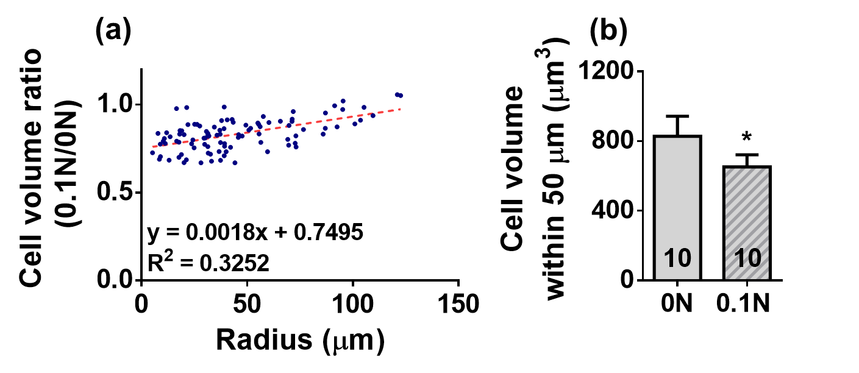electrically stimulated for 8 s in an *in vivo* murine model1.

**Fig. S2** (a) Fold change in cell volume due to uniaxial preload (0.1 N) as a function of the radius from the apex of the articular surface (data are for the lateral femoral condyles only). Each data point represents fold change in volume of a single cell. A strong relationship between cell volume ratio and the radius from the articular cartilage apex was observed (R2=0.33, slope=0.0018, p<0.0001). (b) Average cell volume per specimen quantified within 50 m from the apex of the articular surface before and after application of static pre-strain. Numbers indicate the sample size of the tested specimens. (*) denotes p<0.05. The data are mean+SD. A linear regression model and paired Student’s t-test were used to analyze data in (a) and (b), respectively.

1. **Absolute measurements of cell volume before and after other volume-perturbing interventions**

The absolute volume of *in situ* chondrocytes in cartilage-on-bone explants from murine femurs was significantly reduced by hydrostatic preconditioning (Fig. S3a) and hyper-osmotic challenge (Fig. S3b, see main manuscript for detailed methods). Absolute cell volume in a hypo-osmotic bath was not affected by inhibition of RVD (Fig. S3c). Additionally, cell volume was significantly increased when specimens were incubated in hypo-osmotic HBSS containing DMSO versus HBSS without DMSO (Fig. S4).

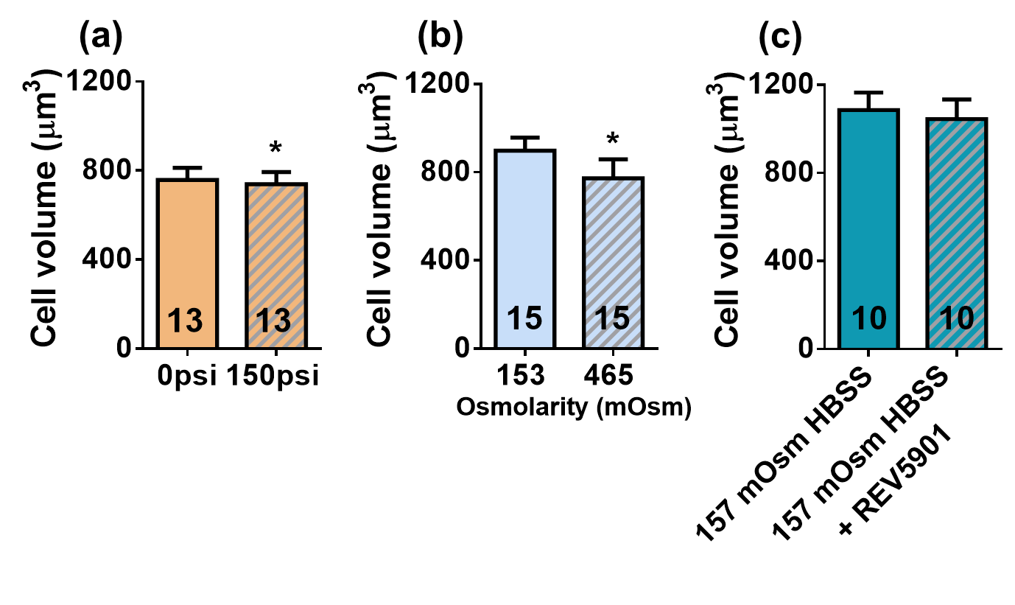**Fig. S3** Absolute measurements of cell volume in the control and intervention groups (a) before and after specimens were preconditioned with 150 psi of hydrostatic pressure, (b) when specimens were incubated in hypo- (153 mOsm) and hyper- (465 mOsm) osmotic HBSS, and (c) when specimens were incubated in hypo-osmotic HBSS (157 mOsm) with/without the RVD-inhibitor REV5901. A paired Student’s t-test was used to compare control and intervention groups. (*) denotes p<0.05. Data are mean+SD. Numbers indicate the sample size per group.

**Fig. S4** Absolute measurements of cell volume when specimens were incubated in hypo-osmotic HBSS with (n = 10) and without (n=15) the addition of DMSO. A Student’s t-test was used to compare the control and intervention groups. (*) denotes p<0.05. The data are mean+SD. Numbers indicate the sample size per group.



1. **Absolute area of injured cells after impact when volume-perturbing interventions are or are not applied beforehand**

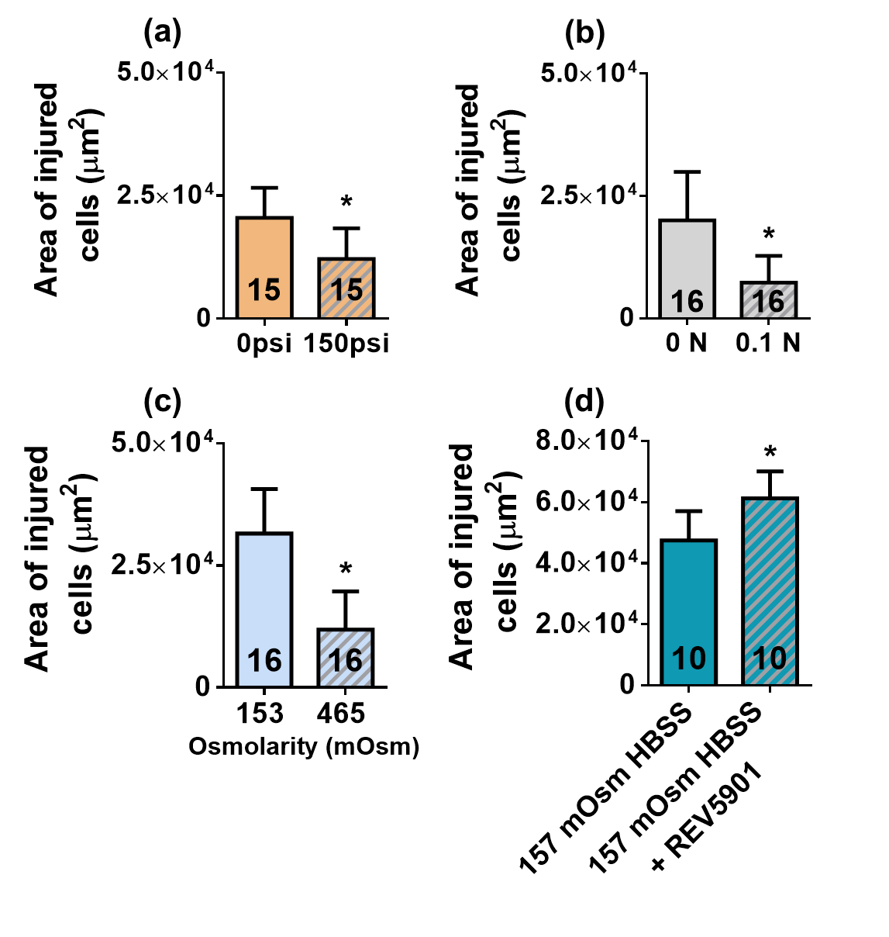The absolute area of injured cells after impact was significantly reduced by hydrostatic preconditioning (Fig. S5a), uniaxial preload (Fig. S5b) and hypertonic challenge (Fig. S5c, see main manuscript for detailed methods). In contrast, the absolute area of injured cells after impact was increased when hypo-osmotic challenge was applied and RVD was inhibited (Fig. S5d). Additionally, the absolute area of injured cells was significantly increased when specimens were incubated in hypo-osmotic HBSS containing DMSO versus HBSS without DMSO (Fig. S6).

**Fig. S5** Absolute area of injured cells for specimens subjected to a 1 mJ impact (a) with or without prior hydrostatic pressurization to 150 psi; (b) with or without uniaxial preload to 0.1 N load; (c) after incubation in hypo- (153 mOsm) or hyper- (465 mOsm) osmotic HBSS; and (d) after incubation in hypo-osmotic HBSS (157 mOsm) with or without inhibition of RVD using the small molecule REV5901. A paired Student’s t-test was used to compare the control vs. intervention groups. (*) denotes p<0.05. The data are mean + SD. Numbers indicate the sample size per group.



**Fig. S6** Absolute area of injured cells for specimens subjected to 1 mJ impact after incubation in hypo-osmotic HBSS with (n = 10) and without (n=15) the addition of DMSO. A Student’s t-test was used to compare the control and intervention groups. (*) denotes p<0.05. The data are mean+SD. Numbers indicate the sample size per group.

1. **Absolute measurements of tissue thickness, radius of curvature, boundary displacement, peak infinitesimal strain and cartilage Young’s modulus in different intervention groups**

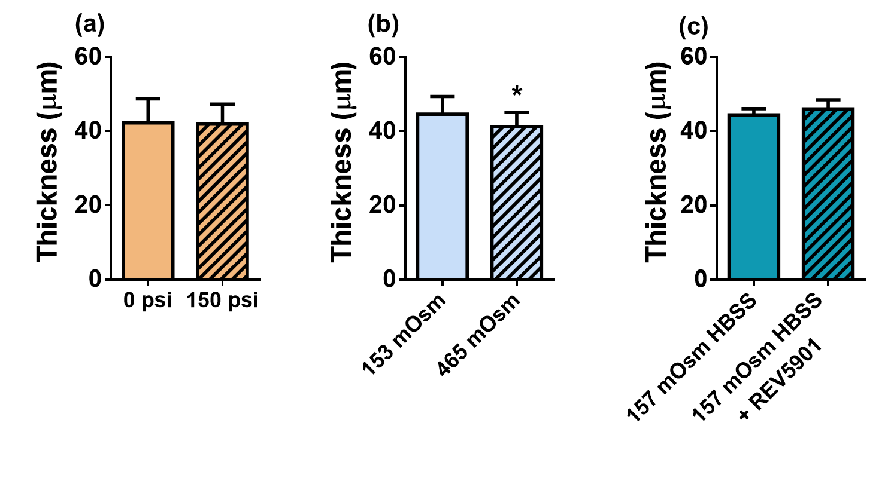Only osmotic challenge altered tissue thickness, which was unaffected by hydrostatic preconditioning and inhibition of RVD in a hypo-osmotic environment (Fig. S7, see main manuscript for detailed methods). Hydrostatic preconditioning, osmotic challenge and inhibition of RVD in a hypo-osmotic environment did not significantly impact radius of curvature (Fig. S8), boundary displacement after application of a 0.1 N load (Fig. S9), peak cartilage infinitesimal strain (Fig. S10) or cartilage Young’s modulus (Fig. S11).

**Fig. S7** Measured thickness of the articular cartilage on the murine femoral lateral condyles (n=6/group) for different applied interventions. These thicknesses were used to construct specimen-specific 3D finite element models. A paired Student’s t-test was used to compare the control versus intervention groups. Data are mean+SD; (*) denotes p<0.05.

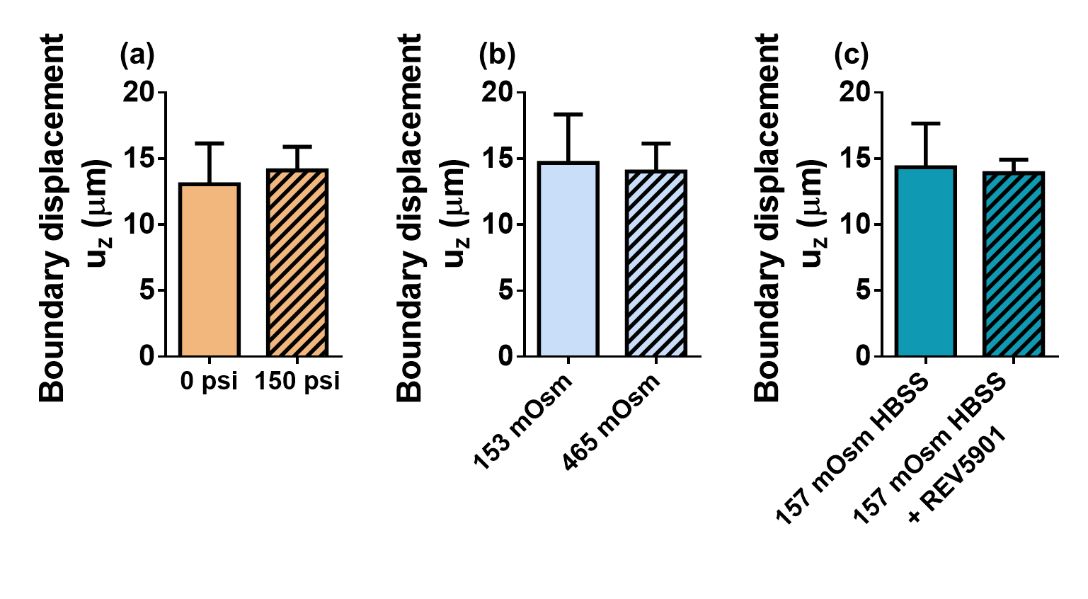**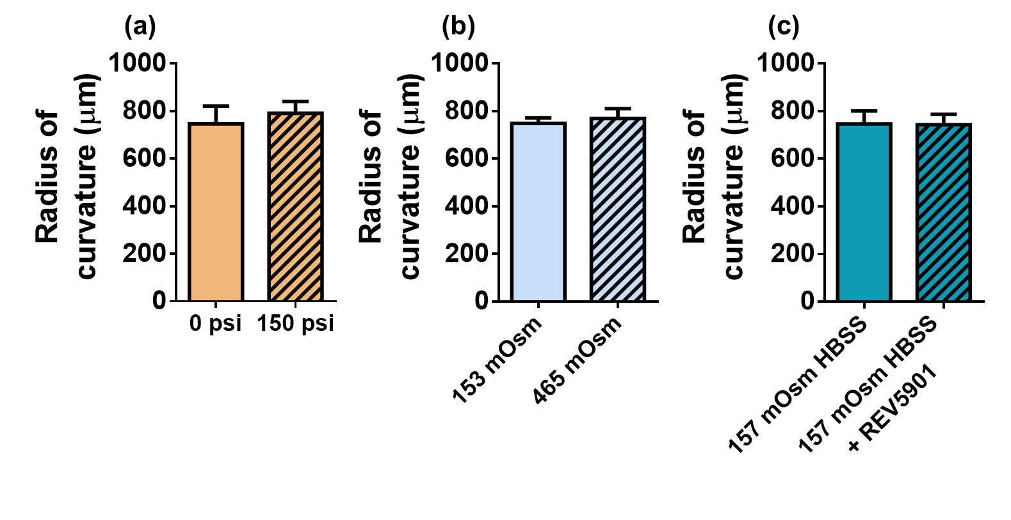Fig. S8** Measured radius of curvature of articular surface in murine lateral femoral condyles (n = 6/group) for different applied interventions. These radii were used to construct specimen-specific 3D finite element models. A paired Student’s t-test was used to compare the control versus intervention groups. Data are mean+SD.

**Fig. S9** Measured boundary displacements of the cover glass used to compress articular cartilage in murine lateral femoral condyles (n=6/group) for different applied interventions. Displacements are assessed relative to the (stationary) bone in response to a 0.1 N load. These data were prescribed to the rigid platen used to compress cartilage in the specimen-specific FEMs used to determine cartilage material properties. A paired Student’s t-test was used to compare the control versus intervention groups. Data are mean+SD.

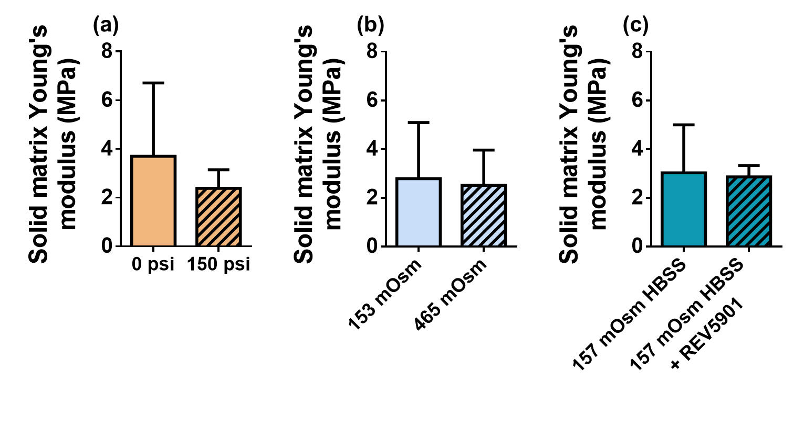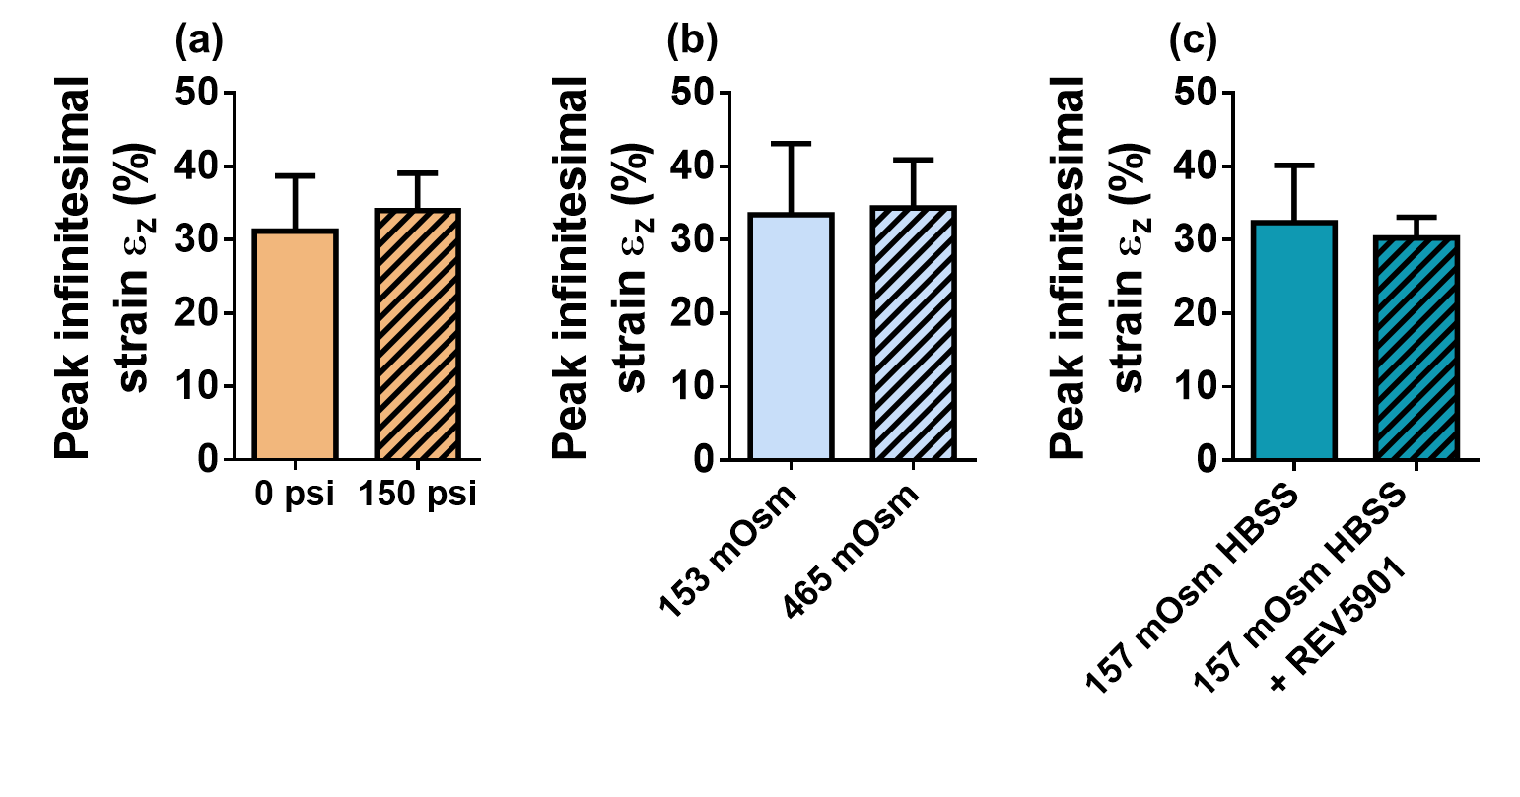**Fig. S10** Peak infinitesimal strains induced by the application of a 0.1 N load on top of the tested specimens for 5 min. The strains were calculated by dividing uz (Fig. S7) by the corresponding tissue thickness (Fig. S5) for every treatment condition (n=6/group). A paired Student’s t-test was used to compare the control versus intervention groups. Data are mean+SD.

**Fig. S11** Young’s modulus of the articular cartilage on murine lateral femoral condyles measured through the inverse finite element analysis for different applied interventions (n = 6/group). A paired Student’s t-test was used to compare the control versus intervention groups. Data are mean+SD.

1. **Assessment of contact forces on lateral femoral condyles**

The contact forces on lateral femoral condyles due to application of an 0.1 N load on the top of specimens used for quantification of Young’s modulus (Fig. 4a) were quantified as described previously2. Briefly, a moment balance equation based on the locations of three contact points (medial condyle-glass, lateral condyle-glass, and bone-glass contacts) was used, and the coordinates of these contact points were determined by placing the specimen on a sheet covered with black ink and compressing with the prescribed load. Specimens with ink-stained contact areas were then transferred to a cover glass and imaged using both inverted and upright microscopes. Contact locations were assessed from the acquired micrographs. The reaction forces on the lateral femoral condyles were 0.04 ± 0.006 N (Fig. S12).



**Fig. S12** Measured contact force between cartilage on the lateral femoral condyle and the underlying cover glass induced by a load of 0.1 N applied on top of the specimen. Each data point represents a single contact force measured on the lateral condyles of a different specimen. The solid horizontal line indicates the mean contact force, and error bars are +/- SD.

**References**

1. Abusara Z, Seerattan R, Leumann A, Thompson R, Herzog W. A novel method for determining articular cartilage chondrocyte mechanics in vivo. J Biomech 2011:44(5): 930-934.

2. Kotelsky A, Woo CW, Delgadillo LF, Richards MS, Buckley MR. An alternative method to characterize the quasi-static, nonlinear material properties of murine articular cartilage. J Biomech Eng 2018:140(1).