Additional file 2
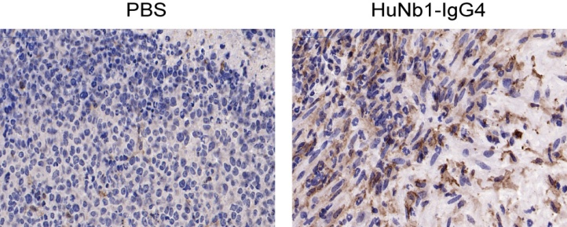
Figure S2 The IHC staining of HuNb1-IgG4 on macrophage in lymphoma mouse model. The male NOG mice were subcutaneously transplanted with Raji cells and treated with 20 mg/kg HuNb1-IgG4 or PBS as the control (n=6). The tumor sections from mice were stained with F4/80 (brown) and one representative result was displayed.

