**Supplementary Material**

**A unique benthic microbial community underlying the *Phaeocystis* *antarctica*-dominated Amundsen Sea polynya, Antarctica: a proxy for assessing the impact of global changes**

Hyeyoun Cho1, Chung Yeon Hwang2, Jong-Geol Kim3, Sanghoon Kang4, Katrin Knittel5, Ayeon Choi1, Sung-Han Kim1,6, Sung-Keun Rhee3, Eun Jin Yang7, Sang Hoon Lee7, and Jung-Ho Hyun1*

**Affiliation**

1*Department of Marine Sciences & Convergent Technology*, *Hanyang University, 55 Hanyangdaehak-ro Ansan, Gyeonggi-do, 15588, South Korea*

2 *School of Earth and Environmental Sciences and Research Institute of Oceanography*, *Seoul National University, Seoul 08826, South Korea*

3 *Department of Microbiology, Chungbuk National University, Heungduk-gu, Cheongju, 28644, South Korea*

4*Department of Biological Sciences, Eastern Illinois University, 600 Lincoln Avenue, Charleston, IL 61920, USA*

5*Max Planck Institute for Marine Microbiology, Celsiusstr. 1, 28359 Bremen, Germany*

*6Korea Institute of Ocean Science & Technology, 385 Haeyang-ro, Yengdo-gu, Busan Metropolitan City 49111, South Korea*

*7Korea Polar Research Institute, 26 Songdomirae-ro, Yeonsu-gu, Incheon 21990, South Korea*

\***Correspondence:** Jung-Ho Hyun ([hyunjh@hanyang.ac.kr](mailto:hyunjh@hanyang.ac.kr))

This file includes:

I. Supplementary Methods

II. Supplementary Tables

III. Supplementary Figures

**I. Supplementary Methods**

**16S rRNA gene Amplification**

For each sample, PCR amplification of the 16S rRNA genes (V5-V8 region) was performed in three technical replicates using a primer set of Uni787F (Roesch et al., 2007) and Uni1391R (Lane et al., 1985) according to the settings given in Jorgensen et al. (2012) (thermal cycler conditions: 95°C for 15 min, then 25–30 cycles of 94°C for 45 s, 53°C for 45 s, 72°C for 1 min followed by 72°C for 7 min). Each reaction mixture contained 1Χ PCR buffer, 2 mM MgCl2, 0.2 mM dNTPs, 5% dimethyl sulfoxide, 0.1% bovine serum albumin, 1.2 μM primers, 2.5 units/μl DNA polymerase (Takara Bio, Shiga, Japan). After confirming PCR products by gel electrophoresis and UV illumination, PCR products from the triplicate PCR reaction were pooled and purified using the QIAquick PCR Purification Kit (Qiagen). The purified products were quantified using the Quant-iTTM PicoGreen® dsDNA Assay Kit (Invitrogen). An equal DNA amount of the purified PCR products from each sample was pooled for pyrosequencing.

**Quantitative Real-time Polymerase Chain Reaction (q-PCR)**

q-PCR was used to determine the copy number of archaeal and bacterial 16S rRNA genes and archaeal *amoA* genes by a TaqMan assay and SYBR Green I assay, respectively. The PCR products from the 16S rRNA gene of *Escherichia coli* DH5α and an environmental thaumarchaeotal 16S rRNA gene sequence amplified from natural sediment of the ASP were used as the standards for bacterial and archaeal quantification, respectively. Quantitative PCR was performed using an ABI 7500 Real-Time PCR System (Applied Biosystems, Foster City, CA, USA). TaqMan assay for quantification of bacterial and archaeal 16S rRNA genes was performed using Premix Ex Taq™ (TaKaRa Co., Japan), and reaction mixtures were prepared in which the concentration of each primer and the TaqMan probe was optimized as described in previous study (Takai and Horikoshi, 2000; Nadkarni et al., 2002). The TaqMan probes had a fluorescent FAM reporter dye at the 5’ end and Black Hole Quencher dye at the 3’ end (Integrated DNA Technologies, Illinois, USA). The temperature profile for the TaqMan assay was composed of an initial incubation step for 2 min at 50°C (polymerase activation) followed by a 10 min pre-denaturation step at 95°C, 40 cycles of denaturation for 30 s at 95°C, and annealing and elongation for 1 min at 60°C. q-PCR was also used to determine the abundance of archaeal *amoA* genes with SYBR Green I assays. Standards were purified plasmid DNAs from a clone generated from archaeal *amoA* gene recovered from sediment sample of ASP. PCR conditions for *amoA* gene amplification are as described in the previous study (Moin et al., 2009). SYBR Green assay was performed using TB Green™ Premix Ex Taq™ (TaKaRa Co., Japan) with 20 μM of the primers. SYBR Green I Assays included a melting curve analysis to verify PCR specificity. Melting-curve peaks for the standards and samples amplified using the *amoA* gene-specific primers occurred at temperatures between 83.0 and 85.5°C. Every q-PCR included a set of standards with concentrations ranging between 102 and 107 fragment copies per μL and a blank (where the sample was replaced with sterilized distilled water), both run in triplicate. The efficiency of the PCR reactions for the archaeal *amoA* gene was 98%, with a standard curve slope of −3.38, and 97% for 16S rRNA gene sequencing, with a standard curve slope of −3.4. R2 values of >0.99 for all q-PCR reactions suggested high-quality performance in all samples. We used automatic settings for determination of the threshold cycle line. Gene targets as well as probe and primer sequences used in this study are summarized in Table S1.

**Measurement of Total Organic Carbon and Total Nitrogen Contents**

To measure total organic carbon (TOC) in the sediments, 5-10 mg of dried sediment in a silver capsule was treated with 6% H2SO4 for dissolution of carbonates. Treated sediments were analyzed with a Carlo Erba NA-1500 Elemental Analyzer (Verardo et al., 1990).

To determine total nitrogen (TN), 10-15 mg of dried-sediment was placed in a tin capsule and analyzed with Elemental Analyzer (Carlo Erba, NA-1500) (Verardo et al., 1990).

**References**

Jorgensen, S. L., Hannisdal, B., Lansén, A., Baumberger, T., Flesland, K., Fonseca, R. *et al*. (2012). Correlating microbial community profiles with geochemical data in highly stratified sediments from the Arctic Mid-Ocean Ridge. *Proc. Natl. Acad. Sci. USA* 109, 2846–2855.

Lane, D. J., Pace, B., Olsen, G. J., Stahl, D. A., Sogin, M. L., and Pace, N. R. (1985). Rapid determination of 16S ribosomal RNA sequences for phylogenetic analyses. *Proc. Natl. Acad. Sci. USA* 82, 6955–6959.

Moin, N., Nelson, K., Bush, A., and Bernhard, A. (2009). Distribution and diversity of archaeal and bacterial ammonia oxidizers in salt marsh sediments. *Appl. Environ. Microbiol.* 75, 7461-7468.

Nadkarni, M. A., Martin, F. E., Nicholas, A. J., and Hunter, N. (2002). Determination of bacterial load by real-time PCR using a broad-range (universal) probe and primers set. *Microbiol*. 148, 257-266.

Roesch, L. F. W., Fulthorpe, R. R., Riva, A., Casella, G., Hadwin, A. K. M., *et al*. (2007). Pyrosequencing enumerates and contrasts soil microbial diversity. *ISME J.* 1, 283–290.

Schippers, A., and Neretin, L. N. (2006). Quantification of microbial communities in near-surface and deeply buried marine sediments on the Peru continental margin using real-time PCR. *Envrion. Microbiol.* 8: 1251-1260.

Takai, K., and Horikoshi, K. (2000) Rapid detection and quantification of members of the archaeal community by quantitative PCR using fluorogenic probe. *Appl.* *Environ.* *Microiol.* 66, 5066-5072.

Verardo, D. J., Froelich, P. N., and McIntyre, A. (1990). Determination of organic carbon and nitrogen in marine sediments using the Carlo Erba Na-1500 Analzer. *Deep-Sea Res. Part A* 37, 157-165.

**II. Supplementary Tables**

Table S1 Primer and probe sequences used in quantitative PCR

|  |  |  |
| --- | --- | --- |
| Primer | Target gene | Sequence (5’-3’) |
| 349F | *Archaea* 16S rRNA | GYG CAS CAG KCG MGA AW |
| 806R | *Archaea* 16S rRNA | GGA CTA CVS GGG TAT CTA AT |
| 516F (probe) | *Archaea* 16S rRNA | TGY CAG CCG CCG CGG TAA HAC CVG C |
| 331F | *Bacteria* 16S rRNA | TCC TAC GGG AGG CAG CAG T |
| 797R | *Bacteria* 16S rRNA | GGA CTA CCA GGG TAT CTA ATC CTG TT |
| 518R (probe) | *Bacteria* 16S rRNA | CGT ATT ACC GCG GCT GGC AC |
| *amoA*F | Archaeal *amoA* | STA ATG GTC TGG CTT AGA CG |
| *amoA*R | Archaeal *amoA* | GCG GCC ATC CAT CTG TAT GT |

Table S2 Results of Procrustes tests among sampling sites based on NMDS ordination configurations.

|  |  |  |  |  |
| --- | --- | --- | --- | --- |
| All | | | | |
|  |  | Stn. 17 | Stn. 19 | Stn. 83 |
| Stn. 10 | *t* | **0.819** | **0.758** | **0.87** |
|  | *P* | 0.001 | 0.004 | 0.001 |
| Stn. 17 | *t* |  | **0.828** | **0.83** |
|  | *P* |  | 0.001 | 0.002 |
| Stn. 19 | *t* |  |  | **0.797** |
|  | *P* |  |  | 0.003 |

|  |  |  |  |  |
| --- | --- | --- | --- | --- |
| Archaea | | | | |
|  |  | Stn. 17 | Stn. 19 | Stn. 83 |
| Stn. 10 | *t* | 0.502 | 0.365 | 0.436 |
|  | *P* | 0.091 | 0.534 | 0.318 |
| Stn. 17 | *t* |  | 0.44 | **0.673** |
|  | *P* |  | 0.259 | 0.029 |
| Stn. 19 | *t* |  |  | **0.734** |
|  | *P* |  |  | 0.012 |

|  |  |  |  |  |
| --- | --- | --- | --- | --- |
| Bacteria | | | | |
|  |  | Stn. 17 | Stn. 19 | Stn. 83 |
| Stn. 10 | *t* | 0.397 | **0.633** | 0.435 |
|  | *P* | 0.436 | 0.048 | 0.009 |
| Stn. 17 | *t* |  | 0.329 | 0.294 |
|  | *P* |  | 0.625 | 0.675 |
| Stn. 19 | *t* |  |  | **0.694** |
|  | *P* |  |  | 0.02 |

|  |  |  |  |  |
| --- | --- | --- | --- | --- |
| Phyla | | | | |
|  |  | Stn. 17 | Stn. 19 | Stn. 83 |
| Stn. 10 | *t* | **0.649** | 0.399 | **0.705** |
|  | *P* | 0.043 | 0.577 | 0.009 |
| Stn. 17 | *t* |  | 0.435 | **0.792** |
|  | *P* |  | 0.446 | 0.003 |
| Stn. 19 | *t* |  |  | 0.554 |
|  | *P* |  |  | 0.168 |
|  |  |  |  |  |

|  |  |  |  |  |
| --- | --- | --- | --- | --- |
| Order | | | | |
|  |  | Stn. 17 | Stn. 19 | Stn. 83 |
| Stn. 10 | *t* | **0.612** | 0.595 | 0.484 |
|  | *P* | 0.057 | 0.089 | 0.326 |
| Stn. 17 | *t* |  | **0.774** | **0.838** |
|  | *P* |  | 0.008 | 0.001 |
| Stn. 19 | *t* |  |  | 0.591 |
|  | *P* |  |  | 0.098 |

**III. Supplementary Figures**

**Supplementary figure legends**

Figure S1. Depth profiles of the archaeal 16S rRNA gene and archaeal *amoA* gene in the sediments of the Amundsen Sea polynya

Figure S2. Non-metric multidimensional scaling (NMDS) ordination of the bacterial (A) and archaeal (B) communities based on the OTUs of 16S rRNA genes, and total prokaryotic communities at phyla level (C) and order level (D).

Figure S3. Redundancy analysis (RDA) models Stations 10 (A. adj. *R*2 = 0.262, *P* = 0.001), 17 (B. adj. *R*2 = 0.382, *P* = 0.001), 19 (C. adj. *R*2 = 0.262, *P* = 0.001) and 83 (D. adj. *R*2 = 0.288, *P* = 0.001) based on phyla level prokaryotic communities with selected significant environmental variables with minimum collinearity

Figure S4. Linear regression between the relative abundance of individual taxa in the total prokaryotic 16S rRNA gene sequences and total organic carbon (TOC) contents in the Amundsen Sea polynya sediments

Figure S5. Relative abundance of major groups in the phylum *Planctomycetes* (based on order level) of the total 16S rRNA gene sequences at each sample

Figure S6. Relative abundance of major proteobacterial groups (based on order level) of the total 16S rRNA gene sequences at each sample

Figure S7. Relative abundance of major class groups in the total *Chloroflexi* sequences

Figure S8. Relative abundance of thaumarchaeal subgroups in the total 16S rRNA gene sequences at each sample.

Figure S9. Linear regression between geochemical properties and relative abundance of major groups (*Pirellula*-like, MSBL9, and *Brocadia*) in *Planctomycetes*

Figure S10. Linear regression between microbial the proportion of relative abundance (%) (A and B) and total organic carbon (TOC) content (A and B), and between diversity indices (C and D) between and TOC content (C and D) in the ASP sediments. The 16S rRNA gene copy numbers were converted to cell numbers using conversion factors of 1.5 for Archaea and 4.1 for Bacteria, following recommendations by Schippers & Neretin (2006).



Figure S1. Depth profiles of the archaeal 16S rRNA gene and archaeal *amoA* gene in the sediments of the Amundsen Sea

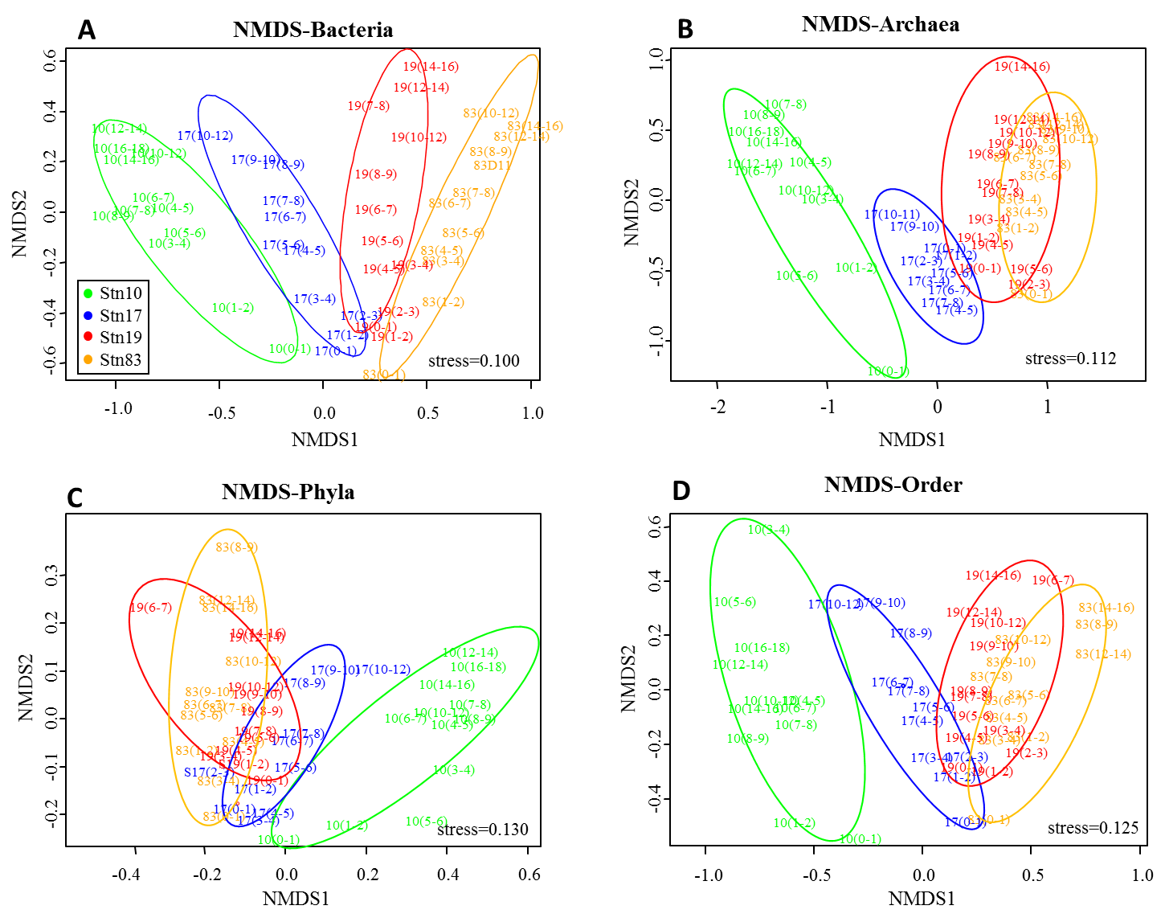

Figure S2. Non-metric multidimensional scaling (NMDS) ordination of the bacterial (A) and archaeal (B) communities based on the OTUs of 16S rRNA genes, and total prokaryotic communities at phyla level (C) and order level (D).

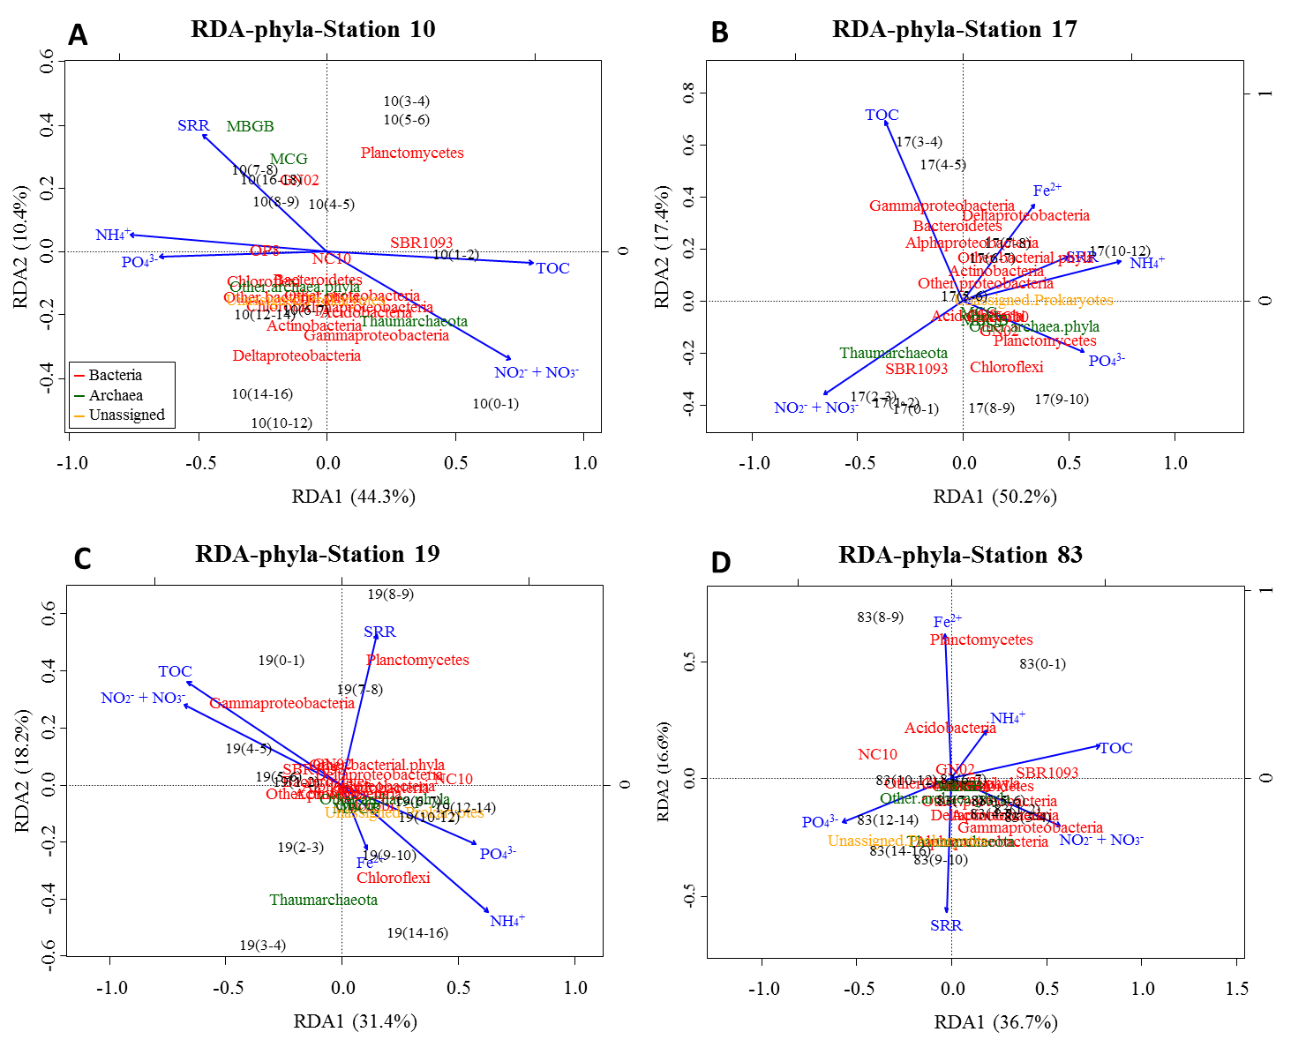

Figure S3. Redundancy analysis (RDA) models Stations 10 (A. adj. *R*2 = 0.262, *P* = 0.001), 17 (B. adj. *R*2 = 0.382, *P* = 0.001), 19 (C. adj. *R*2 = 0.262, *P* = 0.001) and 83 (D. adj. *R*2 = 0.288, *P* = 0.001) based on phyla level prokaryotic communities with selected significant environmental variables with minimum collinearity



Figure S4. Linear regression between the relative abundance of individual taxa in the total prokaryotic 16S rRNA gene sequences and total organic carbon (TOC) contents in the Amundsen Sea polynya sediments

.

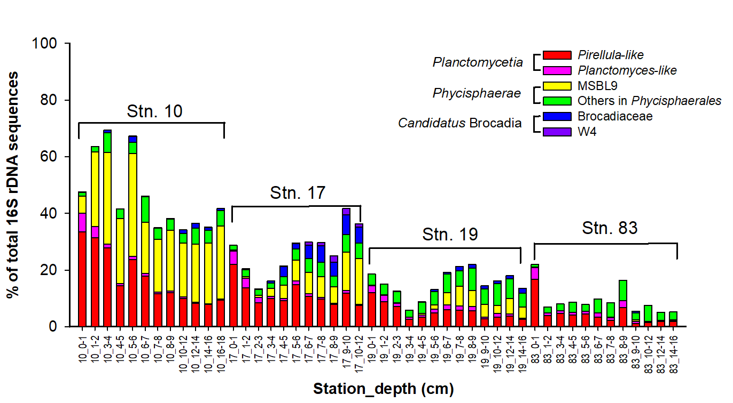

Figure S5. Relative abundance of major groups in the phylum *Planctomycetes* (based on order level) of the total 16S rRNA gene sequences at each sample



Figure S6. Relative abundance of major proteobacterial groups (based on order level) of the total 16S rRNA gene sequences at each sample



Figure S7. Relative abundance of major class groups in the total *Chloroflexi* sequences



Figure S8. Relative abundance of thaumarchaeal subgroups in the total 16S rRNA gene sequences at each sample.



Figure S9. Linear regression between geochemical properties and relative abundance of major groups (*Pirellula*-like, MSBL9, and *Brocadia*) in *Planctomycetes*

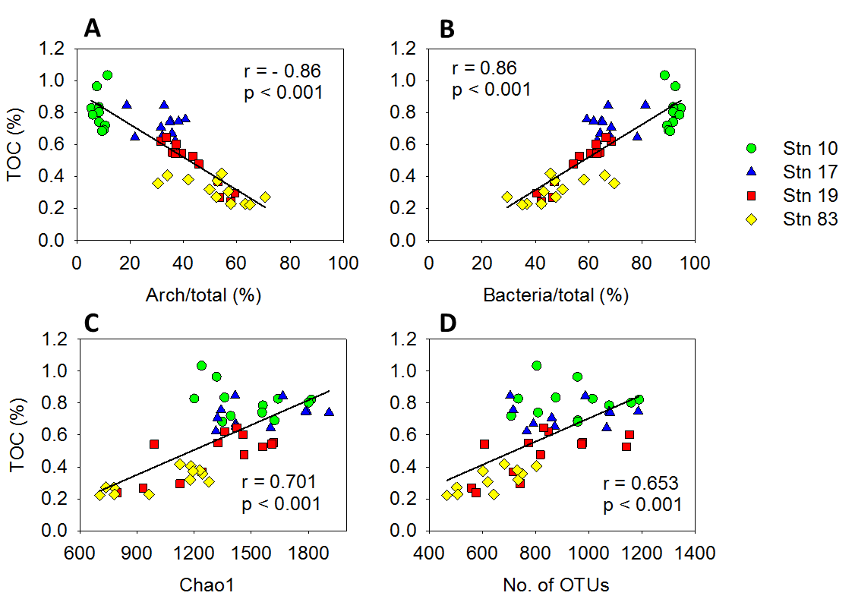

Figure S10. Linear regression between microbial the proportion of relative abundance (%) (A and B) and total organic carbon (TOC) content (A and B), and between diversity indices (C and D) between and TOC content (C and D) in the ASP sediments. The 16S rRNA gene copy numbers were converted to cell numbers using conversion factors of 1.5 for *Archaea* and 4.1 for *Bacteria*, following recommendations by Schippers & Neretin (2006).