Supporting information

SQSTM1/p62 activates NFE2L2/NRF2 via ULK1-mediated autophagic KEAP1 degradation and protects mouse liver from lipotoxicity

Da Hyun Lee^{1,2#}, Jeong Su Park^{1#}, Yu Seol Lee^{1,2}, Jisu Han¹, Dong-Kyu Lee⁵, Sung Won Kwon^{5,6}, Dai Hoon Han³, Yong-ho Lee⁴, and Soo Han Bae¹*
¹ Severance Biomedical Science Institute, Yonsei University College of Medicine, 50 Yonsei-ro, Seodaemun-gu, Seoul 03722, Republic of Korea

² Brain Korea 21 PLUS Project for Medical Science, Yonsei University
³Department of Surgery, Yonsei University College of Medicine, 50-1 Yonsei-ro, Seodaemun-gu, Seoul 03722, Republic of Korea
⁴ Division of Endocrinology and Metabolism, Department of Internal Medicine, Yonsei University College of Medicine, 50-1, Yonsei-ro, Seodaemun-gu, Seoul 03722, Republic of Korea
⁵ Research Institute of Pharmaceutical Sciences, Seoul National University, Seoul 08826, Republic of Korea
⁶ College of Pharmacy, Seoul National University, Seoul 08826, Republic of Korea
#These authors contributed equally to this work.

Corresponding author:

Soo Han Bae, Ph.D.
Severance Biomedical Science Institute, Yonsei University College of Medicine, 50-1 Yonsei-ro, Seodaemun-gu, Seoul 03722, Republic of Korea
Tel.: +82-2 2228-0756; Fax: +82-2-2227-8129; E-mail address: soohanbae@yuhs.ac
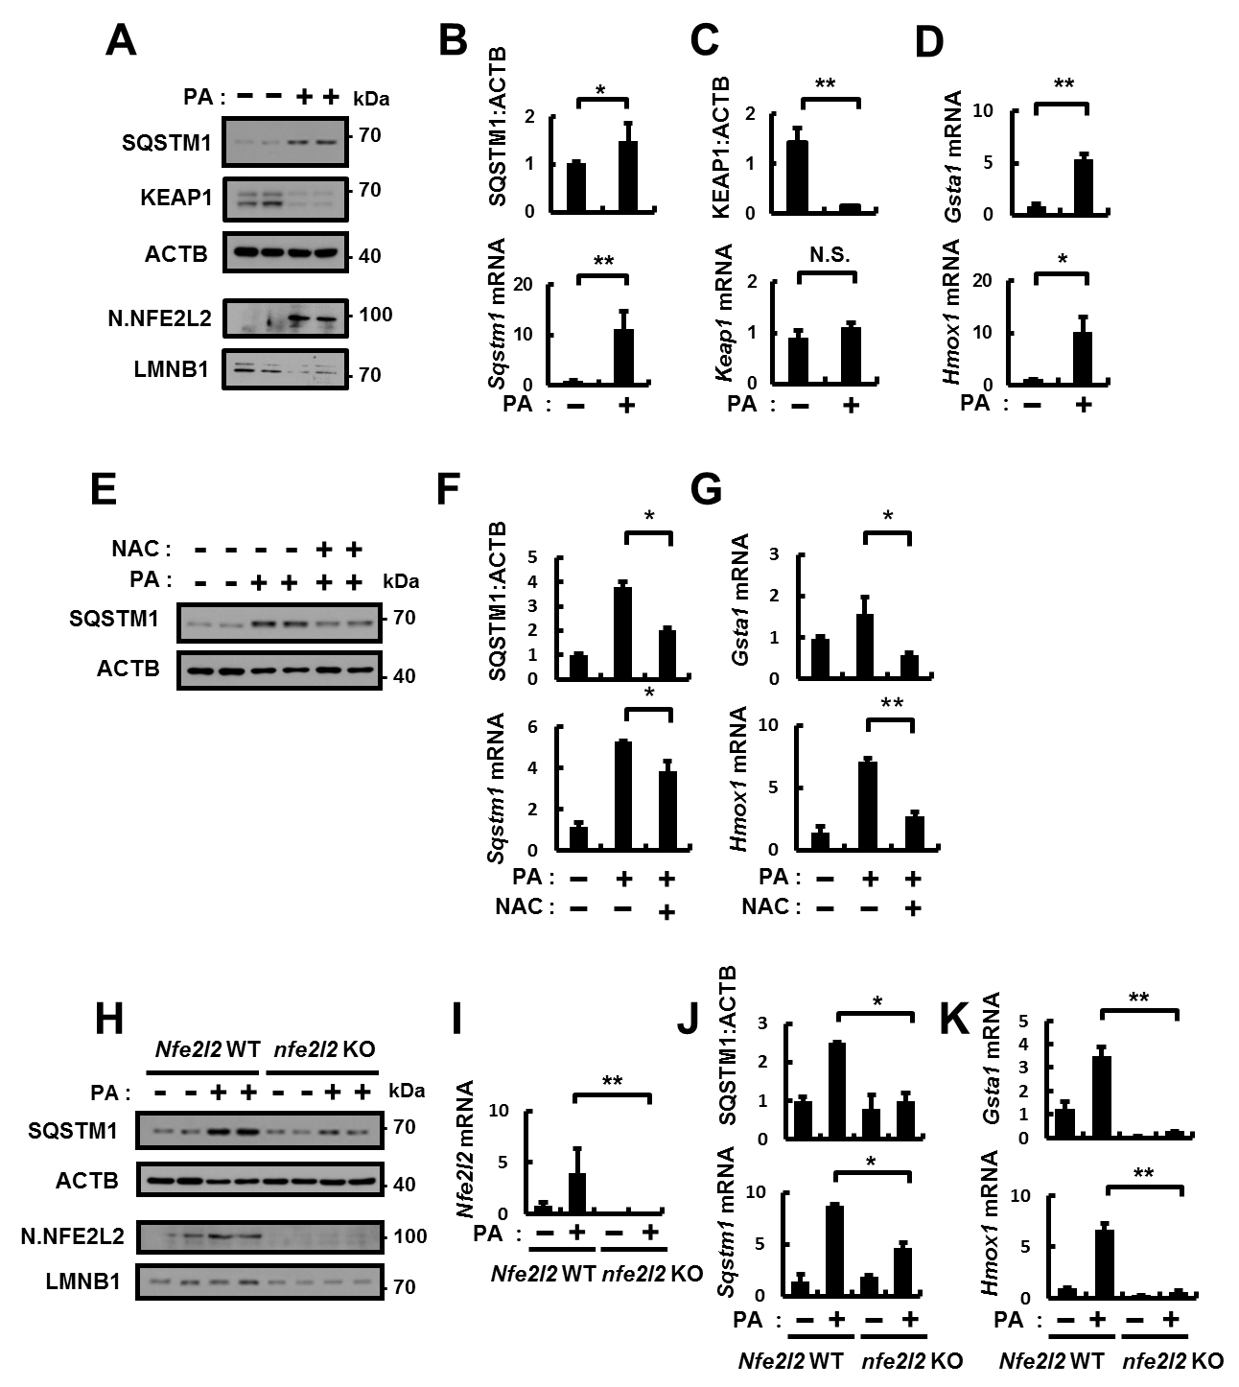

Figure S1. SQSTM1 induction is mainly dependent on ROS-NFE2L2 axis under lipotoxic stress. (A) Hepa1c1c7 cells were incubated with PA (500 μM) for 18 h. Immunoblot analysis with antibodies against SQSTM1, KEAP1, and ACTB (loading control), nuclear NFE2L2, and LMNB1 (nuclear marker). (B-D) The densitometric analysis of SQSTM1 (B) and KEAP1 (C) immunoblots. Total mRNA isolation from cells were treated as described in (A) and subjected to qRT-PCR analysis for relative mRNA expression of Sqstm1 (B), Keap1 (C), and Gsta1, Hmox1 (D). (E) Hepa1c1c7 cells were incubated with PA (500 μM) and NAC (5 mM) for 18 h. Immunoblot analysis with antibodies against SQSTM1 and ACTB (loading control). (F) The densitometric analysis of SQSTM1 immunoblots and relative mRNA expression of Sqstm1. (G) qRT-PCR analysis for relative mRNA expression of Gsta1 and Hmox1. (H) Nfe2l2 WT or nfe2l2 KO MEFs were incubated with PA (500 μM) for 18 h. Immunoblot analysis with antibodies against SQSTM1, ACTB (loading control), nuclear (N) NFE2L2, and LMNB1 (nuclear marker). (I) qRT-PCR analysis for relative mRNA expression of Nfe2l2. (J) The densitometric analysis of SQSTM1 immunoblots and relative mRNA expression of Sqstm1. (K) qRT-PCR analysis for relative mRNA expression of Gsta1 and Hmox1. Data are mean ± SD from 3 independent experiments. *p < 0.05 and **p < 0.01. Related to Figure 1.

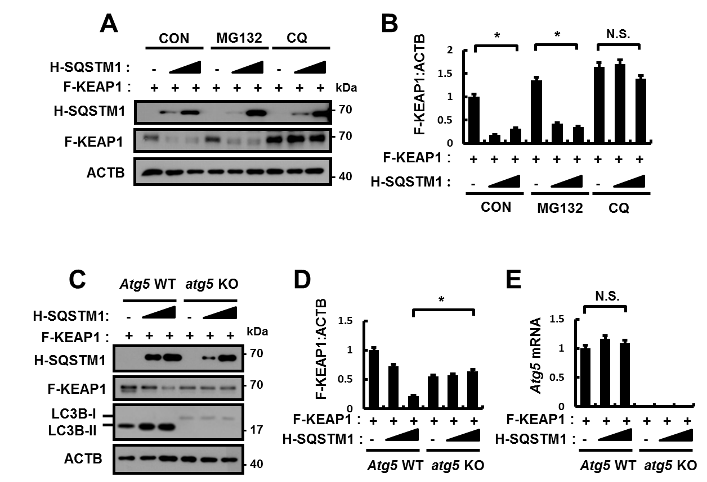

Figure S2. SQSTM1-mediated KEAP1 degradation is mainly dependent on autophagy. (A) HEK293 cells were transfected with vectors of HA (H)-SQSTM1 and FLAG (F)-KEAP1, and incubated with or without DMSO, MG132, and CQ. Lysates of the cells were subjected to immunoblot analysis with antibodies against HA, FLAG, and ACTB (loading control). (B) Densitometric analysis was obtained. (C) Atg5 WT or atg5 KO MEFs were transfected with vectors of HA-SQSTM1 and FLAG-KEAP1. Lysates of the cells were subjected to immunoblot analysis with antibodies against HA, FLAG, LC3B, and ACTB (loading control). (D) Densitometric analysis was obtained. (E) qRT-PCR analysis for relative mRNA expression of Atg5. Data are means ± SDs from 3 independent experiments. *p < 0.05 and N.S., not significant. Related to Figure 1.

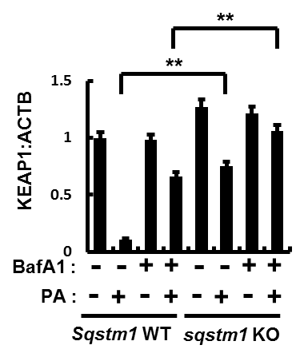

Figure S3. SQSTM1 is required for autophagic KEAP1 degradation. The densitometric analysis of KEAP1 immunoblot. Data are means ± SDs from 3 independent experiments. **p < 0.01. Related to Figure 1D.

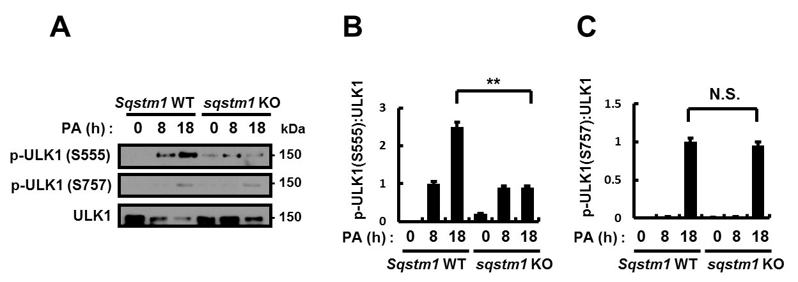
Figure S4. The phosphorylation sites of ULK1 in response to PA. (A) Sqstm1 WT or sqstm1 KO MEFs were incubated with PA (500 μM) for indicated times and subjected to immunoblot analysis with antibodies against p-ULK1 (S555), p-ULK1 (S757), and ULK1. (B-C) Densitometric analysis of p-ULK1 (S555):ULK1 (B), and p-ULK1 (S757):ULK1 (C). Data are means ± SDs from 3 independent experiments. **p < 0.01 and N.S., not significant. Related to Figure 2.

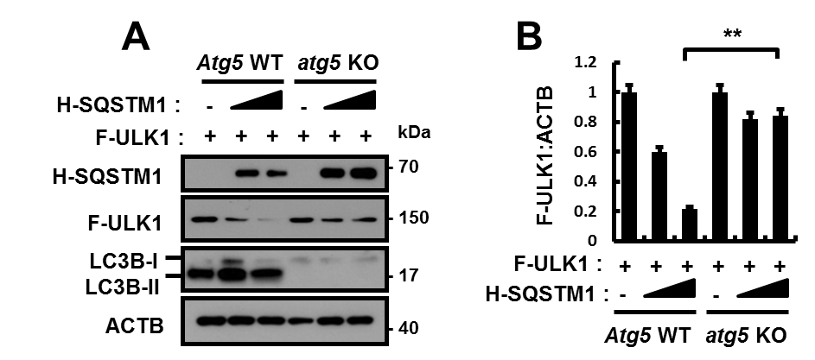

Figure S5. SQSTM1-mediated ULK1 degradation is mainly dependent on autophagy. (A) Atg5 WT or atg5 KO MEFs were transfected with vectors of HA (H)-SQSTM1 and FLAG (F)-ULK1. Lysates of the cells were subjected to immunoblot analysis with antibodies against HA, FLAG, LC3B, and ACTB (loading control). (B) Densitometric analysis was obtained. Data are means ± SDs from 3 independent experiments. **p < 0.01. Related to Figure 2.

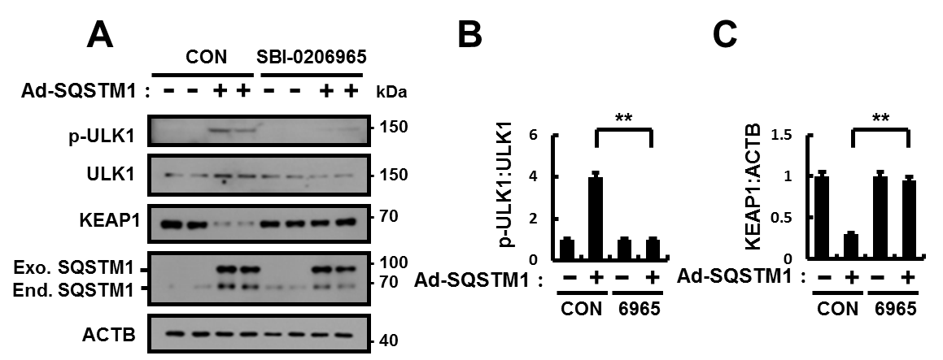

Figure S6. ULK1 is required for SQSTM1-induced autophagic KEAP1 degradation. (A) Hepa1c1c7 cells were treated with SBI-0206965 (ULK1 inhibitor), and infected with Ad-SQSTM1 for 18 h. The lysates from cells subjected to immunoblot analysis with antibodies against p-ULK1 (S317), ULK1, KEAP1, SQSTM1, and ACTB (loading control). (B-C) Densitometric analysis of p-ULK1:ULK1 (B) and KEAP1 (C) immunoblots. Data are means ± SDs from 3 independent experiments. **p < 0.01. Related to Figure 2.

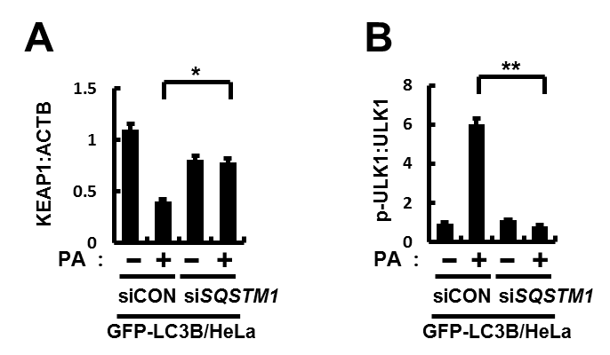

Figure S7. SQSTM1 activates autophagy in response to lipotoxicity. (A-B) Densitometric analysis of KEAP1 (A) and p-ULK1:ULK1 (B) immunoblots. Data are means ± SDs from 3 independent experiments. *p < 0.05 and **p < 0.01. Related to Figure 2L.

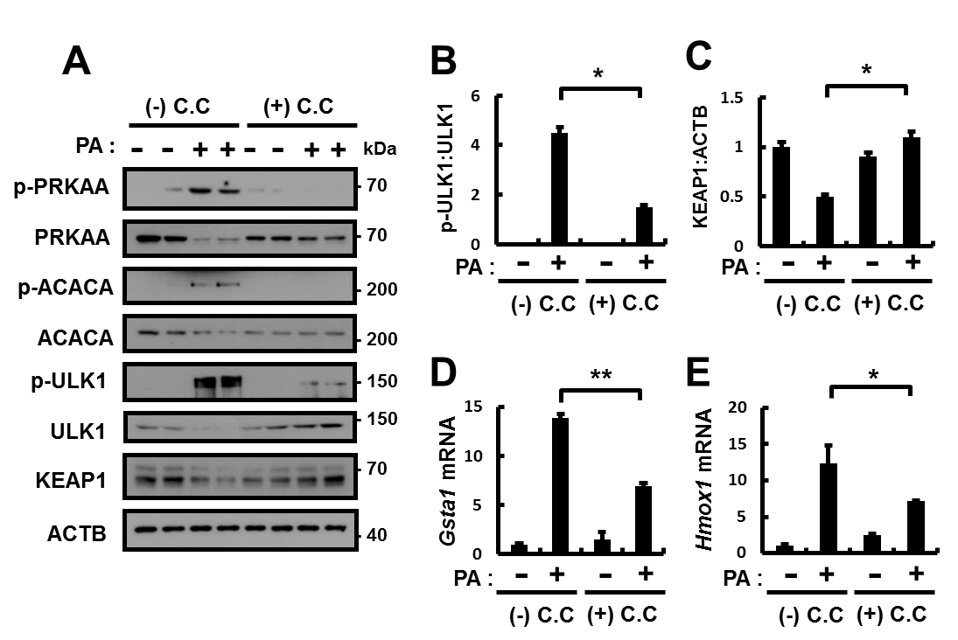

Figure S8. Palmitica acid (PA)-mediated AMPK-ULK1 axis induces autophagic KEAP1 degradation and NFE2L2 activation. Hepa1c1c7 cells were treated with compound C (C.C, AMPK inhibitor), and incubated with PA (500 μM) for 18 h. (A) The lysates from cells subjected to immunoblot analysis with antibodies against p-PRKAA (T172), PRKAA, p-ACACA (S79), ACACA, p-ULK1 (S317), ULK1, KEAP1, and ACTB (loading control). (B-C) Densitometric analysis of p-ULK1:ULK1 (B) and KEAP1 (C) immunoblots. (D-E) qRT-PCR analysis for relative mRNA expression of Gsta1 (D) and Hmox1 (E). Data are means ± SDs from 3 independent experiments. *p < 0.05 and **p < 0.01. Related to Figure 5.

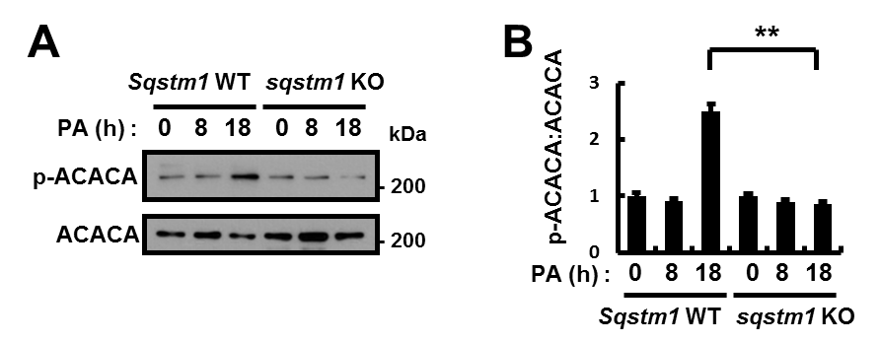

Figure S9. SQSTM1 is required for AMPK activation. (A) Immunoblot analysis with antibodies against p-ACACA (S79) and ACACA. (B) The densitometric analysis of p-ACACA:ACACA immunoblot. Data are means ± SDs from 3 independent experiments. **p < 0.01. Related to Figure 2A.

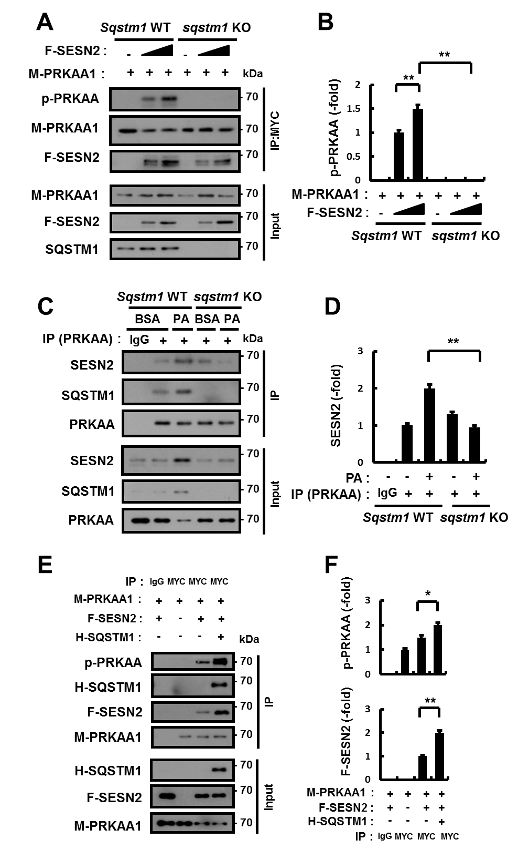
Figure S10. SQSTM1 mediated AMPK activation dependent on SESN2 (sestrin 2). (A) Sqstm1 WT or sqstm1 KO MEF cells were transfected with vectors of FLAG (F)-SESN2 and MYC-PRKAA1/AMPKα1 (M-PRKAA1). Lysates of the cells were subjected to immunoblot analysis with antibodies against p-PRKAA (T172), MYC, FLAG, and SQSTM1. (B) Densitometric analysis was obtained. (C) Sqstm1 WT or sqstm1 KO MEFs were treated with PA (500 μM) for 18 h, and subjected to immunoprecipitation with antibodies against PRKAA, and the resulting precipitates (IPs) were subjected to immunoblot analysis with antibodies against SESN2, SQSTM1, and PRKAA. (D) Densitometric analysis was obtained. (E) Lysates from HEK293 cells transfected with vectors encoding MYC-PRKAA1/AMPKα1 and FLAG-SESN2 together with expressing HA (H)-SQSTM1 were subjected to immunoprecipitation with antibodies against MYC, and the resulting precipitates (IPs) as well as whole cell lysates (WCLs) were subjected to immunoblot analysis with antibodies against p-PRKAA (T172), HA, FLAG, and MYC. (F) Densitometric analysis was obtained. Data are means ± SDs from 3 independent experiments. *p < 0.05 and **p < 0.01. Related to Figure 5 and Figure 6.

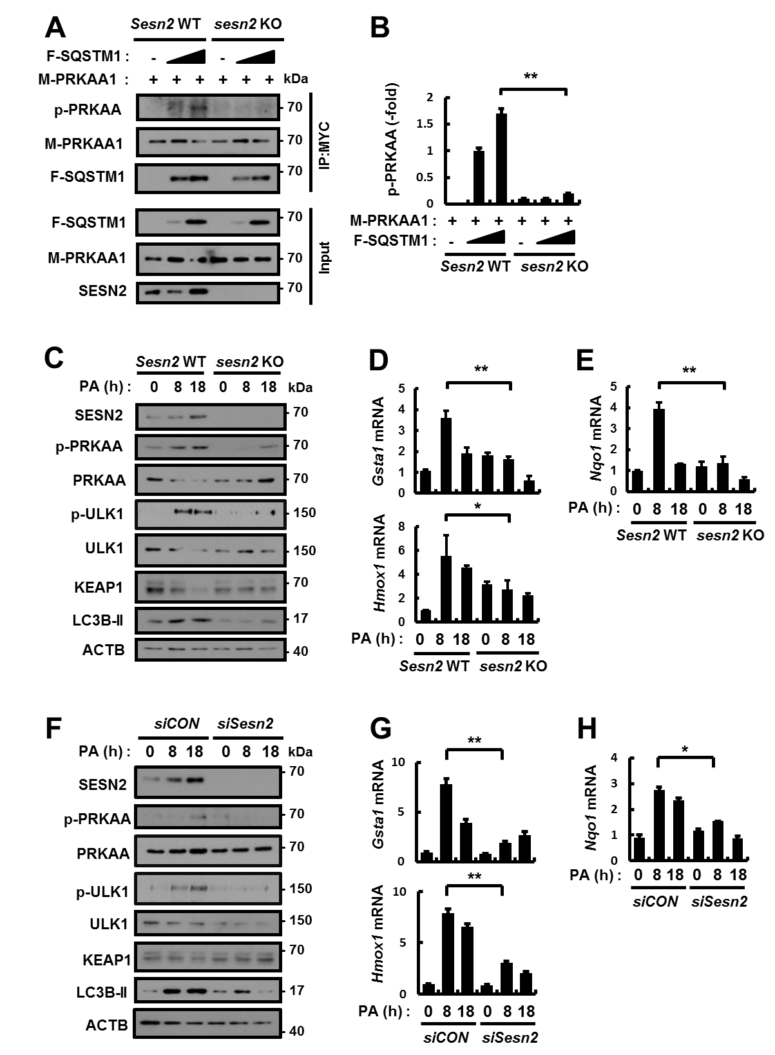
Figure S11. SQSTM1 mediated AMPK activation dependent on SESN2 (sestrin 2) in response to palmitic acid (PA). (A) Sesn2 WT or sesn2 KO MEFs transfected with vectors encoding FLAG (F)-SQSTM1 and MYC-PRKAA1/AMPKα1 (M-PRKAA1) were subjected cell lysates to co-immunoprecipitation with antibodies against MYC, and the resulting precipitates (IPs) as well as whole cell lysates (WCLs) were subjected to immunoblot analysis with antibodies against p-PRKAA (T172), MYC, FLAG, and SESN2. (B) Densitometric analysis was obtained. (C) Sesn2 WT or sesn2 KO MEFs were incubated with PA (500 μM) for indicated times and subjected to immunoblot analysis with antibodies against SESN2, p-PRKAA (T172), PRKAA, p-ULK1 (S317), ULK1, KEAP1, LC3B, and ACTB (loading control). (D-E) Total mRNA isolation from cells were treated as described in (C) and subjected to qRT-PCR analysis for relative mRNA expression of Gsta1, Hmox1 (D), and Nqo1 (E). (F) Hepa1c1c7 cells transfected with control siRNA (siCON) or Sesn2 siRNA and treated with PA for 18 h and subjected to immunoblot analysis with antibodies against SESN2, p-PRKAA (T172), PRKAA, p-ULK1 (S317), ULK1, KEAP1, LC3B, and ACTB (loading control). (G-H) Total mRNA isolation from cells were treated as described in (F) and subjected to qRT-PCR analysis for relative mRNA expression of Gsta1, Hmox1 (G), and Nqo1 (H). Data are means ± SDs from 3 independent experiments. *p < 0.05 and **p < 0.01. Related to Figure 5 and Figure 6.

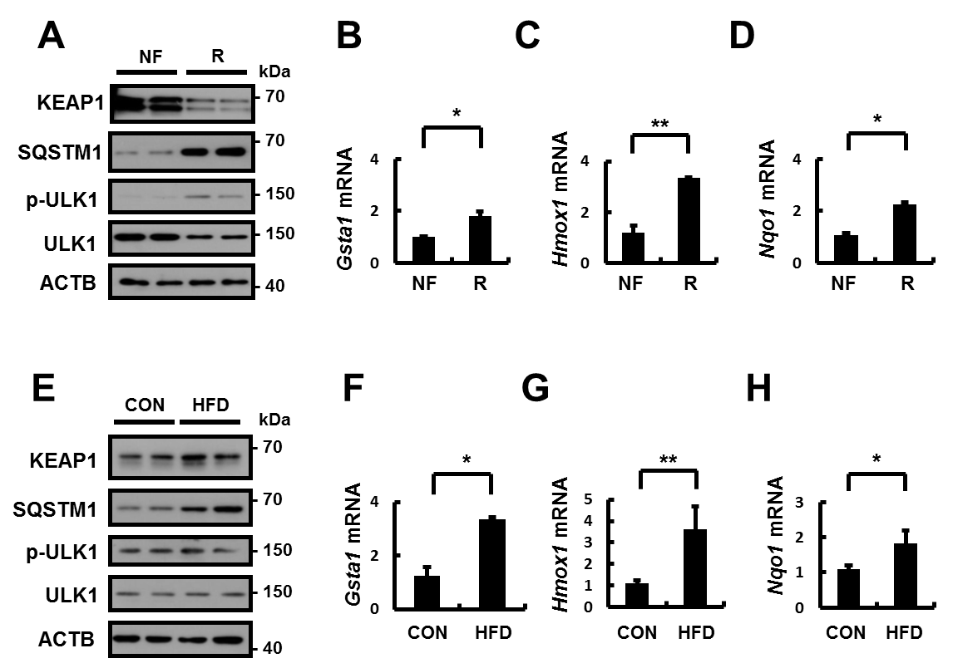

Figure S12. The regulation of SQSTM1-KEAP1-NFE2L2 pathway under acute and chronic lipotoxic stress in mouse liver. C57BL/6J mice were maintained in a non-fasted state (NF) or fasted overnight and then re-fed a high-carbohydrate, fat-free diet (R). These animals were randomly assigned to 2 groups (8-9 mice in each group). (A) Immunoblot analysis of KEAP1, SQSTM1, p-ULK1 (S317), ULK1, and ACTB (loading control). (B-D) qRT-PCR analysis for relative mRNA expression of Gsta1 (B), Hmox1 (C), and Nqo1 (D). C57BL/6J mice were maintained in chow diet (CON) or high-fat diet (HFD). These animals were randomly assigned to 2 groups (8-9 mice in each group). (E) Immunoblot analysis of KEAP1, SQSTM1, p-ULK1 (S317), ULK1, and ACTB (loading control). (F-H) qRT-PCR analysis for relative mRNA expression of Gsta1 (F), Hmox1 (G), and Nqo1 (H). Data are means ± standard errors for 8 or 9 mice per group. *p < 0.05 and **p < 0.01. Related to Figure 8.

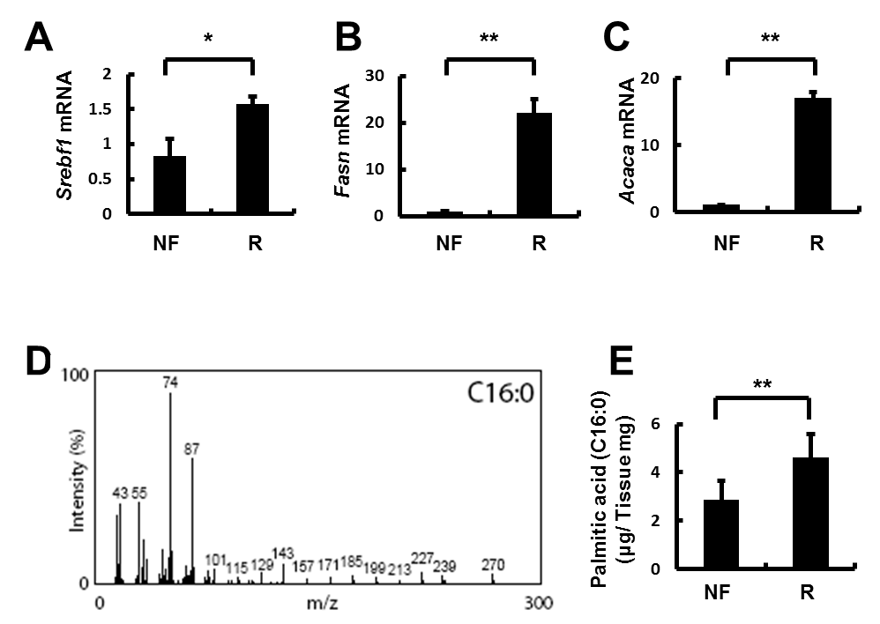

Figure S13. The increase of palmitic acid under acute lipotoxic stress in mouse liver. C57BL/6J mice were maintained in a non-fasted state (NF) or fasted overnight and then re-fed a high-carbohydrate, fat-free diet (R). These animals were randomly assigned to 2 groups (8-9 mice in each group). (A-C) qRT-PCR analysis for relative mRNA expression of mRNAs of Srebf1 (A), Fasn (B), and Acaca (C). (D) Retention index (RI) was measured using alkane mixture (C7-C40, Sigma-Aldrich) and NIST mass spectral library (NIST08) was compared with the spectrum of each peak. Peak area of fatty acids was integrated using total ion chromatogram and normalized based on that of the internal standard. (E) The livers of 8 or 9 mice of each group were homogenized, respectively. Lipid of the homogenates were subjected to hydrolysis and acidic transmethylation, and then detected by GC-MS. The Amount of fatty acids containing palmitic acid is expressed per mg of liver. Data are means ± Standard error for 8 or 9 mice of each group. *p < 0.05 and **p < 0.01. Related to Figure 8.

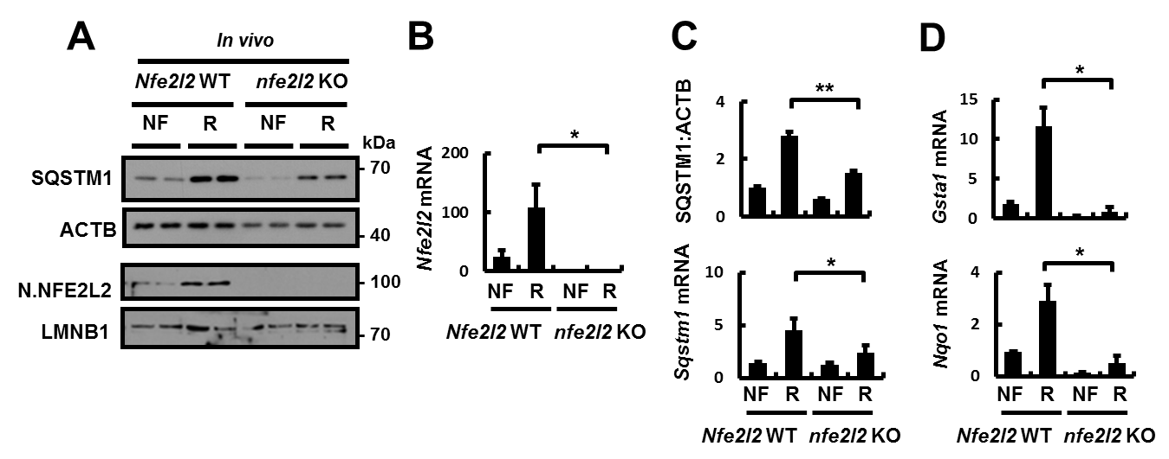

Figure S14. SQSTM1 induction is mainly dependent on ROS-NFE2L2 axis under lipotoxic stress in the mouse liver. Nfe2l2 WT or nfe2l2 KO mice were maintained in a non-fasted state (NF) or fasted overnight and then re-fed a high-carbohydrate, fat-free diet (R). These animals were randomly assigned to 4 groups (3-4 mice in each group). (A) Immunoblot analysis with antibodies against SQSTM1, ACTB (loading control), nuclear NFE2L2, and LMNB1 (nuclear marker). (B) qRT-PCR analysis for relative mRNA expression of Nfe2l2. (C) The densitometric analysis of SQSTM1 immunoblot and relative mRNA expression of Sqstm1. (D) qRT-PCR analysis for relative mRNA expression of Gsta1 and Nqo1. Data are means ± standard errors for 3 or 4 mice per group. *p < 0.05 and **p < 0.01. Related to Figure 1.

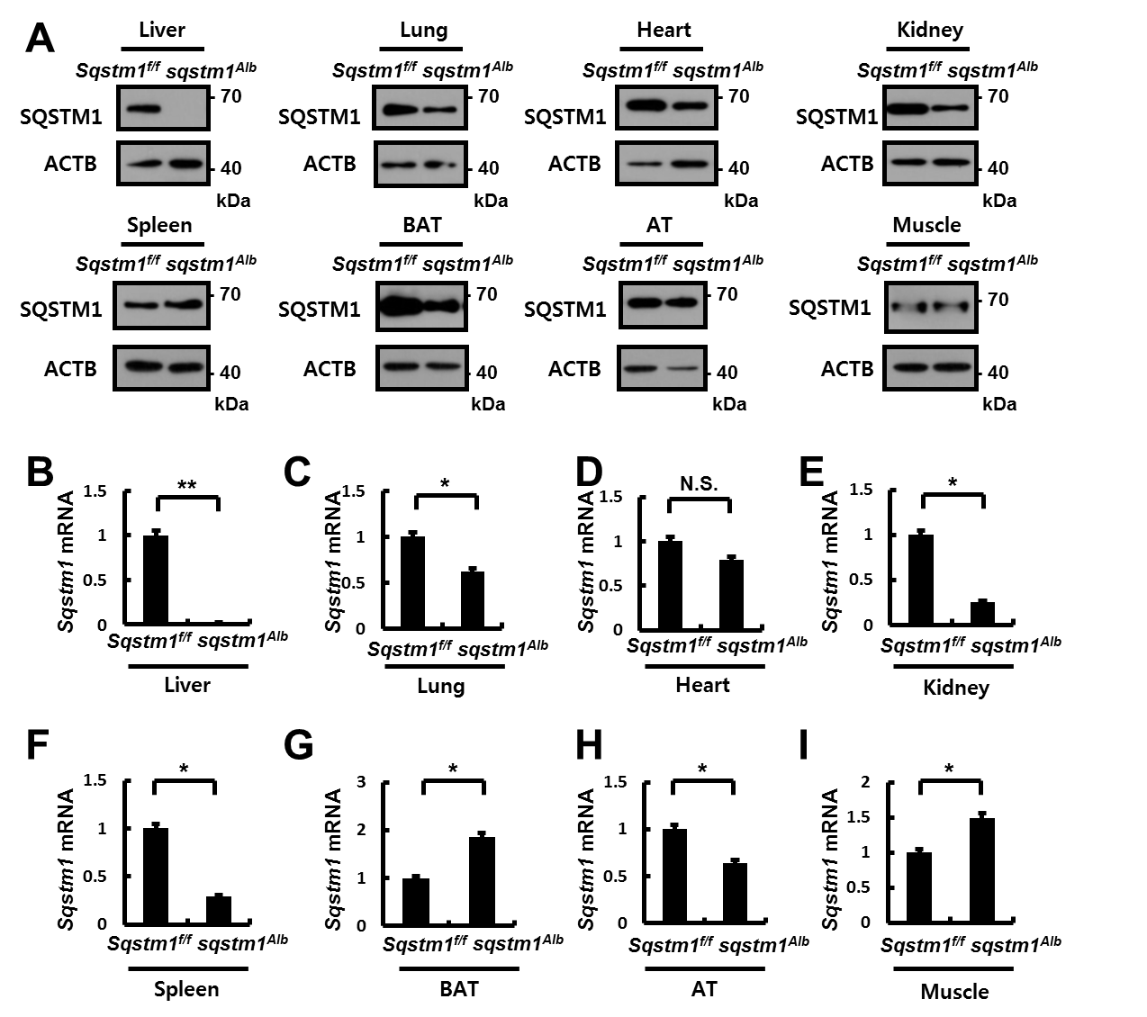

Figure S15. Generation of liver-specific sqstm1 KO mice. Liver-specific sqstm1 KO mice (sqstm1^{Alb} mice) were generated by crossing Sqstm1-floxed mice (Sqstm1^{f/f} mice) with Alb-Cre transgenic mice. These animals were randomly assigned to 2 groups (3 mice in each group). (A) Immunoblot analysis of SQSTM1 and ACTB (loading control) from various organs. (B-I) qRT-PCR analysis for relative mRNA expression of Sqstm1 in liver (B), lung (C) , heart (D) , kidney (E) , spleen (F) , brown adipose tissue (BAT) (G) , adipose tissue (AT) (H), and muscle (I). Data are means ± standard errors for 3 mice per group. *p < 0.05, **p < 0.01, and N.S., not significant. Related to Figure 12.

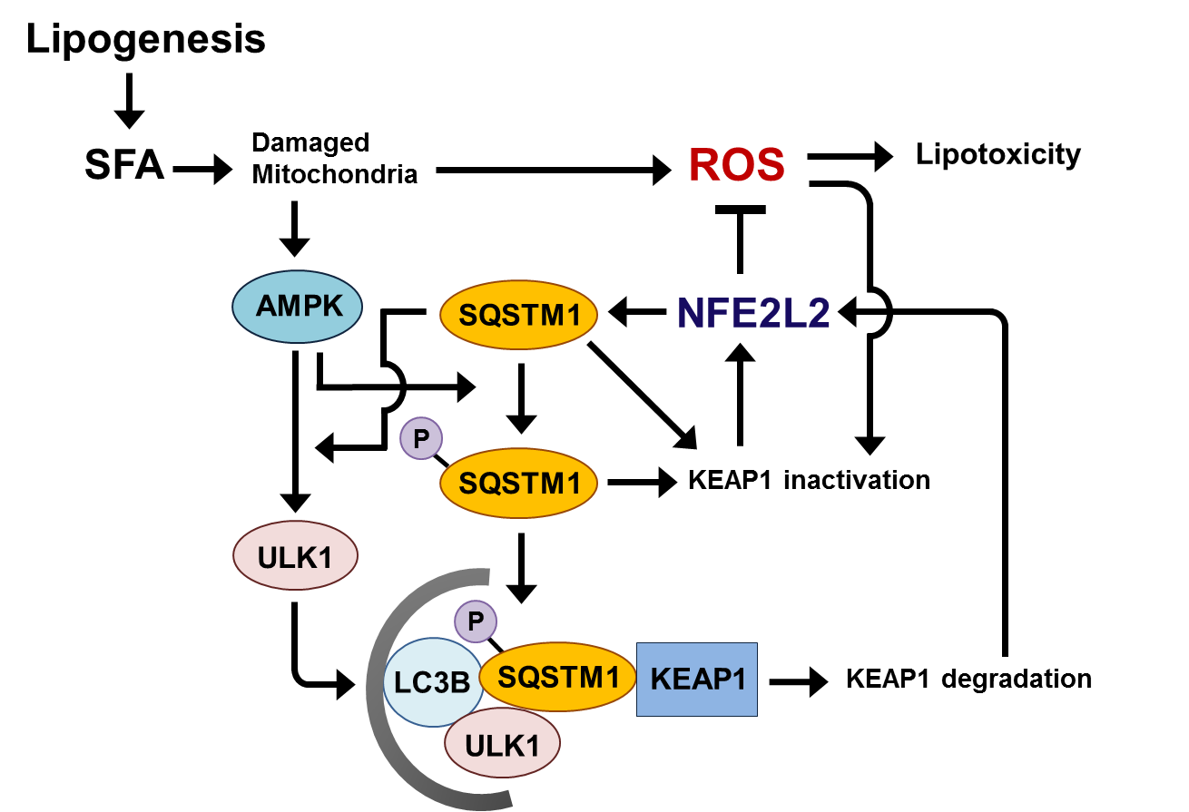

Figure S16. Underlying mechanism of hepatoprotective role of SQSTM1 against lipotoxicity through AMPK-ULK1-mediated activation of noncanonical KEAP1-NFE2L2 pathway. See the text for details.

