Supporting Information for :

Quantitative Surface-Enhanced Raman Spectroscopy Analysis through 3D Superlattice Arrays of Au Nanoframes with Attomolar detection

Dajeong Kimª, Jinhaeng Leeª, Sungjae Yooª, Sungwoo Choi^{b}, Doojae Park^{b}, and Sungho Parkª*

ªDepartment of Chemistry, Sungkyunkwan University, Suwon, 16419, South Korea
^{b}Department of Applied Optics and Physics, Hallym University, Chuncheon, 24252, South Korea
*email : spark72@skku.edu

Experiments and methods

Materials
Hydrogen tetrachloroaurate(iii) hydrate (HAuCl₄·nH₂O, 99%) and hydrogen hexachloroplatinate(iv) hydrate (H₂PtCl₆·nH₂O, 99%) were purchased from Kojima. Sodium tetrahydroborate (NaBH₄, 98%) and silver nitrate (AgNO₃, 99.8%) were purchased from Junsei. Sodium iodide (NaI, 99.5%) and l-ascorbic acid (C₆H₈O₆, 99.5%) were purchased from Sigma-Aldrich. Hydrochloric acid (HCl, 35%) was purchased from Samchun. Hexadecyltrimethylammonium bromide (CTAB, C₁₉H₄₂BrN, 95%) was supplied by Sigma-Aldrich. All reagents were dissolved in distilled water (18.2 MΩ) that was prepared using a Milli-Q water purification system from Millipore.

Synthesis of Au seed nanoparticles
The Au seed NPs were synthesized as follows: 0.6 mL of a 10 mM ice-cold NaBH₄ aqueous solution was added to a mixture of 7 mL of 0.75 M hexadecyltrimethylammonium bromide (CTAB, C₁₉H₄₂BrN, 95%) and 87.5 μL of 20 mM HAuCl₄·4H₂O (aq.) under vigorous stirring. This was followed by stirring at 28 °C for 3 h to obtain small spherical Au NPs with sizes ranging from 3 to 5 nm.

Synthesis of truncated octahedral (TOh) Au nanoparticles
TOh Au NPs were prepared through step seed-mediated method.
Step 1: 0.45 mL of a 100 times diluted Au seed solution was added to a solution containing 36.3 mL of 16 mM hexadecyltrimethylammonium bromide (CTAB, C₁₉H₄₂BrN, 95%), 75 μL of 20 mM HAuCl₄ and 1.16 mL of 38.8 mM ascorbic acid (AA), and the solution was kept in a 30 °C oven for 12 h.
Step 2: 12 mL of the solution prepared in step 1 was added to a solution containing 12 mL of 16 mM hexadecyltrimethylammonium bromide (CTAB, C₁₉H₄₂BrN, 95%), 3 mL of 2 mM HAuCl₄ and 4.6 mL of 12 mM ascorbic acid (AA), and the solution was kept in a 70 °C oven for approximately 15 min. Upon the completion of the reaction, the aqueous sample was spun in a centrifuge at 4800 rpm for 30 min, followed by removal of the supernatant, refilling with water and sonication. This washing process was repeated two times in total.

Synthesis of truncated octahedra(TOh) Au@Pt NPs
To synthesize TOh Au@Pt NPs, 15 mL of 50 mM CTAB, 10 mL of the second growth seed (Optical density : 1.2), 50 μL of 2 mM AgNO₃, and 288 μL of 0.1 M ascorbic acid were added to a vial in the presence of iodide ions (50 μM). The solution was heated to 70 °C and kept in an oven to promote the deposition of thin Ag layers onto the TOh Au NPs. After 1 h, 288 μL of 0.1 M HCl and 333 μL of a 2 mM aqueous H₂PtCl₆ solution were injected into the growth solution. The mixture was maintained at 70 °C for approximately 4 h. After the completion of the reaction, we spun the samples in a centrifuge at 5000 rpm for 25 min. This washing process was repeated two times in total.

Synthesis of truncated octahedra (TOh) Au NFs
To prepare TOh Pt@Au NFs, first, 15 mL of 50 mM CTAB, 550 μL of 2 mM HAuCl₄, and 10 mL of synthesized TOh Au@Pt NPs were mixed in the presence of iodide ions (50 μM). Etching was carried out for 2 h at 50 °C. After the completion of the reaction, we spun the samples in a centrifuge at 8000 rpm for 20 min. And then 2 mM HAuCl₄ solution was added to 10 ml of synthesized Pt frame nanoparticle in CTAB (I⁻) solution in the following volumes: 200 μL and 500 μL. Then, 100 mM ascorbic acid was added to the resulting mixtures in a 1:20 volume ratio.

Experimental fabrication of 3D Au NF arrays
Gold-coated silicon wafers (16 mm × 16 mm) used as the substrates were cleaned in absolute ethanol for 3 min to remove organic contaminants. Teflon cell (47.5 mm × 47.5 mm × 5 mm) with 16 holes perforated vertically (diameter of a hole = 1.5 mm) was used as a hydrophobic template.^{[1]} The distance between holes is 2 mm. For fabrication of 3D Au NF arrays, colloid suspension of Au NFs dispersed in 50 μL deionized water after centrifugation at 7500 rpm for 5 min in a 1.5 mL tube. Then, the gold-coated silicon wafer was placed under the Teflon cell template and attached tightly with other Teflon cell, which was used as a bottom side for fixing the wafer between the Teflon cells. The wafer between the Teflon cells could be fixed by connecting two Teflon cells using four bolts and nuts. Then, the 4 μL of purified and concentrated Au NFs suspension (concentration of Au NFs solution is 83 μM.) was injected into the holes by using pipette, resulting in 4 layers of Au nanoframes. Usually, it takes from 5 to 6 hours to drying at 30 ℃.^{[2]} After evaporation of colloid suspension inside the holes, the wafer was removed from the Teflon cells and immediately cleaned in absolute ethanol for 5 min to eliminate organic molecules such as cetyltrimethylammonium bromide (CTAB). Disk-like uniform films with ≈ 1.3 mm diameter were formed and this can be confirmed from the FE-SEM image and AFM image in Figure 1.^{[3][4]}

Experimental conditions for Raman measurement
Raman spectra were measured by using Confocal Raman spectroscopy (WiTec alpha 300R) equipped with a 633 nm He-Ne laser. A ×20 microscope was used to focus the laser onto the sample plane and laser power was 4 mW. Benzenethiol (BT) was purchased from Sigma Aldrich and dissolved in ethanol to prepare a solution with various concentrations. Before SERS measurement, the fabricated SERS substrate samples were cleaned by O₂ plasma for 5 min to remove the adsorbed organic molecules.^{[5]} Plasma cleaner Zepto (Diener) was used for O₂ plasma treatment, and the samples were exposed to O₂ plasma for 2 min at 70 Watt. After O₂ plasma cleaning, the samples were washed in deionized water and absolute ethanol for 5 min, respectively. Then, the samples were soaked for 3 hours in 10 mL ethanol solution of BT with various concentration (10^-1 M to 10^-18 M). After 3 hours, the samples were washed for 5 min in absolute ethanol and dried at room temperature. To reliable detection, the SERS measurement of the samples was performed through the large-area SERS mapping (200 × 200 μm²) and exposure time was 1 s for one mapping pixel, for a spectra range between 500 ~ 1800 cm⁻¹ of Raman shift.

Electric Field Simulations
Simulations of the electric field near the nanoframe were performed by means of a conventional FDTD method (FDTD Solutions, LumericalTM. The simulation volume of 250 nm×300 nm×1.3 μm was used to completely cover the nanoframe structure and the light source. A vertically polarized light source (polarized along the y direction in Figure. 2 and Figure S7) of plane wave form for each simulated wavelength was positioned 300 nm away from the nanoframes, and a monitor of dimensions 200 nm×250 nm was positioned at the center of the nanoframes. To ensure precise simulation, the minimum mesh size was set to 0.1 nm.

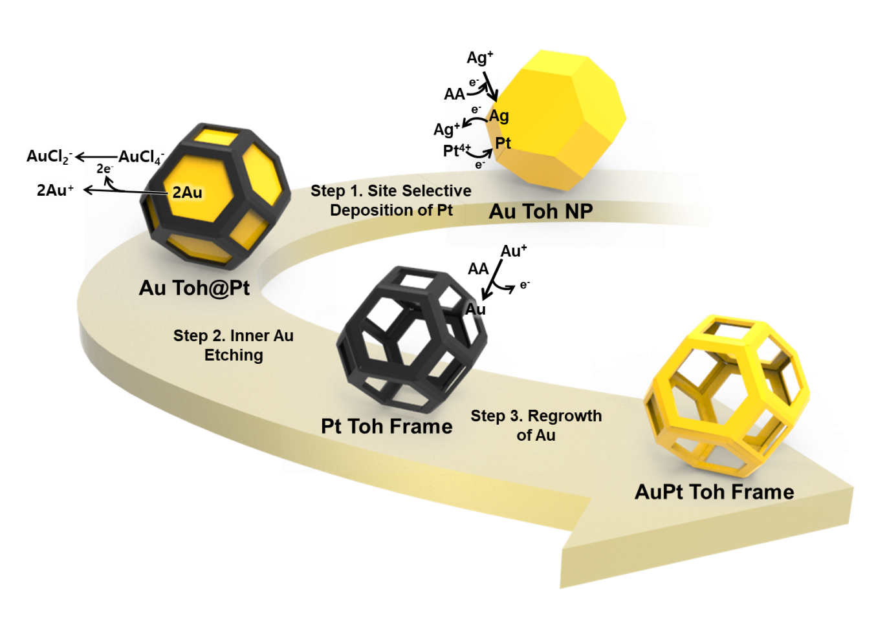
Figrue S1. Synthetic process of TOh Au nanoframes. TOh Au NPs are used as start material, and Pt is site-specifically deposited on TOh Au NPs (Step 1). The chain reaction for synthesis of TOh Au NFs occurred by etching of the inner Au by HAuCl₄ (Step 2) and regrowth of Au by ascorbic acid (A.A) (Step 3) on the Pt nanoframe.

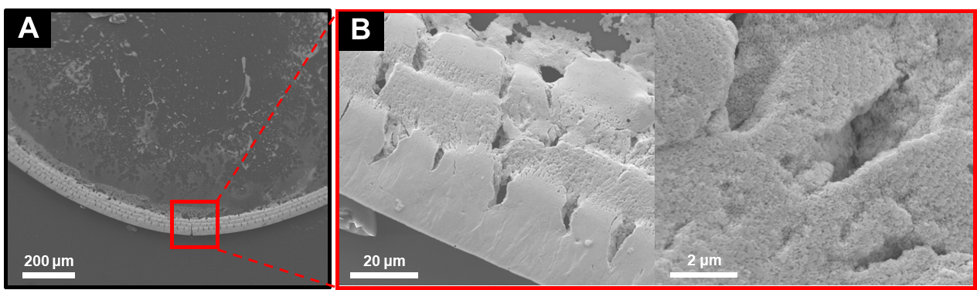

Figure S2. FE-SEM images of a ring-like deposition of Au NFs formed by droplet evaporation on a Si substrate.

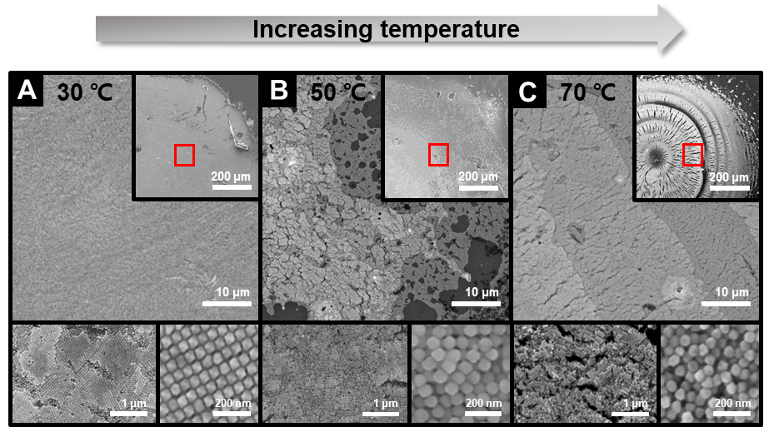

Figure S3. FE-SEM images of different TOh Au NPs deposition behavior depending on the temperature when droplet evaporated inside the holes of hydrophobic Teflon cell template. The temperature is (A) 30 ℃, (B) 50 ℃ and (C) 70 ℃.

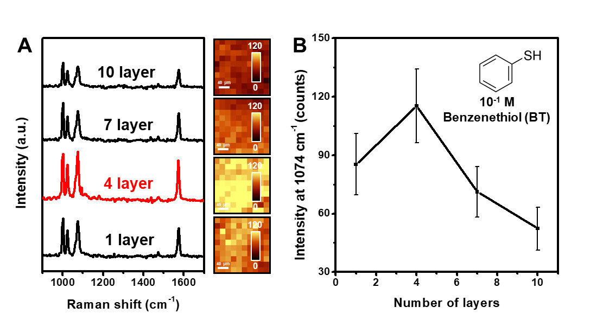
Figure S4. SERS spectra of adsorbed benzenethiol with a concentration of 10⁻¹ M on different layers of 3D Au NF arrays (rim thickness of Au NFs: 18 nm) (A) and SERS intensity at 1074 cm⁻¹ with different layers of 3D Au NF arrays (B).

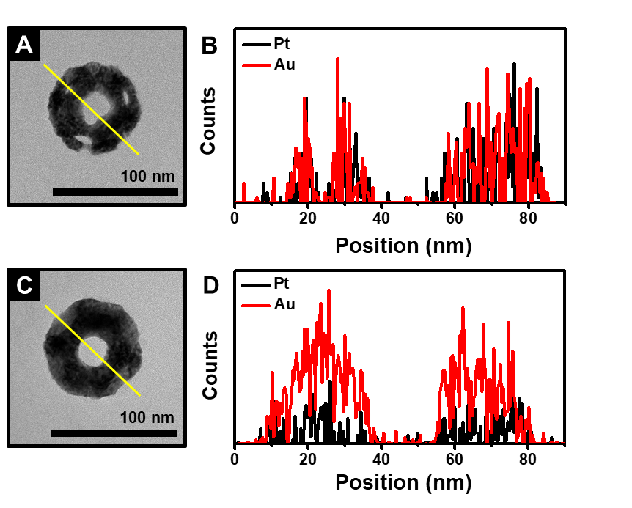
Figure S5. TEM images of Au NFs with different rim thickness: (A) rim thickness of Au NFs is 11 nm; (C) rim thickness of Au NFs is 18 nm and corresponding EDS line mapping (B, D).

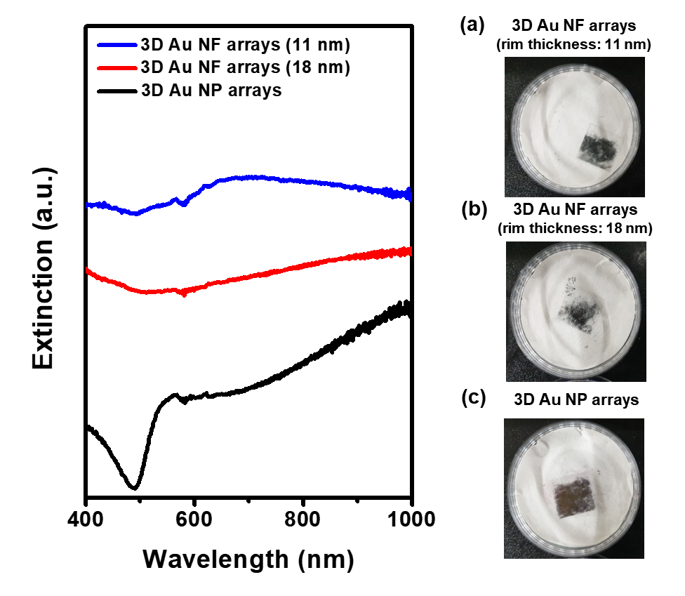
Figure S6. UV-vis-NIR spectra of 3D Au NP arrays (black line), 3D Au NF arrays (rim thickness of Au NFs: 18 nm, red line) and 3D Au NF arrays (rim thickness of Au NFs: 11 nm, blue line) on ITO-coated glass substrate and their corresponding optical images (a-c). Each array was fabricated with four stacking layers using Langmuir-Blodgett method.

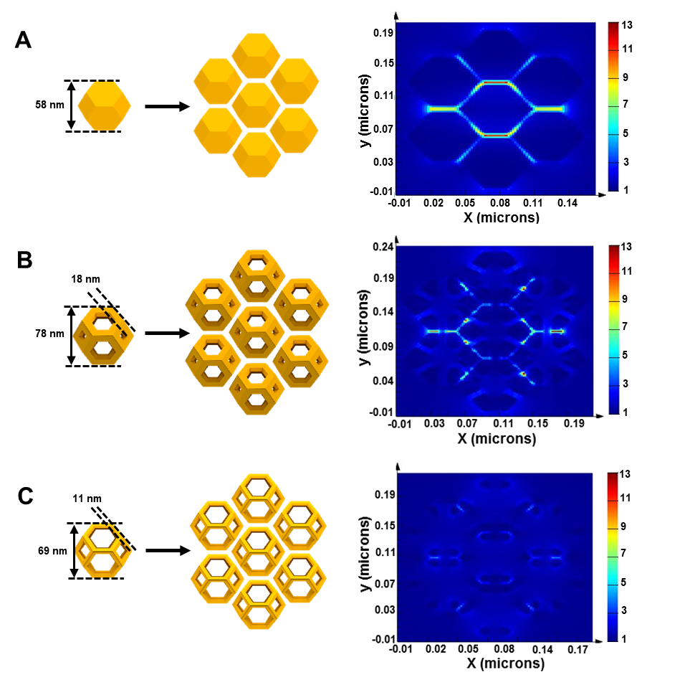
Figure S7. Dimensions and electric field enhancement for (A) Au NP arrays, (B) Au NF arrays (rim thickness of Au NFs: 18 nm) and (C) Au NF arrays (rim thickness of Au NFs: 11 nm) at 633 nm wavelength.
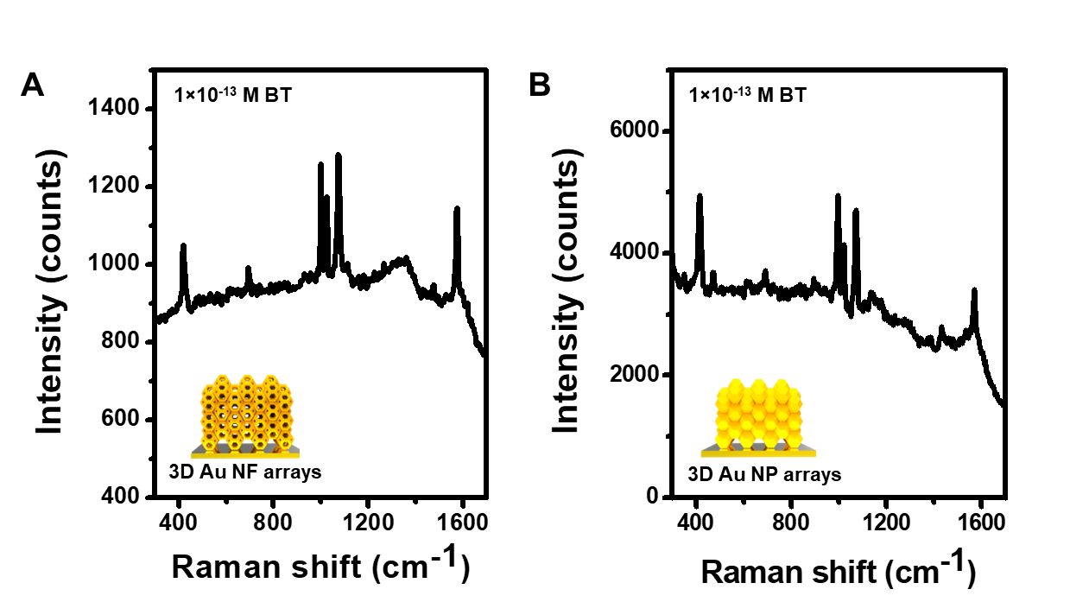

Figure S8. SERS spectra of adsorbed 10⁻¹³ M benzenethiol on (A) 3D arrays of Au NFs with 18 nm rim thickness and (B) 3D Au NP arrays with the fluorescence background.

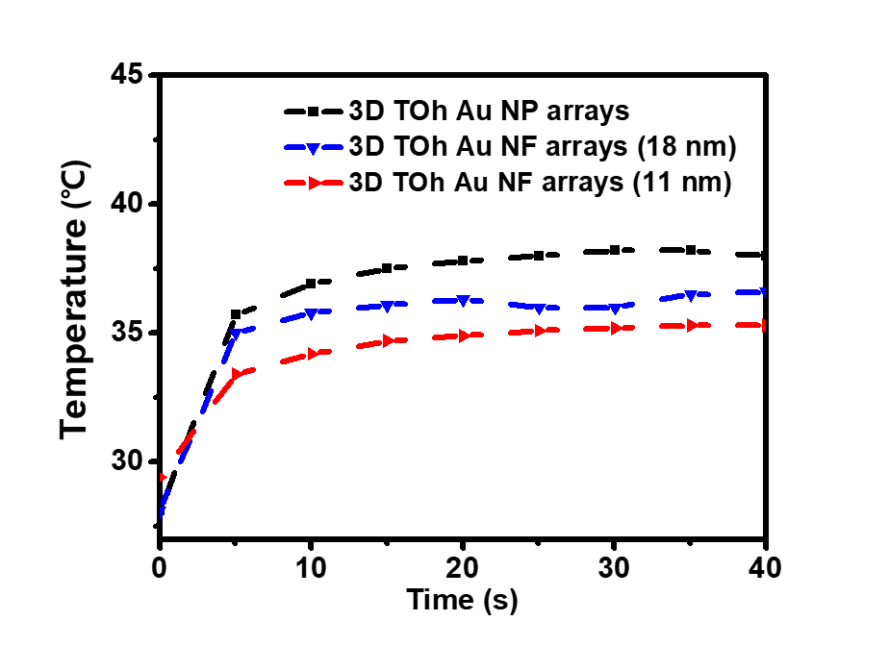
Figure S9. Measurement bulk temperature of 3D Au NP arrays (black line), 3D Au NF arrays (rim thickness of Au NFs: 18 nm, blue line), and 3D Au NF arrays (rim thickness of Au NFs: 11 nm, red line) by using thermometer as a function of illumination time of light (633 nm excitation wavelength).
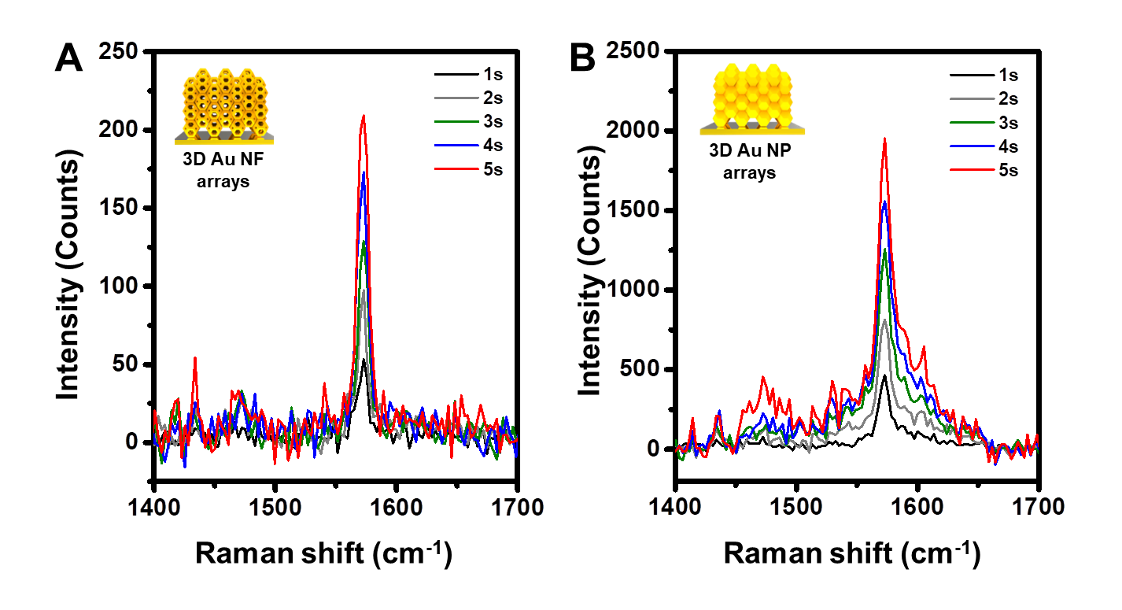
Figure S10. SERS spectra of adsorbed 10⁻⁴ M benzenethiol on (A) 3D arrays of Au NFs with 18 nm rim thickness and (B) 3D Au NP arrays as a function of increasing irradiation times (633 nm excitation wavelength). Laser power was fixed as 4mW

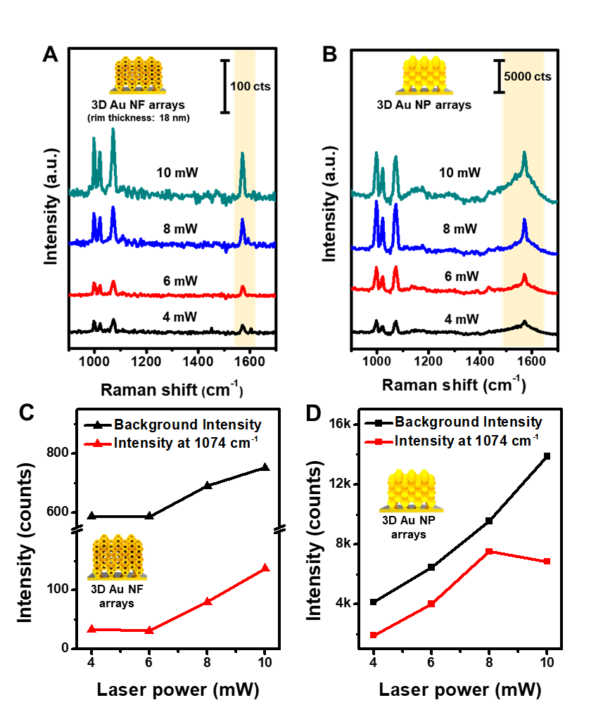
Figure S11. SERS spectra of adsorbed 10⁻¹³ M benzenethiol on (A) 3D arrays of Au NFs with 18 nm rim thickness and (B) 3D Au NP arrays as a function of increasing laser power density (633 nm excitation wavelength). Relationship between the radiating laser power and SERS intensity at 1074 cm⁻¹ (red trace), background intensity (black trace) on (C) 3D Au NF arrays, and (D) 3D Au NP arrays.

References
[1] S. Das, A. Dey, G. Reddy, D. D. Sarma, J. Phys. Chem. Lett. 2017, 8, 4704–4709.
[2] Y. Xie, S. Guo, C. Guo, M. He, D. Chen, Y. Ji, Z. Chen, X. Wu, Q. Liu, S. Xie, Langmuir 2013, 29, 6232–6241.
[3] P. Li, Y. Li, Z.-K. Zhou, S. Tang, X.-F. Yu, S. Xiao, Z. Wu, Q. Xiao, Y. Zhao, H. Wang, et al., Adv. Mater. 2016, 28, 2466–2466.
[4] V. R. Dugyala, M. G. Basavaraj, J. Phys. Chem. B 2015, 119, 3860–3867.
[5] P. Krüger, R. Knes, J. Friedrich, Surf. Coatings Technol. 1999, 112, 240–244.

