**Adapting Load Limiter Deployment for Frontal Crash Diversity- Supplemental File**

**Occupant Compartment Model**

The retractor was located at the shoulder belt lower anchorage and was locked at 1ms in to each simulated impact. The belt feed from the retractor was restricted when the amount of belt introduced into the system exceeded 400 mm. The driver airbag was adapted from the TNO frontal application model (TNO 2013). It was a standard fold circular airbag with a volume of approximately 43 litres. The passenger compartment contained a generic frontal airbag with a volume of approximately 120 litres, adapted from the European PRISM project (Bosch-Rekveldt et al. 2015). It had a two-stage inflation characteristic, fabric permiability and vent-hole response definition. Both airbags were positioned to provide an adequate representation of dummy interaction with the airbag while deployed. The stiffness characteristics of the vehicle interior components such as the steering column, front fascia and seats were based on those defined for the TNO frontal application model (TNO 2013). The windscreen, floor and toe pan were considered to be rigid.

Models were validated using data obtained from USNCAP frontal barrier test reports of vehicles classified as a small family car according to EuroNCAP, and the baseline predictions for head, chest and pelvic acceleration were compared against measures obtained from a validated model in comparable tests. Full details of the validation procedures can be found in Ekambaram et al (2015). Passenger compartment intrusion was not considered in the numerical simulation because intrusion would limit the scope for injury reduction using variable load limits.

Dummy seat track position is at best an estimate because in the real world this can vary, even with occupants of the same size. However, it is reasonable to assume that a very small driver would adjust the seat to the fully forward position, a tall driver to the rearmost location and an average sized driver would use a mid-range position. The front passenger seat adjustment is less predictable, the small stature passenger probably most of all. It was assumed that a tall passenger might use the rearmost position for more leg room, and the average sized occupant is content with a mid-track position. The small stature front passenger was not evaluated pending confirmatory current positioning data and validation of any corresponding interaction between the dummy and deploying airbag. However, It should be noted that a small occupant in the front passenger seat accounted for only 6% of the real world sample matched with crash pulse data. The following numerical models were therefore developed to conduct a parametric load limiter adaptation study.

* 50th percentile male dummy in driver position.
* 5th percentile female dummy in driver position.
* 95th percentile male dummy in driver position.
* 50th percentile male dummy in front passenger position.
* 95th percentile male dummy in front passenger position.

**Selection of Best Load Limiter Configuration**

Optimising the restraints to benefit one body region may increase injury risks to other body regions. Therefore, it was necessary to check whether reducing the injury risk to the chest had any detrimental effect on other body regions. The performance of a load limiter configuration in each crash scenario was quantified by employing a method used by NHTSA to determine the joint injury probability (Pjoint). The evaluation combines the injury risk to each selected body region assuming that injury to different body regions are independent events and are expressed as Eq. (1) (NHTSA 2008).

$P_{joint}=1-[\left(1-P_{head}\right)\left(1-P_{neck}\right)\left(1-P_{chest}\right)\left(1-P_{femur}\right)]$ (1)

The Phead, Pneck, Pchest and Pfemur are the injury probability of head, neck and chest sustaining AIS 3+ injury and the femur sustaining AIS 2+ injury (NHTSA 2008). The injury responses of 5th and 95th percentile dummies were scaled (normalised) to account for the difference in the biomechanical characteristics with the 50th percentile dummy using Injury Assessment Reference Values (IARVs) (Mertz et al. 2016; NHTSA 2002). It would have been possible to modify the standard Pjoint calculation used by NHTSA, using an AIS 2+ chest injury risk curve. However, this would not have influenced the selection of best load limiter based on AIS 2+ chest injury in this study.

The presence of the steering wheel reduces the ride down space on the driver side. High dummy excursions induced by the low SBL thresholds generally increased the risk of dummy contact with the vehicle interior and unfavourable interaction with the deploying frontal airbag. An excursion limit was therefore introduced to cater for driver dummy movement into a zone where interior interaction became more likely. The best restraint system was selected in the driver test configurations only if the chest injury was reduced without increasing the overall injury risk (Pjoint) and the distance between the dummy chest and steering wheel hub remained greater than 80 mm, an excursion limit suggested by real- world data analysis (Ekambaram et al. 2015). The best restraint system was selected in the passenger test configurations only if there was no excessive forward movement of the dummy resulting in unstable contact with the airbag. This was checked using head and chest acceleration plots and animation video.

**Benefit Quantification**

In order to calculate benefits, first, the simulated chest injury outcomes required adjusting for occupant age. This was achieved by using an age-related chest injury risk function developed by Ekambaram et al. (2015) as expressed in Eq. (2).

$P\left(AIS 2+\right)=\frac{1}{1+\operatorname{EXP}\left(12.432-0.0562Age-1.7955{\left(ChestDefl\right)}^{0.4612}\right)}$ (2)

The occupants in the real-world sample were classified into young (17 - 39 years), middle-age (40 - 64 years) and old (65+) of whom 35 were young (12%), 165 (55%) were middle aged and 98 (33%) were older occupants. In the AIS 2+ chest injury risk function, the age was set as 30, 50 and 70 years for young, middle-aged and older occupants respectively and is based on the mean value of age categories from the accident sample.

The real-world injury reduction benefit was quantified by applying the estimated relative chest injury risk reduction obtained from simulations to the matched real-world accident sample according to the occupant seating positions, impact scenario, occupant sizes and occupant age. It was assumed that in each of the categorised crash scenarios, the predicted chest injury risk of the baseline model would be representative of the real-world chest injury risk, and by switching to the best load limiter model, the real-world injury risk would reduce relative to the corresponding simulated reduction. The new frequency of AIS 2+ seat belt- related chest injury after employing the adaptive restraint was estimated using Eq. (3).

${\left[F_{smart}\right]}_{age}={\left[F_{actual}\right]}_{age}\left[\sum_{i=1}^{2 position}{\sum_{j=1}^{5 impacts }{\sum_{k=1}^{3 sizes}{W_{ijk}\frac{{\left[R_{best}\right]}_{ijk}}{{\left[R_{base}\right]}_{ijk}}}}}\right]$ (3)

Where,

Fsmart is the estimated number of occupants to sustain AIS 2+ chest injury with an adaptive system for that particular age group;

Factual is the actual number of AIS 2+ chest injured in the sample for that particular age group;

positions= Driver, Front seat passenger;

impacts = Low FRB, Low ODB, Mid, EuroNCAP and USNCAP;

sizes= HIII05, HIII50, HIII95

$W_{ijk}$ is the age dependent, real world weighting factor, such that $W_{ijk} is { W}_{{pos}_{i}} {x W}_{{impact}_{j}} x{ W}_{{size}_{k}}$

${\left[R_{best}\right]}_{ijk}$ and ${\left[R_{base}\right]}_{ijk}$ are the AIS 2+ chest injury risk of the best and baseline model respectively for particular seat position, impact severity, occupant size and age group.

Weighting factors used to evaluate EQ 3 are reported in Table A 2 which are based on the sample with occupants who had sustained AIS 2+ chest injuries from seatbelt restraining loads. Accordingly, all of the terms of the equation were estimated for each of the age groups. Therefore, three age groups produced three frequency values (Fsmart). The occupants in the data sample were classified as 5th percentile (≤ 158 cm), 50th percentile (159 - 182 cm), and 95th percentile (≥ 183 cm) based on their height. It was also assumed that all vehicles in the target sample of accident data had a 4 kN SBL (similar to the baseline numerical model).

**Explanation of Tables A3 and A4**

In each body region column, a bar to the left of the central line denotes a reduction in risk, while a bar to the right denotes an increase in risk. The unshaded bar in Table A 3 denotes that the minimum distance between the driver dummy and the steering wheel was less than the selected 80 mm threshold. The unshaded bar in Table A 4 denotes excessive forward movement of the passenger dummy. The ‘best’ selected restraint system in each of the crash pulses is represented with an asterisk.

In all crash scenarios, reducing the SBL threshold (allowing a greater amount of forward displacement) resulted in higher femur loads. For example, changing the load limiting threshold from 4 kN to 2 kN for 50th percentile driver in Low FRB impact condition predicted increase in the femur force from 0.7 to 1.7 kN (an 143% increase). However, the corresponding AIS 2+ injury risk of femur fracture was low (0.90 % to 1.20 %) having no significant effect on the Pjoint value.

**Observed Dummy Kinematics and Best Load Limiter Configuration**

**50th percentile driver** In all crash pulses, the extra seat belt webbing with the 2 and 3 kN SBL allowed the dummy to displace further towards the steering wheel than with the baseline model. The forward displacement of the dummy in each crash pulse was lowest with the 6 kN SBL. In low pulse tests, the limit of dummy excursion remained more than 80 mm from the wheel with all four SBL configurations. The predicted head, chest and overall injury scores were lowest with the 2 kN SBL and this was selected as the best restraint system in the low pulse impacts. The 2 kN SBL in the Mid pulse impact produced best head, chest and overall injury scores, however, the forward displacement of the thorax moved it to less than 80 mm from the steering wheel hub. The 3 kN SBL produced lower injury risks than the baseline model while not displacing the dummy closer than 80 mm. By changing the SBL value from 4 to 3 kN, the chest compression decreased from 34.2 to 30.0 mm (12% reduction) and the overall injury risk (Pjoint) score reduced by 19%. In both high crash pulses, the chest excursion with a 2 and 3 kN SBL surpassed the pre-determined limit from the steering wheel. In fact, it was less than 40 mm from the wheel with the 2 kN SBL in both high crash pulses, suggesting that any extra forward displacement of the thorax could have induced much harder contact with the steering wheel. In the USNCAP pulse, the forward excursion of the head and chest with the baseline 4 kN SBL was borderline. With the 6 kN SBL, it was well outside of the pre-determined limit but the predicted chest injury risk and overall injury risk (Pjoint) was greater than the baseline SBL. For these reasons, the baseline model was chosen as the best restraint configuration in both high pulse scenarios.

**5th percentile driver** Unlike the50th percentile dummy,the small stature dummy, excursed to less than 80 mm from the steering wheel in all impacts. This was almost certainly due to the fact that the dummy was initially positioned closer (229 mm) to the steering wheel compared to the 50th percentile dummy (320 mm). In the low FRB impact, the airbag was fired late in the simulation (45 ms), resulting in the forward displacing dummy head contacting the airbag during inflation in all four tested SBL configurations. This unstable loading of the dummy head with the airbag resulted in a high resultant head acceleration (>100 g, Figure A 2 a). However, the resultant head acceleration 3 ms exceedance values were well within the European regulatory limit of 80 g. Early interaction of the dummy’s head with the airbag, due to the dummy forward seating position, was also noted with other crash scenarios which can be distinguished by initial peaks in the head resultant acceleration (Figure A 2). This was due to the dummy contacting the airbag soon after inflation, whilst the pressure inside the airbag was still high. This interaction seems to be almost independent of crash pulse and SBL configuration. With the 2 kN SBL in the EuroNCAP impact, the head was observed to ‘bottom out’ the airbag. The head of the dummy penetrated through the airbag and contacted the steering hub. The increase in the head acceleration during the period of head-hub loading can be seen with the head resultant acceleration peak at almost 65 g (Figure A 2 d). When the SBL threshold was increased (>2 kN) the head did not strike the steering hub. The 6 kN showed some improvements to chest injury risk, however it was limited. It was considered that varying the load limiter for smaller occupants who tend to sit closer to the steering wheel has limited scope with the restraint system tested. For this reason, the baseline 4 kN SBL was chosen for the small female dummy in all simulated impacts.

**95th percentile driver** The 2 kN SBL gave the best chest and overall injury outcome in both low pulse scenarios, with dummy forward displacement outside of the pre-determined limit. In Low FRB and Low ODB crash pulses, employing a 2 kN SBL reduced the Pjoint value by 16% and 13% respectively when compared to the baseline model. In the Mid pulse with a 2 kN SBL and NCAP impacts with the 2 and 3 kN SBL, the forward displacing dummy pushed the airbag upwards and rearwards, reducing the amount of airbag between the thorax and steering wheel. This resulted in relatively stiff loading region between the chest and airbag. In those test configurations, the peak chest accelerations were greater than the baseline outcome (Figure A 3). The chest compression in the USNCAP impact with a 2 kN SBL remained within the regulatory limit but the chest acceleration exceeded the US FMVSS 208 limit of 60 g. The overall injury risk predicted with the 2 kN SBL in EuroNCAP and USNCAP pulses were greater than the baseline by 7% and 10% respectively. The results show that the SBL threshold can be reduced to 3 kN in Mid pulse impacts but in high pulse impacts, reducing the SBL threshold from 4 kN may increase occupant injury severity risk.

**50th percentile passenger** The dummy did not have a hard contact with the vehicle interior in any of the simulated impacts. The HIC outcomes were generally lowest using the 2 kN SBL. The only exception was a higher HIC for the low FRB pulse when using the 2 kN SBL. The 2 kN SBL produced lowest chest compression scores in all impacts. However, a greater forward displacement of the dummy in high-pulse impacts with a 2 kN SBL resulted in higher chest and head peak acceleration. More simulation runs with different adapted dummy postures and crash pulses would be required for a greater understanding of the effect of the 2 kN SBL in such crash scenarios. The 3 kN SBL in Mid-pulse and EuroNCAP impacts provided the best injury protection with stable airbag loading. Varying the load limiting threshold from the baseline level did not produce any injury reduction benefit for the USNCAP impact.

**95th percentile passenger** In low severity impacts, using a 2 kN SBL produced best chest and overall injury outcomes. In the mid pulse and NCAP impacts, employing a 2 kN SBL resulted in a ‘belt-spool out effect’ i.e. the amount of belt fed into the system reached the maximum modelled amount of 400 mm, abruptly stopping the introduction of belt from the retractor and resulting in greater acceleration forces to the dummy head and chest regions (Figure A 4 & Figure A 5). In fact, the chest acceleration in the NCAP impacts with the 2 kN SBL was above 50 g, however it was less than the FMVSS 208 maximum allowable limit of 60 g. When the SBL threshold was above 2 kN, the belt spool out effect was not noticed. In the Mid and NCAP scenarios, the peak chest acceleration outcome with the 3 kN SBL was higher than the baseline model. The Pjoint value of the 3 kN SBL was almost similar to the baseline, which suggests that employing a 3 kN SBL has no/limited injury reduction benefit in those impacts, despite further forward movement of the dummy. In crash scenarios where no injury benefit was predicted by the low load limiting options, the default SBL threshold of 4 kN was selected as the best restraint model.

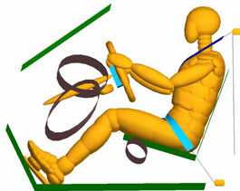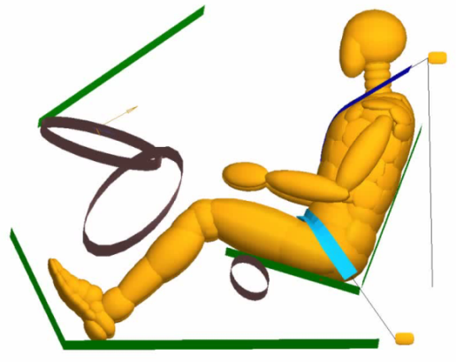

Figure A 1 Baseline Driver (left) and Front Passenger (right) Simulation Models

Table A 1 Baseline dummy positioning measurements in the compartment model

|  |  |  |
| --- | --- | --- |
| **Description** | **units** | **Measurements** |
| Windshield angle | deg | 34 |
| Steering wheel angle | deg | 67.4 |
| Steering column angle | deg | 22.7 |
| Head to windshield distance | mm | 556 |
| Nose to rim distance | mm | 415 |
| Chest to steering hub distance | mm | 320 |
| Rim to abdomen distance | mm | 206 |
| Knee to dashboard | mm | 145 |
| Pelvic angle | deg | 22.9 |

Table A 2 Real- World Weighting Factors from AIS 2+ chest injured target sample

|  |  |  |  |  |  |  |
| --- | --- | --- | --- | --- | --- | --- |
| **Age group** | **Wposition** | | **Wimapct** | | **Wsize** | |
| **Position** | **Weight** | **Impact type** | **Weight** | **Occupant** | **Weight** |
| **Young** | Driver | 0.686 | 26 km/h FRB | 0.417 | HIII 05 | 0.109 |
| 40 km/h ODB | 0.375 | HIII 50 | 0.723 |
| 56 km/h ODB | 0.000 | HIII 95 | 0.168 |
| EuroNCAP | 0.000 | **sum** | **1.000** |
| USNCAP | 0.208 |  |  |
| **sum** | **1.000** |  |  |
|  |  |  |  |  |  |
| FSP | 0.314 | 26 km/h FRB | 0.818 | HIII 05 | 0.166 |
| 40 km/h ODB | 0.091 | HIII 50 | 0.731 |
| 56 km/h ODB | 0.000 | HIII 95 | 0.103 |
| EuroNCAP | 0.000 | **sum** | **1.000** |
| USNCAP | 0.091 |  |  |
| **sum** | **1.000** |  |  |
| **sum** | **1.000** |  |  |  |  |
| **Mid** | Driver | 0.821 | 26 km/h FRB | 0.634 | HIII 05 | 0.109 |
| 40 km/h ODB | 0.313 | HIII 50 | 0.723 |
| 56 km/h ODB | 0.000 | HIII 95 | 0.168 |
| EuroNCAP | 0.000 | **sum** | **1.000** |
| USNCAP | 0.052 |  |  |
| **sum** | **1.000** |  |  |
|  |  |  |  |  |  |
| FSP | 0.179 | 26 km/h FRB | 0.467 | HIII 05 | 0.166 |
| 40 km/h ODB | 0.433 | HIII 50 | 0.731 |
| 56 km/h ODB | 0.000 | HIII 95 | 0.103 |
| EuroNCAP | 0.033 | **sum** | **1.000** |
| USNCAP | 0.067 |  |  |
| **sum** | **1.000** |  |  |
| **sum** | **1.000** |  |  |  |  |
| **Old** | Driver | 0.641 | 26 km/h FRB | 0.349 | HIII 05 | 0.109 |
| 40 km/h ODB | 0.556 | HIII 50 | 0.723 |
| 56 km/h ODB | 0.000 | HIII 95 | 0.168 |
| EuroNCAP | 0.000 | **sum** | **1.000** |
| USNCAP | 0.095 |  |  |
| **sum** | **1.000** |  |  |
|  |  |  |  |  |  |
| FSP | 0.359 | 26 km/h FRB | 0.457 | HIII 05 | 0.166 |
| 40 km/h ODB | 0.457 | HIII 50 | 0.731 |
| 56 km/h ODB | 0.029 | HIII 95 | 0.103 |
| EuroNCAP | 0.000 | **sum** | **1.000** |
| USNCAP | 0.057 |  |  |
| **sum** | **1.000** |  |  |
| **sum** | **1.000** |  |  |  |  |

Table A 3 Driver Simulation Results



*Best Selected Load Limiter Setting. Unshaded bar denotes that the minimum distance between the driver dummy and the steering wheel was less than the selected 80 mm threshold.

Table A 4 Front Seat Passenger Simulation Results



*Best Selected Load Limiter Setting. Unshaded bar denotes excessive forward movement of the passenger dummy.

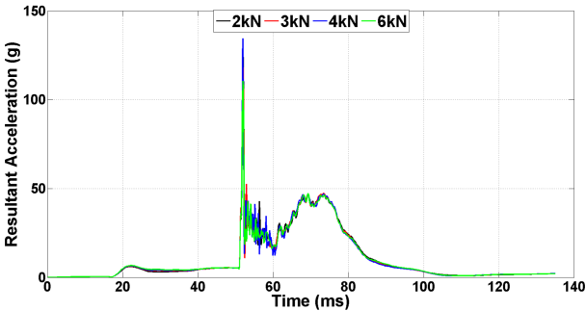

a) Low FRB

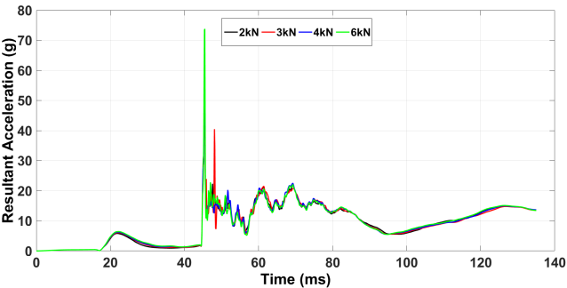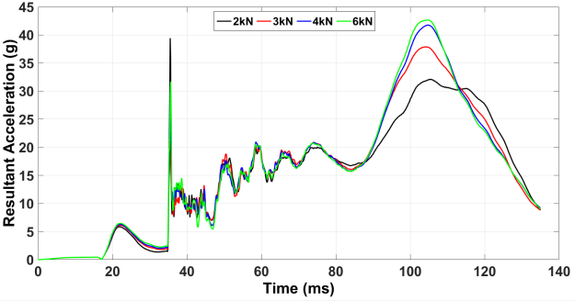

b) Low ODB c) Mid

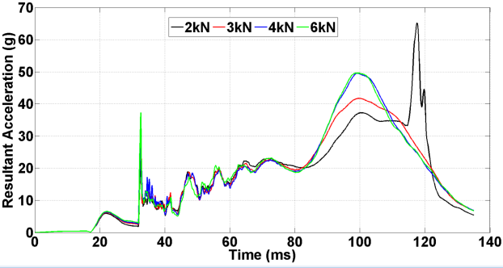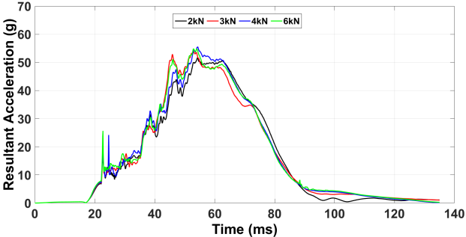

d) EuroNCAP e) USNCAP

Figure A 2 Head Resultant Acceleration Time History Curves- 5th Percentile Driver

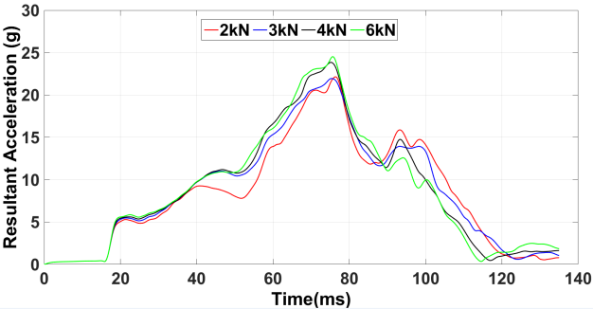

a) Low FRB

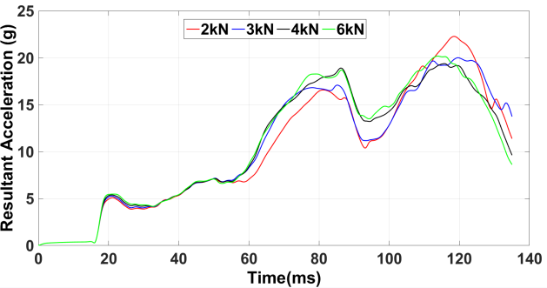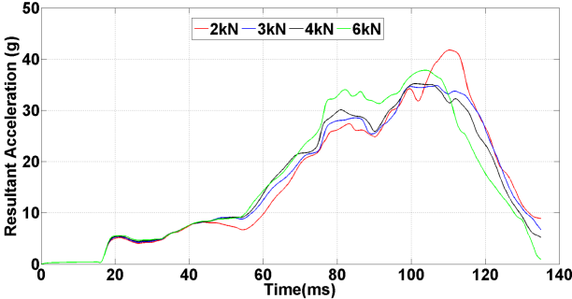

b) Low ODB c) Mid

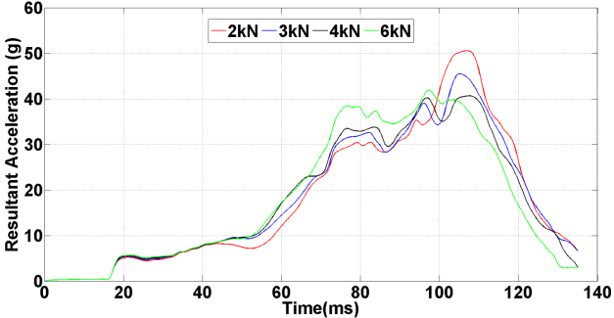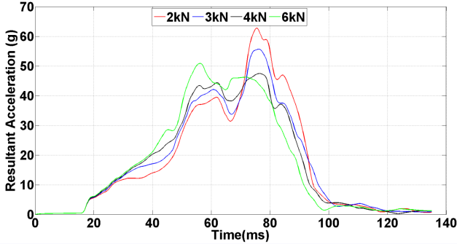

d) EuroNCAP e) USNCAP

Figure A 3 Chest Resultant Acceleration Time History Curves- 95th Percentile Driver

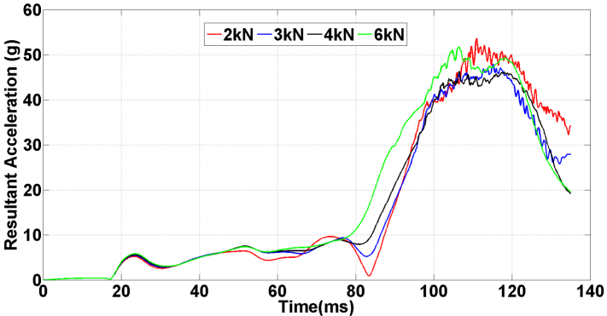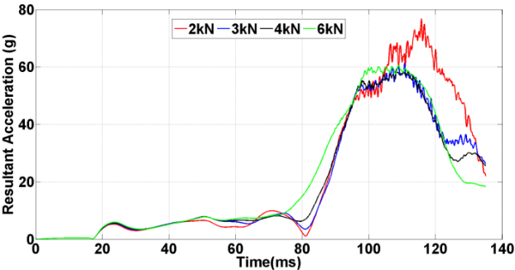

a) Mid b) *EuroNCAP*

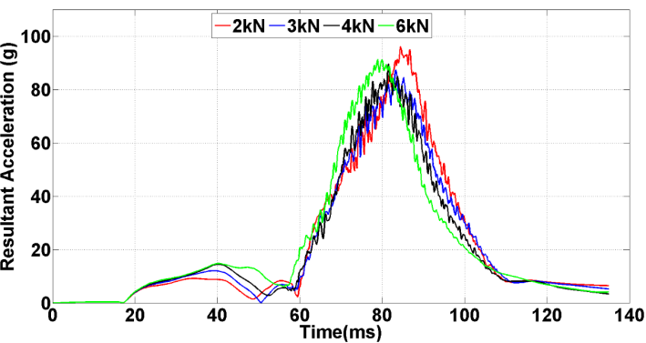

c) USNCAP

Figure A 4 Head Acceleration Time History Curves- 95th Percentile FSP

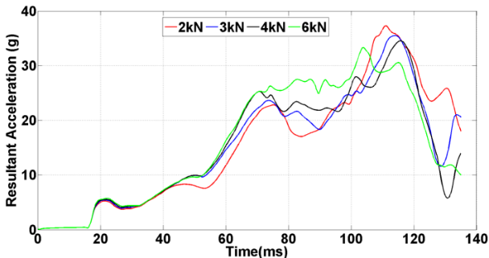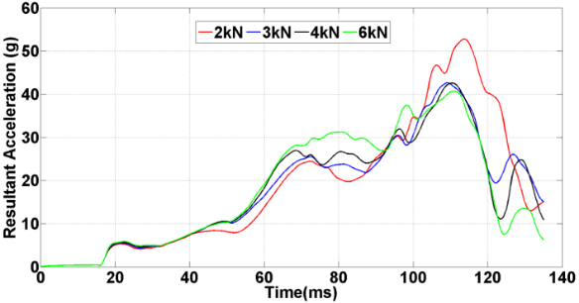

a) Mid b) *EuroNCAP*

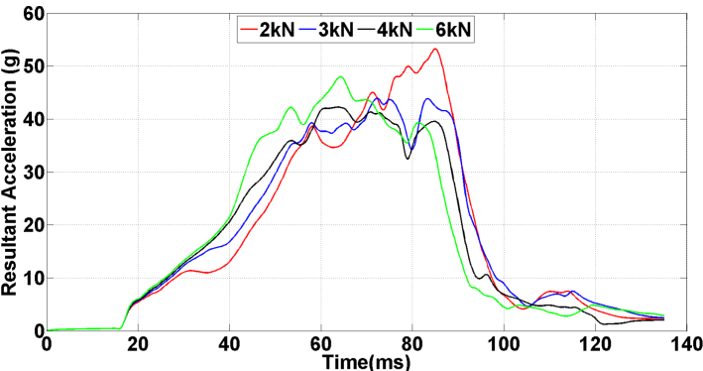

c) USNCAP

Figure A 5 Chest Acceleration Time History Curves- 95th Percentile FSP

Table A 5 Estimated AIS 2+ Chest Injury Risk of Baseline and Best SBL Models

