Supplemental Table 1: Treatment effects (model inputs)
DMD | HR 6-month CDP (95% CrI) | ARR (95% CrI)
Cladribine tablets | 0.542 (0.294-0.986) | 0.419 (0.318-0.538)
Alemtuzumab | 0.398 (0.207-0.726) | 0.322 (0.259-0.391)
Dimethyl fumarate | 0.639 (0.409-0.967) | 0.535 (0.450-0.630)
Fingolimod | 0.687 (0.451-1.049) | 0.459 (0.398-0.525)
Glatiramer acetate | 0.672 (0.418-1.071) | 0.654 (0.590-0.721)
Interferon beta-1a 44 mg (Rebif®) | 0.712 (0.454-1.157) | 0.662 (0.586-0.740)
Interferon beta-1a (Avonex®) | 0.685 (0.446-1.068) | 0.806 (0.724-0.887)
Interferon beta-1b | 0.305 (0.139-0.680) | 0.672 (0.588-0.758)
Peginterferon beta-1a | - | 0.657 (0.501-0.848)
Natalizumab | 0.447 (0.252-0.797) | 0.341 (0.281-0.406)
Teriflunomide | 0.819 (0.537-1.258) | 0.671 (0.579-0.771)
Ocrelizumab | 0.431 (0.229-0.839) | 0.367 (0.292-0.449)
Abbreviations. ARR = annualized relapse rate; CDP = confirmed disability progression; CrI = credible interval; DMD = disease-modifying therapy; HR = hazard ratio; mg = milligram.
Notes. The treatments effects for the RRMS population were derived from an indirect treatment comparison, in which all treatments were compared to placebo [45]. The indirect treatment comparison was performed using a random effects model. The 6-month CDP HR for peginterferon beta-1a was not included in the network meta-analysis that the indirect treatment comparison is based on. As such, we assumed that this DMD has the same effect as BSC.

Supplemental Table 2: Health utilities (model inputs)
Health state | Patient health utility (E) | Caregiver disutility (SE)
Relapse (hospital) | -0.071 (0.013) | -
Relapse (non-hospital) |  | -
EDSS 0 | 0.906 (0.026) | -0.002 (0.053)
EDSS 1.0 | 0.845 (0.046) | -0.002 (0.053)
EDSS 2.0 | 0.804 (0.012) | -0.002 (0.053)
EDSS 3.0 | 0.701 (0.012) | -0.045 (0.057)
EDSS 4.0 | 0.655 (0.013) | -0.142 (0.062)
EDSS 5.0 | 0.565 (0.026) | -0.160 (0.055)
EDSS 6.0 | 0.496 (0.012) | -0.173 (0.054)
EDSS 7.0 | 0.392 (0.032) | -0.030 (0.038)
EDSS 8.0 | 0.025 (0.038) | -0.095 (0.075)
EDSS 9.0 | -0.195 (0.119) | -0.095 (0.075)
EDSS 10.0 (death) | - | -
Abbreviations. EDSS = Expanded Disability Status Scale; RRMS = relapsing-remitting multiple sclerosis; SE = standard error.
Notes. Utility decrease for each relapse (0.071) was derived from Orme and colleagues [52]. The utilities for EDSS states were extracted from the CLARITY trial and a study by Hawton and Green [51]. Caregiver disutility based on EDSS states was extracted from Acaster and colleagues [53]

Supplemental Table 3: Adverse events (model inputs)
 | Probability of AE
DMD | Infusion site reaction | Injection site reaction | Progressive multifocal leukoencep-halopathy | Serious infection | Macular edema | Gastrointestinal disorder | Hypersensitivity reaction | Thyroid-related event | Influenza-like illness | Malignancy | Immune thrombocytopenic purpura
Cladribine tablets | - | - | - | 2.8% | - | 24.5% | - | 5.1% | 1.3% | 0.6% | -
Alemtuzumab | 90.1% | - | - | 2.3% | - | 22.8% | - | 11.3% | 1.1% | 0.6% | 1.8%
Dimethyl fumarate | - | - | 0.00001% | 2.2% | 0.4% | 30.4% | - | 1.2% | 1.2% | 0.6% | -
Fingolimod | - | - | 0.00001% | 2.2% | 0.4% | 30.4% | - | 1.2% | 0.7% | 0.6% | -
Glatiramer acetate | - | 55.9% | - | 1.6% | - | 18.6% | 11.7% | 1.2% | 0.7% | 0.6% | -
Interferon beta-1a 44mg (Rebif®) | - | 75.7% | - | 0.7% | - | 21.0% | 1.2% | 2.6% | 6.4% | 0.6% | -
Interferon beta-1a (Avonex®) | - | 27.1% | - | 3.0% | - | 26.4% | 1.2% | 1.7% | 7.8% | 0.6% | -
Interferon beta-1b | - | 66.2% | - | 2.0% | - | 22.8% | 5.2% | 4.7% | 8.4% | 0.6% | -
Peginterferon beta-1a | - | 83.8% | - | 0.7% | - | 22.8% | 1.2% | 1.2% | 6.7% | 0.6% | -
Natalizumab | 23.6% | - | 0.2% | 1.9% | - | 22.8% | 4.0% | 1.2% | 0.2% | 0.6% | -
Teriflunomide | - | - | - | 2.0% | - | 39.4% | - | 1.2% | 0.1% | 0.6% | -
Ocrelizumab | 34.3% | - | - | 1.9% | - | 22.8% | - | 1.2% | 1.2% | 0.6% | -
Disutility of AE (SE) | -0.011 (0.002) | -0.011 (0.002) | -0.200 (0.040) | -0.190 (0.038) | -0.040 (0.008) | -0.240 (0.048) | -1.000 (0.200) | -0.110 (0.022) | -0.210 (0.042) | -0.116 (0.023) | -0.090 (0.018)

Abbreviations. AE = adverse event; SE = standard error.
Notes. Disutility per event numbers and probabilities were extracted from multiple sources in the literature [54-56]. Due to limited sources of the disutility of AEs in the literature, the AE disutility parameters depended on data from other chronic conditions. The data per event was combined with data on the duration of AEs to determine total QALY impact.

Supplemental Table 4: Mortality rate adjusted for age, sex and EDSS state (model inputs)
 |  |  | EDSS state
Cycle | Mean age | Ratio female:male | 0 | 1 | 2 | 3 | 4 | 5 | 6 | 7 | 8 | 9
0 -1 | 38.7 | 1.93 | 0% | 0% | 0% | 0% | 0% | 0% | 0% | 0% | 0% | 0%
1 -2 | 39.7 | 1.93 | 0% | 0% | 0% | 0% | 0% | 0% | 0% | 0% | 0% | 0%
2 -3 | 40.7 | 1.94 | 0% | 0% | 0% | 0% | 0% | 0% | 0% | 0% | 0% | 0%
3 -4 | 41.7 | 1.94 | 0% | 0% | 0% | 0% | 0% | 0% | 0% | 0% | 0% | 0%
4 -5 | 42.7 | 1.94 | 0% | 0% | 0% | 0% | 0% | 0% | 0% | 0% | 0% | 0%
5 -6 | 43.7 | 1.94 | 0% | 0% | 0% | 0% | 0% | 0% | 0% | 0% | 0% | 0%
6 -7 | 44.7 | 1.94 | 0% | 0% | 0% | 0% | 0% | 0% | 0% | 0% | 0% | 0%
7 -8 | 45.7 | 1.94 | 0% | 0% | 0% | 0% | 0% | 0% | 0% | 0% | 0% | 0%
8 -9 | 46.7 | 1.94 | 0% | 0% | 0% | 0% | 0% | 0% | 0% | 0% | 0% | 0%
9 -10 | 47.7 | 1.95 | 0% | 0% | 0% | 0% | 0% | 0% | 0% | 0% | 0% | 0%
10 -11 | 48.7 | 1.95 | 0% | 0% | 0% | 0% | 0% | 0% | 0% | 0% | 0% | 0%
11 -12 | 49.7 | 1.95 | 0% | 0% | 0% | 0% | 0% | 0% | 0% | 0% | 0% | 0%
12 -13 | 50.7 | 1.95 | 0% | 0% | 0% | 0% | 0% | 0% | 0% | 0% | 0% | 0%
13 -14 | 51.7 | 1.95 | 0% | 0% | 0% | 0% | 0% | 0% | 0% | 0% | 0% | 0%
14 -15 | 52.7 | 1.96 | 0% | 0% | 0% | 0% | 0% | 0% | 0% | 0% | 0% | 0%
15 -16 | 53.7 | 1.96 | 1% | 1% | 1% | 1% | 1% | 1% | 1% | 1% | 1% | 1%
16 -17 | 54.7 | 1.96 | 1% | 1% | 1% | 1% | 1% | 1% | 1% | 1% | 1% | 1%
17 -18 | 55.7 | 1.96 | 1% | 1% | 1% | 1% | 1% | 1% | 1% | 1% | 1% | 1%
18 -19 | 56.7 | 1.97 | 1% | 1% | 1% | 1% | 1% | 1% | 1% | 1% | 1% | 1%
19 -20 | 57.7 | 1.97 | 1% | 1% | 1% | 1% | 1% | 1% | 1% | 1% | 1% | 1%
20 -21 | 58.7 | 1.97 | 1% | 1% | 1% | 1% | 1% | 1% | 1% | 1% | 1% | 1%
21 -22 | 59.7 | 1.98 | 1% | 1% | 1% | 1% | 1% | 1% | 1% | 1% | 1% | 1%
22 -23 | 60.7 | 1.98 | 1% | 1% | 1% | 1% | 1% | 1% | 1% | 1% | 1% | 1%
23 -24 | 61.7 | 1.99 | 1% | 1% | 1% | 1% | 1% | 1% | 1% | 1% | 1% | 1%
24 -25 | 62.7 | 1.99 | 1% | 1% | 1% | 1% | 1% | 1% | 1% | 1% | 1% | 1%
25 -26 | 63.7 | 2.00 | 1% | 1% | 1% | 1% | 1% | 1% | 1% | 1% | 1% | 1%
26 -27 | 64.7 | 2.01 | 1% | 1% | 1% | 1% | 1% | 1% | 1% | 1% | 1% | 1%
27 -28 | 65.7 | 2.02 | 2% | 2% | 2% | 2% | 2% | 2% | 2% | 2% | 2% | 2%
28 -29 | 66.7 | 2.03 | 2% | 2% | 2% | 2% | 2% | 2% | 2% | 2% | 2% | 2%
29 -30 | 67.7 | 2.03 | 2% | 2% | 2% | 2% | 2% | 2% | 2% | 2% | 2% | 2%
30 -31 | 68.7 | 2.04 | 2% | 2% | 2% | 2% | 2% | 2% | 2% | 2% | 2% | 2%
31 -32 | 69.7 | 2.05 | 2% | 2% | 2% | 2% | 2% | 2% | 2% | 2% | 2% | 2%
32 -33 | 70.7 | 2.07 | 2% | 2% | 2% | 2% | 2% | 2% | 2% | 2% | 2% | 2%
33 -34 | 71.7 | 2.08 | 3% | 3% | 3% | 3% | 3% | 3% | 3% | 3% | 3% | 3%
34 -35 | 72.7 | 2.10 | 3% | 3% | 3% | 3% | 3% | 3% | 3% | 3% | 3% | 3%
35 -36 | 73.7 | 2.11 | 3% | 3% | 3% | 3% | 3% | 3% | 3% | 3% | 3% | 3%
36 -37 | 74.7 | 2.13 | 4% | 4% | 4% | 4% | 4% | 4% | 4% | 4% | 4% | 4%
37 -38 | 75.7 | 2.15 | 4% | 4% | 4% | 4% | 4% | 4% | 4% | 4% | 4% | 4%
38 -39 | 76.7 | 2.17 | 5% | 5% | 5% | 5% | 5% | 5% | 5% | 5% | 5% | 5%
39 -40 | 77.7 | 2.20 | 5% | 5% | 5% | 5% | 5% | 5% | 5% | 5% | 5% | 5%
40 -41 | 78.7 | 2.22 | 6% | 6% | 6% | 6% | 6% | 6% | 6% | 6% | 6% | 6%
41 -42 | 79.7 | 2.25 | 6% | 6% | 6% | 6% | 6% | 6% | 6% | 6% | 6% | 6%
42 -43 | 80.7 | 2.29 | 7% | 7% | 7% | 7% | 7% | 7% | 7% | 7% | 7% | 7%
43 -44 | 81.7 | 2.32 | 8% | 8% | 8% | 8% | 8% | 8% | 8% | 8% | 8% | 8%
44 -45 | 82.7 | 2.36 | 9% | 9% | 9% | 9% | 9% | 9% | 9% | 9% | 9% | 9%
45 -46 | 83.7 | 2.41 | 10% | 10% | 10% | 10% | 10% | 10% | 10% | 10% | 10% | 10%
46 -47 | 84.7 | 2.46 | 11% | 11% | 11% | 11% | 11% | 11% | 11% | 11% | 11% | 11%
47 -48 | 85.7 | 2.51 | 13% | 13% | 13% | 13% | 13% | 13% | 13% | 13% | 13% | 13%
48 -49 | 86.7 | 2.57 | 14% | 14% | 14% | 14% | 14% | 14% | 14% | 14% | 14% | 14%
49 -50 | 87.7 | 2.63 | 16% | 16% | 16% | 16% | 16% | 16% | 16% | 16% | 16% | 16%

Supplemental Table 5: Treatment discontinuation (model inputs)
DMD | Discontinuation rate first treatment cycle (years 0-2) | Annual discontinuation rate (years 2 – 50)
Cladribine | 4.9% | -
Alemtuzumab | 2.3% | -
Dimethyl fumarate | 17.3% | 17.3%
Fingolimod | 13.6% | 13.6%
Glatiramer acetate | 10.1% | 10.1%
Interferon beta-1a 44 mg (Rebif®) | 2.7% | 2.7%
Interferon beta-1a (Avonex©) | 8.0% | 8.0%
Interferon beta-1b | 11.8% | 11.8%
Peginterferon beta-1a | 5.1% | 5.1%
Natalizumab | 6.0% | 6.0%
Teriflunomide | 13.8% | 13.8%
Ocrelizumab | 6.0% | 6.0%
Abbreviations. DMD = disease-modifying therapy; mg = milligram.
Notes. Cladribine tablets and alemtuzumab are short-term courses so the discontinuation rate only applied to the first treatment cycle (years 0-2). The discontinuation rates for all other treatments were applied for each year in the simulation.

Supplemental Figure 1: Sensitivity analysis - cumulative total relapses

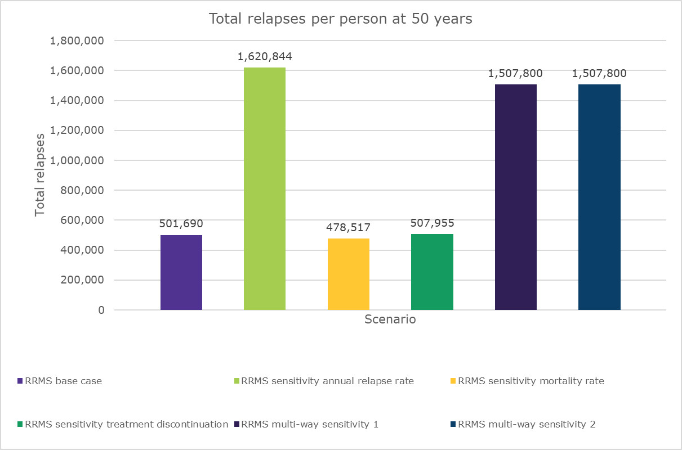
Abbreviations. RRMS = relapsing-remitting multiple sclerosis.
Notes. In multi-way sensitivity analysis 1, the annual relapse rate and mortality rate were simultaneously varied; in multi-way sensitivity analysis 2, annual relapse rate, mortality rate, and treatment discontinuation were varied.

Supplemental Figure 2: Sensitivity analysis - cumulative discounted QALYs
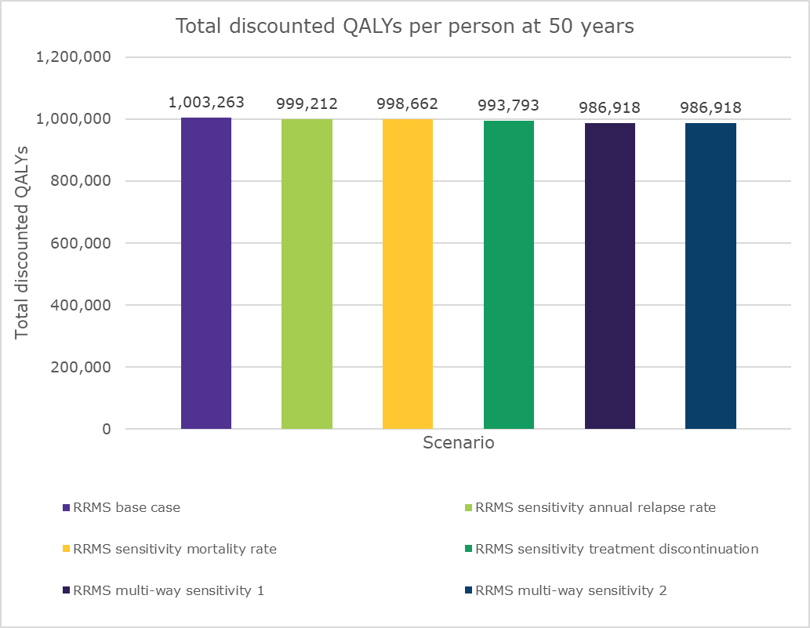

Abbreviations. QALY = quality-adjusted life-year; RRMS = relapsing-remitting multiple sclerosis.
Notes. In multi-way sensitivity analysis 1, the annual relapse rate and mortality rate were simultaneously varied; in multi-way sensitivity analysis 2, annual relapse rate, mortality rate, and treatment discontinuation were varied.

Supplemental Figure 3: Sensitivity analysis - average EDSS over time

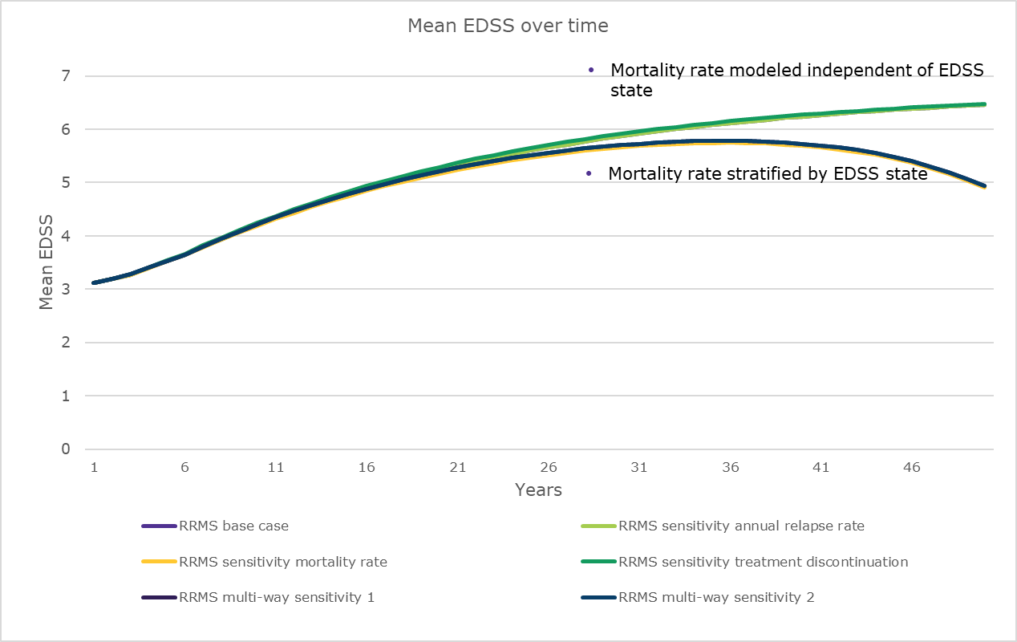
Abbreviations. EDSS = Expanded Disability Status Scale; RRMS = relapsing-remitting multiple sclerosis.
Notes. In multi-way sensitivity analysis 1, the annual relapse rate and mortality rate were simultaneously varied; in multi-way sensitivity analysis 2, annual relapse rate, mortality rate, and treatment discontinuation were varied.

