Video-club: Guidance for supervisors on the making of, sharing of, and use of video-recordings

Thank you for agreeing to take part in a video-club. This document is intended to complement the information that you have already received in the Plain Language Statement.
Background
As a GP-supervisor you have many roles, with your clinical and educational roles being core. In your ad hoc supervision of registrars and protected teaching sessions you typically move between these roles, balancing ‘service’ and teaching. In the video-club, the focus is intentionally targeted on your role as teacher.
With this focus in mind, we suggest that the overarching aim of the video-club is to deepen supervisors’ understanding of learning and teaching.
We think that this will be achieved by supervisors being enabled to:
- Conceptualise teaching as difficult, which presents supervisors with a series of problems to be solved
- Reflect on their beliefs about teaching and learning
- Reflect on the impact of teaching on registrar outcomes
- Discussing the why as well as the how of teaching
- Learning to reason and examine teaching in new and multiple ways
- Develop a stronger sense of professionalism (as a teacher)
- Develop a professional vision of what it means to teach, and
- Implement changes in teaching practices.
These bullet points therefore reflect the hoped for outcomes of participating in a video-club, which are more formally stated in Appendix A.
Discussions of extracts from video-recordings of participating supervisors’ protected teaching sessions are the foundational material that will enable the realisation of these outcomes.
We would encourage you to see your video-extracts as a gift to your supervisor colleagues. The extracts are the raw material that enables your colleagues to discuss learning and teaching.
Making a video-recording
By participating in the video-club, you have agreed to make a video-recording of one protected teaching session, and any registrars will have also consented for the video-recording to be made.
The supervisors will agree amongst themselves at which video-club they will show their extracts.
You can choose how to make the video recording. You may have video equipment in your practice that you can use. You may choose to use a smart phone or tablet. Alternatively, you can invite a member of the research team to bring a video camera to your practice to make the recording.
Whichever method you choose it is important that you pay attention to the quality of the video-recording; particularly the framing of yourself and the registrar on the screen and its audibility.
Sharing the video-recording with the research team
After you have made the video-recording you need a means of sharing the recording with the research team. We need to achieve this in a secure way. If a member of the research team has facilitated the video-recording, he will simply be able to take it away. Alternatively:
- You can upload the recording to a secure site. You will be given details if you choose this option.
- You can mail the recording by Express Post on a password-protected memory stick. You can be reimbursed for the cost of doing this.
Selecting which video-extracts to use
You may be anticipating some level of discomfort about showing extracts from the video-recording to your peers. There are a number of ways of selecting extracts. You can choose the option that you feel most comfortable with.
Protected teaching sessions run for about 60 minutes. We want to select three short extracts from the hour. Our experience is that an extract of about three to four minutes contains plenty of material to generate rich discussion. We only anticipate using two extracts in the video-club, but it is good to have an extra one in reserve.
We want to encourage some thought about which extracts to share. It may be tempting to ‘cherry pick’ the extracts where you think you are showing yourself at your best; and one can learn a lot by looking at exemplary practice. However, if you look at an earlier bullet-point, we think that the best outcomes will be achieved by viewing teaching as difficult, which suggests that there is merit in choosing extracts where you felt more uncomfortable; possibly reflecting doubts about the teaching. Related to this perspective is the notion that the video clips you choose should provide something for the video-club participants to puzzle over or speculate about. The questions that you and your supervisor colleagues raise, which will be about your genuine concerns, are at the heart of the professional development experience.
The means of selection that creates the least impost on your time is to leave the choosing of the extracts to members of the research team, or through recall to state the parts of the video that you would like to focus on.
The method of selection that will take the most time is for you to review the video-recording yourself and advise the research team which extracts you wish to use. Choosing this option is likely to result in greater personal benefits, because it is likely to stimulate more self-reflection. If you choose this option, it needs to be completed in the week after the recording was made, so that there is ample time for a researcher to make transcripts of the extracts and for the facilitator to preview them.
As above, once the video-extracts have been selected a transcript will be made of each of them, which will be available in the video-club to aid discussion.
Whichever method you choose, you will know which extracts are going to be shown at the video-club.
Using the video-extracts in the video-club
The video-clubs will follow a relatively standard format, with the first and last meetings being slightly longer for setting-up and closure. The core activity in each of the video-clubs is reviewing and discussing the video-extracts, as shown in the figure below:
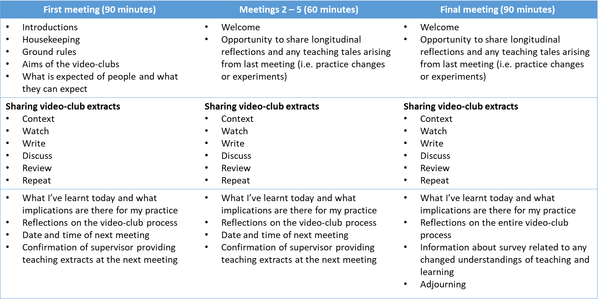
There will be about 45 minutes to discuss the video extracts, giving about 20 – 25 minutes for each extract. There is no requirement to use the second extract, if the discussion about the first extract is still being productive. The facilitator’s role is to make a judgement in this regard.
We suggest the following steps to guide the process of showing and discussing each extract; outlined in the figure above.
- The presenting supervisor provides relevant context for the clip. This should be brief, about 30 seconds. The aim is for the supervisor to provide brief background information that will help the other participants to make sense of the extract. For instance, the stage of training of the registrar; who initiated the content; how long the supervisor has known the registrar, and so on. Any more interpretive comments from the supervisor wait until after the video-extract has been shown.
- The video-club participants watch the entire video-extract from start to finish in silence. The key guidance to everyone is to, ‘Think about what you notice and why you noticed it?’ In an early research paper, what people thought was noteworthy was termed a “call-out”, where people literally called out what they noticed as they watched a video-recording of a teaching session. We are watching the video in silence from start to finish, but the notion of noticing the points at which you wanted to comment is a helpful one.
- Time for participants to jot down what they have noticed (about 3 minutes). A short period of time for each participant to make some brief notes that act as prompts and reminders about his or her ‘call-outs’.
- Supervisor explains, i) why s/he chose this clip, and ii) provides the initial direction for the discussion that follows. The supervisor will have thought about this in advance, and so is encouraged to be focused and relatively brief (60 – 90 seconds).
  - An outline of what the supervisor noticed in the extract and why this is significant to her/him.
  - The supervisor has carte blanche to set the stage for the discussion that follows, but might be guided by this question: ‘What would you like from the group in discussing your ‘call out(s)’?’ For example, the supervisor may or may not want some specific feedback from the group about her performance. She may want to explore the reasons for her approach to teaching and hear from others about how they would have approached the situation. The possibilities are multitude.
- Facilitator invites other members to respond to the supervisor’s comments and question(s). At this stage, the conversation will be emergent, determined by the participants’ responses, remembering that the focus is on learning and teaching. Once the presenting supervisor’s agenda has been addressed, the facilitator will invite other participants to share their ‘call-outs’, to articulate what they noticed and to explain why they thought them significant. The discussion is fundamental to the learning process; the knowledge derived from others’ experiences; from understanding others’ arguments; from comparing personal understandings; listening to others’ reasoning about learning and teaching, and so on. The facilitator has a key role in judging the depth and breadth of the conversation; deciding whether to move on to the second video extract, in which case the process moves back to step 1.
The group have both the video-recording and the transcript as resources. Participants can ask for extracts from the video to be shown again, i.e. to focus in on a particular episode of interest. The transcript can be used to look at what people actually said or to provide focus.

Appendix A: Aim and outcomes submitted to the RACGP for Category 1 CPD points

You may teach multi-level learners in your practice, e.g. medical students as well as GP-registrars. We use ‘registrars’ in the main text to refer to all trainees.

