sqstm1-/-

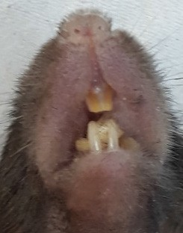

Figure S1. Deletion of Sqstm1/p62 does not compromise pigmentation of murine incisors. The image is representative for n=5 sqstm1-deficient mice.

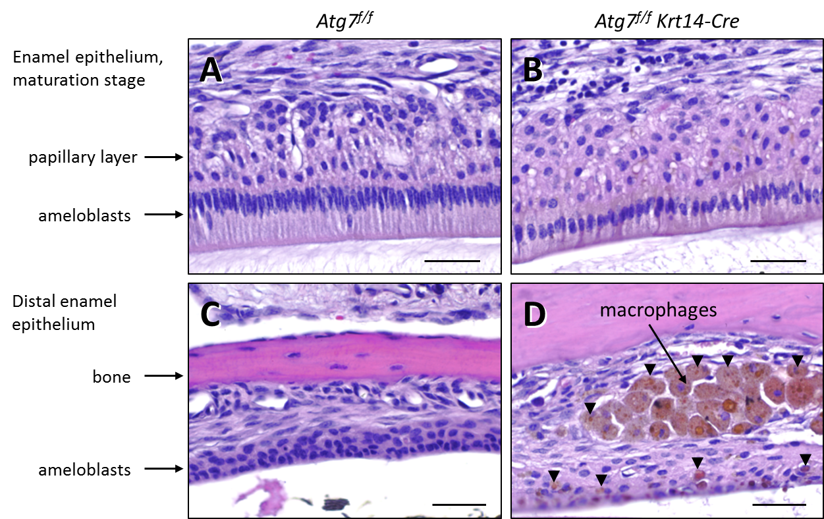

Figure S2. Histology of the maxillary enamel epithelium in fully autophagy-competent and epithelial autophagy-deficient mice. Tissue sections of Atg7f/f (A, C) and Atg7f/f Krt14-Cre (B,
D) mice were stained with hematoxylin and eosin. Brown color indicates accumulation of iron (arrowheads). Scale bars: 20 µm.

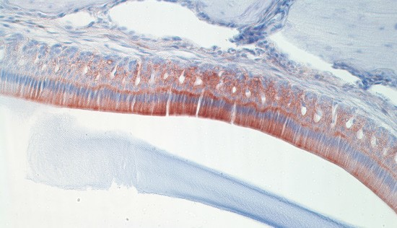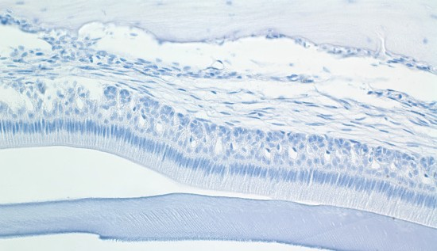
A
Atg7f/f
ferritin
pl
am
early pigmentation stage

B
Atg7f/f
neg. con.
pl
am

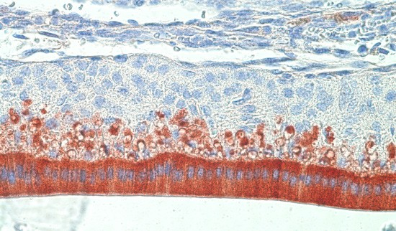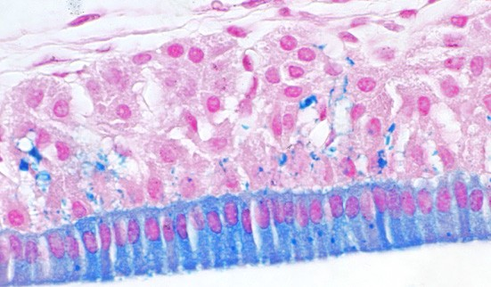
C
Atg7f/f Krt14-Cre
ferritin
pl
am
early pigmentation stage

D
Atg7f/f Krt14-Cre
iron
pl
am

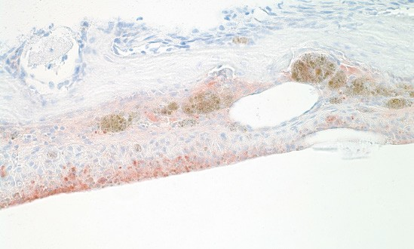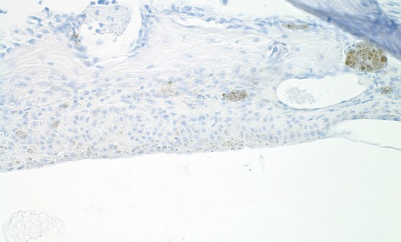
E
Atg7f/f Krt14-Cre
ferritin
distal epithelium
F Atg7f/f Krt14-Cre neg. con.
Figure S3. Control experiments and ferritin immunostaining of early pigmentation stage enamel epithelium. Tissue sections of maxillary incisors of Atg7f/f (A, B) and Atg7f/f Krt14-Cre (C-D) mice were investigated. These results show a similar distribution of ferritin in the early pigmentation stage enamel epithelium (including ameloblasts, am, and papillary layer, pl) of both genotypes (A, C), presence of both ferritin and iron in the papillary layer of the early pigmentation stage (C, D), and specificity of ferritin immunostaining (A, B, E, F). Ferritin was detected by immunohistochemistry with a primary antibody against FTH1 (A, C, E). In negative control staining the primary antibody was replaced by an isotype immunoglobulin (B, F). Iron was detected by staining with Perls’ Prussian blue (D). Nuclei were counterstained with hematoxylin (A-C, E, F) and nuclear fast red (D). Scale bars: 50 µm (A-C, E, F), 20 µm (D).

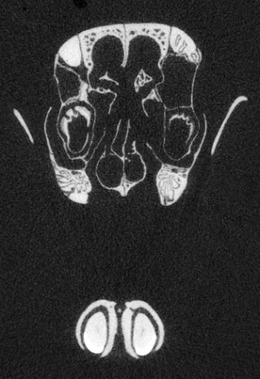
C

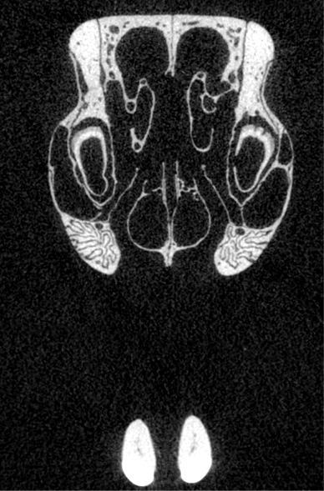
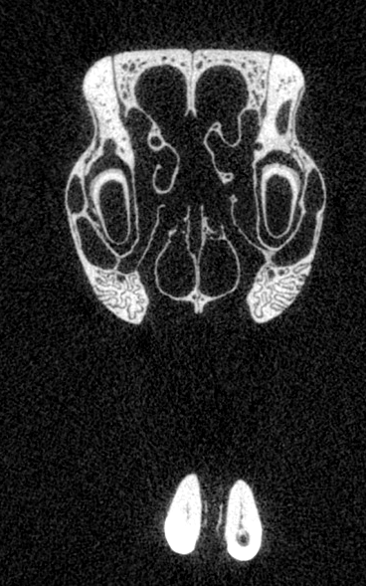
Atg7f/f
A
B

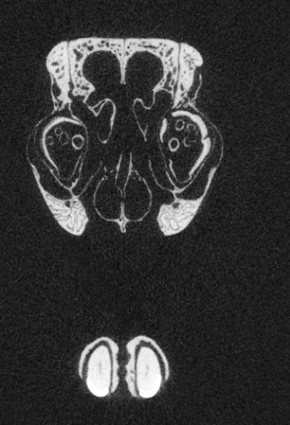
F

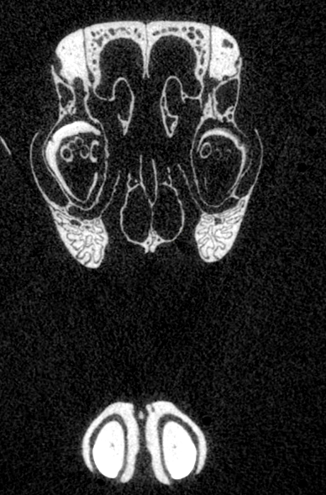
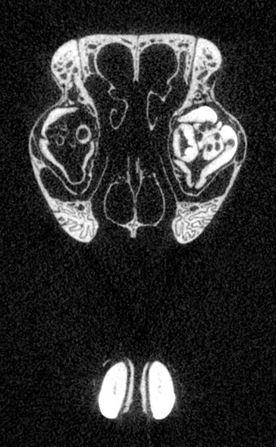
Atg7f/f
D
E
Krt14-Cre

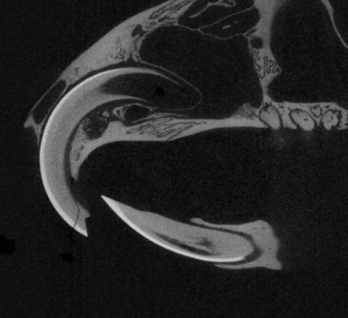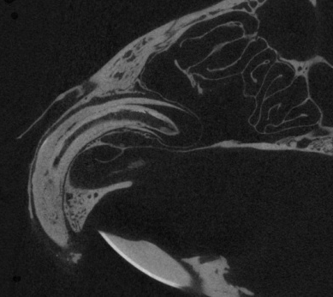
G
Atg7f/f
H
Atg7f/f Krt14-Cre

Figure S4. Micro-CT analysis of old mice. The heads of Atg7f/f (A-C, G) and Atg7f/f Krt14-Cre (D-F, H) mice aged >1.5 years were investigated by micro-CT. Frontal (A-F) and sagittal (G, H) sections are shown. Yellow arrowheads indicate the enamel surface of primordial maxillary incisors. Arrows indicate ectopic incisor tubes. The number of ectopic incisor tubes was significantly different between the 2 genotypes (0.0±0.0 versus 4.7±0.9, mean ± standard deviation, P=0.02, 2-sided t-test).

Atg7f/f Atg7f/f Krt14-Cre

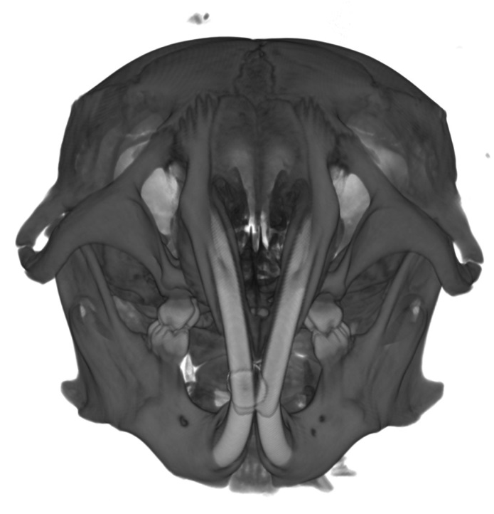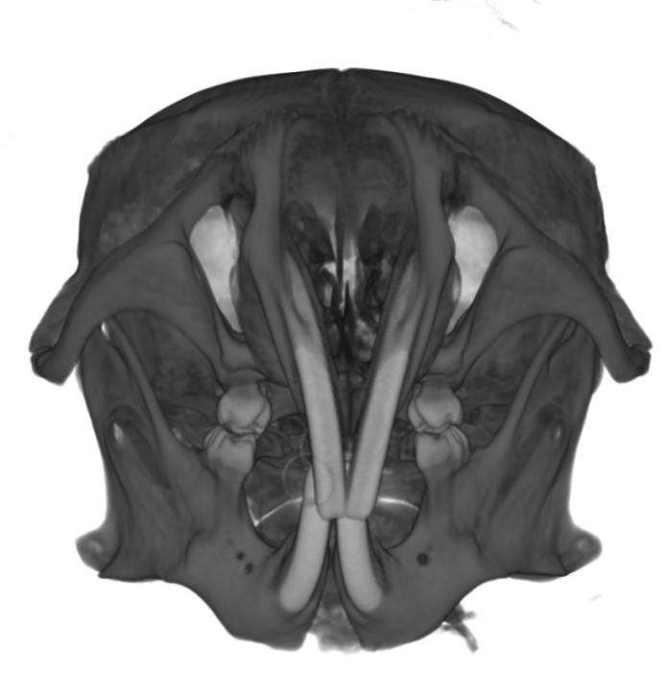
A
B

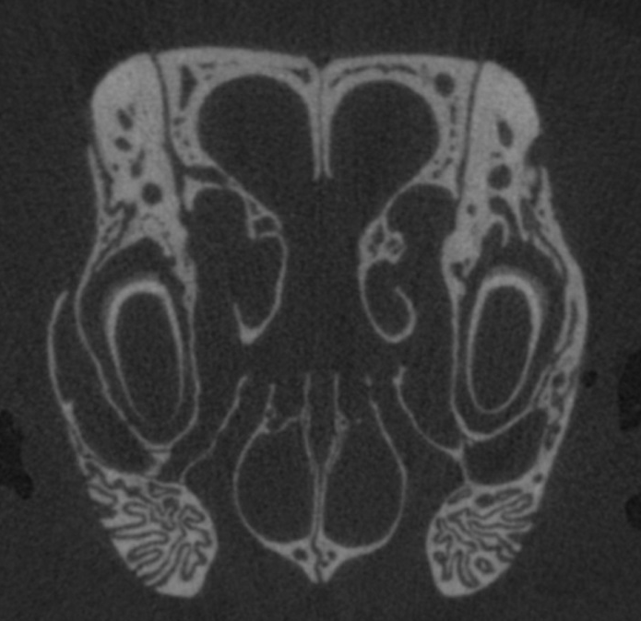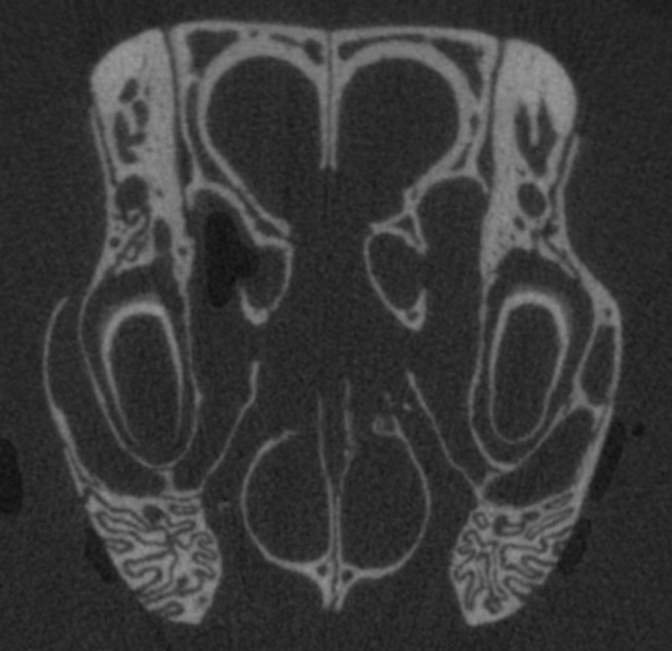
C
D

Figure S5. Micro-CT analysis of young mice. The heads of Atg7f/f (A, C) and Atg7f/f Krt14-Cre (B, D) mice aged <0.5 years were investigated by micro-CT. 3D reconstructions (A, B) and frontal (C, D) sections are shown. Yellow arrowheads indicate the enamel surface of maxillary incisors (C, D).

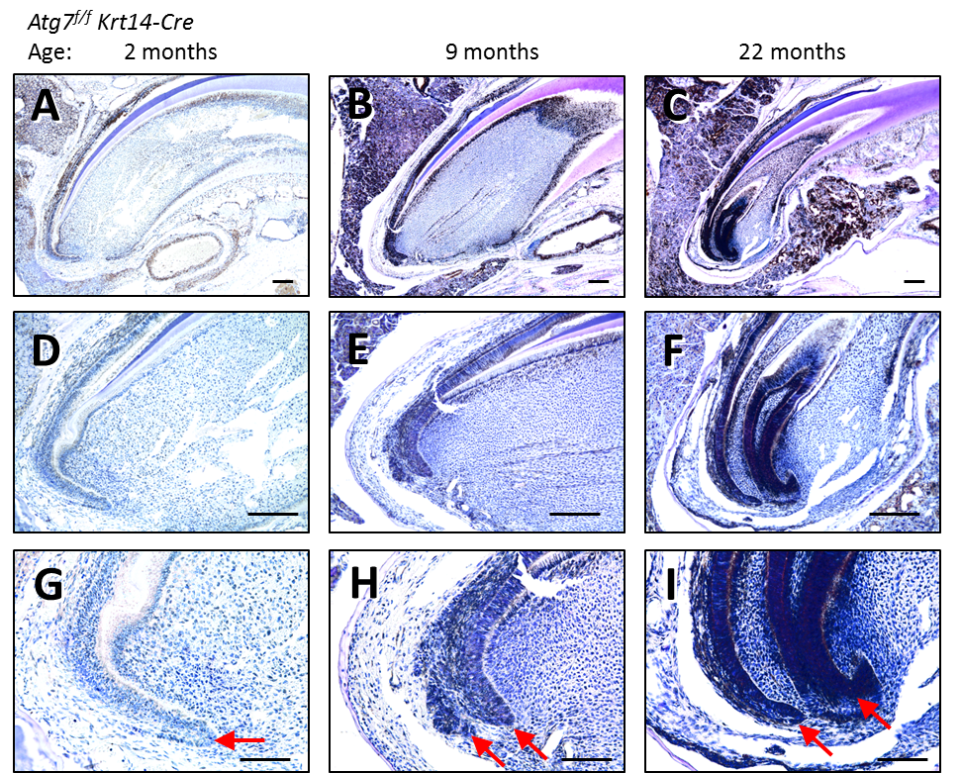
Figure S6. Histology of the cervical loops of maxillary incisors of Atg7f/f Krt14-Cre mice at different ages. Tissue sections were prepared from atg7f/f Krt14-Cre mice aged 2 (A, D, G), 9 (B, E, H), and 22 (C, F, I) months, and stained with hematoxylin and eosin. Red arrows indicate cervical loops. Scale bars: 200 µm (A-F), 100 µm (G-I).

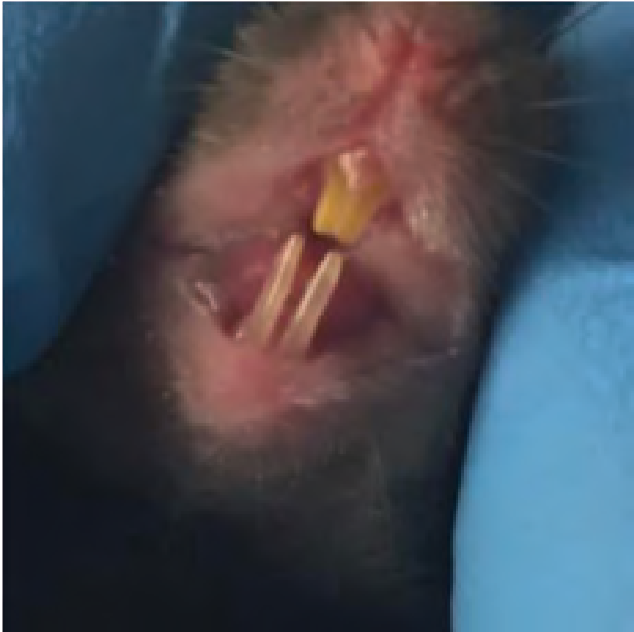
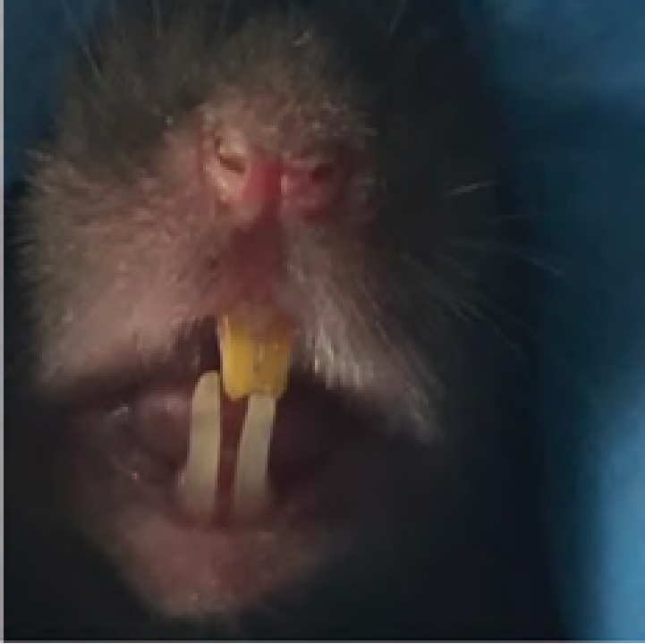
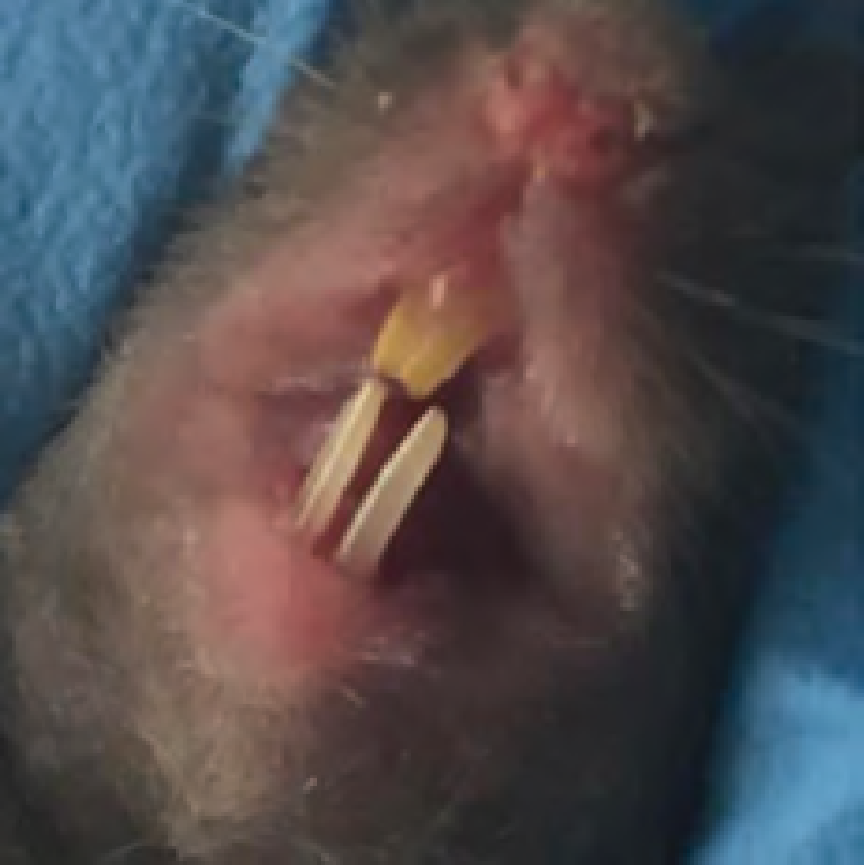
Ncoa4fl/fl; CMV-Cre

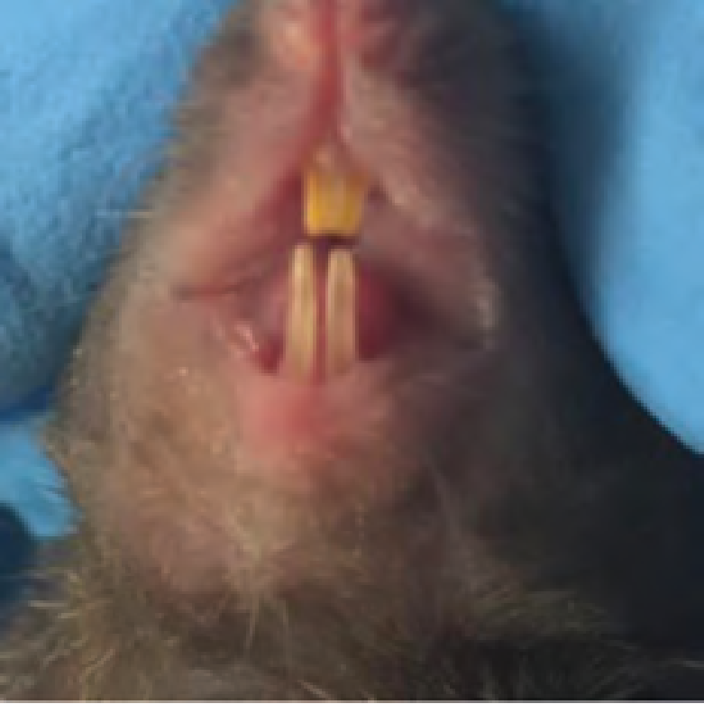
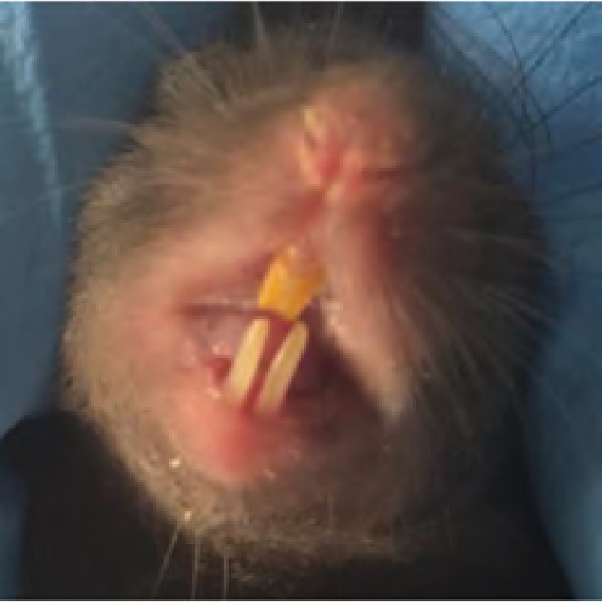
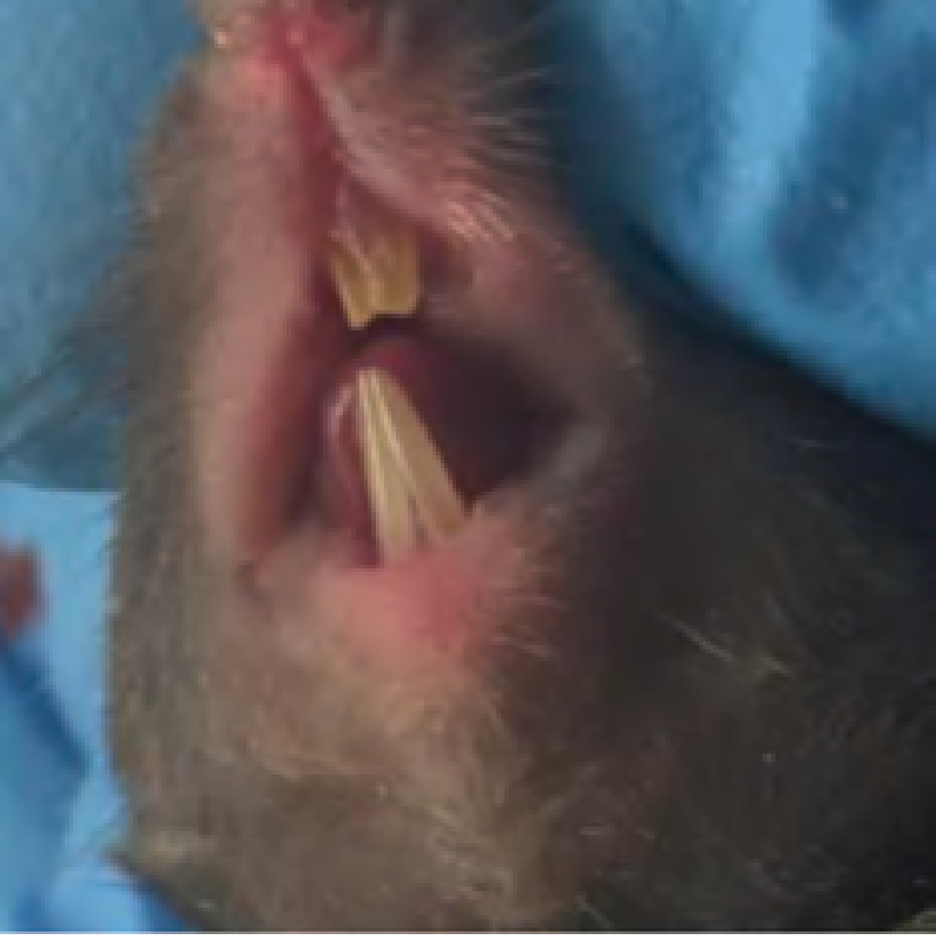
Ncoa4fl/fl

Figure S7. Deletion of the ferritinophagy receptor NCOA4 does not compromise pigmentation of murine incisors. The images show the incisors of Ncoa4fl/fl; CMV-Cre and Ncoa4fl/fl (representative for n=9) mice.

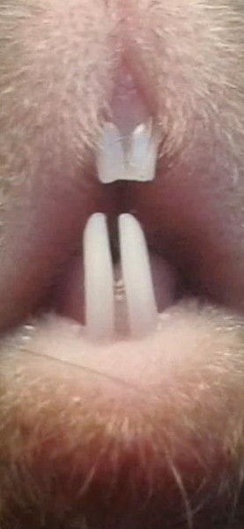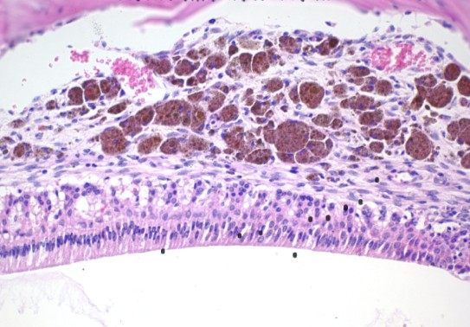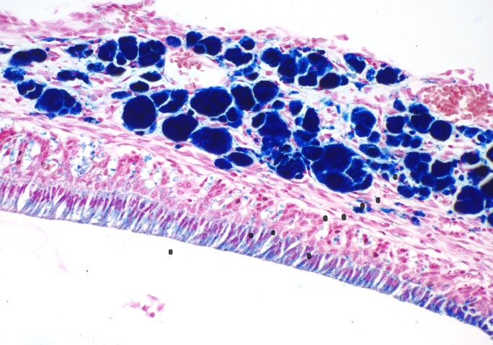
A

nfe2l2-/-
B

H&E
C

Perls' blue

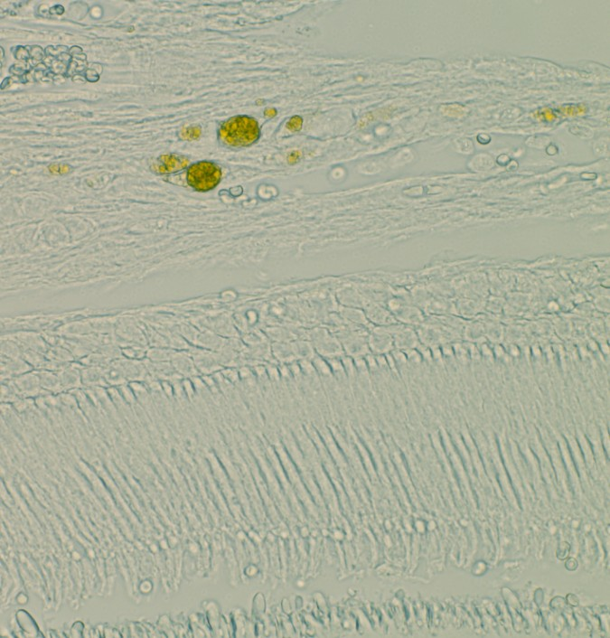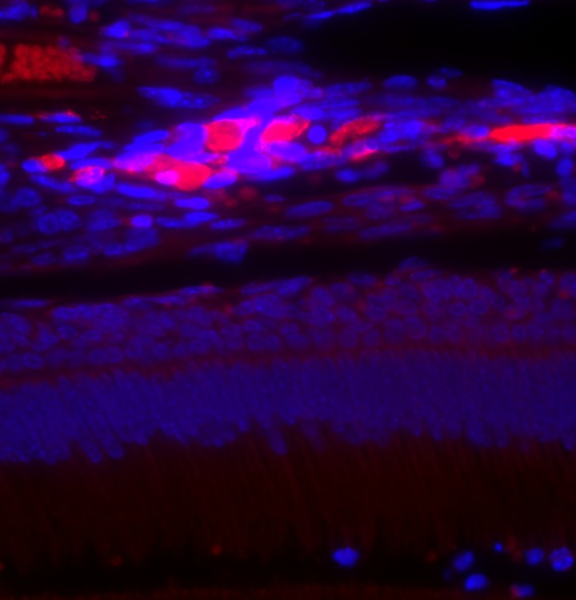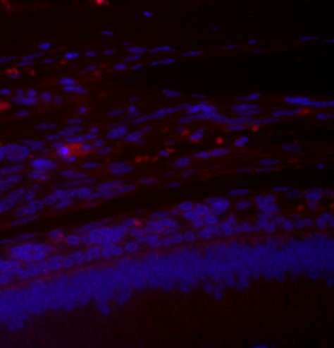
D
Bright field
E
IF: LGASL3/Mac-2
F
IF: isotype control

Figure S8. nfe2l2/nrf2 knockout incisors and enamel epithelium. (A) Macroscopic appearance of incisors of nfe2l2 knockout mouse, representative for n=10. (B) Hematoxylin and eosin staining and (C) Perls' blue staining of the maxillary enamel epithelium. (D) Bright field image and (E) immunofluorescence (IF) labeling for the macrophage marker LGALS3/Mac-2 (red) of the same site. Arrows indicate macrophages containing iron. (F) Isotype control of immunofluorescence labeling. Scale bars: 50 µm (B, C), 20 µm (D-F).

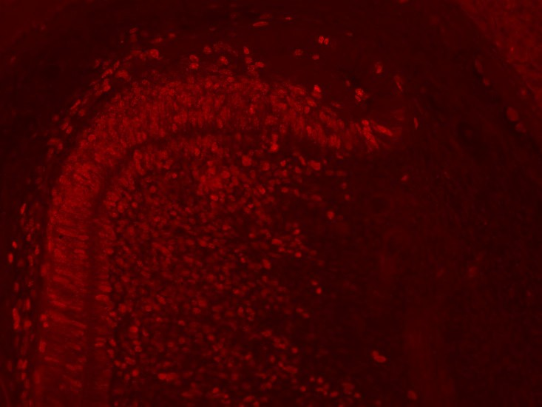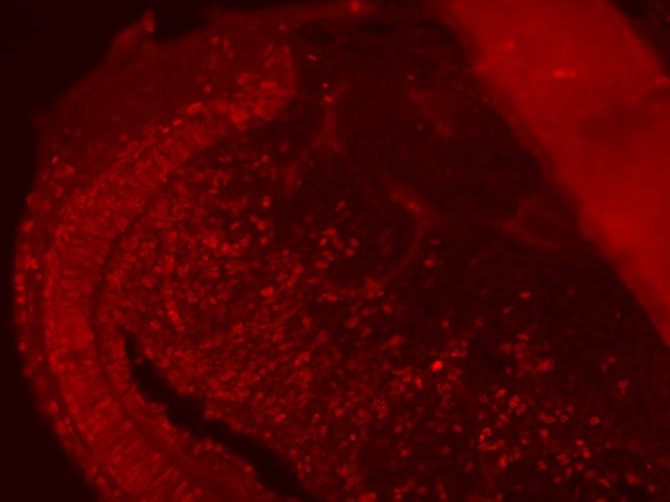
A
Atg7
f/f
*
B
Atg7f/f Krt14-Cre
*

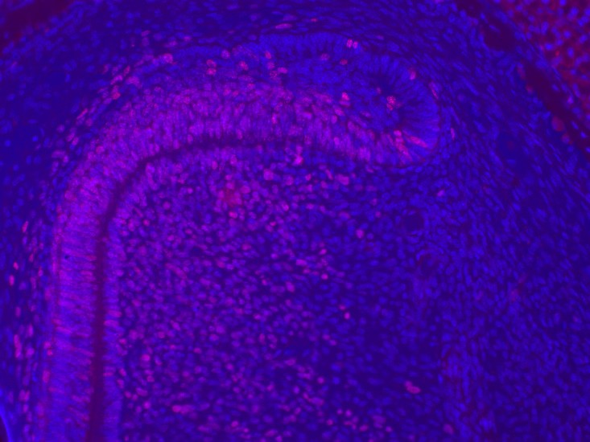
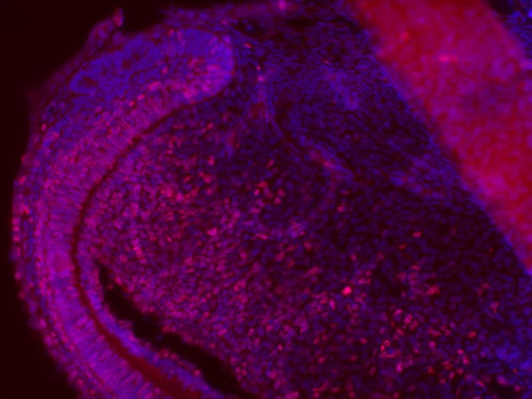
D Atg7f/f Krt14-Cre
C
*
Atg7
OEE SR
IEE
f/f
* OEE
SR IEE

Figure S9. Proliferating cells show a normal distribution in the cervical loops of Atg7f/f and Atg7f/f Krt14-Cre mice. Tissue sections of the labial cervical loop of maxillary incisors of Atg7f/f (A, C) and Atg7f/f Krt14-Cre (B, D) mice (age 1 month) were immunolabeled for the proliferation marker MKI67 (red). Nuclear DNA was labeled with Hoechst dye (blue) (C, D). Note that cell proliferation is largely restricted to the inner enamel epithelium (IEE) and only sparse MKI67-positive cells are detected in the outer enamel epithelium (OEE) and the stellate reticulum (SR) of both genotypes (*). A broken line marks the outer border of the cervical loop. Scale bars: 100 µm.

