The spectacular fossils of the ‘water margin’: the Cambrian biota of Chengjiang, Yunnan, China

Mark Williams¹, David J. Siveter¹, Derek J. Siveter², Sarah E. Gabbott¹, Xiaoya Ma^{3,4}, Mark A. Purnell¹ and Peiyun Cong^{3,4}
¹Department of Geology, University of Leicester
²Oxford University Museum, Oxford
³The Natural History Museum, London
⁴Yunnan University, China

Shi Nai’an’s 14th century Chinese epic ‘Water Margin’ tells of the release of 36 heavenly spirits and 72 baleful stars from their captivity beneath a tablet of stone at Mount Longhu in Jiangxi Province. They are reincarnated as the 108 heroes of the Liangshan marsh in Shandong Province, who rise against an unjust world. The virtuous exploits of the ‘108’ were brought to life through the cathode-ray screens of 1970s television sets, as the TV series The Water Margin introduced heroes like Lin Chong battling his evil nemesis Gao Qiu. Far to the west of Jiangxi Province and several hundred years after the Water Margin during the summer of 1984, a young scientist from Nanjing was working amongst the hills and lakes of southern Yunnan Province. He too overturned a stone slab, releasing from their half-billion year captivity a cornucopia of new Chinese legends. His name was Xianguang Hou and he had made one of the most momentous fossil discoveries in history, uncovering the exceptionally preserved marine fossils of the Chengjiang biota from the ancient water margin of Cambrian seas.

Yunnan
Yunnan Province lies in southwestern China, its borders greeting Vietnam, Laos and Myanmar. A province of both snowy mountains and tropical rainforests, its biological and ethnic human diversity is renowned in China. Three decades ago its provincial capital Kunming was a relatively small Chinese city of just 1 million inhabitants sitting near to the geographical centre of the Province. Dotted against its skyline were a few high-rise buildings, including the iconic ‘Kunming Hotel’, where at that time the rare western visitors to Yunnan usually stayed: even there, finding a cup of coffee was nigh impossible. By 2016 Kunming had more than 6 million inhabitants and today it is on route to become a 21st century megacity, with one of the most recently constructed underground metro systems in the world, and a forest of dazzling skyscrapers. There are coffee shops and pizza restaurants on many corners, streams of electric motor scooters and SUV’s and everyone possesses the latest phones and tablets. Walking the streets in the early 1990s there were few cars, many bicycles and a multitude of blue suits from Chairman Mao’s era. Kunming is your stopping-off point before travelling south to the small county town of Chengjiang.
Figure. 1. A ‘lost’ street scene from two decades ago: ‘Chengjiangers’ in their blue suits chat by the side of the main road in the centre of Chengjiang town.

Figure 2. On route to collecting fossils in the Yunnan countryside, we pass the time of day with a local farmer.

The circa 30 ‘crow flies’ miles from Kunming to Chengjiang used to be a perilous several-hour road journey along winding pot-holed mountain roads, dodging heavily overladen trucks that swerved insanely towards you on hairpin bends, and stray and immovable cattle perched in the middle of the road; and for good measure, sometimes both at the same time. Nowadays there is a sleek superfast highway to Chengjiang town, so that Kunming city passes by unnoticed, connected as one giant metropolitan area to the county town by an ever-increasing southerly marching pack of giant skyscrapers.
Fossils had been recorded from the Cambrian strata of southern Yunnan since the beginning of the 20th century. Then, the French geologists Henri Mansuy and Jacques Deprat passed through this area of hills and lakes in an era of French colonial ambition. These two men were later to clash over an accusation of the fraudulent placement of ‘European’-type trilobites amongst the fossil faunas of Indochina, an accusation that was to cost Deprat his job, reputation, and even his name – he changed it to Herbert Wild.
Many years passed by, the political landscape of southern China changed, and the Cambrian fossils of southern Yunnan were once again reported in the 1930s and 1940s, but they remained somewhat unstudied. Then, in 1980 a young man from Feng County in the north of Jiangsu Province was drawn to this region. His name was Xianguang Hou and the focus of his Master’s research at the Nanjing Institute of Geology and Palaeontology was to collect fossils of small Cambrian arthropods known as Bradoriida. At first Xianguang Hou concentrated his work on a rock succession within Kunming city itself. Then, in 1984 he turned his attention to the rural fields of Yunnan for his second field season. It was now that he was to make a momentous discovery.
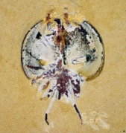
Figure 3. The bradoriid Kunmingella douvillei, its carapace preserved open in ‘butterfly’ style. Projecting beyond the carapace to the top are the antennae, whilst to the bottom are long trailing terminal appendages. Left, reconstruction of the animal with its 10 pairs of appendages labelled. Right, specimen is about 0.83 cm long, including appendages.

A remarkable day
Miraculous discoveries are not to be predicted before they happen. There is the apocryphal apple that falls on to the geniuses’ head, or the Eureka moment in the bath. Xianguang Hou’s miraculous day began as normal. He did not know that he was about to write a celebrated age in Chinese history. Instead, being a man who had grown up in the north of China beyond the main areas of rice cultivation, he began his day with a breakfast of noodles: it was Sunday July 1st 1984. It was a quiet day in the world. Far away in England Bob Marley was at the top of the UK Album charts, but there was little to interrupt Xianguang Hou’s day in China. He left his lodgings at the small village of Dapotou and travelled the 3 miles to Maotian hill where he had been excavating for fossils. His companion on the road was a local farmer who helped with the collecting and transportation of the fossils.

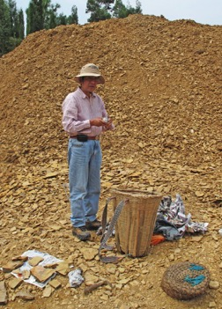
Figure 4. Xianguang Hou collecting Chengjiang fossils at Haikou in 2009.

At about three o’clock in the afternoon that day, a slab of rock broke free to reveal the arthropod Naraoia, a relative of the trilobites and an animal that was known from the famous Middle Cambrian Burgess Shale in the Canadian Rockies. Xianguang Hou had seen fossils like these many times before, but this one was special, it had legs. So well preserved was the fossil that for a time, mesmerized by what he had discovered, he day-dreamed that the animal was re-animated, that it was trying to swim across the surface of the rock to escape from him. That day he continued working at Maotian hill until darkness consumed the landscape around him, making the walk along a winding mountain road back to his lodgings in Dapotou somewhat precarious. Unable to sleep that night, he realized that he had discovered something momentous. After several more weeks of fieldwork ending in August 1984, Xianguang Hou had found many different fossil animals with soft-part preservation not only at Maotian hill, but also at other localities in Chengjiang County and elsewhere in Yunnan.

Two hundred and more heroes
It is difficult to convey the excitement that Xianguang Hou felt on that first evening after he had made his initial fossil discovery. But a sleepless night and a quick return to the field the next day further revealed to him the importance of what he had discovered, a fossil deposit like no other known from China, and comparable to the Burgess Shale of British Columbia, but several million years older. From the initial discovery at Maotian hill, many new fossil sites have been discovered, not only in the Chengjiang area itself but also to the west of Lake Dianchi and to the northeast of Lake Fuxian.

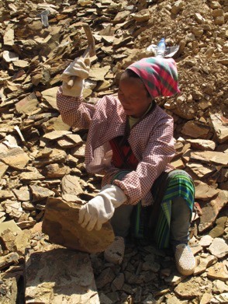
Figure 5. A local farmer helps split rock to recover the Chengjiang fossils.

The fossils of the Chengjiang biota are found in mudstones of the Yu’anshan Member of the Chiungchussu Formation, and this is dated, using trilobites, to the Eoredlichia-Wutingaspis trilobite biozone, of early Cambrian age. The rocks of the Yu’anshan Member formed in a marine environment – an ancient Chinese water margin, on the Yangtze Platform. At that time the Yangtze Platform was situated on the South China palaeocontinent and was bathed by warm tropical Cambrian seas.
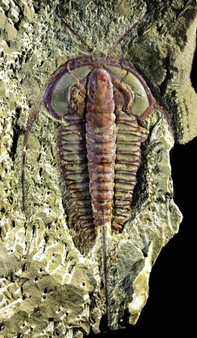
Figure 6. The trilobite Eoredlichia intermedia from the Chengjiang biota. Note the delicate antennae diverging anteriorly from the rounded margin of the head shield. Specimen is 4 cm long excluding the antennae.

In the ensuing four decades of work in southern Yunnan the Chengjiang biota has yielded many thousands of specimens characterized by spectacular details of their non-mineralized soft tissue anatomy, and some 250 fossil species. Here in rocks that are about 520 million years old are the bodies of sponges, worms, arthropods, and even the world’s earliest vertebrates. Chief amongst the Chengjiang organisms, both in their diversity and abundance, are the arthropods (the group that includes beetles and lobsters). These include the tiny bradoriids preserved in their countless thousands, which Xianguang Hou first set out to study. Nearly one-quarter of all of the arthropod species are trilobites and their trilobitomorph allies, with their characteristically sub-elliptical head shields, and trunks made of multiple segments and often terminating in a tail spine. Many less immediately familiar but nevertheless morphologically dramatic arthropods also lurk amongst the fauna, including the stalk-eyed arthropod Isoxys, and Fuxianhuia, specimens of the latter preserving not only its appendages, but also its brain - much the oldest brain preserved anywhere in the fossil record.
Secreted beneath and within the sediments of the Chengjiang biota were the priapulids, more colloquially known as ‘penis worms’ because of the resemblance of many of them to the male reproductive organ. Priapulids are relatively rare in ecosystems today, with less than twenty extant species. However, there are a dozen or so species in the Chengjiang biota, where they form a relatively more dominant part of the fauna than in present day seas, displaying a wide variety of shapes.
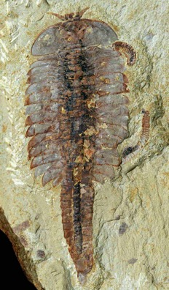
Figure 7. Fuxianhuia protensa. With excellent vision (its eyes and frontal appendages can be seen protruding beyond the head shield at the top) this species may have been a mobile forager. Specimen is 6.1 cm long.

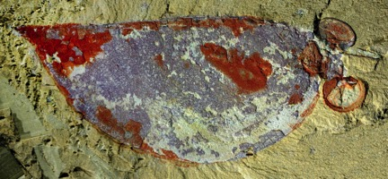
Figure 8. Isoxys auritus had a thin carapace and a pair of forwardly projecting stalked eyes, clearly seen here (to the right). It may have been an active swimmer with a carnivorous or scavenging mode of feeding. Specimen is about 2.5 cm long (including anterodorsal spine).

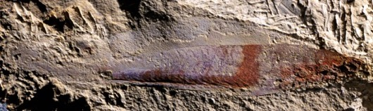
Figure 9. Myllokunmingia is generally regarded as the earliest vertebrate. Specimen is about 4 cm long.

And then there is the vertebrate Myllokunmingia, which provides the earliest evidence of the ecology and anatomy of a group of animals that were to have a profound impact on Phanerozoic ecosystems, being a part of an evolutionary story that would ultimately include human sentience.
But perhaps most exotic amongst the animals of the Chengjiang biota are those that simply defy classification, such as Vetulicola, which looks like a rectangular bag with diamond shaped slits at the anterior end, but sprouts a shrimp-like tail at the opposite end.

The Cambrian aquarium
For 3 billion years, during most of the Precambrian, the biosphere was dominated by microbial life. Molecular evidence suggests that the first animals evolved in the late Neoproterozoic. However, with the exception of possible evidence of biomarkers for sponges in rocks older than 635 million years, and some putative animals amongst the Ediacaran Period biota (typically found in deposits between 580 and ca 541 million years old), there is little evidence for the presence of animals in the rock record until the Cambrian System. Chengjiang is therefore of unique importance because it provides a window on the evolution of complex animal-rich ecosystems not long after these had first evolved in the latest Neoproterozoic and earliest Cambrian. Compared to a world just 100 million years earlier than Chengjiang (that is, 620 million years ago, near the beginning of the Ediacaran Period), the Cambrian seas of South China teamed with animal life, with an ecological complexity akin to those we recognize in modern oceans.
Chengjiang organisms floated or swam in the water column, or lived on or just above the seafloor, some even burrowed within the sediment itself. Animals that swam included ctenophores (comb jellies), chaetognaths (arrow worms) and arthropods such as Isoxys, and probably the fish-like verterbrate Myllokunmingia. The largest predators at the time were the spectacular proto-arthropods, the anomalocaridids, some of which have a set of laterally positioned paddle-like flaps that were likely used for propulsion.
However, most of the Chengjiang fauna lived on the seafloor as organisms that either rested or crawled directly on, or were anchored to the substrate. Here, sponges were the most diverse sessile animals, most growing just above the seafloor but a few ‘giants’ reaching to 30 cm above the sea bed. The abundance of sponges suggests that Chengjiang seas were rich in particulate organic material, perhaps raining down from phytoplankton producers near the sea surface. Other sessile seabed organisms included the peculiar scaly chancellorids and the jelly-like sea squirts. Living with these animals were many scavenging and predatory arthropods such as the trilobitomorphs, as well as many deposit feeders such as some priapulids.
There are many so-called lobopodians in the Chengjiang biota, including the famous Hallucigenia that is also known from the Burgess Shale. They are a very important group for evolutionary origins, as one group of them is thought to be ancestral to the arthropods, whilst other groups are thought to represent the precursors of the modern day terrestrial tardigrades (water bears) and onycophorans (velvet worms). The latter catch their prey, Spiderman-fashion, by squirting a sticky slime that was once thought to be an ancestral relative of spider silk. Many of the Chengjiang lobopodians are thought to have been scavengers, as evidenced by claws at the tips of their appendages that may have been useful for grasping carcasses.
It is evident that an advanced food web was already well developed in the Chengjiang seas, with filter feeders, deposit feeders, scavengers and predators. At the seabed, some half-hidden priapulids waited in their burrows to pounce at unsuspecting passing animals, whilst in the water column above, arthropods such as the anomalocaridids actively scoured the seascape (their eyes indicate they had good vision), grabbing passing prey animals with their well-developed frontal appendages. Amongst these hunter-arthropods we can find Fortiforceps – whose name really gives away its method of hunting. Armed with its great frontal appendages, Fortiforceps may have speared or smashed its prey in the manner of living mantis shrimp.

Exceptional brains
The diversity of life in the Chengjiang biota is wondrous, and the types of organs that are preserved are truly remarkable. These include eyes, brains, guts and nervous systems, as well as cardiovascular systems. And within the guts there is sometimes evidence of the last meal, so that the Cambrian food web can be constructed with greater precision. Work on Chengjiang fossils routinely includes scanning electron microscopy and X-Ray CT scanning of specimens, which has allowed for the entire alimentary and nervous systems of animals to be reconstructed.
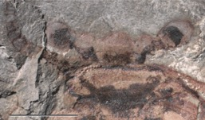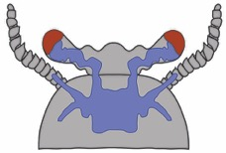
Figure 10. Left, the brain, eyes and optic nerves of Fuxianhuia protensa: right, interpretation of the structures. Scale bar is 1 cm.

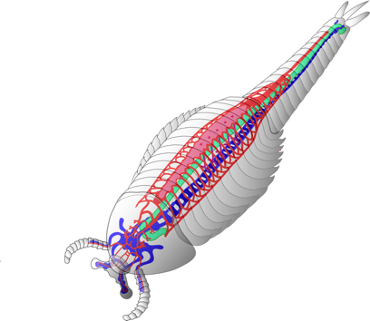
Figure 11. Reconstruction of the nervous system (blue), gut (green), and cardiovascular system (red) of Fuxianhuia protensa.

Using the latest imaging and analytical techniques, as well as interdisciplinary approaches, the future of Chengjiang fossil studies will enable palaeontologists to understand, with ever-greater precision, the functioning of organs within some of the earliest animal-based ecosystems on Earth. In turn, this might lead to a greater understanding of how complex animal relationships developed in early ecosystems, and might garner a better understanding of how complexity is built and maintained in the biosphere. That final message is resonant today, when ecosystem diversity is suffering from the onslaught of human influence.

Acknowledgments We are indebted to Xianguang Hou for his friendship and generosity in sharing the Chengjiang fossils with us for over 20 years. We dedicate this article to him, and also to our long-term friend and colleague the late Richard (Dick) Aldridge, with whom we shared many great visits to China. We thank Nick Strausfeld for permission to reproduce the images for figures 10 and 11. Our work on Chengjiang fossils is supported by the Royal Society (International Joint Project IE131457), the Natural Environment Research Council (NE/L011751/1), The Leverhulme Trust (EM 2014-068), and The National Natural Science Foundation of China (U1302232).

Further reading
1. For a general overview of the whole Chengjiang biota
Xianguang Hou, Richard J Aldridge, Peiyun Cong, Sarah E Gabbott, Xiaoya Ma, Mark A Purnell, David J Siveter, Derek J Siveter, Mark Williams. In press. The Cambrian fossils of Chengjiang, China. The flowering of early animal life. Wiley-Blackwell.

2. Brains, guts and circulatory systems
Ma, Xiaoya., Cong Peiyun, Hou Xianguang, Edgecombe, G.D. & Strausfeld. N.J. 2014. An exceptionally preserved arthropod cardiovascular system from the early Cambrian. Nature Communications 5, 3560. doi: 10.1038/ncomms4560.

Ma Xiaoya, Hou Xianguang, Edgecombe, G.D. & Strausfeld, N.J. 2012. Complex brain and optic lobes in an early Cambrian arthropod. Nature, 490, 258-262.

3. Bradoriids, the group that started the hunt for Chengjiang biota
Hou Xianguang, Williams, M., Siveter, D.J., Aldridge, R.J. & Sansom, R.S. 2010. Soft-part anatomy of the Early Cambrian bivalved arthropods Kunyangella and Kunmingella: significance for the phylogenetic relationships of Bradoriida. Proceedings of the Royal Society, London B, 277, 1835–1841.

Websites
Information on how Chengjiang became a UNESCO world heritage site at: http://whc.unesco.org/en/list/1388

