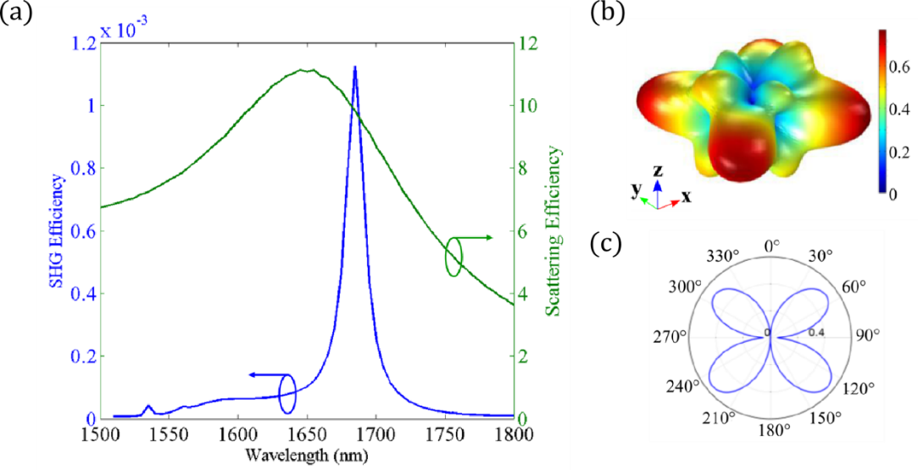
Figure 1S. SHG analysis for an air-suspended AlGaAs nanocylinder with radius r = 225 nm and height h = 400 nm. External excitation is a plane wave with k vector along z and linearly polarized along x axis (i.e. [100] crystalline direction). Pump intensity is fixed at 1 GW/cm². (a) Solid green line represents the linear scattering efficiency, blue solid line the SHG one. The x axis refers to the pump wavelength. (b) 3D Nonlinear far-field distribution at SH wavelength equal to 843 nm. (c) Side view of plot in (b) in the xz plane at y=0. $θ=0^{∘}$ is the z axis and $θ={90}^{∘}$ is the x axis. Reprinted with permission from [36].

Figure 2S. (a) AlGaAs nanosphere and crystalline lattice structure. (b) SHG efficiency from AlGaAs nanosphere at normal incidence, at 1.55 µm FF wavelength. Solid black line shows the total SH intensity, normalized to 10¹³ W/m² FF intensity and the geometric cross section πa². Colored lines are multipoles contributions to the SH intensity. Reprinted with permission from [37]

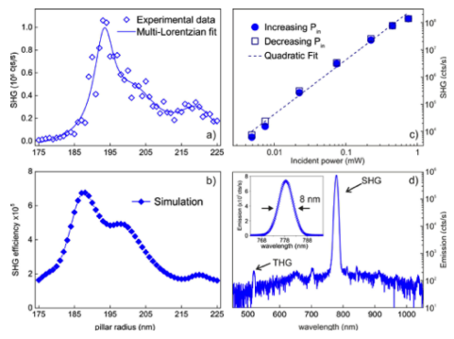
Figure 3S. Simulated and experimental SHG efficiency in AlGaAs nanopillars for a linearly polarized normal excitation at 1550 nm. Impinging intensity is set at 1.6 GW/cm². (a) Experimental results obtained with confocal microscopy in reflection with numerical aperture is NA = 0.85. Diamonds shows experimental results for different pillars’ radii while the solid line is the result of a 3-pole Lorentzian interpolation. (b) SHG vs power, and a quadratic fit testifying the second order nonlinear process. (c) Results of numerical model for the same radii as in (a). (d) Spectral analysis of collected signal showing two main peaks at SH and TH wavelengths. Reprinted with permission from [30].

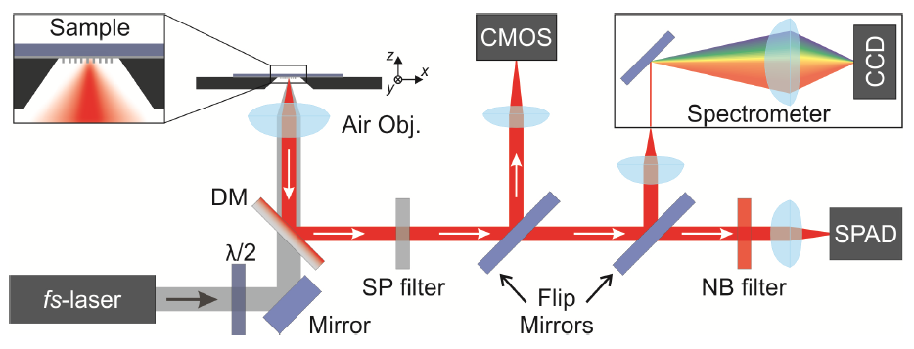
Figure 4S. Experimental setup for nonlinear spectroscopy of a nanoantenna. An Er⁺-doped fiber laser delivers 150-fs pulses at 1554 nm. Linear polarization is controlled by a λ/2 plate. FF beam is focused on the sample by a high-NA objective and reflected SH beam is separated by a dichroic mirror, filtered and analyzed by either a CMOS camera, a spectrometer or a single-photon counter. Reprinted with permission from [30].

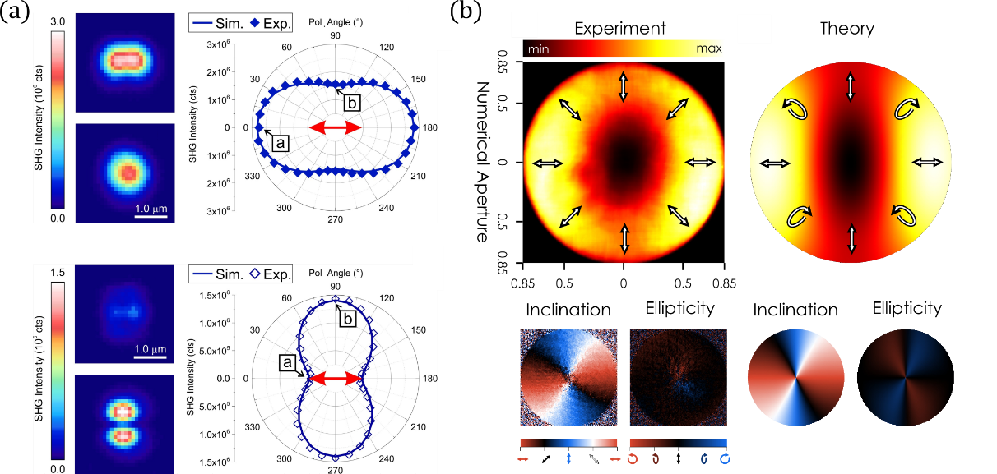
Figure 5S. Simulated and measured polarization state of SH signal in AlGaAs resonators. (a) Polarization for a pillar with radius r = 190 nm (top) and r = 220 nm (bottom) and height h = 400 nm: measurements (diamonds) and calculations (line). Results reprinted with permission from [40]. (b) Back focal plane analysis of transmitted SH for a nanoantenna with r = 250 nm and h = 300 nm. Left: experimental result for directivity, inclination and ellipticity; right: comparison with numerical model. Results reprinted with permission from [31]

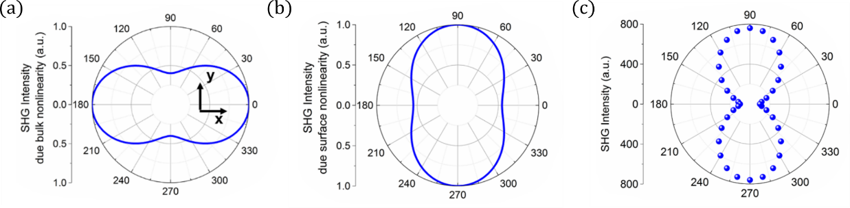
Figure 6S. SH polarization state from GaAs nanocylinders. (a) Numerically calculated polar plot of SH polarization considering just bulk $χ^{(2)}$. (b) Same as in (a) with surface $χ^{(2)}$ taken into account. (c) Experimental measurement verifying the model in (b). Reprinted with permission from [42].

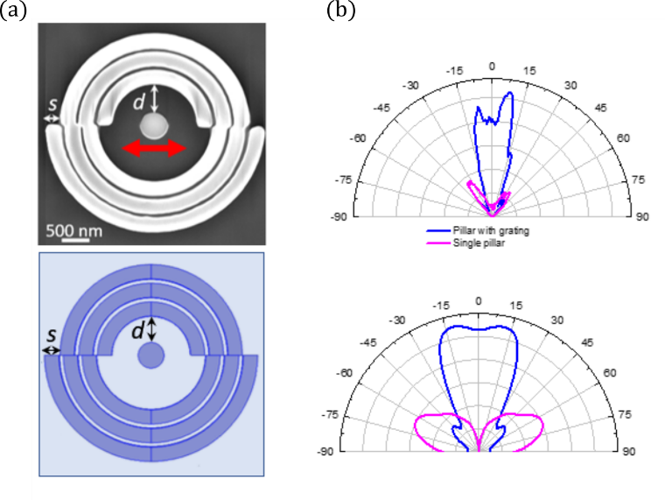
Figure 7S. Control over SHG directionality from single AlGaAs nanopillar using a dielectric grating. (a) SEM image (top) and sketch (bottom) of the device. The pillar is separated with a distance d from a concentric 3-period grating. The symmetry of the system is broken introducing a spatial delay s between the two halves of the grating. (b) Experimental (top) and numerical (bottom) SH radiation pattern for λ=1570 nm pump wavelength in case of a bare resonator (purple line) and a nanocylinder coupled to external grating (blue line). Reprinted with permission from [44].

Figure 8S. (a) Schematic of the single nanoantenna made from (111)-GaAs. The inset shows the zincblende crystal structure in (111)-orientation, that is rotated with respect to the optical axis z. (b) SHG from a (111)-GaAs nanodisk with h = 400 nm and r = 320 nm for pump polarizations φ = 30°, and φ = 60°. Simulated radiation patterns (c) Multipole expansion of the nonlinear currents. Reprinted with permission from [45].

