Online Supplementary Material
Search strategy: MEDLINE, EMBASE, SPORTDiscus
01. antioxidant*
02. anti-oxidant*
03. vitamin c
04. ascorbic acid
05. vitamin e
06. beta-tocopherol*
07. gamma-tocopherol*
08. alpha‐tocopherol*
09. tocopherol*
10. 1 or 2 or 3 or 4 or 5 or 6 or 7 or 8 or 9
11. exercis*
12. resistance training
13. eccentric
14. endurance
15. strength
16. aerobic
17. muscle hypertrophy
18. training
19. adaptation*
20. exercise performance
21. 11 or 12 or 13 or 14 or 15 or 16 or 17 or 18 or 19 or 20
22. 10 and 21
23. randomized controlled trial
24. controlled clinical trial
25. randomized
26. placebo
27. randomly
28. trial
29. 23 or 24 or 25 or 26 or 27 or 28
30. exp animals/ not humans.sh
31. 29 not 30
32. 22 and 31

Table S1: PICOS methodology
Population | Adult participants (≥18 years); no exclusion criteria were applied in relation to participants’ health status
Intervention | Vitamin C and E supplementation were included if they provided information on the dose, frequency and route of administration. Only studies in which the intervention was combined with a supervised exercise program were included.
Comparator | Supplementation with a placebo or antioxidant-free supplement or a least a control group who performed the same the exercise training as the intervention group.
Outcome | Trials reporting the effects of vitamin C and E (or a combination of the two) on muscle hypertrophy, strength, aerobic capacity or endurance performance alongside a ≥4 week exercise training program. No exclusion were employed for the training program or type of test used to assess these outcomes.
Study design | Randomized controlled trials (no exclusion criteria were used for study design, or blinding). Human trials only; animal data was excluded.

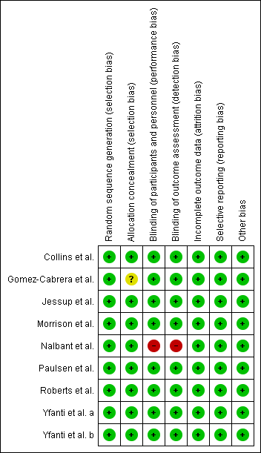

Figure S1: Summary of risk of bias for studies measuring adaptations to aerobic exercise. Yfanti et al. a represents Yfanti et al. (2011) and Yfanti et al. b represents Yfanti et al. (2012).

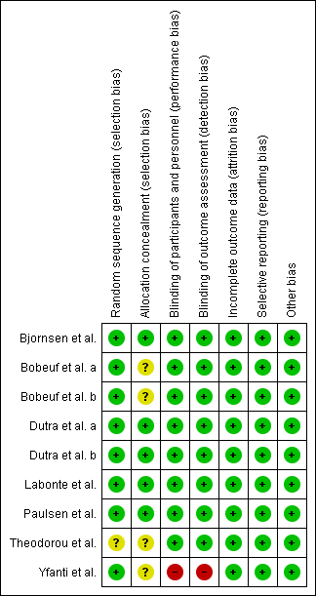

Figure S2: Summary of risk of bias for studies measuring adaptations to resistance training. Bobeuf et al. a represents Bobeuf et al. (2010) and Bobeuf et al. b represents Bobeuf et al. (2011).

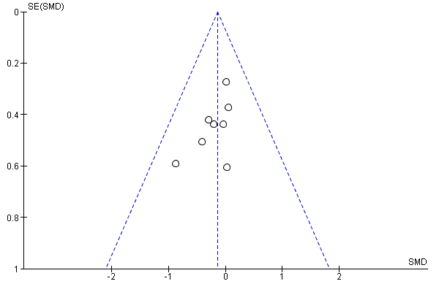

Figure S3: Funnel plot evaluating publication bias of trials assessing $\dot{V}$O_{2max} (n=8).

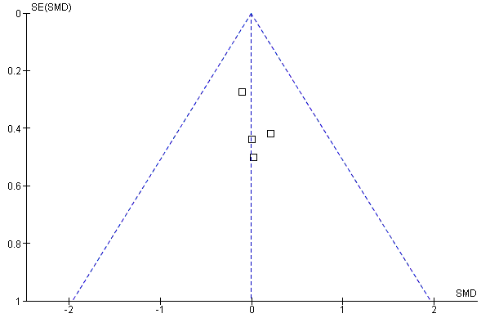

Figure S4: Funnel plot evaluating publication bias of trials assessing endurance performance (n=4).

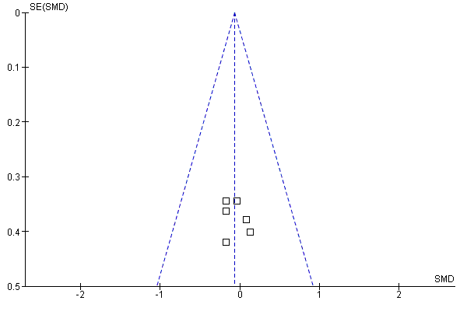
Figure S5: Funnel plot evaluating publication bias of trials assessing lean mass (n=6).

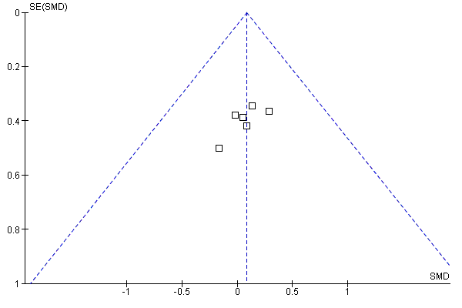

Figure S6: Funnel plot evaluating publication bias of trials assessing muscle strength (n=6).

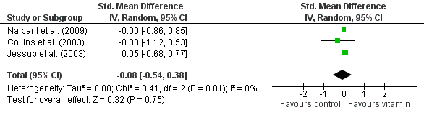

Figure S7: Forest plot for studies examining the effects of vitamin C and/or E on adaptations to aerobic exercise in older adults (≥60 years of age) (n=3).

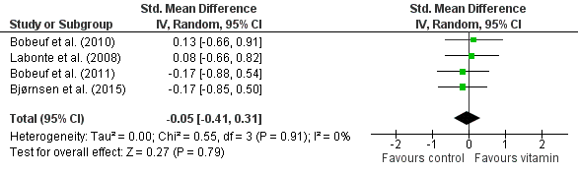

Figure S7: Forest plot for studies examining the effects of vitamin C and/or E on adaptations to resistance training in older adults (≥60 years of age) (n=4).

Studies searched but excluded from analysis (n = 12)
***Ristow, M., Zarse, K., Oberbach, A., Klöting, N., Birringer, M., Kiehntopf, M., ... & Blüher, M. (2009). Antioxidants prevent health-promoting effects of physical exercise in humans. Proceedings of the National Academy of Sciences, 106(21), 8665-8670.
***Alessio, H. M., Goldfarb, A. H., & Cao, G. (1997). Exercise-induced oxidative stress before and after vitamin C supplementation. International Journal of Sport Nutrition, 7(1), 1-9.
*Braakhuis, A. J., Hopkins, W. G., & Lowe, T. E. (2014). Effects of dietary antioxidants on training and performance in female runners. European Journal of Sport Science, 14(2), 160-168.
*Bryant, R. J., Ryder, J., Martino, P., Kim, J., & Craig, B. W. (2003). Effects of vitamin E and C supplementation either alone or in combination on exercise-induced lipid peroxidation in trained cyclists. Journal of strength and conditioning research, 17(4), 792-800.
***Azizbeigi, K., Stannard, S. R., Atashak, S., & Haghighi, M. M. (2014). Antioxidant enzymes and oxidative stress adaptation to exercise training: Comparison of endurance, resistance, and concurrent training in untrained males. Journal of Exercise Science & Fitness, 12(1), 1-6.
**Chuin, A., Labonté, M., Tessier, D., Khalil, A., Bobeuf, F., Doyon, C. Y., ... & Dionne, I. J. (2009). Effect of antioxidants combined to resistance training on BMD in elderly women: a pilot study. Osteoporosis International, 20(7), 1253-1258.
***Garelnabi, M., Veledar, E., White-Welkley, J., Santanam, N., Abramson, J., Weintraub, W., & Parthasarathy, S. (2012). Vitamin E differentially affects short term exercise induced changes in oxidative stress, lipids, and inflammatory markers. Nutrition, Metabolism and Cardiovascular Diseases, 22(10), 907-913.
***Godala, M., Materek-Kuśmierkiewicz, I., Moczulski, D., Rutkowski, M., Szatko, F., Gaszyńska, E., ... & Kowalski, J. (2015). Physical activity in patients with symptoms of metabolic syndrome reduces the concentration of plasma antioxidant vitamins-protective effect of vitamin C. Polski merkuriusz lekarski: organ Polskiego Towarzystwa Lekarskiego, 38(227), 258-262.
***Simar, D., Malatesta, D., Mas, E., Delage, M., & Caillaud, C. (2012). Effect of an 8-weeks aerobic training program in elderly on oxidative stress and HSP72 expression in leukocytes during antioxidant supplementation. The journal of Nutrition, Health & Aging, 16(2), 155-161.
*Skaug, A., Sveen, O., & Raastad, T. (2014). An antioxidant and multivitamin supplement reduced improvements in VO₂max. The Journal of Sports Medicine and Physical Fitness, 54(1), 63-69.
**Yfanti, C., Akerström, T., Nielsen, S., Nielsen, A. R., Mounier, R., Mortensen, O. H., ... & Pedersen, B. K. (2010). Antioxidant supplementation does not alter endurance training adaptation. Medicine and science in Sports and Exercise, 42(7), 1388-1395.
*Zoppi, C. C., Hohl, R., Silva, F. C., Lazarim, F. L., Neto, J. A., Stancanneli, M., & Macedo, D. V. (2006). Vitamin C and e supplementation effects in professional soccer players under regular training. Journal of the International Society of Sports Nutrition, 3(2), 37.
*Training not supervised
**Data already used in another study
***Did not measure outcome

