Feature

The palaeontological record of the Anthropocene

Mark Williams¹, Jan Zalasiewicz¹, Colin Waters¹, Stephen Himson¹, Colin Summerhayes², Anthony Barnosky³ and Reinhold Leinfelder⁴
¹School of Geography, Geology and the Environment, University of Leicester, UK
²Scott Polar Research Institute, University of Cambridge, Lensfield Road, Cambridge, UK
³Jasper Ridge Biological Preserve and Department of Biology, Stanford University, Stanford, California, USA
⁴Department of Geological Sciences, Freie Universität, Berlin, Germany

Most species on planet Earth have specific ecological ranges. In the near surface of the oceans planktonic foraminifera define water masses that are warm in the tropics, and cold in polar-regions. Tropical rainforests have trees and animals that are distinct from those in warm temperate or cold temperate zones. The fauna and flora of Australia are distinct from those of the Americas. These natural patterns, defined by factors such as latitudinal changes in surface temperature and rainfall, or geographical isolation, have evolved over millions, sometimes tens of millions of years. Now that natural pattern is being overprinted by the actions of a single species, Homo sapiens, that has made the whole Earth its ecological range, and some parts of nearby space too. The human ancestral pattern of gradually increasing impact on the Earth can be traced in the stratigraphic record for nearly 3 million years, and in its later and more pervasive phases may serve to help define a biostratigraphical signal for the Anthropocene Epoch.

Humans are part of an evolutionary story that threads back through time almost 3 million years, since our first Homo ancestors walked across the landscape of Africa. Our earliest traces - a mandible with teeth in sedimentary deposits from Ethiopia - are joined by other traces in stone tools, which even pre-date the earliest fossils of Homo, and were probably used by our Australopithecine cousins. This might seem like an inauspicious start for Homo, and any alien civilization visiting Earth at that time might have commented disparagingly on this curious ape. Homo would not seem likely to give rise to a species with a population of 7600 million individuals in the year 2018 CE.

Around 1.4 million years ago, ancestral humans developed the third metacarpal styloid process. This technical term belies the importance of this structure at the base of the middle finger, which helps to lock your hand into your wrist; it is the reason why humans can hold and manipulate a power drill. It allowed our ancestors to prepare stone tools of increasing complexity.

About 300,000 years ago, our own species, Homo sapiens, evolved in Africa. The earliest evidence so far are skeletal remains associated with stone tools in Morocco. For most of the following human story there is little record of our impact on the biology around us, but nevertheless we can discern a growing efficiency in our technology as increasingly elaborate stone-tool designs. By about 50,000 years ago there is evidence that humans were exerting a new environmental pressure on the biosphere around them, and some of these patterns have been seen as the earliest potential palaeontological markers of the Anthropocene.

The Late Quaternary Extinction
The first Homo erectus left Africa for Asia, perhaps about 2 million years ago. This early expansion of ancestral humans beyond their original territory established a precedent. One descendent species, Homo sapiens, eventually colonised all continents, including Antarctica. Humans, and one could argue their commensal bacteria, are unique in this sense, in being able to occupy nearly all terrestrial-environments on planet Earth. This ability, to engineer the environment around us to suit our means, has left a distinctive palaeontological pattern in the sedimentary record of the land, and latterly also the sea. The pattern on land is the earliest to develop.

From about 50,000 years ago, a series of prominent extinctions of large mammals, together with many large birds and reptiles, can be recognised in the fossil record and this is termed the ‘Late Quaternary Extinction’. In Australia, some wonderful animals disappeared from the landscape, such as the large flightless bird Genyornis newtoni. Whether this was due to humans, who entered the Australian landscape about 65,000 years ago, to climate change, or the combined impact of both, remains a subject of contention. In North America the loss of large animals is generally much later, and focused on the period between 13,500 to 11,500 years ago. This interval is associated with major climate change, but is also the time of arrival of the Clovis people into North America. They carried with them a sophisticated stone-tool kit, notable for their precision-engineered spear points, which facilitated the hunting of large animals.

In Europe and Asia, large mammals were lost from Ireland to eastern Asiatic Russia. This phase of extinction unfolded from about 14,000 years ago, and eventually included the magnificent Irish elk, and the iconic woolly mammoth, though the latter clung on in a diminutive form on Wrangel Island until about 4,000 years ago. Mammoths were once so prolific on the grassy plains of Siberia that the fossil tusks of these giants, preserved in sedimentary deposits along the Kolyma River, are harvested - illegally - for the black market ivory trade. There is an echo of this catastrophic demise of a species in the almost total annihilation of the North American bison in the late 19th century, though thankfully human agency intervened to preserve that species.
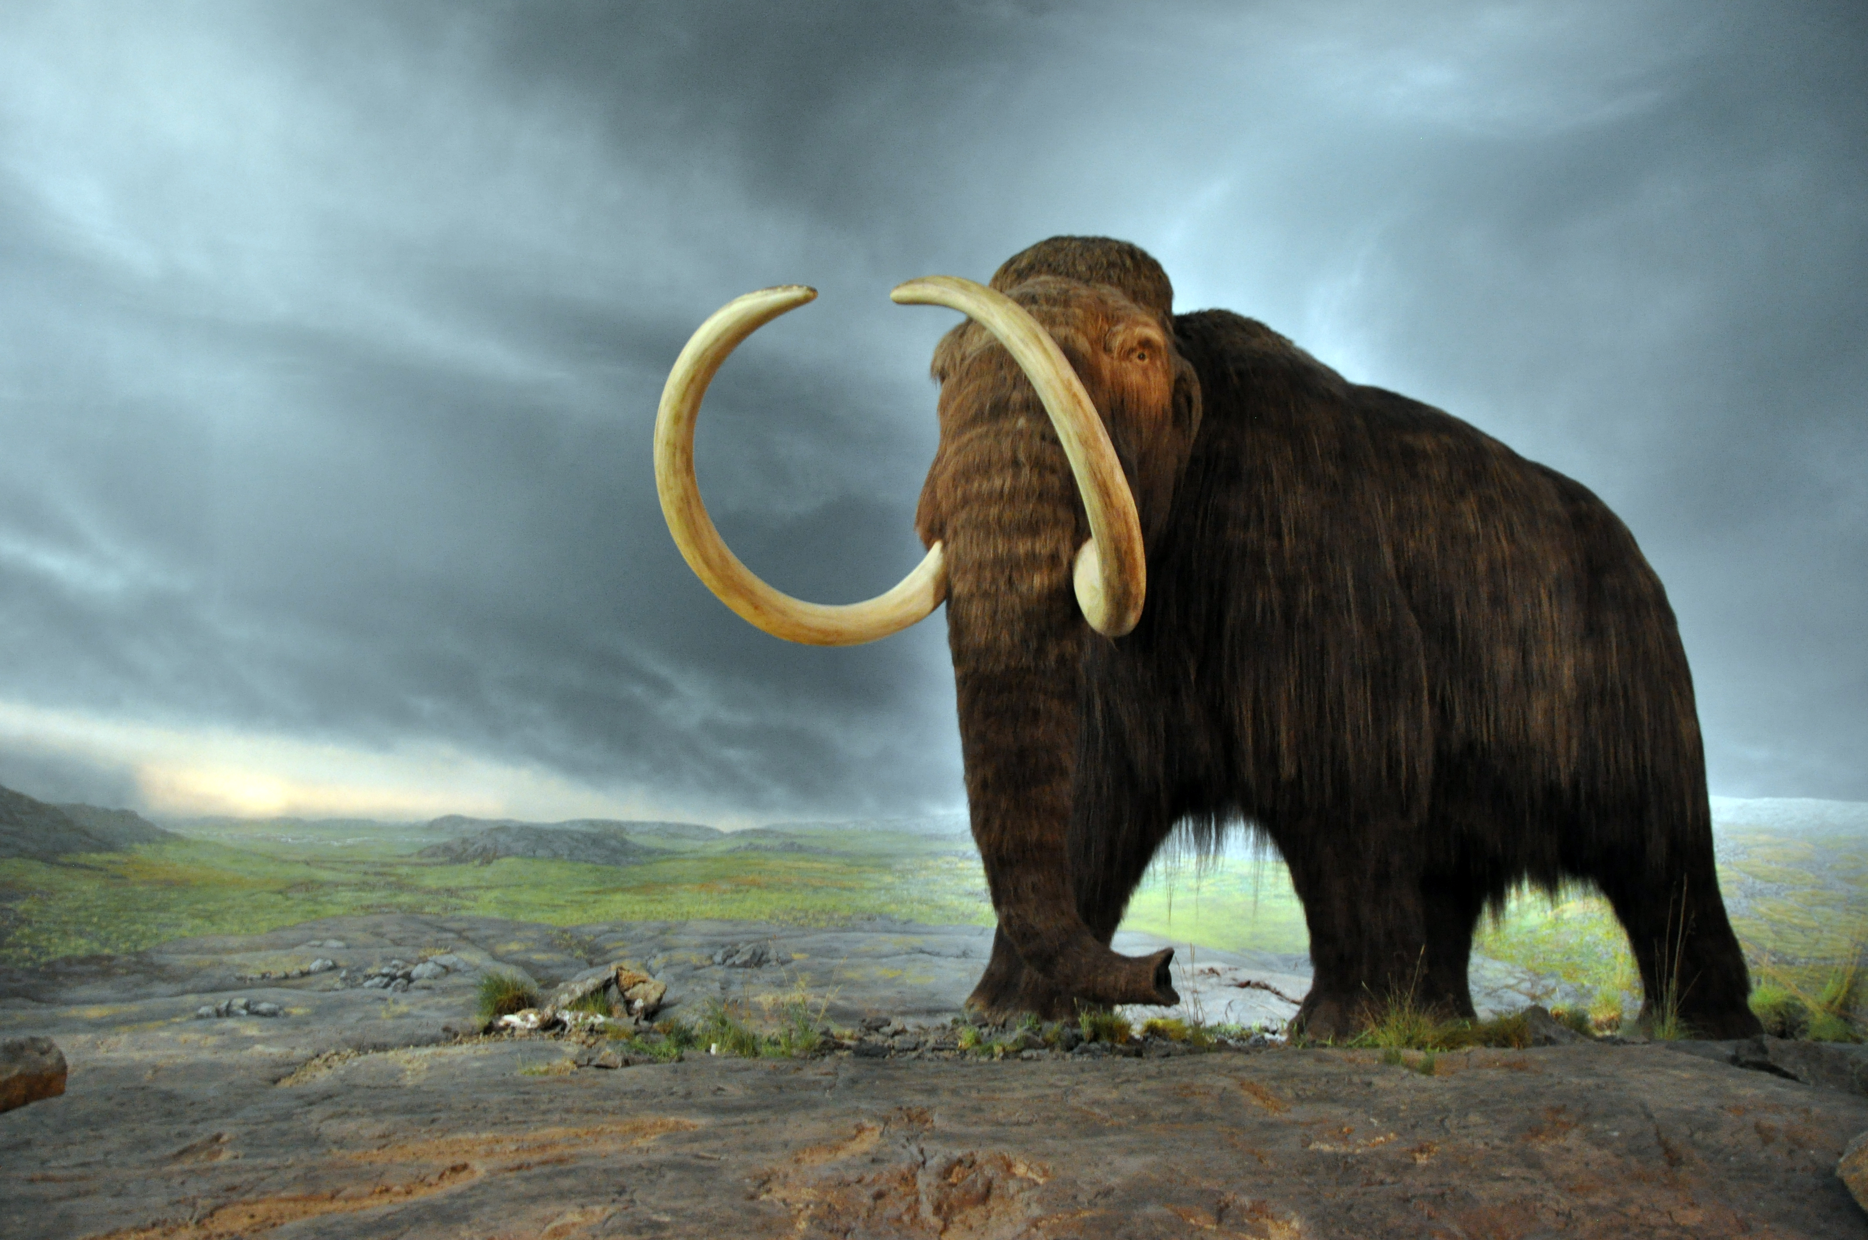
Although these biostratigraphical signals of extinction extend from the Americas to Asia, and are associated with colonization of these regions by modern humans, they range over several tens of thousands of years. For this reason they do not provide the stratigraphical resolution that is necessary for the definition of the Anthropocene (Waters et al., this issue). Nevertheless, regional biostratigraphical units can be defined that record biotic restructuring caused by humans, as for example the Santarosean North American Land Mammal Age that began about ~14,000 years ago marked by the entry of Homo sapiens and extinction of megafauna in the New World, and the ensuing Saintaugustinean North American Land Mammal Age, which began in the mid-16th century and is marked by the exchange of species from the Old to New Worlds (and vice versa) as Spanish colonizers brought in their domestic and commensal fauna.
Figure 1. The iconic woolly mammoth once roamed from North America to Asiatic Russia and has left an extensive fossil record of its life, and final demise just a few thousand years ago. https://commons.wikimedia.org/wiki/File:Woolly_mammoth.jpg

The neobiota
Humans have been domesticating and transporting animals, plants and microbes beyond their natural ranges for millennia, likely beginning in the latest Pleistocene. Whilst the spread of domesticated animals like dogs, cats, sheep, pigs and chickens has left a biostratigraphical signal, rats must rank amongst the most widely trans-migrated wild mammal. Three species in particular, the black rat (Rattus rattus), Pacific rat (R. exulans) and brown rat (R. norvegicus) are widespread.
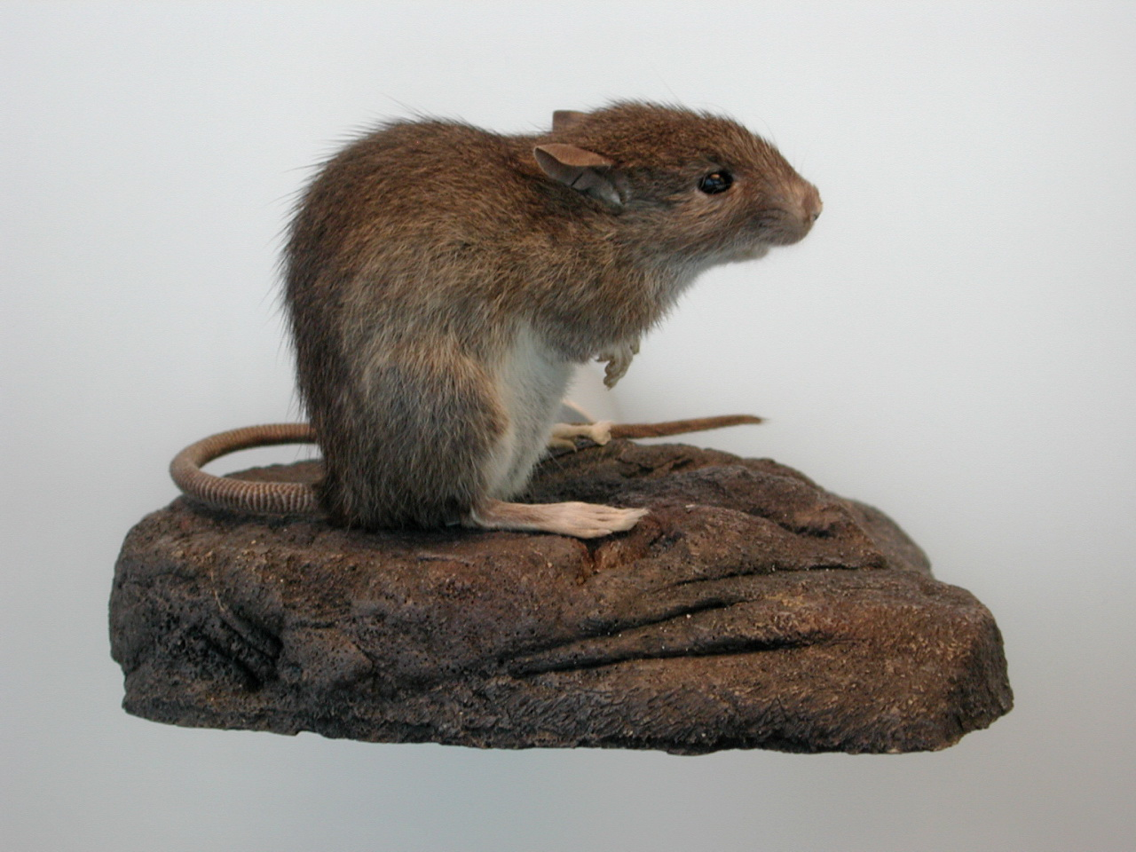
Figure 2. The Pacific Rat, a widespread species through SE Asia, and invasive in Polynesia. Pacific Rats are typically up to about 15 cm long. https://commons.wikimedia.org/wiki/File:Pacific_rat.jpg
The appearance of these species beyond their native ranges, which is inferred to be East Asia, provides good biostratigraphical evidence of human migration, sometimes into previously uninhabited regions. For example, in New Zealand the first human colonisation is linked with the arrival of Pacific rats in the 13th century CE, but this species was almost extirpated by the late 19th century as a consequence of the introduction of other rat species by European settlers. Polynesian peoples transferred many neobiota including pigs, dogs, and the sweet potato as they extended across the Pacific Ocean. Rat migration is also implicated in the spread of human diseases that have left a physical record. Thus, the ‘black death’, apparently transmitted by fleas carried by black rats, has left mass human burial sites within major cities that can be correlated with historical accounts of plague. In London, for example, there are widespread plague pits with skeletal remains that date to a major outbreak in the mid-17th century, and which may form a biostratigraphical record of human disease long into the future.

Processes of species exchange between widely separate geographies likely gathered pace during the voyages of European ‘discovery’ from the 14th century onwards. For example, maize began to spread from the Americas into the ‘Old World’ during the 16th century and reached parts of East Africa by the late 19th century.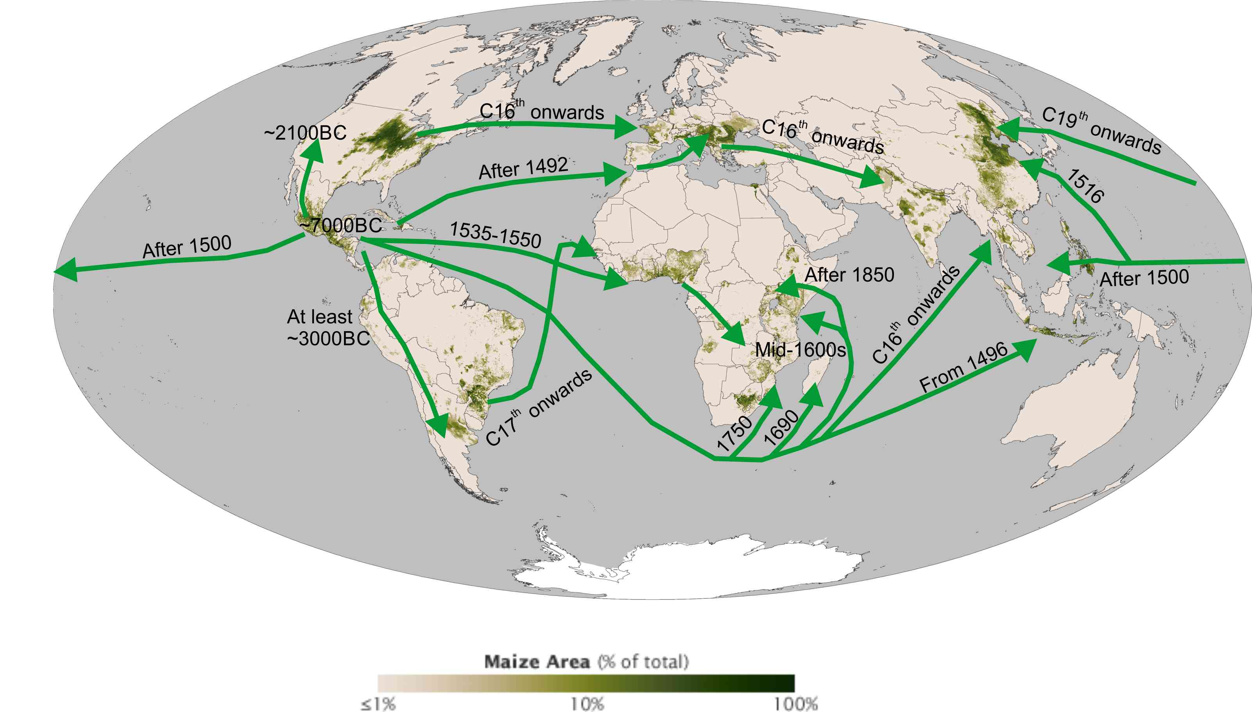
Figure 3. The spread of Maize around the world was a slow process over millennia in the Americas, and then was rapidly spread throughout the world through the process of globalisation from the 16th century onwards. Figure drawn by Colin Waters.

This ‘Columbian Exchange’ has been mooted as a possible contender for an Anthropocene Series boundary and is associated with the large-scale exchange of plants, animals and diseases that has probably left some significant biostratigraphical signatures. All of these earlier neobiota migrations, from dogs onwards, left a time-transgressive signal of their migration over thousands of years. Thus maize, which can leave a fossil record of pollen and phytoliths, was first domesticated in Mexico over 7,000 years ago, spread through South America over millennia, and only reached North America much later. These time-constraints would be too loose to define an Anthropocene boundary, and for this reason we need to look for biostratigraphical markers that show widespread pan-continental migration of neobiota at sub-decadal resolution. To do that we have to move into the industrialised and increasingly connected world of the 19th century onwards.

The famous 1967 song by Scott McKenzie implored visitors to San Francisco to wear flowers in their hair, but the San Francisco Bay area has become the home for some less benign visitors since then: it is perhaps the most invaded aquatic ecosystem on Earth, or at least the best documented. Over 200 neobiotic species have been identified, ranging from foraminifera to molluscs and plants. Driven by the Gold Rush of 1849, San Francisco Bay, the largest estuary on the Pacific Coast of the USA, quickly became a focal point for immigration and trade, attracting ships harbouring biological threats from across the globe. Invading organisms have been arriving since the 1850s, both from deliberate introduction by humans, and by accidental dispersal. Whilst many are soft-bodied and therefore will likely leave no biostratigraphical trace – except in historical accounts - many are hard-shelled and abundant, and will leave a geological record.

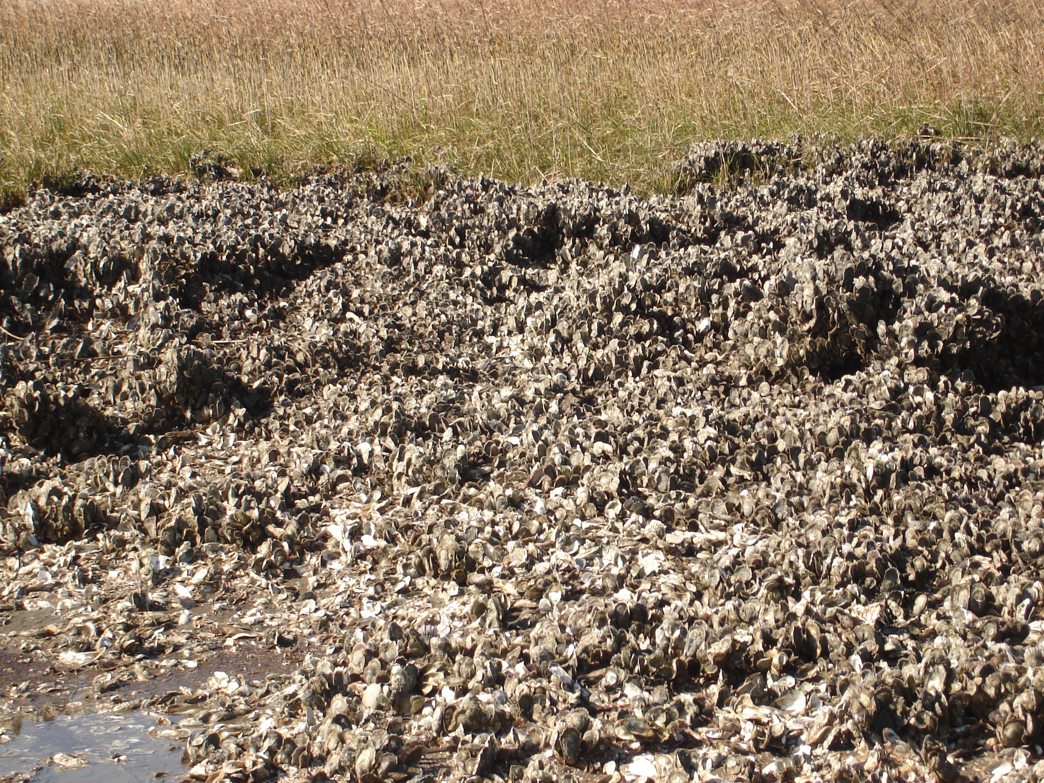
Figure 4. The eastern oyster, Crassostrea virginica, forming a bivalve reef on Cockspur Island, Georgia: the robust shells of this species can exceed 10 cm in length. https://en.wikipedia.org/wiki/Eastern_oyster#/media/File:OysterBed.jpg. Crassostrea virginica was introduced in to San Francisco Bay on the west coast of North America during the late 19th century for aquaculture, but the introduction was ultimately not successful.
Chief amongst these are the bivalve molluscs. These were in the vanguard of colonization in the 1860s, at first introduced deliberately for oyster aquaculture, and today are still planted along the western coast of North America. The translocation of Atlantic oysters was facilitated by the construction of the Transcontinental Railroad in 1869 linking the Atlantic and Pacific coasts of the USA. The Railroad also became the primary vector for introducing Atlantic fish species such as the American Shad (Alosa sapidissima) to supplement declining fish stocks in San Francisco Bay. Shipments of oysters arriving on the newly constructed Transcontinental Railroad carried with them species new to the west coast of the USA. Today, as many as thirty species, constituting 15% of the introduced biota are considered to a direct result of the Atlantic oyster trade.

More recent mollusc invasions reflect trans-Pacific shipping, such as the Amur River Clam (Potamocorbula amurensis), which has a native range in East Asia. The Amur River Clam was introduced into San Francisco Bay in 1986 where it now colonises in vast numbers. In some places as many as 48,000 individuals have been counted per m². This species is such a voracious feeder that the populations in northern San Francisco Bay are thought to be able to filter the entire water column of phytoplankton more than once per day causing a nutrient deficit in the downstream reaches of the Bay. This clam was likely introduced from the ballast waters of shipping and its wide temperature and salinity tolerance suggests it may be widely distributed across the globe. Although such transfers are now very tightly controlled with preventative measures, the numbers in the Bay seem likely to leave a significant and abrupt biostratigraphical marker of trans-Pacific trade in the post-World War II period.

Figure 5. The US Navy deposit truckloads of the eastern oyster, Crassostrea virginica, to develop new artificial oyster reefs on the mudflats of Little Creek Cove, Oregon. https://commons.wikimedia.org/wiki/File:US_Navy_100428-N-3154P-149_Sailors_assigned_to_Amphibious_Construction_Battalion_(ACB)_2,_use_heavy_machinery_to_load_oyster_shells_for_two_new_artificial_oyster_reef_sites_in_the_mud_flats_of_Little_Creek_Cove.jpg
Recent and future extinctions
Arrivals of neobiota are often strongly correlated with the local extirpation of indigenous taxa. This can be seen in the land snails of the Hawaiian Islands, which have been supplanted with species such as the Cannibal Snail of Central America (Euglandina rosea). The irony is that this snail was itself introduced by humans to curtail the spread of another neobiotic species, the Giant African Land Snail (Achatina fulica), and both have left a signal of their shells in recently formed sedimentary deposits.

Many recently lost-species evoke the impact of humans across the globe, and in many different environments. The Caribbean Monk Seal was last sighted in 1952, and the Yangtze Dolphin half a century later. Over 300 years earlier, the loss of the Dodo on Mauritius is an iconic symbol of the impact of humans on localized island species that have limited ecological ranges. All of these species, whilst representing significant individual losses, will not leave a widespread biostratigraphical record. Similarly, the extinction of the smallpox virus in December 1979 CE represents a profound example of humanity’s ability to manipulate the biological world around it, but does not leave a physical biostratigraphical record, other than the bone deformity Osteomyelitis variolosa it caused in infected humans. Instead, we need clearer patterns. Some of these are beginning to unfold.

In 2016 and then again in 2017 there has been widespread bleaching of the Great Barrier reef of Australia across 100s km. Bleaching has happened before, first becoming extensive in the 1980s, but never before in two consecutive years, and it now includes some 1500 km of the reef’s 2300 km extent. Bleaching happens when surface ocean temperatures rise above their normal ambient state, and as a result the corals expel their symbiotic zooxanthellae, tiny dinoflagellates that provide the corals with glycerol, carbohydrates and other organic compounds, whilst in return the coral provides carbon dioxide and nutrients for photosynthesis which are not easily available in the super-oligotrophic tropical reef settings. The loss of the zooxanthellae first leads to starvation of the reef corals and can ultimately lead to their death. The problem is widespread in tropical regions and is part of a wider ‘double-whammy’ attack on coral reef systems worldwide, both from elevated sea temperatures and decreasing alkalinity (often referred to as ocean acidification), both of which are caused by carbon dioxide emissions from burning fossil fuels. Some projections of the impacts of acidification on reef systems suggest that many tropical reefs will struggle to grow by the mid-21st century. In addition, rising sea temperatures will lead to sea level rise, which, given the other environmental stresses on coral reefs, may strongly curtail their growth.

The pattern is complex, and locally some components of the coral reef may survive, to replace the species that are lost. This too would leave a very distinctive biostratigraphical signal, with an interval of reduced diversity reefs or unusual reef types marking the near future.

Past coral reef loss on a global basis has produced a distinctive stratigraphical signature for example in the Late Devonian, at the Permian-Triassic boundary, and at the Paleocene-Eocene boundary. Given that coral reef systems are estimated to support some 25% of ocean species diversity, such a calamitous loss of living reefs would leave a physical signature, both in cessation of growth, and probably a linked signal to the extinction of many associated species.

A biostratigraphical signal of human traces
A geological boundary can also be marked by a distinctive change in trace fossils. The Precambrian-Cambrian boundary is defined on the appearance of a complex suite of trace fossils that include the characteristic three-pronged burrows of Treptichnus pedum. The traces identify a fundamental change in the structure of the global biosphere some 541 million years ago, providing evidence for the widespread appearance of muscular, bilaterally symmetrical animals at the beginning of the Cambrian Period, and Phanerozoic Eon. It is possible to think of the structures made by humans as potential trace fossils too, most notably underground excavations like mines that will preserve long into the future. These excavations in themselves date back into prehistory, and suffer the same time-transgressive problems of the Late Quaternary Extinction, or of the spread of neobiota prior to the 19th century.

However, certain styles of human excavation are very recent in their form and function, and have spread across the Earth rapidly. One such trace – a potential fossil of the future – is the spread of underground railway systems since the 1860s. The first such system began development in London in 1861. Underground rail systems have spread to all continents bar Antarctica in 15 decades. This resolution is too low to define an Anthropocene boundary (see Waters et al. this issue), but nevertheless serves as a potential trace fossil marker of the rapid massing of people in giant cities, of huge human energy-consumption in urban areas, and of the need to evolve effective means of transport in such enormous concentrations of humans and habitations. In a similar way, the global road system may form a distinctive stratigraphical marker of the 20th century.

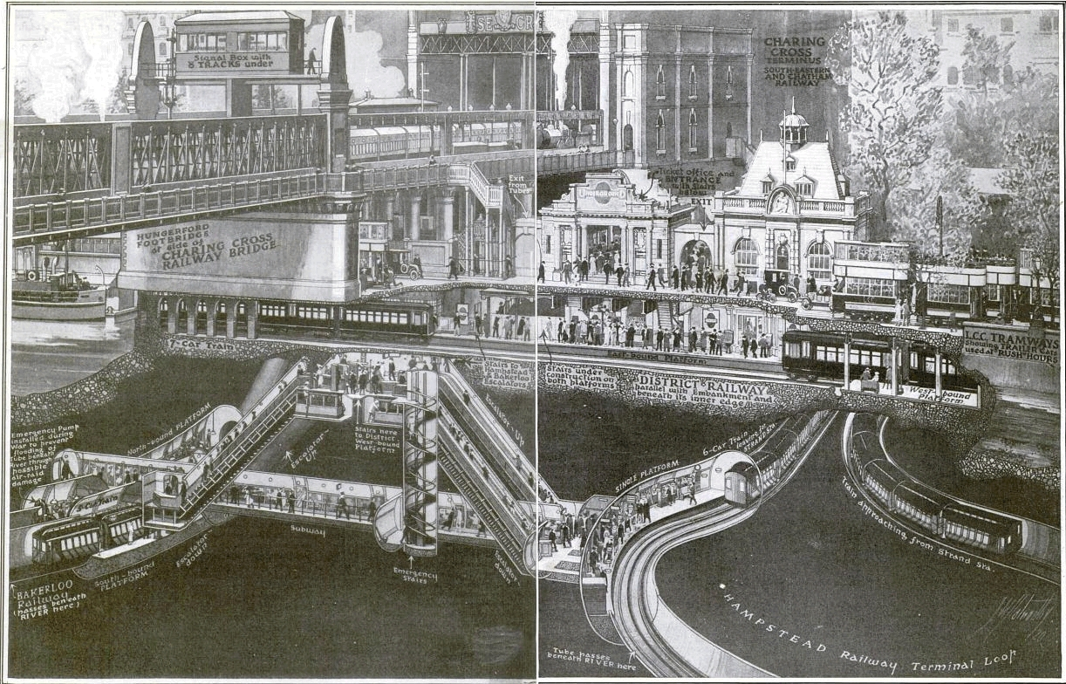
Figure 6. Traffic interchange at Charing Cross Station, London (now called Embankment Station), taken from the Popular Science Magazine, January 1921, pp. 44-45, drawing by S.W. Clatworthy. The Hampstead and Bakerloo railways are deep tunnels that may leave a permanent ‘trace fossil’ signature of human activity. Picture from the Popular Science Archive at: http://www.popsci.com/archive-viewer?id=YSoDAAAAMBAJandpg=44andquery=charing%20cross.

Biostratigraphy of the Anthropocene
It is evident that there are distinctive biostratigraphical markers of human activity, and of human impacts on the biosphere, extending into deep time. However, most of these markers lack the time-precision necessary to define the Anthropocene (Waters et al., this volume). That said, the rapid pan-continental spread of certain skeletonized neobiota in the latter part of the 20th century – such as the Amur River Clam - might provide decisive supporting evidence for such a boundary. These neobiota also mark a substantially changed global ecosystem, with San Francisco Bay highlighting the degree of that change. Sadly, a future catastrophic collapse of coral reef systems – or a more widespread extinction event on land and in the sea, might provide a more globally synchronous, geographically widespread biostratigraphical marker. That begs the question - is a major biological extinction on the way? Thanks to ongoing conservation efforts, some well-known species have been pulled back from the brink in recent years, including albatrosses, condors, manatees, oryxes, pandas and others. Hopefully humanity can avoid the catastrophe of causing a mass extinction as pronounced as the dinosaur extinction, but that will only be possible with very careful nurturing of the biology around us.

Suggested reading

The Anthropocene
Waters et al. this issue

Zalasiewicz et al. this issue

On human evolution
Villmoare, B., et al. 2015. Early Homo at 2.8 Ma from Ledi-Geraru, Afar, Ethiopia. Science 347, 1352-1355.

Ward, C.V., et al. 2014. Early Pleistocene third metacarpal from Kenya and the evolution of modern human-like hand morphology. PNAS 111, 121-124.

Late Quaternary and near-future extinctions
Barnosky, A.D., et al. 2014. Prelude to the Anthropocene: Two new North American Land Mammal Ages (NALMAS). The Anthropocene Review 1(3), 225–242.

Barnosky, A. D., et al. 2011. Has the Earth’s Sixth Mass Extinction Already Arrived? Nature, 471, 51–57.

Koch, P.L., Barnosky, A.D. 2006. Late Quaternary extinctions: state of the debate. Annual Review of Ecology, Evolution, and Systematics 37, 215-250.

Ceballos, G. et al. 2015. Accelerated modern human–induced species losses: Entering the sixth mass extinction. Science Advances, 1(5), e1400253
DOI: 10.1126/sciadv.1400253

The neobiota and human-induced changes to the biosphere

Bar-On, Y.M., Phillips, R. & Milo, R. 2018. The biomass distribution on Earth. www.pnas.org/cgi/doi/10.1073/pnas.1711842115

Burney, D.A., et al. 2001. Fossil evidence for a diverse biota from Kaua‘i and its transformation since human arrival. Ecological Monographs 7, 615-641.

Cohen, A.N., Carlton, J.T. 1998. Accelerating invasion rate in a highly invaded estuary. Science 279, 555-557.

Williams, M. et al. 2016. The Anthropocene: a conspicuous stratigraphical signal of anthropogenic changes in production and consumption across the biosphere. Earth’s Future 4, doi:10.1002/2015EF000339.

An excellent overview of the human impact on biology
E.O. Wilson, 2016. Half-Earth: Our Planet's Fight for Life. Liveright publishing Corp. New York, London, 257pp.

Websites (neobiota, plague pits, and coral reefs)
Cohen, A.N. 2011. The Exotics Guide: Non-native Marine Species of the North American Pacific Coast. Center for Research on Aquatic Bioinvasions, Richmond, CA, and San Francisco Estuary Institute, Oakland, CA. Revised September 2011. http://www.exoticsguide.org

Plague pits in London. http://www.crossrail.co.uk/news/articles/suspected-1665-great-plague-pit-unearthed-at-crossrail-liverpool-street-site

Richard Schiffman 2017. A close-up look at the catastrophic bleaching of the Great Barrier Reef. https://e360.yale.edu/features/inside-look-at-catastrophic-bleaching-of-the-great-barrier-reef-2017-hughes

