Systematics and Biodiversity

Unexpected systematic affinities and geographic expansion of a marine alien hydroid (Cnidaria: Hydrozoa)

Xikun Song, Mingxin Lyu, Bernhard Ruthensteiner, Jianjun Wang, Cinzia Gravili

Electronic supplementary material

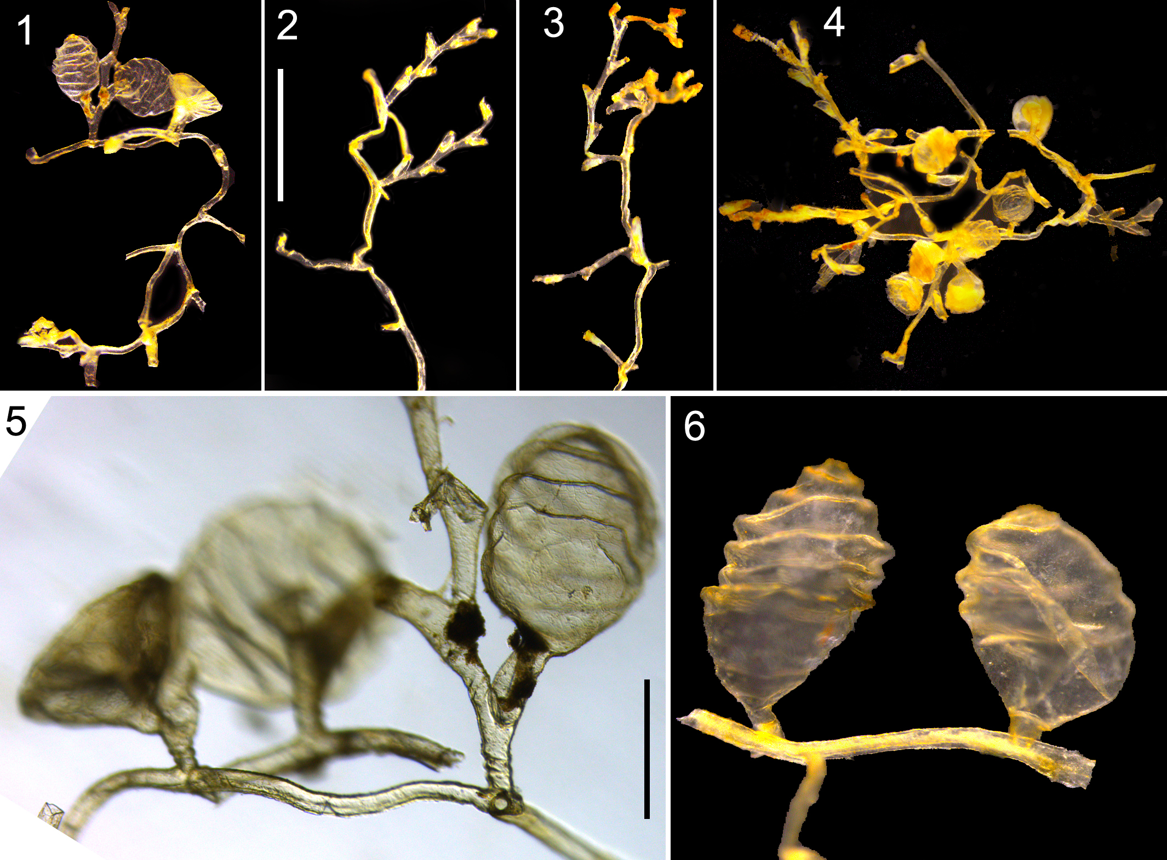
Fig. S1. Bicaularia tongensis (Stechow, 1919) comb. nov. Hydroid fragments used for DNA extraction. (1) XMUB000550-1; (2) XMUB000550-2; (3) XMUB000550-3; (4) XMUB000550-4; (5) XMUB000550-1, the right gonotheca arising from within hydrothecal cavity; (6) XMUB000550-4, two gonothecae directly originating from the surface of hydroid stalk. Scale bars: (1–4) 1 mm; (5–6) 0.25 mm.

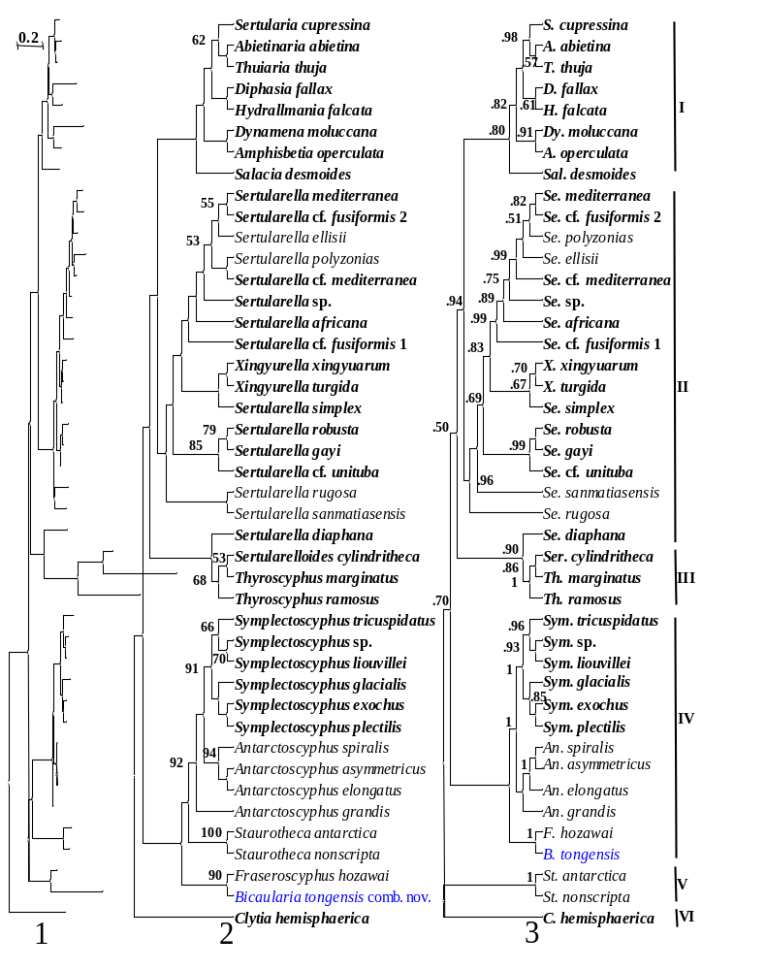
Fig. S2. Phylogenetic analyses based on partial sequences of the 16S rRNA gene (483 bp after multiple sequence alignments) using TIM2+I+G model. (1–2), maximum-likelihood analyses; (3), Bayesian analyses. (1) phylogram; the scale bar represents 0.2 substitutions per site; (2–3), cladograms. Numbers near the nodes indicate bootstrap or Bayesian posterior probability values. Values lower than 50 or 0.5 were omitted. Taxa in bold indicate parts of the tree for which the topology was the same in the maximum-likelihood (1, 2) and Bayesian trees (3). Annotations of the clades I–VI are Sertulariidae sensu stricto Maronna et al. 2016, Sertularellidae, Thyroscyphidae, Symplectoscyphidae, Staurothecidae and the outgroup, respectively.
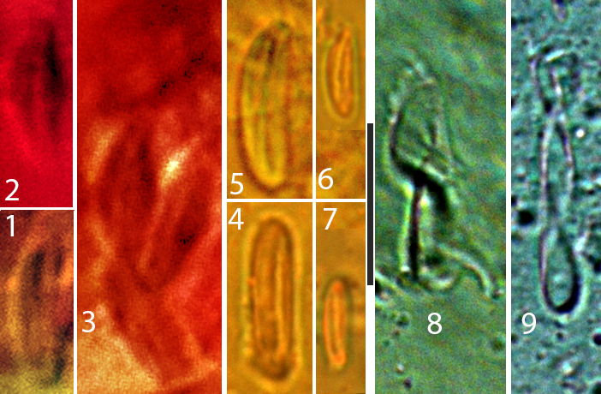
Fig. S3. Nematocysts of Bicaularia tongensis (Stechow, 1919) comb. nov. (1–3) ZSM20041540, paralectotype, (3) showing four nematocyst capsules clustered in hydroid tissue; (4–9) MBM280464; (8–9) showing two discharged nematocysts. Scale bar: 10 μm.

Table S1. Specimens examined in this study
Specimen ID | Type status | Fixation method | Locality | Latitude | Longitude | Water Depth | Collector | Collecting date | Morphological notes
ZSM 20041539 | Lectotype | Microslide | Tonga Islands | / | / | / | / | No later than 1876 | One fragment, with six hydrothecae and one gonotheca (possibly male), with a hydrocladium arising from within the hydrothecal cavity
ZSM 20041540 | Paralectotype | Microslide | Tonga Islands | / | / | / | / | No later than 1876 | One fragment, with ten hydrothecae, with a hydrocladium and a gonotheca (possibly male) both arising from within the hydrothecal cavity
ZSM 20041541 | Paralectotype | Microslides | Tonga Islands | / | / | / | / | No later than 1876 | One fragment, 3 mm high, 10 mm wide, with creeping stolon, five stems, no hydrocladium, no gonotheca
MBM280462 | Non-type | Formalin fixed, ethanol stored | Guadeloupe, Caribbean Sea | 16.4537°N | 61.5355°W | 17 m | H. Galea | 2009.XI.19 | Eight colonies, two fragments, one gonotheca, sex unknown, arising from the aperture of a small tube (not a hydrotheca), with a hydrocladium arising from the aperture of hydrotheca
MBM280463 | Non-type | Formalin fixed, ethanol stored | Guadeloupe, Caribbean Sea | 16.4464°N | 61.5401°W | 12–15 m | H. Galea | 2009.XI.30 | Formalin fixed, ethanol stored, with a slide sample of operculum, two colonies, no gonotheca
MBM280464 | Non-type | Formalin fixed, ethanol stored | Martinique, Caribbean Sea | 14.8419°N | 61.2279°W | 13 m | H. Galea | 2012.II.18 | With a nematocyst slide sample, two colonies, attached to other hydroids, one gonotheca, arising from the aperture of a small tube
XMUB000550 | Non-type | Ethanol | Mariana Islands | 12.3868°N | 143.9512°E | 0.5 m | X. Song | 2017.VI.4 | Thirteen colonies attached to a floating Sargassaceae algae fragment, with eight gonothecae, five of them arising from the aperture of hydrothecae
XMUB000550-1  (DNA sample) | Non-type | Ethanol | Mariana Islands | 12.3868°N | 143.9512°E | 0.5 m | X. Song | 2017.VI.4 | With three gonothecae, two of them arising from the aperture of hydrothecae
XMUB000550-2  (DNA sample) | Non-type | Ethanol | Mariana Islands | 12.3868°N | 143.9512°E | 0.5 m | X. Song | 2017.VI.4 | A hydroid fragment for molecular experiment, gonotheca absent
XMUB000550-3  (DNA sample) | Non-type | Ethanol | Mariana Islands | 12.3868°N | 143.9512°E | 0.5 m | X. Song | 2017.VI.4 | A hydroid fragment for molecular experiment, gonotheca absent
XMUB000550-4  (DNA sample) | non-type | ethanol | Mariana Islands | 12.3868°N | 143.9512°E | 0.5 m | X. Song | 2017.VI.4 | A hydroid fragment for molecular experiment, with seven gonothecae, four of them arising from the aperture of hydrothecae

Table S2. Information on molecular sequences used in this study
Species | Locality | Voucher | GenBank number | Reference
Abietinaria abietina | Iceland | MHNG-INVE-29946 | AY787898 (16S) | Cunningham (2004) direct submission
 |  |  | FJ550554 (18S) | Leclère et al. (2009)
 |  |  | FJ550411 (28S)
Abietinaria filicula | Iceland: Gardur | MHNG-INVE-29947 | FJ550485 (16S)
 |  |  | FJ550555 (18S)
 |  |  | FJ550412 (28S)
Amphisbetia minima | New Zealand: Devonport | MHNG-INVE-25071 | FJ550486 (16S)
 |  |  | FJ550556 (18S)
 |  |  | FJ550413 (28S)
Amphisbetia operculata | South Africa | MHNG-INVE-34014 | FJ550489 (16S)
 |  |  | FJ550561 (18S)
 |  |  | FJ550418 (28S)
Antarctoscyphus asymmetricus |  |  | KT824434 (16S) | Maronna et al. (2016)
Antarctoscyphus elongatus | Antarctica | / | FN424138 (16S) | Peña Cantero et al. (2010)
Antarctoscyphus grandis | Antarctica | / | FN424139 (16S)
 | Ross Sea | LEM m3X46A | KT722383 (18S) | Maronna et al. (2016)
 |  |  | KT757185 (28S)
Antarctoscyphus spiralis | Antarctica | lem_S151 | FN424140 (16S) | Peña Cantero et al. (2010)
 |  |  | KT722384 (18S) | Maronna et al. (2016)
 |  |  | KT757141(28S)
Bicaularia tongensis | Mariana | XMUB000550-1 | MF948613 (16S) ^{[3]}  MF945585 (COI) ^{[1]}  MF945586 (COI) ^{[2]}  MG763081 (18S) ^{[4]} | This study
 |  | XMUB000550-2 | MF948613 (16S) ^{[3]}  MF945586 (COI) ^{[2]}
 |  | XMUB000550-3 | MF948613 (16S) ^{[1]}  MF945585 (COI) ^{[1]}
 |  | XMUB000550-4 | MG001906 (28S) ^{[1]}
Clytia hemisphaerica | North Sea | / | AY789814 (16S) | Govindarajan et al. (2006)
 |  |  | FJ550601 (18S) | Leclère et al. (2009)
 |  |  | FJ550457 (28S)
Diphasia fallax | Iceland | MHNG-INVE-29950 | AY787901 (16S) | Cunningham (2004) direct submission
 |  |  | FJ550557 (18S) | Leclère et al. (2009)
 |  |  | FJ550414 (28S)
Dynamena crisioides | Brazil | MZUSP: 1679 | KT266609 (16S) | Maronna et al. (2016)
 |  |  | KT722391 (18S)
 |  |  | KT757177 (28S)
Dynamena moluccana | Indonesia | / | FJ550494 (16S) | Leclère et al. (2009)
 |  |  | FJ550563 (18S)
 |  |  | FJ550429 (28S)
Fraseroscyphus hozawai | Qingdao, China | MBM280006 | KT190714 (16S) | Song et al. (2016b)
 |  |  | KT190766 (18S)
 |  |  | KT190773 (28S)
Hydrallmania falcata | Plymouth UK | / | AM888325 (16S) | Moura et al. (2008)
 | Iceland | MHNG-INVE-29948 | FJ550559 (18S) | Leclère et al. (2009)
 |  |  | FJ550416 (28S)
Halecium beanii | South Africa | MHNG-INVE-34009 | FJ550488 (16S)
 |  |  | FJ550560 (18S)
 |  |  | FJ550417 (28S)
Halecium halecinum | USA | MZUSP:1782 | KT266617 (16S) | Maronna et al. (2016)
 |  |  | KT722399 (18S)
 |  |  | KT757152 (28S)
Halecium labrosum | Iceland | MHNG-INVE-29030 | AY787916 (16S) | Cunningham (2004) direct submission
 |  |  | FJ550550 (18S) | Leclère et al. (2009)
 |  |  | FJ550407 (28S)
Halecium lenticulare | New Zealand | MHNG-INVE-33461 | FJ550469 (16S)
 |  |  | FJ550532 (18S)
 |  |  | FJ550387 (28S)
Halecium pusillum | France | MHNG-INVE-36295 | FJ550499 (16S)
 |  |  | FJ550580 (18S)
 |  |  | FJ550437 (28S)
Idiellana pristis | Brazil | MZUSP: 1651 | KT266622 (16S) | Maronna et al. (2016)
 |  |  | KT722404 (18S)
 |  |  | KT757193 (28S)
Salacia desmoides | Portugal | / | FJ550464 (16S) | Leclère et al. (2009)
 |  |  | FJ550528 (18S)
 |  |  | FJ550381 (28S)
Sertularella africana | South Africa | MHNG-INVE-34017 | FJ550490 (16S)
 |  |  | FJ550563 (18S)
 |  |  | FJ550420 (28S)
Sertularella cf. fusiformis 1 | Lido, Funchal naval club, Madeira | / | JF898041 (16S) | Moura et al. (2011)
Sertularella cf. fusiformis 2 | Azores, Boca Caldeirinhas | / | JF898050 (16S)
Sertularella cf. mediterranea | Off Viana do Castelo, NW Portugal | / | JF898028 (16S)
Sertularella cf. unituba | Azores Bank, Azores | / | JF898045 (16S)
Sertularella diaphana | Cidade de Maceio:Alagoas | MZUSP: 1725 | KT266639 (16S) | Maronna et al. (2016)
 |  |  | KT722430 (18S)
 |  |  | KT757131 (28S)
Sertularella ellisii | Mallorca, Spain | MHNG-INVE-32156 | FJ550478 (16S) | Leclère et al. (2009)
 |  |  | FJ550545 (18S)
 |  |  | FJ550402 (28S)
Sertularella gayi | Morocco: Mercator mud volcano, Gulf of Cadiz, NE Atlantic | / | AM888340 (16S) | Moura et al. (2008)
 | France: Roscoff | MHNG-INVE-36302 | FJ550579 (18S) | Leclère et al. (2009)
 |  |  | FJ550436 (28S)
Sertularella mediterranea | Banyuls-sur-Me, France | MHNG-INVE-32948 | FJ550479 (16S)
 |  |  | FJ550546 (18S)
 |  |  | FJ550403 (28S)
Sertularella ornata | Estelas Bxa Alagada, W Portugal | / | JF898051 (16S) | Moura et al. (2011)
 | Berlengas, Rinchao, W Portugal | / | JF898052 (16S)
Sertularella perpusilla | Spain, Cala Murada, Mallorca | MHNG-INVE-29765 | AY787894 (16S) | Cunningham (2004) direct submission
 |  |  | EU305532 (28S) | Cartwright et al. 2008
Sertularella polyzonias | Plymouth, UK | / | JF898025 (16S) | Moura et al. (2011)
Sertularella robusta | Morocco: Pen Duick Escarpment, Gulf of Cadiz, NE Atlantic | / | AM888339 (16S) | Moura et al. (2008)
Sertularella rugosa | Iceland: Sandgerdi & Gardur | MHNG-INVE-29032 | AY787906 (16S) | Cunningham (2004) direct submission
Sertularella sanmatiasensis | Antarctica, Low Island | / | FN424141 (16S) | Peña Cantero et al. (2010)
 | Antarctica | LEM m3XS158 | KT722431 (18S) | Maronna et al. (2016)
 |  |  | KT757202 (28S)
Sertularella simplex | Otago, Surat Bay, New Zealand | MHNG-INVE-91078 | KX355446 (16S) | Schuchert (2016) direct submission
Sertularella sp. | Flores Island, Azores | / | JF898048 (16S) | Moura et al. (2011)
Sertularelloides cylindritheca | Praia do Frances, Marechal Deodoro, Alagoas, Brazil | MZUSP: 1677 | KT266640 (16S) | Maronna et al. (2016)
 |  |  | KT722433 (18S)
Sertularia argentea | France: Roscoff |  | FJ550461 (16S) | Leclère et al. (2009)
 |  |  | FJ550520 (18S)
 |  |  | FJ550373 (28S)
Sertularia cupressina | Iceland | MHNG-INVE-29949 | FJ550475 (16S)
 |  |  | FJ550539 (18S)
 |  |  | FJ550395 (28S)
Sertularia distans | Brazil | MZUSP: 1705 | KT266641 (16S) | Maronna et al. (2016)
 |  |  | KT722434 (18S)
 |  |  | KT757163 (28S)
Sertularia marginata | Brazil | MZUSP: 1656 | KT266642 (16S)
 |  |  | KT722435 (18S)
 |  |  | KT757150 (28S)
Sertularia tumida | Brazil | MZUSP: 4200 | KT266643 (16S)
 |  |  | KT722436 (18S)
 |  |  | KT757154 (28S)
Sertularia turbinata | Brazil | MZUSP: 1704 | KT266644 (16S)
 |  |  | KT722437 (18S)
 |  |  | KT757147 (28S)
Staurotheca antarctica | Antarctic | lem_S155 | FN424142 (16S) | Peña Cantero et al. (2010)
 |  |  | KT722438 (18S) | Maronna et al. (2016)
 |  |  | KT757203 (28S)
Staurotheca nonscripta | Antarctica | / | FN424144 (16S) | Peña Cantero et al. (2010)
Symplectoscyphus exochus | Antarctica | lem_S123 | FN424147 (16S)
 |  |  | KT722440 (18S) | Maronna et al. (2016)
 |  |  | KT757172 (28S)
Symplectoscyphus glacialis | Antarctica | lem_S153 | FN424148 (16S) | Peña Cantero et al. (2010)
 |  |  | KT722441 (18S) | Maronna et al. (2016)
 |  |  | KT757178 (28S)
Symplectoscyphus liouvillei | Antarctica | / | FN424149 (16S) | Peña Cantero et al. (2010)
Symplectoscyphus plectilis | Antarctica | / | FN424150 (16S)
Symplectoscyphus sp. | Antarctica | / | FN424151 (16S)
Symplectoscyphus tricuspidatus | Bering Sea | MBM240558 | KT190741 (16S) | Song et al. (2016b)
 |  |  | KT190771 (18S)
 |  |  | KT190775 (28S)
Thuiaria thuja | Iceland | MHNG-INVE-29951 | AY787908 (16S) | Cunningham (2004) direct submission
 |  |  | EU305503 (18S) | Cartwright et al. (2008)
 |  |  | EU305536 (28S)
Thyroscyphus marginatus | Honduras | MHNG-INVE-35477 | FJ550495 (16S) | Leclère et al. (2009)
 |  |  | FJ550573 (18S)
 |  |  | FJ550430 (28S)
Thyroscyphus ramosus | Brazil | MZUSP: 1664 | KM822774 (16S) | Maronna et al. (2016)
 |  |  | KM822775 (18S)
 |  |  | KM822776 (28S)
Xingyurella turgida | California | MHNG-INVE-29467 | FJ550462 (16S) | Leclère et al. (2009)
 |  |  | FJ550524 (18S)
 |  |  | FJ550377 (28S)
Xingyurella xingyuarum | Yellow Sea | MBM280254 | MF135581 (16S) | Song et al. (2018)
 |  |  | MG763073 (18S)
 |  | MBM280259 | MG763080 (28S)
Notes: MBM = Marine Biological Museum of Chinese Academy of Sciences, Institute of Oceanology, CAS; MHNG = Muséum d'histoire naturelle de la Ville de Genève; MZUSP = Museu de Zoologia da Universidade de São Paulo
The superscript numbers for Bicaularia tongensis indicate the numbers of the haplotype replicates picked up for each hydroid fragment during the molecular cloning experiments. See references below.

Table S3. Morphological comparisons of selected species
Nominal Species | I | Branching pattern |  |  |  | Hydrotheca |  |  |  |  |  |  |  |  |  | Gonotheca |  |  | R
Nominal Species | I | B1 | B2 | B3 | B4 | H1 | H2 | H3 | H4 | H5 | H6 | H7 | H8 | H9 | H10 | G1 | G2 | G3 | R
■Bicaularia tongensis | 0 | 1 | 0 | 0 | 0 | 0 | 2 | 0 | 0 | 2 | 2 | 1 | 1 | 2 | 2 | 2 | 0 | 1 | 1
▲■Thyroscyphus ramosus | 0 | 1 | 1 | 1 | 0 | 1 | 4 | 1 | 1 | 2 | 4 | 2 | 2 | 0 | 0 | 0 | 0 | 0 | 2
▲■Sertularella polyzonias | 0 | 1 | 0 | 1 | 0 | 0 | 4 | 1 | 1 | 2 | 4 | 2 | 2 | 0 | 0 | 1 | 1 | 1 | 3
▲Sertularella mirabilis | 0 | 1 | 0 | 1 | 1 | 0 | 4 | 1 | 1 | 2 | 4 | 2 | 2 | 0 | 0 | 2 | 1 | 1 | 4
▲Sertularella rugosa | 0 | 0/1 | 0 | 0 | 0 | 0 | 4 | 1 | 1 | 2 | 4 | 2 | 2 | 0 | 0 | 2 | 1 | 1 | 5
▲Xingyurella turgida | 0 | 0/1 | 0 | 1 | 0 | 0 | 3 | 1 | 2 | 0 | 3 | 2 | 1 | 0 | 0 | 4 | 1 | 1 | 6
■Symplectoscyphus johnstoni | 0 | 1 | 1 | 1 | 1 | 0 | 3 | 1 | 2 | 0 | 3 | 2 | 1 | 0 | 0 | 2 | 0 | 1 | 7
▲Symplectoscyphus tricuspidatus | 0 | 1 | 1 | 1 | 1 | 0 | 3 | 1 | 2 | 0 | 3 | 2 | 1 | 0 | 0 | 2 | 0 | 1 | 8
▲■Antarctoscyphus elongatus | 0 | 1 | 1 | 1 | 1 | 0 | 3 | 1 | 2 | 0 | 3 | 2 | 1 | 0 | 0 | 0 | 0 | 0 | 9
▲■Fraseroscyphus hozawai | 0 | 0/1 | 0 | 0 | 0 | 0 | 3 | 1 | 2 | 0 | 3 | 2 | 1 | 0 | 0 | 0 | 0 | 1 | 10
▲■Sertularia argentea | 0 | 1 | 1 | 1 | 1 | 0 | 2 | 0 | 0 | 2 | 2 | 1 | 1 | 0 | 0 | 0 | 1 | 1 | 11
▲Sertularia plumosa | 0 | 1 | 1 | 1 | 1 | 0 | 2 | 0 | 0 | 2 | 2 | 1 | 1 | 0 | 0 | 0 | 1 | 1 | 12
▲Abietinaria pulchra | 0 | 1 | 1 | 1 | 1 | 0 | 0 | 0 | 0 | 0 | 1 | 1 | 0 | 0 | 0 | 0 | 1 | 1 | 13
▲Sertularia cf. cupressoides | 0 | 1 | 1 | 0 | 0 | 0 | 2 | 0 | 0 | 2 | 2 | 1 | 1 | 0 | 0 | 0 | 1 | 1 | 14
▲Sertularia xuelongi | 0 | 1 | 1 | 1 | 1 | 0 | 2 | 0 | 0 | 2 | 2 | 1 | 1 | 0 | 0 | 0 | 0 | 1 | 15
▲Sertularia robusta | 0 | 1 | 1 | 1 | 1 | 0 | 2 | 0 | 0 | 2 | 2 | 1 | 1 | 0 | 0 | 0 | 1 | 1 | 16
▲■Idiellana pristis | 0 | 1 | 1 | 1 | 0 | 0 | 2 | 0 | 0 | 2 | 1 | 1 | 0 | 2 | 1 | 3 | 0 | 1 | 17
■Papilionella spasskii | 0 | 1 | ? | ? | 0 | 0 | 0 | 0 | 0 | 0 | 3 | 1 | 0 | 1 | 1 | 2 | 0 | 1 | 18
▲■Dynamena pumila | 1 | 1 | 1 | 1 | 0 | 0 | 3 | 2 | 1 | 0 | 2 | 1 | 1 | ? | ? | 1 | 0 | 1 | 19
D. bilamellata | 1 | 0 | 0 | 0 | 0 | 0 | 3 | 1 | 0 | 2 | 2 | 1 | 1 | 1 | 1 | ? | ? | ? | 20
D. disticha | 1 | 1 | 1 | 1 | 0 | 0 | 3 | 1 | 0 | 2 | 2 | 1 | 1 | 1 | 1 | 2 | 0 | 1 | 21
D. crisioides | 1 | 1 | 1 | 1 | 0 | 0 | 3 | 1 | 0 | 2 | 2 | 1 | 1 | 1 | 1 | 0 | 0 | 1 | 22
D. decipiens | 1 | 1 | ? | ? | 0 | 0 | 3 | 1 | 0 | 2 | 2 | 1 | 1 | 1 | 1 | ? | ? | ? | 23
Sertularia marginata | 1 | 1 | 1 | 1 | 0 | 0 | 3 | 1 | 0 | 2 | 2 | 1 | 1 | 1 | 1 | 2 | 1 | 1 | 24
Sertularia mertoni | 1 | 1 | 1 | 1 | 0 | 0 | 3 | 1 | 0 | 2 | 2 | 1 | 1 | 1 | 1 | 0 | 0 | 1 | 25
Sertularia vervoorti | 1 | 0 | 0 | 0 | 0 | 0 | 3 | 1 | 0 | 2 | 2 | 1 | 1 | 1 | 1 | 2 | 0 | 1 | 26
Sertularia malayensis | 1 | 0 | 0 | 0 | 0 | 0 | 2 | 0 | 0 | 2 | 2 | 1 | 1 | 1 | 1 | 0 | 0 | 1 | 27
See statistics for species of Sertulariidae with the character of "gonothecae or hydrocladia origin from within the hydrothecal cavity" in Song et al. (2016b).
▲ Species with partial sequences of the 16S rRNA and/or COI gene.
■ Type species.

Abbreviations and codes for morphological characters:
Internode hinge-joint (I): internodes of hydroculus or hydrocladium with (1) or without (0) hinge-joint; Branching pattern (B): B1, with (1) or without (0) hydrocladium; B2, with (1) or without (0) branching hydrocladial apophysis; B3, with (1) or without (0) axillary hydrotheca; B4, with (1) or without (0) repeated dichotomous branchlets; Hydrotheca (H): H1, hydrotheca pedicellate (1) or not pedicellate (0); H2, number of hydrothecal marginal cusps; H3, number of hydrothecal adcauline marginal cusps; H4, number of hydrothecal abcauline marginal cusps; H5, number of hydrothecal lateral cusps; H6, number of operculum valves; H7, number of adcauline operculum valves; H8, number of abcauline operculum valves; H9, fold on the operculum valve, without fold (0), only the adcauline valve (1) or each valve (2) with a fold; H10, total number of folds; Gonotheca (G): G1, matured gonothecal surface smooth (0), with fine transversal ridges, undulates or grooves (1), with deep transversal undulates, grooves or ridges (2); with longitudinal ridges (3), gonotheca surface (the apical region excluded) with spines (4); G2, with (1) or without (0) apical spines or horns; G3, with (1) or without (0) short distal neck; References / data resources (R): 1, See Systematics; 2, Allman (1877), Shimabukuro & Marques (2006), Galea (2008); 3, Cornelius (1995), Schuchert (2001); 4, Hirohito (1995), Song (2016); 5, Naumov (1960), Cornelius (1995), Schuchert (2001), Song (2016); 6, Trask (1857), Song (2016); 7, Hartlaub (1901), Ralph (1961); 8, Naumov (1960), Schuchert (2001), Song (2016); 9, Peña Cantero, Svoboda & Vervoort (1999), Song (2016); 10, Song (2016), Song et al. (2016b); 11, Cornelius (1995), Song (2016); 12, Clark (1877), Song (2016); 13, Nutting (1904), Naumov (1960), Song (2016); 14, Song (2016); 15, Song (2016), Song et al. (2016a); 16, Clark (1877), Naumov (1960), Song (2016); 17, Hirohito (1995), Song (2016); 18, Fenyuk (1947), Naumov (1960), Antsulevich and Vervoort (1993); 19, Naumov (1960), Cornelius (1995), Schuchert (2001), Bouillon et al. (2006); 20, Watson (2000); 21, Billard (1925), Vervoort (1941, 1967), as Dynamena cornicina; 22, Vervoort (1968), Hirohito (1995), Song (2016); 23, Levinsen (1913); 24, Vervoort (1968) as Sertularia inflata; 25, Watson (2000); 26, Migotto & Calder (1998); 27, Billard (1925), Vervoort & Vasseur (1977), Hirohito (1995). References (R): See below.

Table S4. Records of species of the family Sertulariidae with folded opercular valves
Nominal Species | Number of |  | Records
Nominal Species | valves | folded valves | Records
Bicaularia tongensis (Stechow, 1919) | 2 | 2 | Morri et al. (2009) as Sertularia thecocarpa, Galea (2010) as Sertularia tongensis
Dynamena bilamellata Watson, 2000 | 2 | 1 (adcauline) | Watson (2000)
D. disticha (Bosc, 1802) | 2 | 1 (adcauline) | Billard (1925), Vervoort (1941, 1967) as Dynamena cornicina
D. crisioides Lamouroux, 1824 | 2 | 1 (adcauline) | Vervoort (1968), Song (2016)
D. decipiens (Levinsen, 1913) | 2 | 1 (adcauline) | Levinsen (1913)
Sertularia marginata (Kirchenpauer, 1864) | 2 | 1 (adcauline) | Vervoort (1968) as Sertularia inflata
Sertularia mertoni (Stechow & Muller, 1923) | 2 | 1 (adcauline) | Watson (2000) as Dynamena mertoni
Sertularia vervoorti Migotto & Calder, 1998 | 2 | 1 (adcauline) | Migotto & Calder (1998)
Idiellana pristis (Lamouroux, 1816) | 1 | 1 | Hirohito (1995), Song (2016)
Papilionella spasskii (Fenyuk, 1947) | 1 | 1(adcauline) | Antsulevich & Vervoort (1993), Bouillon et al. (2006)
Sertularia malayensis Billard, 1924 | 2 | 1 (adculine) | Billard (1925), Vervoort & Vasseur (1977)

References

Allman, G.J. (1877). Report on the Hydroida collected during the Exploration of the Gulf Stream by L. F. de Pourtalès, Assistant United States Coast Survey. Memoirs of the Museum of Comparative Zoology, 5, 1–66.
Antsulevich, A. E., & Vervoort, W., (1993). Some little-known species of hydroids (Cnidaria: Hydrozoa: Lafoeidae) and description of Papilionella pterophora gen. nov., spec. nov. (Sertulariidae). Zoologische Mededelingen, Leiden, 67, 431–443.
Billard, A. (1925). Les Hydroides de l'Expedition du Siboga. II. Synthecidae et Sertularidae. Siboga Expeditie, 7, 1–232.
Bouillon, J., Gravili, C., Pages, F., Gili, J. M., & Boero, F. (2006). An introduction to Hydrozoa. Memoires du Museum National D'Histoire Naturelle, 194, 1–591.
Cartwright, P., Evans N. M., Dunn C. W., Marques A. C., Miglietta M. P., Schuchert P., & Collins A. G. (2008). Phylogenetics of Hydroidolina (Hydrozoa: Cnidaria). Journal of the Marine Biological Association of the United Kingdom, 88, 1663–1672.
Clark, S.F. (1877). Report on the hydroids collected on the coast of Alaska and the Aleutian Islands by W.H. Dall, U.S. Coast Survey, and party, from 1871 to 1874 inclusive. Proceedings of the Academy of Natural Sciences of Philadelphia, 28, 209–238.
Cornelius, P.F.S. (1995). North-west European thecate hydroids and their medusae. Part 2. Sertulariidae to Campanulariidae. Synopses of the British Fauna, New Series, 50, 1–386.
Fenyuk, V. (1947). Some materials on the hydroids (Thecaphora) from the Ochotsk Sea. Byulleten' Moskovskogo Obshchestva Ispytatelei Prirody n. ser, 52, 3–13.
Galea, H. R. (2010). Additional shallow-water thecate hydroids (Cnidaria: Hydrozoa) from Guadeloupe and Les Saintes, French Lesser Antilles. Zootaxa, 2570, 1–40.
Galea, H.R. (2008). On a collection of shallow-water hydroids (Cnidaria: Hydrozoa) from Guadeloupe and Les Saintes, French Lesser Antilles. Zootaxa, 1878, 1–54.
Govindarajan, A. F., Boero, F., & Halanych, K. M. (2006). Phylogenetic analysis with multiple markers indicates repeated loss of the adult medusa stage in Campanulariidae (Hydrozoa, Cnidaria). Molecular Phylogenetics and Evolution, 38, 820–834.
Hartlaub, C. (1901). Revision der Sertularella Arten. Abhandlungen aus dem Gebiete der Naturwissenschaften, Naturwissenschaftlicher Verein in Hamburg, 16, 1–143.
Hirohito, Emperor of Japan. (1995). The hydroids of Sagami Bay II. Thecata. Tokyo: Biological Laboratory of the Imperial Household.
Leclère, L., Schuchert, P., Cruaud, C., Couloux, A., & Manuel, M. (2009). Molecular phylogenetics of Thecata (Hydrozoa, Cnidaria) reveals long-term maintenance of life history traits despite high frequency of recent character changes. Systematic Biology, 58, 509–526.
Levinsen, G.M.R. (1913). Systematic Studies on the Sertulariidae. Videnskabelige Meddelelser fra dansk Naturhistorisk Forening, 64, 249–323.
Maronna, M. M., Miranda, T. P., Peña Cantero, A. L., Barbeitos, M. S., & Marques, A. C. (2016). Towards a phylogenetic classification of Leptothecata (Cnidaria, Hydrozoa). Scientific Reports, 6, 18075
Migotto, A. E., & Calder, D. R. (1998). Sertularia vervoorti (Hydrozoa: Sertulariidae), an undescribed species of hydroid from Brazil. Zoologische Mededelingen, Leiden, 323, 169–174.
Morri, C., Puce, S., Bianchi, C. N., Bitar, G., Zibrowius, H., & Bavestrello, G. (2009). Hydroids (Cnidaria: Hydrozoa) from the Levant Sea (mainly Lebanon), with emphasis on alien species. Journal of the Marine Biological Association of the United Kingdom, 89, 49–62.
Moura, C. J., Cunha, M. R., Porteiro, F. M., & Rogers, A. D. (2011). The use of the DNA barcode gene 16S mRNA for the clarification of taxonomic problems within the family Sertulariidae (Cnidaria, Hydrozoa). Zoologica Scripta, 40, 520–537.
Moura, C. J., Harris, D. J., Cunha, M. R., & Rogers, A. D. (2008). DNA barcoding reveals cryptic diversity in marine hydroids (Cnidaria, Hydrozoa) from coastal and deep-sea environments. Zoologica Scripta, 37, 93–108.
Naumov, D.V. (1960). Hydroids and Hydromedusae of the marine, brackish and freshwater basins of the U.S.S.R. Opredeliteli po Faune SSSR 70. Academia Nauk Pablishes, Moskwa-Leningrad, 626 pp.
Nutting, C.C. (1904). American hydroids. Part II. The Sertularidae. Bulletin of the American Museum of Natural History, 4, 1–151.
Peña Cantero, A. L., Sentandreu, V., & Latorre, A. (2010). Phylogenetic relationships of the endemic Antarctic benthic hydroids (Cnidaria, Hydrozoa): what does the mitochondrial 16S rRNA tell us about it? Polar Biology, 33, 41–57.
Peña Cantero, Á.L., Svoboda, A., Vervoort, W. (1999). Species of Antarctoscyphus Peña Cantero, García Carrascosa and Vervoort, 1997 (Cnidaria, Hydrozoa, Sertulariidae) from recent Antarctic expeditions with R.V. Polarstern, with the description of two new species. Journal of Natural History, 33, 1739–1765.
Ralph, P.M. (1961). New Zealand thecate hydroids. Part III.–Family Sertulariidae. Transactions and Proceedings of the Royal Society of New Zealand, 88, 749–838.
Schuchert, P. (2001). Hydroids of Greenland and Iceland (Cnidaria, Hydrozoa). Meddelelser om Grønland, Bioscience, 53, 1–184.
Shimabukuro, V., Marques, A.C. (2006). Morphometrical analysis, histology, and taxonomy of Thyroscyphus ramosus (Cnidaria, Hydrozoa) from the coast of Brazil. Zootaxa, 1184, 29–42.
Song, X. (2016). Diversity and evolution of Sertulariidae Lamouroux, 1812 (Cnidaria: Hydrozoa) in China, with records from Chinese Arctic and Antarctic National Research Expeditions (Doctoral dissertation), University of Chinese Academy of Sciences, Beijing, and Institute of Oceanology, Chinese Academy of Sciences, Qingdao, Shandong.
Song, X., Gravili, C., Ruthensteiner, B., Lyu, M., & Wang, J. (2018). Incongruent cladistics reveal a new hydrozoan genus (Cnidaria: Sertularellidae) endemic to the eastern and western coasts of the North Pacific Ocean. Invertebrate Systematics, 32, 1083–1101.
Song, X., Gravili, C., Wang, J., Deng, Y., Wang, Y., Fang, L., Lin, H., Wang, S., Zheng, Y., & Lin, J. (2016a). A new deep-sea hydroid (Cnidaria: Hydrozoa) from the Bering Sea Basin reveals high genetic relevance to Arctic and adjacent shallow-water species. Polar Biology, 39, 461–471.
Song, X., Xiao, Z., Gravili, C., Ruthensteiner, B., Mackenzie, M., Wang, S., … & Wang, J. (2016b). Worldwide revision of the genus Fraseroscyphus Boero and Bouillon, 1993 (Cnidaria: Hydrozoa): an integrative approach to establish new generic diagnoses. Zootaxa, 4168, 1–37.
Trask, J.B. (1857). On nine new species of zoophytes from the Bay of San Francisco and adjacent localities. Proceedings of the California Academy of Sciences, 1, 112–115.
Vervoort, W. (1941). The Hydroida of the Snellius Expedition (Milleporidae and Stylasteridae excluded). Biological results of the Snellius Expedition XI. Temminckia, 6, 186–240.
Vervoort, W. (1967). The Hydroida and Chondrophora of the Israel South Red Sea Expedition. Israel South Red Sea Expedition Reports, 25, 18–54.
Vervoort, W. (1968). Report on a collection of Hydroida from the Caribbean region, including an annotated checklist of Caribbean hydroids. Zoologische Mededelingen, Leiden, 92, 1–124.
Vervoort, W., & Vasseur, P. (1977). Hydroids from French Polynesia with notes on distribution and ecology. Zoologische Mededelingen, Leiden, 159, 1–98.
Watson, J. E. (2000). Hydroids (Hydrozoa: Leptothecatae) from the Beagle Gulf and Darwin Harbour, northern Australia. The Beagle, Records of the Museums and Art Galleries of the Northern Territory, 16, 1–82.

