**Supplementary Information**

**An ultrasensitive and selective “turn off ” fluorescent sensor with simple operation for determination of trace copper (II) ions in water and various beverage samples**

# Şükriye Nihan KARUK ELMASa, Ibrahim Berk GUNAYa, Kenan Koranb, Furkan OZENc, Duygu AYDINa, Fatma Nur ARSLANa, Ahmet Orhan Gorgulub, Ibrahim YILMAZa*

*aKaramanoglu Mehmetbey University, Kamil Ozdag Science Faculty, Department of Chemistry, Karaman, 70100 Turkey*

bFirat University, Science Faculty, Department of Chemistry, Elazıg, 23119, TURKEY

*cAkdeniz University, Faculty of Education, Department of Mathematics and Science, Antalya, Turkey*

*dVan’t Hoff Institute for Molecular Sciences, Analytical-Chemistry Group, University of Amsterdam, Amsterdam, Netherlands*

**Scheme S1.** Synthetic Scheme andnumeration of each H and C atom at comp. **TMAN** and **TMAC**

Fig. S1. (A) FT-IR spectrum of TMAN (KBr Pellet).

Fig. S2. 1H NMR spectrum of TMAN in Chloroform-D1

**Fig. S3.** 13C APT MR spectrum of **TMAN** in **Chloroform**-D**1**

**Fig. S4**. FT-IR spectrum of **TMAC** (KBr Pellet)

**Fig. S5.** 1H NMR spectrum of **TMAC** in DMSO-D6 solution

**Fig. S6.** 13C NMR spectrum of **TMAC** in DMSO-D6 solution

**Fig. S7.** ESI-MS spectrum of **TMAC**

**Fig. S8.** FT-IR spectrum of **TMAC**-Cu2+ complex.

**Fig. S9.** Changes in the fluorescence intensity ratio (Io/I) of **TMAC** in the presence of various metal ions at 481 nm in ACN/HEPES (v/v=95/5) solution (ex= 364 nm).

Fig. S10. Job plots of TMAC-Cu2+ complex in ACN/HEPES buffer solution (95:5, v/v, 5 μM, pH 7.0) at 445 nm (ex= 364 nm).

**Figure S11.** Response time of **TMAC-**Cu2+complex.

**Table S1.** Comparison of fluorescent probe **APICP** for detection of Cu2+ ions.

**Table S2.** Determination of Cu2+ in water and beverage samples by TMAC

**Table S3.** Determination of Cu2+ in water and beverage samples by AAS

**Scheme S1.** Synthetic Scheme andnumeration of each H and C atom at comp. **TMAN** and **TMAC**



Fig. S1. (A) FT-IR spectrum of TMAN (KBr Pellet).



Fig. S2. 1H NMR spectrum of TMAN in Chloroform-D1



**Fig. S3.** 13C APT MR spectrum of **TMAN** in **Chloroform**-D**1**



**Fig. S4**. FT-IR spectrum of **TMAC** (KBr Pellet)



**Fig. S5.** 1H NMR spectrum of **TMAC** in DMSO-D6 solution



**Fig. S6.** 13C NMR spectrum of **TMAC** in DMSO-d6 solution



**Fig. S7.** ESI-MS spectrum of **TMAC**

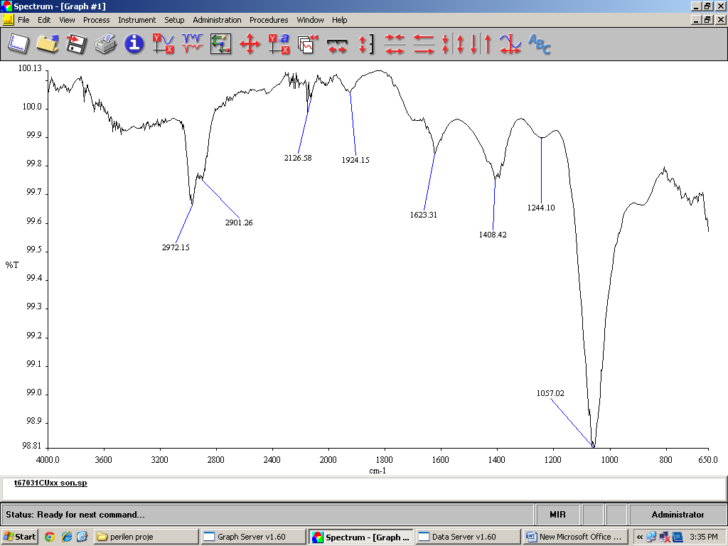

**Fig. S8.** FT-IR spectrum of **TMAC**-Cu2+ complex.

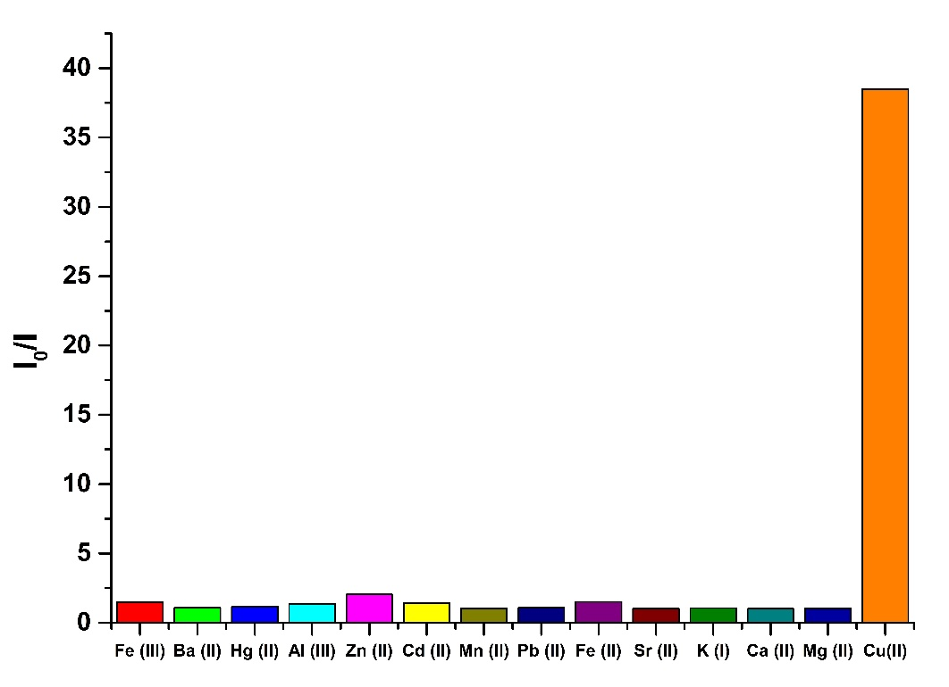

**Fig. S9.** Changes in the fluorescence intensity ratio (Io/I) of **TMAC** in the presence of various metal ions at 481 nm in ACN/HEPES (v/v=95/5) solution (ex= 364 nm).

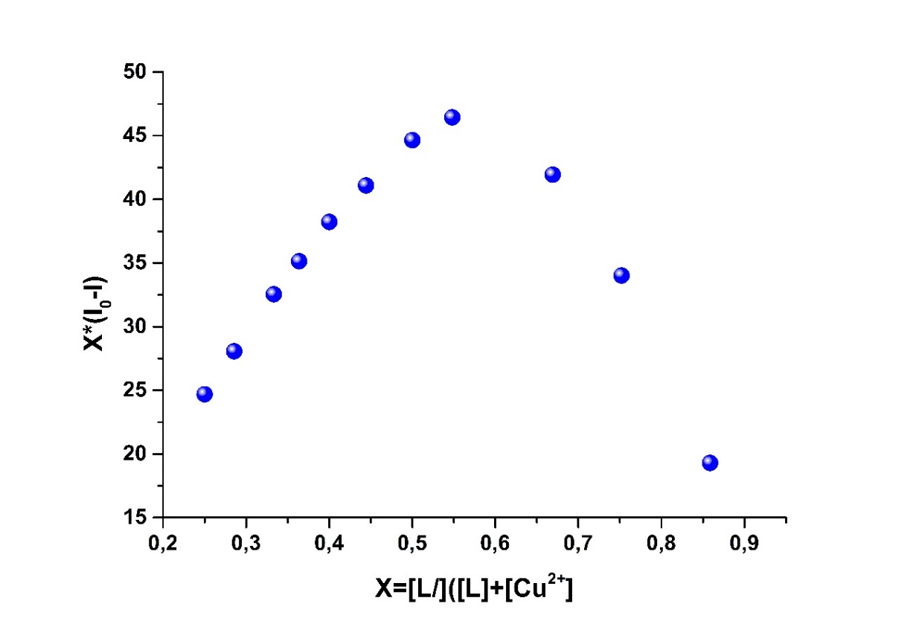

Fig. S10. Job plots of TMAC-Cu2+ complex in ACN/HEPES buffer solution (95:5, v/v, 5 μM, pH 7.0) at 445 nm (ex= 364 nm).

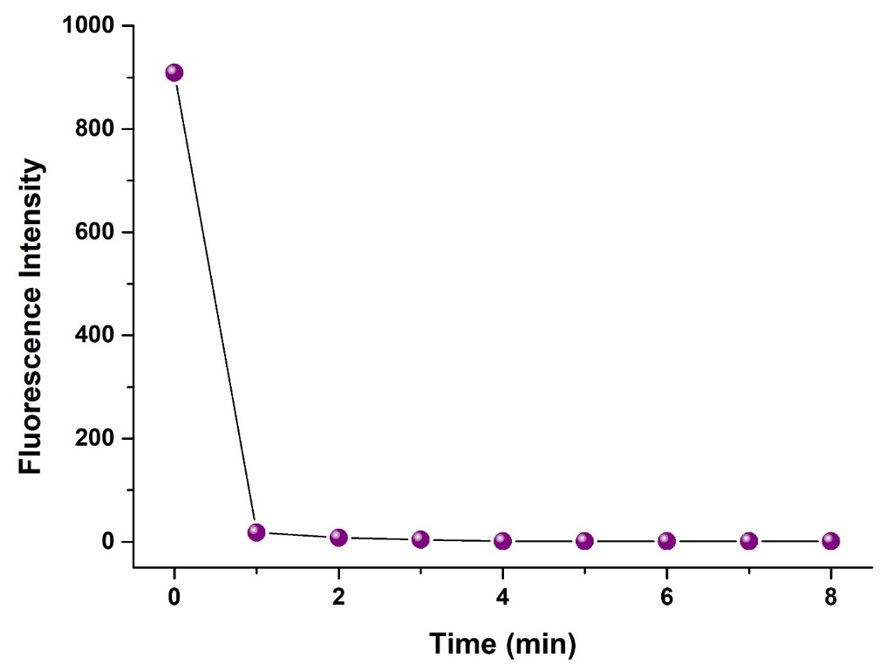

**Figure S11.** Response time of **TMAC-Cu2+** complex.

**Table S1.** Comparison of fluorescent probe **APICP** for detection of Cu2+ ions.

|  |  |  |  |
| --- | --- | --- | --- |
| **Fluorescent Cu2+ Sensor** | **Mode** | **Detection Limit for Cu3+** | **Ref** |
|  | Turn-off | 40 nM | (Mani et al., 2019) |
|  | Turn-off | 6 µM | (Roy, Chakraborty, & Ghosh, 2018) |
|  | Turn-off | 0.1 µM | (Xu, Wang, Zhang, Wu, & Liu, 2013) |
|  | Turn-off | 0.64 µM | (Warrier & Kharkar, 2018) |
|  | Turn-off | 5.13 nM | Our work |

**Table S2.** Determination of Cu2+ in various water and beverage samples by TMAC

|  |  |  |  |  |
| --- | --- | --- | --- | --- |
| **sample** | **Cu(II) added (μmol L−1)** | **Cu(II) found (μmol L−1)** | **recovery (%)** | **RSD (%) (n=3)** |
| ***fizzy drink samples*** |  |  |  |  |
| soda water (unfruitful) | 0.00 | 2.79 ±0.01 |  | 0.26 |
| 0.10 | 2.88 ±0.01 | 94.83 | 0.41 |
| 0.20 | 2.99 ±0.03 | 98.82 | 0.83 |
| soda water (grape&black mulberry–flavored) | 0.00 | 0.11 ±0.01 |  | 4.90 |
| 0.10 | 0.21 ±0.01 | 95.84 | 2.78 |
| 0.20 | 0.32 ±0.01 | 106.24 | 2.15 |
| energy drink (mixed fruit–flavored) | 0.00 | 0.25 ±0.01 |  | 2.83 |
| 0.10 | 0.35 ±0.01 | 107.87 | 1.42 |
| 0.20 | 0.45 ±0.01 | 99.08 | 1.23 |
| fizzy drink(orange–flavored) | 0.00 | 0.16 ±0.01 |  | 3.44 |
| 0.10 | 0.26 ±0.01 | 102.01 | 2.01 |
| 0.20 | 0.35 ±0.01 | 96.14 | 1.88 |
| cola | 0.00 | 0.04 ±0.002 |  | 5.46 |
| 0.10 | 0.13±0.006 | 91.19 | 4.64 |
| 0.20 | 0.24 ±0.005 | 102.31 | 2.03 |
| fizzy drink (mixed fruit–flavored) | 0.00 | 0.05 ±0.001 |  | 1.29 |
| 0.10 | 0.15±0.004 | 95.90 | 2.74 |
| 0.20 | 0.27 ±0.003 | 108.95 | 1.24 |
| ***tea and coffee samples*** |  |  |  |  |
| ice tea (nectar fruit–flavored) | 0.00 | 0.70 ±0.01 |  | 0.97 |
| 0.10 | 0.80±0.01 | 100.52 | 1.35 |
| 0.20 | 0.89 ±0.01 | 94.60 | 1.24 |
| green tea (mint and lemon–flavored) | 0.00 | 0.47 ±0.01 |  | 1.37 |
| 0.10 | 0.56±0.01 | 92.20 | 0.80 |
| 0.20 | 0.65 ±0.01 | 91.23 | 1.53 |
| coffee | 0.00 | 6.26 ±0.08 |  | 1.21 |
| 0.10 | 6.37±0.09 | 107.68 | 1.51 |
| 0.20 | 6.45 ±0.06 | 97.06 | 0.91 |
| black tea (bergamot–flavored) | 0.00 | 0.29 ±0.01 |  | 1.71 |
| 0.10 | 0.40±0.01 | 103.94 | 2.15 |
| 0.20 | 0.49 ±0.01 | 100.76 | 1.22 |
| ***milk samples*** |  |  |  |  |
| milk | 0.00 | 2.85 ±0.07 |  | 2.46 |
| 0.10 | 2.95 ±0.06 | 99.28 | 2.02 |
| 0.20 | 3.06 ±0.05 | 102.22 | 1.73 |
| Milk (strawberry–flavored) | 0.00 | 1.68 ±0.02 |  | 1.19 |
| 0.10 | 1.78 ±0.03 | 105.48 | 1.41 |
| 0.20 | 1.86 ±0.02 | 90.24 | 1.08 |
| latte | 0.00 | 2.71 ±0.11 |  | 4.14 |
| 0.10 | 2.82 ±0.06 | 107.70 | 2.08 |
| 0.20 | 2.91 ±0.08 | 95.80 | 2.60 |
| ***water samples*** |  |  |  |  |
| drinking water | 0.00 | 0.44 ±0.01 |  | 1.08 |
| 0.10 | 0.54 ±0.01 | 102.19 | 0.67 |
| 0.20 | 0.65 ±0.01 | 107.98 | 1.17 |
| tap water | 0.00 | 0.23 ±0.01 |  | 3.74 |
| 0.10 | 0.33 ±0.01 | 95.37 | 1.39 |
| 0.20 | 0.43 ±0.01 | 100.00 | 1.86 |
| Fisandun dam water | 0.00 | 0.14 ±0.003 |  | 2.33 |
| 0.10 | 0.23 ±0.003 | 94.86 | 1.32 |
| 0.20 | 0.36 ±0.005 | 109.75 | 1.44 |
| ultra pure water | 0.00 | 0.12 ±0.001 |  | 0.85 |
| 0.10 | 0.21 ±0.004 | 94.04 | 1.96 |
| 0.20 | 0.32 ±0.002 | 98.94 | 0.63 |
| ***fruit juice samples*** |  |  |  |  |
| orange juice | 0.00 | 0.26 ±0.01 |  | 4.49 |
| 0.10 | 0.36±0.01 | 99.08 | 3.66 |
| 0.20 | 0.47 ±0.01 | 107.00 | 2.04 |
| cherry juice | 0.00 | 0.21 ±0.01 |  | 2.79 |
| 0.10 | 0.31±0.01 | 105.53 | 3.20 |
| 0.20 | 0.42 ±0.01 | 105.56 | 2.39 |
| apple juice-1 | 0.00 | 0.16 ±0.01 |  | 2.88 |
| 0.10 | 0.27±0.01 | 105.90 | 1.48 |
| 0.20 | 0.38 ±0.01 | 108.43 | 1.54 |
| tomato juice | 0.00 | 3.59 ±0.02 |  | 0.58 |
| 0.10 | 3.69 ±0.04 | 107.45 | 1.18 |
| 0.20 | 3.80 ±0.05 | 106.15 | 1.33 |
| apple juice-2 | 0.00 | 0.53 ±0.01 |  | 1.05 |
| 0.10 | 0.64 ±0.01 | 103.76 | 1.07 |
| 0.20 | 0.72 ±0.01 | 93.08 | 1.49 |
| fruit juice (mixed fruit–flavored) | 0.00 | 0.71 ±0.02 |  | 2.19 |
| 0.10 | 0.80 ±0.01 | 94.47 | 1.52 |
| 0.20 | 0.89 ±0.02 | 91.23 | 1.98 |
| ***alcoholic beverage samples*** |  |  |  |  |
| beer | 0.00 | 0.33 ±0.01 |  | 2.68 |
| 0.10 | 0.43 ±0.01 | 100.63 | 1.37 |
| 0.20 | 0.54 ±0.01 | 107.57 | 2.00 |
| red wine | 0.00 | 0.26 ±0.01 |  | 2.87 |
| 0.10 | 0.37 ±0.01 | 102.03 | 1.58 |
| 0.20 | 0.46 ±0.01 | 98.77 | 1.19 |

**Table S3.** Determination of Cu2+ in water and beverage samples by AAS

|  |  |  |  |  |
| --- | --- | --- | --- | --- |
| **sample** | **Cu(II) added (μg L−1)** | **Cu(II) found (μg L−1)** | **recovery (%)** | **RSD (%) (n=3)** |
| ***fizzy drink samples*** |  |  |  |  |
| soda water (unfruitful) | 0 | 175.21 ±0.99 |  | 0.56 |
| 10 | 185.52 ±1.36 | 103.15 | 0.73 |
| 20 | 194.80 ±0.92 | 97.97 | 0.47 |
| soda water (grape&black mulberry–flavored) | 0 | 6.89 ±0.06 |  | 0.87 |
| 10 | 15.92 ±0.08 | 90.28 | 0.50 |
| 20 | 25.16 ±0.28 | 91.32 | 1.09 |
| energy drink (mixed fruit–flavored) | 0 | 15.79 ±0.19 |  | 1.18 |
| 10 | 25.05 ±0.15 | 92.60 | 0.62 |
| 20 | 35.23 ±0.27 | 97.17 | 0.76 |
| fizzy drink(orange–flavored) | 0 | 10.19 ±0.03 |  | 0.27 |
| 10 | 20.20 ±0.35 | 100.12 | 1.75 |
| 20 | 29.99 ±0.12 | 99.00 | 0.39 |
| cola | 0 | 2.51 ±0.03 |  | 1.14 |
| 10 | 12.14 ±0.10 | 96.28 | 0.86 |
| 20 | 22.43 ±0.52 | 99.63 | 2.32 |
| fizzy drink (mixed fruit–flavored) | 0 | 3.17 ±0.04 |  | 1.19 |
| 10 | 13.31 ±0.39 | 101.42 | 2.93 |
| 20 | 23.78 ±1.28 | 103.07 | 5.39 |
| ***tea and coffee samples*** |  |  |  |  |
| ice tea (nectar fruit–flavored) | 0 | 44.51 ±0.16 |  | 0.36 |
| 10 | 54.33 ±0.42 | 98.19 | 0.78 |
| 20 | 65.33 ±1.53 | 104.11 | 2.34 |
| green tea (mint and lemon–flavored) | 0 | 29.76 ±0.08 |  | 0.25 |
| 10 | 39.42 ±0.18 | 96.65 | 0.47 |
| 20 | 50.11 ±1.15 | 101.75 | 2.30 |
| coffee | 0 | 397.17 ±0.58 |  | 0.15 |
| 10 | 406.41 ±0.57 | 92.36 | 0.14 |
| 20 | 417.59 ±1.46 | 102.09 | 0.35 |
| black tea (bergamot–flavored) | 0 | 18.46 ±0.05 |  | 0.29 |
| 10 | 28.63 ±0.28 | 101.68 | 0.96 |
| 20 | 38.35 ±0.52 | 99.45 | 1.36 |
| ***milk samples*** |  |  |  |  |
| milk | 0 | 180.89 ±0.19 |  | 0.11 |
| 10 | 190.35 ±0.53 | 94.53 | 0.28 |
| 20 | 201.08 ±1.81 | 100.95 | 0.90 |
| Milk (strawberry–flavored) | 0 | 107.04 ±0.18 |  | 0.17 |
| 10 | 116.24 ±0.68 | 91.98 | 0.59 |
| 20 | 127.25 ±2.07 | 101.05 | 1.63 |
| latte | 0 | 172.43 ±0.47 |  | 0.27 |
| 10 | 182.13 ±2.96 | 96.95 | 1.62 |
| 20 | 193.57 ±2.38 | 105.68 | 1.23 |
| ***water samples*** |  |  |  |  |
| drinking water | 0 | 27.38 ±0.95 |  | 3.46 |
| 10 | 36.97 ±0.59 | 95.93 | 1.60 |
| 20 | 47.88 ±1.97 | 102.48 | 4.11 |
| tap water | 0 | 14.55 ±0.45 |  | 3.10 |
| 10 | 24.55 ±0.96 | 99.96 | 3.90 |
| 20 | 35.29 ±2.06 | 103.69 | 5.84 |
| Fisandun dam water | 0 | 8.63 ±0.36 |  | 4.19 |
| 10 | 18.91 ±0.40 | 102.82 | 2.12 |
| 20 | 29.45 ±0.51 | 104.13 | 1.75 |
| ultra pure water | 0 | 7.55 ±0.20 |  | 2.59 |
| 10 | 17.01 ±0.60 | 94.60 | 3.52 |
| 20 | 28.17 ±0.82 | 103.08 | 2.91 |
| ***fruit juice samples*** |  |  |  |  |
| orange juice | 0 | 16.51 ±0.17 |  | 1.02 |
| 10 | 26.69 ±0.95 | 101.85 | 3.56 |
| 20 | 34.89 ±2.17 | 91.93 | 6.21 |
| cherry juice | 0 | 13.53 ±0.08 |  | 0.60 |
| 10 | 23.74 ±0.80 | 102.06 | 3.36 |
| 20 | 33.20 ±2.52 | 98.36 | 7.60 |
| apple juice-1 | 0 | 10.30 ±0.20 |  | 1.98 |
| 10 | 20.17 ±0.18 | 98.67 | 0.91 |
| 20 | 31.10 ±0.36 | 104.01 | 1.16 |
| tomato juice | 0 | 227.40 ±0.75 |  | 0.33 |
| 10 | 237.22 ±0.78 | 98.13 | 0.33 |
| 20 | 247.87 ±0.53 | 102.35 | 0.21 |
| apple juice-2 | 0 | 33.66 ±0.41 |  | 1.20 |
| 10 | 43.53 ±0.49 | 98.74 | 1.12 |
| 20 | 53.67 ±2.85 | 100.08 | 5.31 |
| fruit juice (mixed fruit–flavored) | 0 | 45.72 ±0.33 |  | 0.72 |
| 10 | 54.75 ±0.60 | 90.29 | 1.10 |
| 20 | 66.04 ±1.29 | 101.58 | 1.95 |
| ***alcoholic beverage samples*** |  |  |  |  |
| beer | 0 | 21.05 ±0.42 |  | 2.00 |
| 10 | 30.58 ±0.92 | 95.36 | 3.02 |
| 20 | 41.68 ±1.36 | 103.18 | 3.25 |
| red wine | 0 | 16.62 ±0.27 |  | 1.65 |
| 10 | 26.20 ±0.61 | 95.79 | 2.33 |
| 20 | 37.03 ±0.98 | 102.02 | 2.65 |