Overlap of highly FDG-avid and FMISO hypoxic tumour subvolumes in patients with head and neck cancer

David Mönnich^{a,b}, Daniela Thorwarth^{a,b}, Sara Leibfarthª, Christina Pfannenberg^{c}, Gerald Reischl^{d}, Paul-Stefan Mauz^{e}, Konstantin Nikolaou^{c}, Christian la Fougère^{f}, Daniel Zips^{b,g}, Stefan Welz^{g}

ªSection for Biomedical Physics, Department of Radiation Oncology, University Hospital and Medical Faculty, Eberhard Karls University Tübingen, Tübingen, Germany; ^{b}German Cancer Consortium (DKTK), partner site Tübingen; and German Cancer Research Center (DKFZ), Heidelberg, Germany; ^{c}Department of Diagnostic and Interventional Radiology, University Hospital and Medical Faculty, Eberhard Karls University Tübingen, Tübingen, Germany; ^{d}Preclinical Imaging and Radiopharmacy, Department of Diagnostic and Interventional Radiology, University Hospital and Medical Faculty, Eberhard Karls University Tübingen, Tübingen, Germany; ^{e}Head and Neck Surgery, Department of Otorhinolaryngology, University Hospital and Medical Faculty, Eberhard Karls University Tübingen, Tübingen, Germany; ^{f}Nuclear Medicine, Department of Radiology, University Hospital and Medical Faculty, Eberhard Karls University Tübingen, Tübingen, Germany; ^{g}Department of Radiation Oncology, University Hospital and Medical Faculty, Eberhard Karls University Tübingen, Tübingen, Germany

Corresponding author:
Address: David Mönnich, Section for Biomedical Physics, Department of Radiation Oncology, Hoppe-Seyler-Str. 3, 72076 Tübingen, Germany; E-mail address: david.moennich@med.uni-tuebingen.de

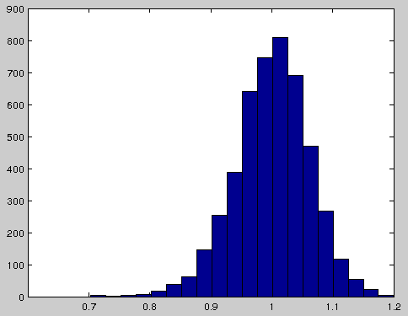
SD = 0.06
mean = 1.00
TMR in neck muscle (all patients)

Supplementary Material Figure 1: The overall histogram of TMR values in the muscle ROIs for all patients. For each patient the muscle values were normalized by the respective mean value, to calculate the TMR. Consequently, the mean of the distribution is 1.00. A standard deviation of 0.06 was observed. Thus, a TMR threshold value of 1.4 to identify hypoxic subvolumes is more than six times the standard deviation higher than the mean muscle activity.
Supplementary Material Table 1: Voxel-based correlations between the three different PET tracers in the GTV_{prim} expanded by a 5 mm margin. The Pearson correlation coefficient r_{p} and the Spearman rank correlation coefficient r_{s} are shown.
 | r_{s} | r_{p}
FMISO_{4h} - FDG | 0.62 (0.28-0.84) | 0.65 (0.38-0.87)
FMISO _{4h} - M | 0.28 (0.00-0.65) | 0.34 (-0.04-0.71)
FDG - M | 0.28 (-0.09-0.62) | 0.33 (-0.07-0.78)
Supplementary Material Table 2: Absolute volumes of the different segmentations were compared using a Mann-Whitney U test. The table shows p values for the different combinations. All p values are smaller than 0.05.
 | GTV_{prim} | V_{FDG} | V_{H} | V_{M}
GTV_{prim} | 1 | 4.87×10⁻⁷ | 2.55×10⁻⁶ | 5.21×10⁻⁸
V_{FDG} |  | 1 | 3.15×10⁻² | 5.34×10⁻⁷
V_{H} |  |  | 1 | 6.26×10⁻³
V_{M} |  |  |  | 1
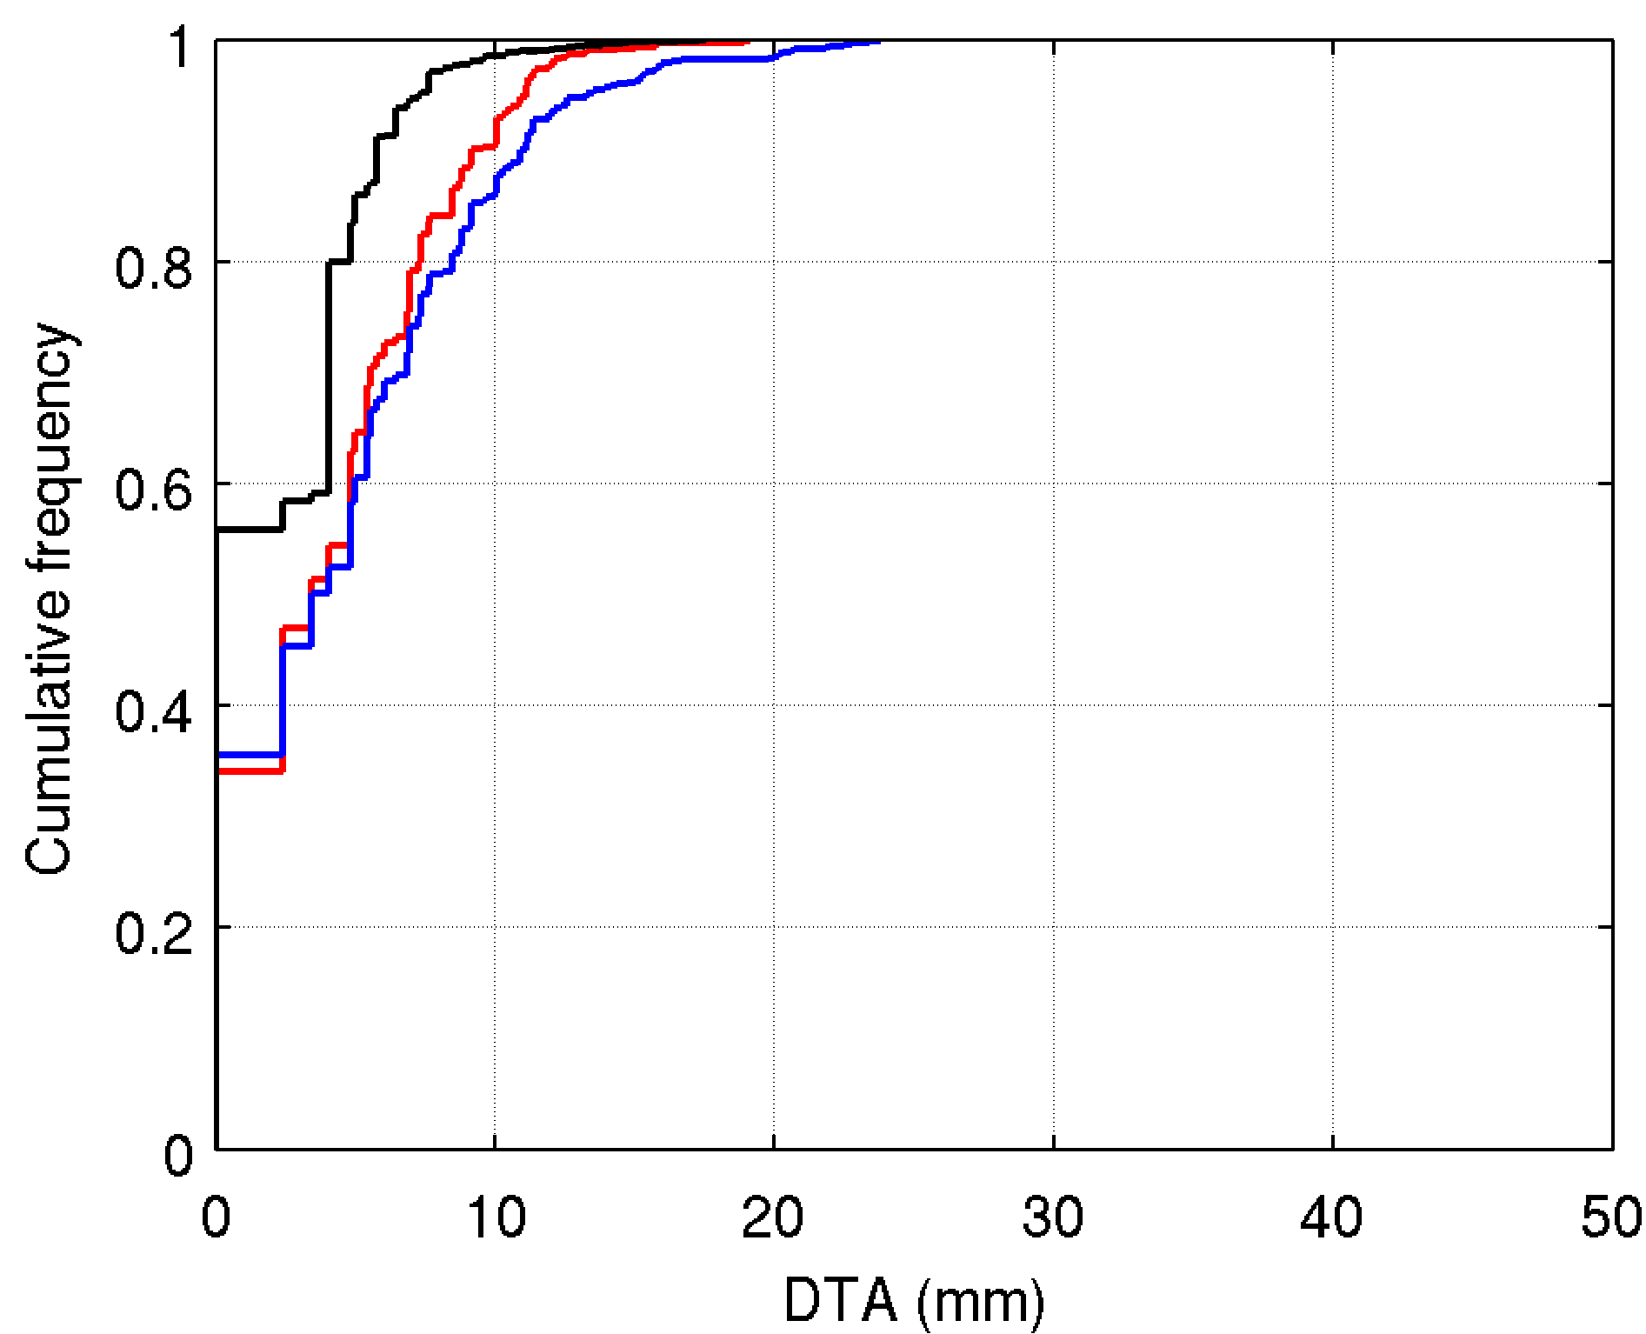
Supplementary Material Figure 2: The small number of very large DTAs in Figure 1 disappear if patients Tue012 and Tue017 are excluded from the analysis.
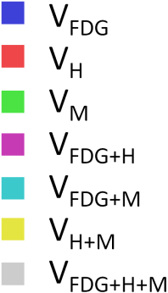
Supplementary Material Figure 3: Legend for Supplementary Material Figures 4-24.

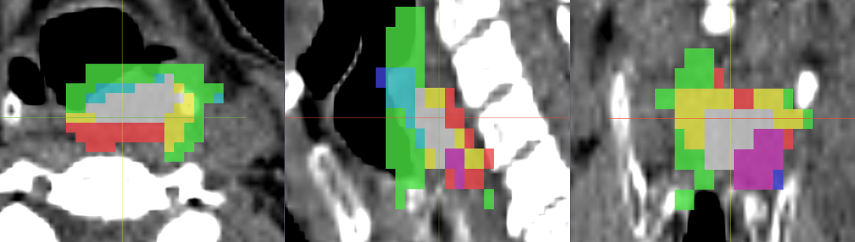
Supplementary Material Figure 4: Tue004
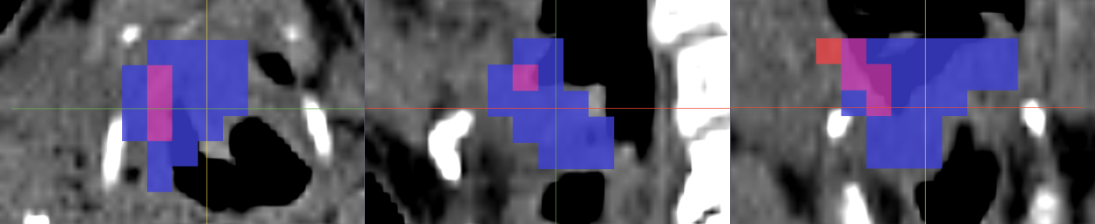
Supplementary Material Figure 5: Tue005
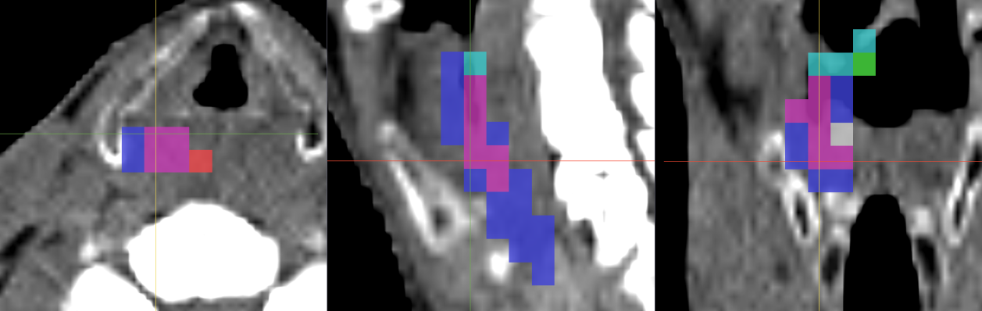
Supplementary Material Figure 6: Tue006
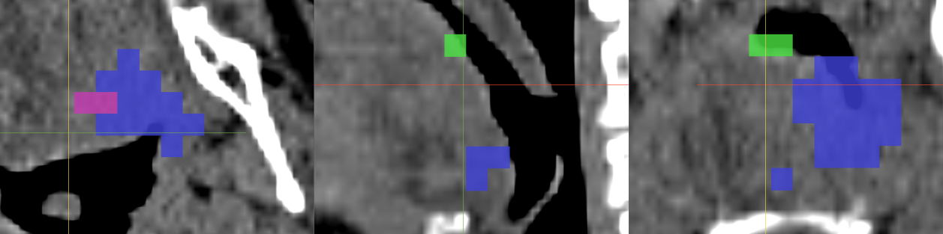
Supplementary Material Figure 7: Tue007
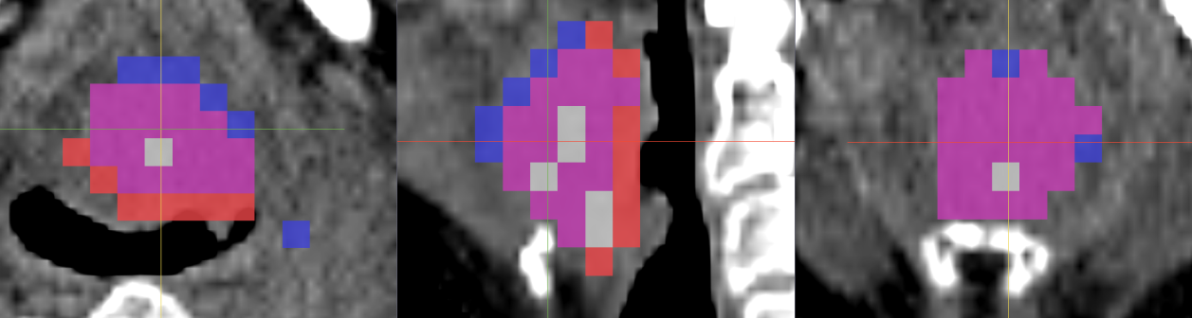
Supplementary Material Figure 8: Tue008
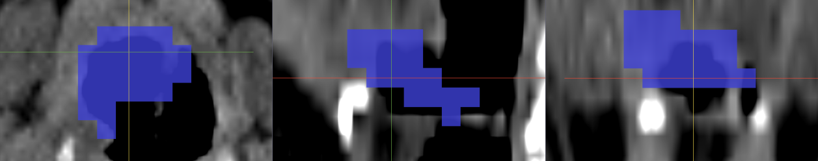
Supplementary Material Figure 9: Tue009
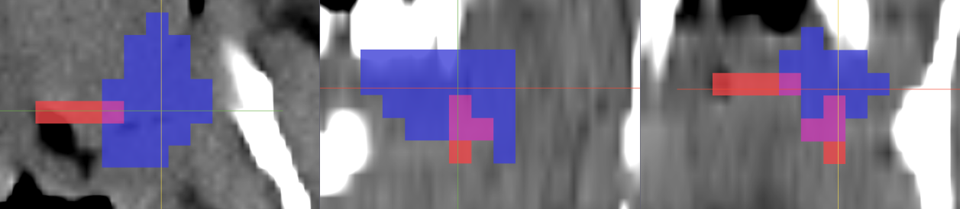
Supplementary Material Figure 10: Tue010
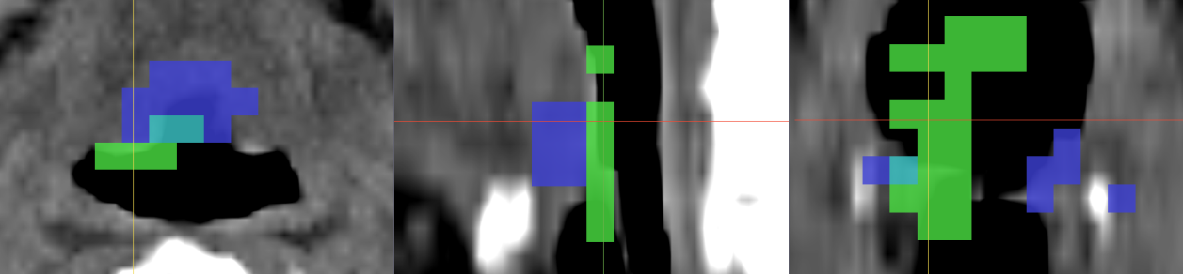
Supplementary Material Figure 11: Tue011
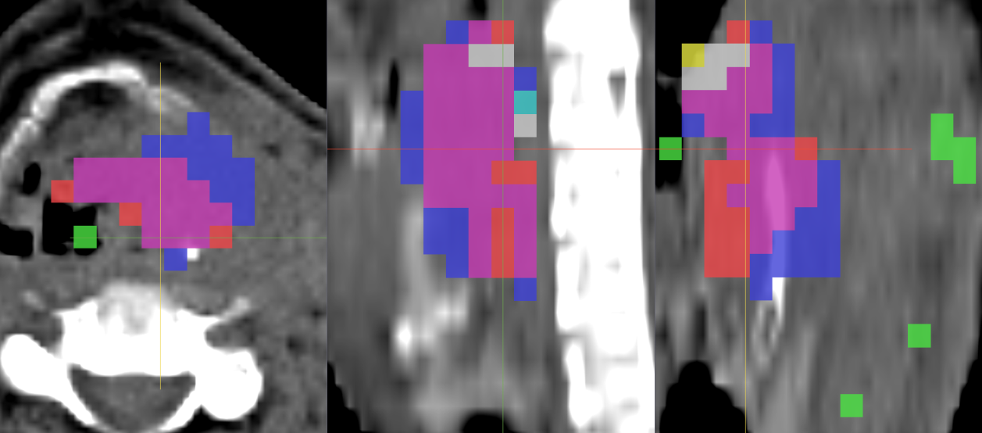
Supplementary Material Figure 12: Tue012
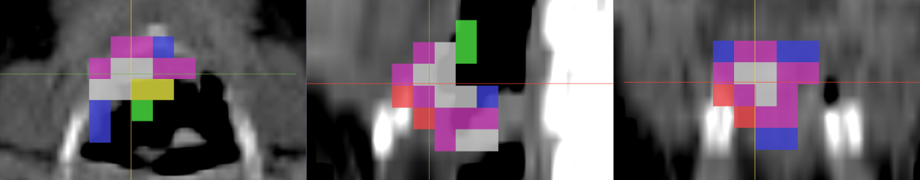
Supplementary Material Figure 13: Tue013
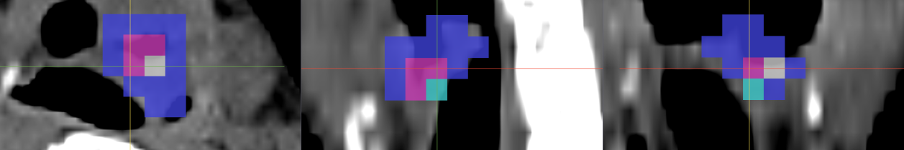
Supplementary Material Figure 14: Tue014
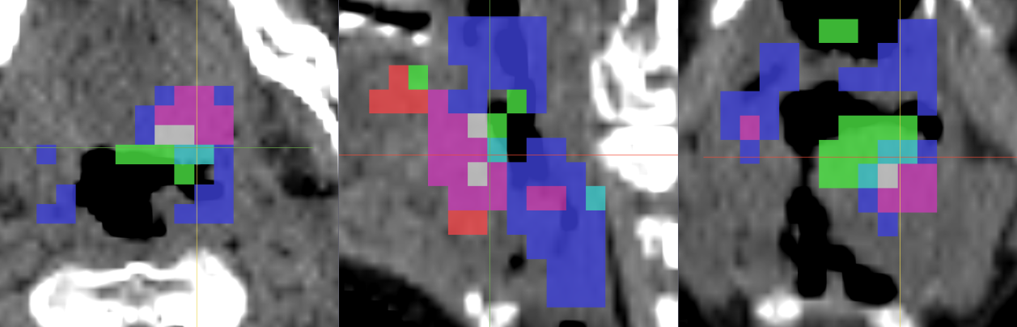
Supplementary Material Figure 15: Tue15
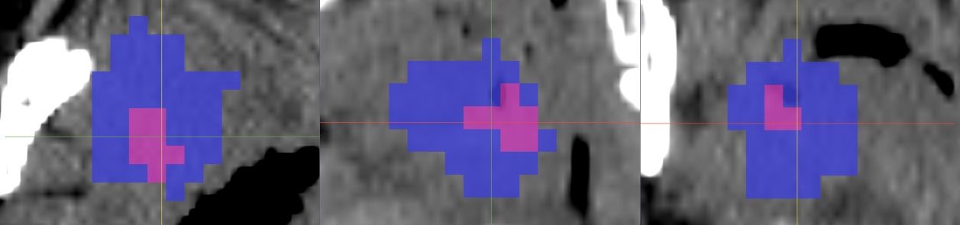
Supplementary Material Figure 16: Tue016
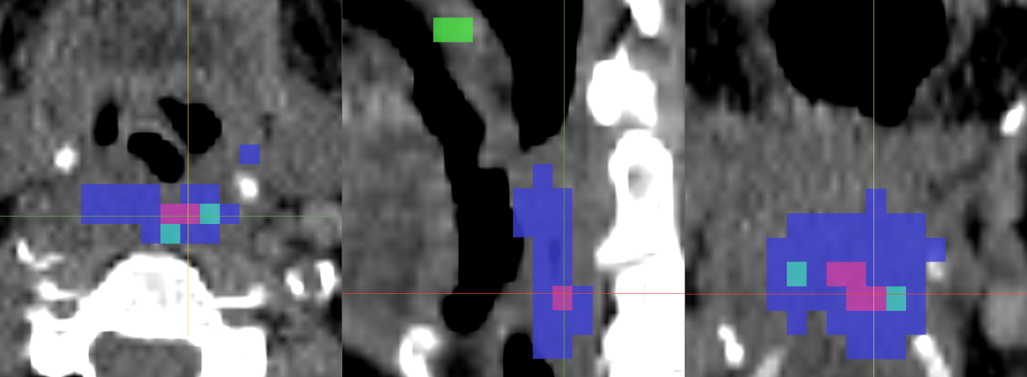
Supplementary Material Figure 17: Tue017
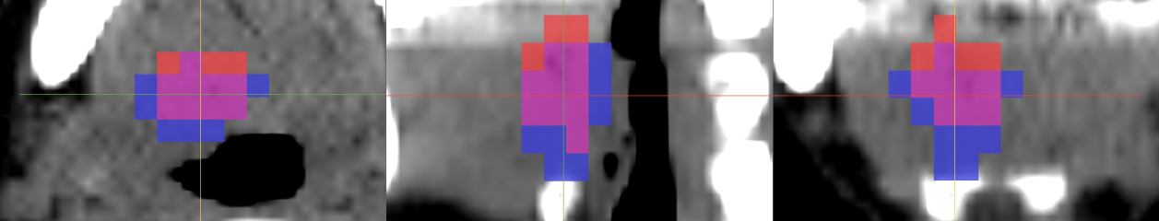
Supplementary Material Figure 18: Tue018
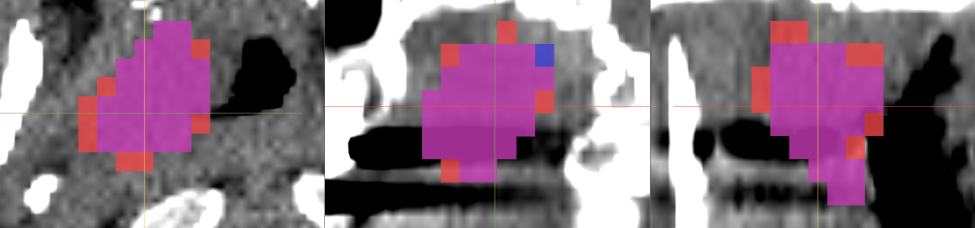
Supplementary Material Figure 19: Tue019
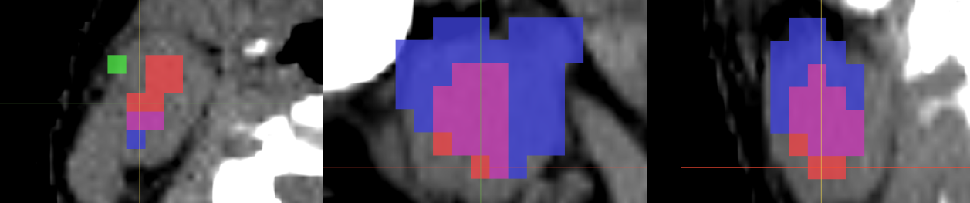
Supplementary Material Figure 20: Tue020
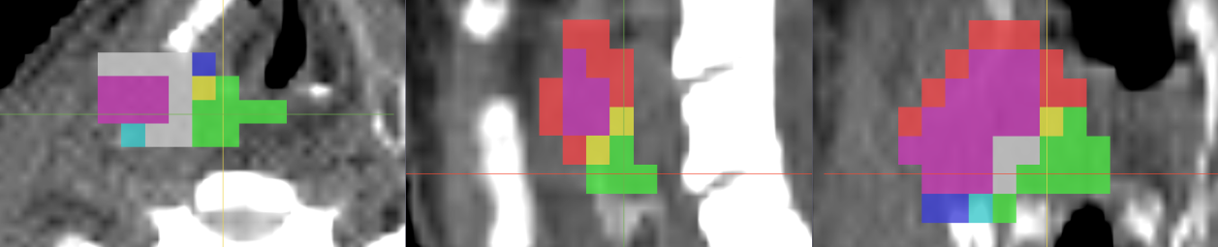
Supplementary Material Figure 21: Tue022
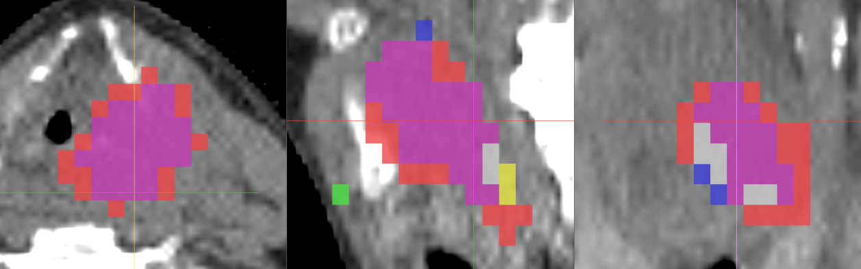
Supplementary Material Figure 22: Tue023
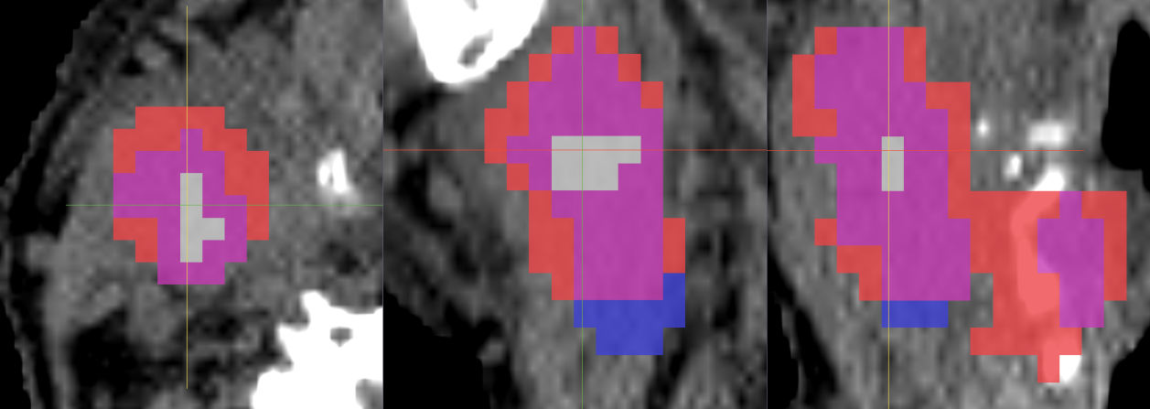
Supplementary Material Figure 23: Tue24
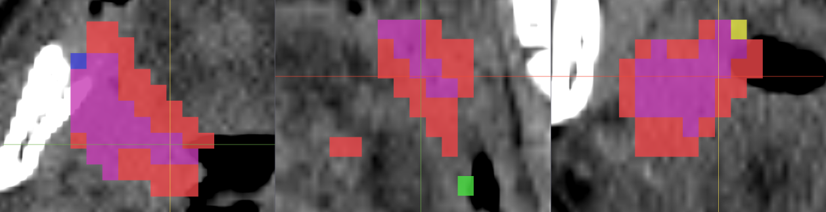
Supplementary Material Figure 24: Tue025

