a
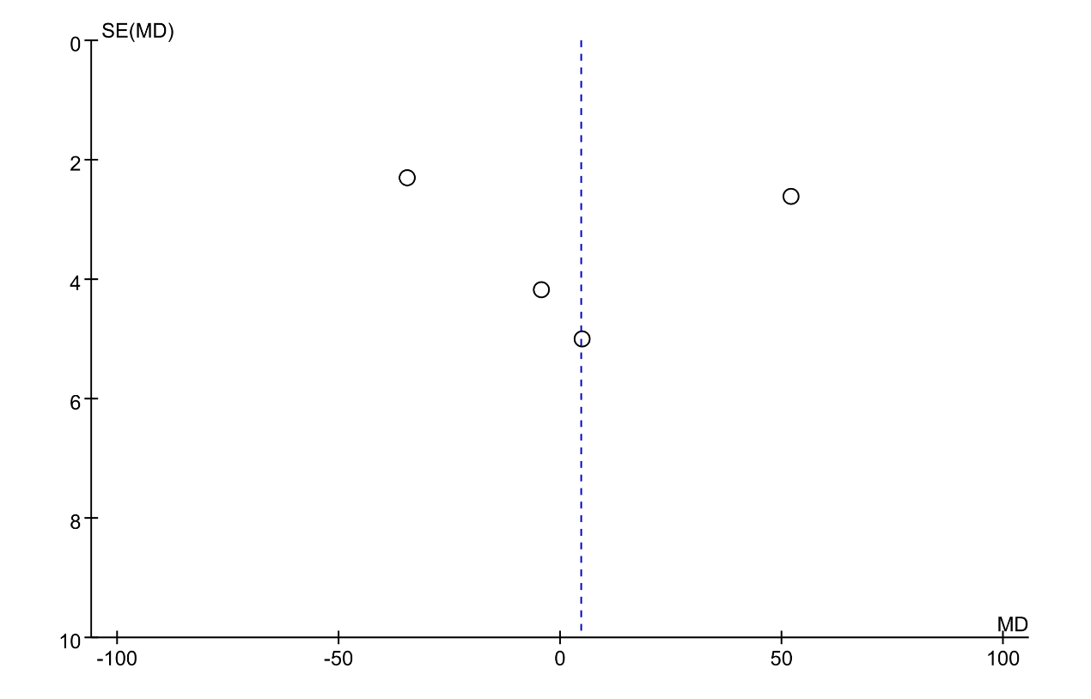
b
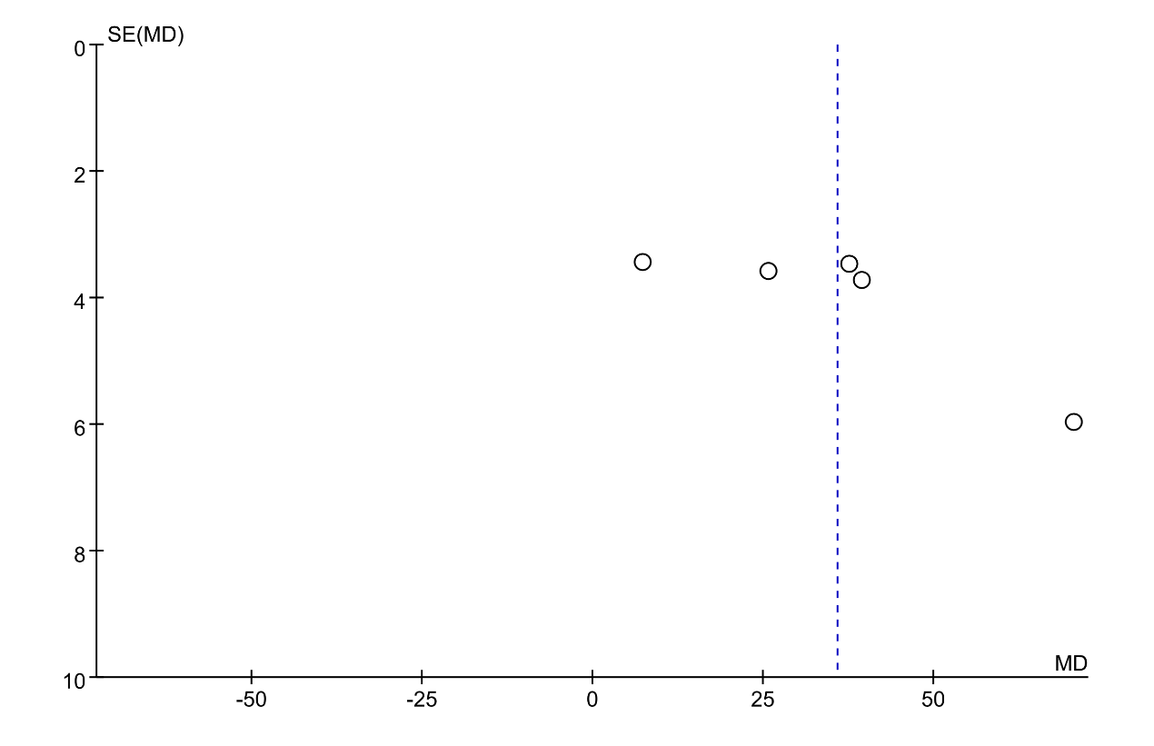
Fig. S12
Funnel plot of flare: a fexofenadine vs. the second-generation antihistamines; b fexofenadine vs. placebo.

