Table S1. The effects of exogenous AHL molecules on biofilm formation in P. fluorescens (mean ± SD).
Additive | Concentration | Biofilm formationª | Stimulation rate (%)^{b}
Control | 0 μL/mL | 0.793±0.021^{g} | —
C₄-HSL | 2 μg/mL | 1.804±0.013^{c} | 127.49%
C₆-HSL | 2 μg/mL | 1.212±0.025e | 52.83%
C₈-HSL | 2 μg/mL | 1.182±0.009e | 49.05%
C₁₀-HSL | 2 μg/mL | 0.814±0.021^{g} | 2.64%
C₁₂-HSL | 2 μg/mL | 0.915±0.010^{f} | 15.38%
C₁₄-HSL | 2 μg/mL | 1.481±0.031^{d} | 86.76%
ªExpressed as OD₅₉₅ after staining with crystal violet
^{b}The stimulation rate = [(OD experimental group – OD control group) / OD control group] ×100
^{c-g}Significantly different means (P < 0.05)

Table S2. The effect of AHLs on protease activity of P. fluorescens (mean ± SD)
Additive | Concentration | Proteinase activity (mm)ª |  | Stimulation rate (%)^{b}
Control | 0 μL/mL | 20.03±0.05^{g} | —
C₄-HSL | 2 μg/mL | 32.73±0.09^{c} | 63.40%
C₆-HSL | 2 μg/mL | 27.31±0.07e | 36.35%
C₈-HSL | 2 μg/mL | 26.17±0.11e | 30.65%
C₁₀-HSL | 2 μg/mL | 21.31±0.17^{g} | 6.39%
C₁₂-HSL | 2 μg/mL | 23.45±0.05^{f} | 17.07%
C₁₄-HSL | 2 μg/mL | 30.53±0.19^{d} | 52.42%
ªExpressed as diameter of the transparent enzymolysis circle generated by P. fluorescens in milk agar plates.
^{b}The stimulation rate = [(OD experimental group – OD control group) / OD control group] ×100
^{c-g}Significantly different means (P < 0.05)

Table S3. Structures and scores of P. fluorescens RhlR proteins models
Proteins | Template | Description | GMQE | QMEAN | Model
RhlR-type | 4y13.1.A | Transcriptional regulator of ftsQAZ gene cluster | 0.75 | -2.31 | 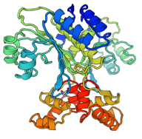
 | 3qp5.1.A | CviR transcriptional regulator | 0.45 | -4.15 | 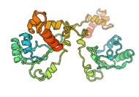

Table S4. Docking results of RhlR type protein of P. fluorescens with AHLs
Protein | Ligand | Total score | Crashª | Polar^{b} | Cscore^{c}
RhlR type | C₄-HSL | 4.09 | -0.85 | 2.83 | 4
 | C₆-HSL | 7.87 | -0.69 | 3.09 | 4
 | C₈-HSL | 7.11 | -1.11 | 1.69 | 4
 | C₁₀-HSL | 8.67 | -2.06 | 3.08 | 4
 | C₁₂-HSL | 8.16 | -1.55 | 2.06 | 4
 | C₁₄-HSL | 6.94 | -2.89 | 3.00 | 4
ªCrash represents the degree of inappropriate penetration by the ligand into the protein
^{b}Polar represents the contribution of hydrogen bonding and salt bridge interactions to the total score
^{c} Cscore is the function for ranking the binding affinity of ligands to the active site of a receptor

Fig. S1. The effect of exogenous AHL molecules on the growth of P. fluorescens at 28°C. Data are presented as means ± SD.
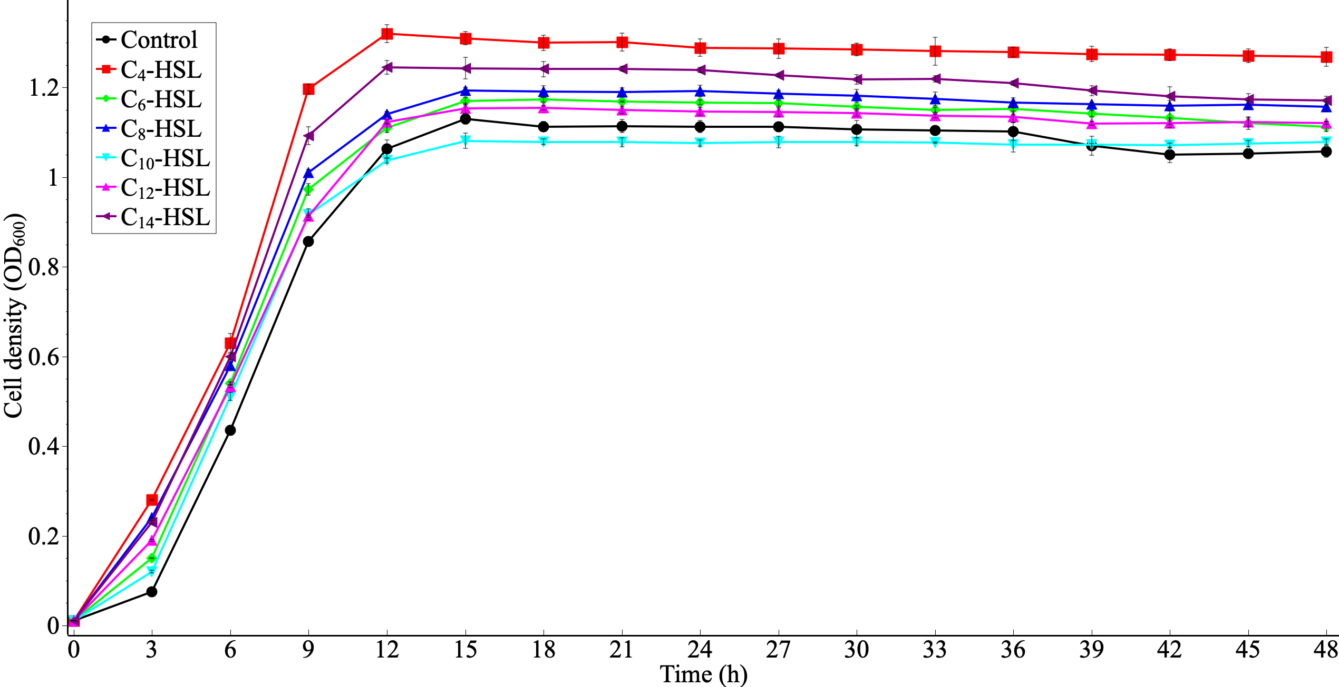
Fig. S2. GC-MS ion m/z 143 chromatograms of a mixture of standard AHL molecules (A) and the extracted supernatants of a pure P. fluorescens culture (B). The peaks detected at the retention time of 4.406 and 10.678 min were found to be C₄-HSL and C₁₀-HSL.
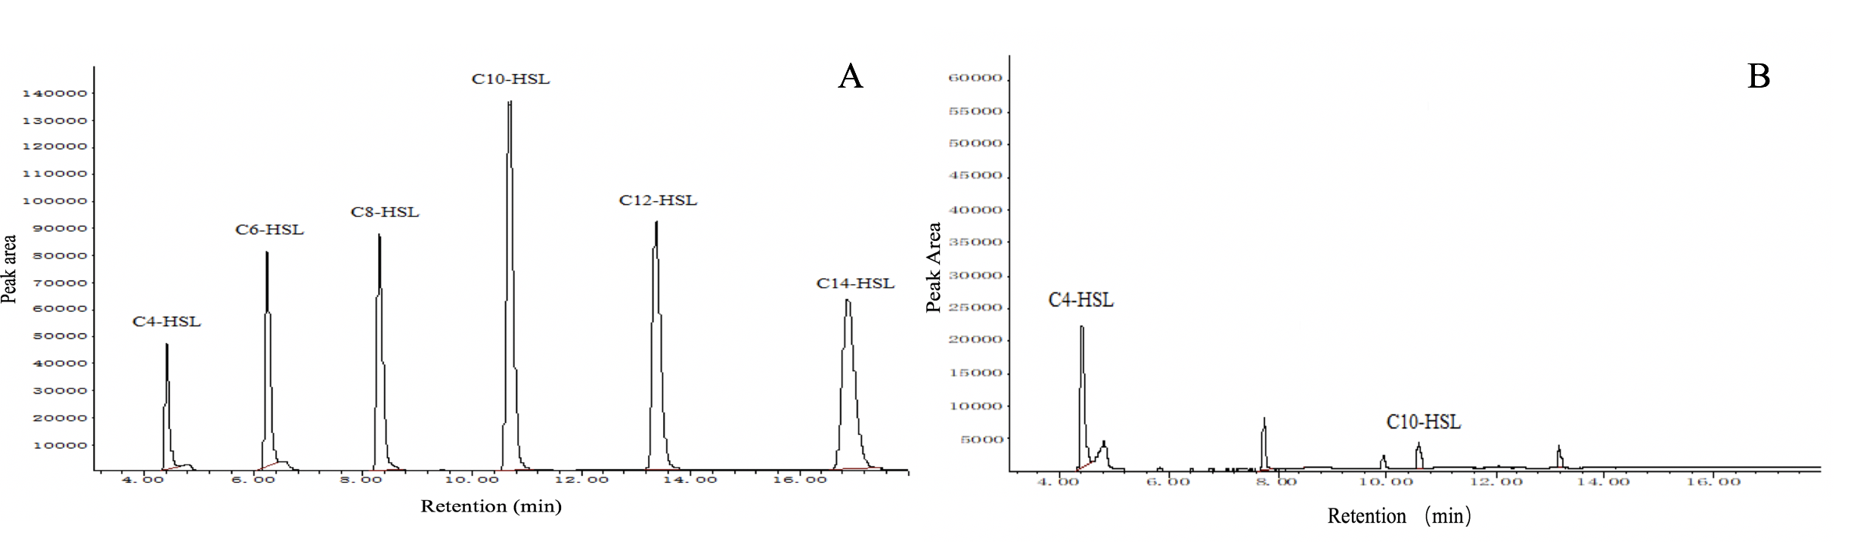

Fig. S3. Part of the sequence alignment results for RhlR proteins in P. fluorescens and its matching proteins.
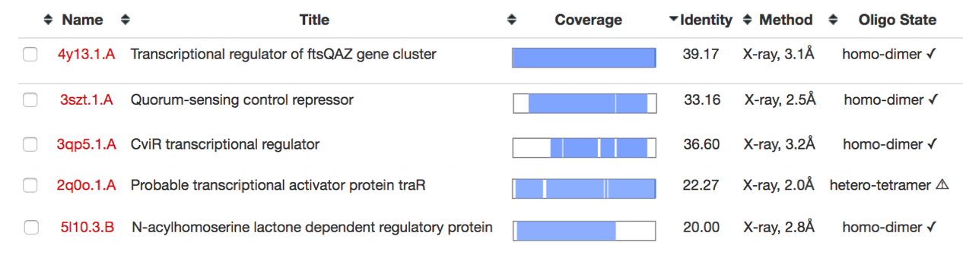
Fig. S4. Assessment of the quality of RhlR protein model of P. fluorescens.
