SUPPLEMENTAL MATERIAL

Upregulated Phospholipase D Activity Towards Glycosylphosphatidylinositol-Anchored Proteins in Micelle-Like Serum Complexes in Metabolically Deranged Rats and Humans

Günter A. Müller, Matthias H. Tschöp and Timo D. Müller

MATERIALS AND METHODS

Materials

Recombinant (E. coli) human GPI-PLD1 (0.5 units/mg protein) was purchased from Creative BioMart Inc. (New York, USA). Phosphatidylinositol (PI)-specific phospholipase C (PI-PLC; Bacillus cereus, 1 U/mg protein), bovine erythrocyte membranes, BSA (fraction V, defatted), 5,5-dithiobis-(2-nitrobenzoic acid)(DTNB), acetylcholine iodide, CNBr-activated Sepharose 4B, 9-amino-1,2,3,4-tetrahydroacridine hydrochloridehydrate (tacrine), 1,10-phenanthroline and reagents for the Bradford protein assay were bought from Sigma-Aldrich Chemie GmbH (Munich, Germany). Recombinant human annexin-V was delivered by ProSpec (East Brunswick, NJ, USA). Egg york L-α-phosphatidylcholine (PC), bovine brain L-α-phosphatidylserine (PS), bovine brain L-α-lysophosphatidylcholine (lysoPC) and cholesterol (all stored in chloroform) were obtained from Avanti Polar Lipids (Alabaster, AL, USA). Protease inhibitor cocktail (“complete Ultra” tablets) was provided by Roche Biochemicals (Mannheim, Germany). Reagents for chemical coupling were delivered by Pierce/Thermo Scientific (Rockford, IL, USA). Octyl glucoside, TX-100, TX-114, PBS (tablets), buffer substances and all other reagents (highest purity available) were from Calbiochem/Merck (Darmstadt, Germany). Polystyrene Bio-Beads SM-2 (20-50 mesh) were bought from Bio-Rad Laboratories (Munich, Germany). Rat und human sera were made available by A.W. Herling and A. Lechner, respectively, with the procedures of collection as well as the characteristics of the rats and probands as described previously (47).

Extraction and purification of full-length AChE and reconstitution into detergent micelles

AChE was prepared according to Refs. 28, 80, 81 with the following modification: Bovine erythrocyte membranes (stored at -20°C) were suspended in four volumes of 10 mM Tris/HCl (pH 7.4), 144 mM NaCl, 1 mM MgCl₂, thereafter homogenized in a Dounce homogenisator (on ice, 2 min) and then centrifuged (28,000xg, 20 min, 4°C). The supernatant was removed and this process was repeated a second time with the pellet fraction. The membrane lipids were removed from the AChE-containing pellet by chloroform/methanol (1:2 v/v; 30 min, 24°C). After centrifugation (2000xg, 10 min, 4°C) to eliminate organic supernatant, AChE was extracted by suspension of the delipidated pellet in 10 mM Tris/HCl (pH 7.4), 144 mM NaCl, 60 mM octyl glucoside. After incubation (15 h, 4°C, head-over rotation) and centrifugation (100,000xg, 30 min, 4°C), the supernatant containing approximately 3 IU/ml amphiphilic detergent-solubilized AChE (specific activity 1.2 IU/mg protein) and accounting for more than 95% of total AChE activity was loaded onto a Sepharose 4B-L-tyrosine-tacrine affinity resin column. The column was prepared by diazotisation of tacrine and coupling of this compound to Sepharose 4B-l-tyrosine as described previously (82), and equilibrated with 0.1 M phosphate buffer (pH 7.4). After washing of the affinity gel with 400 ml of phosphate buffer, AChE was eluted with 10 mM Na₂HPO₄ (pH 7.4), 200 mM NaCl, 0.05% TX-100 under continuous measurement of activity in the fractions at 412 nm and absorbance at 280 nm. Fractions containing substantial activity were dialyzed overnight against 10 mM Tris/HCl (pH 7.4), 150 mM NaCl, then lyophilized overnight and assessed for purity by reducing SDS-PAGE and Coomassie staining (single band of approximately 70 kDa) and protein by the Bradford method (78) with modifications from Read and Northcote (84) using BSA as standard. This one-step purification procedure typically resulted in a 500- to 700-fold enrichment (to apparent homogeneity according to SDS-PAGE and Coomassie staining) and a yield of 20 to 30% vs. the original octyl glucoside extract. The presence of the GPI anchor was evidenced by non-denaturing SDS-PAGE or TX-114 partitioning following incubation of samples in the absence or presence of PI-PLC (Bacillus cereus), which both enabled the discrimination of anchor-containing and anchor-less AChE. Lyophilized portions of AChE were reconstituted into detergent micelles by suspending in 50 mM Tris/HCl (pH 7.4), 150 mM NaCl, 0.02% NaN₃ containing either 15 mM octyl glucoside at 3 µM (final con.) or 0.1% TX-100 at 12 µM, subsequent gentle vortexing and final incubation (20°C, 10 min).

Reconstitution of AChE proteoliposomes and micelle-like AChE complexes using different constituent ratios

Proteoliposomes and micelle-like complexes consisting of PC, PS, lysoPC, cholesterol and AChE were prepared by mixing of these constituents in the detergent-solubilized state and subsequent removal of the detergent by adsorption onto polystyrene Bio-Beads (64) according to previously published protocols (77, 83, 85, 87) with the following modifications (see below). This caused the spontaneous assembly of PC, PS and cholesterol (and minor amounts of lysoPC, if present) together with AChE into unilamellar liposomes as well as of lysoPC (and minor amounts of PC, PS and cholesterol, if present) together with AChE into micelle-like complexes, which upon centrifugation are recovered from the pellet and supernatant fractions, respectively.
Preparation of Bio-Beads SM-2: 25 g of dry beads were added to 175 ml methanol in a plastic bottle. After rotation of the bottle on a tube rotator (20 rpm, 15 min), the slurry of beads and methanol was poured into a sintered glass funnel on a vacuum flask and the methanol removed by suction. Subsequently, the beads were washed sequentially with another 425 ml methanol and 2500 ml deionized water while still residing in the funnel, thereafter suspended in 50 ml of 20 mM HEPES/NaOH (pH 7.5), 100 mM NaCl, 0.02% NaN₃, (HSA) and finally degassed in a vacuum flask (2 h). After having removed any floating beads, the washed beads were stored as a suspension in HSA (20°C, for up to several months). Just before addition of the beads to the reconstitution mixture, an aliquot of beads was weighed out by dispension of slurried beads into a plastic weighing dish, aspiration of any excess liquid from the beads, transfer of damp beads to a second weighing dish on a balance using a pipet tip or spatula until the weight of damp beads equaled the desired amount (typically 50 or 350 mg damp weight) and final transfer of the weighed damp beads to the reconstitution mixture (carefully avoiding drying out of the beads before using them).
Reconstitution: LysoPC, PC and cholesterol in chloroform (10 mg/ml each) together with an invariant amout of PS (0.26 µmol) were dispensed into a glass test tube in a total volume of 1 ml at the indicated constituent ratios (see main text and and below) with regard to an invariant amount of AChE (0.3 nmol) and 2.6 µmol PC for lysoPC : PC or 1.3 µmol cholesterol for lysoPC : cholesterol and PC : cholesterol variations. After evaporation of the chloroform under a stream of N₂ under atmospheric pressure and then in a speed vac under high vacuum (60 min), the dried phospholipids (lipid films) were dispersed in 250 µl HSA and then completely dissolved by gentle vortexing and incubation (20°C, 30 min). The hydrated lipid dispersion was exposed to six freezing-thawing cycles (-180°C/+25°C) and then passed 40 times through a polycarbonate membrane (0.2 µm) with a mini-extruder (Avanti Polar Lipids). Incorporation of AChE was initiated by addition of 750 µl of 20 mM octyl glucoside and incubation (15 min, 25°C), which just destabilises the lipid bilayer to promote protein insertion. Subsequently, 100 µl of 3 µM AChE (0.3 nmol) freshly prepared from the lyophilized materials (see above) was added to the mixture in an Eppendorf tube. Reconstitution was initiated by the addition of 50 mg damp Bio-Beads to the tube and rotation on a tube rotator (20 rpm, 90 min, 20°C). After addition of another 350 mg (damp weight) of Bio-Beads and rotation (180 min), the Bio-Beads were allowed to settle (5 min). The supernatant haboring 300 nM AChE and 2.6 mM lipids in HSA (molar ratio = 8700:1) was carefully removed and represented the source for both AChE proteoliposomes and micelle-like AChE complexes. For separation and recovery, 200-µl portions of the supernatant were centrifuged (400,000xg, 1 h, 4°C; Beckman TL-100 ultracentrifuge, TLA-100 rotor, 95,000 rpm). The pellets containing the AChE proteoliposomes were suspended in 100 µl of HSA. The liposomes were sequentially sized through 0.4- and 0.2-µm polycarbonate membranes to select for large unilamellar ones (100-200 nm). The supernatants containing the micelle-like AChE complexes were subjected to a second cycle of detergent absorption with Bio-Beads (50 and 350 mg, see above). The final clear supernatants were subsequently purified by discontinuous flotation gradients (63, 77, 83, 85). For this, 3-ml portions were thoroughly mixed with 3 ml of sucrose (60% w/v) in 20 mM PIPES (pH 7.2), 100 mM K₂SO₄ at the bottom of 10-ml centrifuge tubes. 1-ml cushions of 10% and 2.5% sucrose (w/v) were successively layered above, followed by 2 ml of buffer. After centrifugation of the density gradients (30,000 rpm, 2 h, 4°C, Beckman SW41 rotor), 0.5-ml fractions were removed from the 2.5%-sucrose buffer interface resulting in about 5- to 6-fold concentration of the purified micelle-like AChE complexes. Control samples containing anchor-less AChE (upon incubation with PI-PLC) were also subjected to the reconstitution and sucrose density gradient flotation procedures. The constituent ratios used were as follows:

LysoPC:AChE a, 5000:1; b, 2000:1; c, 1000:1; d, 500:1; e, 200:1; f, 100:1; g, 50:1; h; 25:1; i, 15:1; k, 10:1; l, 5:1
LysoPC:Cholesterol a, 1000:1; b, 500:1; c, 200:1; d, 100:1; e, 50:1; f, 20:1; g, 10:1; h; 5:1; i, 2:1; k, 1:1; l, 1:2
LysoPC:PC a, 500:1; b, 200:1; c, 100:1; d, 50:1; e, 20:1; f, 10:1; g, 5:1; h; 2:1; i, 1:1; k, 1:2; l, 1:5
PC:AChE a, 5000:1; b, 2000:1; c, 1000:1; d, 500:1; e, 200:1; f, 100:1; g, 50:1; h; 25:1; i, 15:1; k, 10:1; l, 5:1
PC:Cholesterol a, 1000:1; b, 500:1; c, 200:1; d, 100:1; e, 50:1; f, 20:1; g, 10:1; h; 5:1; i, 2:1; k, 1:1; l, 1:2
Cholesterol:AChE a, 5000:1; b, 2000:1; c, 1000:1; d, 500:1; e, 200:1; f, 100:1; g, 50:1; h; 25:1; i, 15:1; k, 10:1; l, 5:1

Chip-based sensing of reconstituted AChE proteoliposomes, micelle-like AChE complexes and serum complexes

Suspensions containing AChE proteoliposomes or micelle-like AChE complexes and adjusted to the same AChE activity or serum samples diluted five-fold and adjusted to the same maximal phase shift as elicited by the "optimized" micelle-like AChE complexes were supplemented with 20 mM PIPES (pH 7.2), 100 mM K₂SO₄, 250 mM sucrose to 28 µl and then injected into α-toxin-coated or "blank" (uncoated) channels at a flow rate of 13 µl/min (period A0, "capture"). After injection of 120 µl of 20 mM PIPES (pH 7.2), 100 mM K₂SO₄, 150 mM NaCl, 250 mM sucrose at a flow rate of 180 µl/min, 2x65 µl of 20 mM Tris/HCl (pH 8.0), 150 mM NaCl, 250 mM sucrose containing 400 nM annexin-V and 40 µM Ca²⁺ at a flow rate of 60 µl/min (period A1, "detection") and then 160 µl of 20 mM PIPES (pH 7.2), 100 mM K₂SO₄, 150 mM NaCl, 250 mM sucrose at a flow rate of 180 µl/min were injected. Subsequently, 120 µl of 20 mM Tris/HCl (pH 8.0), 150 mM NaCl, 250 mM sucrose containing 30 µM PIG37 were injected at a flow rate of 30 µl/min (period B). After injection of 120 µl of 20 mM PIPES (pH 7.2), 100 mM K₂SO₄, 150 mM NaCl, 250 mM sucrose at a flow rate of 180 µl/min, 90 µl of 20 mM Tris/HCl (pH 8.0), 150 mM NaCl, 250 mM sucrose containing 200 µM PIG41 were injected at a flow rate of 30 µl/min (period C). Phase shift (as °) and amplitude (as arb. units) are given after correction for the "blank" channels and "buffer alone" controls (to compensate for unspecific interaction of sample matrix components with the chip surface and altered viscosity of the sample fluid, respectively) and normalization (set at 0 and 1, respectively, at 0 sec). Representative diagrams from two independent "capture"/"detection" reactions are shown for each reconstitution performed in triplicate with the chip channels re-used six times. For studying the effect of various mechanical treatments on AChE proteoliposomes, micelle-like AChE complexes and serum complexes, the procedure was shortened by monitoring the "capture" (period A0) and "detection" (period A1), only.

Measurement of GPI-PLD activity towards AChE liposomes, micelle-like AChE complexes and AChE TX-100 micelles

For determination of GPI-PLD activity, dimeric AChE from bovine erythrocyte membranes which represents a typical GPI-AP (27, 86, 89) served as substrate since it can be converted from the amphiphilic GPI anchor-containing full-length version to an hydrophilic anchor-lacking hydrophilic one by treatment with PI-PLCs of bacterial and trypanosomal origin (27, 86, 88, 90) and GPI-PLD (28, 29). The conversion of amphiphilic to hydrophilic AChE was assessed by phase partitioning using TX-114 (7). In this system, amphiphilic proteins are recovered with the detergent phase, whereas hydrophilic ones partition into the aqueous phase. Since AChE can be detected by activity measurement using the highly sensitive Ellman assay (79), only small amounts of enzyme (approximately 40 mIU or 0.1 pmoles AChE reconstituted into proteoliposomes, detergent micelles or micelle-like complexes per assay) are required, and it is not necessary to purify AChE to homogeneity beyond the level of SDS-PAGE/Coomassie staining. A detergent extract from bovine erythocyte membranes was found to be an appropriate (commercially available) source for amphiphilic AChE. About 60 and 85% of the AChE activity of the crude extract and purified enzyme, respectively, typically partitioned into the detergent phase, while a near quantitative activity recovery in the aqueous phase was obtained after lipolytic cleavage with bacterial PI-PLC.
Incubation of AChE liposomes, micelle-like AChE complexes and AChE TX-100 micelles with GPI-PLD and serum: The incubations were performed according to published protocols (26, 70, 88) with the following modifications: 2-25 µl of AChE liposomes, micelle-like AChE complexes or AChE TX-100 micelles (0.1% TX-100) displaying identical AChE enzymic activity (for the comparison of substrate efficacy for GPI-PLD) were supplemented with 200 mM Tris/Maleate (pH 7.0), 150 mM NaCl to 50 µl (in case of TX-100 micelles the final detergent concentration was adjusted to 0.05%). Sera as a source of GPI-PLD were diluted 50-fold with 10 mM Tris/HCl (pH 7.4), 150 mM NaCl to reduce the impact of potential inhibitors (61). Several dilutions of purified human serum GPI-PLD prepared according to the five-step protocol from Rhode and coworkers (61), recombinant human GPI-PLD1 and rat/human serum were routinely tested for linearity of the cleavage activity with regard to time and sample volume. Serum samples or purified/recombinant GPI-PLD or buffer alone ("blank" incubations) in a total volume of 150 µl of 200 mM Tris/Maleate (pH 7.0), 150 mM NaCl₂, 1 mM MgCl₂, 0.01 mM zinc acetate, 40 µM CaCl₂ were incubated (37°C, 30 min) with 50 µl substrate solution. The reaction was terminated by the addition of 800 µl of ice-cold 10 mM HEPES/NaOH (pH 7.0), 150 mM NaCl, 0.25 mM 1,10 phenanthroline and placing on ice. Subsequently, 50-µl portions were subjected to TX-114 partitioning (7) with the following modifications:
TX-114 partitioning: For precondensation of TX-114, 16 mg of butylated hydroxytoluene were dissolved in 20 g TX-114. After addtion of 980 ml of 10 mM Tris/HCl (pH 7.4), 150 mM NaCl, the mixture was incubated (0°C, 2-4 h) in a glass beaker. For subsequent condensation of TX-114, the clear solution was incubated (overnight, 30°C). Thereafter, the large aqueous phase depleted in detergent was removed from the above smaller phase enriched in detergent and replaced with an equal volume of fresh 10 mM Tris/HCl (pH 7.4), 150 mM NaCl. After mixing of the solution, the condensation was repeated twice. After the third condensation, the upper aqueous phase was removed. The concentration of TX-114 in the final lower phase was determined by comparison of its absorption at 275 nm with that of the original commercial detergent and was found to account typically for 10-20% that of the original one. The precondensed TX-114 was stored (20°C) in a darkened glass bottle.
For temperature-induced TX-114 phase separation of incubation mixtures (containing recombinant/purified GPI-PLD or serum), the sample (max. vol. 50 µl) was diluted to 200 µl with 10 mM Tris/HCl (pH 7.4), 150 mM NaCl, 1% (v/v) TX-114, mixed and left on ice (5 min). Subsequently, the sample was layered on top of 300 µl of 6% (w/v) sucrose, 10 mM Tris/HCl (pH 7.4), 150 mM NaCl, 1% (v/v) TX-114 in a microcentrifuge tube, then incubated (30°C, 3 min) and centrifuged (3000xg, 3 min, 30°C, swing-out rotor). Thereafter, the upper aqueous phase (200 µl) was transferred to a new tube and supplemented with TX-114 to a final concentration of 0.5% (v/v). After mixing and incubation (0°C, 5 min), the solution was overlayed on the same sucrose cushion and again incubated (30°C, 3 min) and centrifuged (3000xg, 3 min, 30°). Subsequently, the upper aqueous phase (200 µl) was transferred to a new tube and supplemented with TX-114 to a final concentration of 2.0% (v/v). After mixing and sequential incubation (0°C, 5 min; 30°C, 3 min), the solution was centrifuged (3000xg, 3 min). Thereafter, 150 µl of the supernatant was carefully transferred to a new tube avoiding any disturbance of the interface. This represents the final aqueous phase containing the lipolytically cleaved hydrophilic protein moiety of AChE.
Classical assay: The amount of AChE in the aqueous phase was determined by measurement of its enzymic activity at 20°C using the method of Ellman and coworkers (79) with the following slight modifications: This method is based on the hydrolysis of acetylthiocholine by AChE to acetate and thiocholine. The rate of production of thiocholine is followed by the generation of yellow-colored anion 5-thio-2-nitrobenzoic acid as measured at 412 nm in course of reaction of thiocholine with DTNB. 10 to 100 µl of sample were supplemented with H₂O to 800 µl in a 1-ml cuvette and then mixed with assay solution containing 50 µl of 0.5 mM DTNB in 1% sodium citrate and 100 µl of 1 M Tris/HCl (pH 8.0), 5 mM EDTA. After incubation (37°C, 10 min), the reaction was initiated by addition of 50 µl of 10 mM acetylthiocholine iodide and followed spectrophotometrically by the increase in absorbance at 412 nm for 10 min. Enzyme activity (IU/ml) was calculated using the molar absorption coefficient of 13,600 for the nitrobenzoate anion produced in the reaction, according to the following equation with the enzyme activity measured in the absence of acetylcholine iodide being considered to represent the control cuvette activity: IU / ml of enzyme solution = ∆ absorbance (412 nm) / minute x final assay volume (1 ml) / sample volume x 7.35 / 100. Conversion of amphiphilic full-length AChE to hydrophilic (lipolytically) cleaved AChE was calculated according to the equation: % AChE conversion = AChE activity in the aqueous phase x volume of aqueous phase (150 µl) / total AChE activity x total volume (200 µl) x 100. Typically, incubation (25°C, 1 h) of AChE with GPI-PLD or serum samples at the range in amount or volume indicated resulted in linearity of conversion (i.e. lipolytic cleavage) with the sum of AChE activities in both phases remaining constant.
Chip-based assay: 120 µl of aqueous phase sample derived from incubations in the absence or presence of GPI-PLD or serum were injected into α-toxin-coated or "blank" channels of the chip at a flow rate of 36 µl/min. Thereafter, 180 µl of 30 µM PIG41 in 10 mM Tris/HCl (pH 7.4), 150 mM NaCl were injected at a flow rate of 120 µl/min. Phase shift is given (as °) upon corrections for a "blank" channel (unspecific interaction of sample components), “buffer alone” (altered viscosity of the matrix fluid) and a "blank" incubation (amphiphilic-to-hydrophilic conversion of AChE in the absence of serum or recombinant/purified GPI-PLD) and normalization (set at 0 for 0 sec). Representative diagrams from three independent incubations, TX-114 partitionings in triplicate and runs on two channels of distinct chips are shown.

Statistics

Analysis and fitting of primary data were performed with FitMaster Origin-based software (Origin). Statistical significance was calculated with unpaired two-tailed t-test using GraphPad Prism6 software (version 6.0.2, GraphPad Software).

Miscellaneous

Animal handling, serum collection, chemical synthesis of PIG37 and PIG41, protein determination, preparation of α-toxin from the culture supernatant of Clostridium septicum, coupling of α-toxin to the chip gold surface of long-chain 3D CM-dextran sam® 5 chips using conventional EDC/NHS-based protocol in a SamX instrument (SAW/Nanotemper Bonn/Munich), SAW measurement, instrumentation and evaluation were performed as has been described in detail previously (47).

SUPPLEMENTAL TABLES

Substrate | Assay Type
 | Spectroscopic | Chip-based
Micelle-like AChE Complexes: “Optimized” | 1076 + 241 | 1906 + 390
Micelle-like AChE Complexes: LysoPC : PC l, PS | 884 + 208 | 1373 + 407
Micelle-like AChE Complexes: LysoPC : AChE f, PS | 136 + 42 | 219 + 74
AChE TX-100 Micelles | 239 + 23 | 378 + 65
AChE Octyl Glucoside Micelles | 62 + 19 | 97 + 29
AChE Proteoliposomes: LysoPC : PC f, PS | 9.6 + 3.5 | 14.4 + 4.9
AChE Proteoliposomes: PC : AChE c, PS | 1.7 + 1.3 | 4.6 + 3.5

Supplemental Tab. 1. Comparison of the spectroscopic and chip-based enzymic assays for GPI-PLD using micelle-like AChE complexes, AChE detergent micelles and AChE proteoliposomes as substrate. Initially, the chip-based assay was performed with increasing amounts of lipolytically cleaved (PI-PLC) purified bovine erythrocyte AChE and increasing volumes of aqueous phase from GPI-PLD incubation mixtures to evaluate the linear range. With each type of AChE presentation, the spectrocopic and chip-based assays were performed within the linear range regarding enzyme amount and incubation time. The specific activity [nmol / min x mg] was calculated after calibration of the two assay types with defined amounts of purified and reconstituted AChE using recombinant human GPI-PLD from four independent incubations with different substrate preparations each and measurements in triplicate and is given as mean + S.D.

SUPPLEMENTAL FIGURES

Supplemental Fig. S1

Supplemental Fig. S1. Chip-based sensing of complexes/liposomes reconstituted from GPI-AP, (lyso)phospholipids and cholesterol. Micelle-like AChE complexes and AChE liposomes consisting of lysoPC, PC, PS and cholesterol with two selected constituents each at three different molar ratios (brown curve = “low” ratio b; green curve = “medium” ratio f; pink curve = “high” ratio k; see MATERIALS AND METHODS) as indicated were prepared as described in SUPPLEMENTAL MATERIAL. Samples of the complexes or liposomes were injected into α-toxin-coated channels (period A0). The presence of PS in the AChE complexes/liposomes and their specific dissociation from the chip were monitored by sequential injection of annexin-V plus Ca²⁺ (period A1), PIG37 (30 μM; period B) and PIG41 (30 μM; period C) with buffer injections between A0 and A1, A1 and B, B and C. Phase shift (°) and amplitude (arbitrary units) were measured for each sample (with parallel runs in channels 1-3 of the same chip), corrected for unspecific interaction of sample components and changes in viscosity of the sample fluids by subtraction of values obtained with complexes/liposomes of the same composition but lacking AChE and with a "buffer only" control (run in parallel on channels 3 and 4 of the same chip; not shown) and normalized for the same amount of AChE injected with each sample by determination of enzyme activity, which was associated with the complexes/liposomes. For each of the (three) AChE complexes/liposomes with varying ratio, the difference between the maximal phase shift / amplitude reduction at the end of A1 plus the following buffer injection (thick hatched line) and the minimal phase shift /amplitude reduction within B (horizontal colored hatched lines; ∆) as well as the minimal time required for this decline in phase shift / amplitude reduction (vertical colored hatched lines; T) are given as measures for the kinetics of PIG37-induced dissociation of the micelle-like AChE complexes and AChE proteoliposomes from the chip.

Supplemental Fig. S2

Supplemental Fig. S2. Effect of the composition of complexes/liposomes reconstituted from GPI-AP, (lyso)phospholipids and cholesterol on chip-based sensing. Micelle-like AChE complexes and AChE liposomes consisting of lysoPC, PC, PS and cholesterol with two selected constituents each at varying molar ratios as indicated were prepared as described in SUPPLEMENTAL MATERIAL and then assayed for phase shift and amplitude as described for Fig. 1. The differences between the maximal phase shift / amplitude at the end of period A1 plus the following buffer injection and the minimal phase shift /amplitude within period B (for calculation see Fig. 1) and the minimal times required for these changes were used for calculation of the PIG37-induced phase shift / amplitude changes per time as a measure for the kinetics of the PIG37-induced dissociation of the complexes/liposomes from the chip. It represents a simple surrogate for the “overall” time course of the chip-based sensing (signature). For comparison, the PIG37-induced phase shift / amplitude changes per time are given for serum from normal Wistar (hatched lines) and obese ZDF (punctuated lines) rats as measured in course of injection of volumes eliciting the same maximal phase shift / amplitude reduction at the end of period A1 plus buffer as the complexes with “medium” constituent ratio f.

Supplemental Fig. S3

Supplemental Fig. S3. Comparative chip-based sensing of reconstituted AChE micelle-like complexes/liposomes and serum. Micelle-like AChE complexes and AChE liposomes were reconstituted with AChE, PS, lysoPC, PC and cholesterol at the constituent ratios a-l (see legend to Supplemental Fig. S2) and then subjected to vibration (nine 10-sec treatments at max. speed with 10-sec intervals each; neoLab Vortex Mixer 7-2020), centrifugation (3000xg, 10 min, 22°C), exposure to 50°C (20 min), freezing/thawing-cycle (four cycles of freezing at -20°C and subsequent thawing at 22°C), sonication (three 5-sec bursts at 80W and 35 kHz with 10-sec intervals at 4°C; Bandelin electronic RF 100) and exposure to detergent (0.1% v/v TX-100, 60 min, 4°C) or left untreated and then injected into α-toxin-coated channels (period A0). Sera from normal Wistar and obese ZDF rats were injected at volumes eliciting roughly the same maximal phase shift / amplitude reduction at the end of period A1 plus buffer as the micelle-like AChE complexes with “optimized” constituent ratios. The presence of PS was monitored by injection of annexin-V plus Ca²⁺ (period A1). Phase shift and amplitude were measured as described in SUPPLEMENTAL MATERIALS and are given relative to the maximal phase shift induction and amplitude reduction (set at 100% each) elicited by the untreated samples at a certain ratio.

Supplemental Fig. S4
A B
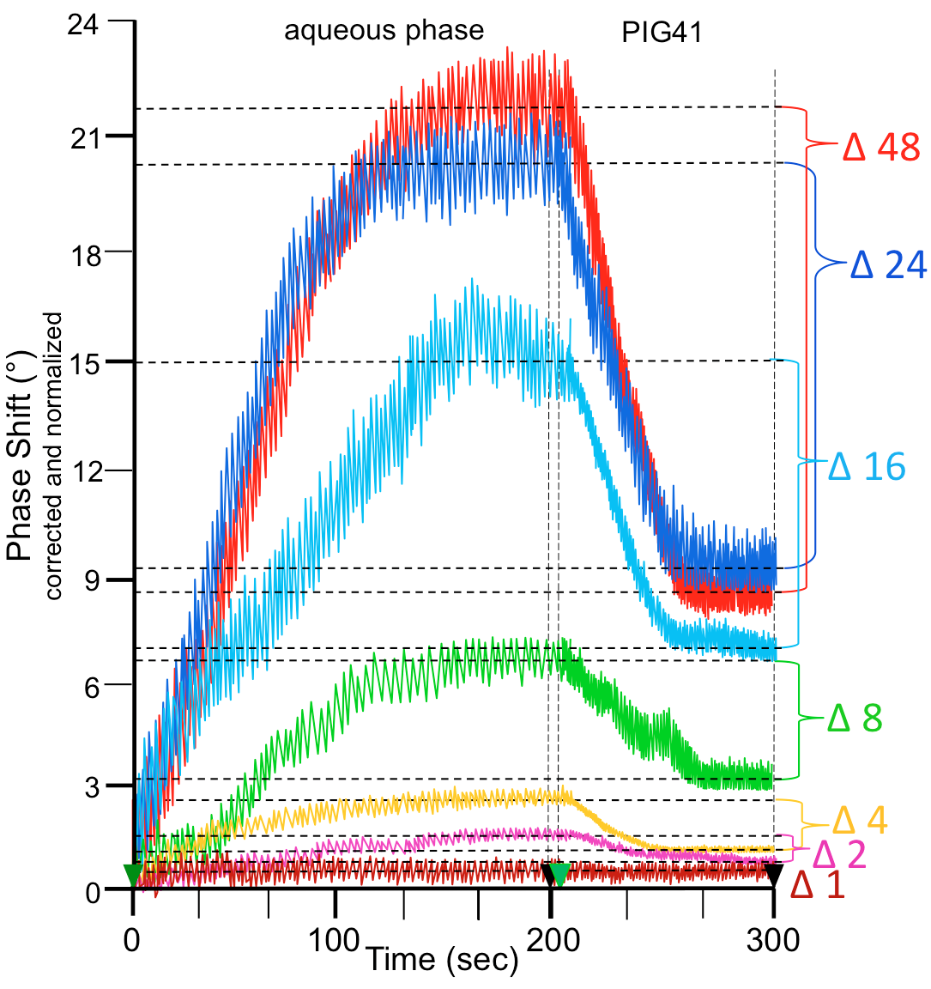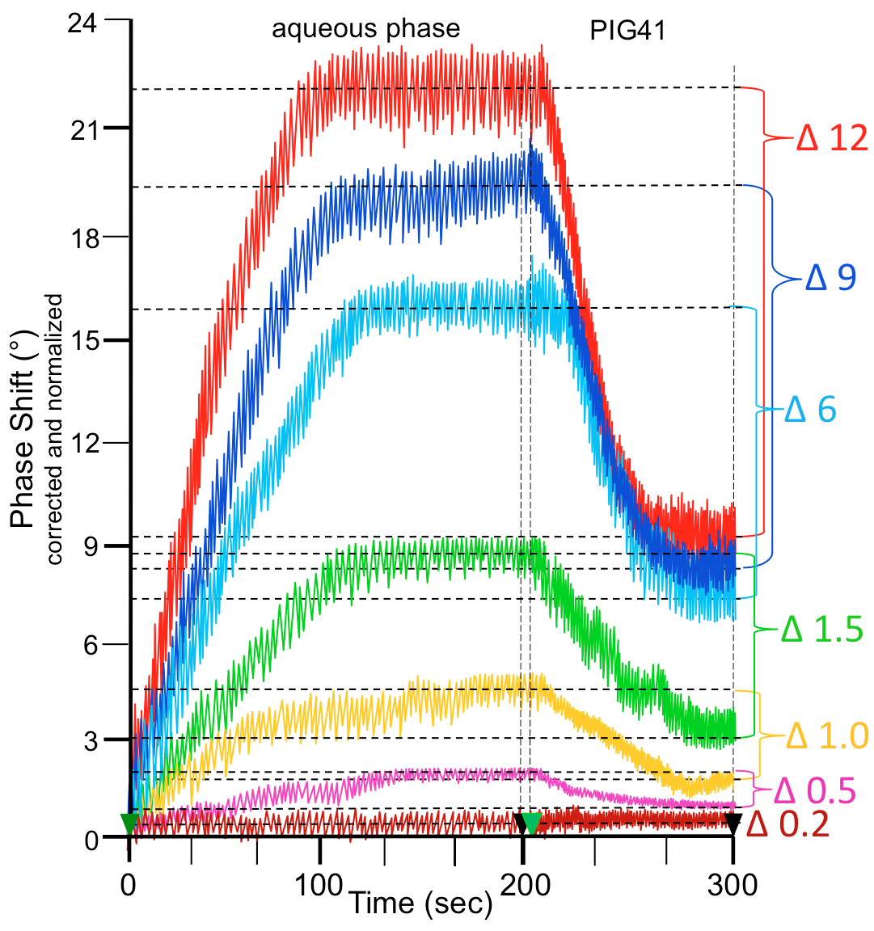

Supplemental Fig. S4. Implementation of the chip-based assay for GPI-PLD activity. Purified bovine erythrocyte AChE was incubated (6 min 37°C) with increasing amounts of recombinant human GPI-PLD (A, mUnits indicated) or with 16 mUnits GPI-PLD for increasing periods of time (B, min indicated) in the presence of TX-100 (0.025%). After TX-114 partitioning of the total incubation mixtures, 60 µl of the aqueous phase was injected (Time point 0) into α-toxin-coated chips. Specific capture of AChE with the core glycan remaining attached was tested by injection of 30 µM PIG41 at time point 203 sec. The measured phase shift was corrected for unspecific interactions of components of the incubation mixtures and altered viscosity of the sample fluid by subtraction of the value which was obtained with an incubation mixture lacking AChE and a "buffer only" control run in parallel on the same chip. Different chips were normalized for varying responsiveness of distinct chips towards GPI-AP capture by injection of increasing volumes of lipolytically cleaved AChE at defined concentration after complete regeneration of the chips using PIG41 and mannose. The maximal phase shift obtained and time required for reaching saturation were measures for the responsiveness of the individual chip channels to bind GPI-AP. The differences (∆) in phase shift between start (Time point 203 sec) and termination (Time point 300 sec) as indicated by horizontal hatched lines were calculated for each constituent ratio and represent a direct measure for GPI-PLD activity.

Supplemental Fig. S5
A B
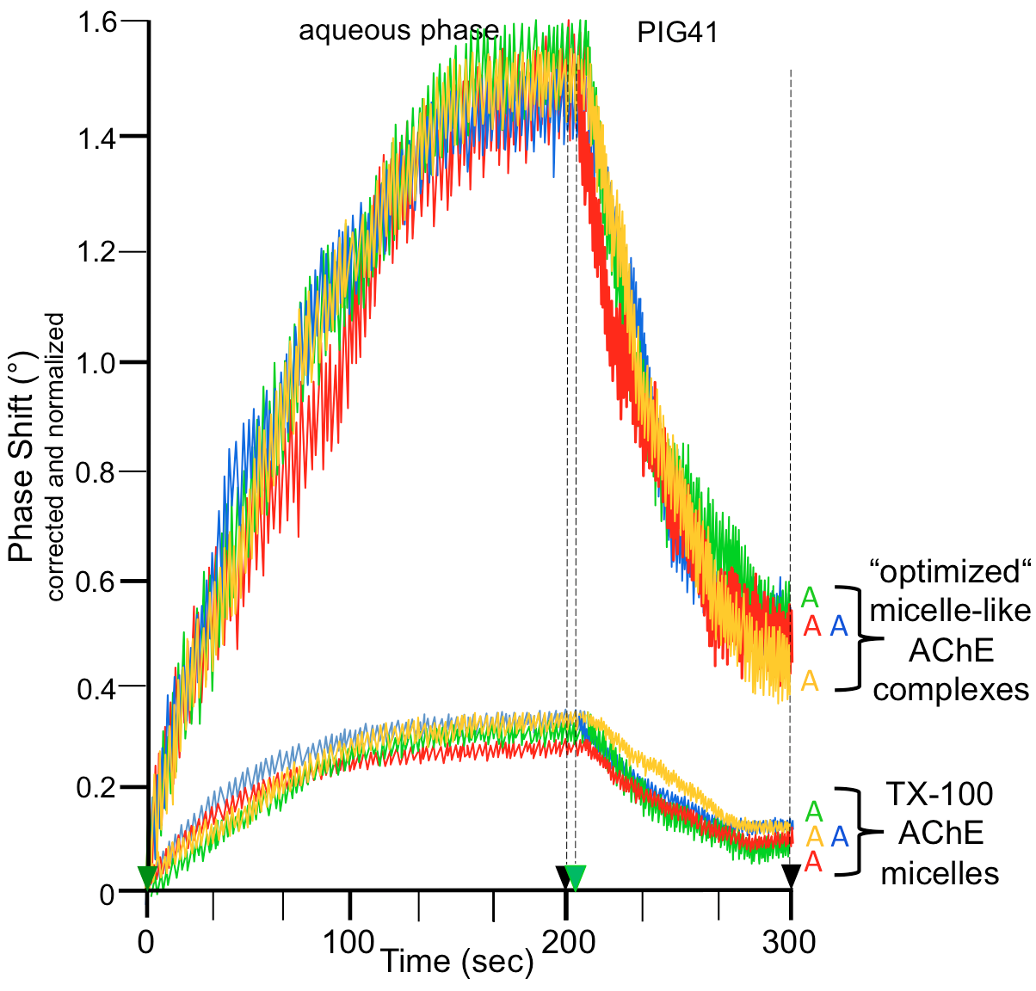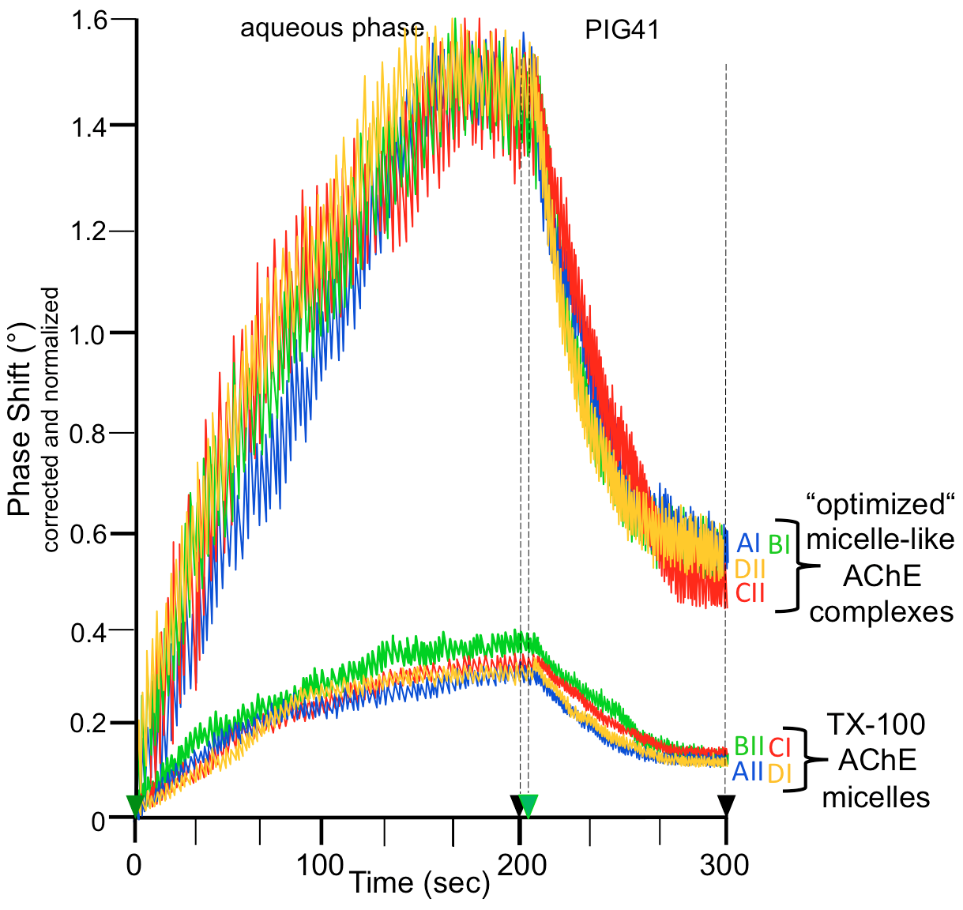

Supplemental Fig. S5. Implementation of the chip-based assay for GPI-PLD activity in serum samples. AChE reconstituted together with (lyso)phospholipids and cholesterol at the “optimized” constituent ratio into micelle-like complexes or into TX-100 micelles as described in SUPPLEMENTAL MATERIALS were incubated with serum samples from obese ZF rats. After TX-114 partitioning of the total incubation mixtures, the aqueous phases harboring the cleaved hydrophilic protein moiety of AChE were injected into α-toxin-coated chips (Time point 0). Specific capture of AChE having lost the phosphatidate moiety of its GPI anchor but retained the core glycan portion was tested by injection of 30 µM PIG41 at time point 203 sec. The measured phase shift was corrected for unspecific interactions of sample components as well as altered viscosity of the sample fluid and normalized for varying responsiveness of distinct chips towards GPI-AP capture as described above. The differences (∆) in phase shift between start (Time point 203 sec) and termination (Time point 300 sec) were calculated for each serum sample and represent a direct measure for GPI-PLD activity. The results of assaying the same incubation mixtures which had been subjected to separate TX-114 partitionings using the same channel (“A”) after four cycles of complete regeneration (routine measurement in “quadruplicate”; A) or of assaying the same aqueous phase upon TX-114 partitioning of the same incubation mixture using the four channels (“A-D”) each of two distinct chips (“I, II”) in "cross-over configuration" (B) as indicated are shown.

REFERENCES

77. Agrand M, Briolay A, Ronzon F, Roux B. Detergent-mediated reconstitution of a glycosyl-phosphatidylinositol-protein into liposomes. Eur J Biochem 250: 168-176, 1997.
78. Bradford M.M. A rapid and sensitive method for the quantitation of microgram quantities of protein utilizing the principle of protein.dye binding. Anal Biochem 72: 248-251, 1976.

79. Ellman GL, Courtney DK, Andres V, Featherstone RM. A new and rapid colorimetric determination of acetylcholinesterase activity. Biochem Pharmacol 7: 88-95, 1961.
80. Futerman AH, Low M, Silman I. A hydrophobic dimer of acetylcholinesterase from Torpedo californica electric organ is solubilized by phosphatidylinositol-specific phospholipase C. Neurosci Lett 40: 85-89, 1983.
81. Gnagey AL, Forte M, Rosenberry TL. Isolation and characterization of acetylcholinesterase from Drosophila. J Biol Chem 262: 13920-13298, 1987.
82. Kaya HB, Özcan B, Sisecioglu M, Ozdemir H. Purification of acetylcholinesterase by 9-amino-1,2,3,4-tetrahydroacridine from human erthrocytes. Appl Biochem Biotechnol 170: 198-209, 2013.
83. Morandat S, Bortolato M, Roux B. Cholesterol-dependent insertion of glycosylphosphatidylinositol-anchored enzyme. Biochim Biophys Acta 1564: 473-478, 2002.
84. Read SM, Northcote DH. Minimization of variation in the response to different proteins of the Coomassie blue G dye-binding assay for protein. Anal Biochem 116: 53-64, 1981.
85. Rigaud J-L, Paternostre M-T, Bluzat A. Mechanisms of membrane protein insertion into liposomes during reconstitution procedures involving the use of detergents. 2 Incorporation of the light-driven proton pump bacteriorhodopsin. Biochemistry 27: 267-2688, 1988.
86. Rosenberry TL, Roberts WL, Haas R. Glycolipid membrane-binding domain of human erythrocyte acetylcholinesterase. Fed Proc 45: 2970-2975, 1986.
87. Smith SA, Morrissey JH. Rapid and efficient incorporation of tissue factor into liposomes. J Thromb Haemost 2: 1155-1162, 2004.
88. Stambuk BU, Cardoso de Almeida ML. An assay for glycosylphosphatidylinositol-anchor degrading phospholipases. J Biochem Biophys Methods 33: 105-115, 1996.
89. Stieger A, Cardoso de Almeida ML, Blatter MC, Brodbeck U, Bordier C. The membrane-anchoring systems of vertebrate acetylcholinesterase and variant surface glycoproteins of African trypanosomes share a common antigenic determinant. FEBS Lett 199: 182-186, 1986.
90. Taguchi R, Ikezawa H. Properties of bovine erythrocyte acetylcholinesterase solubilized by phosphatidylinositol-specific phospholipase C1. J Biochem 102: 803-811, 1987.

